## 

**Diploma Thesis**

*Comparison of Artificial Intelligence systems for the detection of objects on UAV-based images.*

**TRIMAS CHRISTOS**

**CHANIA, AUGUST 2021**

**Committee**

**Professor Zervakis Michalis (Supervisor)**

**Associate Professor Lagoudakis Michalis**

**Professor Petrakis Euripidis**

**Acknowledgements**

First, I would like to thank my family who supported me all those years and never made a discount in my studies.

Next, I would like to thank Professor Michalis Zervakis and Dr. Marios Antonakakis who as my advisors guided me through the whole process of this thesis.

Last, but certainly not least, my dear friends who supported and helped me, through the difficult years of Electrical and Computers Engineering studies.

**Περίληψη**

**Abstract**

**Contents:**

***Chapter 1: Introduction…………………………………………………………….7***

* 1. **Unmanned Aerial Vehicles………………………………………….....7**
  2. **Object Detection………………………………………………………....7**

***Chapter 2: Artificial Intelligence, Machine Learning, Deep Learning…………..9***

* 1. **Machine Learning……………………………………………………….9**
  2. **Deep Learning…………………………………………………………10**
  3. **Convolutional Neural Network (CNN)………………………………10**
     1. *Convolution Layer……………………………………………….1*
     2. *Pooling Layer*
     3. *Fully Connected Layer*
     4. *Activation Functions*
     5. *Loss functions*

***Chapter 3: Convolutional Neural Networks.***

* 1. **Visual Geometry Group Network (VGGNet)**
  2. **Residual Network (ResNet)**
  3. **U-Net**
  4. **Feature Pyramid Network (FPN)**

***Chapter 4: Object Detection systems***

* 1. **Two-stage architectures**
     1. *Regional(R-CNN)*
     2. *Fast R-CNN*
     3. *Faster R-CNN*
  2. **Single Stage architectures**
     1. *You Only Look Once (YOLO)*
     2. *Retina Network*

***Chapter 5: RetinaNet analysis***

* 1. **Backbone Network**
  2. **Classification/Regression Networks**
  3. **Loss Functions.**
  4. **Why Retina?**

***Chapter 6: Dataset.***

* 1. **Stanford Drone Dataset (SDD) description.**
  2. **Changes in the Dataset**

***Chapter 7: Evaluation Metrics***

* 1. **Intersection over Union(IoU)**
  2. **Metrics**

***Chapter 8******: Experiments***

* 1. **Simple Split**
  2. **k-fold Cross Validation**
  3. **Bottom-up FPN architecture**

***Chapter 9: Comparison***

* 1. **Comparison with other models**
  2. **Comparison with original RetinaNet**

***Chapter 10: Conclusions***

* 1. **Limitations**
  2. **Future work**

***Chapter 11: References***

1. **Introduction**

**1.1) Unmanned Aerial Vehicles**

Unmanned systems are typically known as powered vehicles that do not carry a human operator, can be operated autonomously or remotely and can carry a variety of payloads depending on their type, functionality and mission objectives.

Unmanned Aerial Systems, also known as a drone, have experienced the greatest growth. As of 2020, seventeen countries have armed UAVs, and more than 100 countries use UAVs in a military capacity. The global military UAV market is dominated by companies based in the United States and China. With extensive cost reduction in electronics, the defense forces around the globe are utilizing UAVs for applications such as logistics, communications, attack and combat, while commercial applications include aerial photography and filmmaking, cargo transport and detection of disasters [1].

Whether it comes to the detection of objects of interest (refugee waves, tracking and exterminating target), prison surveillance or information gathering of a battlefield, UAVs have proven their usefulness. A significant contribution to this development, played the evolution of cameras. The cameras on-board UAVs are a rich source of information that can be processed in order to extract meaningful information. Besides the cameras, the development of other advanced hardware and software technologies allow drones to carry out their missions without human intervention, such as computer vision, object detection, machine learning, thermal sensors and deep neural networks.

**1.2) Object Detection**

Object detection is a computer technology related to computer vision and image processing that deals with localization and identification of semantic objects of a certain class, in digital images and videos. In other words, given an image or a video stream, an object detector can identify-classify objects of interest and provide information about their positions within the image.

With the evolution of cameras and the oversimplification of data gathering and processing, object detection can be used in the following military and commercial areas:

* Surveillance.
* Search and Rescue missions.
* Anomaly detection.
* Autonomous driving

The basic idea of object detection, is that every object class has its own special features that helps in classifying the class- for example all circles are round. Object detection models learn those special features and create patterns on the objects properties. Features may be specific structures in the image such as points or edges. More broadly a feature is any piece of information which is relevant for solving the computational task related in computer vision applications. The feature extraction process can be a computational expensive and many times due to time constraints, a higher level algorithm may be used to guide the feature detection stage, so that only certain parts of image are searched for features.

There are two kinds of object detection methods:

1. Neural Network approaches.
2. Non-Neural approaches.

Non-Neural approaches use one of the following techniques for feature extraction and an algorithm such as Support Vector Machines for classification of those features.

* **Viola-Jones object detection framework based on Haar features.**
* **Scale-Invariant feature transform.**
* **Histogram of oriented gradients features.**

Neural Network approaches can be distinguished in to two-stage detectors and single-stage detectors. The first ones use a box proposal algorithm as the first stage, and the second stage classifies those proposals, while the second ones detect objects and classify them in the image in one pass through the network.

The most known detectors are:

* **Regional Proposal Networks such as R-CNN.**
* **Single Shot MultiBox Detector.**
* **You Only Look Once (YOLO).**
* **Retina-Net.**

**2. Artificial-Intelligence, Machine-Learning, Deep-Learning**

Nowadays, the word Artificial Intelligence or A.I. sounds everywhere and it is used increasingly. A.I. refers to the simulation of human intelligence in machines that are programmed to think like humans and mimic actions. The term may also be applied to any machine that exhibits traits associated with a human mind such as learning and problem-solving.

The most common applications of A.I. are: autonomous cars, voice and face recognition, data analysis, virtual assistance and other applications in various industries. Subfields of Artificial Intelligence are machine learning and deep learning.

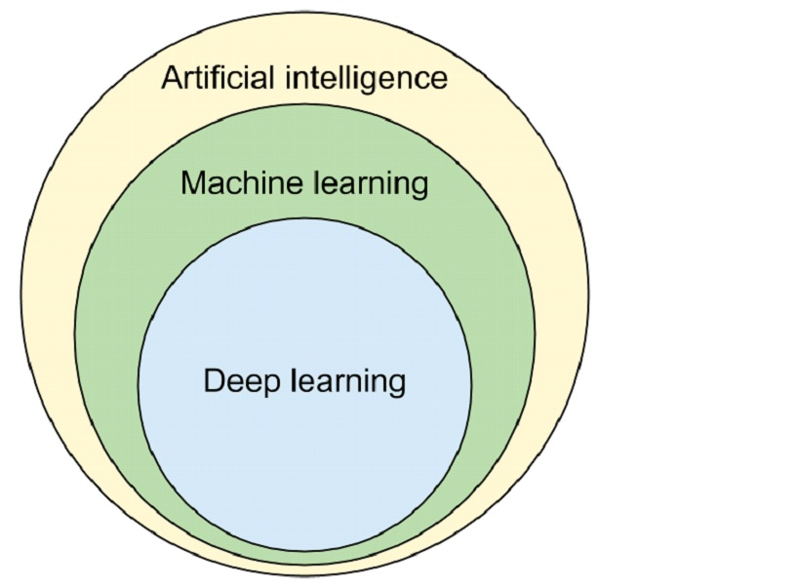

**Image [1]: A.I., M.L. and D.L.**

**2.1) Machine Learning**

The concept of machine learning dramatically changes the way of how classical programming works. In the classical method, someone provides the data and defines the rules of the program to obtain an answer. In machine learning or ML, someone give the data with the answers and demands from the machine to create the rules. The rules can then be applied to a new data to confirm the results and to generate new answers. In other words, ML consists of algorithms that improve automatically through experience and by the use of data.

A subset of Machine Learning is Deep Learning.

**2.2) Deep Learning**

From Machine Learning Deep Learning was born. D.L. is part of a broader family of machine learning methods based on artificial neural networks with feature learning. Deep-learning architecture such as deep neural networks and convolutional neural networks have been applied to fields including computer vision and image analysis.

A Deep Neural Network (DNN) is an artificial neural network with multiple layers between the input and the output layers. In computer vision the most used class of deep neural networks are Convolutional Neural Networks or CNNs.

**2.3) Convolutional Neural Networks**

A Convolutional Neural Network is a Deep Learning algorithm which can take in an input image, assign importance to various objects in the image and be able to differentiate one from the other. ConvNets require less pre-processing compared to other classification algorithms.

The architecture of a CNN is analogous to that of the connectivity pattern of Neurons in the Human Brain and was inspired by the organization of the visual cortex. Individual neurons respond to stimulations only in a restricted region of the visual field known as the Receptive Field. A collection of such overlap cover the entire visual area.

An image is a matrix of pixel values. A lot of times images contain objects that have pixel dependencies throughout the image. A CNN is able to successfully capture spatial dependencies in an image though the application of relevant filters and the network can be trained to understand the sophistication of the image better.

In image [2], an RGB image, which has been separated by its three color planes, is represented. Although this example has small dimensions, real images can reach higher dimensions, for example an 8K image has 7680x4320x3 dimensions, making object detection in such dimensions a computational intensive procedure. The role of CNN is to reduce the image into a form which is easier to process the image, but at the same time without losing features which are critical for getting good predictions.

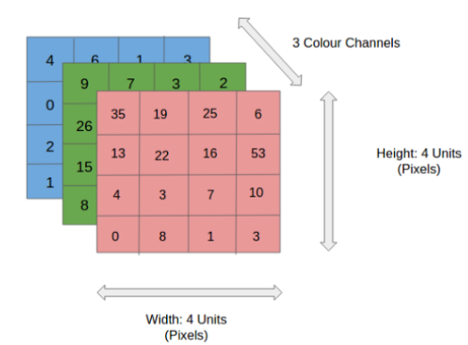

**Image [2]: An RGB image**

ConvNets, usually, are divided into two parts, the convolutional and the densely connected. The first one applies various layers such as Convolution and Pooling to reduce the dimensions and retain the important features of the image, while the second one is responsible for classification. In the following image [3], an example of a CNN architecture is shown.

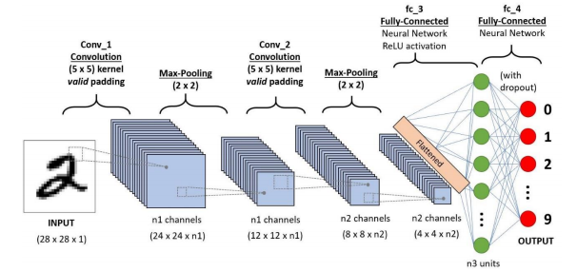

**Image [3]: A 4 layer CNN.**

**2.3.1) Convolution Layer**

In a ConvNet, the input is an image (tensor) with a shape: (H) x (W) x (C), representing height, width and number of channels respectively. After passing the input through the convolutional layer, the image becomes abstracted to a feature map, with new shape: (Feature Map Height) x (Feature Map Width) x (Feature Map Channels).

Generally, a convolutional layer has the following attributes/hyperparameters:

* Convolutional filters, also known as kernels.
* The number of input and output channels.
* Padding (augmentation of the kernel) and Stride (size of the step the kernel parses an image).

A convolutional kernel is basically a matrix that is applied throughout the image. Each filter is convolved across the width and height of the input image, computing the dot product between the filter entries and the input, resulting to a feature map of that filter. The network learns filters that activate when it detects some specific type of feature at some spatial position in the input.

Given a two-dimensional Image **I** as input and a two-dimensional kernel **K** the convolution operation can be described [2]:

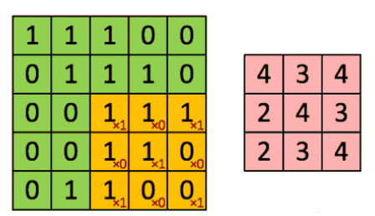

**Image [4]: Original and Convolved Image.**

In image [4], the kernel shifts 9 times in the orginal image, performing every time a matrix multiplication operation between the kernel and the portion of the image over which the kernel is hovering at the time. In this example, the filter parses the image with a stride of 1.

In cases of images with multiple channels such as RGB (Image [5]), the kernel has the same depth as that of the input image, and matrix multiplication is performed between the Kernels and each Channel. The results then are summed to give a squashed one-depth channel Convolved Feature Map.

The goal of Convolution operations is to extract high-level semantically rich features from the input image. One layer is not enough to achieve this, therefore CNNs need not to be limited to only one convolutional layer. The first layers are responsible for Low-Level features such as edges. With more depth in the network, the architecture adapts to the High-Level features as well, providing a network which understands the whole image.

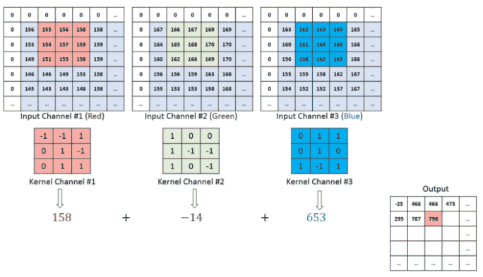

**Image [5]: RGB example of convolution.**

To add more layers (depth) to the network, there are two types of operation. One in which the convolved feature is reduced in dimensionality (Valid padding) compared to the input, and the other in which the dimensionality remains the same or it is increased (Same padding).

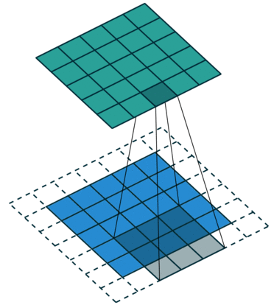

**Image [6]: Same padding with zeros.**

The same padding operation that is shown in Image [6] has been achieved by augmenting the input image from 5x5x1 to 6x6x1 and then applying the 3x3x1 kernel over the augmented image. If the valid padding operations was performed, the convolved matrix will have the same dimensions with the kernel.

**2.3.2) Pooling Layer**

Similar to the convolutional layer, the Pooling layer is responsible for reducing the spatial size of the convolved feature. The goal of pooling layer is to decrease the computational power required to process the data and to extract dominant features through dimensionality reduction.

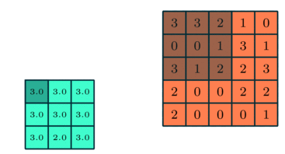

**Image [7]: An example of pooling.**

There are two types of Pooling: Max Pooling and Average Pooling.

**Max pooling** returns the maximum value from a portion of the image I covered by a kernel K. It can be used as a Noise Suppressant, discarding the boisterous activations altogether and hence performing de-noising and dimensionality reduction at the same time.

**Average pooling** returns the average of all the values from the portion of the image I covered by a kernel K and as result performs dimensionality reduction.

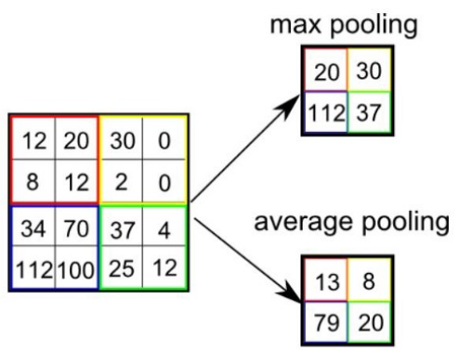

**Image [8]: Avg and Max pooling.**

After repeating convolution and pooling layers for several times, the model will successfully understand low and high level features. The final step is to feed those features to either an Artificial Neural Network or use another technique to perform classification.

**2.3.3) Fully Connected Layer**

Adding a Fully-Connected (FC) layer is a cheap way of learning non-linear combinations of the high-level features as represented by the output of the convolution and pooling layers. In more details, the input to the FC layer is the output from the final convolutional or pooling layer, which is flattened and then fed into the fully connected layer.

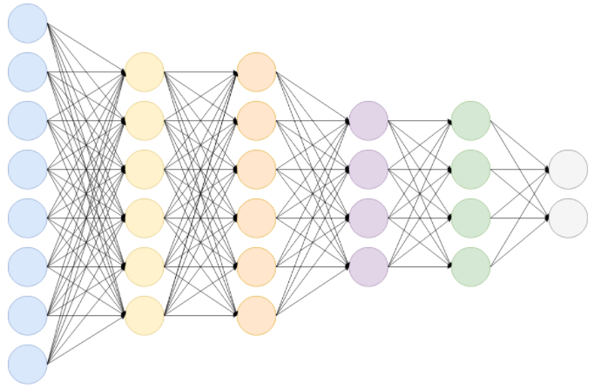

**Image [9]: A Fully Connected Network.**

The output after performing convolutions and pooling layers is a 3-d matrix. To flatten the output, each value of the matrix is stacked and the result is huge vector. The flattened vector is then connected to fully connected layers which are Artificial Neural Nets. Each layer of the ANN applies the following function:

Where,

**x** is the input vector with dimension: ***d1 = (number of neurons, 1)***.

**W** is the weight matrix with dimensions:

***d2 = (number of neurons in previous layer, number of neurons in the current layer)***.

**b** is the bias vector with dimensions: ***d3 = (number of neurons in current layer, 1)***.

**g** is the activation function.

After passing through the FC layers, the final layer uses an activation function (see next subsection) to get the probabilities of the input and classify them into a particular class.

**2.3.4) Activation Functions**

Also known as Transfer Function, is a way to extract the output of a node in an Artificial Neural Network. It maps the resulting values in a well-defined space, depending the function.

Activation functions can be basically divided into 2 types:

1. Linear Activation Functions.
2. Non-Linear Activation Functions.

**Linear of Identity Activation Function:**

The function is a line ranging between (-∞, ∞).

**Equation:.**

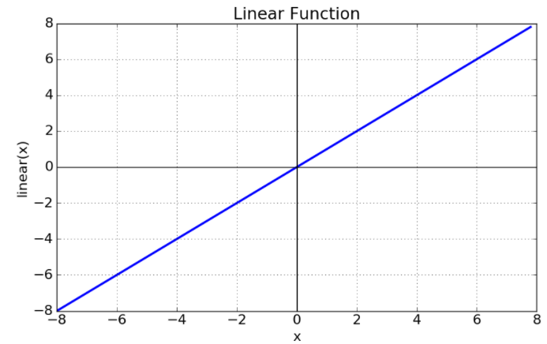

**Image [10]: Linear Activation Function.**

**Sigmoid or Logistic Activation Function:**

A sigmoid function ranges between (0, 1), therefore making it useful in models that predict probabilities as an output. The function is differentiable and monotonic.

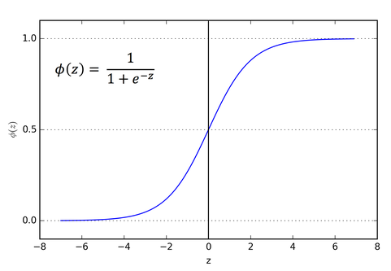

**Image [11]: Sigmoid Function.**

A huge disadvantage is that the logistic function can cause a neural network to get stuck during the training phase. This is because, if a strongly-negative input is provided, it outputs the value very near to zero. This behavior slowdowns the update of the learnable parameters, such as weights and bias.

**Equation:**

**Rectified Linear Unit (ReLU) Activation Function:**

This function maps every negative value immediately to zero. It ranges from zero to infinity, and the function and its derivative are monotonic.

**Equation:**

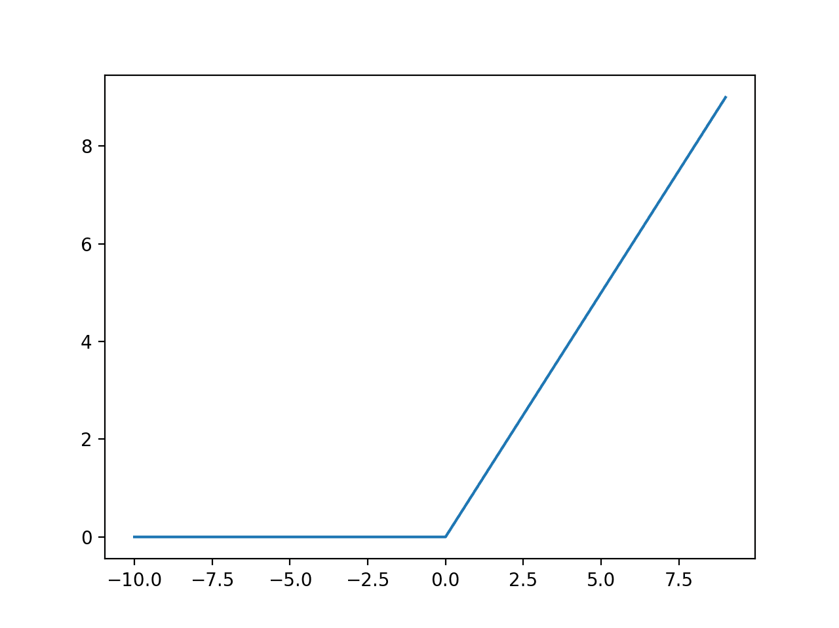

**Image [12]: ReLU Activation Function.**

**Softmax Activation Function:**

Softmax maps the output in range between [0, 1]. Furthermore, the total sum of the mapped output is 1. Therefore, the output of Softmax is a probability distribution.

**Equation:**

**For j = 1,…,K.**

**2.3.5) Loss Functions**

In Neural Networks, the term Loss refers to the prediction error of the Neural Network. The calculation of the loss with the use of a function is called Loss Function. Loss function is responsible for the update of weights of the Neural Network.

There are various Loss functions and the selection of the one that fits the best to a model depends on various factors, such as the type of problem (Regression or Classification), the model architecture and many more.

Few of the most known Loss Functions are:

**Cross Entropy:** One of the most known loss functions, it measures the performance of a classification model whose output is a probability value.

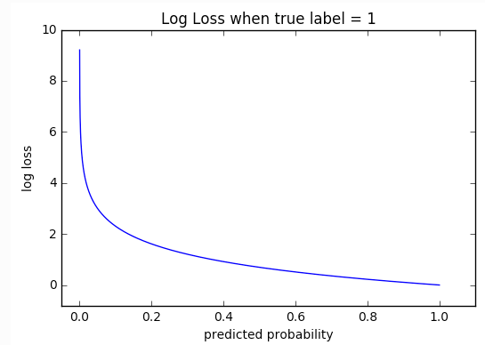

**Image [13]: Cross-entropy loss.**

Cross-entropy can be described by the following equation

where, M is the number of the classes, log the natural logarithm, y the binary indicator (0 or 1) if class label i is the correct classification and y_hat is the predicted label.

**Kullback-Leibler divergence:** Also called *relative entropy*, it is the gain or loss of entropy when switching from distribution one to distribution two – and it allows to compare the two distributions.

KL divergence is primarily used in Variational Autoencoders or in multiclass classification scenarios. Mathematically can be described by the following equation:

**Smooth L1:** Mostly used in object detectors for bounding box regression.

After defining L1 or Manhattan distance:

The smooth L1 can be defined:

where x is the Manhattan distance between 2 vectors.

From the above equation the smooth L1 can be re-written:

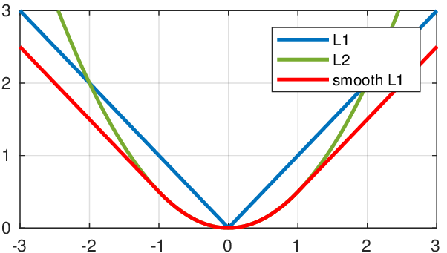

**Image [14]: Smooth L1 Loss.**

In a more general way, the smooth L1 loss can be re-written:

In other words, the goal of smooth L1 is to minimize the absolute difference between the target and the estimated value.

**Focal Loss [3]:** Focal loss is a modification of the cross-entropy function, that reduces the contribution from easy examples and increases the importance of correcting misclassified examples.

From the Cross-Entropy function:

Modifying the above loss function in more simplistic terms:

By applying (2), in equation (1):

At this point, Cross-Entropy handles only the weight of positive and negative examples. Positive examples are the target class and negative examples are non-target class or background information. However, in object detection there are samples that were correctly classified as positive or negative example, and there are samples misclassified as negative or positive examples. Those are easy and hard positives/negatives respectively and Cross-Entropy does not handle them at all. Apart from that, usually dataset suffer from class imbalance, making the network biased towards the dominant class.

To solve those problems, Focal Loss adds a modulating factor to the cross-entropy loss, with a tunable hyper-parameter.

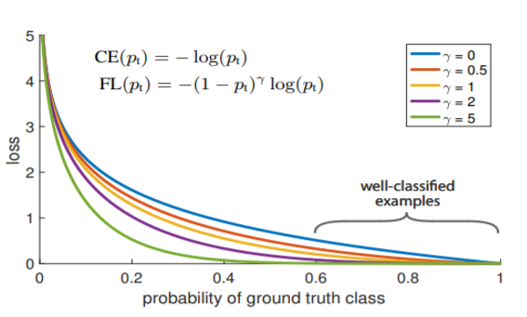

**Image [15]: Focal Loss.**

If the gamma parameter gets the value zero, then the focal loss becomes cross-entropy.

There are other loss functions, such as categorical cross-entropy, hinge loss, Huber loss, Mean Square Error and many more.

3. **Modern Convolutional Neural Networks**

With the combination of the layers described in Chapter 2, various ConvNets architectures can be built and deployed, depending on the task. Traditionally, CNNs are a good option for classification problems, but modern object detection pipelines utilize CNNs as feature extractors as well. This chapter, describes some of the most well established ConvNets and two Fully Convolutional Networks that have make a significant contribution in Computer Vision.

**3.1) Visual Geometry Group (VGGNet)**

Designed by the Department of Science and Engineering of Oxford University, VGGNets [4] are a series of convolutional neural network models. The original purpose of VGG’s research on the depth of ConvNets, was to understand how the depth of NN affects the accuracy of image classification and recognition. Beginning with VGG, two more upgraded models were designed VGG16 and VGG19, with the number representing the depth of the model.

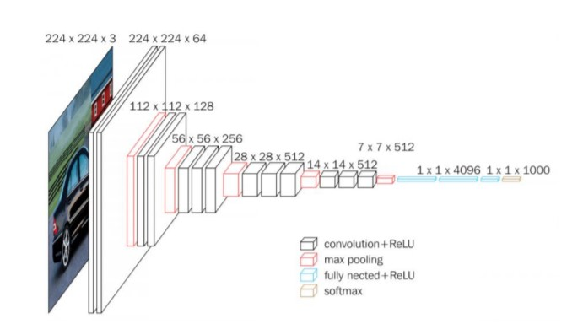

**Image [16]: VGG16 architecture.**

Oxford University proposed the idea of seeing the design of a neural network architecture more abstract and first introduced the idea of blocks and repeating patterns. Visual Geometry Group Networks can be split into six blocks. As can be seen in Image [16], the input image is passed through five blocks. Each block is a sequence of Convolution, Rectified Linear Unit and max pooling layers. The final block, flats the output and uses SoftMax for classification.

One important feature of VGG Net is that it uses convolutional blocks based on 3x3 modules. For example, in the first block each of the output characteristics depends on a 3x3 region of the original image, in the second conv block it depends on 5x5 of the original image and so on. Therefore, each block has a dependency from the original image, that follows this rule:

Where n = 0, 1, ,.., number of blocks.

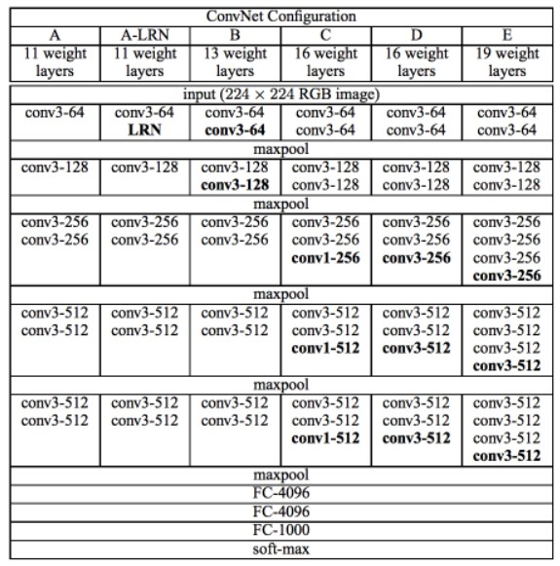

**Image [17]: VGGNets.**

VGG shows a simple structure where lower blocks can extract global, semantically rich features and the higher blocks can process the higher resolution pixels of the image.

**3.2) Residual Networks (ResNet)**

Designing deep neural networks can be a very challenging task to complete. As more layers were stacked in a CNN, more problems were emerging (exploding or vanishing gradient problem). It is important that the addition of layers makes the network strictly more accurate, more expressive rather than just different.

Considering **Ꞙ** is the class of functions that a specific network architecture can reach, then exists some set of parameters (biases, weights) that can be obtained through training on a suitable dataset. If ***f\**** is the target function and it belongs in **Ꞙ**, then the network is in a good “shape”. Unfortunately, this is rather unlucky, so instead the network tries to find some which best fits within **Ꞙ**. Given a dataset with features **X** and labels **y**, the network tries to solve the following optimization problem:

It is only reasonable to assume that designing a different and more powerful architecture **Ꞙ’** it should arrive at a better outcome. However, if **Ꞙ** is not a subsample of **Ꞙ’** then it is not guaranteed that the architecture will perform better. In other words, non-nested function classes do not always move closer to the target function, as illustrated in Image [18]. However, if each architecture is as good as the previous one with the addition of extra complexity (nested functions), then each new model will move towards the target function.

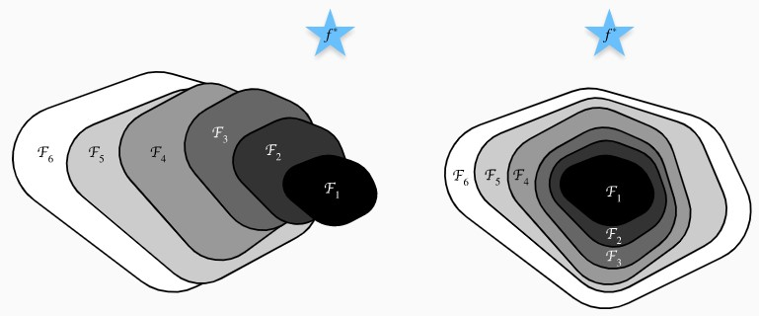

**Image [18]: Non-nested and Nested function classes.**

For deep neural networks, the newly-added layer can be trained into an identity function ***f(x) = x,*** the new model will be as effective as the original model. As the new model may get a better solution to fit the training dataset, the added layer might make it easier to reduce training errors.

Assuming a classical convolutional neural network exists then it maps the input **x** to the output **y = f(x)**. A residual network will use a replica of the input **x** to the output of the network and the learning algorithm will only learn the differences between the input and the output. Therefore, the output of the network is ***f(x)+x***. The advantage of this method (residual block), is that it creates layers that they are at least efficient as the previous ones. Furthermore, the architecture of the model is relatively simple, since the same topology is repeated through the entire network.

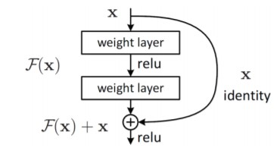

**Image [19]: Residual Block.**

ResNet or Residual Networks were invented by Microsoft to solve the problems that were stated in the beginning. There are many architecture such as ResNet 18, ResNet 34, ResNet50, Resnet101 and ResNet152, with the number representing the number of layers in each architecture.

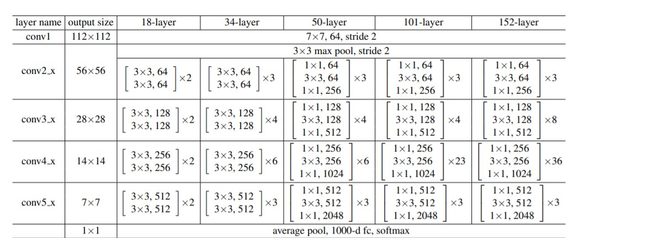

**Image [20]: Residual Networks architecture.**

ResNet34[5] for example has five convolutional blocks and one block for classification. In each convolutional block the spatial dimensions are reduced by a factor of 0.5, while the number of filters doubles in each block. In the last block, average pooling is applied and a fully connected layer, to flatten the network in the appropriate number of classes. To classify the objects, a softmax layer is applied at the end.

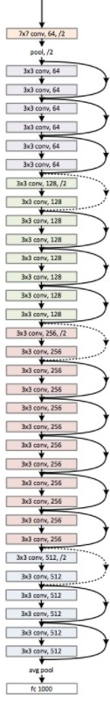

**Image [21]: ResNet34 architecture.**

**3.3) U-Net**

Convolutional Networks are powerful visual models that yield hierarches of features. All models described in previous sections utilized fully connected layers for classification. Unlike classic CNNs, a Fully Convolutional Network (FCN) does not have fully connected layers. The neural network can only perform convolution and pooling operations (for FCN pooling is either up-sampling or down-sampling). The CNNs layers typically reduce or down-sample the spatial dimensions of the input (height and width), or keep it unchanged. For a Fully Convolutional Network architecture, since they perform pixel-wise classification most of the times, it will be convenient if the spatial dimensions of the input and output are the same. To achieve this, especially after the spatial dimensions are reduced after each convolution step, another type of layer called transposed convolution can be used to increase (up-sample) the spatial dimensions of the intermediate feature maps.

Given a input tensor and kernel. Sliding the kernel window with stride of one for times in each row and times in each column yields a total of intermediate results. Each intermediate result is a tensor that are initialized as zeros. To compute each intermediate tensor, each element in the input tensor is multiplied by the kernel so that resulting tensor replaces a portion in each intermediate tensor. In the end, all intermediate results are summed together to produce the output of the transposed convolution. An example can be seen in the following Image.

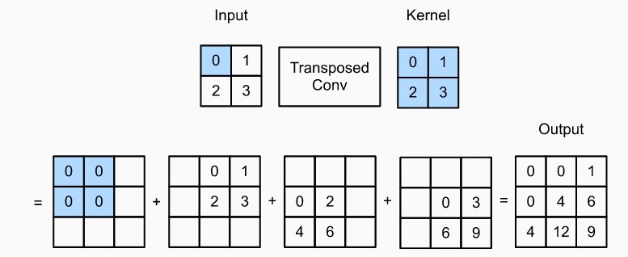

**Image[22]: Transpose Convolution example.**

An example of fully convolutional network is the U-net[6]. It took its name because of its U shape, which can be seen in Image[23]. The network consists of a contracting path (top-down pathway) and an expansive path (bottom-up pathway).

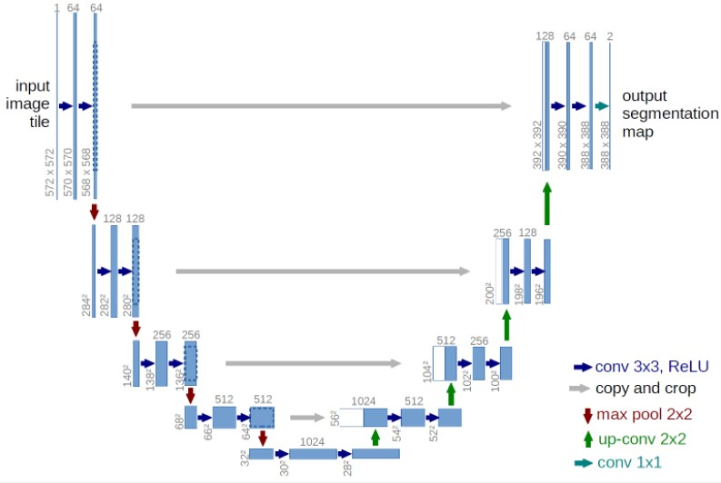

**Image[23]: U-net architecture.**

The top-down path follows the architecture of a simple ConvNet, consisting of convolutions and max pooling operations. At first, two 3x3 zero-padded convolutions are applied, each followed by a ReLU and a 2x2 max polling operation with stride of 2 channels. At each down-sampling step the spatial dimensions are reduced by a factor of 0.5 and the number of feature channels are doubled.

Every step in the bottom-up pathway consists of an up-sampling operation of the feature map, followed by a 2x2 “up-convolution” that halves the number of feature channels, followed by a concatenation with the corresponding cropped feature map from the dilated path and two 3x3 convolutions, followed by a ReLU. The cropping operation is necessary to match the size of the new feature map that is produced after each convolution step. As a final layer a 1x1 convolution is used to map each component feature vector to the desire number of classes.

U-net was initially developed for biomedical-segmentation, but it is widely used in semantic segmentation problems (pixel-wise classification).

**3.4) Feature Pyramid Network (FPN)**

Detecting objects in different scales is challenging in particular for small objects. Feature pyramids upon image pyramids form the bases of a standard solution to this problem. These pyramids are scale-invariant in the sense that an object’s scale change is offset by shifting its level in the pyramid. This property, enables a model to detect objects across a large range of scales by scanning the model over both positions and pyramid levels.

Featurized image pyramids were heavily used in the era of hand-engineered features. In the modern days, tasks like recognition and object detection use features that have been computed by an algorithm or by another deep learning model and not by hand.

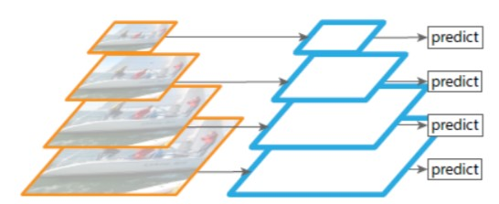

**Image[24]: Featurized Image Pyramids.**

Furthermore, featurizing each level of an image pyramid has various limitations. Inference time increases considerably, making this approach impractical for real applications. Also, training a deep neural network end-to-end on an image pyramid is memory consuming.

Another way to compute a multi-scale feature representation is by using a ConvNet. A CNN computes a feature “hierarchy” layer by layer and with sub-sampling layers the hierarchy gets a multiscale pyramidal shape.

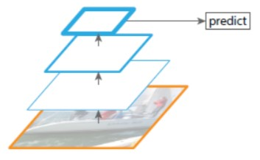

**Image[25]: Single Feature Map.**

This hierarchy produces feature maps of different spatial resolutions, but introduces large semantic gaps caused by different depths. As the network goes deeper, the resolution of the image reduces, but semantically strong features are being extracted. The single feature map model misses the opportunity to reuse higher-resolution maps, consequently misses the detection of object of different sizes.

Feature Pyramid Network or FPN combines low-resolution but semantically strong features with high resolution but semantically weak features. To achieve this, it utilizes a bottom-up and a top-down pathway with lateral or skip connections.

The bottom-up pathway uses a ConvNet like ResNet or VGG. From one convolution module to the next, the spatial dimensions are reduced by ½. The output of each convolution module is later used in the top-down pathway.

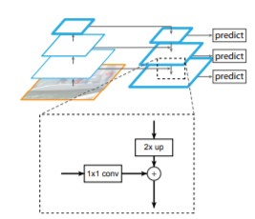

**Image[26]: FPN architecture.**

Each output of the bottom-up pathway is used as input in the top-down pathway. To fit the dimensions the FPN uses lateral connections, which is simple a 1x1 convolution filter to reduce the output channel depth. Going down the path, each previous layer is up-sampled by 2, using nearest neighbors up-sampling (Image[26]).

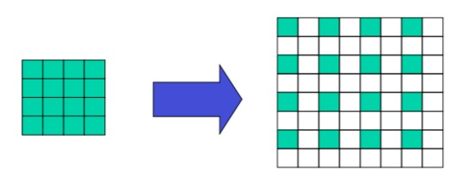

**Image[27]: Up-sampling.**

The result is an image with double the size of the spatial dimensions. Again, a 1x1 convolution is applied to the corresponding feature maps in the bottom-up pathway. Then the results are added element-wise. Finally, a 3x3 convolution filter is applied to all merged layers. This final filter is applied to reduce the aliasing effect of the up/down-sampling that takes place.

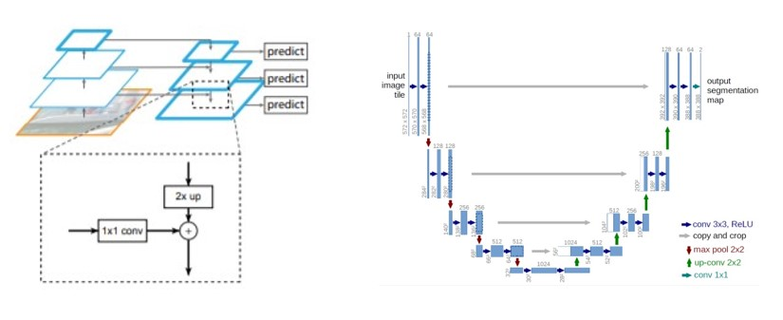

**Image[28]: U-net vs FPN.**

Both U-net and Feature Pyramid network are Fully Convolutional Networks. While they seem to have big similarities, the main difference is that FPN utilizes lateral connections, while U-net only copies and concatenates the cropped areas.

1. **Object detection systems**

Object detection systems, based on the architecture, can be classified in two detector categories:

* Single-stage detectors.
* Two-stage detectors.

The difference between the two pipelines is that two-stage detectors use in the first stage an algorithm or even an entire Neural Network to create possible locations of objects in an image and the second stage is responsible for classification and box location correction, while single-stage detectors localize an object and classify it in a single pass.

Two-stage detectors were designed for accuracy, while single-stage detectors for speed. As deep neural networks advanced over the years, so did object detector systems, to the point were two-stage and single-stage detectors perform at the same accuracy and speed level.

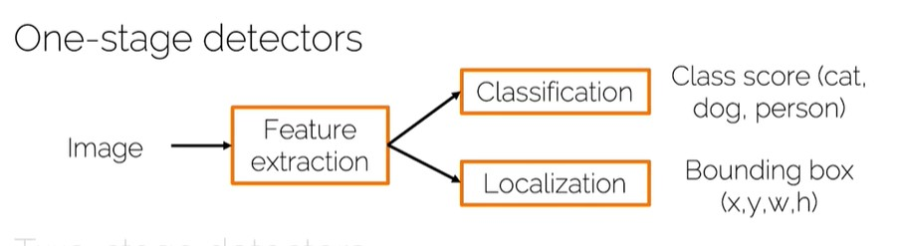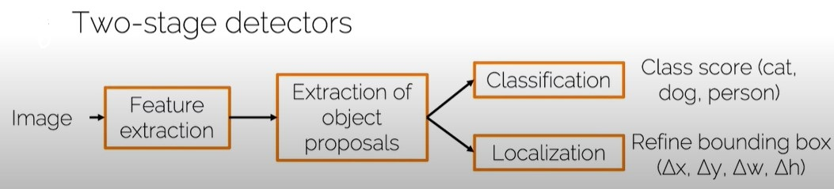

**Image[29]: Object Detection Pipelines.**

**4.1) Two-stage architectures**

The problem of object detection can be separated into two sub-problems. Box localization and classification of the proposed location. Due to unknown number of instances of an object in an image, a simple ConvNet architecture is not enough. As an alternative, the image can be divided in a fixed number of regions, and the ConvNet can classify if the image contains a certain class of objects. The problem with this approach is that different objects have different spatial locations within an image and different aspect ratios. Hence, a huge number of regions must be selected, making it a huge computational problem.

To bypass this problem various methods were proposed aiming the reduction of the proposed locations. The Networks that utilize that kind of techniques were known as Region-based Convolutional Neural Networks (RCNNs) or two-stage detectors.

**4.1.1) Regional CNN (R-CNN)**

The first Region Proposal Network (R-CNN) took an image as input and produce a set of bounding boxes as output, where each bounding box contains an object and also the category of the object. In order to keep the number of proposed locations small, R-CNN utilizes in the first stage of the pipeline a mechanism called Selective Search to extract regions of interest (ROI). Each ROI is a rectangle that may represent the boundary of an object in an image.

|  |  |  |
| --- | --- | --- |
| ***Selective Search using Hierarchical Grouping*** | | |
|  | ***Input****: Image.* | |
|  | ***Output****: Set of object location hypotheses L.* | |
| **1** | *Obtain initial regions R = {r1, …, rn} using F&H method.* | |
| **2** | *Initialize similarity set S = Ø.* | |
| **3** | ***foreach*** *neighboring region pair (ri ,rj)* ***do*** | |
| **4** |  | *Calculate similarity s(ri, rj).* |
| **5** |  | *S =* |
| **6** | ***while*** *S ≠ Ø* ***do*** | |
| **7** |  | *Get highest similarity s(ri,rj) = max(S)* |
| **8** |  | *Merge corresponding regions* |
| **9** |  | *Remove similarities regarding* |
| **10** |  | *Remove similarities regarding* |
| **11** |  | *Calculate similarity set St between rt and its neighbors.* |
| **12** |  | *S =* |
| **13** |  | *R = R* |
| **14** | *Extract object location boxes L from regions in R.* | |

Usually, selective search calculates approximately 2.000 possible object locations. After that, each ROI is warped into a square and fed through a convolutional neural network that produces an output feature vector. Each ROI’s feature output is fed into a Support Vector Machine to classify the presence of the object within that candidate region proposal. In addition to predicting the presence of an object withing the region proposals, the algorithm also predicts four values, which are offset values to increase the precision of the bounding box. In other words, the algorithm uses these 4 values to adjust the coordinates of the region proposal, as close as possible to the ground truth.

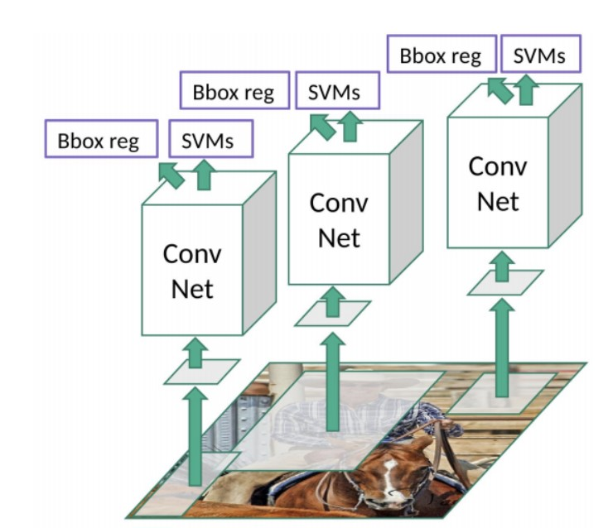

**Image[30]: RCNN architecture.**

In Image[30], the architecture of RCNN can be seen. In this particular image example, there are three region proposals that are warped into a fix size rectangle and they are fed into a ConvNet. Each feature vector is then used to adjust the bounding box and classify the object within the region. Although the example looks simple, in a real dataset they would be around 2.000 proposals for each image, making the whole process a difficult computational problem. Furthermore, the selective search algorithm is a fixed algorithm and no learning is happening at that stage. This could lead to the generation of bad candidate region proposals.

**4.1.2) Fast R-CNN**

The main performance bottleneck of an R-CNN lies in the independent CNN forward propagation for each region proposal. Fast R-CNN proposed a different mechanism to the region proposal extraction. The approach is similar to the R-CNN algorithm, but instead of feeding the region proposal to the CNN, the input image is fed to the ConvNet to generate a convolutional feature map. Then, from the convolutional feature map, the region proposals are identified through selective search and warped into squares of fixed size. To achieve that, Fast R-CNN introduces Region of Interest pooling layer, which is a similar operation to max-pooling.

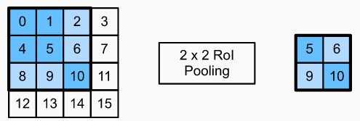

**Image[31]: A 2x2 ROI pooling layer example.**

The feature output from the ConvNet and the region proposals from the selective search algorithm are input into the ROI pooling layer, outputting concatenated features that are further extracted for all the region proposals. The output of the ROI pooling layer is called ROI feature vector. Each of these feature vectors are of fixed size, and they can be fed into a fully connected layer to flatten down the dimensions, and later used as input into a softmax layer to predict the class of the proposed region and also the offset values for the bounding box.

Unlike R-CNN, Fast R-CNN does not have to feed 2.000 region proposals to the ConvNet every time, instead the convolution operation is done only once per image and a feature map is generated from it.

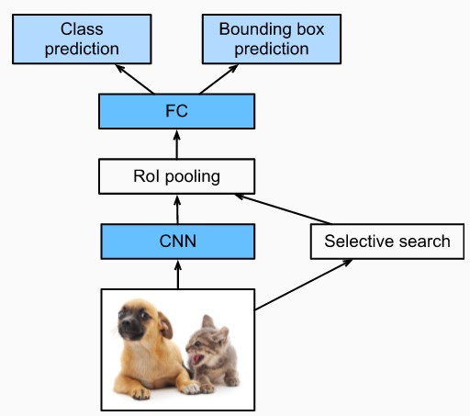

**Image[32]: Fast R-CNN architecture.**

**4.1.3) Faster R-CNN**

Both R-CNN and Fast R-CNN use selective search to find out the region proposals. Selective search is a slow and time-consuming process affecting the performance of the network. Instead of using Selective Search algorithm on the feature map to identify the region proposals, a separate network is used to predict the region proposals, called Region Proposal Network (RPN).

Region Proposal Networks follow these three steps:

* Generate Anchor boxes.
* Classify each anchor box whether it is foreground of background.
* Learn the shape offsets for anchor boxes to them for objects.

Anchor boxes are a set of predefined bounding boxes of a certain height and width. They are defined to capture the scale and aspect ratio of specific object classes that need to be detected and they are typically chosen based on object sizes in the training dataset.

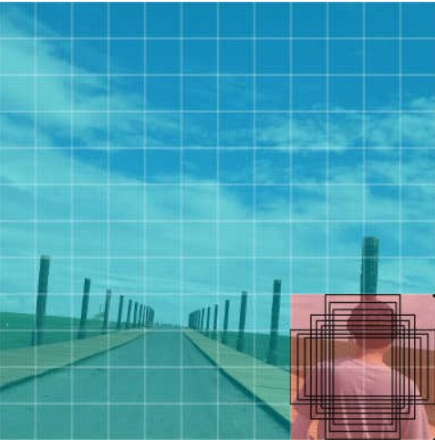

**Image[33]: Anchor boxes example.**

After producing the anchor boxes, the RPN predicts the binary class (background or object) and bounding box for each anchor box. Sometimes, due to the large number of boxes produced, more than one bounding box predicts the same object. To remove overlapped results, non-maximum suppression is applied. The remaining predicted bounding boxes for objects are the region proposals required by the ROI pooling layer.

|  |  |  |  |  |  |
| --- | --- | --- | --- | --- | --- |
| **Non-Max suppression** | | | | | |
| 1 | **Procedure** NMS(B,c) | | | | |
| 2 | Bnms 🡨 *Ø* | | | | |
| 3 |  | | | | |
| 4 |  | Discard 🡨 False | | | |
| 5 |  |  | | | |
| 6 |  |  | **If** same (bi,bj) > λnms **then** | | |
| 7 |  |  |  | **If** score (c,bj) > score(c,bi) **then** | |
| 8 |  |  |  |  | Discard 🡨 True |
| 9 |  | **If** not discard **then** | | | |
| 10 |  |  | Bnms 🡨 | | |
| 11 | **Return** Bnms | | | | |

Faster R-CNN is an upgrade of the Fast R-CNN. They follow they same architecture, but Faster R-CNN utilizes RPN instead of Selective Search.

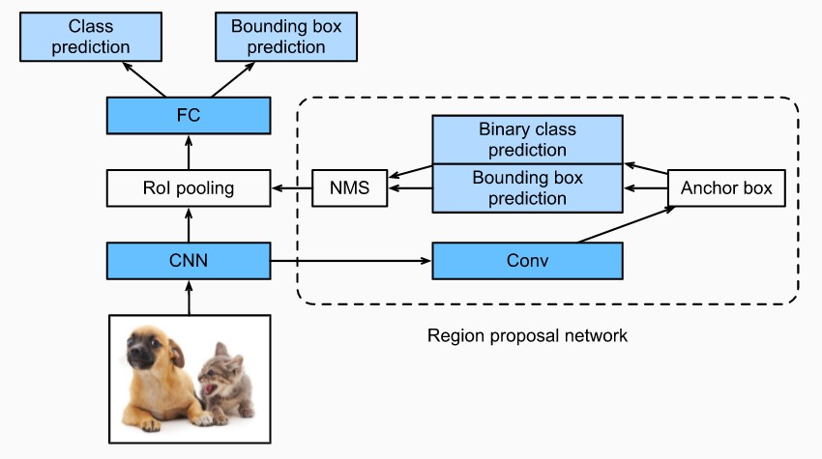

**Image[34]: Faster R-CNN architecture.**

As part of the whole model, the region proposal network is jointly trained with the rest of the model. In other words, the loss or objective function of the Faster R-CNN includes not only the class and bounding box prediction in object detection, but also the binary class and bounding box prediction of anchor boxes in the RPN. The result is an end-to-end training method, where the RPN learns how to generate high-quality region proposals, so as to stay accurate in object detection with a reduced number of region proposals that are learned from data.

**4.2) Single-stage architectures**

Single stage model architectures, unlike Regional Neural Networks, directly predict object bounding boxes and classification score for an image. There is no intermediate task like detecting region proposals through a neural network or with an algorithm like Selective Search. The result is a much simpler and faster architecture.

Usually, Single Stage architectures utilize a ConvNet such as VGG or ResNet as a backbone network. The backbone network is responsible for feature extraction. Then, usually, two more Fully Convolutional Networks are deployed for box regression and object classification.

**4.3.1) You Only Look Once (YOLO)**

YOLO is a family of deep learning models, designed for fast object Detection. At the moment, there are three YOLO versions. YOLOv1 (Image[35]) proposed the general architecture, where the second version introduced anchor boxes to improve the bounding box proposal. Version number three proposed changes in the training process of the model.

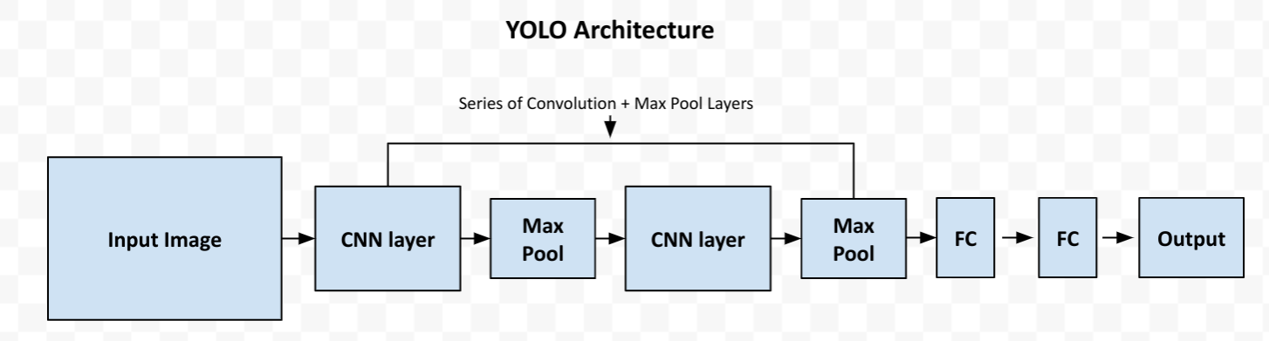

**Image[35]: YOLO architecture.**

As seen in Image[35], the basic architecture of YOLO relied on a series of Convolutions and Max Pooling layers. Finally, for YOLOv1, two fully connected layers are responsible for predicting the bounding boxes. In v2, the fully connected layers were removed and instead, the anchor boxes are responsible for box regression.

In general, YOLO is a very successful object detector. The simplicity of the architecture, allows YOLO to be trained quite fast and version three is as accurate as the best two-stage object detector.

**4.3.2) Retina Network**

Focal loss was introduced with RetinaNet. The goal was that a simple Fully Convolutional architecture with the appropriate loss function could fix the extreme foreground-background class imbalance problem that came with single-stage architectures.

RetinaNet[12] consists of a backbone network (ConvNet +FPN) and two task specific fully convolutional networks, one for box regression and one for object classification.

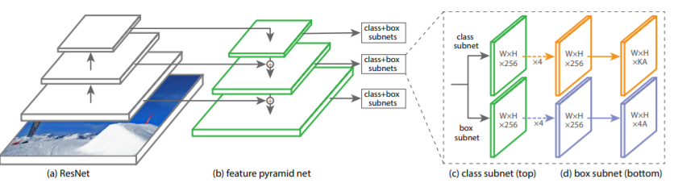

**Image[36]: RetinaNet architecture.**

The backbone network is responsible for computing a convolutional feature map over an entire image and is off-the-self convolutional network.

As previously stated, networks that utilize anchor boxes suffer from extreme foreground-background class imbalance due to dense sampling of anchor boxes. In RetinaNet, each Feature Pyramid level can contain thousands of anchor boxes. Only a few will be assigned to a ground-truth object, while the rest will be background class. These easy examples or detections with high probability, although resulting in small loss values can collectively overwhelm the model. For that reason, Focal Loss was chosen as loss function in the model training phase. FL reduces the loss contribution from easy examples and increases the importance of correcting misclassified examples (see also section 2).

There are many more single-stage detectors such as Single Shot Detector or SSD, SqueezeDet, DetectNet. Also, there are variations of the well-known detectors such as Tiny or Fast YOLO that have been developed for more speed or less computing power.

5. **RetinaNet analysis**

The RetinaNet can be separated in three major components:

1. The backbone Network, which consists of a bottom-up and a top-down pathway.
2. Two subnetworks for classification and regression.
3. The loss function to train the model.

**5.1) Backbone Network**

As mentioned in 4.3.2 the backbone net is a fully convolutional network with lateral connection. It consists of an encoder and a decoder. In the original paper the encoder was a residual network such as ResNet50 and the decoder was a Feature Pyramid Network. The original image gets fed into the encoder, which processes the image through convolutional kernels and generates deep features. The bottom-up pathway as it is also called can be any convolutional network, as long as it does not contain any fully connected layers.

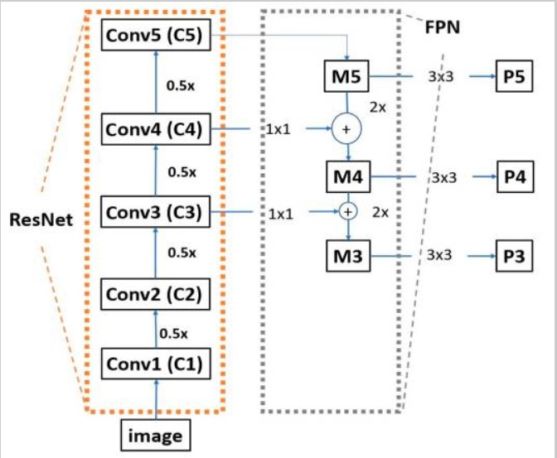

**Image[37]: Backbone Network.**

As seen in Image[37], moving from the bottom all the way to the top, the spatial dimensions are reduced at each convolutional block by a factor of 0.5.

For each feature map produced by the ResNet, the FPN does the exactly opposite operation. It up-samples the spatial resolution of each feature map input by a factor of two. The result is then merged with the corresponding bottom-up map, which undergoes a 1x1 convolution to reduce channel dimension for element-wise addition.

**5.2) Classification/Regression Networks.**

The classification and regression networks are two Fully Convolutional Networks with simple architecture. The classification network predicts the probability of an object to present at each spatial position for each of the A anchors and K object classes, while the regression net predicts the relative offset between anchor and the ground truth box.

The classification network design is simple. As input takes a feature map with C (256) channels from a pyramid level. Then it applies four 3x3 convolutional layers, each with C filters, followed by ReLU activation functions, followed by a 3x3 convolutional layers with KA filters. As last layer, sigmoid function is attached to output the KA predictions per spatial location.

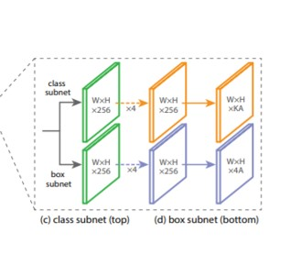

**Image[38]: Classification/Regression Networks.**

The bounding box regression network has an identical design, with the difference of having 4A linear outputs per spatial location.

These two small FCNs are attached to each FPN level. Meaning if the FPN has four levels, 8 subnetworks are needed to perform object detection. Furthermore, although the two networks share identical architecture, they use separate parameters (weights, biases).

**5.3) Loss Functions.**

For classification, RetinaNet uses a modification of the Cross-Entropy loss function, called Focal Loss (see 2.3.5) or FL. Focal Loss reduces the contribution from easy examples and increases the importance of correcting misclassified examples.

For box regression uses smooth L1 (see 2.3.5) or Least absolute deviation or Least Absolute Error, as a loss function. The goal is to minimize the absolute difference between the target value and the estimated value.

**5.4) Why Retina?**

Choosing a deep learning model to complete a certain task is quite challenging. The evaluation process depends on many factors such as the challenge, the data, the application of the model and many more. In order to have a general idea how a network performs organizations and companies release from time-to-time huge datasets with many classes and evaluate their models with them. One of those datasets is Microsoft’s Common Objects in Context or the COCO dataset.

The COCO image dataset was created with the goal of advancing image recognition. The COCO dataset contains challenging, high-quality visual datasets for computer vision, mostly state-of-the-art neural networks. It often used to benchmark algorithms to compare the performance of real-time object detection. It contains 80 classes of objects and most of the well-known object detectors come with a pre-trained model on the COCO dataset.

Having all the above in mind, the following chart, showcases the Mean Average Precision of different Object Detectors using the COCO dataset.

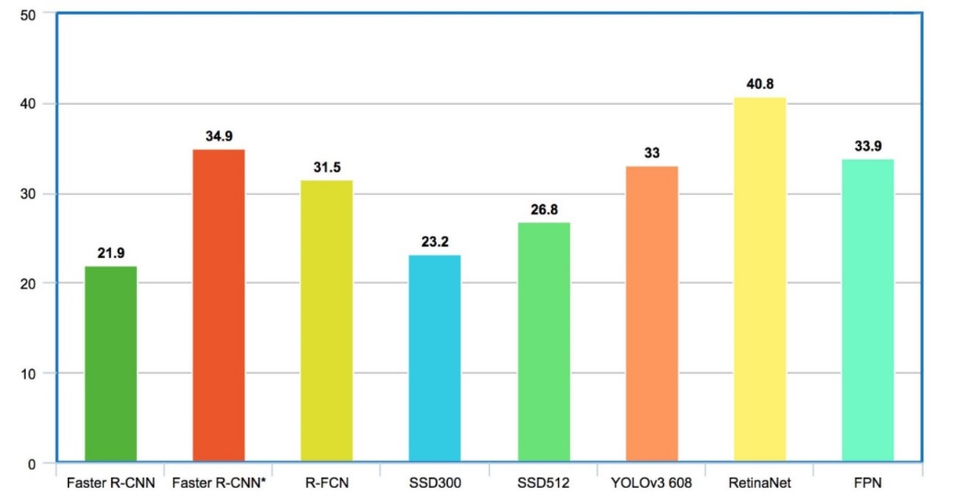

**Image[39]: COCO MAP results.**

At the particular time, comparing to the other famous object detectors, RetinaNet really stands out. Taking in to consideration the fact that it is a Single Stage Detector, therefore it is fast, it was only logical to select this deep learning architecture as our base model for comparison.

6. **Dataset**

**6.1) Stanford Drone Dataset (SDD) description.**

The SDD is a massive data set of aerial images collected by drones over the Stanford campus. The data set is ideal for object detection and tracking problems. It contains more than 60 aerial videos or 69GB of data. The dataset consists of eight unique scenes. For each video, a model can detect 6 different agents – “Pedestrians”, “Bikers”, “Skaters”, “Carts”, “Cars” and “Bus”. Unfortunately, the dataset is biased, since the classes of Pedestrians and Bikers are covering more than 80% of the annotations.

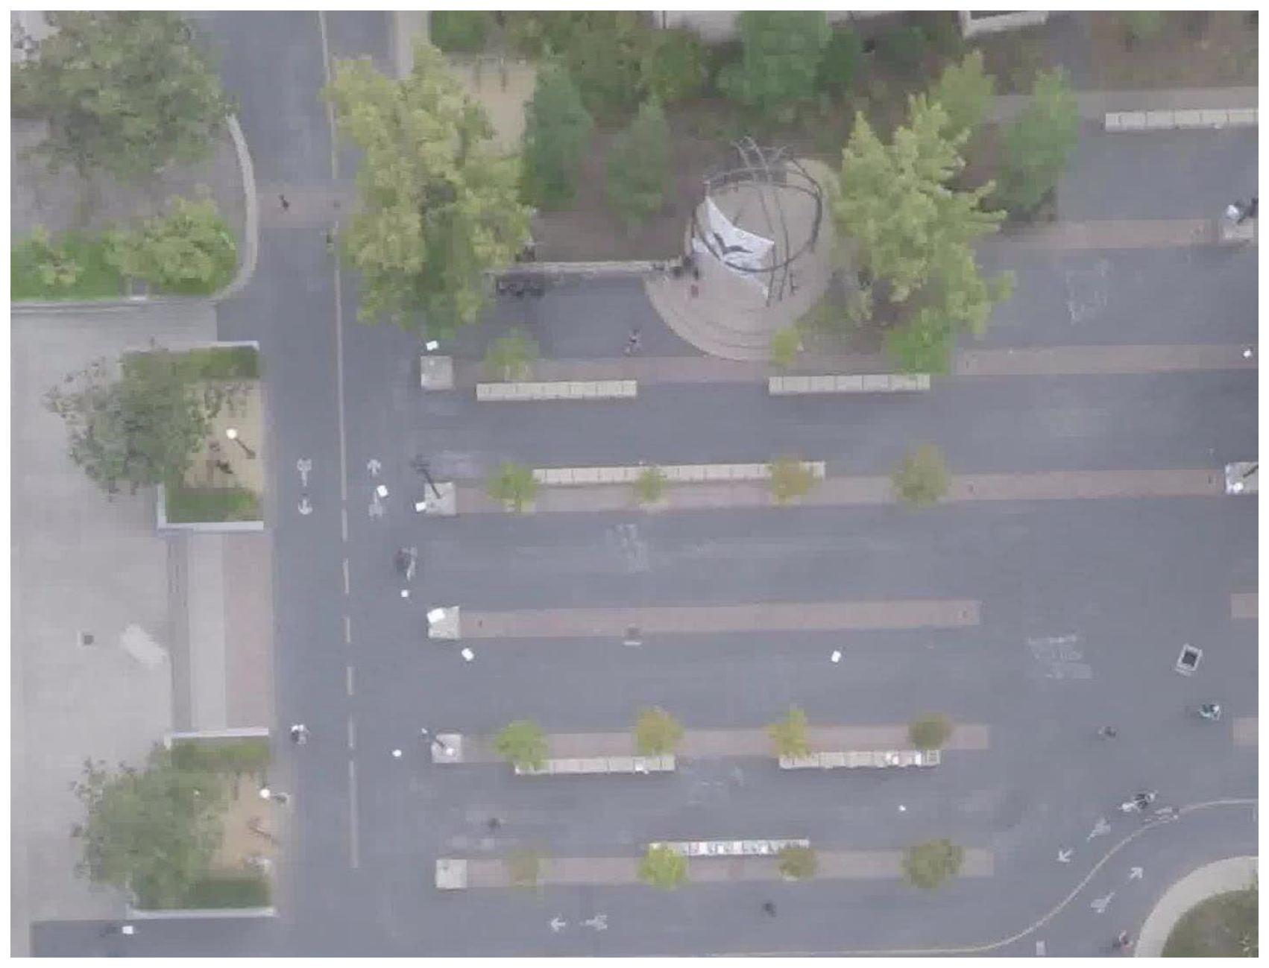

**Image[40]: SDD image example.**

**6.2) Changes in the Dataset.**

For the experiments that were conducted, some of the agents were merged into new classes. To be more precise, the “Pedestrian” and “Skater” classes merged into a new class called “Person”. The “Biker” class remained as it is. The “Car” and “Cart” agents were combined and the class kept the name “Car”. The “Bus” class remained also as it is.

After all the editing, the Training and Testing annotations for the experiments were:

|  |  |
| --- | --- |
| **Classes (Training Annotations)** | **Number** |
| **Person** | **22.673** |
| **Biker** | **11.479** |
| **Car** | **1.512** |
| **Bus** | **101** |
| **Total** | **35.765** |

|  |  |
| --- | --- |
| **Classes (Testing Annotations)** | **Number** |
| **Person** | **5.558** |
| **Biker** | **1.204** |
| **Car** | **23** |
| **Bus** | **31** |
| **Total** | **6.816** |

The dataset is stored in a csv file in the Pascal VOC format:

(image, x1, y1, x2, y2, class_name)

Where x1, x2, y1, y2 are the four coordinates needed to locate an object.

*7.* ***Evaluation Metrics***

**7.1) Intersection Over Union (IoU).**

Intersection Over Union is a metric that evaluates the overlap between two bounding boxes. It requires a ground truth bounding box Bgt and a predicted bounding box Bp. By applying the IoU we can evaluate whether a detection is valid (True Positive) or not (False Positive).

IoU is given by the overlapping area between the predicted bounding box and the ground truth bounding box, divided by the area of union between them:

To represent the above equation in terms of detection, the image below illustrates the IoU between a ground truth bounding box in green and a detected bounding box in red.

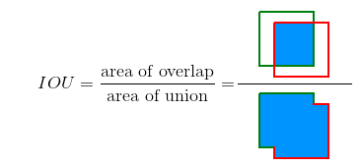

**Image[41]: IoU representation.**

Using IoU the following concepts can be defined:

* **True Positive** **(TP)**: A correct detection. IoU ≥ threshold.
* **False Positive (FP)**: A wrong detection. IoU < threshold.
* **False Negative (FN)**: A ground truth object not detected.
* **True Negative (TN)**: In object detection this metric has no use, since it represents a corrected misdetection and in object detection there are many possible bounding boxes that should not be detected within an image. Thus TN would be all possible bounding boxes that were correctly not detected.

The threshold is a constant that is metric dependent. It is usually set to values above 0.5 or 50%.

**7.2) Metrics.**

Using the concepts that were defined in section 7.1, the following metrics can also be extracted:

Classification Accuracy is the simplest metric to use and it is defined as the number of correct predictions, divided by the total number of predictions.

Precision is the ratio of true positives and total positives predicted.

Many times, accuracy is not enough to determine whether a model behaves ideally. Therefore, precision needs to be considered. A precision score towards 1 will signify that the model did not miss any true positives and is able to classify well between correct and incorrect labeling. A low precision score on the other hand, means that the classifier has a high number of false positives which can be an outcome of imbalanced class or untuned model hyperparameters.

Sensitivity, is essentially the ratio of true positives to all the positives in ground truth. Recall towards 1 will signify that the model did not miss any true positives and it is able to classify well between correctly and incorrectly labeling. A low recall score, means that the classifier has a high number of false negatives which can be an outcome of imbalanced class or again untuned model hyperparameters.

The F1-score metric, is a combination of precision and recall. To be more accurate, F1 is the harmonic mean of the two metrics.

A high F1-score, symbolizes a high precision as well as high recall. It presents a good balance between precision and recall and gives good results on imbalanced classification datasets.

A low F1 score is difficult to explain. Both of the metrics can be responsible for a low F1-score. Low sensitivity means that the model did not do well on very much of the entire test set. Low precision means that among the cases that were identified as positive, the model did not get many of them right.

Average Precision?

Mean Average Precision?

Anything Else?

*8.* ***Experiments***

To create a base case, the original RetinaNet model was trained using a simple split of the dataset. Eighty percent of the data were used in the training process and twenty percent for testing.

For convenience, the training process took place in Google Colab. For the training process, NVIDIA Tesla P100/V100 GPU accelerators were deployed.

Tesla P100 is powered by NVIDIA Pascal architecture. There are 3.584 CUDA cores and the accelerator can perform at 4.7 TeraFLOPS. The memory of the GPU is 16GB CoWoS HBM2 at 732 GB/s, with maximum power consumption at 250W.

Tesla V100 is powered by the Volta architecture. It combines Tensor and Cuda Cores within a unified architecture. To be more specific, it is equipped with 640 Tensor cores and 5.120 CUDA cores. It performs at 7 TeraFlops and the GPU memory is 32GB HBM2. With a combination of improved raw bandwidth of 900GB/s and higher DRAM utilization efficiency, the V100 delivers 1.5X higher memory bandwidth over the P100. The maximum Power consumption is at 250W like the P100.

Both the P100 and V100 support every major deep learning framework such as Tensorflow, PyTorch, Caffe2, etc.

**8.1) Simple Split.**

For the first experiment, the process was relatively simple. First the data were split into training and testing data, 80/20 split. Then the training annotations were fed into the network as input images. The model was trained for 100 epochs using the NVIDIA Tesla P100 GPU accelerator. To make the training process faster, a pre-trained ResNet in the COCO dataset was utilized. Therefore, only the classification and regression networks needed to be trained and readjust their weights to detect the objects of the SDD.

**Image[42]: Training/Testing process.**

In the following matrix the metrics of the experiment are represented. For a prediction to be classified as True, a 0.6 threshold was chosen.

|  |  |
| --- | --- |
| **Metric** | **Simple split (0.6 threshold)** |
| **Accuracy** | 0.800 |
| **Precision** | 0.847 |
| **Recall** | 0.934 |
| **F_1 score** | 0.889 |

**Matrix[1]: Simple split results.**

To evaluate how well the model performs over each class, a confusion matrix was constructed. Furthermore, a None class was added to the CM, representing class objects the model found, but they were not in the set of the testing annotations.

From the results in matrix No.2 the precision for each class can be calculated:

|  |  |  |  |  |
| --- | --- | --- | --- | --- |
| **Person** | **4829** | 582 | 0 | 0 |
| **Biker** | 415 | **738** | 0 | 0 |
| **Bus** | 0 | 0 | **22** | 0 |
| **Car** | 0 | 0 | 8 | **14** |
| **None** | 643 | 122 | 1 | 6 |
|  | **Person** | **Biker** | **Bus** | **Car** |

**Matrix[2]: Confusion Matrix**