A3 Final Question

Christopher Zheng

04/04/2020

1. Remove the last 12 values from the Beer data set by using

beer_original = dget("beer.Rput")  
beer <- head(beer_original,-12)

1. Find an ARIMA model for the logarithms of the beer data. Your analysis should include:
2. a logical explanation of the steps taken to choose the final model;
3. appropriate 95% bounds for the components of φ and θ;
4. an examination of the residuals to check for similarity to a white noise process;
5. a graph of the series showing forecasts of the removed 12 values and 95% prediction bounds;
6. numerical values for the 12-step ahead forecast and the corresponding 95% prediction bounds
7. a table of the actual forecast errors, i.e. observed - predicted, for the removed 12 values

beer <- log(beer)  
#autoplot(beer)  
#acf(beer)

# Decompose w/ stl  
beer_stl<-stl(beer,s.window=12)  
autoplot(beer_stl)

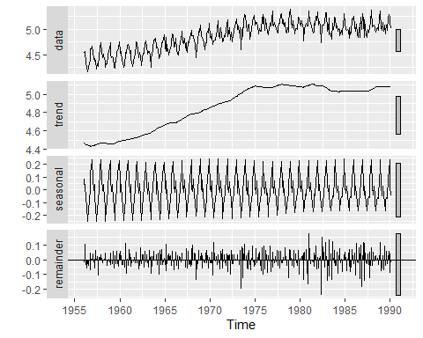

# Use tslm() to extract the seasonality and the quadratic trend  
beer_tslm <- tslm(beer~trend + I(trend^2) + season)  
beer_tslm_forecast <- forecast(beer_tslm, h = 12)  
autoplot(beer_tslm_forecast)

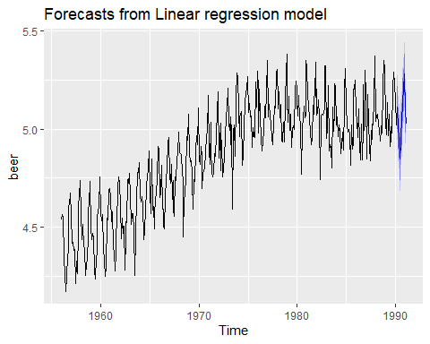

# Focus on the remainder. Since ACF(remainder) suggests a strong autocovariance out of the confidence interval band, it is not a white noise and we need an ARMA to fit the remainder component.  
autoplot(beer_stl$time.series[,'remainder'])

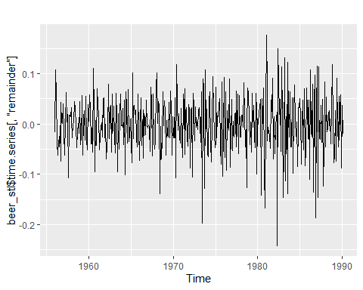

checkresiduals(beer_stl$time.series[,'remainder'])

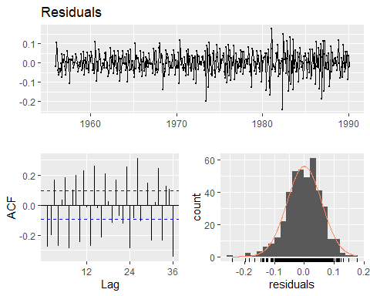

# Use auto.arima() to fit data into an ARMA(5,1), which is ideal because the resulted residuals do not witness a strong autocovariance.  
  
beer_model_part_b <- auto.arima(beer_stl$time.series[,"remainder"], stepwise = FALSE, seasonal = FALSE, ic = "aic", trace = TRUE, max.order = 10, max.d = 0)

##   
## Fitting models using approximations to speed things up...  
##   
## ARIMA(0,0,0) with zero mean : -1167.818  
## ARIMA(0,0,0) with non-zero mean : -1165.82  
## ARIMA(0,0,1) with zero mean : -1256.687  
## ARIMA(0,0,1) with non-zero mean : -1254.926  
## ARIMA(0,0,2) with zero mean : -1312.783  
## ARIMA(0,0,2) with non-zero mean : -1311.074  
## ARIMA(0,0,3) with zero mean : -1311.503  
## ARIMA(0,0,3) with non-zero mean : -1309.798  
## ARIMA(0,0,4) with zero mean : -1320.639  
## ARIMA(0,0,4) with non-zero mean : -1318.91  
## ARIMA(0,0,5) with zero mean : -1326.706  
## ARIMA(0,0,5) with non-zero mean : -1325.008  
## ARIMA(1,0,0) with zero mean : -1197.809  
## ARIMA(1,0,0) with non-zero mean : -1195.809  
## ARIMA(1,0,1) with zero mean : -1310.018  
## ARIMA(1,0,1) with non-zero mean : -1308.069  
## ARIMA(1,0,2) with zero mean : -1313.66  
## ARIMA(1,0,2) with non-zero mean : -1311.851  
## ARIMA(1,0,3) with zero mean : -1313.648  
## ARIMA(1,0,3) with non-zero mean : -1311.866  
## ARIMA(1,0,4) with zero mean : -1322.149  
## ARIMA(1,0,4) with non-zero mean : -1320.315  
## ARIMA(1,0,5) with zero mean : -1331.193  
## ARIMA(1,0,5) with non-zero mean : -1329.193  
## ARIMA(2,0,0) with zero mean : -1237.671  
## ARIMA(2,0,0) with non-zero mean : -1235.69  
## ARIMA(2,0,1) with zero mean : -1279.599  
## ARIMA(2,0,1) with non-zero mean : -1277.955  
## ARIMA(2,0,2) with zero mean : -1300.604  
## ARIMA(2,0,2) with non-zero mean : -1299.01  
## ARIMA(2,0,3) with zero mean : -1299.075  
## ARIMA(2,0,3) with non-zero mean : -1297.477  
## ARIMA(2,0,4) with zero mean : -1359.852  
## ARIMA(2,0,4) with non-zero mean : -1358.181  
## ARIMA(2,0,5) with zero mean : -1366.592  
## ARIMA(2,0,5) with non-zero mean : -1364.925  
## ARIMA(3,0,0) with zero mean : -1237.681  
## ARIMA(3,0,0) with non-zero mean : -1235.731  
## ARIMA(3,0,1) with zero mean : -1270.749  
## ARIMA(3,0,1) with non-zero mean : -1269.054  
## ARIMA(3,0,2) with zero mean : -1281.815  
## ARIMA(3,0,2) with non-zero mean : -1280.151  
## ARIMA(3,0,3) with zero mean : Inf  
## ARIMA(3,0,3) with non-zero mean : Inf  
## ARIMA(3,0,4) with zero mean : -1314.367  
## ARIMA(3,0,4) with non-zero mean : -1312.739  
## ARIMA(3,0,5) with zero mean : -1312.672  
## ARIMA(3,0,5) with non-zero mean : -1311.035  
## ARIMA(4,0,0) with zero mean : -1282.117  
## ARIMA(4,0,0) with non-zero mean : -1280.19  
## ARIMA(4,0,1) with zero mean : -1320.789  
## ARIMA(4,0,1) with non-zero mean : -1319.058  
## ARIMA(4,0,2) with zero mean : -1338.146  
## ARIMA(4,0,2) with non-zero mean : -1336.172  
## ARIMA(4,0,3) with zero mean : Inf  
## ARIMA(4,0,3) with non-zero mean : Inf  
## ARIMA(4,0,4) with zero mean : Inf  
## ARIMA(4,0,4) with non-zero mean : Inf  
## ARIMA(4,0,5) with zero mean : Inf  
## ARIMA(4,0,5) with non-zero mean : Inf  
## ARIMA(5,0,0) with zero mean : -1289.149  
## ARIMA(5,0,0) with non-zero mean : -1287.209  
## ARIMA(5,0,1) with zero mean : -1346.94  
## ARIMA(5,0,1) with non-zero mean : -1344.991  
## ARIMA(5,0,2) with zero mean : -1352.495  
## ARIMA(5,0,2) with non-zero mean : Inf  
## ARIMA(5,0,3) with zero mean : Inf  
## ARIMA(5,0,3) with non-zero mean : Inf  
## ARIMA(5,0,4) with zero mean : Inf  
## ARIMA(5,0,4) with non-zero mean : Inf  
## ARIMA(5,0,5) with zero mean : Inf  
## ARIMA(5,0,5) with non-zero mean : Inf  
##   
## Now re-fitting the best model(s) without approximations...  
##   
## ARIMA(0,0,0) with zero mean : -1167.818  
## ARIMA(0,0,0) with non-zero mean : -1165.82  
## ARIMA(0,0,1) with zero mean : -1255.194  
## ARIMA(0,0,1) with non-zero mean : -1253.362  
## ARIMA(0,0,2) with zero mean : -1313.3  
## ARIMA(0,0,2) with non-zero mean : -1311.341  
## ARIMA(0,0,3) with zero mean : -1311.825  
## ARIMA(0,0,3) with non-zero mean : -1309.88  
## ARIMA(0,0,4) with zero mean : -1322.096  
## ARIMA(0,0,4) with non-zero mean : -1320.097  
## ARIMA(0,0,5) with zero mean : -1327.382  
## ARIMA(0,0,5) with non-zero mean : -1325.427  
## ARIMA(1,0,0) with zero mean : -1198.642  
## ARIMA(1,0,0) with non-zero mean : -1196.643  
## ARIMA(1,0,1) with zero mean : -1308.656  
## ARIMA(1,0,1) with non-zero mean : -1306.662  
## ARIMA(1,0,2) with zero mean : -1312.72  
## ARIMA(1,0,2) with non-zero mean : -1310.79  
## ARIMA(1,0,3) with zero mean : -1312.975  
## ARIMA(1,0,3) with non-zero mean : -1311.037  
## ARIMA(1,0,4) with zero mean : -1322.216  
## ARIMA(1,0,4) with non-zero mean : -1320.216  
## ARIMA(1,0,5) with zero mean : -1326.94  
## ARIMA(1,0,5) with non-zero mean : -1325.025  
## ARIMA(2,0,0) with zero mean : -1235.925  
## ARIMA(2,0,0) with non-zero mean : -1233.931  
## ARIMA(2,0,1) with zero mean : -1307.916  
## ARIMA(2,0,1) with non-zero mean : -1305.936  
## ARIMA(2,0,2) with zero mean : -1316.337  
## ARIMA(2,0,2) with non-zero mean : -1314.362  
## ARIMA(2,0,3) with zero mean : -1315.183  
## ARIMA(2,0,3) with non-zero mean : -1313.197  
## ARIMA(2,0,4) with zero mean : Inf  
## ARIMA(2,0,4) with non-zero mean : Inf  
## ARIMA(2,0,5) with zero mean : Inf  
## ARIMA(2,0,5) with non-zero mean : Inf  
## ARIMA(3,0,0) with zero mean : -1233.955  
## ARIMA(3,0,0) with non-zero mean : -1231.961  
## ARIMA(3,0,1) with zero mean : -1307.097  
## ARIMA(3,0,1) with non-zero mean : -1305.104  
## ARIMA(3,0,2) with zero mean : -1317.345  
## ARIMA(3,0,2) with non-zero mean : -1315.348  
## ARIMA(3,0,3) with zero mean : Inf  
## ARIMA(3,0,3) with non-zero mean : Inf  
## ARIMA(3,0,4) with zero mean : Inf  
## ARIMA(3,0,4) with non-zero mean : Inf  
## ARIMA(3,0,5) with zero mean : Inf  
## ARIMA(3,0,5) with non-zero mean : Inf  
## ARIMA(4,0,0) with zero mean : -1278.86  
## ARIMA(4,0,0) with non-zero mean : -1276.883  
## ARIMA(4,0,1) with zero mean : -1333.842  
## ARIMA(4,0,1) with non-zero mean : -1331.929  
## ARIMA(4,0,2) with zero mean : -1334.693  
## ARIMA(4,0,2) with non-zero mean : -1332.765  
## ARIMA(4,0,3) with zero mean : Inf  
## ARIMA(4,0,3) with non-zero mean : Inf  
## ARIMA(4,0,4) with zero mean : Inf  
## ARIMA(4,0,4) with non-zero mean : Inf  
## ARIMA(4,0,5) with zero mean : Inf  
## ARIMA(4,0,5) with non-zero mean : Inf  
## ARIMA(5,0,0) with zero mean : -1285.853  
## ARIMA(5,0,0) with non-zero mean : -1283.888  
## ARIMA(5,0,1) with zero mean : -1335.382  
## ARIMA(5,0,1) with non-zero mean : -1333.441  
## ARIMA(5,0,2) with zero mean : -1333.472  
## ARIMA(5,0,2) with non-zero mean : -1331.532  
## ARIMA(5,0,3) with zero mean : Inf  
## ARIMA(5,0,3) with non-zero mean : Inf  
## ARIMA(5,0,4) with zero mean : Inf  
## ARIMA(5,0,4) with non-zero mean : Inf  
## ARIMA(5,0,5) with zero mean : Inf  
## ARIMA(5,0,5) with non-zero mean : Inf  
##   
##   
##   
##   
##   
## Best model: ARIMA(5,0,1) with zero mean

checkresiduals(beer_model_part_b)

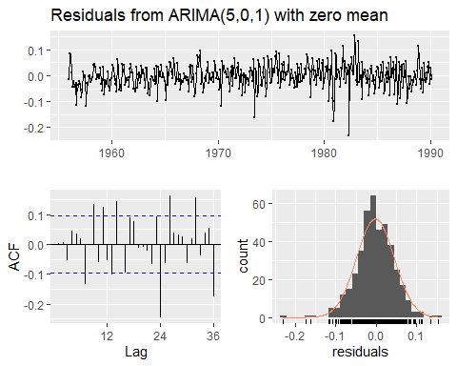

##   
## Ljung-Box test  
##   
## data: Residuals from ARIMA(5,0,1) with zero mean  
## Q* = 82.054, df = 18, p-value = 3.737e-10  
##   
## Model df: 6. Total lags used: 24

test(residuals(beer_model_part_b))

## Null hypothesis: Residuals are iid noise.  
## Test Distribution Statistic p-value  
## Ljung-Box Q Q ~ chisq(20) 50.11 2e-04 *  
## McLeod-Li Q Q ~ chisq(20) 40.29 0.0046 *  
## Turning points T (T-272)/8.5 ~ N(0,1) 293 0.0137 *  
## Diff signs S (S-204.5)/5.9 ~ N(0,1) 207 0.6692  
## Rank P (P-41922.5)/1386.2 ~ N(0,1) 45636 0.0074 *

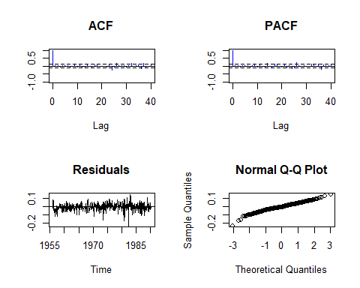

# Side note: ARMA(4,1), AR(4) and AR(5) are also acceptable since 0 is contained in the 95% interval.  
confint(beer_model_part_b)

## 2.5 % 97.5 %  
## ar1 0.320861311 0.52205552  
## ar2 -0.216736258 -0.01455726  
## ar3 0.055485219 0.25838971  
## ar4 -0.403400686 -0.20021308  
## ar5 -0.004051991 0.19891227  
## ma1 -0.998377015 -0.94133262

# Forecasting w/ ARMA(5,1)  
beer_model_part_b_forecast <- forecast(beer_model_part_b, h = 12)  
autoplot(beer_model_part_b_forecast)

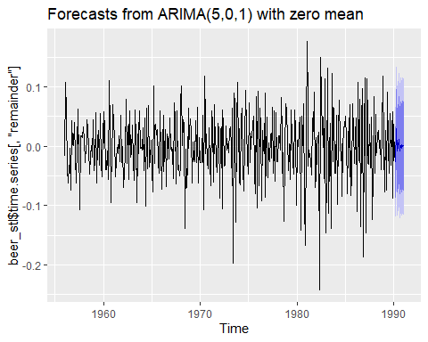

# Combine the tslm() and ARMA() forecasting results.  
beer_model_part_b_forecast_wmean <- beer_model_part_b_forecast  
beer_model_part_b_forecast_wmean$x <- beer_tslm_forecast$x + beer_model_part_b_forecast$x  
beer_model_part_b_forecast_wmean$mean <- beer_tslm_forecast$mean + beer_model_part_b_forecast$mean  
beer_model_part_b_forecast_wmean$lower <- beer_tslm_forecast$mean + beer_model_part_b_forecast$lower  
beer_model_part_b_forecast_wmean$upper <- beer_tslm_forecast$mean + beer_model_part_b_forecast$upper  
autoplot(beer_model_part_b_forecast_wmean)

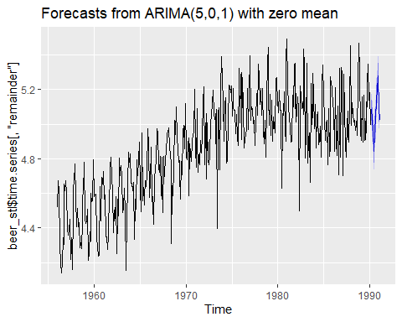

# Evaluation  
beer_tail <- log(tail(beer_original, 12))  
errors <- beer_tail - beer_model_part_b_forecast_wmean$mean  
  
df <- data.frame(beer_model_part_b_forecast_wmean$mean, errors, beer_model_part_b_forecast_wmean$lower, beer_model_part_b_forecast_wmean$upper)  
#rename  
colnames(df) <- c("Estimate", "Errors", "80% C.I. Lower", "95% C.I. Lower", "80% C.I. Upper", "95% C.I. Upper")  
df

## Estimate Errors 80% C.I. Lower 95% C.I. Lower 80% C.I. Upper  
## 1 5.084305 0.0094454226 5.024243 4.992449 5.144366  
## 2 5.033403 0.0009489748 4.964903 4.928641 5.101903  
## 3 4.957986 0.0711438940 4.886390 4.848489 5.029582  
## 4 4.845262 0.0629713172 4.773527 4.735553 4.916997  
## 5 4.939564 0.0596735517 4.865353 4.826068 5.013775  
## 6 4.974467 0.0247702934 4.900149 4.860807 5.048785  
## 7 5.023972 -0.1298707404 4.949260 4.909710 5.098684  
## 8 5.150515 0.1163120522 5.075716 5.036120 5.225313  
## 9 5.193854 0.1456048570 5.118927 5.079263 5.268782  
## 10 5.280787 0.0024164039 5.205859 5.166194 5.355716  
## 11 5.094439 0.0054273469 5.019457 4.979764 5.169421  
## 12 5.024512 -0.0273001441 4.949520 4.909821 5.099505  
## 95% C.I. Upper  
## 1 5.176161  
## 2 5.138165  
## 3 5.067483  
## 4 4.954971  
## 5 5.053059  
## 6 5.088127  
## 7 5.138234  
## 8 5.264909  
## 9 5.308446  
## 10 5.395381  
## 11 5.209114  
## 12 5.139204

1. Repeat the steps in part (b), but instead use a classical decomposition approach by deseasonalizing, subtracting a quadratic trend, and then fitting and ARMA model to the residuals. Then compare your forecast errors to those in part (b).

# We have deseasonalized the log series in (b), so now we further remove the quadratic trend.  
b <- beer_stl$time.series[,"trend"] + beer_stl$time.series[,"remainder"]  
quadratic = trend(b, p=2)  
res = quadratic - b  
#autoplot(res)  
acf(res)

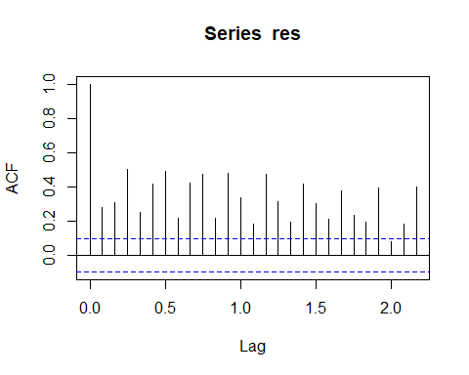

# Strong autocorrelation but no seasonality.  
# An ARMA suffices.

model <- auto.arima(res, stepwise = FALSE, seasonal = FALSE, ic="aic", trace = TRUE, max.d = 0)

##   
## Fitting models using approximations to speed things up...  
##   
## ARIMA(0,0,0) with zero mean : -931.6883  
## ARIMA(0,0,0) with non-zero mean : -929.6883  
## ARIMA(0,0,1) with zero mean : -953.5766  
## ARIMA(0,0,1) with non-zero mean : -951.5767  
## ARIMA(0,0,2) with zero mean : -962.6016  
## ARIMA(0,0,2) with non-zero mean : -960.6057  
## ARIMA(0,0,3) with zero mean : -1011.104  
## ARIMA(0,0,3) with non-zero mean : -1009.121  
## ARIMA(0,0,4) with zero mean : -1013.057  
## ARIMA(0,0,4) with non-zero mean : -1011.086  
## ARIMA(0,0,5) with zero mean : -1034.401  
## ARIMA(0,0,5) with non-zero mean : -1032.472  
## ARIMA(1,0,0) with zero mean : -965.4083  
## ARIMA(1,0,0) with non-zero mean : -963.4176  
## ARIMA(1,0,1) with zero mean : -1093.212  
## ARIMA(1,0,1) with non-zero mean : -1091.934  
## ARIMA(1,0,2) with zero mean : -1119.574  
## ARIMA(1,0,2) with non-zero mean : -1118.265  
## ARIMA(1,0,3) with zero mean : -1129.924  
## ARIMA(1,0,3) with non-zero mean : -1128.543  
## ARIMA(1,0,4) with zero mean : -1130.919  
## ARIMA(1,0,4) with non-zero mean : -1129.585  
## ARIMA(2,0,0) with zero mean : -999.7246  
## ARIMA(2,0,0) with non-zero mean : -997.7889  
## ARIMA(2,0,1) with zero mean : -1097.856  
## ARIMA(2,0,1) with non-zero mean : -1096.739  
## ARIMA(2,0,2) with zero mean : -1099.108  
## ARIMA(2,0,2) with non-zero mean : -1097.926  
## ARIMA(2,0,3) with zero mean : -1127.045  
## ARIMA(2,0,3) with non-zero mean : -1125.82  
## ARIMA(3,0,0) with zero mean : -1091.853  
## ARIMA(3,0,0) with non-zero mean : -1090.043  
## ARIMA(3,0,1) with zero mean : -1123.338  
## ARIMA(3,0,1) with non-zero mean : -1122.065  
## ARIMA(3,0,2) with zero mean : -1130.027  
## ARIMA(3,0,2) with non-zero mean : -1128.815  
## ARIMA(4,0,0) with zero mean : -1090.744  
## ARIMA(4,0,0) with non-zero mean : -1088.933  
## ARIMA(4,0,1) with zero mean : -1137.667  
## ARIMA(4,0,1) with non-zero mean : -1136.199  
## ARIMA(5,0,0) with zero mean : -1119.94  
## ARIMA(5,0,0) with non-zero mean : -1118.134  
##   
## Now re-fitting the best model(s) without approximations...  
##   
## ARIMA(0,0,0) with zero mean : -931.6883  
## ARIMA(0,0,0) with non-zero mean : -929.6883  
## ARIMA(0,0,1) with zero mean : -953.6117  
## ARIMA(0,0,1) with non-zero mean : -951.6118  
## ARIMA(0,0,2) with zero mean : -963.2431  
## ARIMA(0,0,2) with non-zero mean : -961.2456  
## ARIMA(0,0,3) with zero mean : -1013.309  
## ARIMA(0,0,3) with non-zero mean : -1011.314  
## ARIMA(0,0,4) with zero mean : -1016.323  
## ARIMA(0,0,4) with non-zero mean : -1014.332  
## ARIMA(0,0,5) with zero mean : -1039.042  
## ARIMA(0,0,5) with non-zero mean : -1037.064  
## ARIMA(1,0,0) with zero mean : -962.773  
## ARIMA(1,0,0) with non-zero mean : -960.7738  
## ARIMA(1,0,1) with zero mean : Inf  
## ARIMA(1,0,1) with non-zero mean : Inf  
## ARIMA(1,0,2) with zero mean : Inf  
## ARIMA(1,0,2) with non-zero mean : Inf  
## ARIMA(1,0,3) with zero mean : Inf  
## ARIMA(1,0,3) with non-zero mean : -1120.07  
## ARIMA(1,0,4) with zero mean : Inf  
## ARIMA(1,0,4) with non-zero mean : Inf  
## ARIMA(2,0,0) with zero mean : -988.8586  
## ARIMA(2,0,0) with non-zero mean : -986.8697  
## ARIMA(2,0,1) with zero mean : Inf  
## ARIMA(2,0,1) with non-zero mean : Inf  
## ARIMA(2,0,2) with zero mean : -1119.552  
## ARIMA(2,0,2) with non-zero mean : -1118.042  
## ARIMA(2,0,3) with zero mean : Inf  
## ARIMA(2,0,3) with non-zero mean : Inf  
## ARIMA(3,0,0) with zero mean : -1078.489  
## ARIMA(3,0,0) with non-zero mean : -1076.569  
## ARIMA(3,0,1) with zero mean : Inf  
## ARIMA(3,0,1) with non-zero mean : Inf  
## ARIMA(3,0,2) with zero mean : Inf  
## ARIMA(3,0,2) with non-zero mean : Inf  
## ARIMA(4,0,0) with zero mean : -1078.247  
## ARIMA(4,0,0) with non-zero mean : -1076.345  
## ARIMA(4,0,1) with zero mean : Inf  
## ARIMA(4,0,1) with non-zero mean : Inf  
## ARIMA(5,0,0) with zero mean : -1105.872  
## ARIMA(5,0,0) with non-zero mean : -1104.058  
##   
##   
##   
##   
##   
## Best model: ARIMA(1,0,3) with non-zero mean

# It says ARMA(1,3) is the best

model_part_c <- arima(res, c(1,0,3))  
summary(model_part_c)

##   
## Call:  
## arima(x = res, order = c(1, 0, 3))  
##   
## Coefficients:  
## ar1 ma1 ma2 ma3 intercept  
## 0.9883 -1.0841 -0.0061 0.2352 -0.0161  
## s.e. 0.0077 0.0536 0.0920 0.0619 0.0318  
##   
## sigma^2 estimated as 0.003683: log likelihood = 566.03, aic = -1120.07  
##   
## Training set error measures:  
## ME RMSE MAE MPE MAPE MASE  
## Training set 0.002965673 0.06069078 0.0483887 98.44751 268.4778 0.6630548  
## ACF1  
## Training set -0.0216579

checkresiduals(model_part_c)

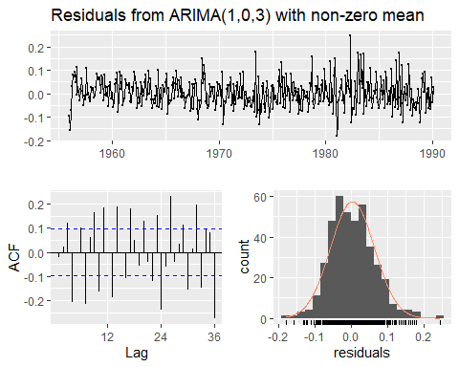

##   
## Ljung-Box test  
##   
## data: Residuals from ARIMA(1,0,3) with non-zero mean  
## Q* = 187.21, df = 19, p-value < 2.2e-16  
##   
## Model df: 5. Total lags used: 24

test(residuals(model_part_c))

## Null hypothesis: Residuals are iid noise.  
## Test Distribution Statistic p-value  
## Ljung-Box Q Q ~ chisq(20) 144.92 0 *  
## McLeod-Li Q Q ~ chisq(20) 37.8 0.0094 *  
## Turning points T (T-272)/8.5 ~ N(0,1) 285 0.127  
## Diff signs S (S-204.5)/5.9 ~ N(0,1) 211 0.2667  
## Rank P (P-41922.5)/1386.2 ~ N(0,1) 38675 0.0191 *

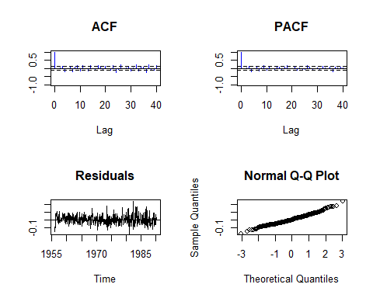

confint(arima(window(res),c(1,0,3))) # These figures suggest that ARma(1,3) suffices.

## 2.5 % 97.5 %  
## ar1 0.97320834 1.00348210  
## ma1 -1.18923496 -0.97901564  
## ma2 -0.18647590 0.17417922  
## ma3 0.11384685 0.35660945  
## intercept -0.07841339 0.04617739

# Forecasting w/ ARMA(1,3)  
remainder <- forecast(model, h = 12)  
  
dummy1 <- as.numeric(forecast(quadratic, h = 12)$mean)  
t1 <- ts(dummy1, start = c(1990, 3), end = c(1991, 2), frequency = 12)  
  
dummy2 <- as.numeric(beer_stl$time.series[,"seasonal"])  
t2 <- ts(tail(dummy2, 12), start = c(1990, 3), end = c(1991, 2), frequency = 12)  
  
remainder$mean <- t1 + remainder$mean + t2  
remainder$lower <- t1 + remainder$lower + t2  
remainder$upper <- t1 + remainder$upper + t2  
  
# Make sure do not use ggfortify and forecast simultaneously  
autoplot(remainder, ylim=c(4,6)) + autolayer(beer)

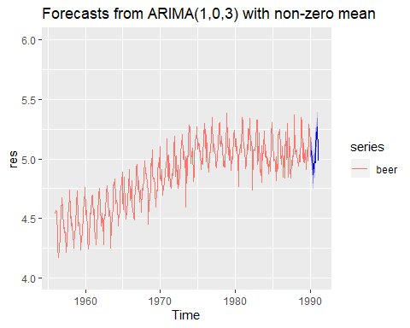

errors <- beer_tail - remainder$mean  
df2 <- data.frame(remainder$mean, errors, remainder$lower, remainder$upper)  
colnames(df2) <- c("Estimate", "Errors", "80% C.I. Lower", "95% C.I. Lower", "80% C.I. Upper", "95% C.I. Upper")  
df2

## Estimate Errors 80% C.I. Lower 95% C.I. Lower 80% C.I. Upper  
## 1 5.066742 0.02700864 4.988485 4.947058 5.144999  
## 2 4.990779 0.04357311 4.912164 4.870547 5.069394  
## 3 4.939153 0.08997675 4.860143 4.818318 5.018163  
## 4 4.867174 0.04105907 4.787455 4.745254 4.946894  
## 5 4.953062 0.04617520 4.872656 4.830091 5.033468  
## 6 4.972182 0.02705554 4.891110 4.848194 5.053253  
## 7 4.965868 -0.07176689 4.884152 4.840894 5.047585  
## 8 5.133099 0.13372811 5.050758 5.007169 5.215440  
## 9 5.180510 0.15894923 5.097563 5.053654 5.263457  
## 10 5.267113 0.01609029 5.183579 5.139359 5.350648  
## 11 5.058233 0.04163369 4.974128 4.929606 5.142337  
## 12 4.981379 0.01583343 4.896721 4.851906 5.066036  
## 95% C.I. Upper  
## 1 5.186425  
## 2 5.111010  
## 3 5.059989  
## 4 4.989095  
## 5 5.076033  
## 6 5.096170  
## 7 5.090842  
## 8 5.259028  
## 9 5.307366  
## 10 5.394868  
## 11 5.186859  
## 12 5.110851

As we can see, the method of part b and the method of part c are of the same quality. This is because in part b we use tslm to estimate the trend while in part c we estimate the trend quite separately. The paths are different but the goals are the same.