Ex.No.2 | Study of Network cables.  - Understand different types of Network cables.  - Make a cross-wired cable and straight through cable using clamping/crimping tool.
Date:
a) Understand different types of network cable.
Different type of cables used in networking are:
  - Unshielded Twisted Pair (UTP) Cable
  - Shielded Twisted Pair (STP) Cable
  - Coaxial Cable
  - Fibre Optic Cable

Cable type | Category | Maximum  Data  Transmission | Advantages/ Disadvantages | Application/Use |  |  |  | Image
UTP | Category 3 | 10 bps | Advantages  - Cheaper in cost  - Easy to install as they have a smaller overall diameter.  Disadvantages  - More prone to (EMI) Electromagneti c interference and noise | 10Base-T Ethernet  Fast Ethernet,  Gigabit Ethernet  Fast Ethernet,  Gigabit Ethernet |  |  |  | 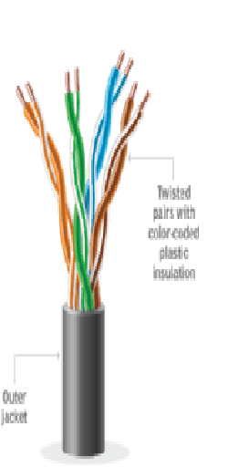
UTP | Category 5 | Up to 100  Mbps
UTP | Category 5e | 1Gbps
STP  SSTP | Category6,6a | 10Gbps  10Gbps | Advantages ● Shielded.  - Faster than UTP.  - Less  susceptible to noise and interference  Disadvantages  - Expensive  - Greater  installatio n effort | Gigabit Ethernet,  10G Ethernet  (55m)  Widely used in data centres |  |  |  | 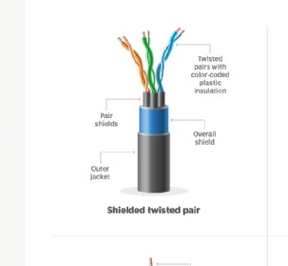  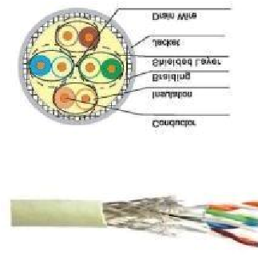
STP  SSTP | Category 7
 |  |  |  | Gigabit Ethernet,
 |  |  |  | 10G Ethernet
 |  |  |  | (100m)

Coaxial cable | RG-6 RG-59  RG-11 | 10-100Mbps | - High bandwidth  - Immune  to interferen ce  - Low loss bandwidt h  - Versatile  - Disadvantages  - Limited distance  - Cost  - Size is bulky | Speed of signal is  500m  Televisi on network High speed internet connect ions | 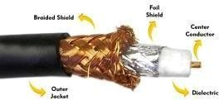
fibre optics cable | Single mode  Multi mode | 100Gbps | Advantages  - High speed  - High bandwidth  - High security  - Long distance  Disadvantages  - Expensive  - Requires  skilled installers | ● Maximum  distance of fibre optics cable is around 100meters | 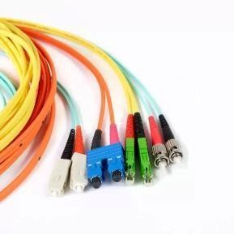

(b) Make Your Own Ethernet Cross-Over Cable/ Straight cable
Tools and parts needed:
- Ethernet cabling. CAT5e is certified for gigabit support, but CAT5 cabling works as well, just over shorter distances.
- A crimping tool. This is an all-in-one networking tool shaped to push down the pins in the plug and strip and cut the shielding off the cables.
- Two RJ45 plugs.
- Optional two plug shields.
- Ethernet Cable (CAT5e/CAT5)
  - CAT5e is recommended because it supports Gigabit Ethernet (1000 Mbps). ● CAT5 also works but supports lower speeds and shorter distances.
- Crimping Tool
  - A networking tool used to:
o Strip the outer insulation of the cable. o Arrange and trim the wires. o Crimp (press) the RJ45 connector onto the cable. • RJ45 Connectors (2)
  - Plastic connectors fitted at both ends of the Ethernet cable.
  - Used to connect the cable to computers, switches, routers, etc.
- Plug Shields (Optional)
  - Protective covers placed over the RJ45 connectors.
  - Prevent damage to the locking clip and reduce strain on the cable.

