Ex.No.14 | Develop a customized ping command to test the server connectivity
DATE:

6.1 Customized ping command to test the server connectivity Aim:
To develop a customized ping command to test the server connectivity.
Algorithm for Program1: Customized ping command to test the server connectivity:
- Start.
- Import the socket and time modules.
- Specify the server name, port number, and number of attempts.
- Create a TCP socket.
- Set the timeout period.
- Record the start time.
- Connect to the server.
- Record the end time.
- Calculate and display the response time.
- If the connection fails, display "Request timed out".
- Repeat Steps 4–10 for the specified number of attempts.
- Stop.

PROGRAM 1:
Customized ping command to test the server connectivity: import socket import time host = "google.com" port = 80 count = 4 for i in range(count):
try:
# Create a socket s = socket.socket(socket.AF_INET, socket.SOCK_STREAM) # Set timeout (optional)
s.settimeout(3) # Record start time start = time.time() # Connect to the server
s.connect((host, port)) # Record end time end = time.time() # Close the socket
s.close() print(f"Reply from {host}: time={(end - start) * 1000:.2f} ms") except Exception:
print("Request timed out")

Sample Output:
Reply from google.com: time=18.52 ms
Reply from google.com: time=17.84 ms
Reply from google.com: time=19.03 ms Reply from google.com: time=18.26 ms

OUTPUT:

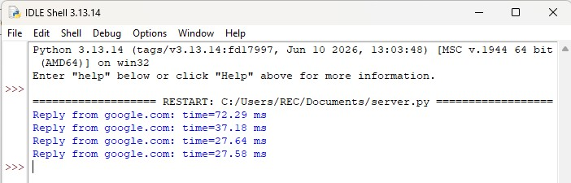

RESULT: Therefore the ping command to test server connectivity has been developed and verified.

6.2 Customized Ping Program to Measure Min, Max, and Average RTT

AIM:
To develop a Customized Ping Program to Measure Min, Max, and Average RTT
ALGORITHM for Program 2:

- Start.
- Import the required modules.
- Initialize the server address, port number, and number of ping attempts.
- Create an empty list to store RTT values.
- Repeat the following for each ping attempt:
  - Create a TCP socket.
  - Set the timeout value. ● Record the start time.
  - Connect to the server.
  - Record the end time.
  - Calculate the RTT and store it in the list.
  - Display the RTT.
  - If the connection fails, display "Request timed out".
- Calculate and display:
  - Packets Sent
  - Packets Received
  - Packets Lost
  - Minimum RTT
  - Maximum RTT
  - Average RTT
- Stop.

PROGRAM2: Customized Ping Program to Measure Min, Max, and Average RTT

import socket import time # Server details host = "google.com" port = 80 count = 4
# List to store RTT values rtt_list = [] print(f"Pinging {host} with TCP packets:\n") for i in range(count):
try:
# Create a TCP socket s = socket.socket(socket.AF_INET, socket.SOCK_STREAM)
s.settimeout(3) # Record start time start = time.time() # Connect to the server
s.connect((host, port)) # Record end time end = time.time() # Close the socket
s.close()
# Calculate RTT in milliseconds rtt = (end - start) * 1000 rtt_list.append(rtt) print(f"Reply {i+1}: time = {rtt:.2f} ms") except Exception:
print(f"Reply {i+1}: Request timed out")
# Display statistics if len(rtt_list) > 0:
print("\n--- Ping Statistics ---") print(f"Packets Sent : {count}") print(f"Packets Received : {len(rtt_list)}") print(f"Packets Lost : {count - len(rtt_list)}") print(f"Minimum RTT : {min(rtt_list):.2f} ms") print(f"Maximum RTT : {max(rtt_list):.2f} ms") print(f"Average RTT : {sum(rtt_list)/len(rtt_list):.2f} ms") else: print("\nNo response received from the server.")

SAMPLE OUTPUT:
Pinging google.com with TCP packets:

Reply 1: time = 18.24 ms
Reply 2: time = 17.81 ms
Reply 3: time = 19.15 ms Reply 4: time = 18.56 ms

--- Ping Statistics ---
Packets Sent : 4
Packets Received : 4
Packets Lost : 0
Minimum RTT : 17.81 ms
Maximum RTT : 19.15 ms
Average RTT : 18.44 ms
OUTPUT:

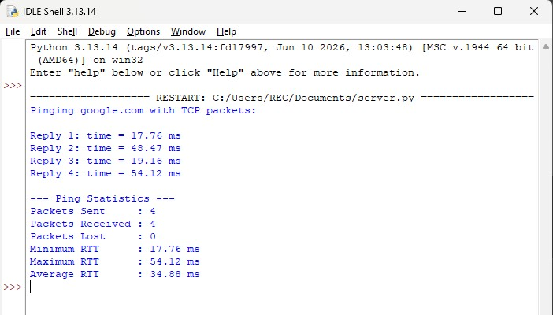

RESULT: Therefore a Customized Ping Program to Measure Min, Max, and Average RTT has been created and verified.

