COMPUTER NETWORKS

AIM: To build an anonymous ftp scanner using ftplib module in python.

FTP Scanner:

A tool that automatically scans IPs/hosts for active FTP servers. It tests connectivity and credentials, reporting successful logins and vulnerabilities.
ftplib:
A built-in Python library for working with the File Transfer Protocol (FTP). It allows connecting to FTP servers, logging in, listing directories, and transferring files.

ALGORITHM:
- Start.
- Import the ftplib module.
- Specify the FTP server hostname.
- Connect to the FTP server.
- Log in using the username anonymous and password anonymous.
- If the login is successful:
  - Display the login status.
  - Display the server's welcome message. ● Display the directory listing.
- Close the FTP connection.
- If the login fails, display an error message.
- Stop.

PROGRAM:
import ftplib def anonymous_login(hostname):
try:
# Connect to the FTP server ftp = ftplib.FTP(hostname)
# Login using anonymous credentials response = ftp.login('anonymous', 'anonymous') print(response)
# Check whether anonymous login is successful if "230" in response:
print("\n[*] FTP Anonymous Login Succeeded.") print("Server:", hostname) # Display welcome message print("\nWelcome Message:") print(ftp.getwelcome()) # Display directory listing print("\nDirectory Listing:") ftp.dir()
# Close the FTP connection
ftp.quit() except Exception as e: print("Error:", e) print("\n[-] FTP Anonymous Login Failed.")
# Main Program hostname = "ftp.be.debian.org" anonymous_login(hostname)

SAMPLE OUTPUT:

230 Login successful.
[*] FTP Anonymous Login Succeeded.
Server: ftp.be.debian.org Welcome Message: 220 FTP Server Ready Directory Listing: drwxr-xr-x 2 ftp ftp 4096 Jan 10 2026 debian drwxr-xr-x 2 ftp ftp 4096 Jan 10 2026 cdimage drwxr-xr-x 2 ftp ftp 4096 Jan 10 2026 project
-rw-r--r-- 1 ftp ftp 512 README.txt
221 Goodbye.

OUTPUT:
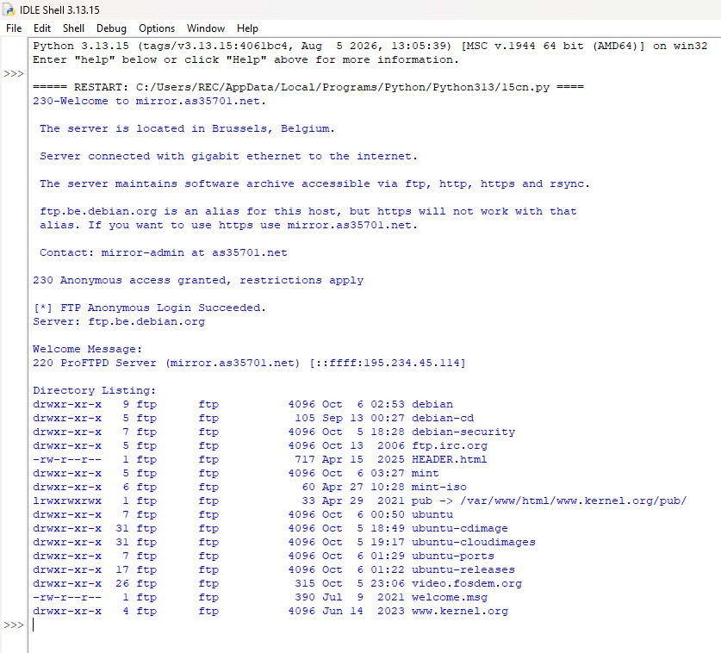
RESULT: Thus an anonymous ftp scanner using ftplib module was built and executed successfully.

