**Module: DLYRPT  
Report: AfterSubmit_Error  
Status: ERROR  
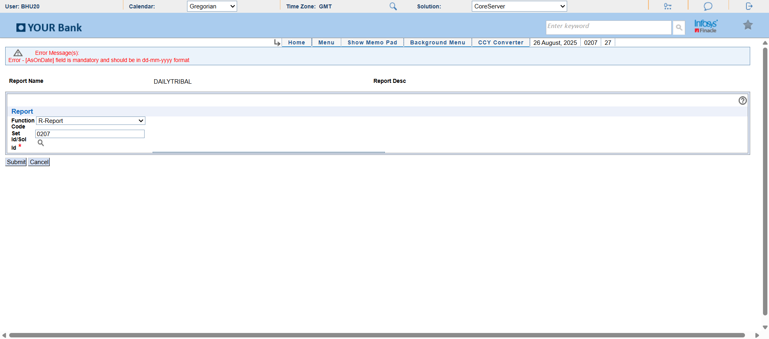**

**Module: DLYRPT  
Report: AfterSubmit_Error  
Status: ERROR  
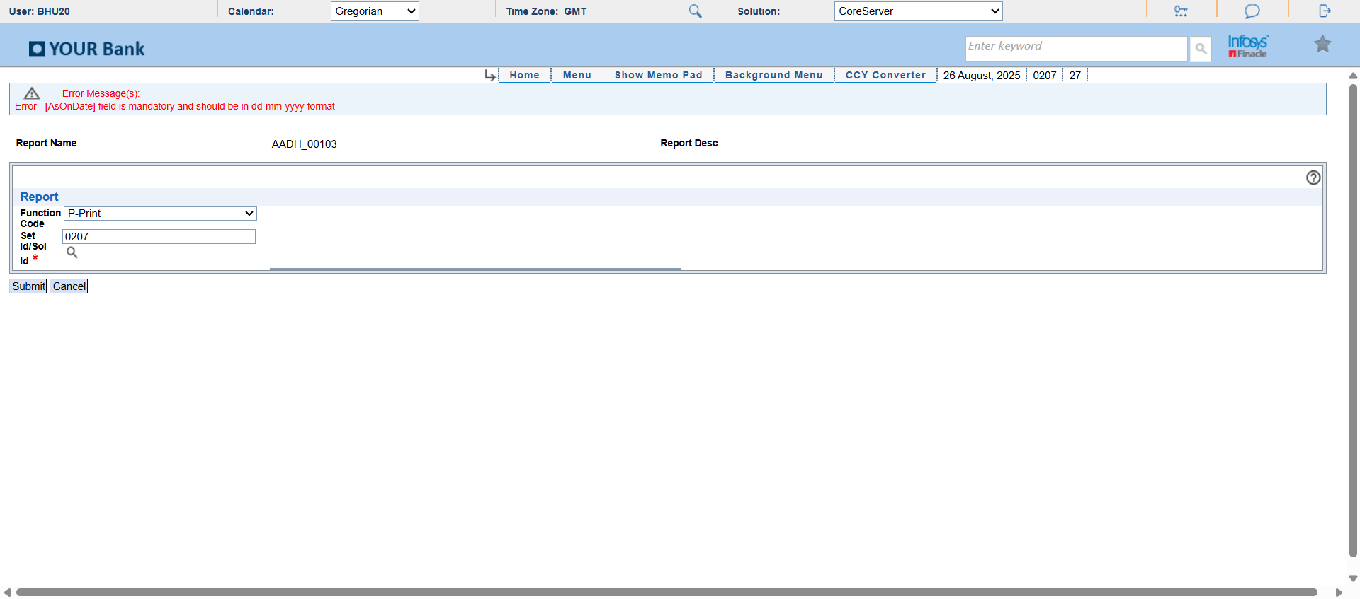**

**Module: DLYRPT  
Report: AfterSubmit_Error  
Status: ERROR  
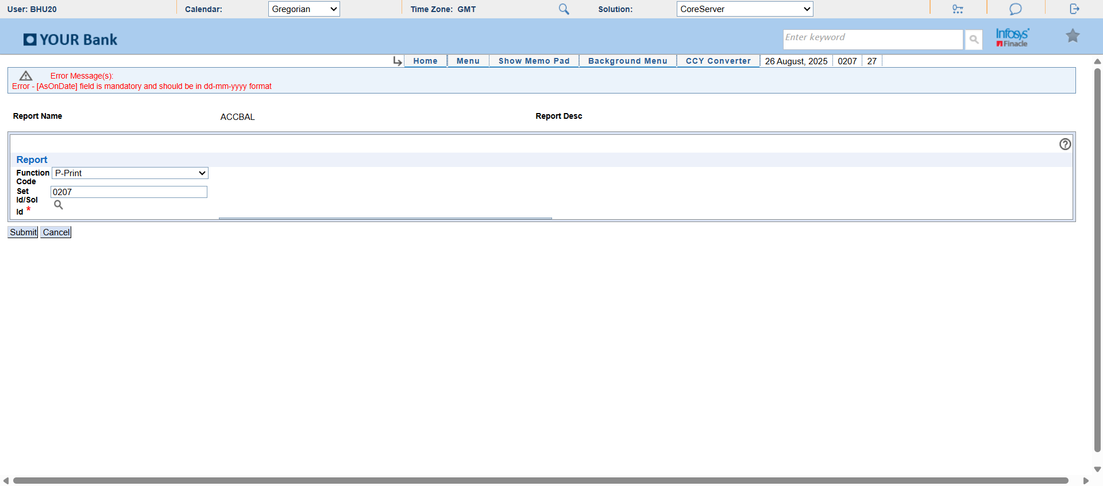**

**Module: DLYRPT  
Report: AfterSubmit_Error  
Status: ERROR  
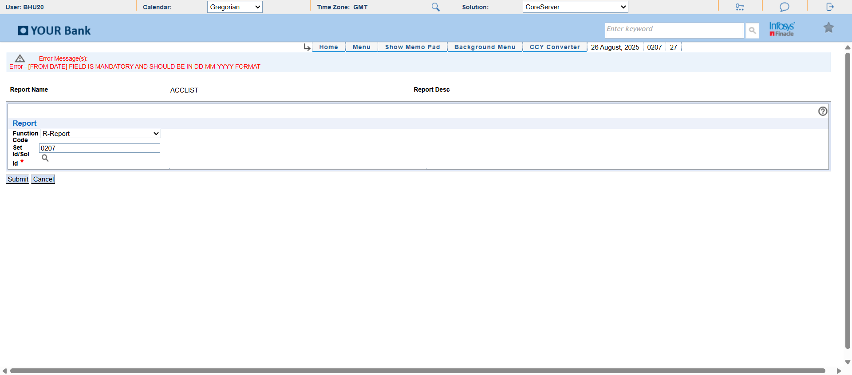**

**Module: DLYRPT  
Report: AfterSubmit_Error  
Status: ERROR  
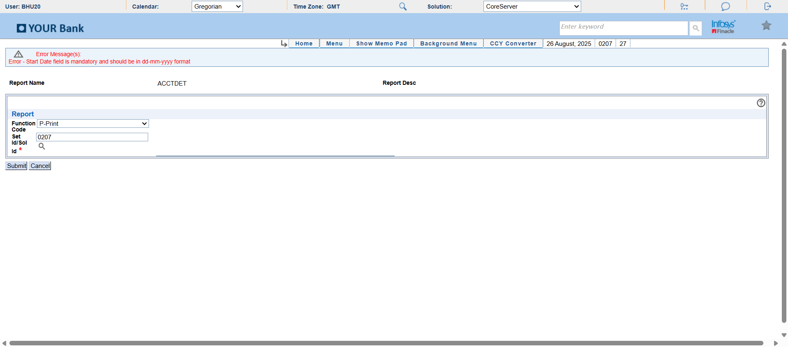**

**Module: DLYRPT  
Report: AfterSubmit_Error  
Status: ERROR  
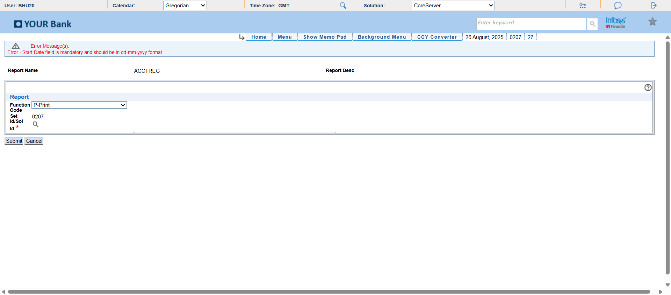**

**Module: DLYRPT  
Report: AfterSubmit_Error  
Status: ERROR  
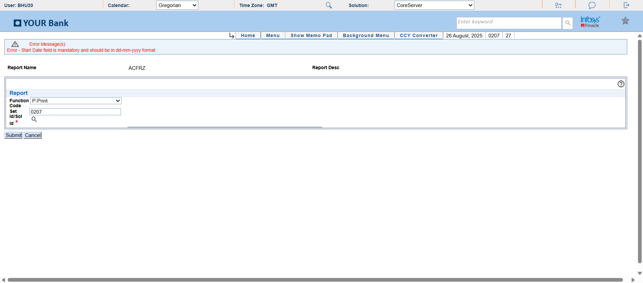**

**Module: DLYRPT  
Report: AfterSubmit_Error  
Status: ERROR  
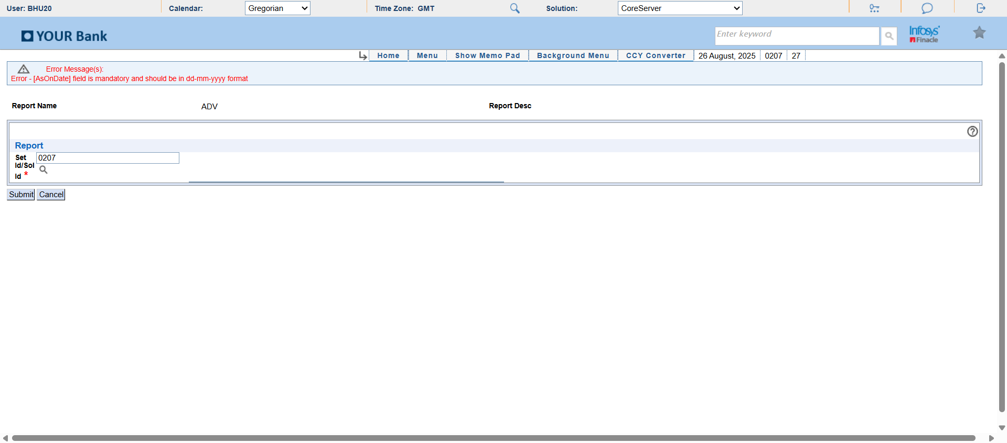**

**Module: DLYRPT  
Report: AfterSubmit_Error  
Status: ERROR  
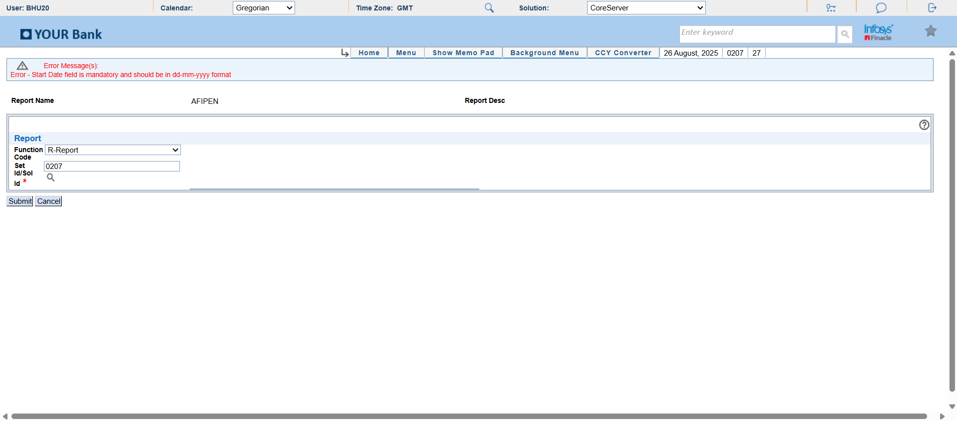**

**Module: DLYRPT  
Report: AfterSubmit_Error  
Status: ERROR  
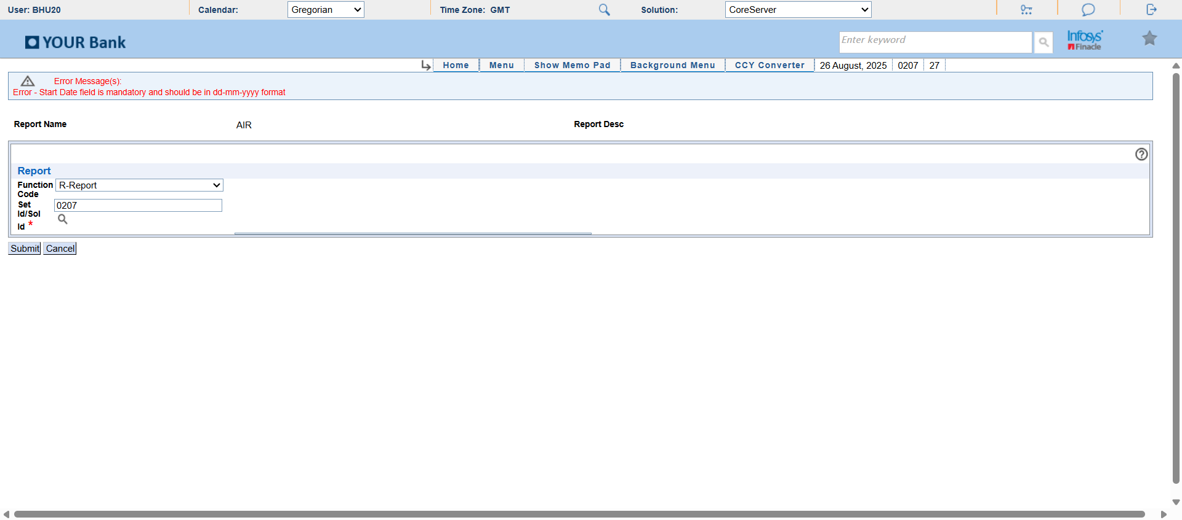**

**Module: DLYRPT  
Report: AfterSubmit  
Status: SUCCESS  
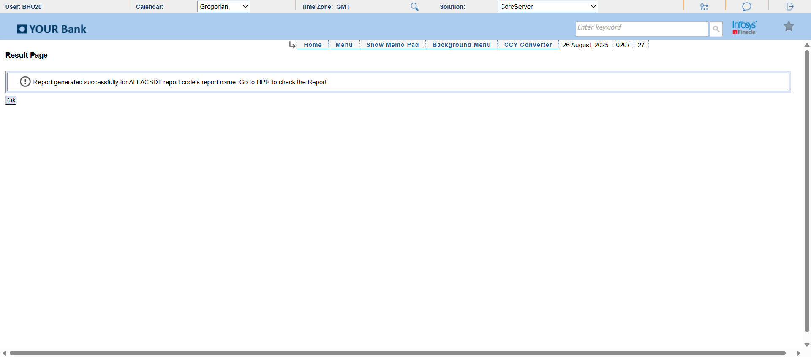**

**Module: PrintQueue  
Report: Latest_Report_Selected  
Status: SUCCESS  
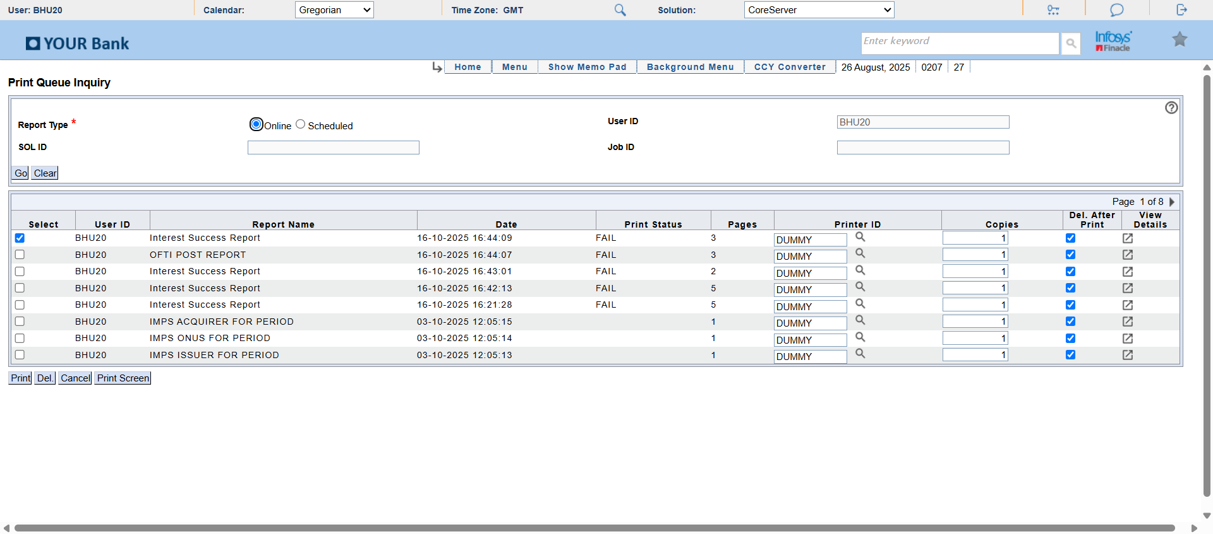**

**Module: PrintQueue  
Report: After_PrintScreen_NoExcel  
Status: SUCCESS  
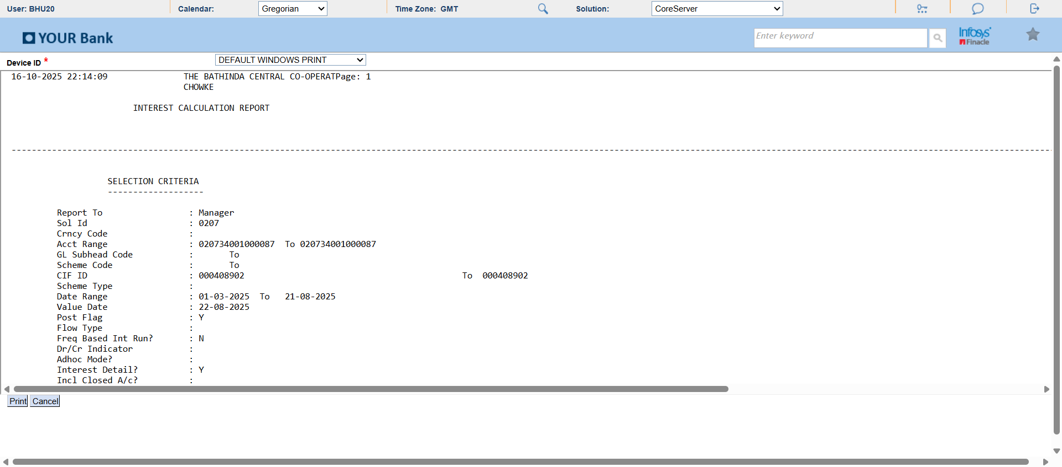**

**Module: DLYRPT  
Report: AfterSubmit_Error  
Status: ERROR  
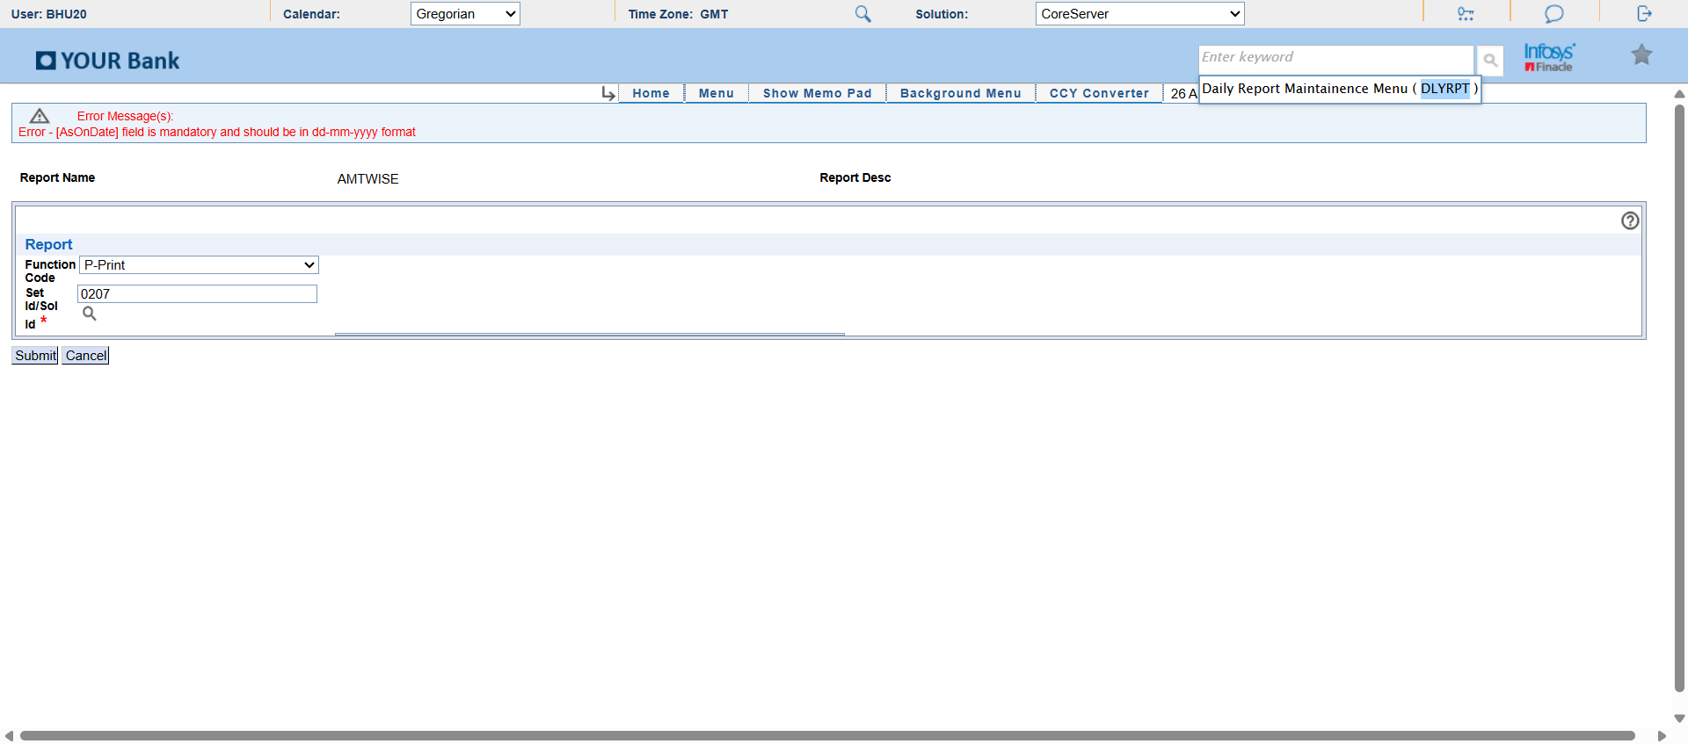**

**Module: DLYRPT  
Report: AfterSubmit_Error  
Status: ERROR  
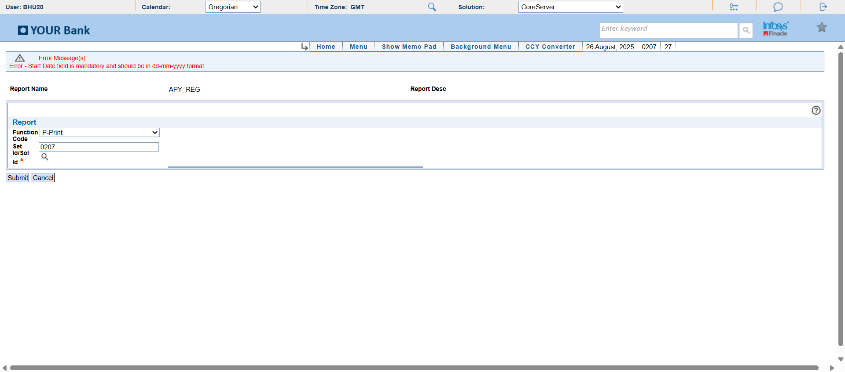**

**Module: DLYRPT  
Report: AfterSubmit_Error  
Status: ERROR  
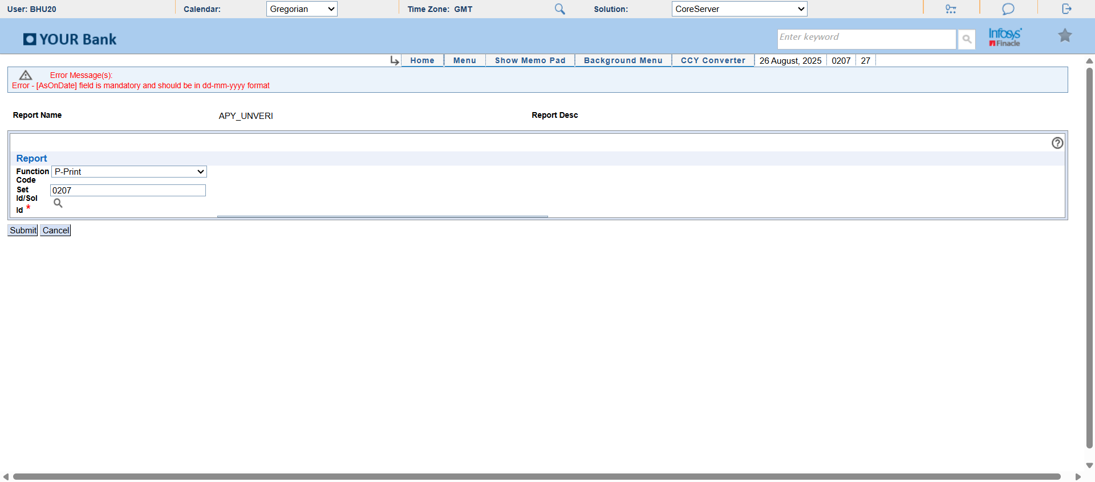**

**Module: DLYRPT  
Report: AfterSubmit_Error  
Status: ERROR  
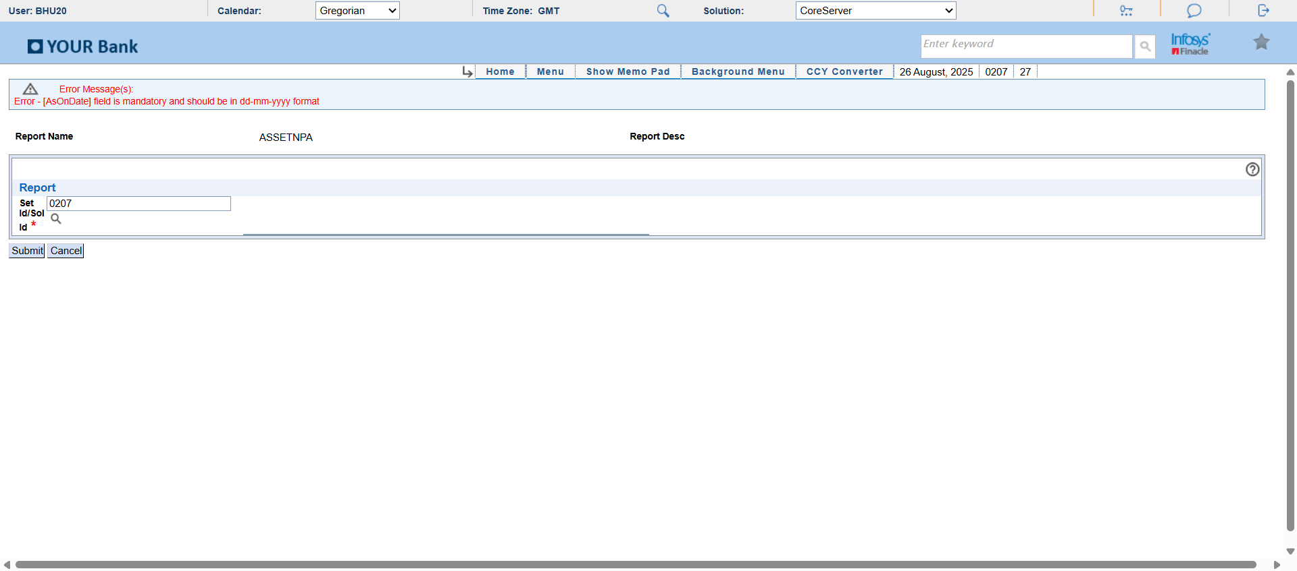**

**Module: DLYRPT  
Report: AfterSubmit  
Status: SUCCESS  
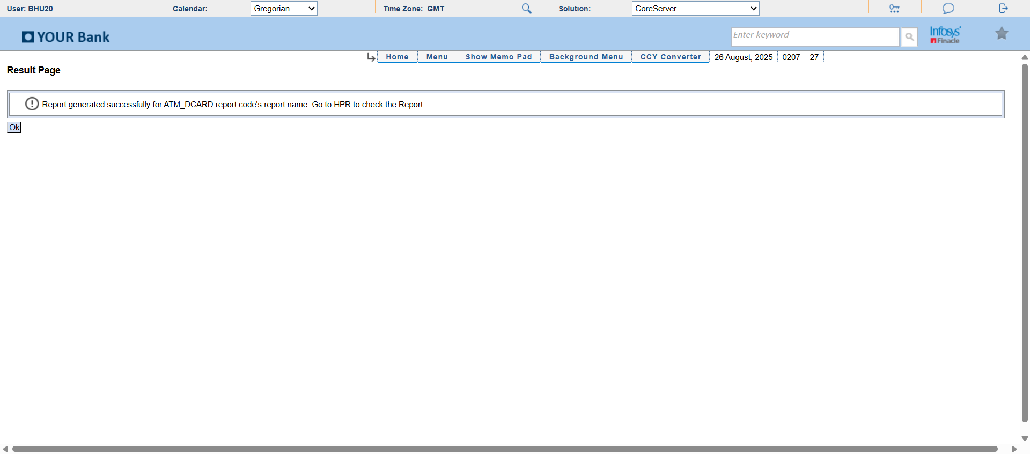**

**Module: PrintQueue  
Report: Latest_Report_Selected  
Status: SUCCESS  
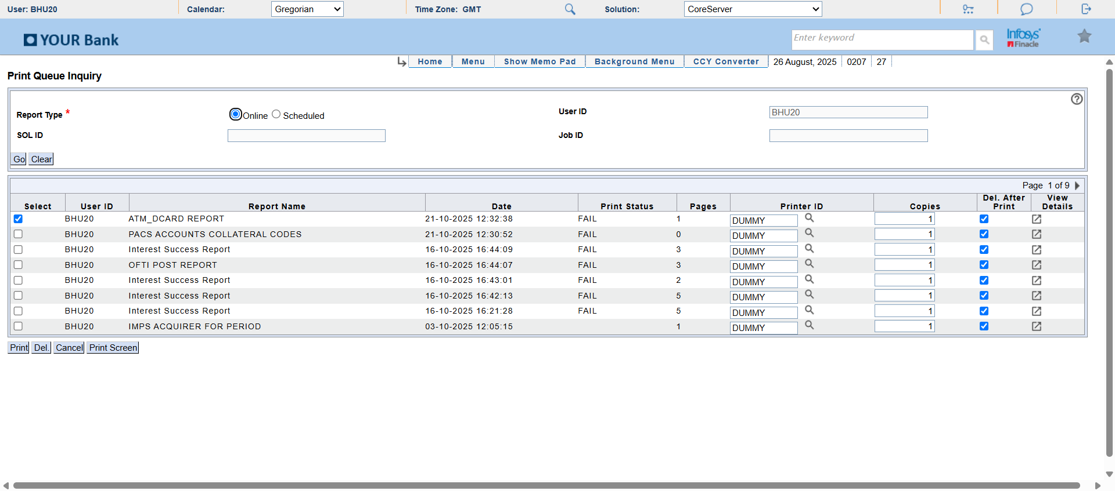**

**Module: DLYRPT  
Report: AfterSubmit_Error  
Status: ERROR  
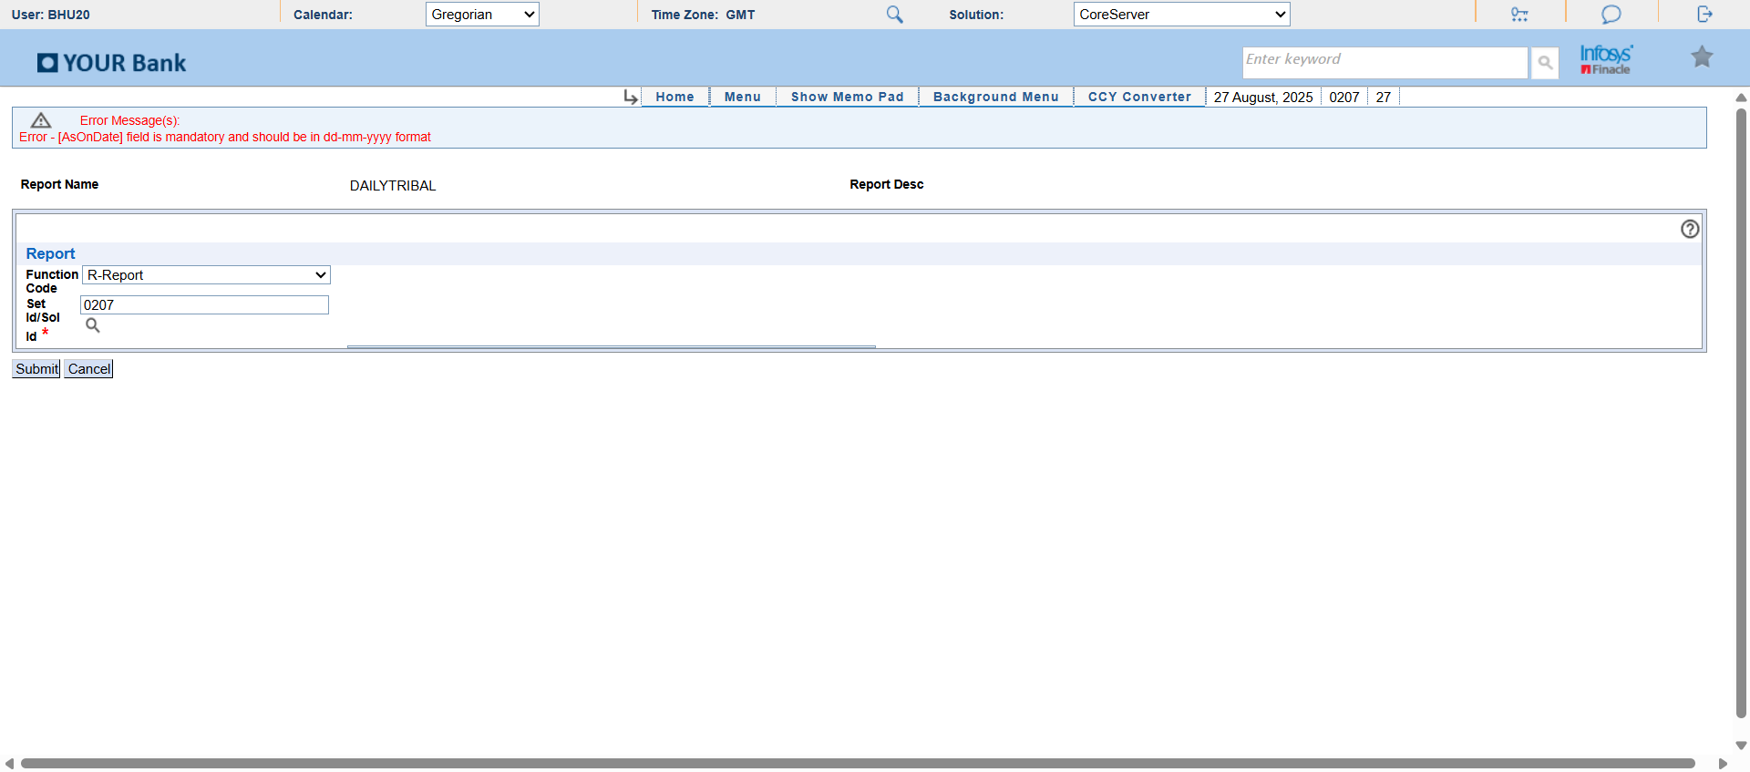**

**Module: DLYRPT  
Report: AfterSubmit_Error  
Status: ERROR  
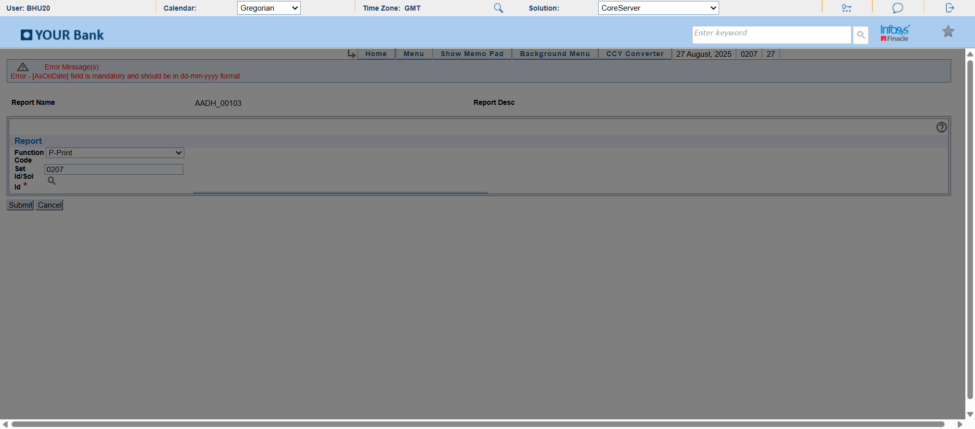**

**Module: DLYRPT  
Report: AfterSubmit_Error  
Status: ERROR  
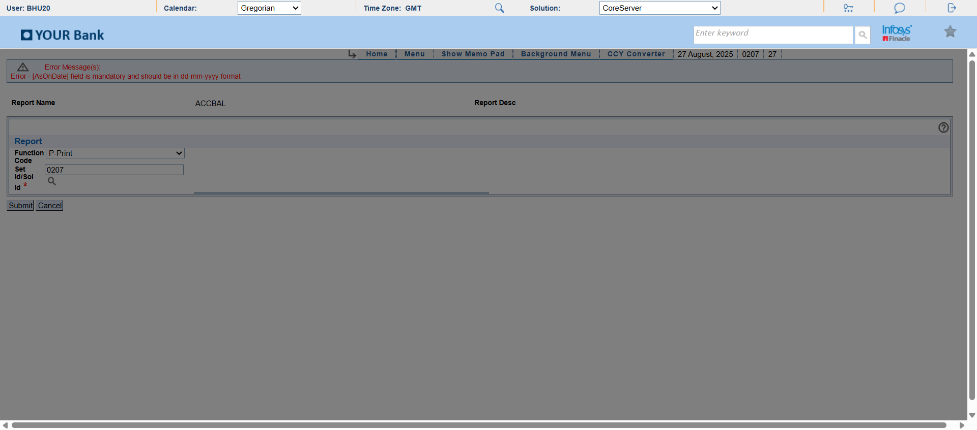**

**Module: DLYRPT  
Report: AfterSubmit_Error  
Status: ERROR  
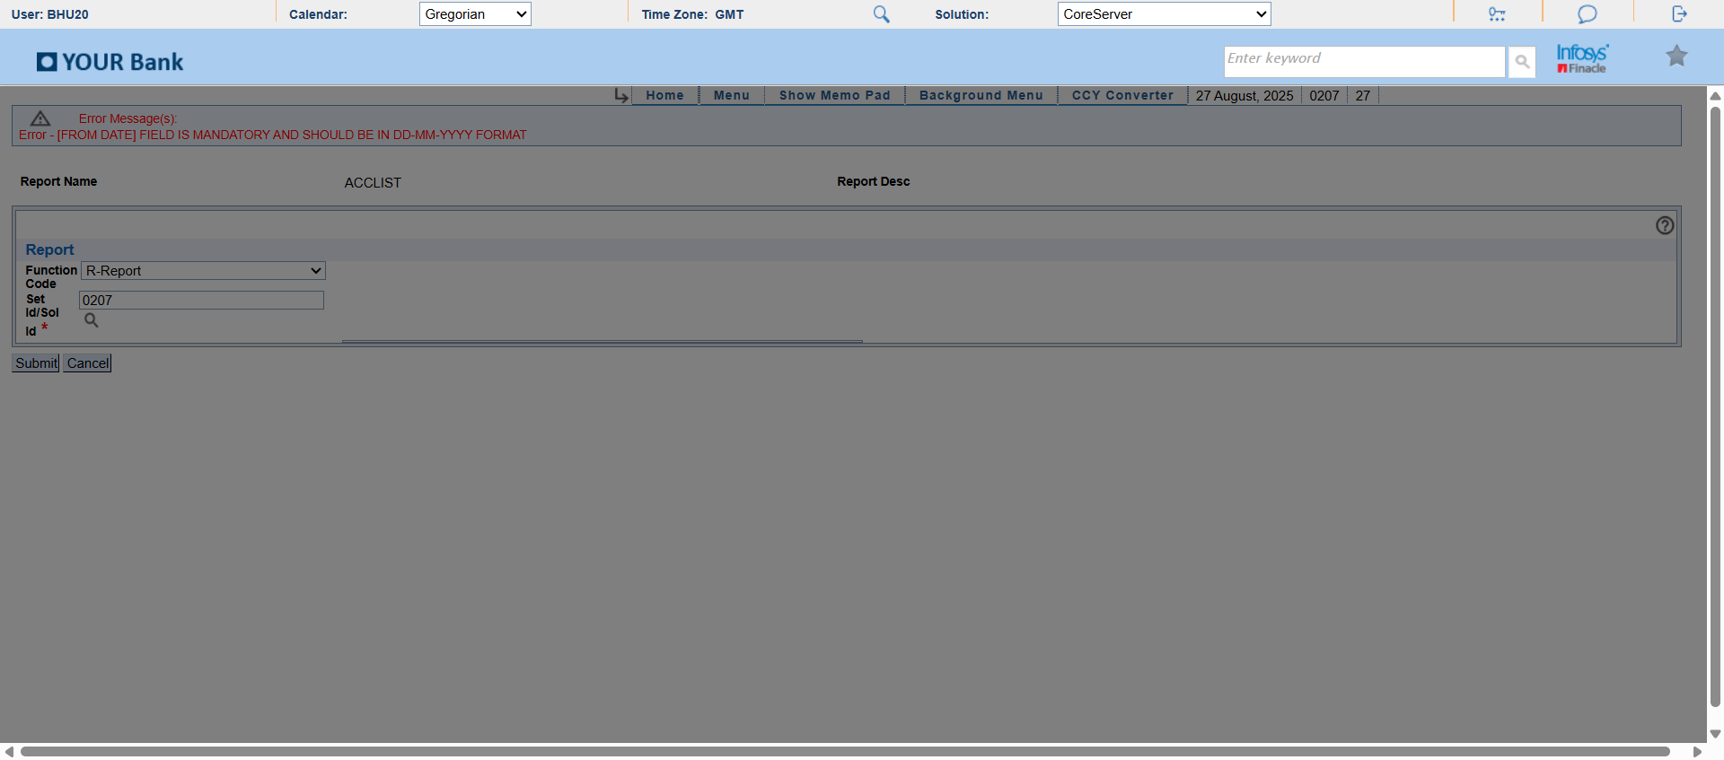**

**Module: DLYRPT  
Report: AfterSubmit_Error  
Status: ERROR  
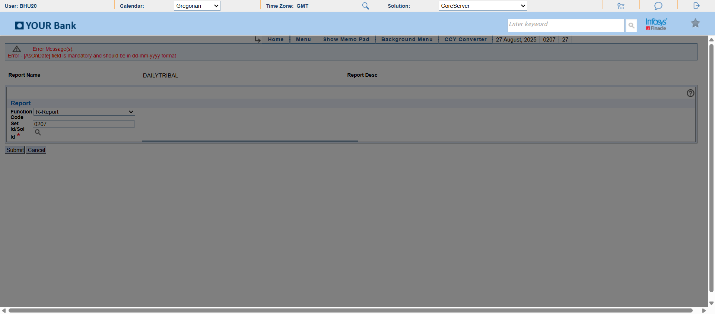**

**Module: DLYRPT  
Report: AfterSubmit_Error  
Status: ERROR  
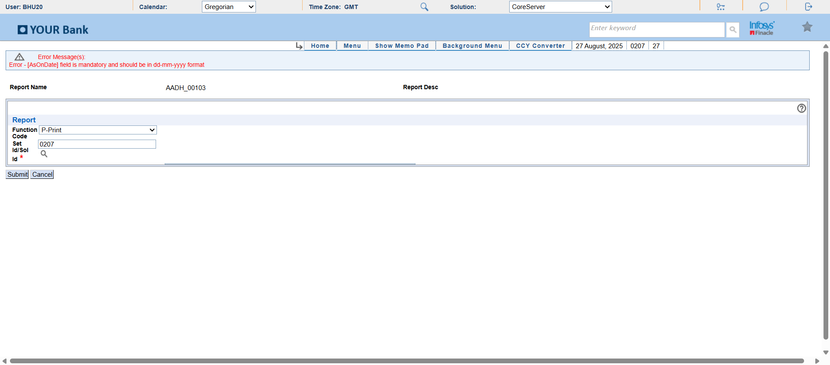**

**Module: DLYRPT  
Report: AfterSubmit_Error  
Status: ERROR  
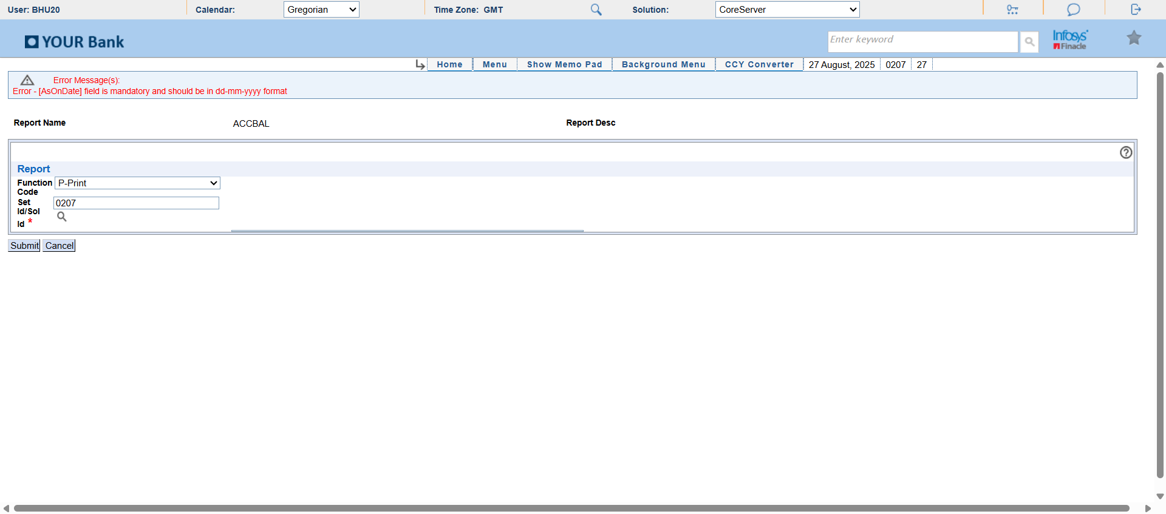**

**Module: DLYRPT  
Report: AfterSubmit_Error  
Status: ERROR  
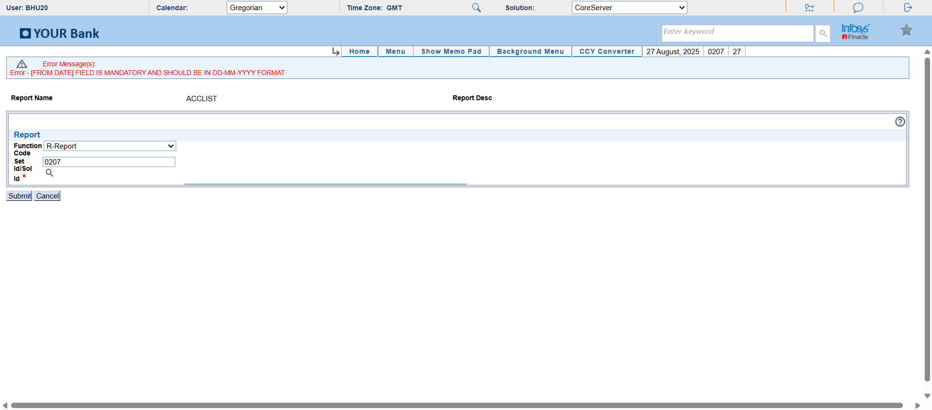**

**Module: DLYRPT  
Report: AfterSubmit_Error  
Status: ERROR  
