Module: DLYRPT
Report: AfterSubmit
Status: SUCCESS
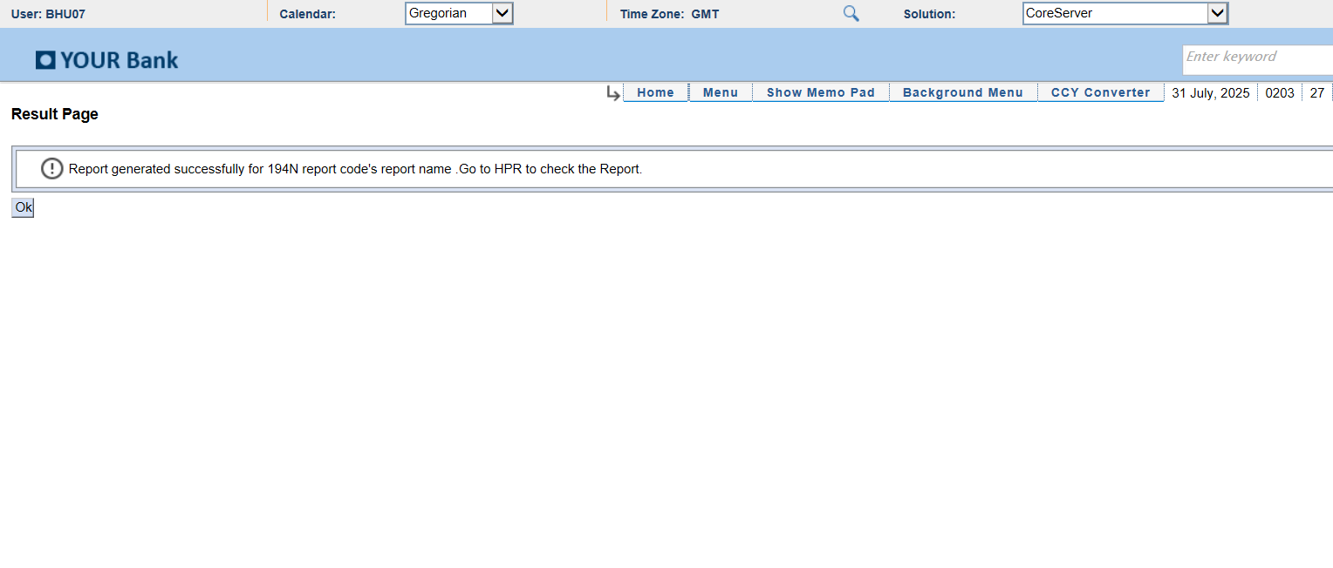
Module: PrintQueue
Report: Latest_Report_Selected
Status: SUCCESS
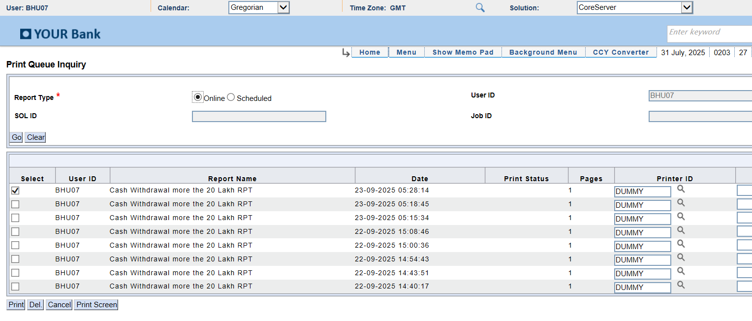
Module: ExcelReport
Report: Excel Screenshot
Status: Excel Window Captured
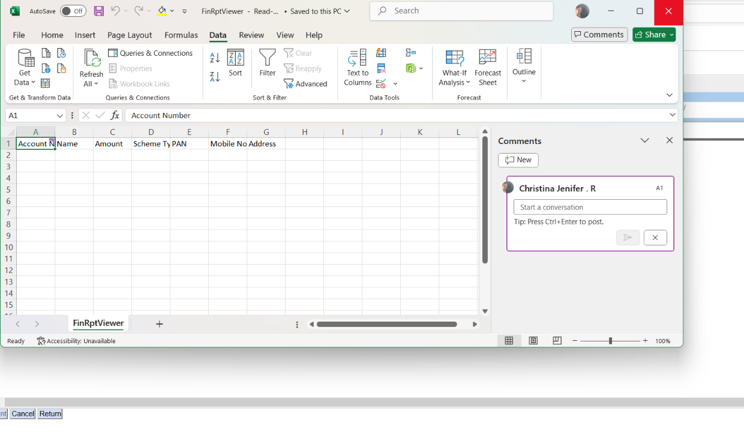
Module: DLYRPT
Report: AfterSubmit
Status: SUCCESS

Module: PrintQueue
Report: Latest_Report_Selected
Status: SUCCESS
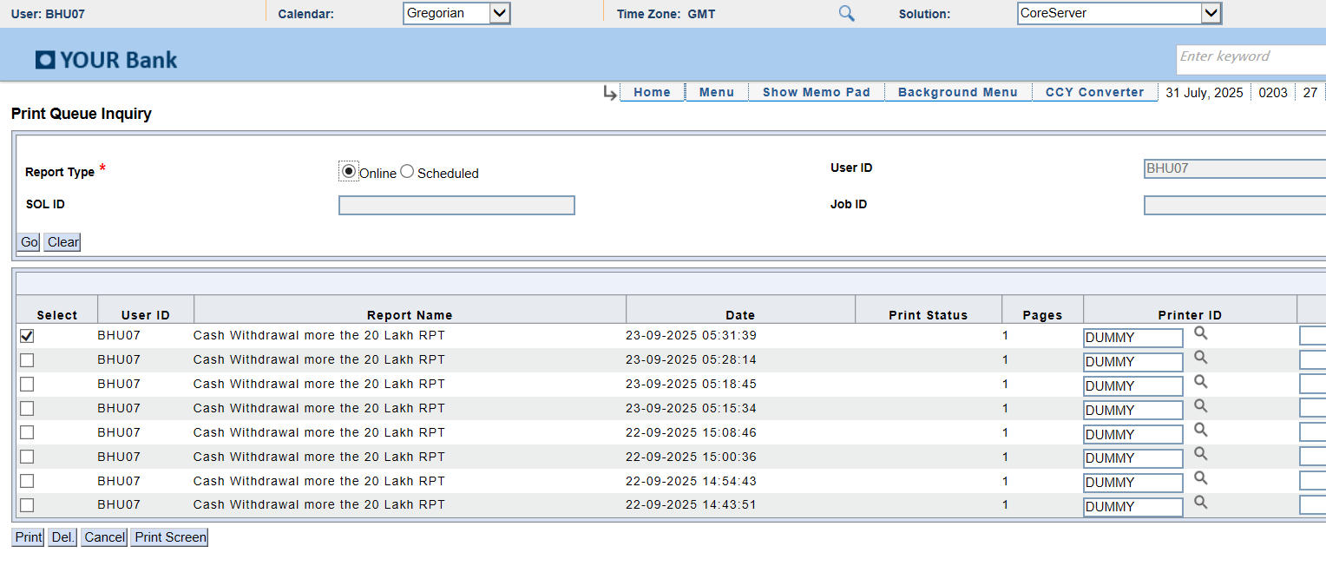
Module: PrintQueue
Report: After_PrintScreen_NoExcel
Status: SUCCESS
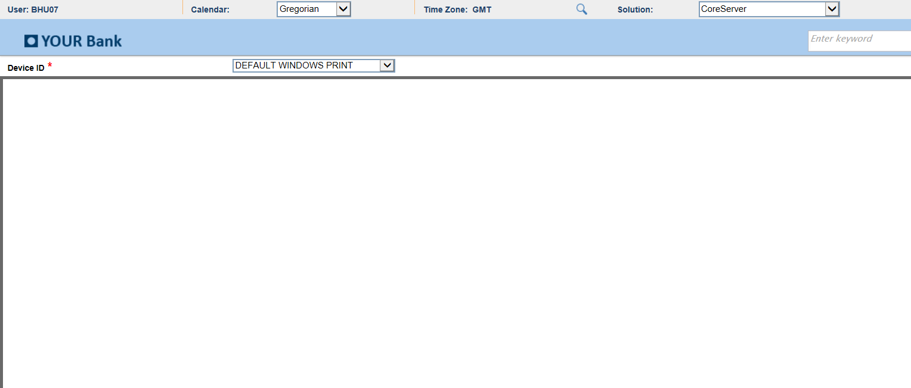
Module: DLYRPT
Report: AfterSubmit
Status: SUCCESS
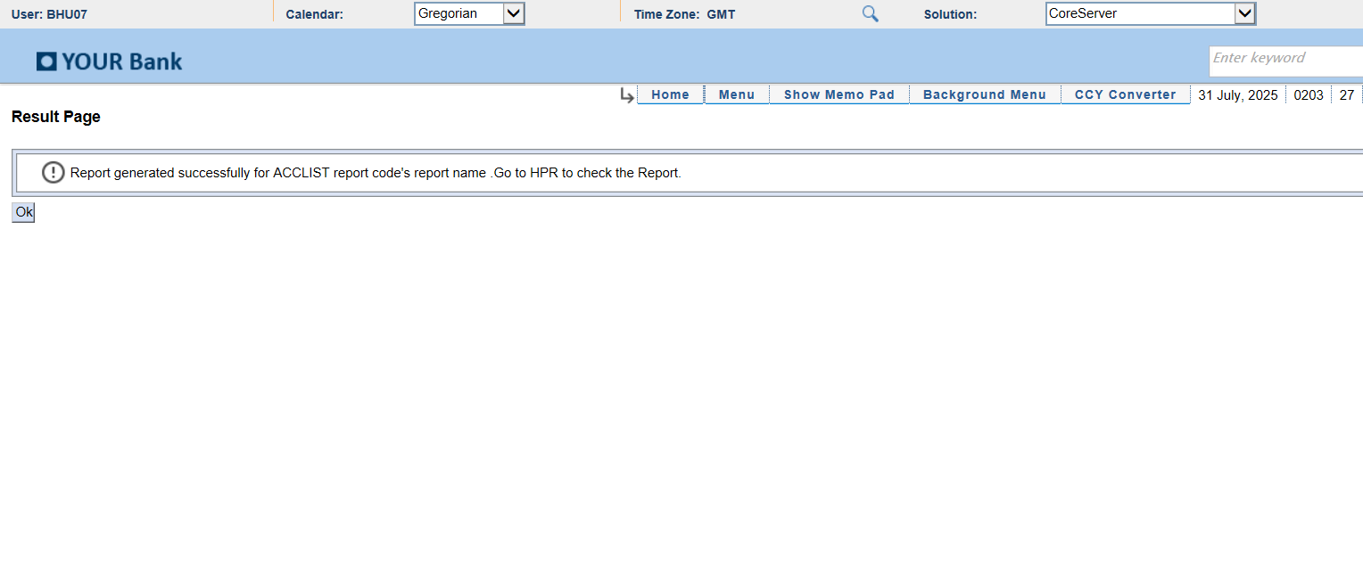
Module: PrintQueue
Report: Latest_Report_Selected
Status: SUCCESS
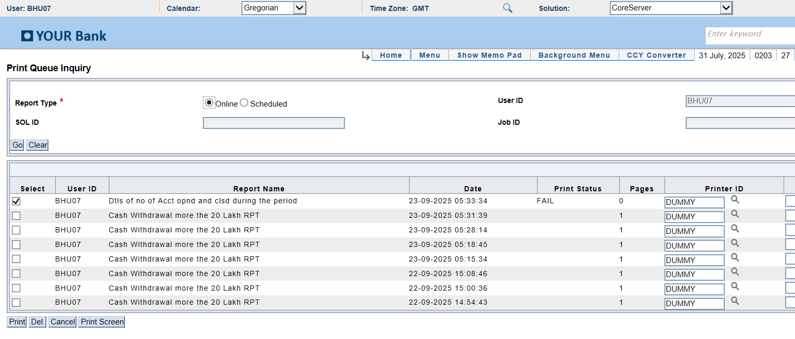
Module: PrintQueue
Report: After_PrintScreen_NoExcel
Status: SUCCESS
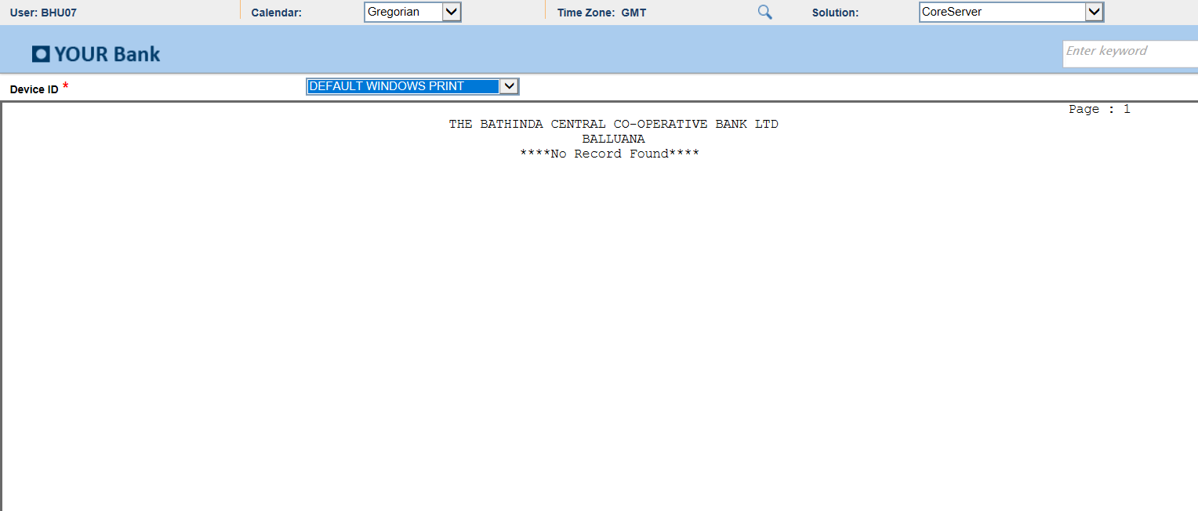
Module: DLYRPT
Report: AfterSubmit
Status: SUCCESS
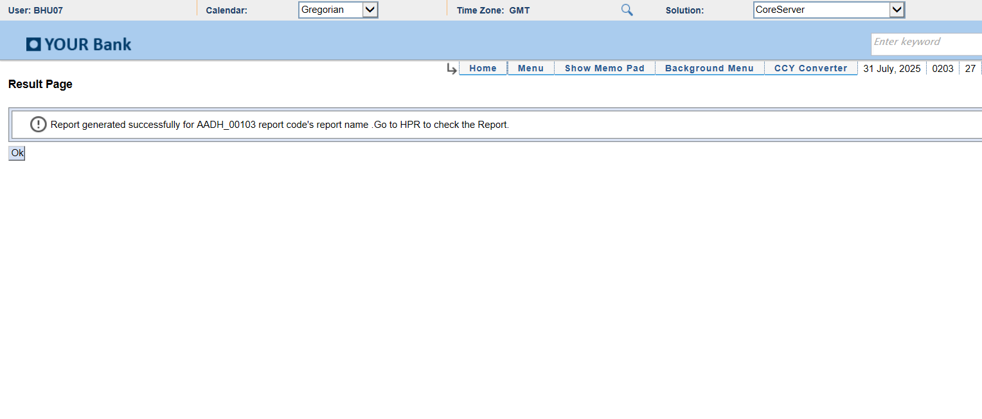
Module: PrintQueue
Report: Latest_Report_Selected
Status: SUCCESS
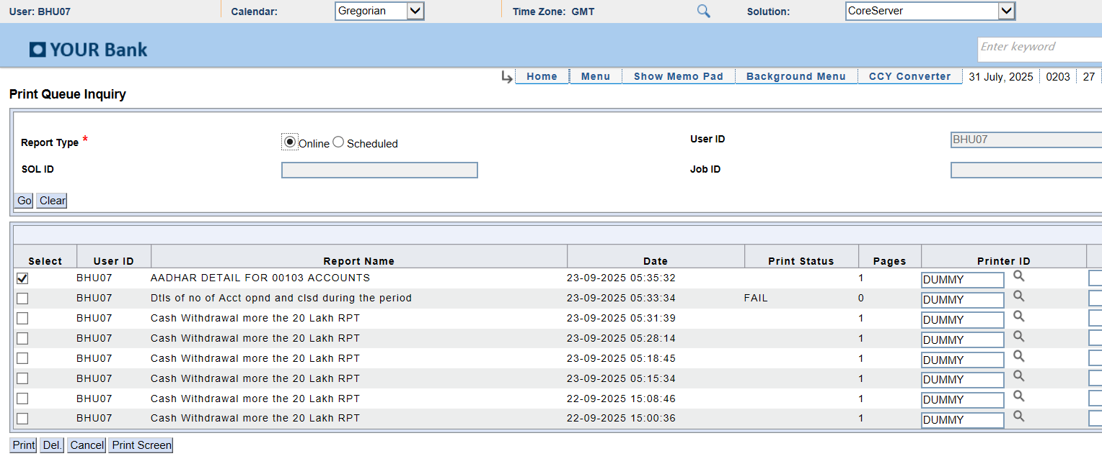
Module: PrintQueue
Report: After_PrintScreen_NoExcel
Status: SUCCESS

Module: DLYRPT
Report: AfterSubmit
Status: SUCCESS
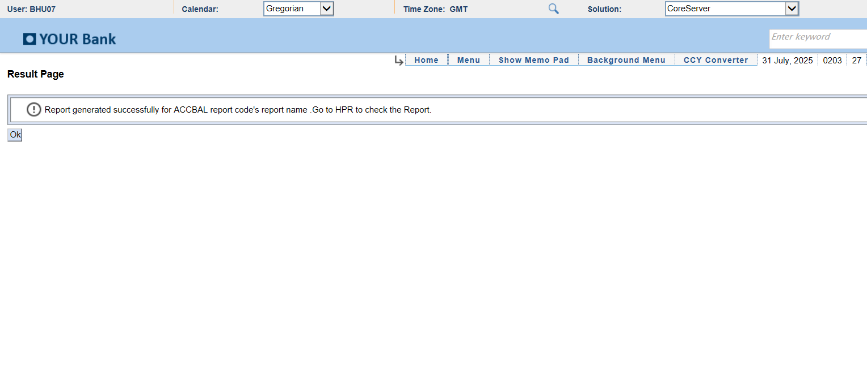
Module: PrintQueue
Report: Latest_Report_Selected
Status: SUCCESS

Module: PrintQueue
Report: After_PrintScreen_NoExcel
Status: SUCCESS

Module: DLYRPT
Report: AfterSubmit
Status: SUCCESS

Module: PrintQueue
Report: Latest_Report_Selected
Status: SUCCESS
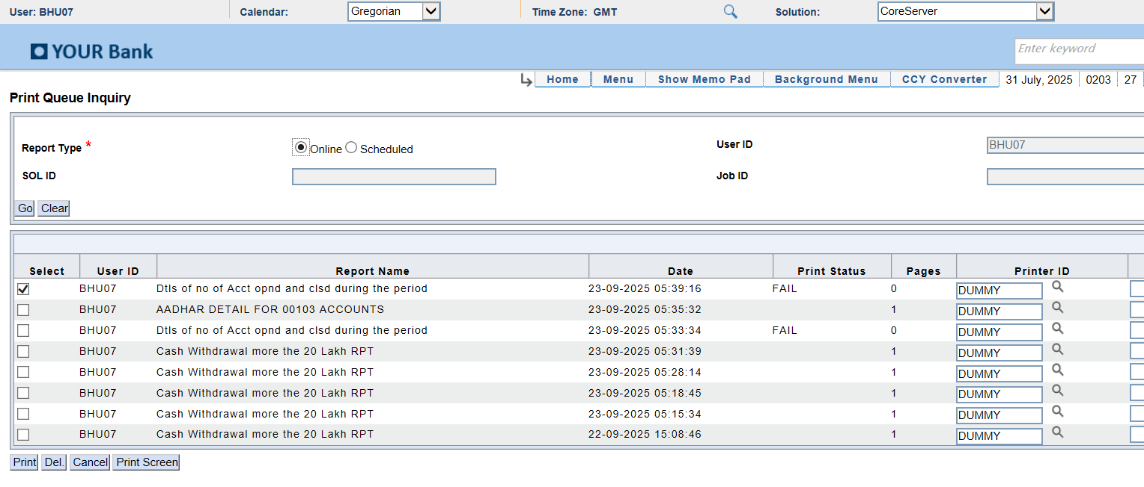
Module: PrintQueue
Report: After_PrintScreen_NoExcel
Status: SUCCESS
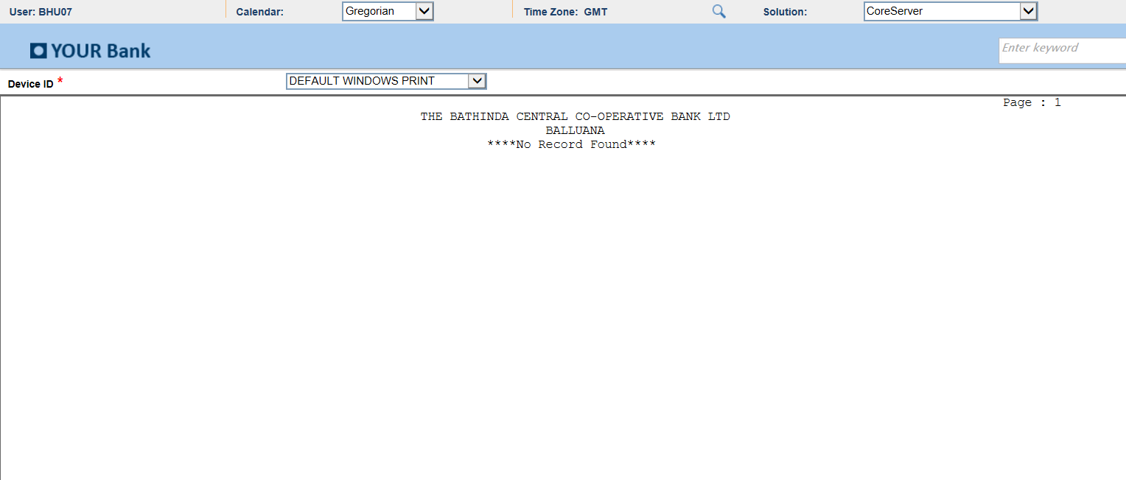
Module: DLYRPT
Report: AfterSubmit
Status: SUCCESS
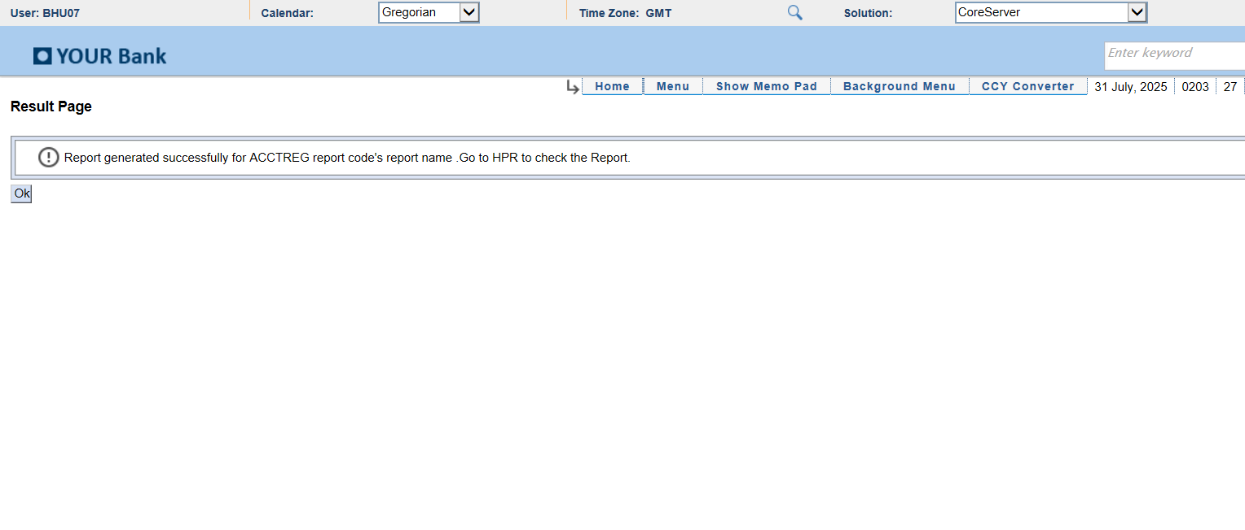
Module: PrintQueue
Report: Latest_Report_Selected
Status: SUCCESS
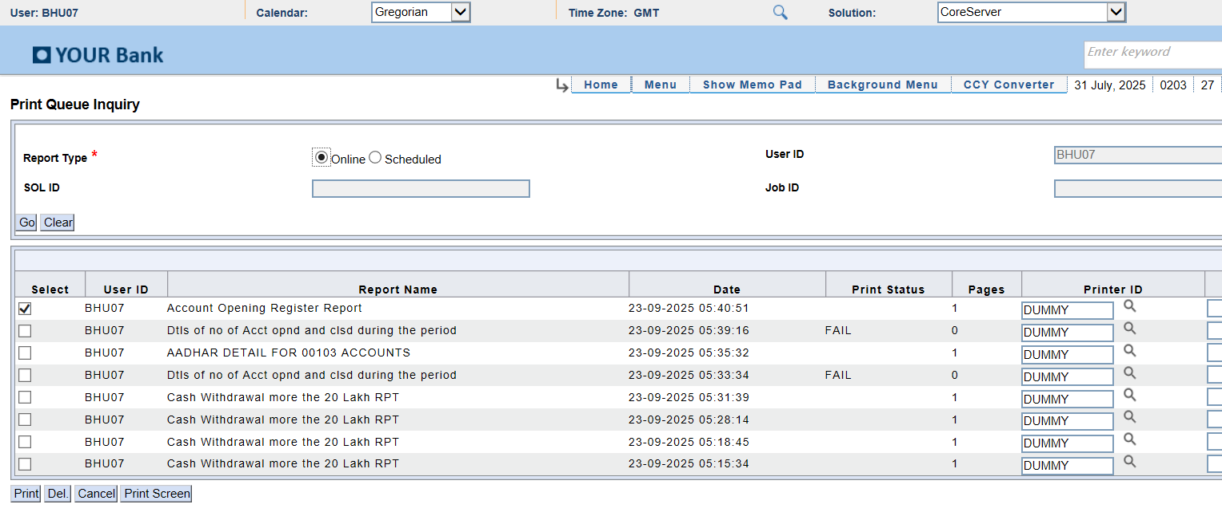
Module: PrintQueue
Report: After_PrintScreen_NoExcel
Status: SUCCESS
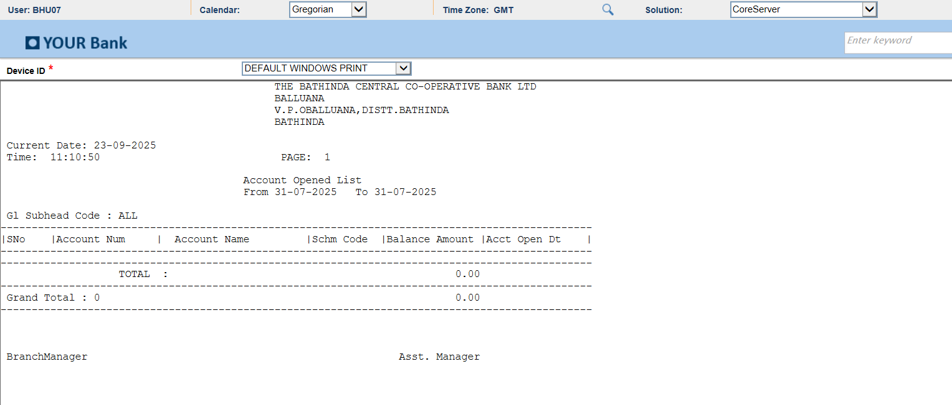
Module: DLYRPT
Report: AfterSubmit
Status: SUCCESS

Module: DLYRPT
Report: AfterSubmit
Status: SUCCESS

Module: PrintQueue
Report: After_PrintScreen_NoExcel
Status: SUCCESS
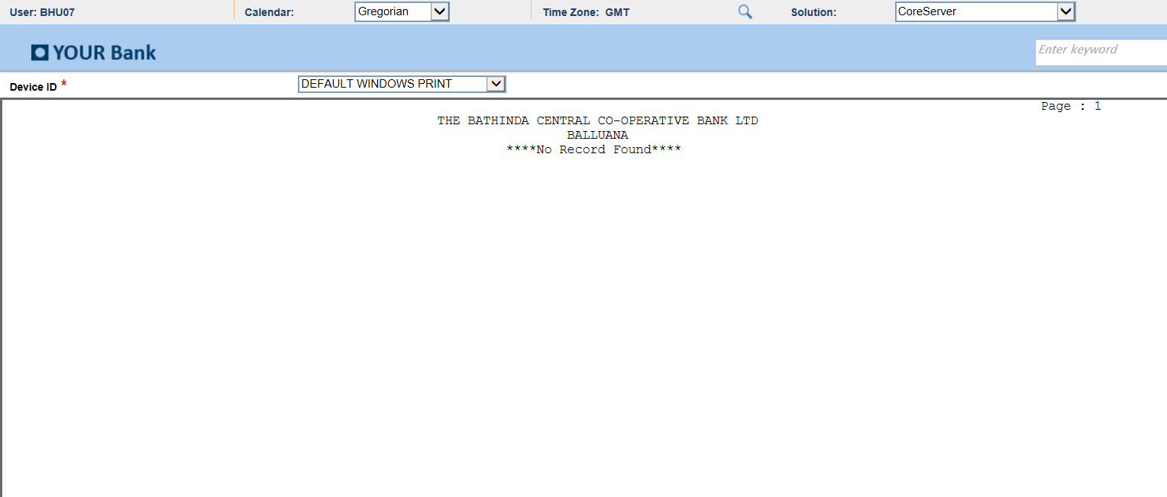
Module: DLYRPT
Report: AfterSubmit
Status: SUCCESS

Module: PrintQueue
Report: Latest_Report_Selected
Status: SUCCESS
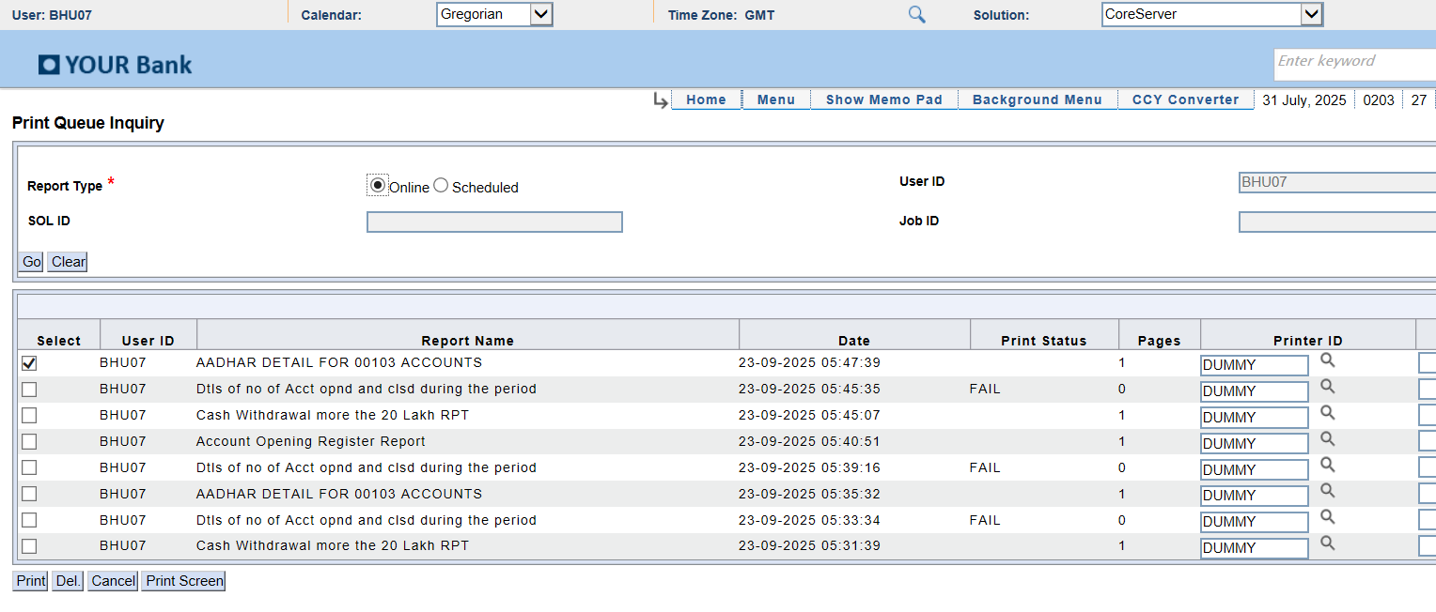
Module: PrintQueue
Report: After_PrintScreen_NoExcel
Status: SUCCESS

Module: DLYRPT
Report: AfterSubmit
Status: SUCCESS

Module: PrintQueue
Report: Latest_Report_Selected
Status: SUCCESS
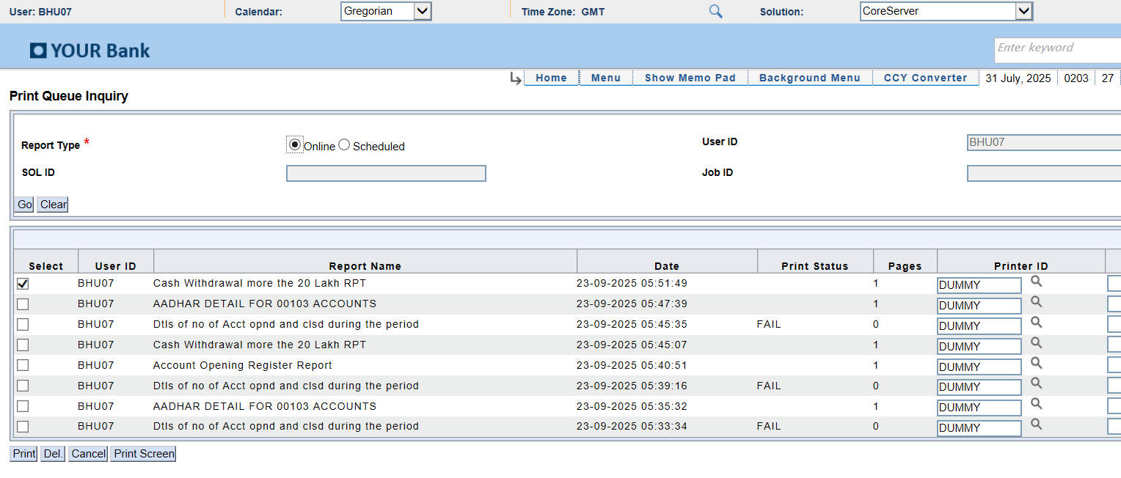
Module: ExcelReport
Report: Excel Screenshot
Status: Excel Window Captured
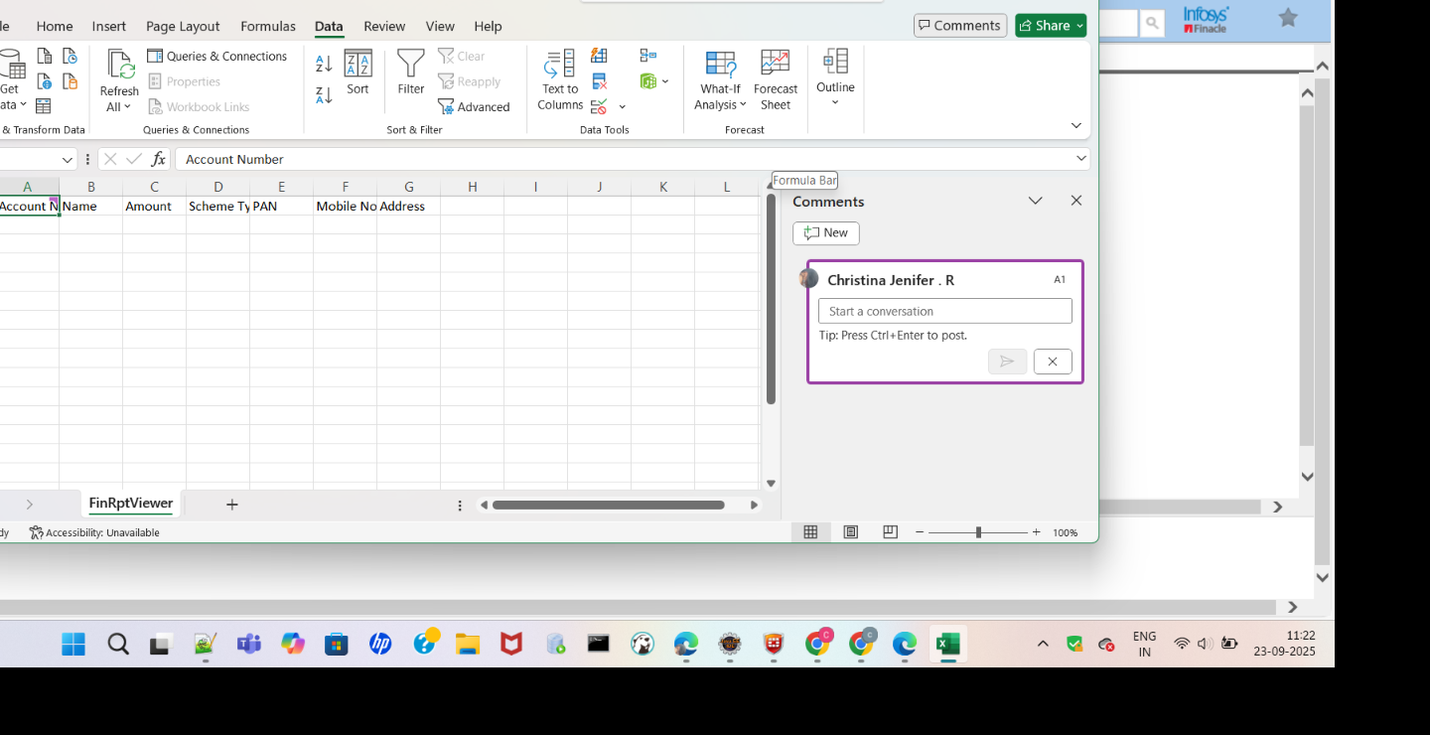
Module: DLYRPT
Report: AfterSubmit
Status: SUCCESS

Module: PrintQueue
Report: Latest_Report_Selected
Status: SUCCESS
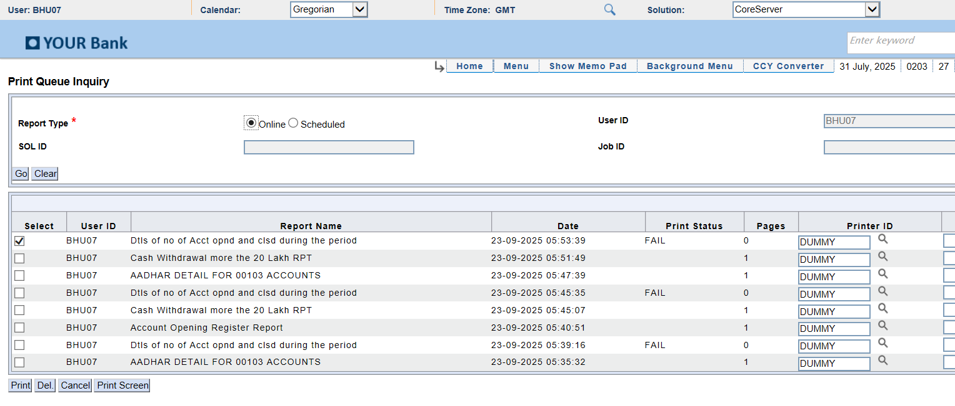
Module: DLYRPT
Report: AfterSubmit_Error
Status: ERROR
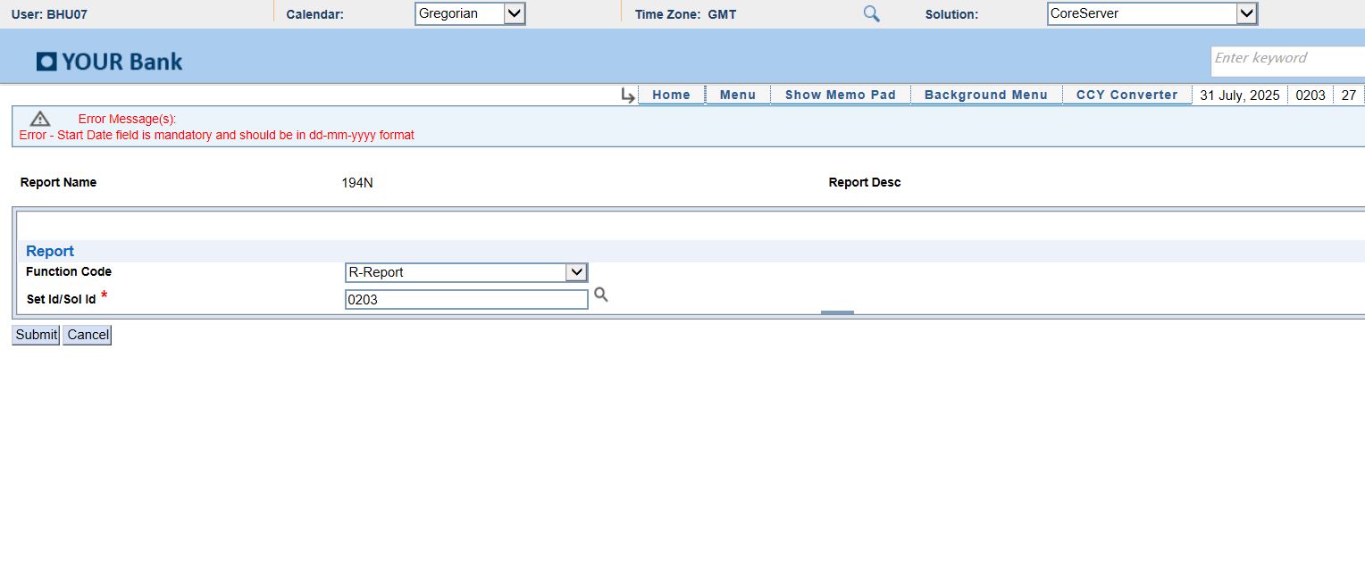
Module: DLYRPT
Report: AfterSubmit
Status: SUCCESS

Module: PrintQueue
Report: Latest_Report_Selected
Status: SUCCESS
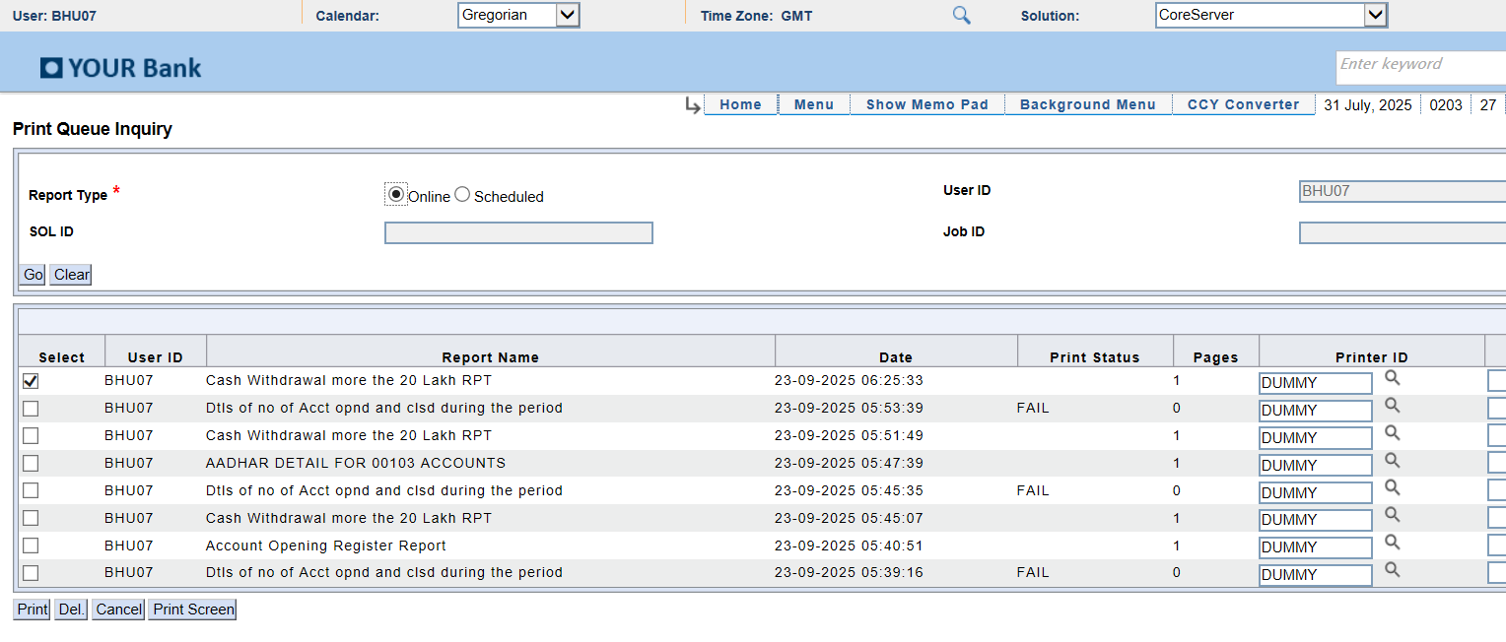
Module: PrintQueue
Report: After_PrintScreen_NoExcel
Status: SUCCESS
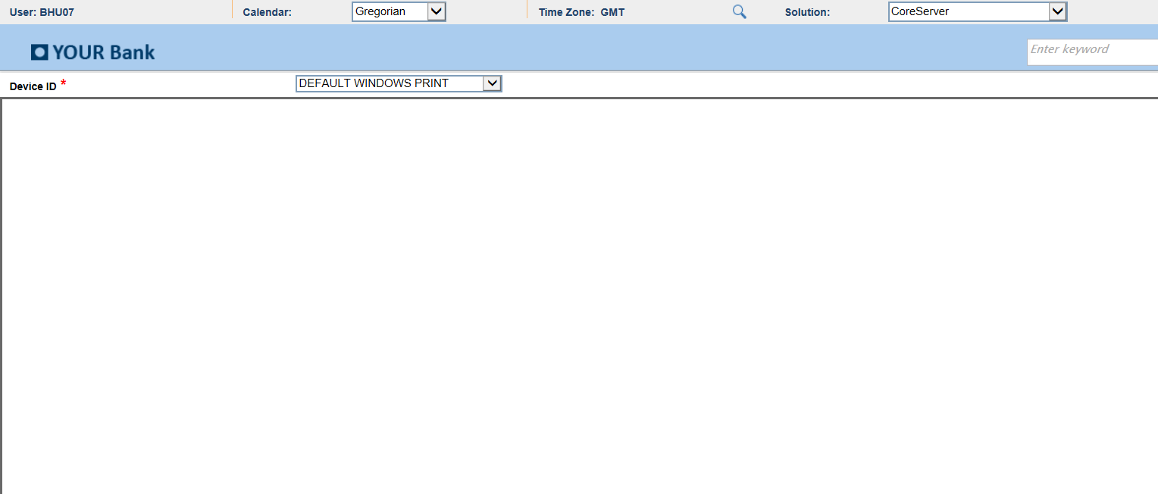
Module: DLYRPT
Report: AfterSubmit_Error
Status: ERROR
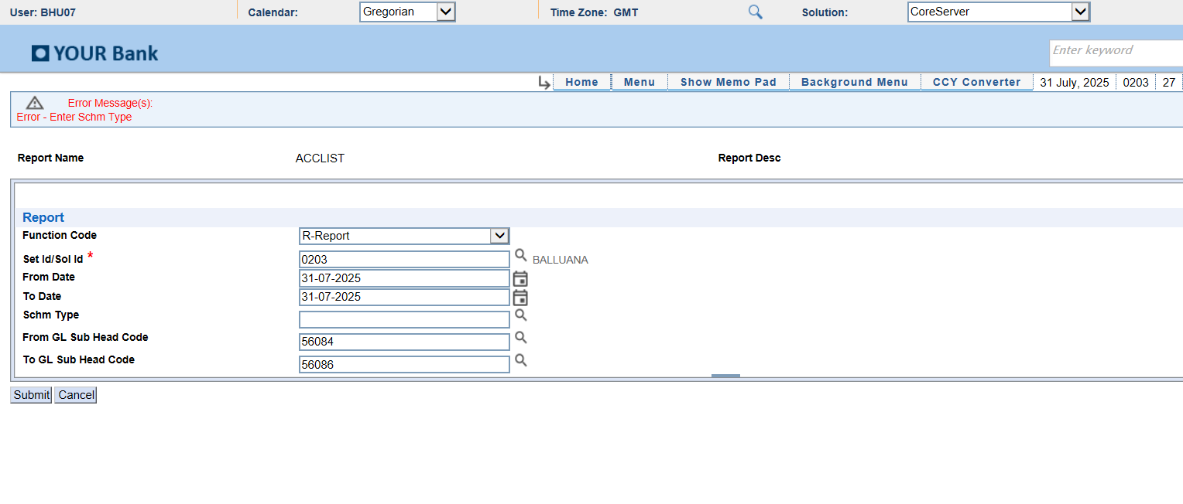
Module: DLYRPT
Report: AfterSubmit
Status: SUCCESS

Module: PrintQueue
Report: Latest_Report_Selected
Status: SUCCESS
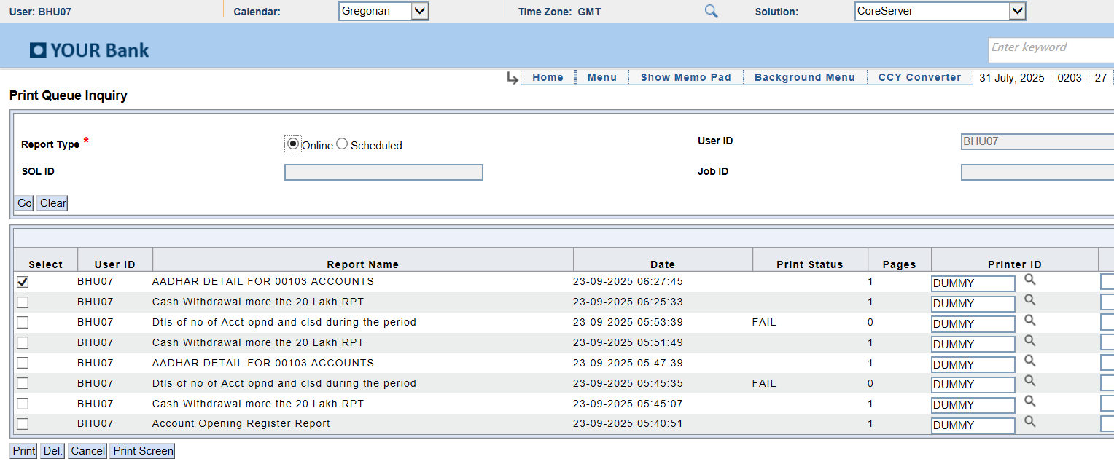
Module: DLYRPT
Report: AfterSubmit
Status: SUCCESS
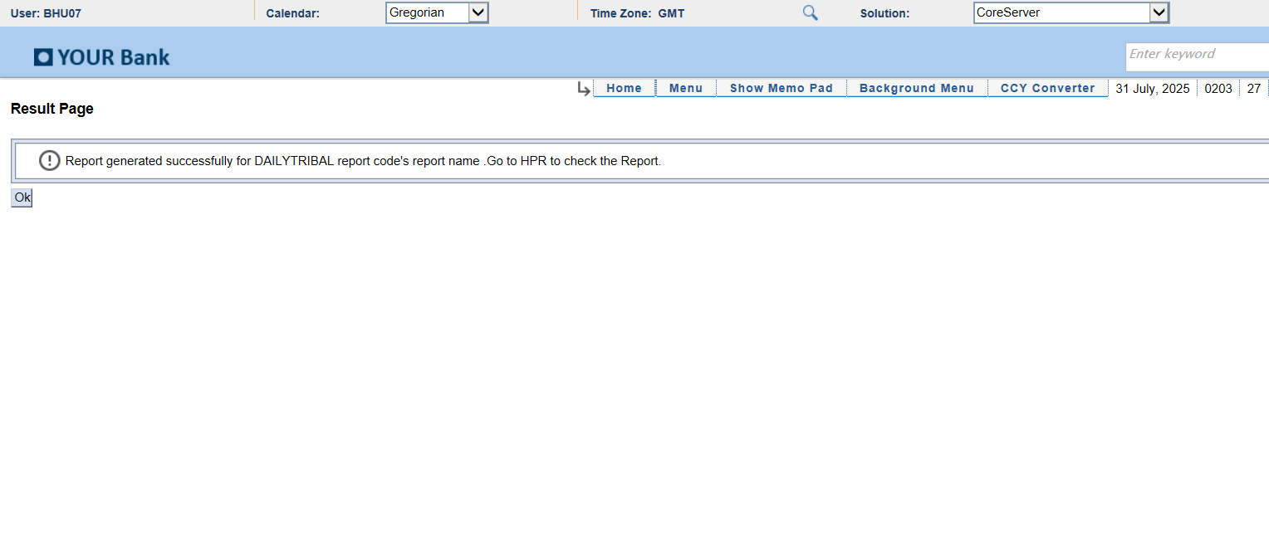
Module: PrintQueue
Report: Latest_Report_Selected
Status: SUCCESS
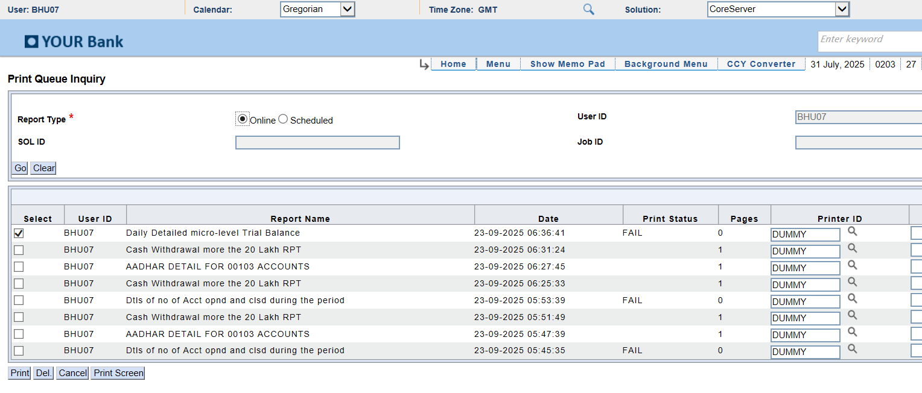
Module: DLYRPT
Report: AfterSubmit_Error
Status: ERROR
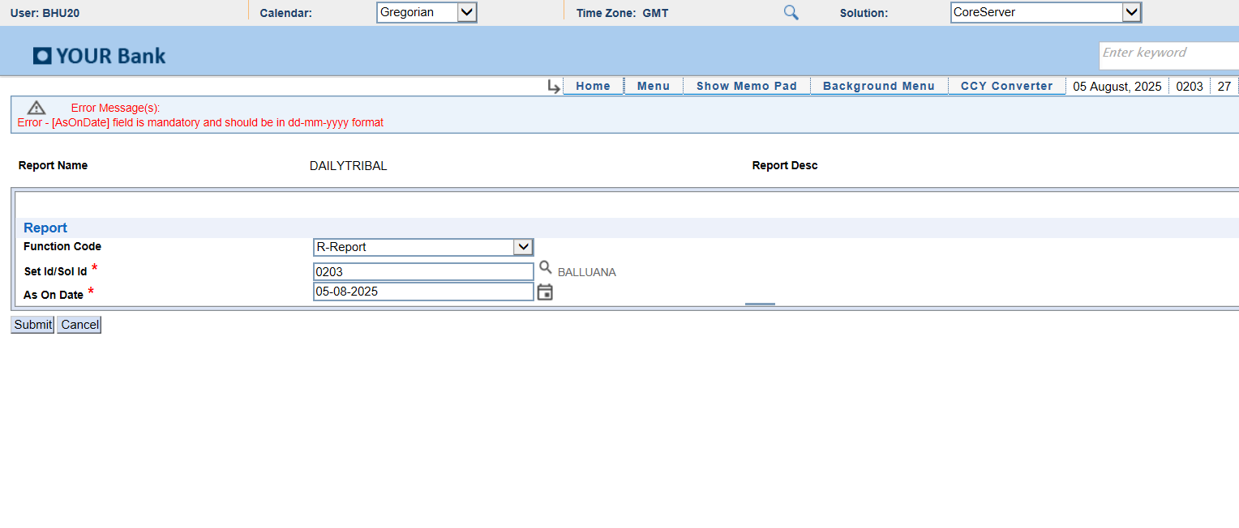
Module: DLYRPT
Report: AfterSubmit_Error
Status: ERROR
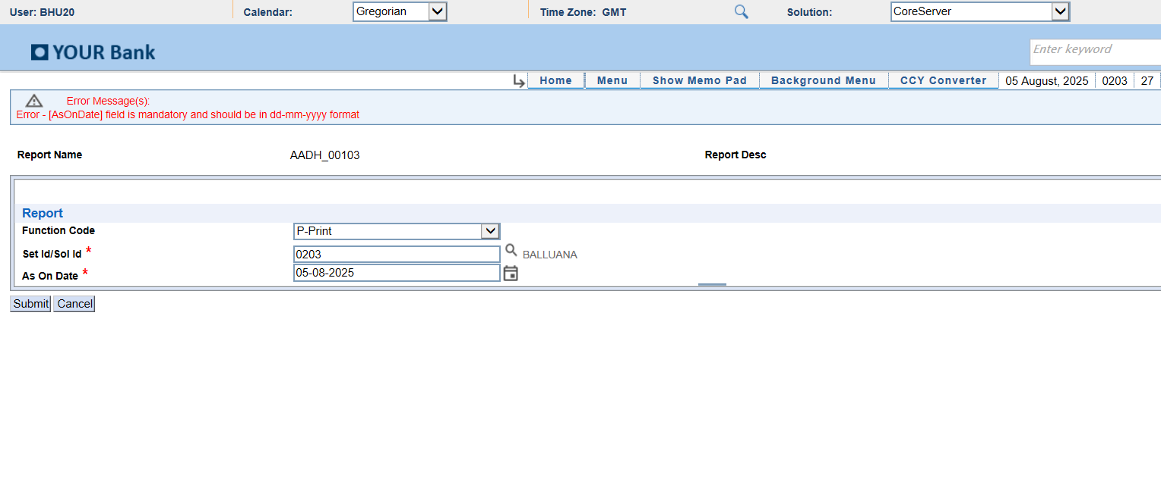
Module: DLYRPT
Report: AfterSubmit_Error
Status: ERROR
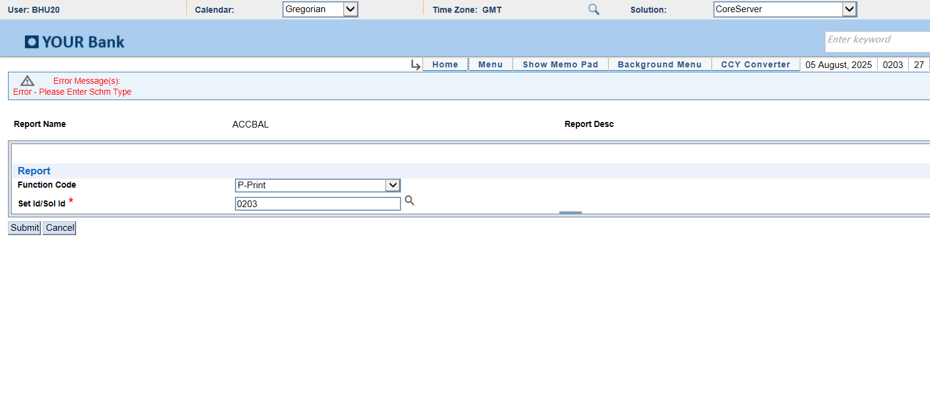
Module: DLYRPT
Report: AfterSubmit
Status: SUCCESS
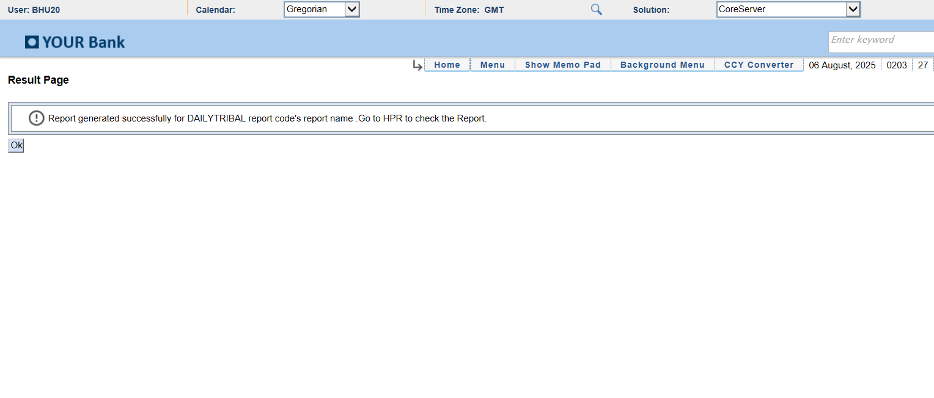
Module: PrintQueue
Report: Latest_Report_Selected
Status: SUCCESS
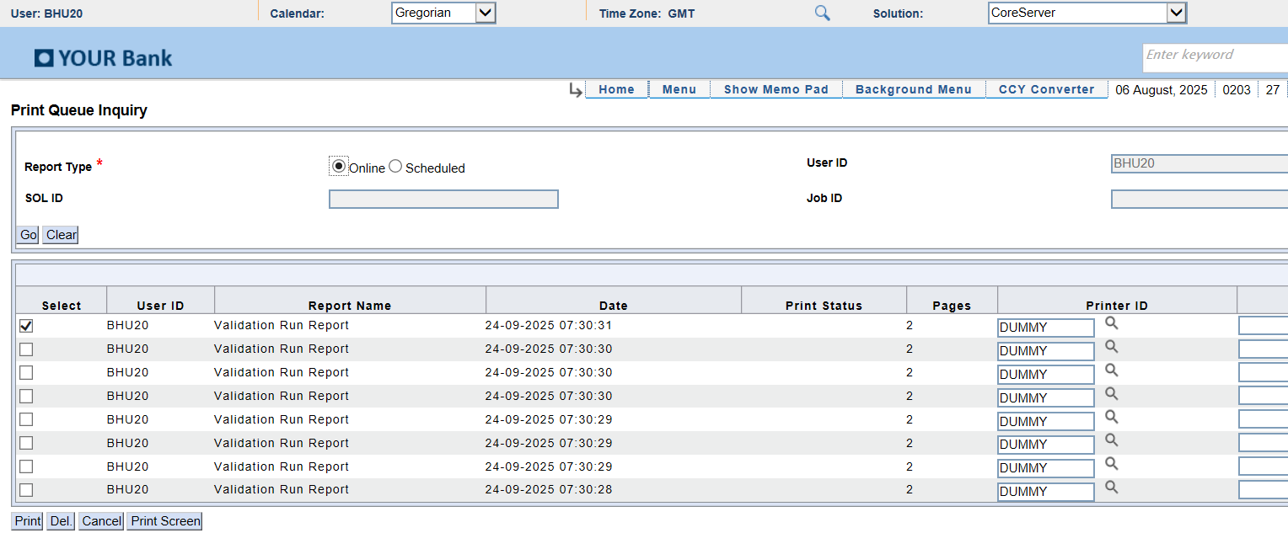
Module: PrintQueue
Report: After_PrintScreen_NoExcel
Status: SUCCESS
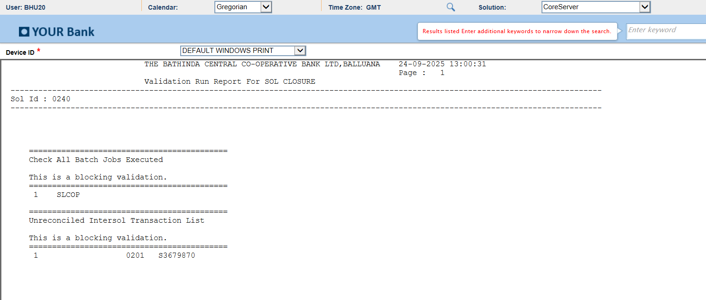
Module: DLYRPT
Report: AfterSubmit
Status: SUCCESS
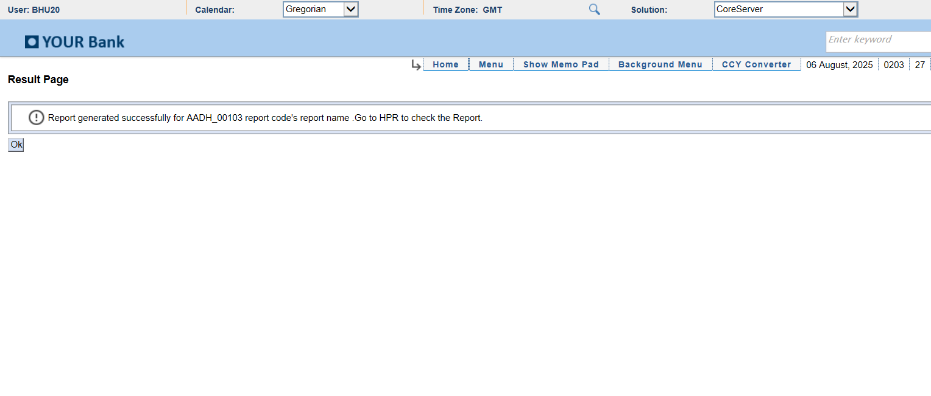
Module: DLYRPT
Report: AfterSubmit
Status: SUCCESS
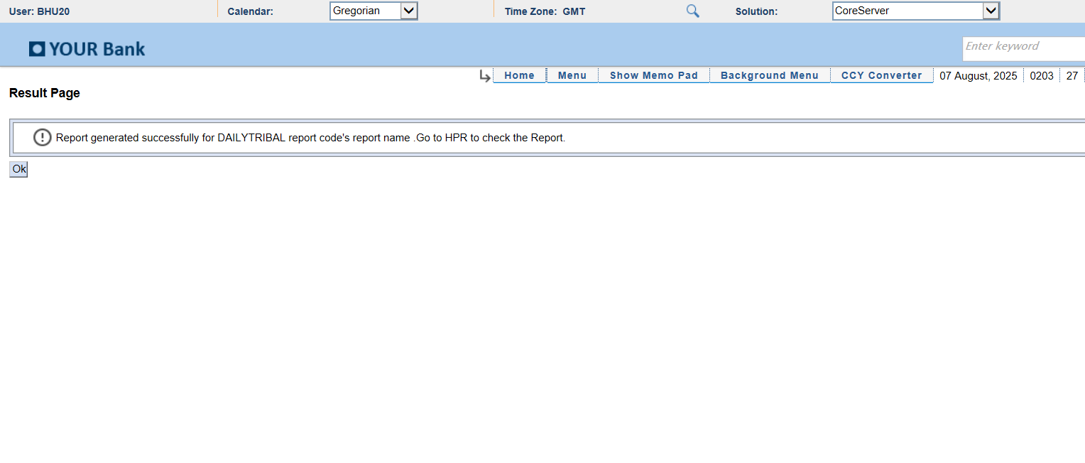
Module: PrintQueue
Report: Latest_Report_Selected
Status: SUCCESS
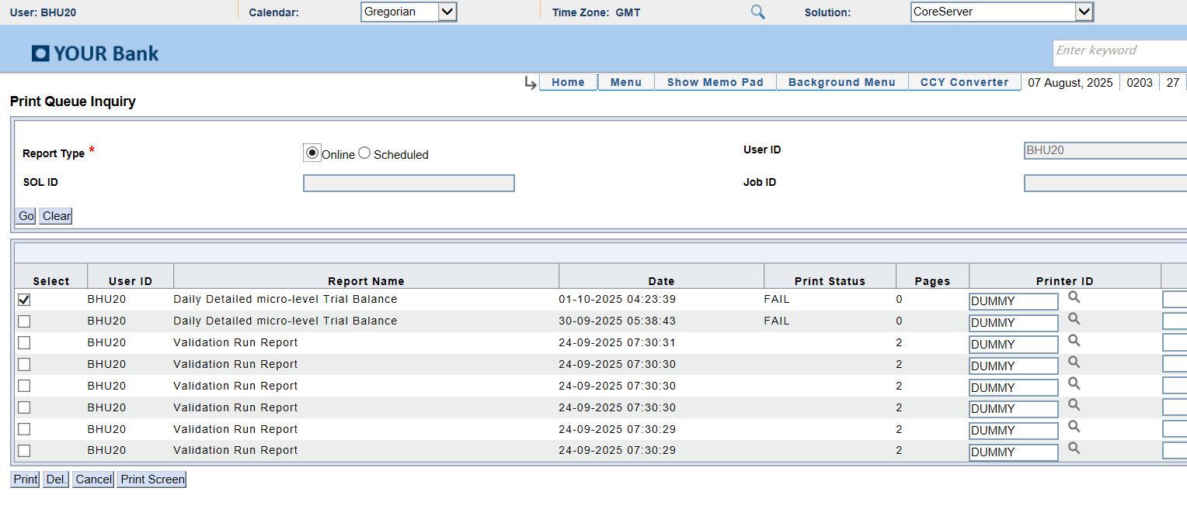
Module: PrintQueue
Report: After_PrintScreen_NoExcel
Status: SUCCESS
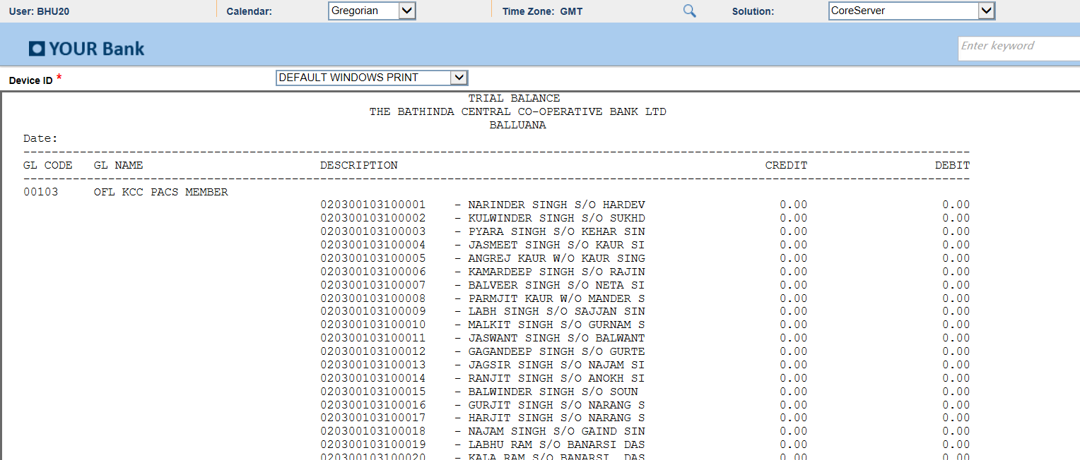
Module: DLYRPT
Report: AfterSubmit_Error
Status: ERROR
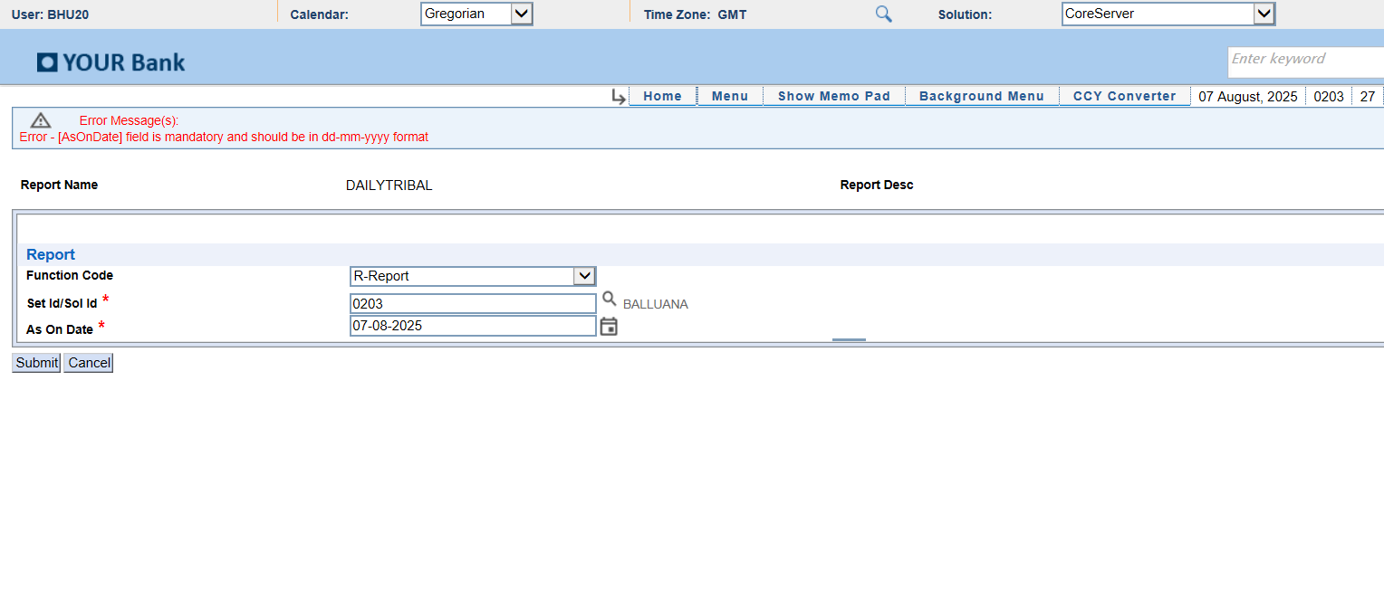
Module: DLYRPT
Report: AfterSubmit
Status: SUCCESS

Module: PrintQueue
Report: Latest_Report_Selected
Status: SUCCESS
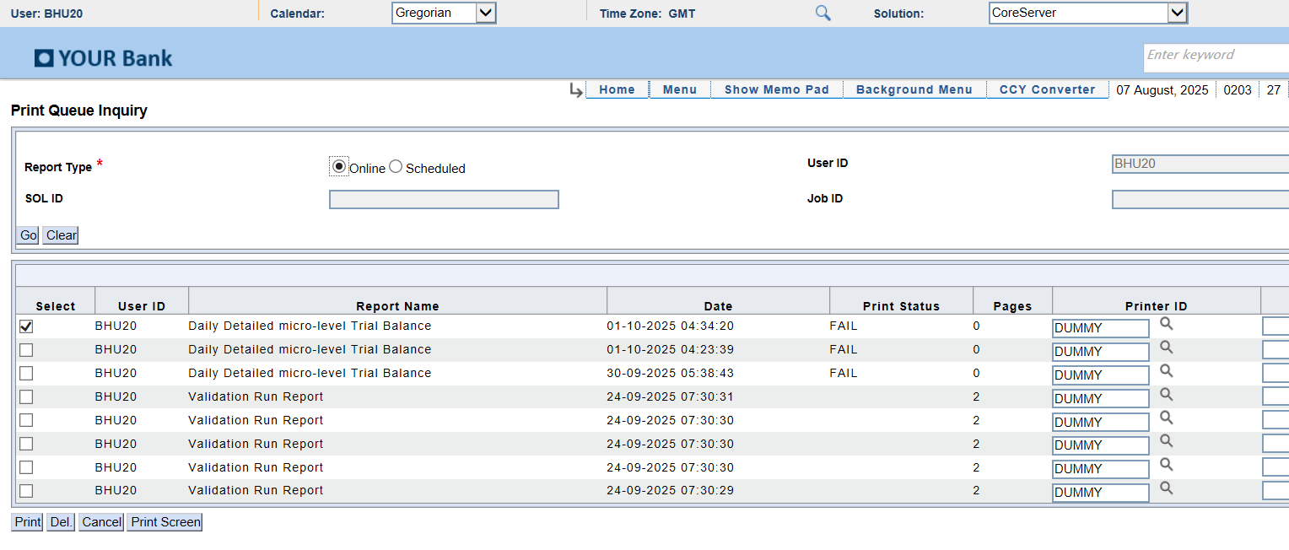
Module: PrintQueue
Report: After_PrintScreen_NoExcel
Status: SUCCESS

Module: DLYRPT
Report: AfterSubmit_Error
Status: ERROR
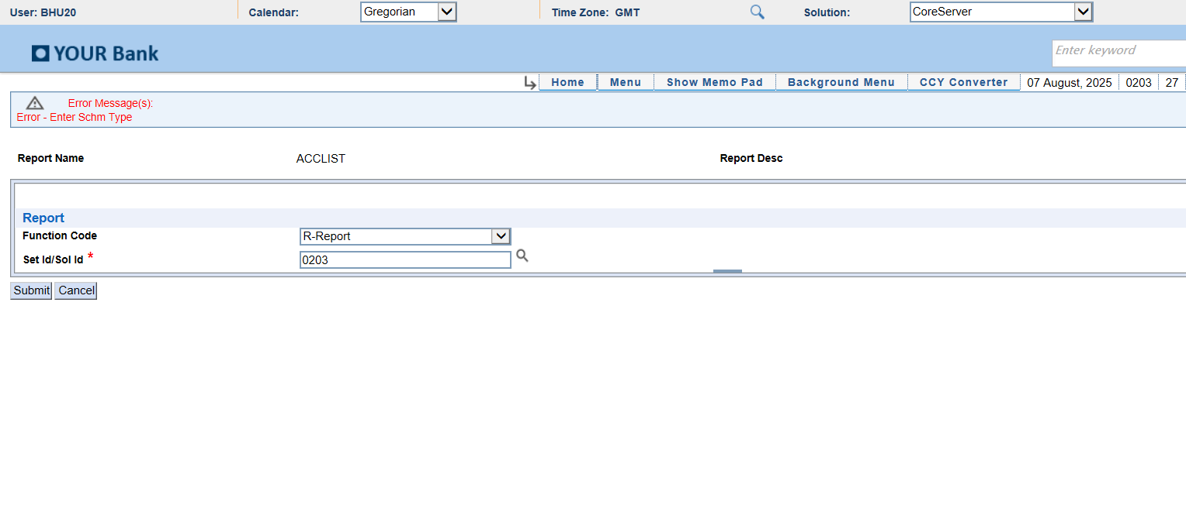
Module: DLYRPT
Report: AfterSubmit
Status: SUCCESS
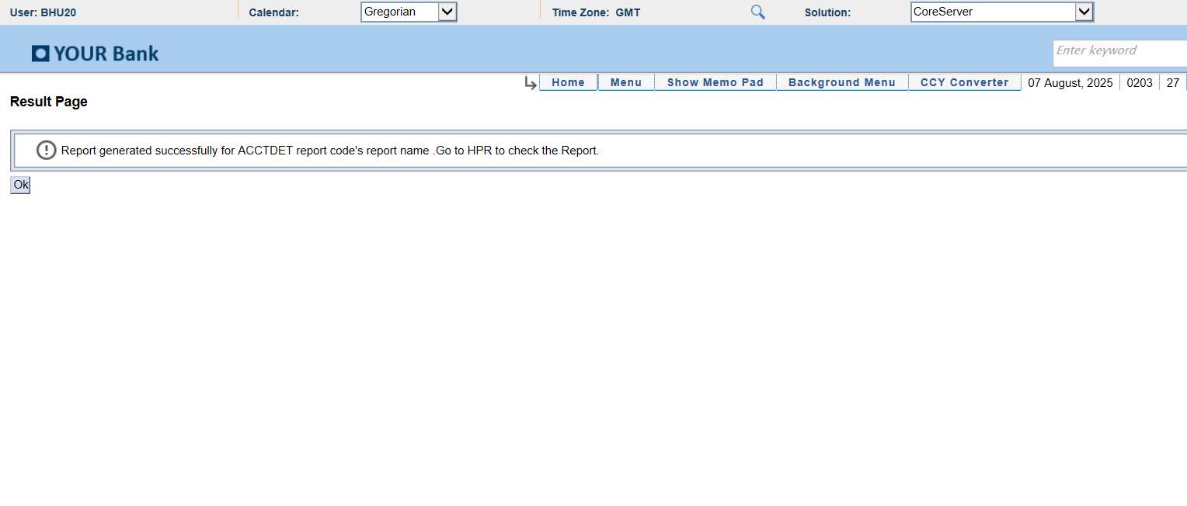
Module: PrintQueue
Report: Latest_Report_Selected
Status: SUCCESS
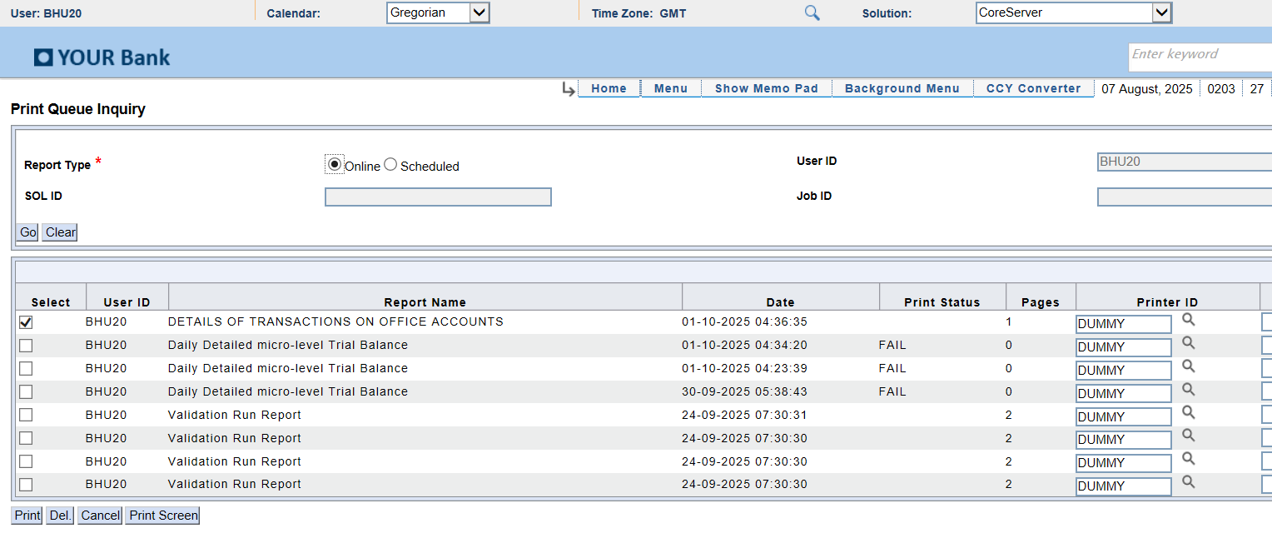
Module: ExcelReport
Report: Excel Screenshot
Status: Excel Window Captured
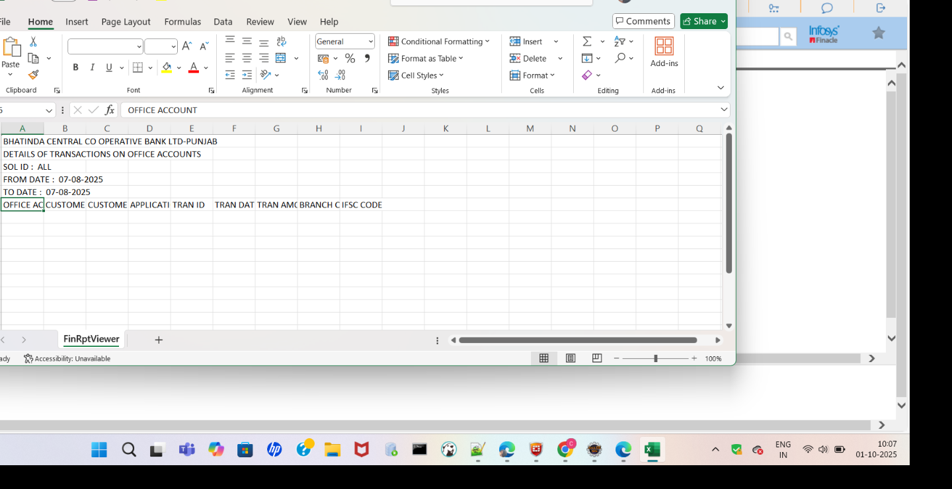
Module: DLYRPT
Report: AfterSubmit_Error
Status: ERROR
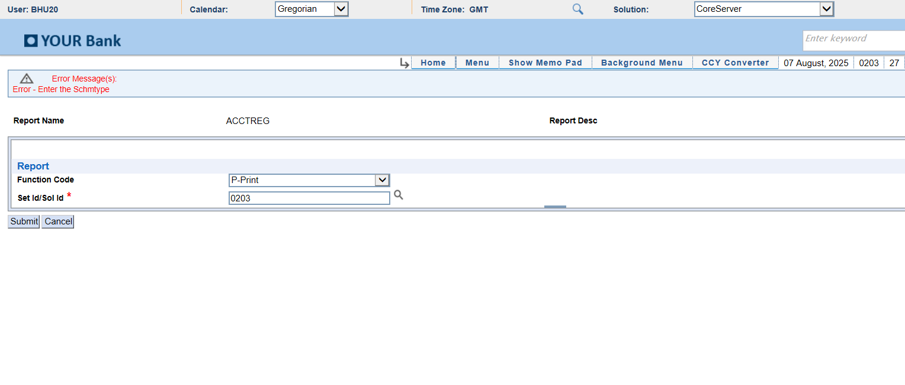
Module: DLYRPT
Report: AfterSubmit
Status: SUCCESS
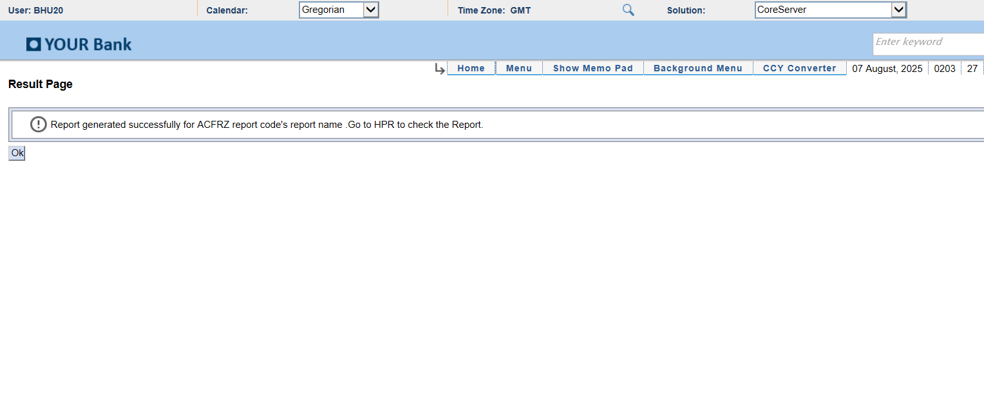
Module: PrintQueue
Report: Latest_Report_Selected
Status: SUCCESS
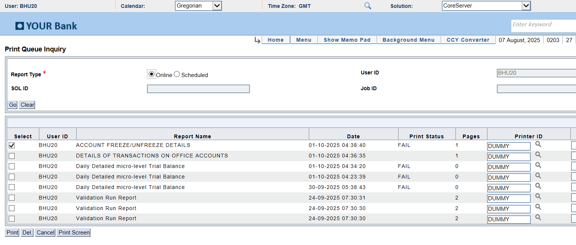
Module: DLYRPT
Report: AfterSubmit
Status: SUCCESS
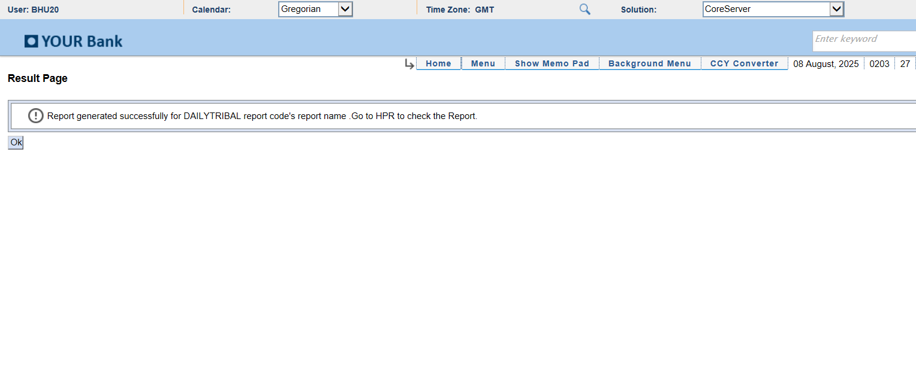
Module: PrintQueue
Report: Latest_Report_Selected
Status: SUCCESS
