Customer Behaviour Analysis: Report on the Customer Dashboard
Jagadha by Padanjaly WooCommerce Orders | Prepared by Christy Andrews | 28 October 2026

1. Introduction
This report explains the Customer Behaviour Analysis dashboard, the fourth dashboard built on the Jagadha by Padanjaly WooCommerce orders dataset (690 orders, 72 columns). The first three dashboards looked at sales overall, at where the sales come from, and at what is being sold. This one looks at who is buying and whether they come back.
The aim is to understand how many customers the shop has, how often they order, how much they spend, how many orders come from guests who cannot be tracked, and where the customers are. The report covers how the customer data was prepared, what the dashboard shows, the insights with the reasons behind them, and the recommendations.

2. Preparing the Customer Data
The orders file records every order, but it has no table of customers. Guest orders carry a customer id of 0, so a separate customer table was built for registered customers only.
- Customer table. A new table was created with one row for each registered customer (customer id other than 0). For each customer it holds the number of orders, the total spend in rupees, the date of the first order and the date of the last order.
- Relationship. The customer table was joined to the orders table on customer id, with one customer linked to many orders, so that the visuals can use both tables together.
- Card measures. Three measures feed the cards: registered customers (distinct customer ids), repeat registered customers % (customers with two or more orders out of all registered customers), and average spend per registered customer. Guest Order % was reused from the sales dashboard.
- Order frequency. A column marks each registered customer as One-time (1 order) or Repeat (2 or more orders), which feeds the donut chart. The guest and registered split in the charts uses the customer type column.

3. The Customer Dashboard
The dashboard has a banner, four KPI cards, two slicers, four visuals and a Key Insights box. The KPI cards show 323 registered customers, 6.50% repeat registered customers, a guest order share of 49.28% and an average spend of ₹4.19K per registered customer. The Year and Country slicers filter the whole page. The visuals are two stacked bar charts of guest and registered orders, one by Indian state and one for Kerala cities, a chart of registered customers (bars) and total revenue (line) by quarter, and a donut chart of one-time and repeat customers. The tooltips of the two bar charts also show the product revenue of each bar.
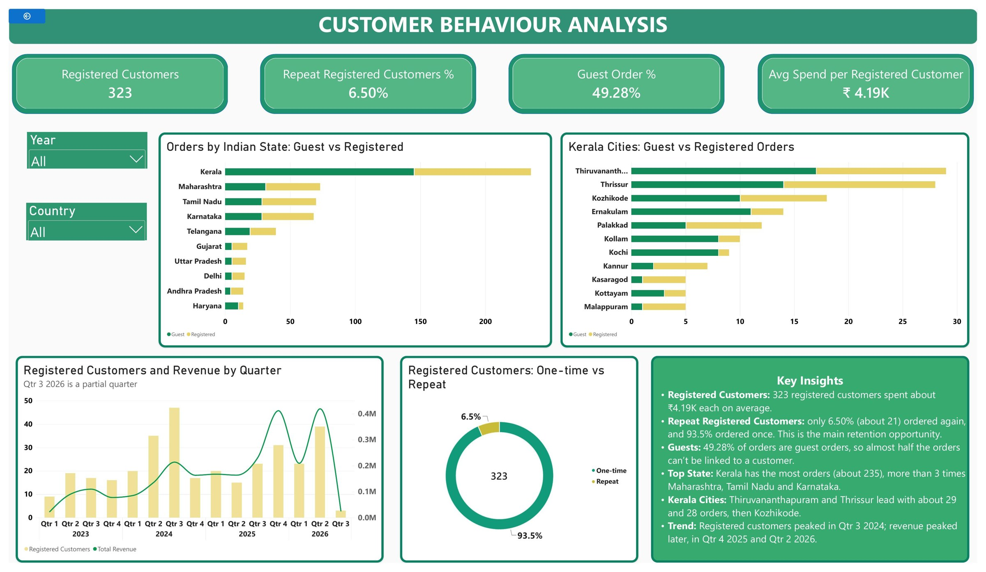
Figure 1: Customer Behaviour Analysis dashboard

4. Key Insights and Why They Appear
- Most registered customers order only once. Of 323 registered customers, only 6.50% (about 21) ordered again, and 93.5% ordered once. Why: a customer probably buys when there is a particular need and then has no reason to return, and nothing in the shop, such as a reminder or offer, brings them back. This is the main retention gap.
- Almost half of all orders come from guests. Guest orders are 49.28% of the 690 orders (about 340), and the sales dashboard shows the guest share of revenue rising every year, from almost nothing in 2023 to about three-quarters in 2026. Why: guest checkout is quicker, and customers who buy once have little reason to make an account. It also means the 6.50% repeat rate may be too low, because a guest who returns cannot be recognised.
- A customer is worth about one order. A registered customer spends about ₹4.19K in total, which is close to one average order (₹3.66K on the sales dashboard). Why: because almost every registered customer ordered once, nearly all the value of a customer comes from the first purchase. A second order would add a lot.
- Kerala is the biggest market. Kerala has about 235 orders, more than three times Maharashtra (about 73), Tamil Nadu (about 70) and Karnataka (about 68). Why: Kerala is the home market of the brand, where it is best known and trusted.
- Kerala buys mostly as guests, other states as registered customers. In Kerala about 145 of the 235 orders are guest orders. In Maharashtra, Tamil Nadu, Karnataka and Telangana registered customers place the larger share. Why: Kerala buyers may reach the shop through social media or word of mouth and prefer a quick checkout. This is an assumption to confirm.
- Kerala orders are spread across many cities. Thiruvananthapuram (about 29) and Thrissur (about 28) lead, followed by Kozhikode (about 18), Ernakulam (14) and Palakkad (12). Kannur, Kasaragod, Kottayam and Malappuram each have only about 5 to 7 orders. Why: no single city dominates, so Kerala sales come from the whole state, with the north having the smallest numbers.
- Registered customers and revenue no longer move together. Registered customers peaked at about 47 in Qtr 3 2024. Revenue peaked later, at about ₹0.4M in Qtr 4 2025 and Qtr 2 2026, when registered customers were only about 31 and 39. Why: revenue includes guest orders, and guests have grown since 2024, so growth in sales is no longer matched by registered customers.
- Points to check. Registered customers means customer id other than 0, so guests are not counted as customers. Repeat means two or more orders in the data. The last quarter (Qtr 3 2026) is incomplete, with only about 3 registered customers, so it should not be read as a fall.

5. Recommendations
- Bring one-time buyers back. Send a follow-up message after delivery, a reorder reminder and a small repeat-order offer. Raising the 6.50% repeat rate is the quickest way to grow without finding new customers.
- Turn guests into registered customers. Offer order tracking or a small discount for creating an account at checkout, so more of the 49.28% guest orders can be linked to a customer.
- Collect contact details from guests. Ask for a phone number or email at guest checkout so returning guests can be recognised and the repeat rate can be measured properly.
- Build on Kerala. Run local campaigns in Thiruvananthapuram, Thrissur and Kozhikode, and try to convert Kerala guest buyers into registered customers.
- Retarget the other states. Maharashtra, Tamil Nadu, Karnataka and Telangana have more registered customers, so use them for repeat-order offers and test the response.
- Track how long customers take to reorder. The customer table already holds first and last order dates, so the next version of the dashboard can show the days between orders and help time the reminders.

6. Conclusion
The customer dashboard shows a shop that wins first orders but rarely wins second ones. Of 323 registered customers, 93.5% ordered once, and almost half of all orders come from guests who cannot be tracked. Kerala is the largest market and buys mostly as guests, while other states have more registered customers. Raising repeat orders and linking guest orders to customers are the main opportunities.

