Product Performance Analysis: Report on the Product Dashboard
Jagadha by Padanjaly WooCommerce Orders | Prepared by Christy Andrews | 27 October 2026

1. Introduction
This report explains the Product Performance Analysis dashboard, which is the third dashboard built on the Jagadha by Padanjaly WooCommerce orders dataset (690 orders, 72 columns). The first dashboard looked at sales overall, and the second looked at where the sales come from. This one looks at what is being sold.
The task was to analyse product-wise sales, revenue, quantity sold and profitability to identify top and low performing products, and to highlight key product trends and insights for business decision-making. The report covers how the product data was prepared, what the dashboard shows, the insights with the reasons behind them, and the recommendations. The dataset has no cost data, so profitability could not be analysed, and revenue and quantity are used to judge performance.

2. Preparing the Product Data
In the orders file, the products of each order were spread across four sets of columns, so they were rearranged in Power Query into one clean product table.
- One row per product. Product Item 1 had 690 values, Item 2 had 108, Item 3 had 22 and Item 4 had only 2. A separate query was made for each item, keeping the order id, date, currency, exchange rate, product name, id, SKU, quantity, total and subtotal, and the four were appended into one Products table of 822 rows. The helper queries were set not to load.
- Rupee values. Orders paid in US dollars were converted to rupees using the exchange rate of the order, so the revenue of every product is in one currency.
- Product names. Names were trimmed and spelling variants were merged, such as "Agnihari, 90gms" to "Agnihari 90gms" and "Agnijith & Kashmeerini Combo Pack" to "Agnijith & Kasmeerini Combo Pack", so that each product appears once. This left 11 products.
- Pack type and region type. A pack type column groups products as Single, Multi-pack or Combo from the product name, and a region type column separates India from International, which feeds the two tables of top products.

3. The Product Dashboard
The dashboard has a banner, five KPI cards, five visuals and a Key Insights box. The KPI cards show 1.08K units sold, an average revenue per pack of ₹2.34K, the top product (Agnijith 90 gms), its revenue share of 49.05%, and 11 products in total. The visuals are a bar chart of revenue by product, with the quantity sold shown in its tooltip, a line chart of quarterly revenue by pack type, a donut chart of revenue by pack type (₹2.52M in total), and two tables showing the top product in each Indian state and in other regions.
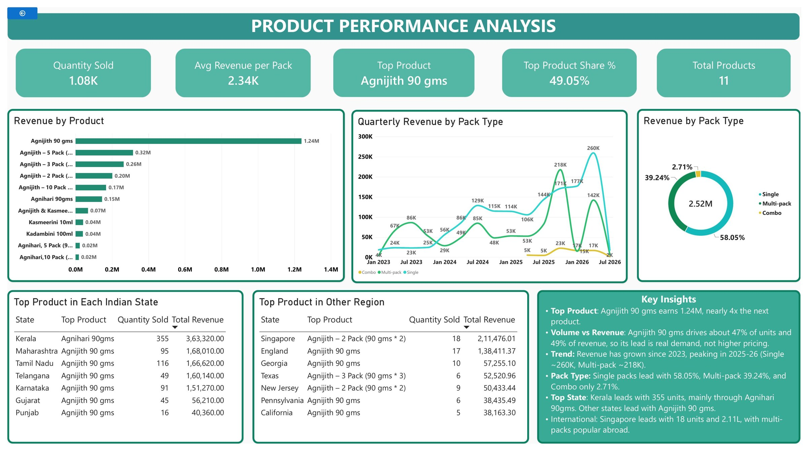
Figure 1: Product Performance Analysis dashboard

4. Key Insights and Why They Appear
- One product carries the business. Agnijith 90 gms earned ₹1.24M, which is 49.05% of revenue and nearly four times the next product, the Agnijith 5 Pack (₹0.32M). Why: Agnijith is the flagship product of the brand, and customers choose it first.
- The lead comes from real demand, not a higher price. Agnijith 90 gms sold 508 of the 1.08K units (about 47%) and earned about 49% of revenue, so its share of units and of revenue are almost equal. Why: customers buy it in large numbers, and it is not just an expensive product with a few sales.
- The low performing products are small variants. Kasmeerini 10ml and Kadambini 100ml earned ₹0.04M each, the Agnihari 5 Pack and 10 Pack ₹0.02M each, and the Agnijith and Kasmeerini Combo Pack ₹0.07M. Why: these look like secondary products bought along with the main one, or by customers who prefer to buy a single Agnihari. They are small products, not failures.
- Single packs lead, but multi-packs bring almost 40%. Single packs bring 58.05% of revenue, multi-packs 39.24% and combo packs only 2.71%. Among multi-packs, the Agnijith 5 Pack (₹0.32M) and 3 Pack (₹0.26M) do best. Why: the treatment is used over a period of time, so many buyers take larger packs. The combo pack sells little, probably because few customers see it or know about it.
- Revenue has grown since 2023, with sharp swings. Quarterly revenue rose from a few thousand rupees in 2023 to peaks in late 2025 (multi-packs about ₹218K) and in 2026 (single packs about ₹260K), with a drop after each peak. Why: the number of customers has grown, helped by guest customers whose share has risen every year in the sales dashboard. With only about 50 orders a quarter, a few large multi-pack orders can move the line a lot.
- Kerala prefers Agnihari, and other states prefer Agnijith. Agnihari 90gms is the top product in Kerala by units (355), while Agnijith 90 gms leads in Tamil Nadu (116), Maharashtra (95), Karnataka (91), Telangana (49), Gujarat (45) and Punjab (16). Why: Agnihari is the lower priced product. It earned only ₹0.15M overall although 355 units sold in Kerala alone, while Agnijith earned about ₹2,440 a unit. Kerala customers probably know the brand from the clinic and start with the cheaper product.
- Overseas customers buy bundles. Singapore leads the other regions with 18 units and ₹2.11L, and its top product is the Agnijith 2 Pack. Texas leads with the 3 Pack and New Jersey with the 2 Pack, while England, Georgia, Pennsylvania and California lead with the single Agnijith 90 gms. In India, no state has a multi-pack as its top product. Why: a likely reason is that ordering more in one parcel saves shipping cost per pack, and overseas buyers cannot easily find the products locally. The US numbers (5 to 9 units per state) are small, so the market is still early.
- Points to check. No cost data was available, so profit and margin are not shown. The last quarter (Jul 2026) is close to zero and is probably incomplete, so it should not be read as a decline. In the two tables, the revenue column is the total revenue of that state or region, not of its top product. Quantity counts each pack as one unit, whatever the pack size.

5. Recommendations
- Protect Agnijith 90 gms. Half the revenue depends on one product, so keep stock and quality steady and use it to lead every campaign.
- Grow the second tier. The 5 Pack and 3 Pack are the next biggest products, so promote them with bundle offers and repeat-order reminders to lift their sales.
- Fix or drop the combo pack. At 2.71% of revenue, test it as an add-on on the Agnijith product page or with a small discount, and retire it if it still does not sell.
- Use the small products as add-ons. Offer Kasmeerini 10ml, Kadambini 100ml and the Agnihari packs as "bought together" items at checkout instead of as stand-alone products.
- Push multi-packs overseas. Offer packs with a shared shipping cost for Singapore, England and the US, where bundles already sell best.
- Record cost data and add slicers. Keep product cost in the data so profit can be analysed, and add slicers for product, year and region in the final dashboard.

6. Conclusion
The product dashboard shows a business that depends heavily on one product. Agnijith 90 gms brings about half the revenue and nearly half the units, single packs lead and multi-packs bring almost 40%, the smallest products and the combo pack add very little, and revenue has grown since 2023. Kerala prefers the cheaper Agnihari, while overseas buyers favour bundles. Profitability could not be measured without cost data, and it should be added when that data is available.

