Location Sales Analysis: Report on the Regional Sales Dashboard
Jagadha by Padanjaly WooCommerce Orders | Prepared by Christy Andrews | 24 October 2026

1. Introduction
This report explains the Location Sales Analysis dashboard, which is the second dashboard built on the Jagadha by Padanjaly WooCommerce orders dataset (690 orders, January 2023 to May 2026, 72 columns). The first dashboard looked at sales overall, covering trends, products, guest customers and payment methods. This one looks at where the sales come from.
The task was to analyse sales by country, state and city to identify high and low performing locations, and to create geographical insights and visuals that show regional sales performance. The report covers how the location data was prepared, what the dashboard shows, the insights with the reasons behind them, and the recommendations.

2. Preparing the Location Data
The location columns were typed by customers, so they contained short codes, spelling variants and a few wrong entries. They were cleaned in Power Query, and the original columns were kept next to the new ones.
- State and region names. The short codes (for example KL, TN, TS) were converted to full names using billing_country, because the same code can mean different states in different countries. Each state was checked against the postcode and then the city, and the result was saved in billing_state_full. Wrong codes were corrected, for example Karaikal to Puducherry, Vadodara to Gujarat, Coimbatore to Tamil Nadu and Sugar Hill to Georgia. UK rows were grouped as England, Wales or Northern Ireland.
- Country names. The country codes were converted to full names in billing_country_full, using the city and postcode when the code was blank, such as Singapore for postcode 321022.
- City names. A function was written to bring spelling variants together, such as Trivandrum and Thiruvananthapuram, Bangalore and Bengaluru, and Calicut and Kozhikode. It also used the postcode to correct cities such as Dombivli and Vasai, and the result was saved in billing_city_full and shipping_city_full.
- Match columns. Columns were added to compare billing and shipping state, country and city for each order, with the values Same or Different.

3. The Location Dashboard
The dashboard has a banner, five KPI cards, six visuals and a Key Insights box. The KPI cards show 24 countries served, 73 states and regions served (including regions outside India, such as Singapore and England), an international revenue share of 46.49%, India's revenue of ₹1.35M, and a top state share of 14.39% (Kerala). The visuals are a world map of revenue by billing country, the top 5 and bottom 5 Indian states by revenue (the bottom chart lists seven states because several are tied), a treemap of the top cities, a matrix of units sold by product in the top states, and a donut chart that compares the billing city with the shipping city.
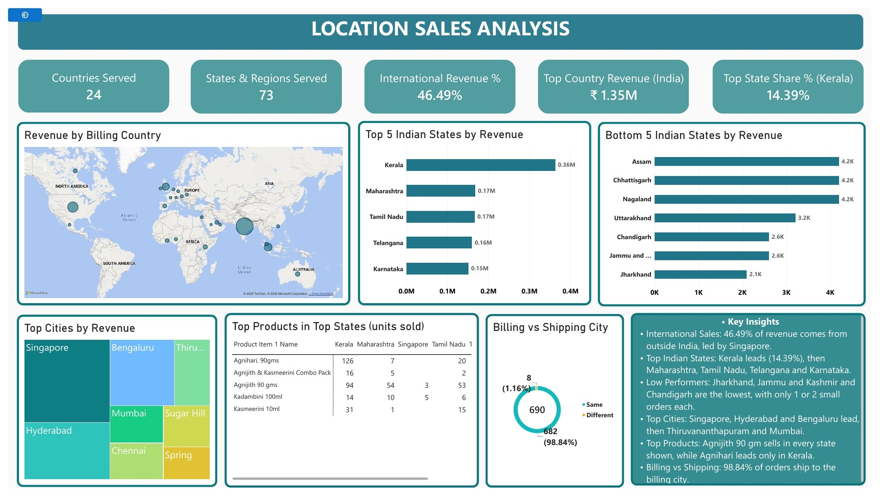
Figure 1: Location Sales Analysis dashboard

4. Key Insights and Why They Appear
- The sales are spread widely. Orders came from 24 countries and 73 states and regions, and no single state dominates, because even the top state accounts for only 14.39% of revenue. Why: the products are sold online and through dealers, so customers anywhere can order, and the brand is known for its treatment of burns and scars, which people look for wherever they live.
- Overseas customers bring almost half the revenue. International revenue is 46.49%, while India accounts for ₹1.35M. Singapore is the strongest overseas market and ranks first among cities. Why: a likely reason is the large Indian and Malayali community in Singapore, and overseas buyers cannot easily get the products locally.
- Kerala is the top Indian state, well ahead of the rest. Kerala brings roughly ₹0.36M, the most of any Indian state, followed by Maharashtra and Tamil Nadu (about ₹0.17M each), Telangana (₹0.16M) and Karnataka (₹0.15M). Why: the company is based in Kuttippuram, Kerala, with its clinic and factory there, so local trust is high. The other states trail Kerala but are close to one another because the online store reaches customers beyond Kerala.
- The low performing locations are one-off orders. The bottom Indian states (Assam, Chhattisgarh and Nagaland at about ₹4,200 each, Uttarakhand at ₹3,200, and Chandigarh, Jammu and Kashmir and Jharkhand at ₹2,600, ₹2,600 and ₹2,100) each earned only about ₹2,100 to ₹4,200. Why: this is the value of one or two small orders, so these places are untapped markets and not failures.
- Big cities lead the city ranking. Singapore is the top city, followed by Hyderabad and Bengaluru, then Thiruvananthapuram and Mumbai. Two US cities, Sugar Hill and Spring, also appear among the top eight. Why: large cities have more customers, faster delivery and more awareness. The US cities are probably a few large orders from the same buyers, which should be confirmed in the order data.
- Agnijith 90 gm sells in every top state, and Agnihari leads only in Kerala. In the matrix, Agnijith 90 gm sold 94 units in Kerala, 54 in Maharashtra, 53 in Tamil Nadu and 27 in Telangana, with a few in Singapore, while Agnihari sold 126 units in Kerala but only 7 in Maharashtra, 20 in Tamil Nadu and 3 in Telangana. Why: Agnijith is the flagship product, so it sells everywhere. Agnihari is the cheaper cream and is probably chosen mainly by Kerala customers who know the brand from the clinic. The Telangana column sits beyond the visible width of the matrix on the dashboard and shows when the matrix is scrolled.
- Almost every order ships to the billing city. For 682 of 690 orders (98.84%) the billing city and shipping city are the same, and only 8 differ. Why: the products meet a personal treatment need, so customers order for themselves and not as gifts. It also means the billing location is a reliable guide to where the product is used.
- Points to check. Singapore is the top city by revenue but shows only 3 to 5 units in the matrix, so its orders are probably made of large packs or products outside the top five listed, and this should be checked in the order data. The states and regions count includes non-Indian regions, so it is not a count of Indian states only, while the top and bottom state charts show Indian states only. The product matrix reads Product Item 1 only.

5. Recommendations
- Defend Kerala and grow the south Indian metros. Keep Kerala customers loyal with reminders and repeat-order offers, and promote the products in Hyderabad, Bengaluru and Chennai, which already rank among the top cities.
- Build the overseas market, starting with Singapore. Use Singapore's success as a model for the UAE, the UK and the US, where the company already has orders or dealers. Check the import rules and herbal product claims in each country first.
- Push Agnijith in the new states. Since Agnijith 90 gm sells well in every top state, lead the campaigns outside Kerala with it, and use Agnihari as the lower-priced entry product.
- Test the low performing states cheaply. Run a small campaign or an online ad in states such as Chandigarh, Jammu and Kashmir and Jharkhand, and track whether the same customers order again, before spending more.
- Improve location data at checkout. Use drop-down lists for state and city, so there are no spelling variants, and the location analysis does not need so much cleaning.

6. Conclusion
The location dashboard shows a store that sells well beyond its home state. Kerala is the largest single market, but its share is only about 14%, and almost half the revenue comes from overseas, led by Singapore. Large cities drive the city ranking, Agnijith 90 gm sells in every top state, the weakest locations are single small orders, and nearly all orders are delivered to the billing city.

