Exploratory Sales Analysis of the Jagadha by Padanjaly WooCommerce Orders
Data overview, cleaning, dashboard, insights and recommendations | Prepared by Christy Andrews | 22 October 2026

1. Introduction
Jagadha by Padanjaly is the brand name of Padanjali Ayurvedic (P) Ltd, a skin treatment centre in Kuttippuram, Malappuram, Kerala, started in 1995. The company makes Ayurvedic creams and oils, and its main product is Agnijith, marketed for burns, burn scars, keloids and other skin concerns. The other products are Agnihari (a milder, cheaper cream), Kasmeerini (a skincare oil) and Kadambini (a hair oil), and the same products are also sold in multi-packs. Sales happen through the company website, doctor consultations, the clinic, Amazon.in and dealers in the UAE.
This report is based on the WooCommerce orders dataset of the store. It holds 690 orders placed between January 2023 and May 2026, with each row representing one order, and has 72 columns. The task was to analyse the sales data to find key patterns, trends, top-performing products and revenue drivers, to calculate basic sales KPIs, and to point out insights or anomalies for further analysis. The report covers the dataset, the cleaning that was needed, the Power BI dashboard that was built, the insights from it with the reasons behind them, and the recommendations.

2. The Dataset
The columns fall into the groups below. Order details sit alongside the money columns, payment and customer information, billing and shipping addresses, and a set of text columns that store the order's tax, shipping, fee, coupon and refund items. The last 28 columns hold up to four line items per order, with the name, id, SKU, quantity, total and subtotal of each product.
Group | Columns | Data type
Order details | order_id, order_number, order_key, wt_import_key, order_date, paid_date, status | Integer / Text / Date
Amounts | shipping_total, shipping_tax_total, fee_total, fee_tax_total, tax_total, cart_discount, order_discount, discount_total, order_total, order_subtotal | Decimal
Payment and customer | order_currency, payment_method, payment_method_title, transaction_id, customer_id, customer_user, customer_ip_address, customer_user_agent | Text / Integer
Billing and shipping | billing_ and shipping_ company, postcode, city, state, country; shipping_phone; shipping_method | Text
Order item blocks | tax_items, shipping_items, fee_items, coupon_items, refund_items, order_notes, download_permissions, line_item_1 to line_item_4 | Text
Product items | Name, id, SKU, Quantity, Total and Subtotal for Product Items 1 to 4 | Text / Integer / Decimal

3. Data Quality Assessment and Cleaning
Before any analysis, the data was checked and cleaned in Power Query without changing the original values. The main steps were as follows.
- Data types. Every column was checked and corrected so that dates are dates, amounts are decimal numbers and identifiers such as postcodes and product ids stay as text.
- Date and time split. order_date and paid_date held the date and time together, so each was split into separate date and time columns. This allows analysis by day, month and quarter.
- Mixed currencies. Orders were recorded in both USD and INR, so the amounts could not be added directly. I downloaded the historical USD to INR reference rates from FBIL (Financial Benchmarks India), matched each order with the rate for its date, and saved the converted amount in a new column, so all revenue is in rupees.
- Zero tax and discount columns. shipping_tax_total, fee_total, fee_tax_total, tax_total, cart_discount, order_discount and discount_total are all zero. They were kept, because the zeros show that the store does not collect tax and offers no discounts or coupons, which matches its website.
- Guest customers and blanks. customer_id = 0 means the customer checked out as a guest, so it was kept and counted separately. Null values were left blank because they carry meaning, such as unpaid orders or orders with only one product.
- Locations. Billing and shipping state and country were verified against the postcode and city, and the full state and country names were written into new columns. Text columns were put into one consistent format.
- Product details. line_item_1 and line_item_2 were split into the Product Item columns. Items 3 and 4 have no data.

4. Exploratory Sales Analysis Dashboard
The dashboard was built in Power BI. Six KPI cards run across the top, followed by five charts and a Key Insights box. The KPIs show total revenue of ₹2.52M from 690 orders, an average order value of ₹3.66K, and a guest order share of 49.28%. The USD cards show $13.45K of revenue from orders placed in dollars, and ₹1.35M from orders placed in rupees. The charts cover quarterly revenue and orders as a line and bar chart, the top 5 products by units sold, revenue by year for guest and registered customers, the top 5 states by revenue, and orders by payment method.
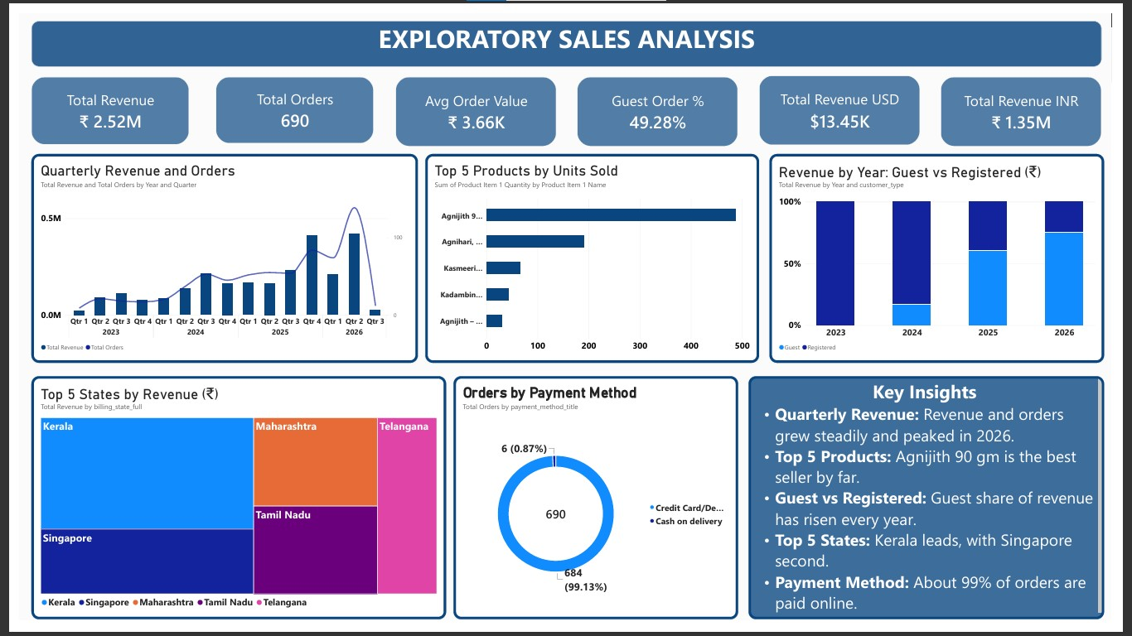
Figure 1: Exploratory Sales Analysis dashboard

5. Key Insights and Why They Appear
- Revenue and order size. The store earned ₹2.52M from 690 orders, with an average order of about ₹3.66K. Why: the website prices explain this. The most common order values (₹510, ₹2,100 and ₹4,200) match the price of Agnihari, Agnijith 90 g and the Agnijith 2-pack, so most orders are built from a few core products, and the multi-packs lift the average.
- Steady growth with a peak in 2025 and 2026. Quarterly revenue and orders rose from 2023 and peaked in the recent quarters. The drop in the last quarter is not a real fall, because the data ends in May 2026. Why: a possible cause is growing awareness of the brand and repeat buying, and festival seasons such as Diwali and Vishu are expected to bring burn cases. The dataset alone cannot prove this, so monthly analysis is needed to confirm it.
- Agnijith 90 gm is the clear best seller. It sold about 490 units, far ahead of Agnihari (about 190). Kasmeerini, Kadambini and the Agnijith 2-pack each sold well under 100. Why: Agnijith is the flagship product, with the most media coverage and a university lab study. Agnihari is a cheaper entry product, Kasmeerini is a small premium-priced bottle, and Kadambini is the only hair product, so it serves a narrower need. Note that the chart counts units, so a pack counts as one unit even though it is worth more.
- Guest customers are growing. Almost half the orders (49.28%) are guest orders, and the guest share of revenue rises every year, to about three quarters in 2026. In 2023 there are almost no guest orders. Why: the products meet a one-time need such as a burn, scar or skin problem, so many buyers do not sign up. It is also possible that guest checkout was added or promoted only after 2023, which should be checked with the store.
- Kerala leads, and Singapore is second. Kerala brings the most revenue, followed by Singapore, then Maharashtra, Tamil Nadu and Telangana. Why: the clinic, factory and local supporters are in Kerala, and nearby states and metros have large Malayali communities. Singapore's rank suggests demand from overseas Indians, and USD orders add $13.45K of revenue, which is a large share of the total once converted.
- Almost every order is paid online. 684 of 690 orders (99.13%) were paid by card, debit card or net banking, and only 6 (0.87%) by cash on delivery. Why: overseas customers cannot use cash on delivery, and the higher-priced products suit prepaid payment, so cash on delivery is rarely chosen.
- Anomalies and points to check. The last quarter is only part of a quarter. A few orders are above ₹10,000, most likely bulk or multi-pack purchases. The chart for products reads only Product Item 1, so products ordered second are not counted. Finally, the data has no cost columns, so profit cannot be analysed.

6. Recommendations
- Offer real bulk deals on Agnijith. The website's savings on multi-packs are small, with nothing on the 2-pack and 3-pack and about 3% on the 5-pack and 10-pack. Find customers who order several times or in large quantities using customer_id, and give them a clearer pack discount or a repeat-order offer.
- Raise sales of the low sellers. Bundle Kasmeerini and Kadambini with Agnijith or Agnihari, as the existing Agnijith and Kasmeerini combo does, and promote them in the season they suit, such as summer for Kasmeerini and monsoon for Kadambini.
- Run campaigns where demand is already strong. Focus marketing on Kerala, Singapore, Maharashtra, Tamil Nadu and Telangana, and test the Gulf countries, where dealers and Malayali communities already exist. Check each country's rules on herbal product claims first.
- Turn guests into registered customers. Since half the orders are guest orders, invite buyers to create an account after checkout and follow up by email or WhatsApp, which makes repeat orders easier to track.
- Plan around the seasons. Run burn-safety content before Diwali and Vishu, and confirm the monthly pattern with a month-by-month chart before the next campaign.

7. Conclusion
The cleaned WooCommerce data shows a store whose sales have grown steadily and rest on a few products, mainly Agnijith. Kerala and overseas Indian customers are the key markets, almost everyone pays online, and half the buyers are guests. The dashboard answers the main questions of the task, and the recommendations (bulk offers, bundles for low sellers, targeted campaigns and guest conversion) follow from these patterns.

