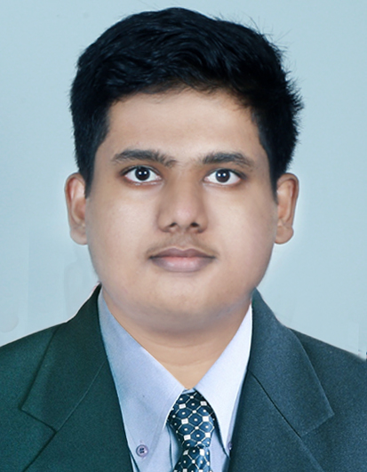CURRICULUM VITAE

**SHIJIN SKARIAH THOMAS**

VALAYIL SHIJIN VILLA

KUDASSANAD PO KUDASSANAD

ALAPPUZHA, KERALA

INDIA

**Email : shijinskariahthomas@gmail.com**

**Mobile No : +918594078342**

**Career Objective**

A highly motivated and ambitious individual able to give timely and accurate advise will be contribute to the growth of the organisation by applying my skills and improving up on it, thus effecting a comprehensive development of my personal capacities along with the organization.

**Acadamic Profile**

|  |  |  |
| --- | --- | --- |
| **Qualification** | **Institution/University** | **Year Of Passing** |
| IATA ( Logistics And Supplychain Management ) | Dream Sky Aviation Training Academy,Adoor,  IATA Canada | 2023 To Present |
| B.Com With Commerce & Tourism And Travel Management | KVVS College, Adoor,  Kerala University | 2022 |
| Plus Two | St John's School,Thumpamon | 2019 |
| S S L C | St John's School,Thumpamon | 2017 |

**Technical Knowledge**

* MS Office

**Language Known**

* English (Write, Speak, Read)
* Malayalam (Write, Speak, Read)
* Hindi (Speak)

**Strength**

* Communication Skill.
* Positive Attitude
* Hard Work And Focused
* Time Management
* Leadership

**Extra Curicular Activity**

I like listening to music and watching movies Etc.

**Personal Profile**

Name : Shijin Skariah Thomas

Father’s Name : Thomas Skariah

Mother’s Name : Jiji Varghese

Gender : Male

Marital Status : Single

Date Of Birth : 11-04-2001

Religion : Christian

Nationality : Indian

Passport No : W7856066

Mother Tongue : Malayalam

**Declaration**

I hereby declare that all that facts and figures given are true and correct to the best of my knowledge and belief.

Date:

Place: Kudassanad  **SHIJIN SKARIAH THOMAS**