## MySQL set up for blog app

**Tables**

blogs

id (auto_increment, primary key)

author

title

content

_created

authors

CREATE TABLE authors(

id int(11) NOT NULL AUTO_INCREMENT, PRIMARY KEY

name varchar(20) NOT NULL,

email varchar(40) NOT NULL,

hash varchar(60) NOT NULL

_created datetime DEFAULT CURRENT_TIMESTAMP,

)

*unique key on name & email

authorblog

authorid

blogid

tokens

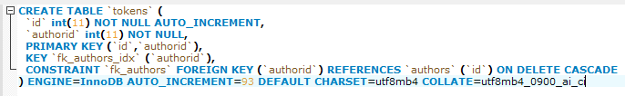

**stored procedures**

spAuthorBlog(author name, id) 🡪 inserts authorid and blogid into authorblog cross ref table, which is used to display author’s blogs using spByAuthor

spByAuthor(authorid) 🡪 returns all of the author’s blogs; blogid, author, blog title

see spByAuthor.sql

**foreign keys**

foreign key constraints on authorblog table: fk_aid, fk_bid

also on tokens table: fk_authors

authorblog fk_aid example here:

CONSTRAINT fk_aid

FOREIGN KEY (authorid)

REFERENCES authors(id)

ON DELETE CASCADE

*ON DELETE CASCADE deletes blogid or authorid from authorblog table when delete from authors or blogs table

*blog insert queries populate both blogs and authorblog tables with code from server