URL-Based Phishing Website Detection Using Machine Learning and Artificial Neural Networks
Christy Francis (124B1B005), Saksham Joshi (124B1B021), Aadesh Patil (124B1B023)
Department of Computer Engineering, Pimpri Chinchwad College of Engineering
Pune, Maharashtra, India

Abstract— Phishing websites pose a serious cybersecurity threat by attempting to steal sensitive information through deceptive web pages and URLs. Traditional blacklist based methods may fail to identify newly created phishing websites. This study presents a machine learning approach for detecting phishing URLs using the PhiUSIIL Phishing URL Dataset. The proposed system performs data preprocessing, exploratory data analysis, feature scaling, and feature selection using Mutual Information. The thirty most informative features are selected and provided to an Artificial Neural Network for binary classification. The proposed network uses multiple dense layers with ReLU activation, dropout, and a sigmoid output layer. The system is evaluated using accuracy, precision, recall, F1 score, ROC AUC, and confusion matrix analysis. The study also considers comparison with traditional machine learning models and an ablation study to examine the effect of feature selection. The approach provides a structured framework for identifying phishing URLs based on their URL and webpage characteristics.
Keywords— Phishing detection, URL classification, machine learning, artificial neural network, feature selection, mutual information, cybersecurity, PhiUSIIL.

I. INTRODUCTION
Phishing is a type of social engineering attack in which attackers create fake websites or messages that appear to come from trusted organizations. The main objective is to steal sensitive information such as usernames, passwords, banking details, and other personal data. Phishing attacks remain difficult to prevent because attackers frequently create new websites and modify URLs to avoid detection. [20]
Traditional blacklist-based systems detect malicious websites by comparing URLs with databases of previously reported threats. While effective against known phishing websites, they may fail to detect newly created URLs that are not yet listed. Rule-based systems identify suspicious characteristics such as unusual characters, IP addresses, and abnormal domain structures, but require continuous updates as attackers change their techniques. [1]
Machine learning provides an alternative by learning patterns from legitimate and phishing URLs. Instead of relying only on blacklists, machine learning models can analyze URL and webpage characteristics such as URL length, domain properties, HTTPS usage, webpage information, and external references to determine whether a URL is likely to be phishing. [5], [7]
This study develops a URL-based phishing detection system using the PhiUSIIL Phishing URL Dataset. The proposed approach combines data preprocessing, exploratory data analysis, feature scaling, Mutual Information-based feature selection, and Artificial Neural Network classification. The thirty most informative features are selected as inputs to the neural network.
The main objectives are to clean and analyze the dataset, remove non-predictive and identifier-based columns, select important features using Mutual Information, develop an Artificial Neural Network for phishing URL classification, and evaluate its performance using suitable classification metrics. The study also compares traditional machine learning models and conducts an ablation study to examine the impact of feature selection. Particular importance is given to recall and F1 score, which are relevant metrics for phishing detection.

II. BACKGROUND
A. Phishing and Phishing Websites
Phishing is a type of social engineering attack in which attackers create deceptive websites or messages that appear to originate from trusted organizations. The primary purpose of these attacks is to convince users to disclose sensitive information such as usernames, passwords, banking details, and other personal information. Phishing websites attempt to create a sense of trust by imitating the appearance, structure, or identity of legitimate websites. [11], [14]
Phishing attacks are particularly difficult to prevent because attackers can continuously create new websites and modify their URLs. This changing nature makes it difficult for detection systems that depend entirely on previously identified threats to recognize newly created phishing websites. Therefore, analyzing the characteristics of URLs and associated webpages can provide an alternative approach for identifying suspicious websites. [1]
B. Traditional Phishing Detection
1) Blacklist Based Detection
Blacklist based detection systems identify malicious websites by maintaining databases of previously reported phishing URLs. When a user attempts to access a website, its URL is compared with the entries stored in the blacklist. If a matching entry is found, the website can be identified as malicious. This approach is useful for detecting previously known threats and can provide fast detection for URLs that have already been reported. [1]
However, blacklist based detection has an important limitation. Newly created phishing websites may not yet be present in the blacklist database. Consequently, an attacker can potentially create a new phishing URL that remains undetected until it is discovered, analyzed, and added to the database. This limitation creates a need for detection methods that can identify suspicious URLs based on their characteristics rather than only their previous reputation. [1]
2) Rule Based Detection
Rule based detection uses predefined conditions to identify potentially malicious URLs. These rules may consider characteristics such as unusual characters, the use of IP addresses, suspicious domain structures, or other patterns commonly associated with phishing websites. Such systems are relatively straightforward because the detection process is based on explicitly defined conditions. [1]
The effectiveness of rule based systems depends heavily on the quality and coverage of their predefined rules. Since attackers can modify their techniques and construct URLs that do not match existing rules, the rules need to be continuously updated. This makes rule based detection less flexible when dealing with changing phishing strategies. [1]
C. Machine Learning Based Detection
Machine learning based detection provides an alternative approach in which models learn patterns from examples of legitimate and phishing URLs. Instead of determining whether a URL has previously been reported as malicious, a trained model can analyze different URL and webpage characteristics and use these characteristics to classify a URL. This allows the system to learn relationships within the available data and make predictions for new samples. [5], [7]
Different characteristics can be used as inputs for machine learning models, including URL length, domain properties, HTTPS usage, webpage information, and external references. The PhiUSIIL dataset used in this study provides several such characteristics, allowing the proposed system to consider multiple aspects of a website rather than depending on a single URL property. [13]
D. PhiUSIIL Phishing URL Dataset
The PhiUSIIL Phishing URL Dataset is used as the primary dataset for this study. It is publicly available through the UCI Machine Learning Repository and contains both legitimate and phishing URL samples. The dataset includes information extracted from URLs and their associated webpages, making it suitable for studying URL based phishing detection. [18]
The dataset contains 235,795 instances, consisting of 134,850 legitimate URLs and 100,945 phishing URLs. The class distribution is therefore not perfectly balanced, although both classes contain a substantial number of samples. The original target labels use 1 to represent legitimate URLs and 0 to represent phishing URLs.
1) Dataset Features
The dataset contains different categories of URL and webpage characteristics. These include URLLength, which represents the length of a URL, URLSimilarityIndex, which represents URL similarity information, and TLDLegitimateProb, which provides statistical information related to the top-level domain. Other characteristics include HTTPS usage, domain and webpage title similarity, favicon presence, hidden fields, JavaScript resources, CSS resources, and external references. [13]
These characteristics provide numerical and categorical information that can be used by classification models to distinguish between legitimate and phishing URLs. However, the presence of a relationship between a feature and the target does not necessarily mean that the feature directly causes phishing. The features are therefore treated as predictive attributes used by the machine learning model.
E. Feature Selection
The dataset contains a relatively large number of features, and not every feature contributes equally to the classification task. Using a large number of features can increase model complexity and computational requirements while potentially introducing less useful information. Feature selection is therefore used to identify the features that provide the most useful information for classification. [13]
The proposed system uses SelectKBest with Mutual Information to rank the available features according to their statistical relationship with the target variable. The thirty features with the highest Mutual Information scores are selected and used as inputs to the Artificial Neural Network. This reduces the feature space while retaining the most informative features identified from the training data.
1) Mutual Information
Mutual Information measures the amount of information that one variable provides about another. In this study, it is used to measure the statistical dependency between individual features and the target class. A higher Mutual Information score indicates a stronger statistical relationship between a feature and the target. However, this relationship represents statistical dependency and should not be interpreted as evidence that the feature directly causes phishing.
F. Artificial Neural Network
An Artificial Neural Network is selected as the primary classification model in the proposed system. The ANN receives the selected thirty features and learns patterns that can be used to distinguish between legitimate and phishing URLs. Neural networks are suitable for this task because they can learn nonlinear relationships between multiple input features and the target classification. [16]
The proposed ANN consists of an input layer containing thirty selected features, followed by three dense hidden layers containing 128, 64, and 32 neurons. Dropout layers are included between the dense layers to help reduce overfitting. The final output layer contains a single neuron with sigmoid activation for binary classification. The overall architecture can therefore be represented as Input 30, Dense 128, Dropout, Dense 64, Dropout, Dense 32, and Output 1.
1) Activation Functions
The hidden layers use the ReLU activation function. ReLU introduces nonlinearity into the network and allows the model to learn more complex relationships between the selected URL and webpage characteristics. The output layer uses sigmoid activation, which produces a value between zero and one. Since the dataset uses 1 for legitimate URLs and 0 for phishing URLs, the output represents the predicted probability of the legitimate class.
2) Dropout and Model Training
Dropout is incorporated into the ANN to reduce overfitting. During training, some neurons are temporarily ignored, which encourages the network to learn more general patterns rather than becoming overly dependent on particular neurons. The exact dropout rate should be taken from the actual implementation used in the experiment.
The proposed ANN uses Binary Cross Entropy as the loss function and the Adam optimizer for training. Binary Cross Entropy measures the difference between the actual class and the predicted probability, while Adam provides adaptive parameter updates during training. The exact learning rate should be reported according to the implementation used in the experimental setup.
G. Research Gap
Although existing phishing detection approaches provide useful protection, several challenges remain. Blacklist based systems may fail to identify newly created phishing URLs, while rule based approaches require continuous updates as attackers modify their techniques. Machine learning approaches can address some of these limitations, but large feature sets may contain redundant information and increase computational complexity. [1], [15]
Additional challenges include model overfitting, limited generalization to newly developed phishing techniques, difficulty in interpreting ANN predictions, and the possibility of adversarial URL manipulation. The proposed study addresses some of these challenges by combining Mutual Information based feature selection with ANN classification and by evaluating the model using multiple performance measures rather than accuracy alone. [12], [4]

III. EXISTING TECHNIQUES
Phishing website detection has traditionally relied on several approaches for identifying malicious websites. These approaches can be broadly categorized into blacklist based detection, rule based detection, and machine learning based detection. Each technique uses different information to determine whether a URL or website should be considered legitimate or malicious. However, the effectiveness of these approaches can vary depending on the availability of threat information and the ability of the system to adapt to new phishing techniques.
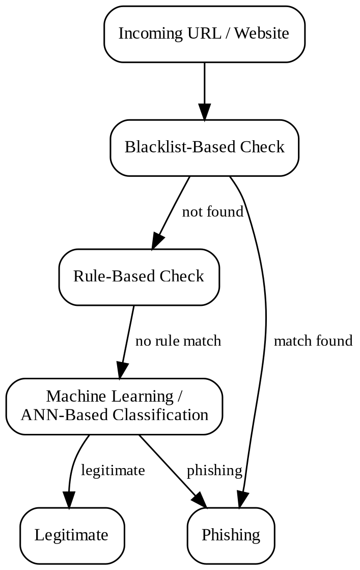
Fig. 1. General phishing URL detection workflow, showing blacklist based, rule based, and machine learning / ANN based classification stages.
A. Blacklist Based Detection
Blacklist based detection is one of the commonly used approaches for identifying phishing websites. In this technique, a database containing previously identified malicious URLs is maintained. When a user attempts to access a website, the requested URL is compared with the URLs stored in the blacklist. If a match is found, the website can be identified as malicious and access can be restricted or a warning can be provided to the user. [1]
The main advantage of blacklist based detection is its simplicity and effectiveness against previously identified threats. However, its major limitation is its dependence on previously collected information. Newly created phishing websites may not yet be present in the blacklist and can therefore remain undetected. Attackers can exploit this limitation by creating new URLs or changing existing URLs. As a result, blacklist databases require continuous updating to remain effective. [1]
B. Rule Based Detection
Rule based detection identifies suspicious websites using a predefined collection of rules. These rules can examine characteristics of a URL, such as unusual characters, the use of IP addresses, or suspicious domain structures. When a URL satisfies one or more predefined conditions, the system can classify it as potentially malicious. [1]
Rule based techniques are relatively simple and can be useful for detecting recognizable phishing patterns. However, these systems depend on manually defined rules and therefore require regular updates. Attackers can modify URL structures and develop new techniques that do not match existing rules. This makes it difficult for a fixed rule set to provide reliable detection against constantly changing phishing strategies. [1]
C. Machine Learning Based Detection
Machine learning based detection approaches use previously collected legitimate and phishing examples to learn patterns associated with each class. Instead of checking only whether a URL is present in a known blacklist or satisfies a predefined rule, the model can analyze multiple characteristics of the URL and associated webpage and use the learned patterns to classify new samples. [5], [7]
Features used for machine learning based phishing detection can include URL length, domain properties, HTTPS usage, webpage information, and external references. The PhiUSIIL dataset used in this study contains several such URL and webpage characteristics, including URLLength, URLSimilarityIndex, TLDLegitimateProb, IsHTTPS, DomainTitleMatchScore, HasFavicon, HasHiddenFields, NoOfJS, NoOfCSS, and NoOfExternalRef. [13]
D. Feature Based Classification
Feature based classification represents a URL or webpage using measurable characteristics rather than using the complete URL as raw text. This allows a classification model to work with numerical and categorical attributes extracted from the URL and associated webpage. Examples include the length and similarity of a URL, domain properties, HTTPS usage, webpage elements, and the number of external resources. [13]
A challenge with feature based approaches is that datasets can contain a large number of features, and some features may provide limited or redundant information. A high dimensional feature space can increase computational requirements and may introduce unnecessary information into the classification model. Feature selection can therefore be applied to identify the most informative attributes before model training. [8], [13]
E. Mutual Information Based Feature Selection
Mutual Information is a feature selection technique used to measure the statistical dependency between a feature and the target variable. In the proposed system, Mutual Information is used to rank the available features according to their relationship with the phishing classification target. The highest ranked features are then selected for use by the classification model. [1]
The use of feature selection can reduce the number of input features, remove less useful attributes, reduce computational cost, simplify the model, and potentially improve generalization. In this study, SelectKBest with Mutual Information is used to select the top thirty features before they are provided to the Artificial Neural Network.
F. Artificial Neural Network Based Detection
Artificial Neural Networks provide a nonlinear machine learning approach for phishing URL classification. An ANN consists of interconnected layers that learn relationships between input features and the target class during training. In the proposed system, the selected thirty features are provided to the ANN, which learns patterns that can be used to distinguish legitimate URLs from phishing URLs. [16]
The proposed ANN architecture contains three dense hidden layers with 128, 64, and 32 neurons. ReLU activation is used in the hidden layers, while a sigmoid activation function is used in the output layer for binary classification. Dropout layers are included to reduce the possibility of overfitting during training.
G. Limitations of Existing Techniques
Although existing techniques provide useful methods for phishing detection, each approach has limitations. Blacklist based systems can fail against newly created URLs, while rule based systems require continuous maintenance as phishing techniques change. Machine learning based approaches can provide more flexible classification, but their performance can be affected by feature redundancy, overfitting, dataset dependency, and limited generalization to new phishing campaigns. [1]
Another limitation is the difficulty of interpreting some machine learning models, particularly neural networks. Furthermore, attackers may deliberately modify URL characteristics to evade detection. These limitations motivate the use of feature selection and neural network based classification in the proposed approach, together with evaluation using multiple performance metrics and an ablation study to examine the contribution of feature selection. [12], [4]

IV. SURVEY OF CURRENT TRENDS
Phishing detection has increasingly moved from traditional blacklist and rule based approaches toward data driven machine learning and deep learning techniques. Recent research focuses not only on improving classification accuracy but also on developing systems that can adapt to new phishing strategies, operate in real time, provide interpretable predictions, and remain robust against adversarial manipulation. Recent surveys indicate continued growth in the use of artificial intelligence for phishing detection, with increasing attention toward deep learning and hybrid approaches. [1]
A. Growth of Machine Learning Based Detection
Machine learning continues to be an important approach for phishing URL detection because it allows models to learn distinguishing characteristics from legitimate and malicious examples. Traditional machine learning algorithms can work effectively with carefully engineered URL, domain, webpage, and hyperlink features. Recent research also continues to investigate feature engineering and feature selection because the quality and representation of input features can strongly influence model performance. [5], [7], [9]
The use of feature selection is particularly relevant when phishing datasets contain a large number of attributes. Selecting informative features can reduce computational requirements and simplify the classification process. This trend is consistent with the approach used in the present study, where Mutual Information is used to identify the most informative features before classification. [13]
B. Transition Toward Deep Learning
A major trend in recent phishing detection research is the increasing use of deep learning models. Research has explored Deep Neural Networks, Convolutional Neural Networks, Recurrent Neural Networks, and Long Short Term Memory networks for learning complex patterns from URLs and webpage information. A review of deep learning based phishing detection studies found that DNN, CNN, and RNN or LSTM architectures are among the commonly investigated approaches. [1]
For URL detection specifically, recent literature has investigated character level representations, word embeddings, handcrafted features, CNNs, RNNs, LSTMs, and hybrid architectures. These approaches attempt to reduce dependence on manually designed features by allowing models to learn useful representations directly from URL sequences or other forms of input data. [16]
C. Hybrid and Ensemble Models
Another current trend is the combination of multiple machine learning or deep learning techniques into hybrid and ensemble systems. Instead of depending on a single classifier, these systems combine different models or information sources to improve classification performance and adaptability. Recent reviews identify hybrid and ensemble frameworks as an important direction because phishing attacks can involve multiple characteristics and attack vectors. [1]
Hybrid approaches can combine handcrafted URL features with webpage content, visual information, or representations learned by deep neural networks. Such systems attempt to capture complementary information that may not be available when using only one type of feature or model. [10]
D. Transformer Based Detection
Transformers represent a more recent direction in malicious URL and phishing detection. Their self attention mechanism allows them to model relationships within sequential and textual information. In phishing research, Transformer based methods can be applied to URL strings and other textual representations to identify suspicious patterns that may be difficult to capture using manually engineered features. Recent surveys specifically identify Transformer based approaches as an emerging area of malicious URL detection research. [1]
The growing interest in Transformers is related to their ability to learn contextual relationships from sequences. However, their computational requirements and the need for suitable training data remain important considerations when compared with lightweight traditional machine learning approaches. [1]
E. Graph Based and Multi Modal Detection
Recent research has also expanded beyond individual URL characteristics toward relationships between different entities and information sources. Graph Neural Networks are being investigated for malicious URL detection because relationships between domains, URLs, webpages, links, and other entities can provide additional information for classification. Recent surveys identify Graph Neural Networks as one of the emerging directions in malicious URL detection. [1]
Another developing direction is multimodal detection, where information from different sources is combined. Instead of analyzing only the URL, a system may consider webpage content, visual appearance, domain information, hyperlinks, and other signals. This approach can potentially provide a broader representation of phishing behavior than URL based features alone. Recent literature identifies multimodal approaches as a promising direction for future phishing detection systems. [10]
F. Explainable Artificial Intelligence
As machine learning and deep learning models become more complex, explainability has become an important research topic. A highly accurate model may still be difficult for security analysts to trust if it cannot provide meaningful information about why a URL was classified as phishing. Explainable Artificial Intelligence techniques are therefore being investigated to identify influential features and provide more interpretable predictions. Recent research reviews highlight interpretability and explainability as important requirements for practical phishing detection systems. [12]
Explainability is particularly relevant for neural network based systems because the internal decision process can be difficult to interpret directly. Future phishing detection systems are therefore expected to place greater emphasis on both predictive performance and the ability to understand model decisions. [12]
G. Adversarial Robustness and Zero Day Detection
Modern phishing detection research increasingly considers the ability of models to handle previously unseen and deliberately modified attacks. Attackers can alter URL structures or other website characteristics in an attempt to avoid detection. Consequently, high performance on a static dataset does not necessarily guarantee reliable performance against future phishing campaigns. Recent reviews identify adversarial attacks, zero day detection, and changing attack behavior as major challenges for current detection systems. [4]
This has encouraged research into adversarial training, adaptive models, continual learning, and evaluation strategies that better represent real world changes. Temporal evaluation and cross source testing are also becoming increasingly important because models trained on one dataset may not generalize effectively to future or independently collected phishing URLs. [4]
H. Large Language Models and Generative AI
Large Language Models represent another emerging direction in phishing detection. Recent research is exploring their ability to analyze semantic information, identify suspicious content, assist with brand or intent recognition, and provide natural language explanations of security decisions. However, the use of large language models in operational phishing detection remains relatively new and introduces challenges related to computational cost, latency, reproducibility, privacy, and potential manipulation of model inputs. [2], [3]
Rather than completely replacing conventional classifiers, current research increasingly considers language models as components of hybrid security architectures. Lightweight machine learning models can perform rapid initial classification, while more computationally expensive models can be used for uncertain or high risk cases. [6], [17]
I. Real Time and Adaptive Detection
Another important trend is the development of detection systems that can operate in real time and adapt to changing phishing behavior. Traditional models trained once on historical datasets may gradually become less effective as attackers change URL structures, domains, and webpage characteristics. Recent research therefore emphasizes adaptive detection, continual learning, and real time deployment as important future directions. [1]
For practical deployment, detection systems must balance classification performance with computational cost and response time. Lightweight feature based models remain relevant in situations where rapid prediction is required, while more complex deep learning or hybrid models can be applied when additional analysis is necessary.
J. Relevance to the Proposed Study
The current study follows the broader trend toward machine learning based phishing detection while maintaining a comparatively structured and lightweight feature based approach. The proposed system uses the PhiUSIIL dataset, performs preprocessing and scaling, applies Mutual Information based feature selection, and uses an Artificial Neural Network for classification.
Compared with emerging Transformer, Graph Neural Network, multimodal, and large language model approaches, the proposed ANN based approach focuses on reducing the feature space and learning from selected URL and webpage characteristics. This provides a practical foundation for evaluating the effectiveness of feature selection and neural network classification while leaving more advanced architectures as potential directions for future research.

V. DATASET AND DATA DESCRIPTION
A. Dataset Source
The proposed phishing detection system uses the PhiUSIIL Phishing URL Dataset, which is publicly available through the UCI Machine Learning Repository. The dataset was developed for phishing URL detection and contains information extracted from both URL strings and the source code of their corresponding webpages. The dataset is designed as a supervised classification dataset and contains real, categorical, and integer feature types. [18]
The dataset contains a large collection of legitimate and phishing URLs, making it suitable for training and evaluating machine learning based phishing detection systems. The original dataset was introduced by Prasad and Chandra as part of the PhiUSIIL phishing URL detection framework.
B. Dataset Composition
The PhiUSIIL dataset contains 235,795 instances, consisting of 134,850 legitimate URLs and 100,945 phishing URLs. Therefore, legitimate URLs represent the larger class in the dataset, while phishing URLs constitute the remaining samples. The dataset contains 54 features according to the UCI repository, in addition to the target variable and other dataset fields.
The original target representation uses 1 for legitimate URLs and 0 for phishing URLs. This label representation is maintained during the proposed classification process. The dataset documentation also reports that there are no missing values in the dataset.
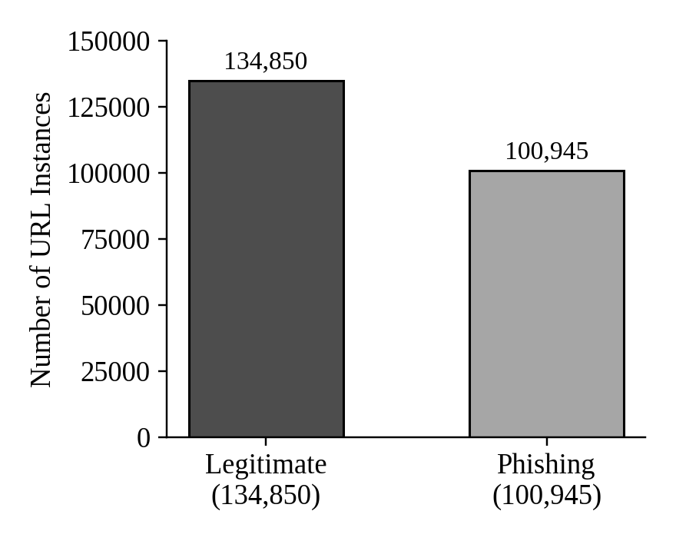
Fig. 2. Class distribution of the PhiUSIIL dataset, showing 134,850 legitimate URLs and 100,945 phishing URLs.
C. Feature Description
The dataset contains features extracted from both the URL and the associated webpage. These features describe different characteristics that can help distinguish legitimate websites from phishing websites. URL related characteristics include URL length, domain information, domain length, whether the domain is represented by an IP address, URL similarity, and properties of the top level domain. [13]
Webpage related features provide additional information about the structure and content of the associated website. Examples include HTTPS usage, webpage title information, domain and title similarity, favicon presence, hidden fields, JavaScript resources, CSS resources, redirects, forms, images, and external references. Such features allow the classification model to consider characteristics beyond the raw URL string.
Some features in the dataset are derived from combinations or transformations of existing URL and webpage characteristics. The dataset documentation identifies features such as CharContinuationRate, URLTitleMatchScore, URLCharProb, and TLDLegitimateProb as derived features. These features provide additional statistical information that can be used during classification.
D. Target Variable
The target variable represents the class of each URL. In the original dataset, a value of 1 represents a legitimate URL, while a value of 0 represents a phishing URL. This binary representation allows the problem to be formulated as a supervised binary classification task.
During model evaluation, phishing detection is treated as the primary security objective. Therefore, particular attention is given to the ability of the model to correctly identify phishing URLs and minimize false negative predictions. This is important because a false negative represents a phishing URL that has been incorrectly classified as legitimate.
E. Data Types
The dataset contains a combination of real, categorical, and integer features. Categorical information includes fields such as URL, domain, title, and top level domain, while numerical information describes measurable characteristics of URLs and webpages.
Because the proposed ANN requires numerical model inputs, raw textual and identifier based columns are not directly used as neural network inputs. Instead, numerical features that have already been extracted from URL and webpage characteristics are used for model development. This allows the ANN to learn from structured representations of the URLs while avoiding direct memorization of individual URL strings.
F. Data Inspection and Preprocessing
Before model training, the dataset is inspected to determine its structure, feature types, target distribution, missing values, and duplicate records. The dataset documentation reports no missing values, but an independent missing value check is still performed as part of the preprocessing procedure.
Duplicate records are also examined because repeated samples can influence model evaluation and may contribute to data leakage if identical samples are present in both the training and testing sets. Where necessary, duplicate records are removed before the dataset is divided for model development.
G. Removal of Non Predictive Columns
Several raw columns are excluded from the numerical model input because they contain identifiers or textual information that may have a large number of unique values. The columns identified in the proposed preprocessing procedure include FILENAME, URL, Domain, Title, and TLD.
Removing these fields helps reduce the possibility that the model simply memorizes individual URLs or domains rather than learning general patterns associated with phishing. At the same time, numerical features that have already been derived from these attributes are retained because they provide structured information that can be used for classification.
H. Feature and Target Separation
After preprocessing, the dataset is divided into two main components: the input feature matrix and the target variable. The input features are represented as X, while the target labels are represented as y. The target contains the original legitimate and phishing class labels.
The resulting feature matrix is subsequently used for feature scaling and feature selection. The selected features are then supplied to the Artificial Neural Network for classification.
I. Training and Testing Data
The dataset is divided into training and testing subsets using an 80 percent training and 20 percent testing split. Stratification is applied during the split so that the class distribution remains approximately consistent between the training and testing datasets.
The training set is used to learn the parameters of the classification model, while the testing set remains separate until the final evaluation. Keeping the testing data separate provides a more reliable estimate of how the trained model performs on previously unseen samples.
J. Data Leakage Prevention
Data leakage is an important consideration when developing a machine learning model for phishing detection. If information from the testing dataset is used during feature selection or scaling, the model may indirectly gain information about the test samples before evaluation. This can result in overly optimistic performance measurements.
To reduce this risk, the proposed methodology fits the feature scaler and feature selection process using only the training data. The learned transformations are subsequently applied to the testing data. This ensures that information from the testing set does not influence the model development process.
K. Class Distribution
The dataset contains more legitimate URLs than phishing URLs, with 134,850 legitimate instances compared with 100,945 phishing instances. Although the difference is not extreme, the classes are not perfectly balanced.
The class distribution is therefore examined during exploratory data analysis and maintained through stratified train-test splitting. This allows the evaluation process to represent both classes while reducing the possibility that the model is evaluated on a substantially different class distribution from the one used during training.

VI. METHODOLOGY
The proposed methodology is designed to detect phishing URLs using a structured machine learning pipeline. The overall process consists of dataset inspection, data cleaning, exploratory data analysis, removal of non predictive columns, feature and target separation, train test splitting, feature scaling, Mutual Information based feature selection, Artificial Neural Network training, and model evaluation. The complete workflow is designed to ensure that the selected features are processed appropriately before being provided to the classification model.
A. Overall Proposed Pipeline
The proposed phishing detection pipeline begins with the PhiUSIIL dataset. The dataset is first inspected and cleaned before exploratory analysis is performed. Raw identifier and textual columns that are not directly suitable as numerical model inputs are removed. The remaining features are separated from the target variable and divided into training and testing subsets. Feature scaling is then performed using the training data, followed by Mutual Information based feature selection. The thirty highest ranked features are provided to the Artificial Neural Network for classification. Finally, the trained model is evaluated using multiple classification metrics.
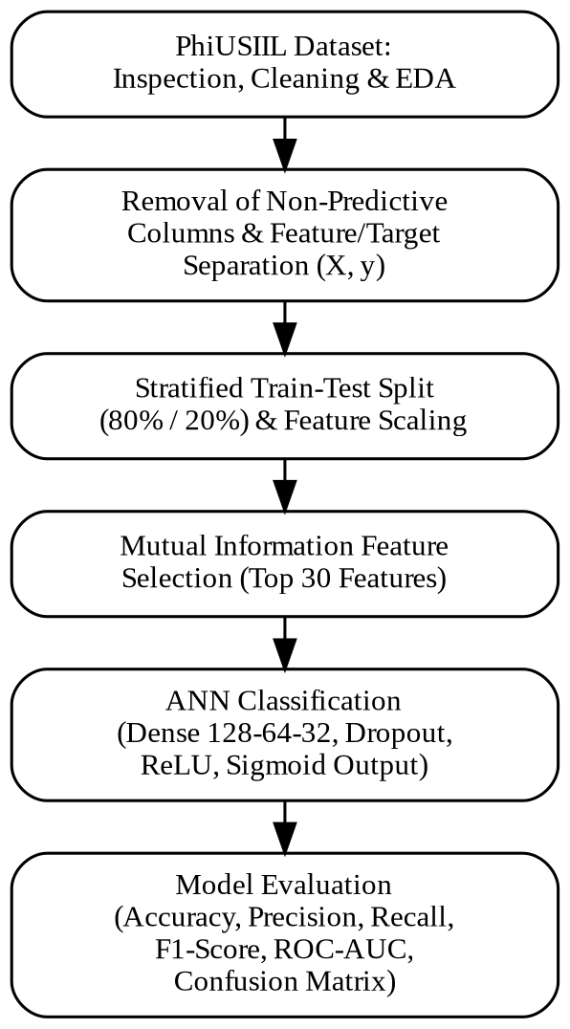
Fig. 3. Overall proposed pipeline, from PhiUSIIL dataset preprocessing through Mutual Information based feature selection, ANN classification, and model evaluation.
B. Data Preprocessing
Data preprocessing is performed to transform the raw dataset into a suitable format for machine learning. The preprocessing stage includes examining the dataset structure, checking data types, identifying the target variable, analyzing class distribution, checking missing values, and identifying duplicate records. These steps help ensure that the input data is consistent before model training.
The dataset documentation reports no missing values; however, missing value analysis is independently performed as part of the preprocessing procedure. Duplicate records are also checked and removed where necessary. Removing duplicates is important because identical samples appearing in both training and testing data can lead to data leakage and produce unrealistically high performance measurements.
C. Removal of Non Predictive Features
Raw identifier and textual columns are excluded from the numerical model input. The proposed preprocessing procedure removes FILENAME, URL, Domain, Title, and TLD. These fields can contain many unique values and may cause a model to memorize individual samples rather than learning general patterns associated with phishing.
The removal of these columns does not eliminate the information extracted from them. Numerical features that have already been derived from URL and webpage characteristics are retained because they provide structured information that can be used by the classification model.
D. Feature and Target Separation
After preprocessing, the dataset is divided into input features and the target variable. The input features are represented by X, while the target labels are represented by y. The original dataset uses 1 for legitimate URLs and 0 for phishing URLs.
The feature matrix is subsequently processed through the scaling and feature selection stages. The resulting selected features form the input to the proposed Artificial Neural Network.
E. Train Test Split
The dataset is divided into training and testing subsets using an 80 percent training and 20 percent testing split. Stratification is applied during the split to maintain approximately the same distribution of legitimate and phishing samples in both subsets.
The training subset is used for model development and learning, while the testing subset is kept separate until the evaluation stage. This separation provides an estimate of the model's ability to classify previously unseen URLs.
F. Feature Scaling
The dataset contains numerical features with different ranges. Some features represent counts, while others represent probabilities or normalized values. Directly using features with substantially different numerical scales can affect the training behavior of a neural network. Therefore, standardization is applied before the features are supplied to the ANN.
Standardization transforms a feature using its mean and standard deviation. The scaler is fitted using only the training data and the resulting transformation is applied to the testing data. This procedure ensures that information from the test set does not influence the preprocessing stage.
G. Mutual Information Based Feature Selection
Feature selection is performed to reduce the number of features supplied to the classification model. The proposed methodology uses SelectKBest together with the Mutual Information classification method. The available usable features are ranked according to their statistical relationship with the target variable, and the thirty highest ranked features are selected.
Mutual Information measures the amount of information that one variable provides about another. A higher Mutual Information score indicates a stronger statistical dependency between a feature and the target. However, the score represents statistical dependency and does not imply that the feature directly causes phishing.
The selected feature set is then passed to the ANN. Reducing the input space can simplify the model, reduce computational requirements, remove less useful information, and potentially improve generalization.
H. Artificial Neural Network Model
The Artificial Neural Network is used as the primary classification model. It receives the thirty features selected through Mutual Information and learns patterns that distinguish legitimate URLs from phishing URLs. The proposed architecture contains an input layer followed by three dense hidden layers and a single output layer.
The architecture consists of an input layer containing thirty features, followed by a dense layer with 128 neurons, a dropout layer, a dense layer with 64 neurons, another dropout layer, a dense layer with 32 neurons, and a single output neuron. ReLU activation is used in the hidden layers, while sigmoid activation is used in the output layer.
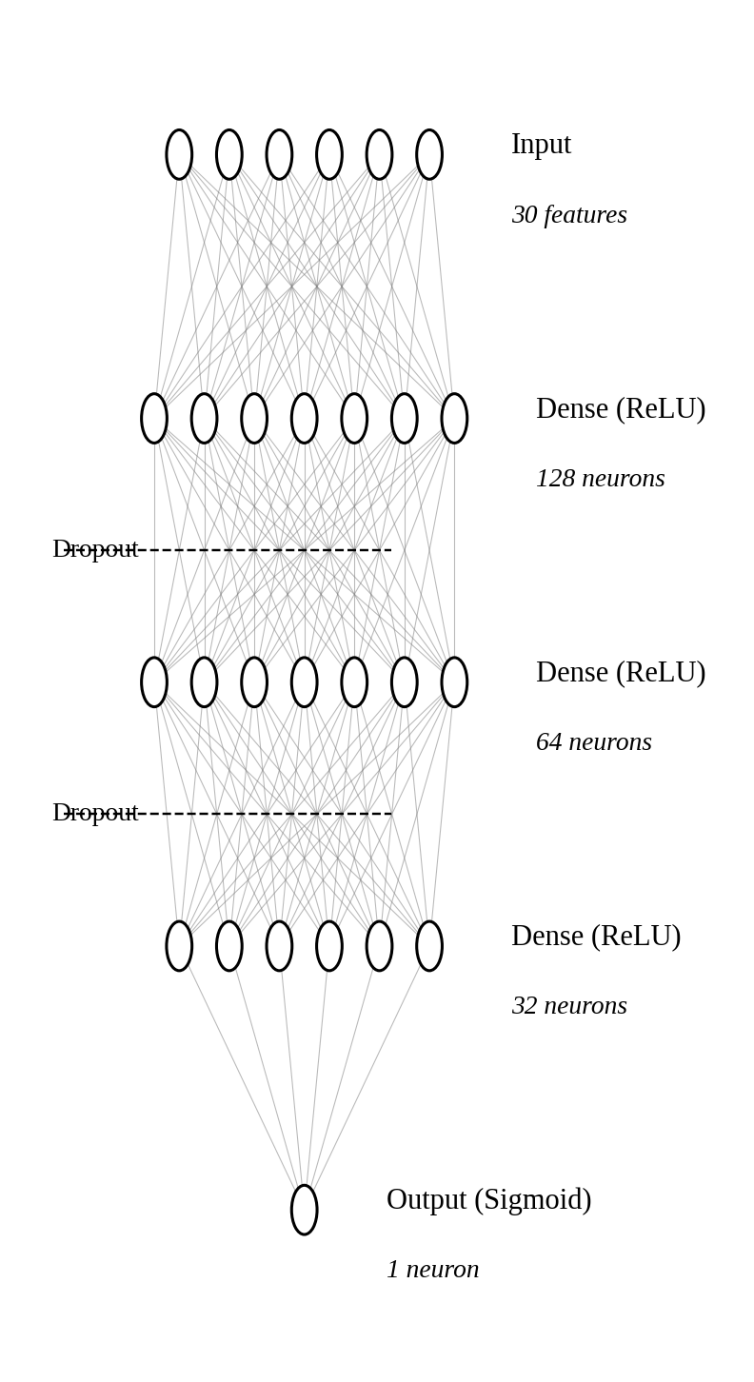
Fig. 4. Proposed Artificial Neural Network architecture: Input (30 features), Dense (128, ReLU), Dropout, Dense (64, ReLU), Dropout, Dense (32, ReLU), Output (1, Sigmoid).
I. Hidden Layer Activation
The hidden layers use the Rectified Linear Unit activation function. ReLU provides the nonlinearity required for the ANN to learn complex relationships between the selected URL and webpage features. Its use in the hidden layers allows the network to construct increasingly higher level representations of the input features.
J. Output Layer and Classification
The final layer contains a single neuron with sigmoid activation. The sigmoid function produces an output between zero and one, which can be interpreted as a predicted probability. Since the original dataset uses 1 for legitimate URLs and 0 for phishing URLs, the output represents the predicted probability of the legitimate class. The probability of phishing can consequently be derived from the complementary probability.
The model therefore performs binary classification by assigning each test URL to either the legitimate or phishing class based on the predicted output and the classification threshold used during evaluation.
K. Dropout Regularization
Dropout is included in the neural network to reduce overfitting. During training, selected neurons are temporarily ignored, encouraging the network to learn more general patterns rather than becoming overly dependent on particular neurons. The exact dropout rate should be reported from the actual implementation used for the experiment.
L. Loss Function and Optimizer
Binary Cross Entropy is used as the loss function for training the binary classification model. The loss function compares the actual class label with the predicted probability and provides an objective that the network minimizes during training.
The Adam optimizer is used to update the network parameters during training. Adam provides adaptive learning rates and is selected in the proposed methodology for stable and efficient optimization. The exact learning rate should be reported according to the implementation used in the experimental setup.
M. Data Leakage Prevention
Data leakage prevention is incorporated throughout the methodology to ensure that the testing data does not influence model development. In particular, feature scaling and feature selection are fitted only on the training data. The transformations learned from the training subset are then applied to the testing subset.
This separation is important because allowing test information to influence feature selection or scaling can result in an overly optimistic estimate of model performance. By keeping the test data isolated until final evaluation, the reported results provide a more reliable indication of the model's generalization ability.
N. Model Training and Testing
During training, the ANN learns relationships between the selected URL and webpage characteristics and the target class. The training dataset is used to optimize the network parameters through the selected loss function and optimizer. The model therefore learns a classification function capable of distinguishing between the legitimate and phishing classes.
After training is completed, the test dataset is supplied to the trained model. The predicted outputs are compared with the actual test labels to determine the classification performance. The testing data remains separate from the training process so that the final evaluation is performed on previously unseen samples.
O. Model Evaluation
The proposed model is evaluated using multiple metrics because accuracy alone does not provide a complete description of phishing detection performance. Phishing is treated as the positive class during evaluation. The selected metrics include accuracy, precision, recall, F1 score, ROC AUC, and confusion matrix analysis.
Accuracy measures the proportion of correctly classified samples. Precision measures how many URLs predicted as phishing are actually phishing, while recall measures how many actual phishing URLs are successfully detected. F1 score provides a balance between precision and recall, and ROC AUC evaluates the model's ability to distinguish between the two classes across different classification thresholds.
The confusion matrix provides four categories of predictions: true positives, true negatives, false positives, and false negatives. False negatives are particularly important in phishing detection because they represent phishing URLs that are incorrectly classified as legitimate.
P. Proposed Methodology Summary
The complete methodology can be summarized as a sequential pipeline beginning with the PhiUSIIL dataset and continuing through data inspection, cleaning, exploratory analysis, removal of non predictive columns, feature and target separation, stratified train test splitting, feature scaling, Mutual Information based selection of the top thirty features, ANN training, prediction, and evaluation. This workflow combines dimensionality reduction through feature selection with nonlinear classification through an Artificial Neural Network.

VII. RESULTS AND DISCUSSION
The proposed phishing URL detection system is evaluated using the PhiUSIIL Phishing URL Dataset. The analysis considers the distribution of legitimate and phishing URLs, the characteristics of selected features, relationships between numerical features, feature importance based on Mutual Information, and the classification performance of the proposed Artificial Neural Network. The evaluation is designed to determine whether the selected URL and webpage characteristics can effectively distinguish phishing URLs from legitimate URLs.
A. Dataset Distribution Analysis
The dataset contains 134,850 legitimate URLs and 100,945 phishing URLs. The distribution indicates that legitimate URLs represent a larger proportion of the dataset, while phishing URLs constitute the remaining samples. Although the two classes are not perfectly balanced, both classes contain a sufficiently large number of instances for supervised binary classification.
The class distribution is examined before model training to understand the composition of the dataset. Stratified train test splitting is subsequently used to maintain an approximately similar class distribution in both the training and testing subsets.
B. Feature Distribution Analysis
Exploratory analysis is performed on important numerical features to understand their distributions across the dataset. Features such as URLLength, URLSimilarityIndex, and TLDLegitimateProb are examined because they represent different aspects of URL and domain characteristics. Visualization of these features provides an understanding of how their values vary across legitimate and phishing samples.
The observed feature distributions provide an initial indication of whether individual characteristics may contain useful information for classification. However, individual features are not considered sufficient on their own, since phishing detection depends on combinations of URL and webpage characteristics.
C. Correlation Analysis
A correlation analysis is performed to identify relationships between numerical features. Highly correlated features may contain similar information and can introduce redundancy into the input feature space. The correlation analysis therefore provides an understanding of relationships among the available numerical attributes before feature selection.
The results of the correlation analysis are considered when interpreting the feature selection stage. Mutual Information is subsequently used to identify features that have stronger statistical relationships with the target rather than relying only on correlations between input features.
D. Outlier Analysis
Boxplots are used to examine the presence of extreme values in selected numerical features. Outliers are not automatically removed because unusual URL or webpage characteristics may themselves provide useful information for distinguishing phishing websites from legitimate websites.
This approach prevents potentially informative abnormal URL characteristics from being discarded solely because their values differ substantially from the majority of observations. The final treatment of such values is therefore based on their relevance to the classification problem.
E. Mutual Information Feature Analysis
Mutual Information is used to rank the available features according to their statistical relationship with the target variable. The proposed methodology selects the thirty features with the highest Mutual Information scores for input to the Artificial Neural Network.
The feature ranking provides information about which URL and webpage characteristics contain the greatest statistical dependency with the classification target. The actual feature ranking and corresponding Mutual Information scores should be reported from the executed feature selection procedure rather than being assumed.
F. ANN Training Performance
The Artificial Neural Network is trained using the selected thirty features. The proposed architecture contains dense layers with 128, 64, and 32 neurons, with dropout layers incorporated to reduce overfitting. The hidden layers use ReLU activation and the output layer uses sigmoid activation for binary classification.
Training and validation performance can be analyzed using the accuracy and loss curves generated during model training. These curves provide an indication of whether the model is learning effectively and whether a significant difference develops between training and validation performance. The final interpretation should be based on the actual training history obtained from the implementation.
G. Classification Performance
The final ANN performance is evaluated on the independent test dataset. Accuracy, precision, recall, F1 score, and ROC AUC are used to provide a comprehensive evaluation of the classification system. The confusion matrix is also analyzed to determine the number of correctly and incorrectly classified legitimate and phishing URLs.
The actual performance values obtained from the trained model should be reported in a table. The current research document does not provide these numerical values, and therefore they should be obtained by executing the final implementation on the test dataset.
Table I. Performance of the Proposed ANN
Metric | Value
Accuracy | [Insert actual value]
Precision | [Insert actual value]
Recall | [Insert actual value]
F1-Score | [Insert actual value]
ROC-AUC | [Insert actual value]
H. Confusion Matrix Analysis
The confusion matrix is used to analyze the classification behavior of the proposed model. True positives represent phishing URLs that are correctly detected, while true negatives represent legitimate URLs that are correctly classified. False positives represent legitimate URLs incorrectly classified as phishing, whereas false negatives represent phishing URLs incorrectly classified as legitimate.
False negatives are particularly important in the context of phishing detection because they represent malicious websites that are incorrectly considered legitimate. Therefore, recall is an important metric for interpreting the effectiveness of the proposed system. A high recall indicates that a larger proportion of actual phishing URLs are successfully identified.
I. Discussion of Model Performance
The performance of the proposed ANN should be interpreted using multiple evaluation metrics rather than accuracy alone. Precision indicates the reliability of phishing predictions, while recall indicates the ability of the model to identify actual phishing URLs. F1 score provides a combined measure of precision and recall, and ROC AUC provides an overall measure of class separation across different classification thresholds.
The final discussion should therefore consider the balance between detecting phishing URLs and avoiding incorrect classification of legitimate websites. Particular attention should be given to false negatives because missed phishing websites represent a direct security concern.
J. Effect of Feature Selection
Feature selection is an important component of the proposed methodology. By selecting the thirty highest ranked features using Mutual Information, the model operates on a reduced feature space rather than using all available attributes. This can reduce computational requirements, remove less useful information, simplify the model, and potentially improve generalization.
The effect of feature selection should be evaluated using the planned ablation study. The performance of the model with feature selection can be compared with the corresponding configuration without feature selection. The actual comparison should be reported using the results obtained from the executed experiments rather than assumed values.
K. Comparison With Other Models
The research design also considers comparison between the proposed ANN and traditional machine learning models. Such a comparison can help determine whether the proposed feature selection and ANN architecture provide meaningful advantages over alternative classification approaches. [5], [7]
The comparison should include the same evaluation metrics for each model where applicable. However, the current research document does not provide the completed numerical comparison results. Therefore, model names and performance values should be added after the corresponding experiments have been executed.
L. Overall Discussion
The results are intended to demonstrate the effectiveness of combining URL and webpage characteristics with feature selection and neural network based classification. The proposed pipeline reduces the original feature space through Mutual Information and subsequently uses the selected features as input to the ANN. This provides a structured approach in which feature relevance is considered before nonlinear classification.
The final experimental results will determine the extent to which the proposed approach successfully distinguishes legitimate URLs from phishing URLs. In particular, accuracy, precision, recall, F1 score, ROC AUC, and confusion matrix results should be considered together to provide a complete assessment of the system. The results should also be interpreted in relation to the feature selection and model training behavior observed during the experiments.

VIII. CONCLUSION
Phishing websites continue to represent a significant cybersecurity challenge because attackers can continuously create and modify deceptive URLs to imitate legitimate websites. This study investigated a machine learning based approach for phishing URL detection using the PhiUSIIL Phishing URL Dataset. The proposed methodology combines data preprocessing, exploratory analysis, feature scaling, Mutual Information based feature selection, and Artificial Neural Network classification to distinguish between legitimate and phishing URLs. [20]
The proposed approach uses the statistical relationship between individual features and the target variable to select the thirty most informative features before model training. This reduces the dimensionality of the input data and allows the Artificial Neural Network to focus on features that provide greater information for classification. The ANN uses multiple dense layers with ReLU activation, dropout regularization, and a sigmoid output layer for binary classification.
The methodology also emphasizes appropriate data preparation and evaluation practices. Stratified train test splitting is used to maintain class distribution, while scaling and feature selection are performed using the training data to reduce the possibility of data leakage. Model evaluation is designed to consider accuracy, precision, recall, F1 score, ROC AUC, and confusion matrix analysis rather than relying solely on accuracy.
Overall, the study provides a structured framework for phishing URL classification by combining feature selection with neural network based learning. The approach provides a foundation for investigating whether a reduced set of informative URL and webpage characteristics can support effective phishing detection while maintaining a manageable model complexity. Future work can further investigate advanced architectures, adaptive learning techniques, explainable artificial intelligence, and evaluation on newly emerging phishing URLs to improve the robustness and practical applicability of phishing detection systems.

IX. FUTURE WORK
The proposed phishing URL detection system provides a foundation for further research and improvement. Although the current methodology combines Mutual Information based feature selection with an Artificial Neural Network, several areas can be explored to improve the adaptability, robustness, interpretability, and practical deployment of the system.
A. Evaluation on Newly Emerging Phishing URLs
Future work can evaluate the proposed model on newly collected phishing URLs and datasets from different sources. Since phishing attacks continuously evolve, evaluation using only historical datasets may not fully represent the performance of a model against newly developed attacks. Testing the model on temporally separated and independently collected data can provide a better understanding of its generalization capability. [1]
B. Advanced Deep Learning Architectures
The current system uses an Artificial Neural Network with fully connected layers. Future research can investigate more advanced architectures such as Convolutional Neural Networks, Recurrent Neural Networks, Long Short Term Memory networks, and Transformer based models. These architectures may provide additional capabilities for learning sequential and contextual patterns from URL strings and webpage characteristics. [16]
C. Hybrid and Ensemble Approaches
Future work can investigate hybrid models that combine multiple machine learning and deep learning techniques. An ensemble approach could combine predictions from different classifiers, while a hybrid system could integrate URL based features with webpage content, domain information, or other security related signals. Such approaches may provide more comprehensive phishing detection than relying on a single classification model. [10]
D. Explainable Artificial Intelligence
The Artificial Neural Network used in the proposed system may provide accurate predictions while offering limited interpretability. Future work can incorporate Explainable Artificial Intelligence techniques to identify the features that contribute most strongly to individual predictions. This can help security analysts understand why a URL is classified as phishing or legitimate and can increase confidence in automated detection systems. [12]
E. Expanded Feature Analysis
The current methodology selects thirty features using Mutual Information. Future studies can investigate alternative feature selection methods and compare their effectiveness with Mutual Information. Methods such as recursive feature elimination, tree based feature importance, or other statistical selection techniques could be evaluated to determine whether different feature subsets provide improved classification performance.

X. REFERENCES
[1] A. Jadhav and P. R. Chandre, “Survey and comparative analysis of phishing detection techniques: Current trends, challenges, and future directions,” IAES International Journal of Artificial Intelligence, vol. 14, no. 2, pp. 853–866, 2025, doi: 10.11591/ijai.v14.i2.pp853-866.
[2] C. Opara, P. Modesti, and L. Golightly, “Evaluating spam filters and stylometric detection of AI-generated phishing emails,” Expert Systems with Applications, vol. 276, Art. no. 127044, 2025, doi: 10.1016/j.eswa.2025.127044.
[3] M. M. Maktabdar Oghaz, L. B. Saheer, K. Dhame, and G. Singaram, “Detection and classification of ChatGPT-generated content using deep transformer models,” Frontiers in Artificial Intelligence, vol. 8, Art. no. 1458707, 2025, doi: 10.3389/frai.2025.1458707.
[4] [Verify bibliographic details before use.] “From ML to LLM: Evaluating the robustness of phishing web page detection models against adversarial attacks,” arXiv preprint arXiv:2509.08375, 2025.
[5] Y. G. R. Yashwanth, C. S. Chinmaya, V. J. Vasudha, R. P. Shetti, and N. R. Neha, “A study on detecting phishing website using machine learning,” International Advanced Research Journal in Science, Engineering and Technology, vol. 11, no. 7, 2024, doi: 10.17148/IARJSET.2024.11711.
[6] E. Mitchell, Y. Lee, A. Khazatsky, C. D. Manning, and C. Finn, “DetectGPT: Zero-shot machine-generated text detection using probability curvature,” in Proc. 40th Int. Conf. Machine Learning, vol. 202, PMLR, 2023, pp. 24950–24962.
[7] C. Sasirekha, R. Nandhini, Karthiga Mai N. L., Bhuvaneshwari R. S., and C. V. S. Chandra, “Email phishing detection using machine learning,” International Journal of Engineering Research & Technology (IJERT), vol. 11, no. 3, 2023, doi: 10.17577/IJERTCONV11IS03045.
[8] R. Purwanto, A. Pal, A. Blair, and S. Jha, “PhishSim: Aiding phishing website detection with a feature-free tool,” 2022, arXiv:2207.10801.
[9] S. A. Salloum, T. Gaber, S. Vadera, and K. Shaalan, “A systematic literature review on phishing email detection using natural language processing techniques,” IEEE Access, vol. 10, pp. 65703–65727, 2022, doi: 10.1109/ACCESS.2022.3183083.
[10] Y. Lin, R. Liu, D. M. Divakaran, J. Y. Ng, Q. Z. Chan, Y. Lu, Y. Si, F. Zhang, and J. S. Dong, “Phishpedia: A hybrid deep learning based approach to visually identify phishing webpages,” in 30th USENIX Security Symposium (USENIX Security 21), 2021.
[11] L. Q. Ribeiro, I. S. Guedes, and C. S. Cardoso, “Which factors predict susceptibility to phishing? An empirical study,” Computers & Security, vol. 136, Art. no. 103558, 2024, doi: 10.1016/j.cose.2023.103558.
[12] [Verify author and publication details.] “A comprehensive review of interpretable machine learning techniques for phishing attack detection,” 2025.
[13] M. Sánchez-Paniagua, E. Fidalgo, E. Alegre, and R. Alaiz-Rodríguez, “Phishing websites detection using a novel multipurpose dataset and web technologies features,” Expert Systems with Applications, vol. 207, Art. no. 118010, 2022, doi: 10.1016/j.eswa.2022.118010.
[14] [Verify author and publication details.] “Defending against vishing attacks: Comprehensive review for prevention and mitigation techniques,” 2024.
[15] P. M. Bhujbal, A. Jadhav, J. N. Nandimath, P. S. Kadam, P. R. Chandre, and P. N. Mahalle, “Zero trust paradigm: Advancements, challenges, and future directions in cybersecurity,” International Journal of Intelligent Systems and Applications in Engineering, 2024.
[16] Y. Wang, W. F. Zhu, H. Xu, Z. Qin, K. Ren, and W. Ma, “A large-scale pretrained deep model for phishing URL detection,” in Proc. IEEE International Conference on Acoustics, Speech and Signal Processing (ICASSP), 2023.
[17] M. M. Maktabdar Oghaz, L. B. Saheer, K. Dhame, and G. Singaram, “Detection and classification of ChatGPT-generated content using deep transformer models,” Frontiers in Artificial Intelligence, vol. 8, Art. no. 1458707, 2025, doi: 10.3389/frai.2025.1458707.
[18] DomCop, “Top 10 million websites based on open data from Common Crawl & Common Search,” [Online]. Available: https://www.domcop.com/top-10-million-websites
[19] [Incorrect/mismatched reference supplied.] The DOI 10.1145/3737295 corresponds to a different ACM publication and should not be used for “From ML to LLM: Evaluating the Robustness of Phishing Web Page Detection Models against Adversarial Attacks” without verification.
[20] G. Varshney, R. Kumawat, V. Varadharajan, U. Tupakula, and C. Gupta, “Anti-phishing: A comprehensive perspective,” Expert Systems with Applications, vol. 238, Part F, Art. no. 122199, 2024, doi: 10.1016/j.eswa.2023.122199.

