**Project Proposal**

1. App Title: Pitchel It

2. Contact

Christy Tran, CTT494, christytran.thu@gmail.com

Denise Ly, dl27458, dply95@gmail.com

3. What sort of app are you building? What will be the major subsystems? What will be the major challenges?

We are building an image editor. It will have a main page for different activities, a gallery to display images, a preview activity to view the image and attributes, and an editor activity to edit images. Some major challenges will be using existing APIS like Facebook, Instagram, aviary, etc. We’re trying to combine all the concepts that we have previously learned in class. Connecting different layouts and activities/fragments and implementing a database of images will be a challenge as well.

4. Sketch the major user interface elements (i.e., actually draw them and include the drawing in your proposal. Focus on elements that are likely to be difficult.

(Sketches on last page)

Page 1: App home page. Has buttons to import photo, take a photo, go to gallery, and carousel of images to edit that have previously been imported.

Page 2: Edit activity. Can edit imported/taken/gallery photo using Aviary SDK/API. Can set tags for the photo. Can save photo to Gallery. Can cancel editing.

Page 3: Gallery of imported/edited photos. Has search functionality to search photos in gallery by tags. Click image: Page 4. Long click: able to delete photo.

Page 4: View of gallery photo with date attribute and tags set. Buttons will allow to start Edit Activity, Export Photo, or Share Photo.

5.Week-by-week schedule.

Week 1: Familiarize with the APIS. Set up layouts.

Week 2: Be able to take a photo & import to gallery. Be able to See Photos in Gallery. Be able to view a photo from Gallery with Tag & Date Edited.

Week 3: Be able to Edit Photo with Basic Functionality. Be able to Save after/Cancel Editing

Week 4: Make sure all deliverables are done.

Week 5: Be able to click photo from Gallery then Edit, Export, or Share (FB, IG, messages)

Week 6: Be able to search by tags. Be able to delete photo from Gallery.

Week 7: Polish UI

Week 8: Polish UI

6. List the APIs you will be using.

-Facebook for sharing functionality

-Instagram for sharing functionality

-Aviary for editing functionality

-Gestures

-Database/storage to store previously edited photos in a gallery

-Other ones that we can’t think of but will probably use

7. Deliverable:

Be able to Take a Picture

Be able to Edit Photo with Basic Functionality

Be able to See Photos in Gallery

Be able to view a photo from Gallery with Tag & Date Edited.

8. VSCO, Afterlight, etc. are very high quality apps on the market. They are very complex though. Our design was inspired by using social media too much.

Page 1 Page 2

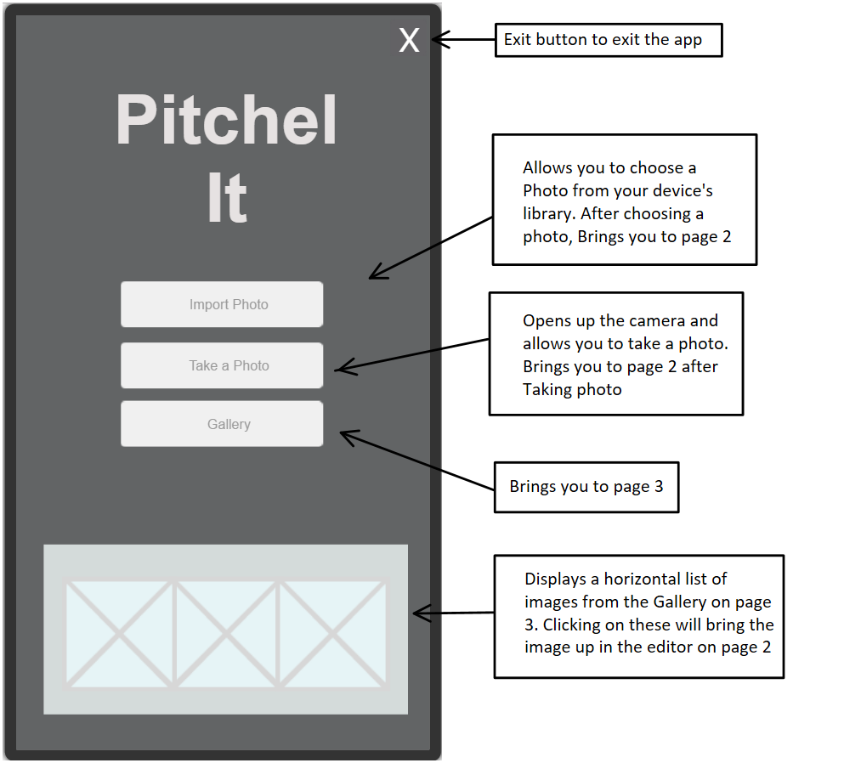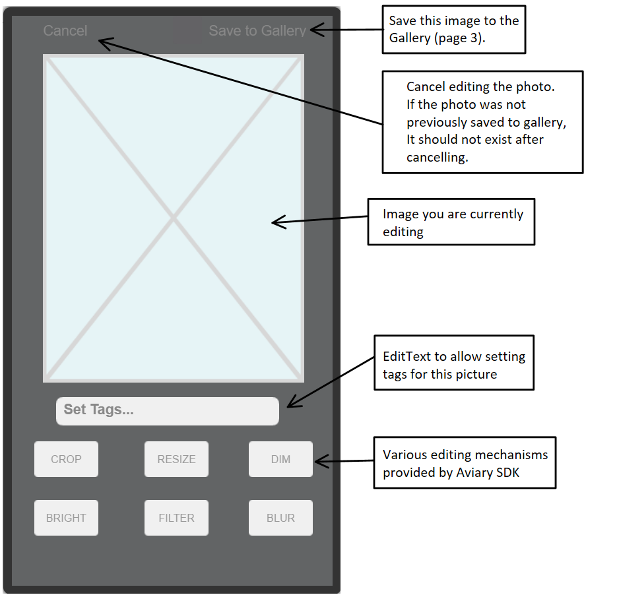

Page 3 Page 4

