Grind & Crumb: An Executive Summary of Operations

Brief company overview
- £8.66m in net sales across the 12 cafes
- £1.07m in store profits
- Rise in sales by 14%
- Manchester Piccadilly cafe is in a loss, 33% of sales spent in rent
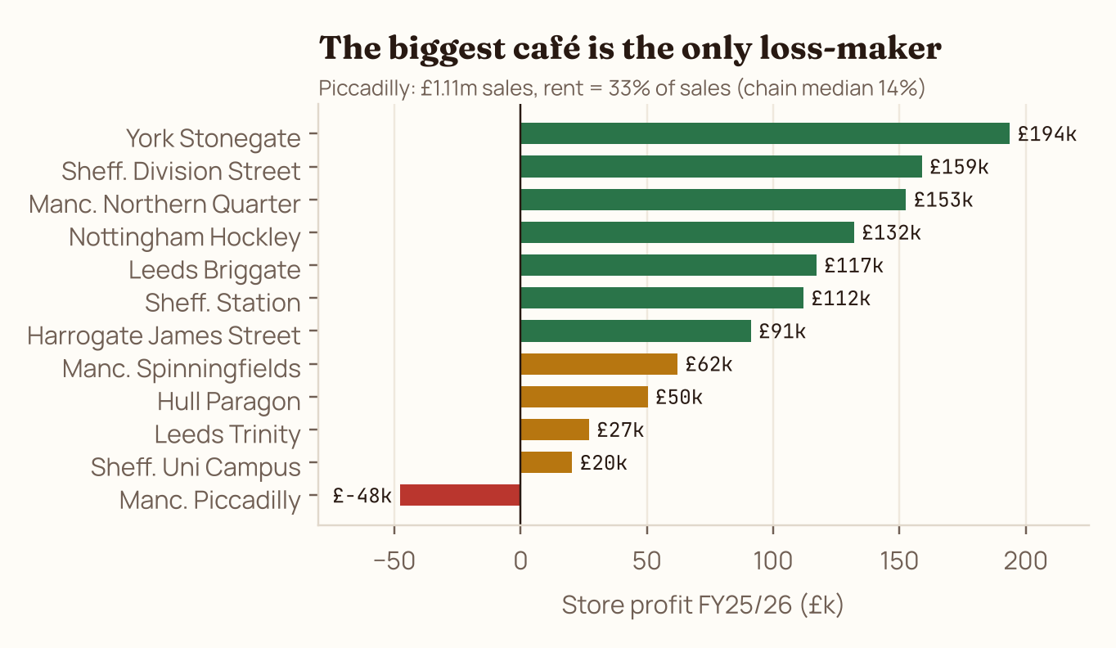

Biggest Problems Currently Being Faced:
- Manchester Piccadilly's rent: Highest sales in the chain (£1.11M) yet it loses £49,697. Rent of £366,000 a year (33% of sales).
- Leeds cannibalisation and waste: Opening Leeds Trinity in September 2025 pulled around 22% of sales away from Leeds Briggate, which kept last year's prep levels — making it the chain's highest food-waste store.
- Delivery is squeezing margin: 29% of delivery orders are under £8 and lose money after commission, packaging and barista time. Dashly also raised its commission from 27% to 33% on 1 April.
- App v3.0 lost click & collect orders: App sales per day fell 32% after 2 March and are still 18% down after the v3.1 fix. Reviews about the app or lost stamps went from 0 before March to 71 between March and June.
- Hull over-orders and its equipment is failing: Hull bins 20.6% of the food it prepares, against 9% chain-wide: £16.3k, the same as Briggate on 61% of the sales. Repairs cost £24.2k against a £7.9k median, and all 43 cleanliness complaints in the reviews are about Hull.

Our Investment Plan Using the 1.5M Budget:
“Planner” = figure in our tool. “Stress test” = our own rebuild from the raw files. Payback = investment ÷ stress-tested extra profit.
Investment | £ in | Planner /yr | Stress /yr | Payback | Evidence and how we checked it | Check
Manchester Oxford Road (CS3) · new | 240,000 | 192,478 | 135,000 | 1.8 yrs | 52k street footfall, the highest of the 7 candidate sites, and the second-lowest fit-out. Footfall model across our 12 cafés: £851k sales × 29.7% chain pre-rent margin − £117.6k rent. The planner’s £950k on 900 sq ft is optimistic. | Optimistic
York Railway Station kiosk (CS4) · new | 180,000 | 134,778 | 77,000 | 2.3 yrs | Copies Sheffield Station, our best café for sales per sq ft (£1,218). At that rate 600 sq ft gives £731k × 31.7% − £154.8k rent. Only 2 competing cafés within 500m, the fewest of any site. | Optimistic
Digital: fix the app + par-level forecasting | 160,000 | 62,000 | 62,000 | 2.6 yrs | Winning back half the £188k app sales gap at a 72.6% gross margin gives £68k, before any waste saving (30% of £134k binned = £40k). Fix stamps and checkout before v4 features. | Conservative
York Stonegate refit (S04) | 160,000 | 45,000 | 45,000 | 3.6 yrs | The most profitable café (£194k) has never been refitted. 9.2 in-store receipts per seat per day vs 7.1 median; 36% weekend trade. 12 extra seats at half the current rate = £112k sales × ~40% after food and labour. | Supported
Piccadilly pickup hatch + 2 lunch staff (S07) | 90,000 | 65,000 | 44,000 | 2.0 yrs | Lifting lunch conversion from 33% to the 41% peer floor wins back 9,700 sales × £6.76 = £65k of sales; at a 68% lunch gross margin that is £44k profit. Riders are 10.5% of lunch receipts. | Optimistic
Energy-saving equipment (all cafés) | 85,000 | 21,000 | 21,000 | 4.0 yrs | A 10% cut on the £214k utility bill. Assumption: the data has no meter-level detail, so pilot in the 3 cafés with the highest bills first. | Assumption
Spinningfields grab-and-go lunch (S06) | 60,000 | 32,000 | 32,000 | 1.9 yrs | 33% lunch conversion vs 41% = 7,700 lost sales × £6.69 × 70% margin = £36k. Lunch waste is only 7.9% because sandwiches sell out by 1:15pm; a chilled fridge needs no extra labour. | Supported
Hull refurbishment (S10) | 50,000 | 18,000 | 18,000 | 2.8 yrs | Waste at the chain rate saves £9.2k; repairs at the median save £16.3k: £25k available. New boiler and dishwasher, a cleaner and forecast prep levels address the 43 hygiene reviews. | Conservative
Capital contingency reserve | 200,000 | – | – | – | Fit-out overruns, lease deposits and working capital for two openings. Trinity’s fit-out cost £385k, more than any candidate quote.
Committed | 1,225,000 | 570,256 | 434,000 | 2.8 yrs | Planner: payback 2.15 yrs, 5-year gain £1.63m. Stress test: +41% on £1.07m profit, 5-year gain £0.95m.

What we would stop doing  - Chasing a 30% delivery share. Add an £8 minimum basket (29% of orders are below it; RushEats reports average order value +18–25%). Move volume from Dashly (33%) to RushEats (30%): up to ~£42k saved.  - Opening within a mile of an existing café. Trinity cost £385k and Leeds combined profit has fallen.  - Judging the app by downloads. Track click & collect orders per week.  - Flat central prep levels. Briggate and Hull still use last year’s; forecast from footfall and weather.  - Assuming the oat surcharge is harmless. Test removing it in 2 cafés for 8 weeks. Also open rent talks at Piccadilly. |  | Key risks and mitigations  - New-site forecasts are the biggest swing (−£115k planner vs our model): fixed-price fit-outs, a turnover-rent cap and a 12-week sales check.  - Another app launch could go wrong like v3.0: pilot in 3 cafés, pay the supplier on milestones.  - The hatch does not fix Piccadilly’s rent: the café stays marginal without a lease renegotiation.  - National Living Wage +6.7% (Apr 2026): our stress test already uses a margin that includes labour.  - Hiring in Manchester while turnover runs at 95–230%: recruit early and track leavers monthly.

Our Solution: A real-time operations dashboard that the CEO and ops team can keep using with quick ai overview and suggestions.
- Link: https://grind-n-crumb.lovable.app

