Quiz Submissions - Post-lab3

Question 1: Match the OSI layer number to the OSI layer name.
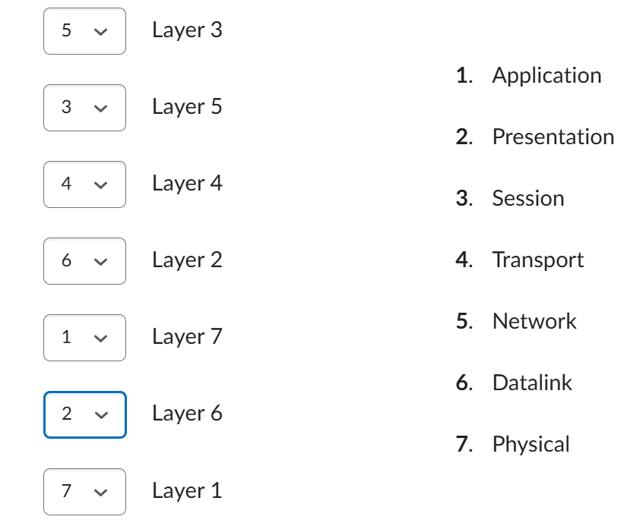
Question 2: Which protocol implements ping request and replies?
A. ICMP B. IP C. Echo Request/Echo Reply D. Client/Server
Question 3 : How many DNS queries were captured? (Be careful not to include DNS query responses in your answer) provide a numeric answer：1
Question 4: For approximately how long did this capture run?
A. Less than one second B. 1 Second C. 10 Seconds D. 20 seconds E. 1 minute F. 9 minutes
Question 5 : Match the protocols to their correct OSl layer number.
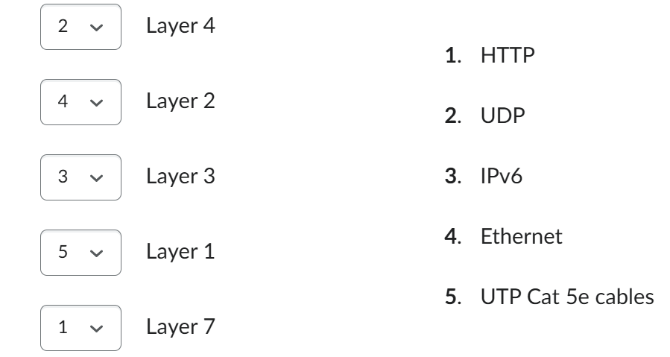
Question 6 : How many "frames" are in this capture? (numeric answer): 13
Question 7 : Match the Protocol Data Unit (PDU) name to its corresponding OSl layer name.
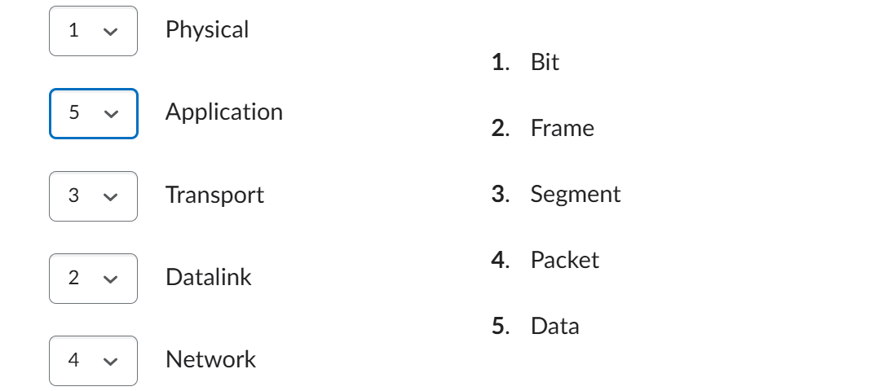
Question 5 : Expand the section for Frame 3. Locate the Domain Name System (Query) area and drill down until you find the "Name" field. What is the value of this field?
www.osi.local
Question 3: What Application Layer protocol is being sent in frame #4?
A. IP B. TCP C. DNS D. HTTP E. None
Question 5

Saved
How many different types of protocols are shown in the "Packet List" pane? (numeric answer)
Question 5 options: 9

