Question 1: Referring to step 3c of task 3, why did your laptop ARP for the MAC address of 192.168.NN.1 when you were trying to reach the web server at 192.168.254.254.
A. The web server is on a different network segment, therefore, all remote communications are directed to my router's MAC address at 192.168.NN.1.
B. None of the answers!
C. My laptop needs to obtain the web server's MAC address and since it is on a remote network, it sends the ARP request to my router who knows the remote and local MAC addresses.
D. All local and remote communications are sent to the router!
Question 2 : What protocol is used on an Ethernet LAN by a host that wants to know (learn) the MAC address of another host on the network? You can assume this is an IP network.
A. TCP B. UDP C. ARP D. DNS
Question 3 : If an Ethernet frame is carrying an IP packet what would the (protocol) type/length field value be? include the leading 0x in your answer
Hint: Examine the HTTP request/response in your Task 3 Wireshark capture.
Question 3 options: 0x0800
Question 4 : Referring to the HTTP get request you identified in step 4 of task 3, examine the Wireshark capture (WS-Task3) to answer the following questions:
1) To which device does the destination MAC address belong?
2) To which device does the destination IP address belong?
A. 1) The MAC belongs to my router's LAN interface 2) The IP belongs to the Eagle Web Server
B. 1) The MAC belongs to my router's LAN interface 2) The IP belongs to my router's LAN IP
C. 1) The MAC belongs to my router's WAN interface 2) The IP belongs to the Eagle Web Server
D. 1) The MAC belongs to the Eagle Web Server 2) The IP belongs to the Eagle Web Server
Question 5 : The first 3 bytes of an Ethernet MAC address identify the manufacturer of the NIC. What is the abbreviation (in upper case) that is used for identifier?
OUI
Question 6 :
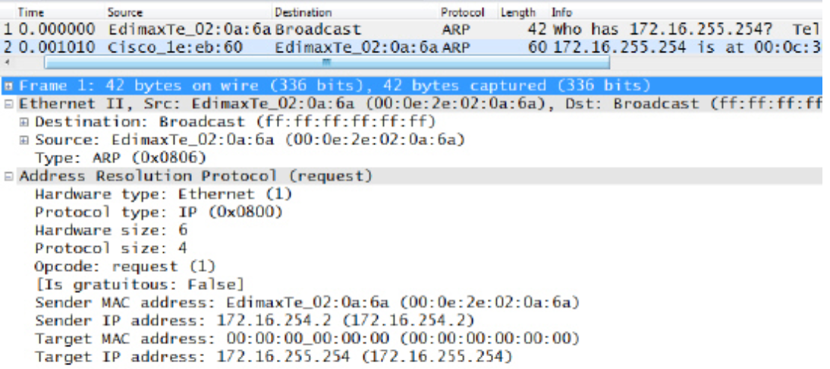
Based on frame 1 which of the following statements are true
A. The host with the IP address 172.16.255.254 is trying to find the MAC address of the host with IP address 172.16.254.2
B. The host with the IP address 172.16.254.2 is trying to find the MAC address of the host with IP address 172.16.255.254
C. The host requesting the MAC address sends it's request as a unicast message
D. The host requesting the MAC address sends it's request as a broadcast
E. The MAC address for the host with the IP address 172.16.255.254 is 00:0e:2e:02:0a:6a
F. The MAC Address for the host with the IP address 172.16.254.2 is 00:0e:2e:02:0a:6a
Question 7 :
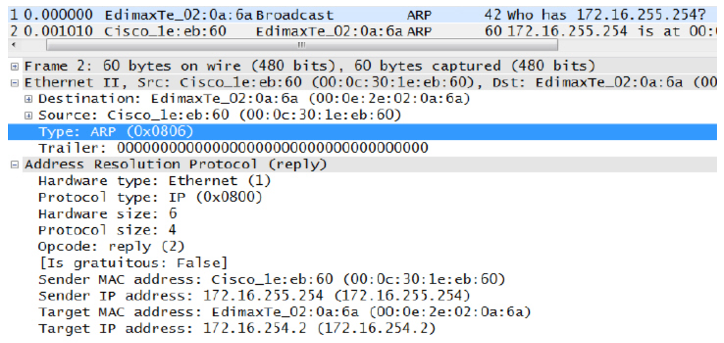
Based on frame 2 which of the following statements are true
A. The host sending this packet has the IP 172.16.255.254
B. The host with the IP address 172.16.255.254 is trying to find the MAC address of the host with IP address 172.16.254.2
C. This is a unicast frame
D. This a broadcast Ethernet frame
E. The MAC address for the host with the IP address 172.16.255.254 is 00:0c:30:1e:eb:60
F. The Mac Address for the host with the IP address 172.16.254.2 is 00:0c:30:1e:eb:60
Question 8 : What is the MAC address used for a broadcast by Ethernet?
ff:ff:ff:ff:ff:ff

