C-WAGS Trial Secretary Manual
Secretary Operations and Event-Day Reference Guide
Version 1.9 - Secretary Edition

Document status: This manual is limited to trial-secretary workflows. Public entrant instructions, restricted system-management controls, and features still under testing are intentionally excluded.

Contents
This manual is written solely for trial secretaries. It follows the secretary workflow from trial creation and approval through entry management, event-day operations, financial record keeping, reports, and closing.
- 1. About the Application
- 2. Secretary Role and Responsibilities
- 3. Logging In and Navigating
- 4. Creating a Trial
- 5. Configuring Days, Classes, Judges, Rings, Fees, and Capacity
- 5.7 Trial Application and Approval
- 6. Publishing and Managing Entries
- 7. Waitlists and Capacity Changes
- 8. Running Orders and Score Sheets
- 9. Live Event Operations
- 10. Scoring and Results
- 11. Financial Management
- 12. Trial Journal
- 13. Closing the Trial
- 14. Troubleshooting
- 15. Complete Trial Workflow
- 16. Page and Button Reference
- 17. Glossary
- 18. Final Secretary Verification

1. About the Application
C-WAGS Trial Management is an online web application hosted through Vercel and connected to a Supabase database. Clubs use the same current version through a web browser; no desktop installation is required.
Internet requirement: The production version requires internet access to communicate with Supabase. A browser may continue displaying an already-loaded page during a brief outage, but database changes cannot be considered saved until the connection returns.

The application is designed to support the complete administrative lifecycle of a trial:
- trial planning and setup
- public and secretary-entered registrations
- round-level capacity limits and waitlists
- running orders and score sheets
- live-event management and scoring
- financial tracking
- journal and audit records
- results and post-trial reporting
Application home or login screen
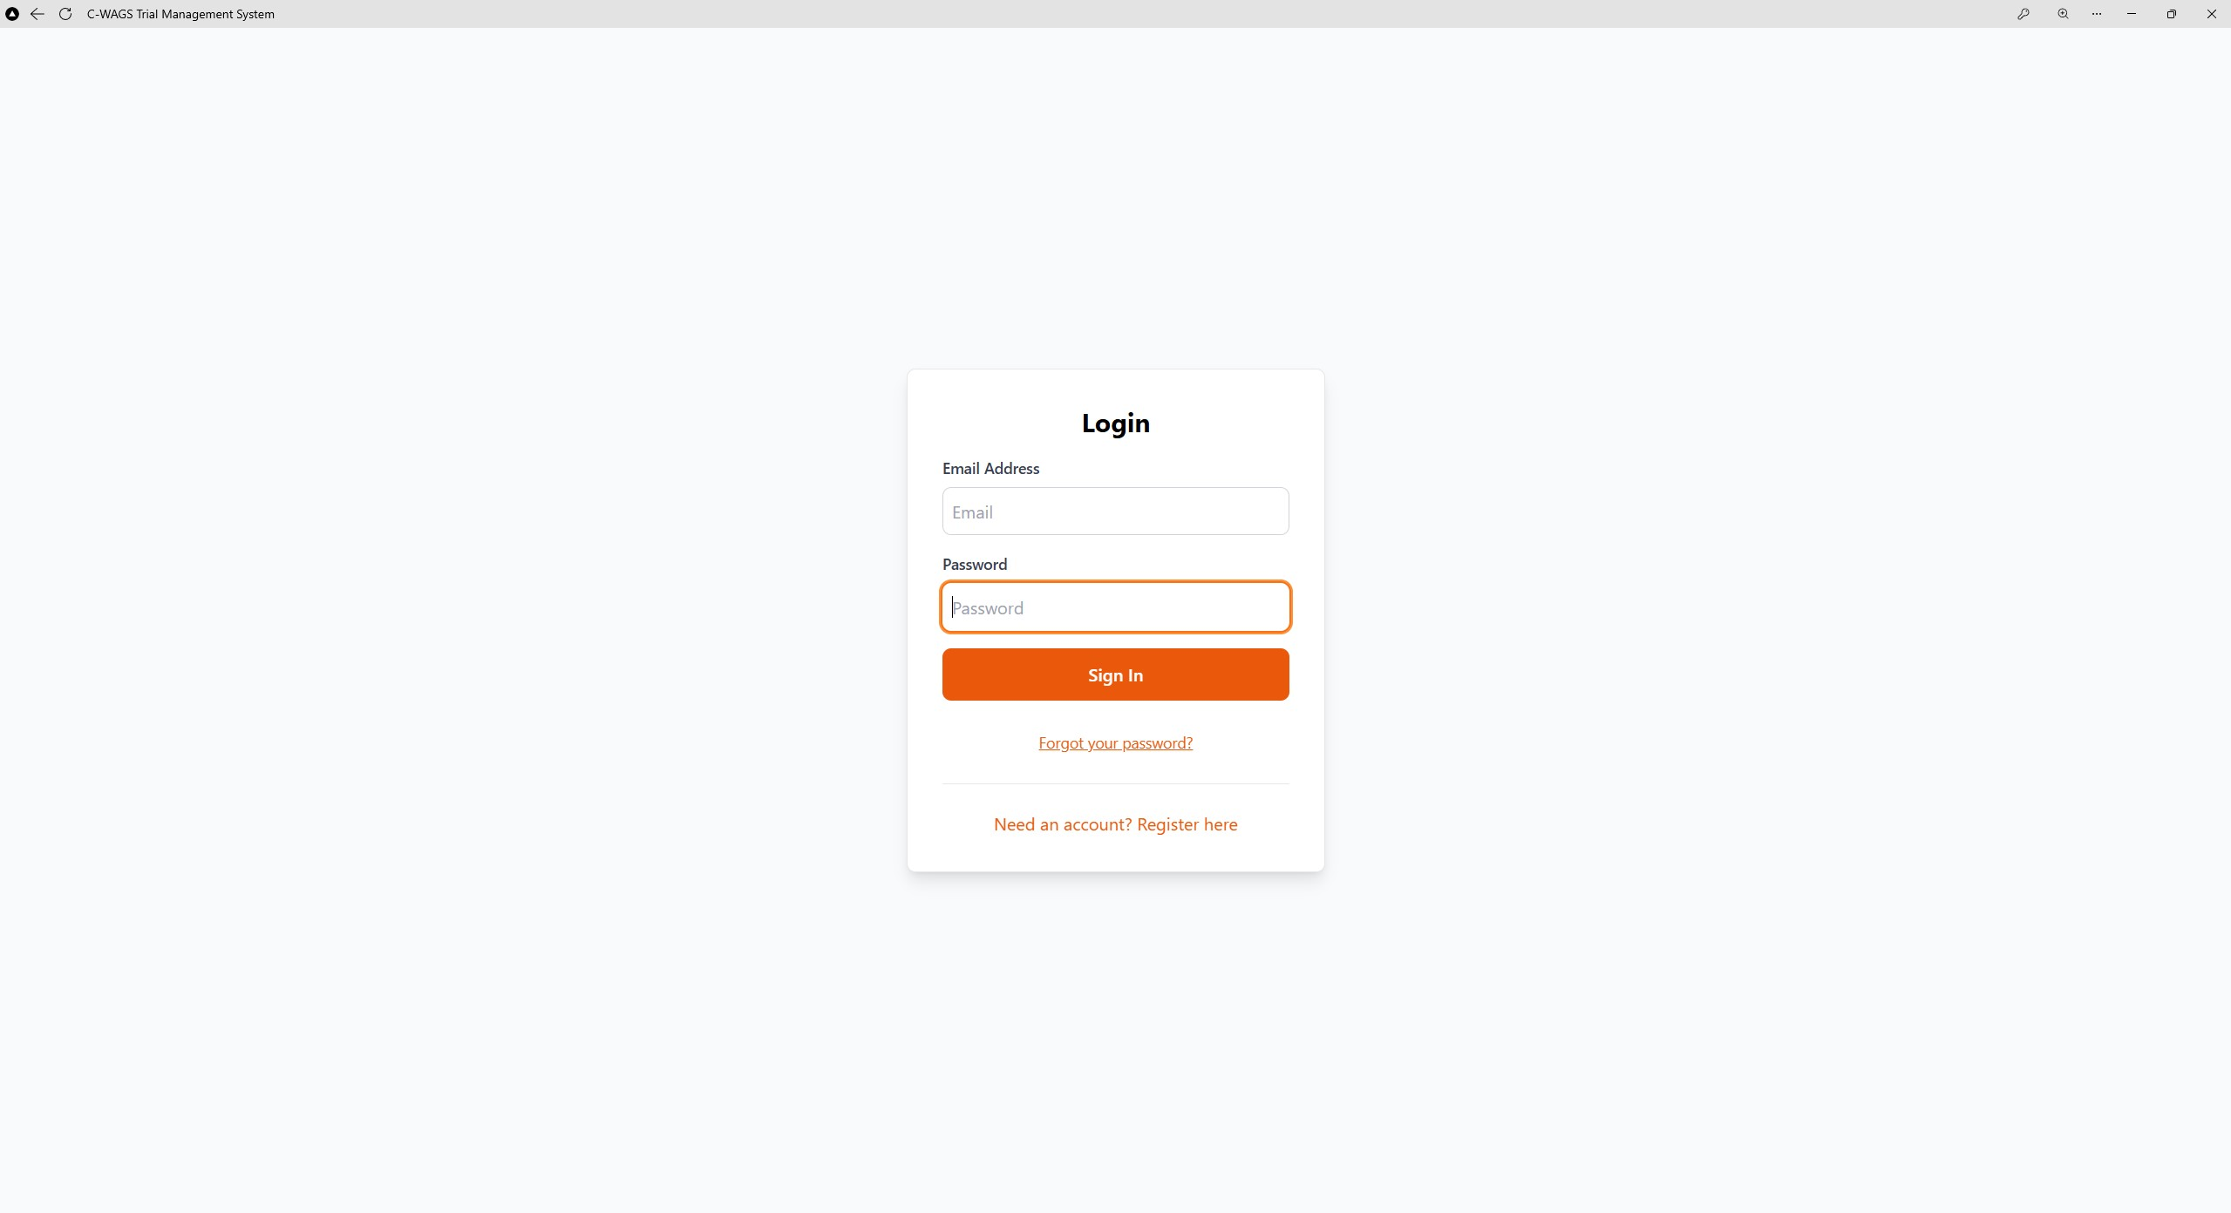
WHAT TO NOTICE
1. Use https://cwagstrialmanagement.vercel.app. 2. Enter the assigned email and password. 3. Use Forgot your password? when a reset is required.

2. Secretary Role and Responsibilities
Access and available actions depend on the user’s role and club permissions.
Role | Typical responsibilities | Examples of access
Trial secretary | Entries, running order, live event, scoring, finances, reports | Assigned trials and operational tools
Rule responsibility: The software supports the host’s workflow but does not replace the official C-WAGS rules, trial approval process, premium, insurance requirements, or the judgment of the C-WAGS Advocate and judge.

3. Logging In and Navigating
- Open https://cwagstrialmanagement.vercel.app in a current browser.
- Enter the email address associated with the club account.
- Enter the password and select Sign In.
- Confirm that the correct club and trial are shown before making changes.
Signed-in dashboard
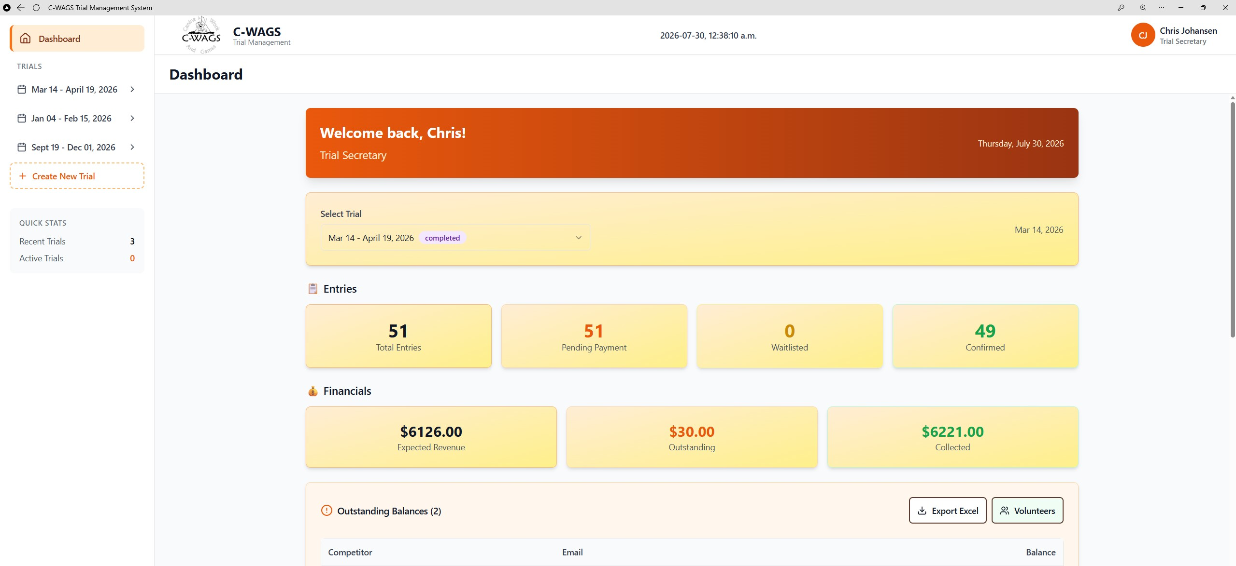
WHAT TO NOTICE
1. Confirm the signed-in secretary. 2. Select the intended trial. 3. Review entry and financial totals before opening a workflow.

Best practice: Use individual accounts rather than sharing one password. The journal is most useful when changes can be attributed to the person who made them.

4. Creating a Trial
Create the electronic trial only after the host has decided the dates, location, programs, classes, judges, rings or search areas, fees, and entry limits. These details parallel the information required on the official trial application.
- From the dashboard, select Create Trial.
- Enter the trial name and host organization.
- Enter the trial dates and location.
- Select the programs being offered: Obedience, Rally, Games, and/or Scent.
- Add the public premium or premium website information.
- Save the trial before adding detailed schedules.
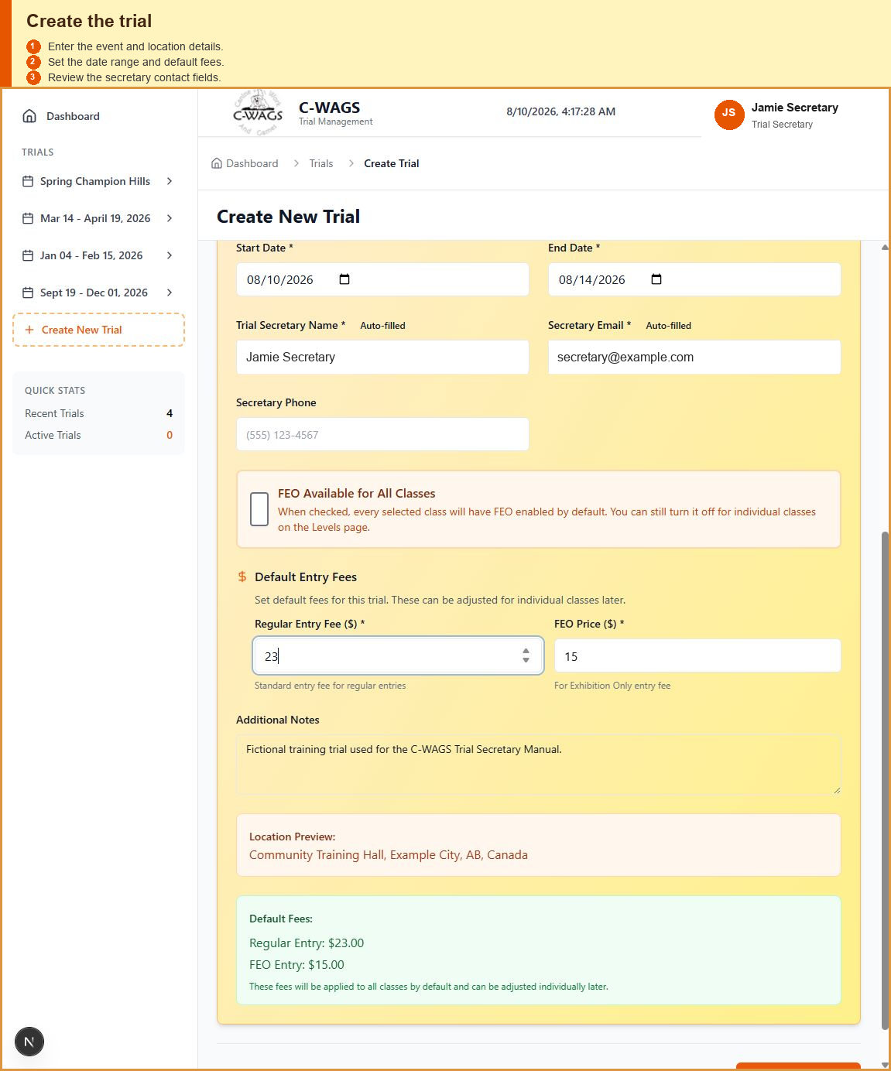
WHAT TO NOTICE
1. Complete the required trial and location fields. 2. Confirm the auto-filled secretary details. 3. Set the date range, default fees, and FEO availability. Capacity is configured later for classes and rounds.

Trial approval: Do not publish an entry link before the trial is approved and the premium is ready. The Host Guide states that a premium should not be posted until approval is received.

5. Configuring the Trial

5.1 Trial Days
- Add each date on which classes will be offered.
- Verify the chronological order.
- Confirm start times and any day-specific notes.
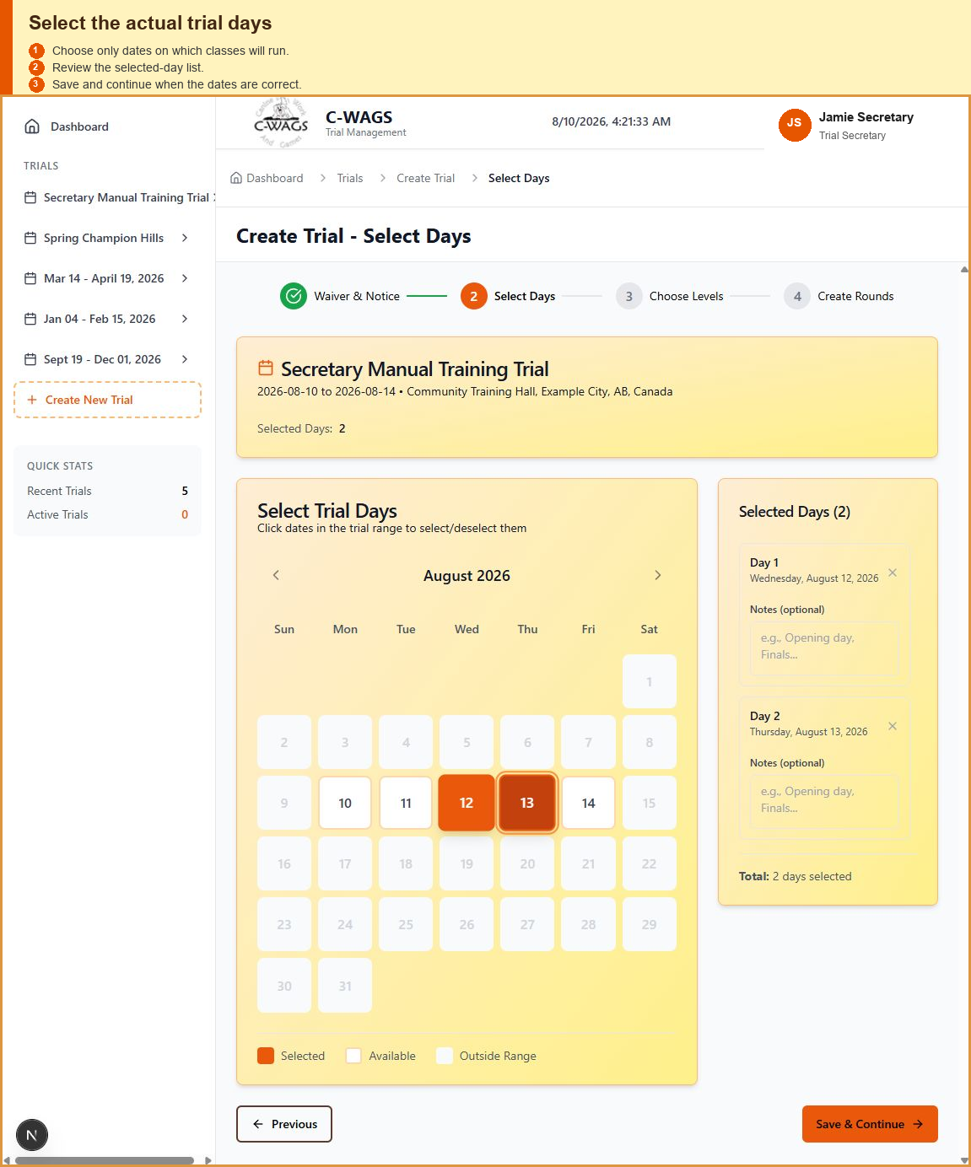
WHAT TO NOTICE
1. Select only actual trial dates. 2. Add optional notes for a selected day when useful. 3. Review the selected days before Save & Continue. Day-level capacity is not used.

5.2 Judges
- Complete Basic Info, Select Days, and Choose Levels before assigning judges.
- On Create Rounds, select the trial day and class, add the required round, and then select its judge.
- Confirm each round's judge and capacity. Start Time and Estimated Duration are optional planning aids and may be left blank. When a reset is required, select Add Reset Round and enter the reset judge once on the new half-round card, such as Round 1.5.
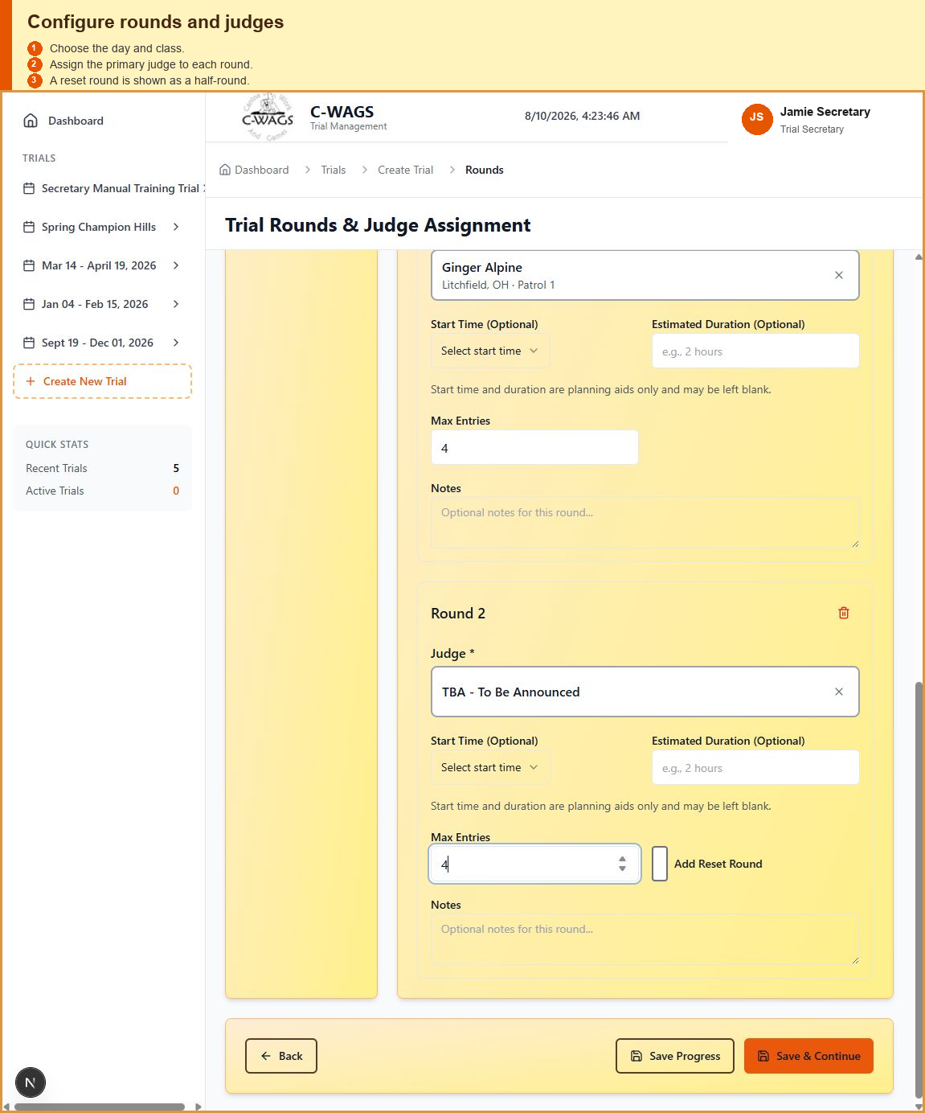
WHAT TO NOTICE
1. Select the trial day and class. 2. Configure each round and its judge. 3. Start Time and Estimated Duration are optional and may be blank. 4. Add Reset Round creates a half-round; select its judge once on that new card.

5.3 Classes and Rounds
A class may contain one or more rounds. Capacity and entry status are tracked at the selection or round level, not only at the whole-entry level.
- Add each class offered.
- Add the required number of rounds or resets.
- Set the judge, day, ring/search area, fee, and FEO fee as applicable.
- Set a capacity limit when the host intends to cap entries.
Class and round configuration
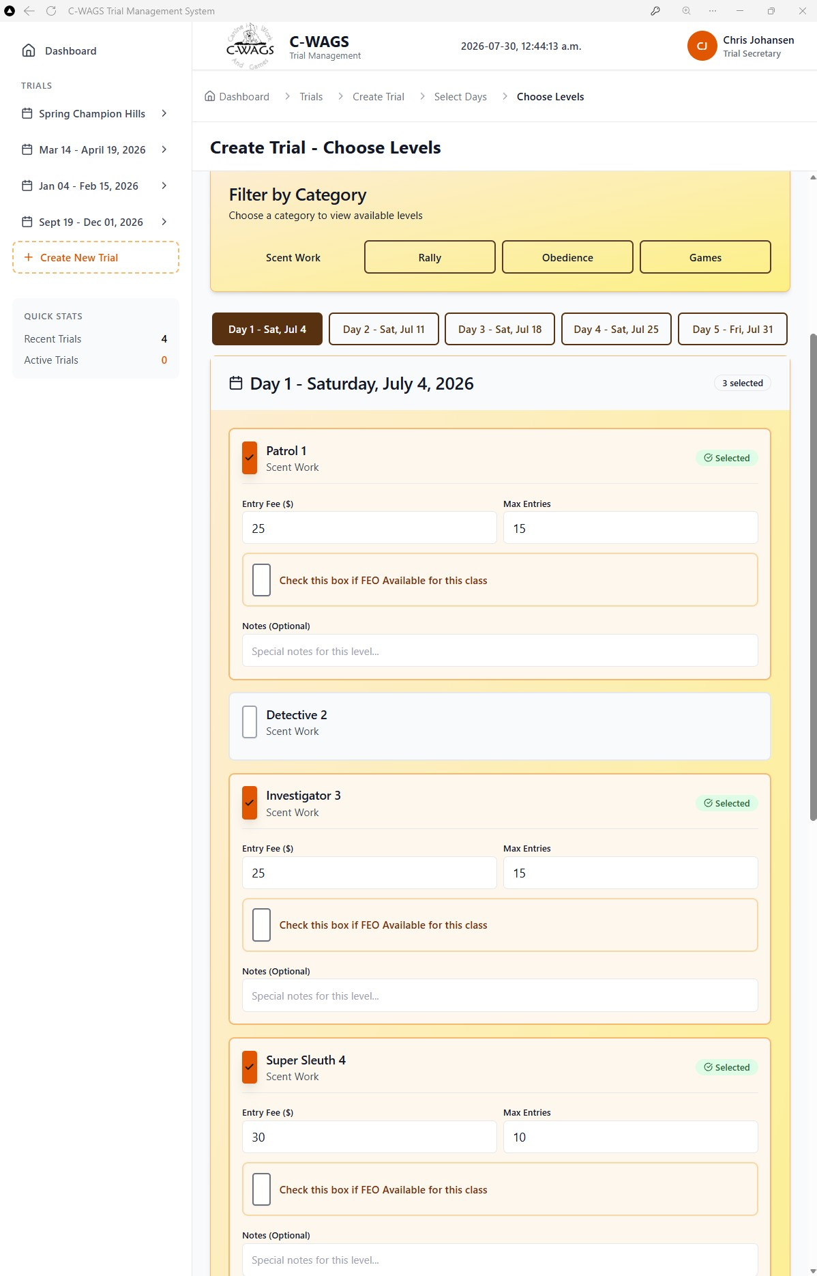
WHAT TO NOTICE
1. Filter by category and select the trial day. 2. Choose the offered levels. 3. Set each level's fee, capacity, FEO availability, and notes. Judges are not assigned on this screen.

5.4 Rings and Search Areas
Use consistent ring or search-area names, especially at multi-ring trials. Names such as “Ring 1,” “Ring 2,” and “Search Area A” should match the premium and trial-day signage.
Multi-ring clarity: Every live-event view, running order, and future competitor display should identify the ring or search area prominently. This reduces confusion when several classes are running simultaneously.

5.5 Fees
Enter the standard fee and, when offered, the FEO fee for each class or round. Waitlisted rounds retain their potential fee but do not count toward the current amount due until promoted.
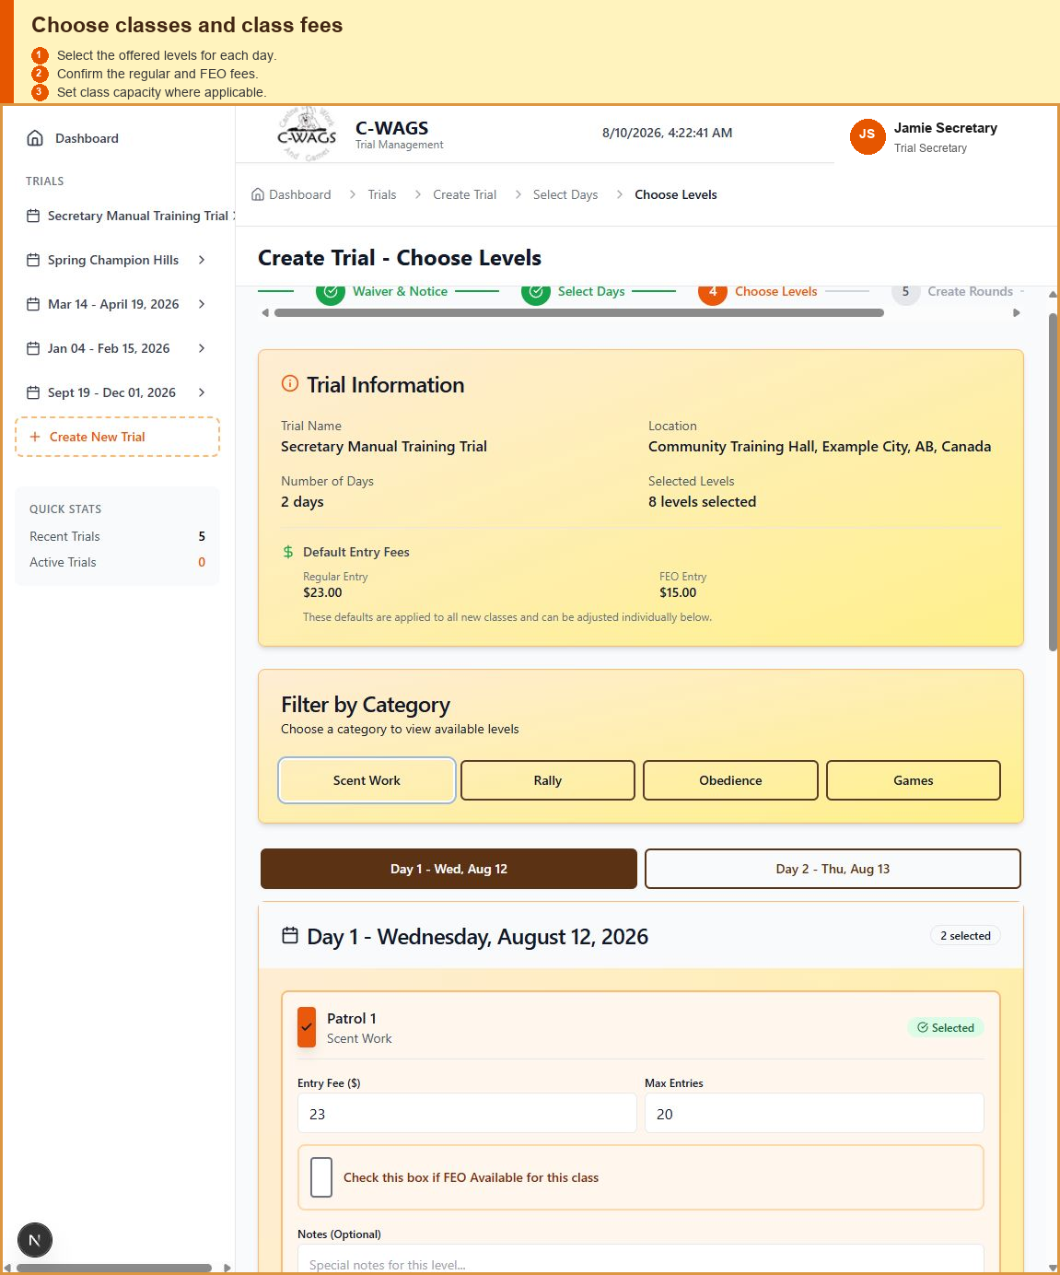
What to verify: Show regular and FEO fees for at least two classes.

5.6 Capacity
Capacity limits apply to individual rounds. A competitor may therefore be accepted in available rounds while being waitlisted in a full round.
Example: A dog entering Patrol 1 Rounds 1, 2, and 3 may be accepted in Round 3 while Rounds 1 and 2 are waitlisted. The accepted round remains valid.

5.7 Trial Application and Approval
After the trial has been configured, generate the Trial Application while the trial is still in Draft. The application can be completed and submitted to C-WAGS before the public trial is published or opened for entries.
- Review the configured days, classes, rounds, judges, fees, capacities, host, dates, and location.
- Open Trial Application and complete any application-only information.
- Download the completed PDF and submit it to C-WAGS for approval.
- Keep the trial in Draft while approval is pending.
- After C-WAGS approval is received, return to Trial Details, publish the trial, and open entries when the host is ready.
Publishing is a separate step. Generating the application does not publish the trial, and the trial does not need to be published before the application is produced.
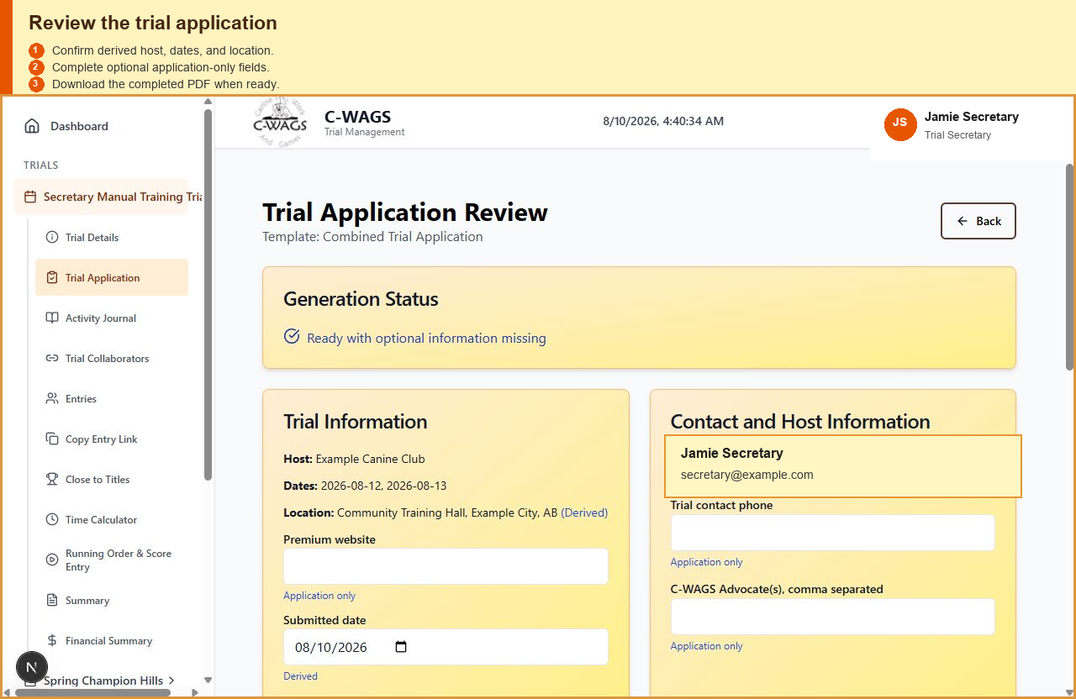
Generate and submit the Trial Application while the trial remains in Draft; publish only after approval.

5.8 Trial Collaborators and Staff Roles
Trial Collaborators allow additional registered users to help with one trial without giving them access to every trial in the system. The person who created the trial is its owner; the owner or an application administrator controls collaborator invitations, role changes, and removal.
- Open Trial Collaborators from the selected trial's sidebar menu.
- Enter the registered user's email address, choose the least-privileged role that fits the assignment, and send the invitation.
- Ask the invited person to sign in and accept the invitation before relying on the assignment.
- Remove or reduce access when the assignment ends.
Secretary: may edit trial setup; manage entries, waitlists, running order, and scores; manage financial records; and generate reports and the Trial Application. A secretary invited to an existing trial cannot manage collaborators or delete the trial. Those actions remain with the trial owner or an administrator.
Assistant: may view the trial and help with entries, waitlists, running order, and score entry. An assistant cannot change trial setup, manage financial records, generate reports or the Trial Application, manage collaborators, or delete the trial.
Use Assistant for event-day help and Secretary only when the person must configure the event or work with financial and official reporting functions. Collaborators never receive access to unrelated trials through this assignment.

5.9 Moving a Postponed Trial Day
Use Edit Days to move an existing trial day to a replacement date. This is not a click-and-drag action. Change the date on the existing day so its classes, rounds, judge assignments, and entries remain attached.
- Open the trial from the dashboard and select Edit Days.
- If the replacement date is outside the current trial range, change Start Date or End Date under Edit Trial Date Range, then select Update Date Range.
- In the Selected Days panel, find the postponed day and select its Trial day date field.
- Choose the replacement date from the date picker or type the new date.
- Select Save Changes at the bottom of the page.
- Return to the trial and verify the new date, classes, rounds, judges, and entry list before reopening entries or continuing event-day work.
Do not remove the old day and create a new one when the day already has setup or entries. Editing the existing Trial day date preserves the day record and its attached information. Each trial day must use a unique date.

6. Publishing and Managing Entries
- Review the trial dates, classes, fees, judges, capacities, and public instructions.
- Open or enable public entries.
- Test the form using a designated test team.
- Confirm that the entry appears correctly on the secretary Entries page.

Scheduled Automatic Opening
A secretary may schedule one opening date and time instead of returning to the program to open entries manually. The timer uses the timezone where the trial is held, not the timezone of the secretary's computer or current location.
- Open Entry Control for the selected trial.
- Under Automatic Opening, choose the opening date and local time at the trial location.
- Choose the timezone where the trial is being held. Use that timezone even when scheduling while travelling.
- Select Save Automatic Opening. The trial returns to Not Yet Open and the public entry page displays a live countdown.
- At zero, the public form begins accepting entries automatically. The server also enforces the opening instant, so changing a device clock cannot open the form early.
- Use Open for Entries to open early if required. Use Closed at any time when the trial is full; manual closure overrides the saved opening schedule.
Existing trials without a saved automatic opening continue to use the manual Not Yet Open, Open for Entries, and Closed controls.

Entries Without an Issued C-WAGS Number
A competitor who is waiting for a registration number can select the waiting-for-number option on the public entry form. The program keeps the entry under a temporary internal number until the official C-WAGS number is received.
- The competitor enters their email address, phone number, and dog name so the entry can be found again without a C-WAGS number.
- Waitlisted and accepted rounds follow the same capacity and fee rules as other entries.
- When the number is issued, the competitor or secretary uses the received-number update and verifies the replacement before saving.
- After replacement, confirm that the registration number appears on the Entries page and that the existing selections, fees, running positions, and scores remain attached.

Deleting an Entry
Delete Entry is intended for a duplicate or genuinely invalid entry, not an ordinary withdrawal. Because deletion also removes financial and result records, only an administrator, trial owner, or secretary with financial permission can use it. Assistants cannot delete entries.
- Open the Entries page and verify the handler, dog, registration number, selected rounds, amount paid, and reason for deletion.
- Select Delete Entry and read the first warning.
- Select Continue only after confirming that the correct entry is displayed.
- Type DELETE in the second confirmation and select Permanently Delete Entry.
- Confirm that the entry disappeared and that remaining running positions are consecutive.
Permanent deletion removes the entry's class selections, scores, and payment transactions. Earlier journal history is preserved and a deletion record remains in the Activity Journal. This action cannot be undone.
Trial publishing controls
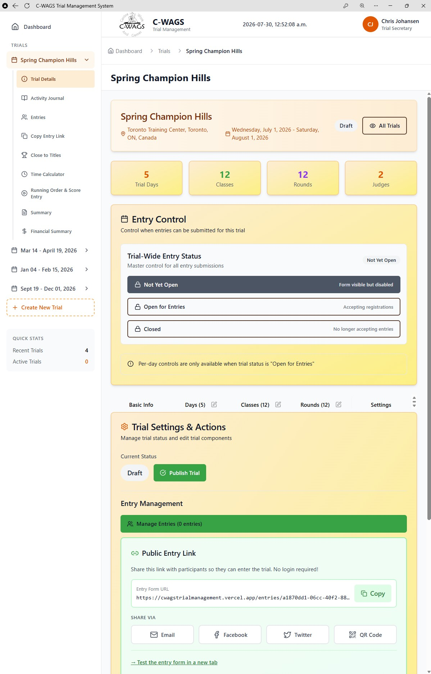
WHAT TO NOTICE
1. Verify the trial summary and Entry Control status. 2. Use Not Yet Open, Open for Entries, or Closed deliberately. 3. Publish only after dates, classes, rounds, judges, fees, and instructions are complete.
Not Yet Open public confirmation
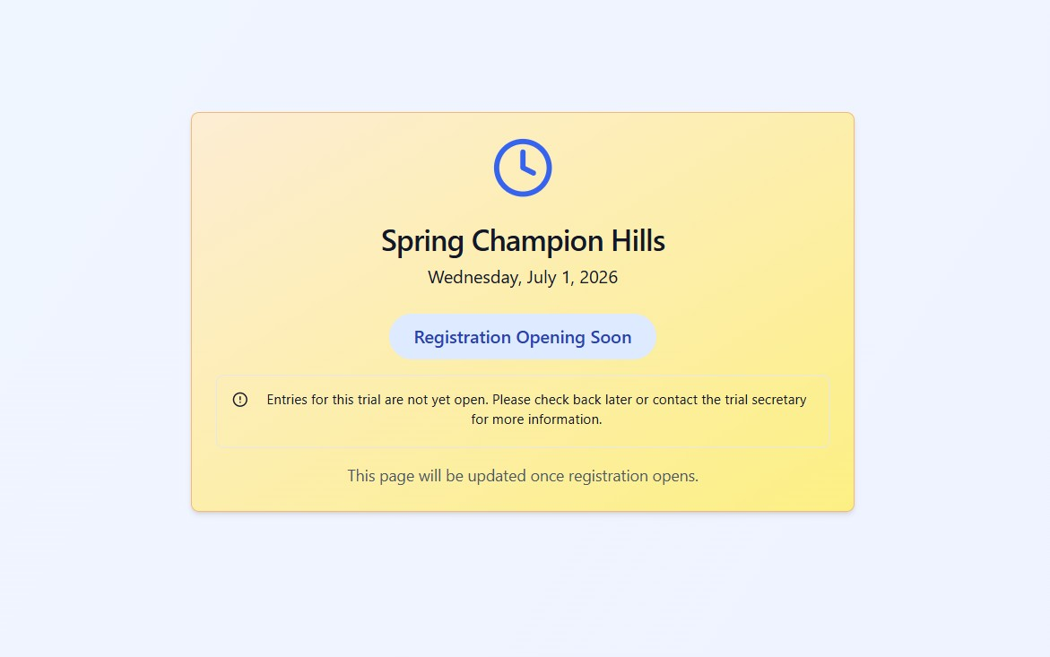
WHAT TO NOTICE
1. Confirm the correct trial name and date. 2. Registration Opening Soon confirms the link works. 3. The message confirms entrants cannot submit yet.

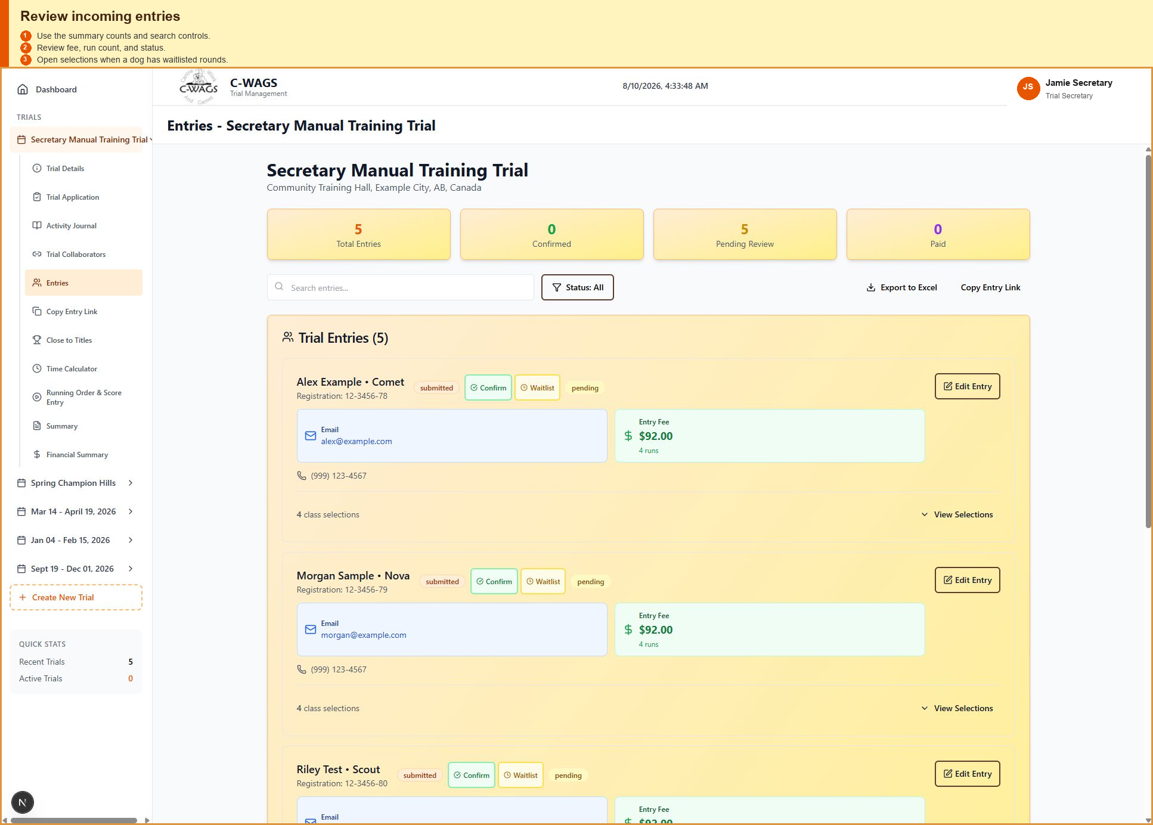
What to verify: Show accepted, mixed accepted/waitlisted, fully waitlisted, withdrawn, and paid/unpaid examples.

7. Waitlists and Capacity Changes

7.1 Selection-Level Waitlisting
Waitlisting is handled per selected round. Waitlisted selections must not appear in the active running order, score sheets, or digital scoring until promoted.

7.2 Waitlist Order
The waitlist should be displayed in the order entries were received. The secretary may promote any dog when there is a legitimate reason, such as a replacement run owed from an earlier issue.

7.3 Promotion
- Open Live Event and select the class and round.
- Review the waitlist shown below the active runs.
- Select Promote beside the desired dog.
- If the dog is not first in line, review the out-of-order warning.
- If the round is full, confirm the capacity increase.
- Verify that the dog moved to the active running order and that its fee became due.
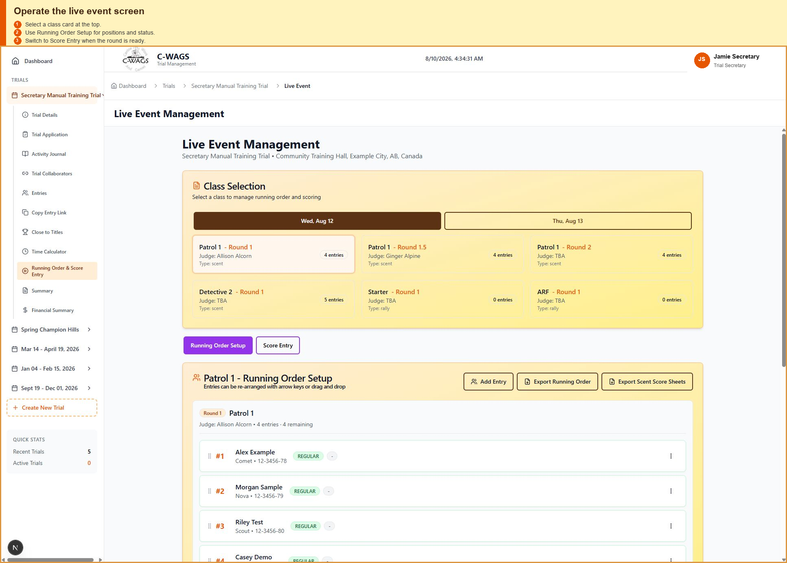
What to verify: Show the active runs, chronological waitlist, entry times, capacity, and Promote controls.

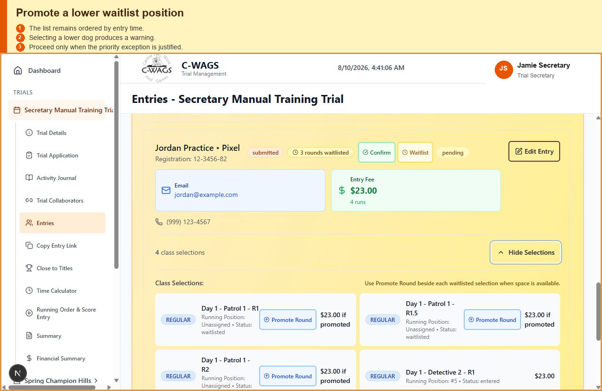
What to verify: Show the confirmation presented when a lower waitlist position is selected.

What to verify: Show old capacity, new capacity, selected dog, and final confirmation.

8. Running Orders and Score Sheets
Running orders should contain only active selections. Waitlisted and withdrawn selections are excluded. A waitlisted selection should receive a running position only after promotion.
- Open the required day, ring, class, and round.
- Review scratches, no-shows, and conflicts.
- Reorder active dogs when necessary.
- Generate or export the running order.
- Generate score sheets from the same active list.
Rule alignment: C-WAGS guidance expects dogs to be judged in scheduled order as much as possible, while allowing movement for conflicts. The software should preserve a clear, deliberate record of those changes.

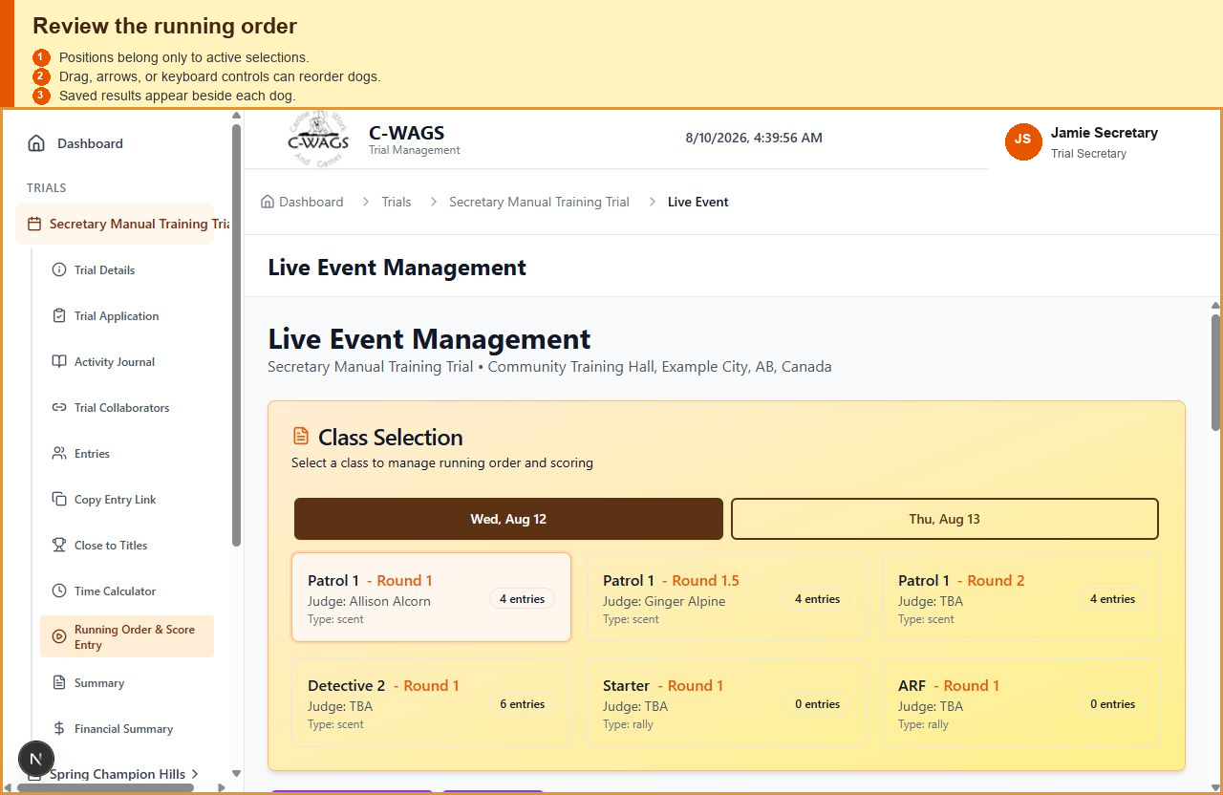
What to verify: Show positions, handler, dog, class, round, jump height where applicable, and status.

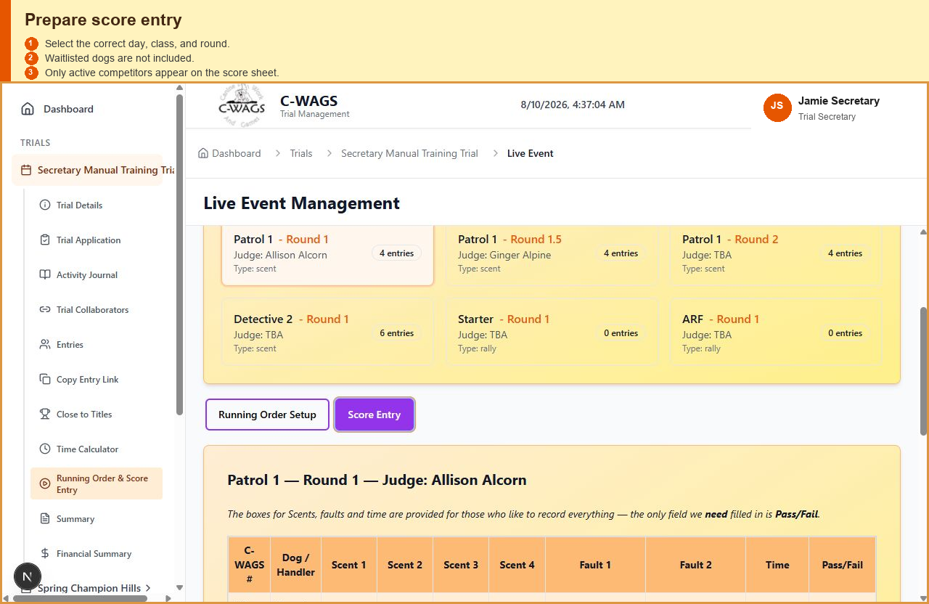
What to verify: Show class/round identification and no waitlisted dogs.

9. Live Event Operations
Live Event is the secretary’s primary trial-day workspace.
- choose the current day, ring, class, and round
- review active runs and the separate waitlist
- mark scratches, absences, or no-shows
- promote selected waitlisted dogs
- adjust capacity where permitted
- enter or review scores
- monitor remaining dogs
What to verify: Capture the full page with ring, class, round, active count, waitlist count, and primary controls.

Quick status actions
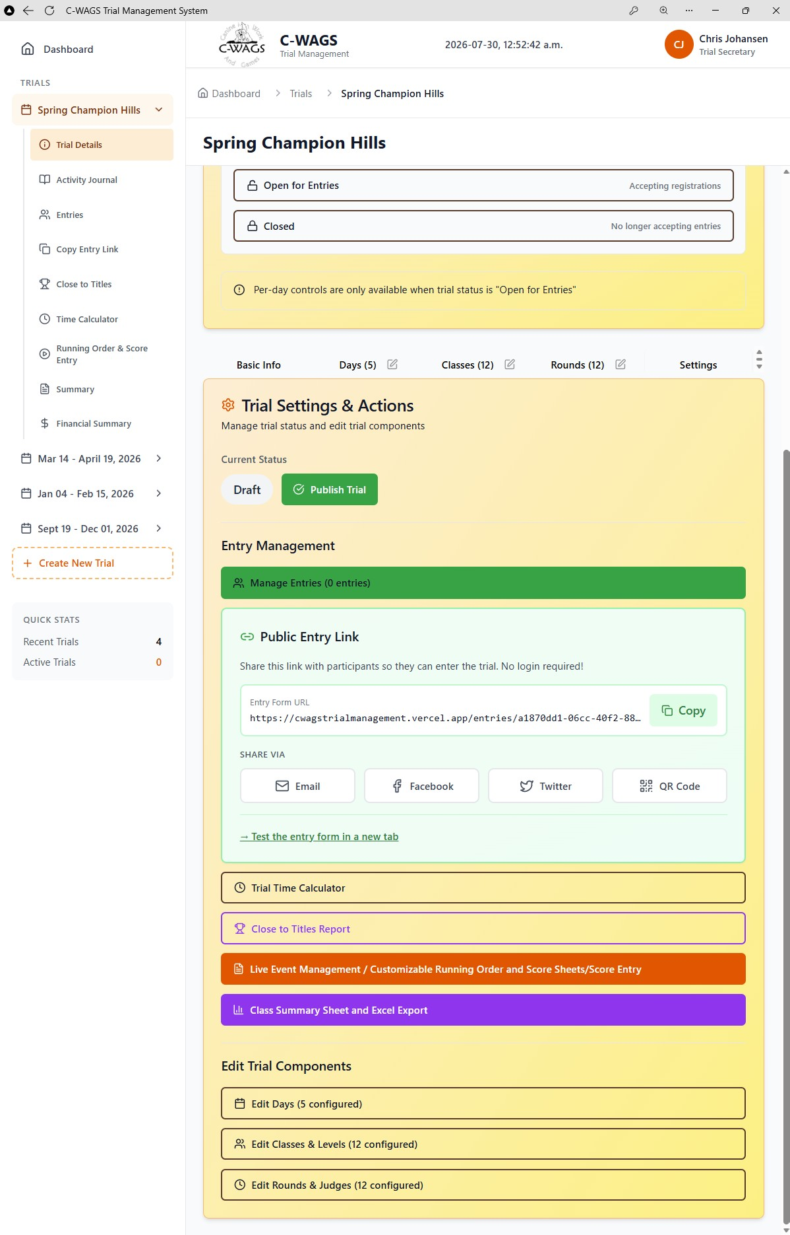
WHAT TO NOTICE
1. Confirm the selected trial and current status. 2. Copy or test the public link when needed. 3. Use the colored action buttons to open the appropriate secretary workflow.

Trial-day discipline: Before printing final paperwork, complete check-in and resolve known scratches. This reduces paper waste and helps keep the running order accurate.

10. Scoring and Results
Scoring screens and exports must follow the rules of the selected program and class. Scent classes are pass/fail; Rally and Obedience use scored exercises and qualifying thresholds defined by their rules.
- Open the correct class and round.
- Confirm the judge and running team.
- Enter the score or pass/fail result.
- Record faults, time, division, FEO status, or notes where applicable.
- Save and verify the result before advancing.
- Use the correction workflow when a saved score must be changed.
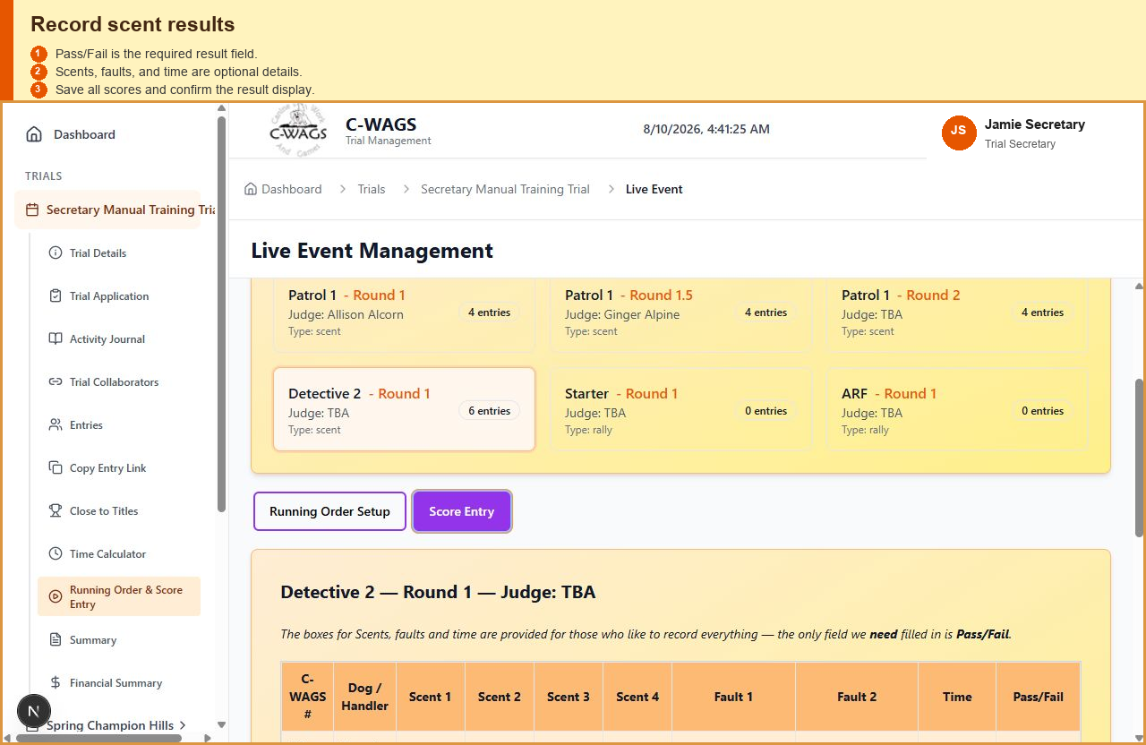
What to verify: Show pass/fail, faults, time, judge, and notes.

FEO: FEO scores are not recorded as official qualifying results and do not earn placements. The software should clearly mark the run as FEO in scoring and reports.

Award Confirmations and title verification
Open Award Confirmations from the selected trial sidebar, or use the title-verification export from Summary. This page helps the host review likely title and Ace awards after scores have been saved.
Timing is important: Close to Titles and Award Confirmations use the dog's existing totals from the C-WAGS tracker as the prior record, then add qualifying results saved in the current trial. Generate and retain both reports before the current trial's results are posted to the tracker. After posting, the tracker may already include those same results, so the reports can overstate progress by effectively counting the current trial twice.
- Select Refresh Saved Results after any score correction so the candidate list reflects the latest saved results.
- For a title candidate, review the prior qualifying judges, the qualifying judges in this trial, and the unique-judge total. A title requires qualifying results under at least two different judges; a candidate who has not met that requirement cannot be confirmed.
- Ace awards do not use the two-judge title requirement. Review the qualifying result count shown for the Ace candidate.
- Confirm or exclude each candidate as appropriate, then select Export Confirmation XLSX when the host wants a workbook for posting or record keeping.
- Saving confirmations requires the optional award-confirmation database table. Candidate review and export remain available even when that optional table has not been installed.
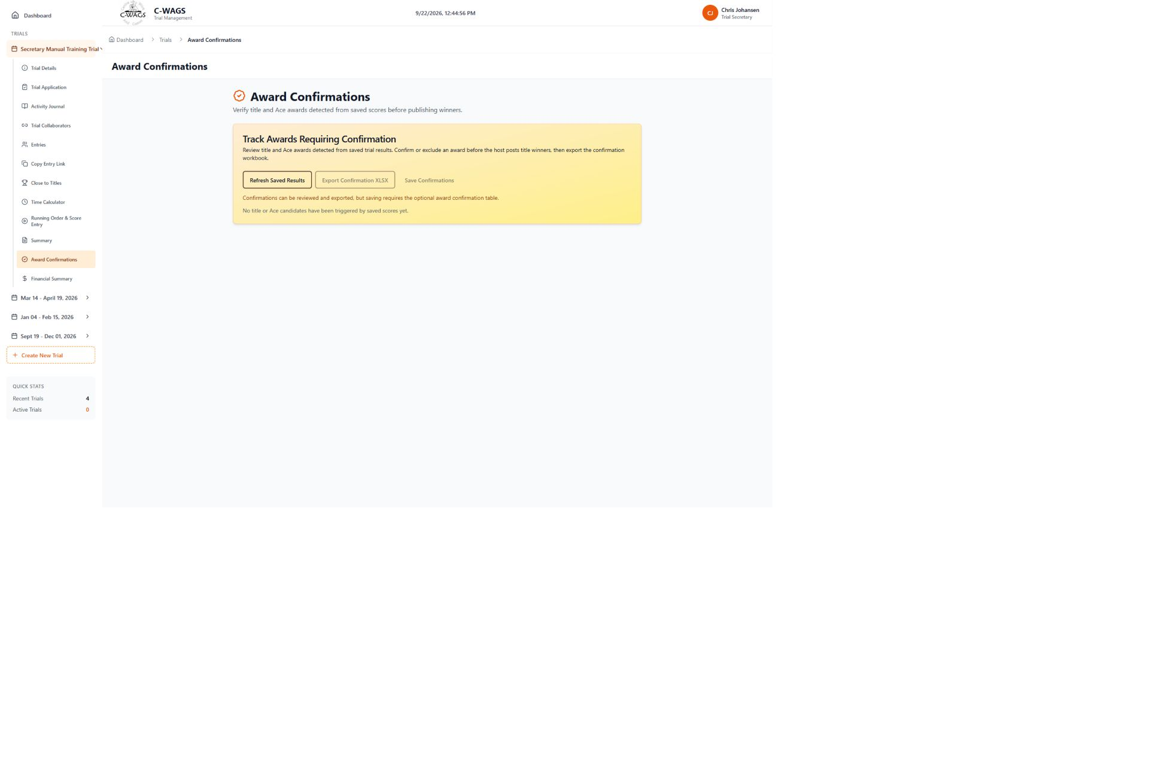
Award Confirmations keeps title verification available without the hidden ribbon-estimator workflow.

11. Financial Management
The public form quotes the fee for available rounds at submission. Full rounds remain waitlisted and show $0 now with the amount that would be charged if promoted. The secretary must not count a waitlisted round as an accepted fee.

From quote to accepted fee
- Submitted entry: available regular and FEO rounds have a quoted total. In the Financial Summary, the quote appears under Awaiting Acceptance rather than Total Entry Fees.
- Confirmed entry: the secretary accepts the entry. Its active-round fee moves into Total Entry Fees; the separate awaiting-acceptance quote decreases.
- Entry Fees Collected is the net of recorded offline payment transactions. A payment is a separate fact from the fee quote or the entry status.
- Entry Fees Outstanding is the remaining balance for accepted entries. Review credits and advance payments separately; a payment recorded before acceptance does not itself confirm an entry.
- If a round is added, dropped, changed between Regular and FEO, or promoted from a waitlist, review its new fee and the entry total. Waivers and reduced judge or volunteer rates are separate actions.
The entry record stores the active-round fee even while the parent status is Submitted. The Financial Summary separates that figure for reporting. If another page appears to treat a submitted quote as already owed, check the entry status and the selections before using that total.
Financial views are record-keeping tools. The application does not process credit cards or transfer funds. Secretary records should distinguish:
- current amount due
- amount paid
- balance owing
- potential waitlist fees
- waived fees
- refunds or credits
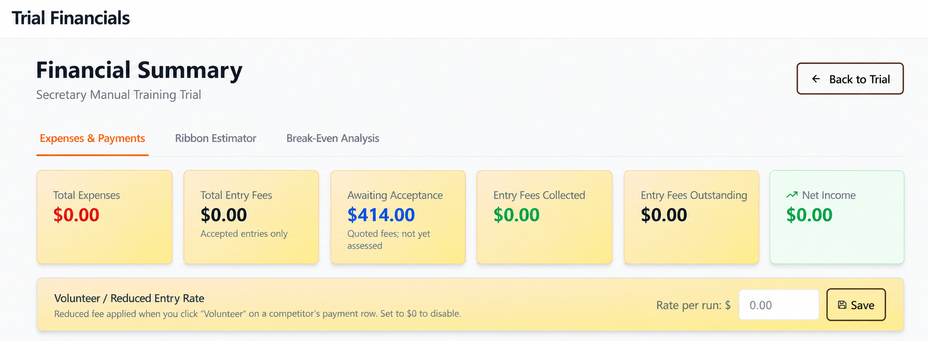
What to verify: Show accepted charges, $0 current waitlist charges, payment, and balance.

What to verify: Show reason and resulting journal entry.

Break-Even setup and the C-WAGS amount
The Break-Even page stores the trial's planning assumptions. The C-WAGS field is a per-regular-run rate, not a lump-sum invoice field. The published charge is currently US $1.75 per regular run. A Canadian host may save either US $1.75 for a USD estimate or a chosen Canadian-dollar equivalent per run for a CAD estimate. Use one currency consistently throughout the trial's financial records.
- Open the trial and select Financial Summary.
- Select the Break-Even Analysis tab.
- In C-WAGS Fee (per run), enter either 1.75 for the current USD rate or the club's chosen Canadian equivalent for one regular run. Do not enter the total remittance in this box.
- Review the other assumptions on the page, then select Save Configuration.
- Wait for the save confirmation before leaving the page.
Select Save Configuration and wait for confirmation. The saved per-run rate reloads when the secretary returns, and the Expenses & Payments tab automatically multiplies that rate by the current regular-run count. The resulting C-WAGS line is a planning estimate until the actual payment is sent.
When the final remittance is known, compare it with the estimate and retain the actual paid amount in the club's records. If the secretary wants the on-screen estimate to equal the final remittance, divide the final amount by the final billable regular-run count and save that effective per-run amount. Never replace the per-run field with the lump-sum payment itself.
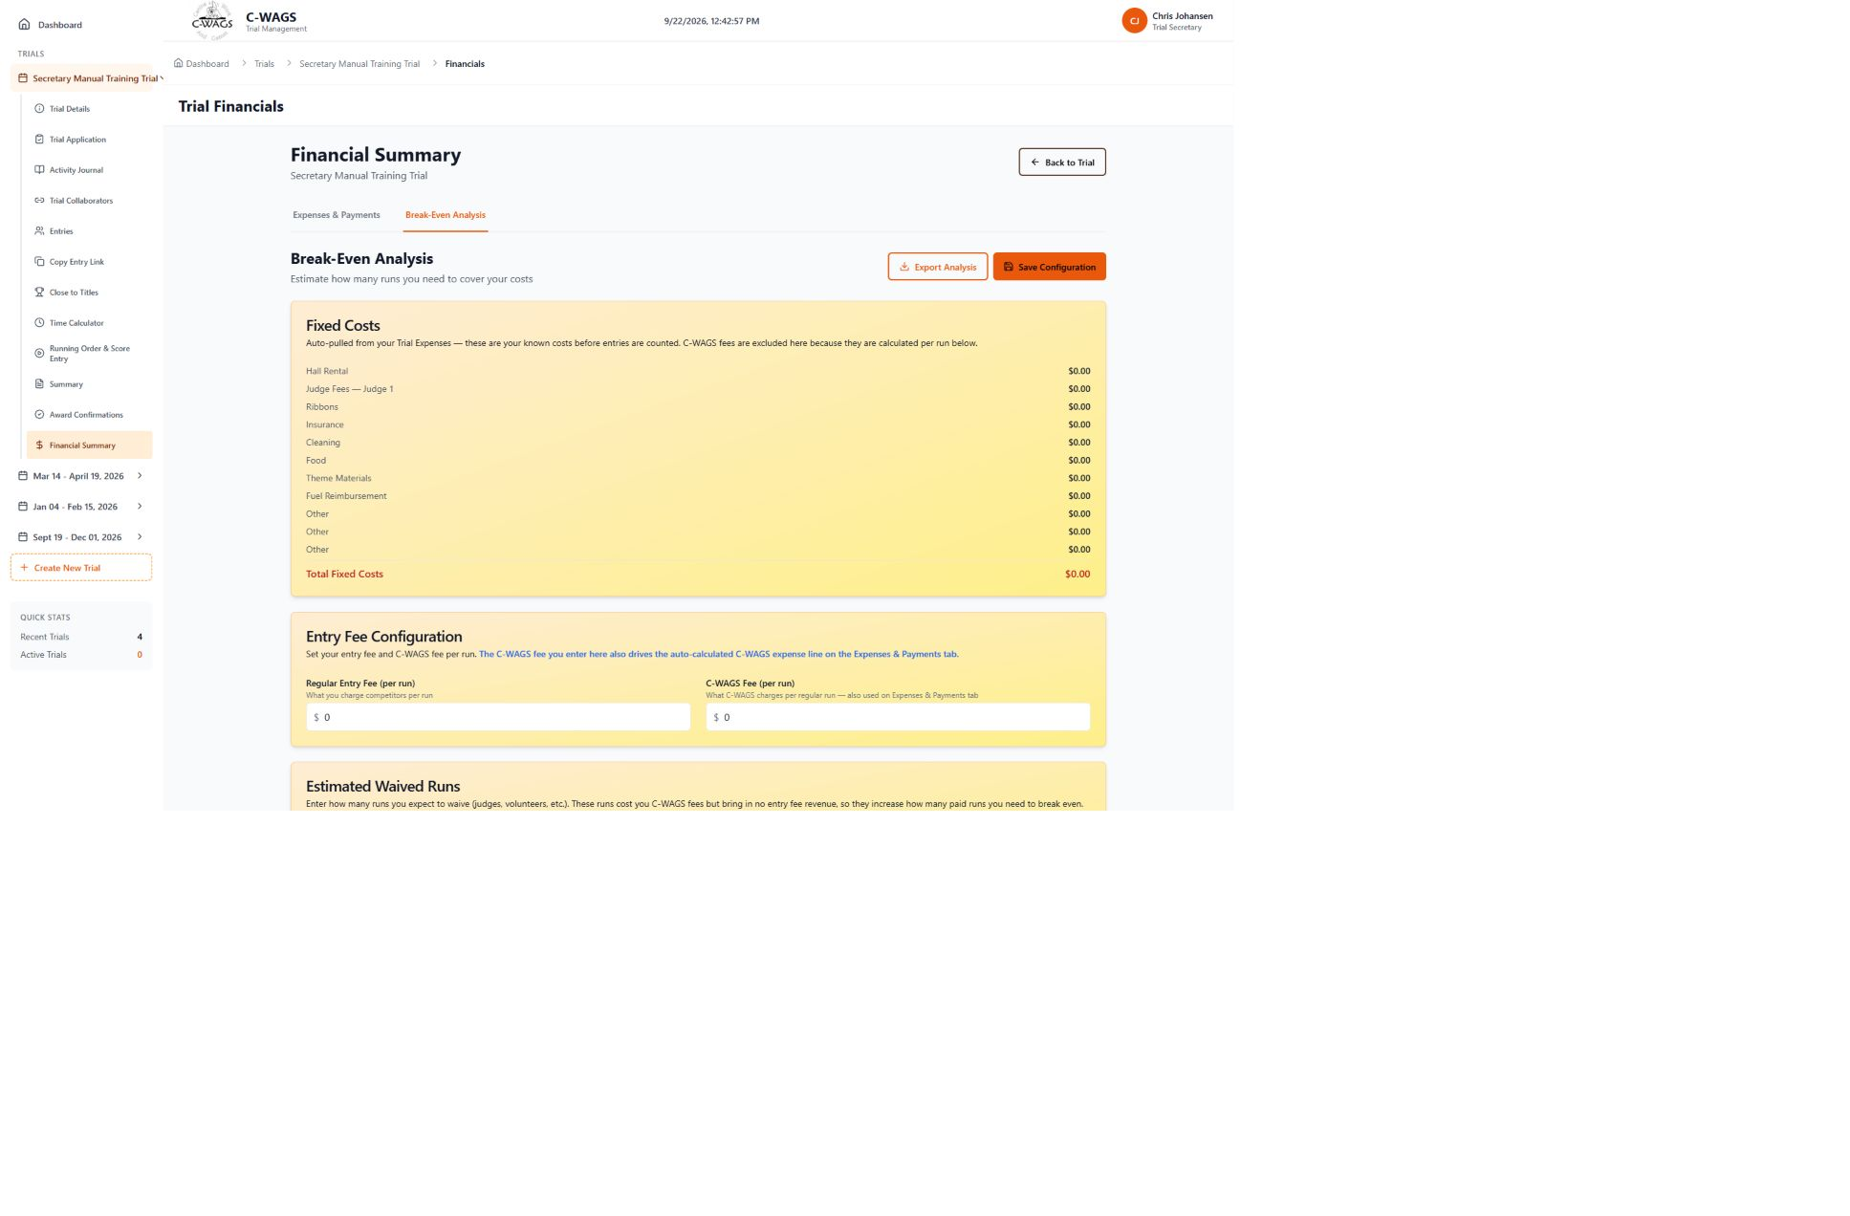
Break-Even Analysis: save the per-run C-WAGS assumption so the automated expense estimate remains available when the page is reopened.

How the calculation changes
- The Break-Even C-WAGS estimate currently counts active regular selections. Review submitted entries separately before treating this estimate as a final amount owed.
- A waitlisted round has a current fee and C-WAGS amount of $0 until it is promoted.
- Promoting a waitlisted run makes it active and adds it to the calculation.
- A withdrawn or waitlisted selection does not count as a billable run. A scored fail still represents a run and remains in the run count.
- A waived regular entry still represents a run owed to C-WAGS; the club absorbs that cost.
- FEO runs are kept separate from this regular-run C-WAGS calculation.
Example: if a trial has 120 active regular runs and the saved C-WAGS fee is $X per run, the displayed amount owed to C-WAGS is 120 x $X. Use the current published fee in place of $X.
Recheck the total after late entries, waitlist promotions, withdrawals, scratches, or fee waivers. The application records financial information but does not collect or transfer payments.

Volunteer and judge reduced entry rates
A judge or volunteer does not receive a reduced entry fee automatically. The secretary applies the host club's approved policy to the appropriate financial row. Configure the rate before recording payment so the displayed balance is the amount the person is expected to pay.
- Full fee: leave the J/V checkbox clear. The normal class entry fees remain in effect.
- Reduced fee: save a Volunteer / Reduced Entry Rate and then select J/V on the approved person's row.
- Full waiver: select Waive and enter a clear reason. A waiver is different from a reduced rate and is retained in the financial and journal records.

How to apply a reduced rate
- Open Financial Summary and remain on Expenses & Payments.
- Enter the approved amount in Volunteer / Reduced Entry Rate - Rate per run.
- Select Save and wait for confirmation.
- Find the judge or volunteer in the payment table and review the dogs and runs included in that row.
- Select the J/V checkbox. The program recalculates the affected entry fees and current balance using the saved rate.
- Verify the new total and balance before recording any offline payment.
Use the reduction only after the person and benefit have been confirmed under the host club's policy. Typical timing is after entries exist and the judge or volunteer assignment is confirmed, but before the payment is recorded. If eligibility changes, clear J/V to restore the normal entry rate. If the saved reduced rate is changed later, clear and reselect J/V for each previously marked row that must be recalculated.
The visible reduced-rate field is the regular-run rate. Review any FEO selections in the same row before applying J/V and do not assume that the regular reduced rate is also the intended FEO rate. A $0 reduced rate should only be used deliberately; for a true full waiver, use Waive so the reason and waived amount are documented.
Judge compensation entered under Trial Expenses is separate from a judge's reduced entry fee. Adding a judge expense does not mark the judge's own dog entries as reduced, and selecting J/V does not create or pay a judge expense.

Correcting a Payment Transaction
Payments are recorded as offline bookkeeping entries; the program does not move money. If a payment was recorded on the wrong or duplicate entry, edit that payment transaction rather than adding an opposite transaction unless an actual refund occurred.
- Open Financial Summary and locate the competitor and payment history.
- Select Edit on the incorrect payment transaction.
- Enter 0.00 when the payment should no longer count against that entry, add a clear note, and save.
- Verify the corrected transaction, paid amount, and current balance. Keep the note with the transaction for later review.
A zero-dollar correction retains the transaction for audit history. Use the refund workflow only when money was actually returned.
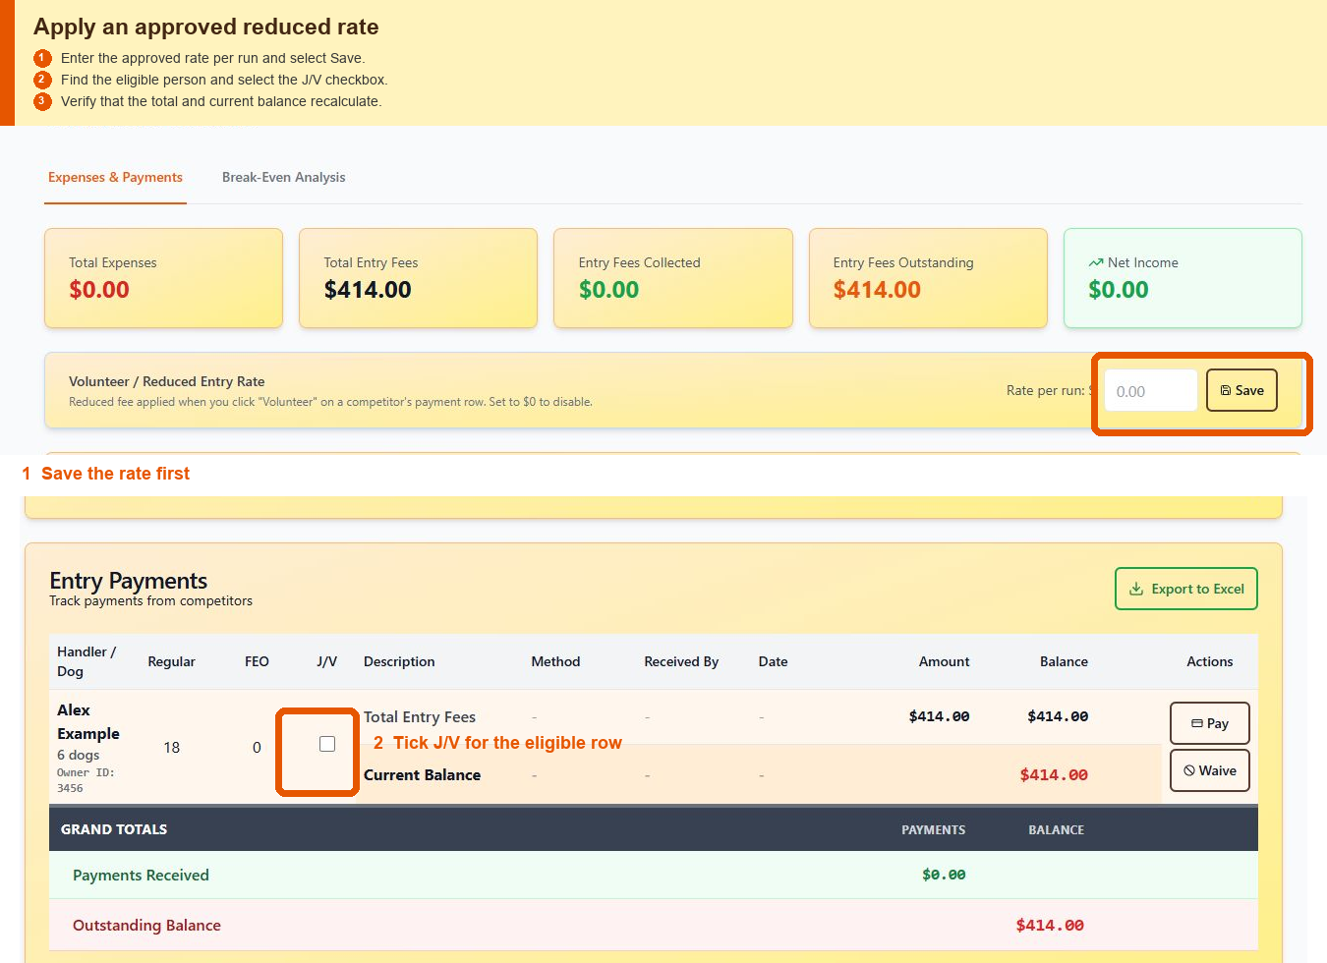
Save the approved rate, then select J/V on the eligible competitor row and confirm the recalculated balance.

12. Trial Journal
Use the Activity Journal to read actions, not to infer a complete historical entry from every card. A full entry submission or modification can contain a historical round snapshot. Payment, waitlist promotion, waiver, score, and status cards normally contain only the facts of that action.

Reading journal detail cards
- Open an Entry submitted card to see the submitted rounds, their entry types and fees, and any waitlisted round at $0 now with its possible fee if promoted. The submitted total is a quote until accepted.
- Open a Waitlist promoted card to see the class, round, fee added, and the before and after entry total when those facts were recorded.
- Open a Payment received card to see the payment amount, method, person who received it, payment calendar date, and the separate time the transaction was recorded in the journal.
- A partial action card must not show fabricated zero classes, zero fees, or an Active entry status. Its absence of a full entry snapshot does not mean the dog had no rounds.
- Routine fee-recalculation audit records remain in the database, but the visible journal does not repeat one generic recalculation card for every selection.

Exporting the Activity Journal
- Use search, event type, and date filters to isolate the records you need.
- Choose Export Excel for a sortable journal table or Export PDF for a printable review copy.
- The export includes only events currently displayed after filtering. Clear the filters first when a full-trial journal export is required.
- The exported event time uses the trial timezone. Keep the exported file with the official trial records when needed.
The Trial Journal provides a chronological record of significant actions. It is especially useful when investigating a later question about entry changes, fees, capacity, or scores.
- entry submitted or modified
- selection waitlisted
- selection promoted
- capacity changed
- fee waiver applied or removed
- offline payment status recorded
- payment transaction corrected, including a correction to $0.00
- dog substituted
- running order changed
- score corrected
- entry permanently deleted with its historical snapshot retained
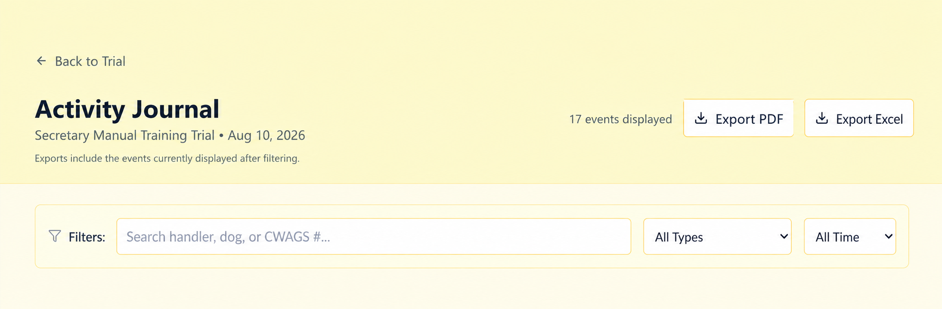
What to verify: Show filters, user, timestamp, action type, and concise summary.

What to verify: Show before/after values and reason for a promotion or score correction.

13. Closing the Trial
- Confirm every class and round has complete results.
- Resolve missing or duplicate scores.
- Verify registration numbers.
- Confirm judge signatures or approvals where required.
- Reconcile payments and balances.
- Export final results and required reports.
- Retain score sheets and records according to C-WAGS requirements.
- Complete and submit post-trial paperwork within the required timeframe.
Host Guide timing: The Host Guide states that post-trial paperwork must be submitted within 15 days and that original score sheets must be retained by the host for one year.

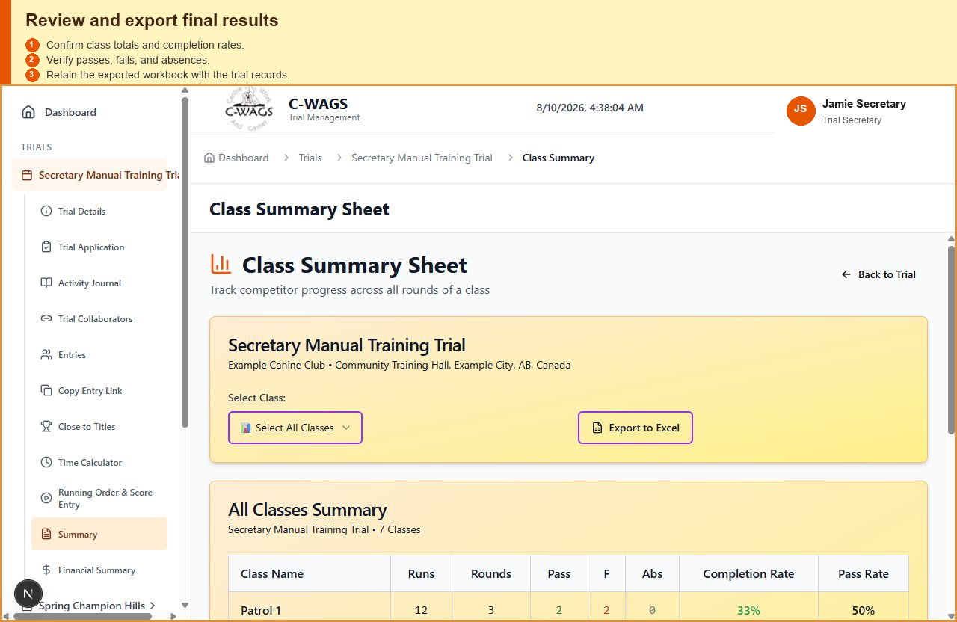
What to verify: Show the final validation or close-trial screen once implemented.

What to verify: Show result, recap, financial, and audit exports.

14. Troubleshooting
Issue | Recommended action
The page says the entry is a duplicate | Search the trial by C-WAGS number. Confirm whether an existing entry is being edited rather than creating a second record.
A valid dog does not appear after lookup | Verify the registration number and registry record. Check that Lookup was selected and that the secretary entry screen received a successful response.
A round should be available but shows full | Review the configured round limit and active selections. Waitlisted and withdrawn selections should not consume capacity.
A waitlisted dog appears on a score sheet | Do not use that paperwork. Regenerate after confirming the selection is still waitlisted. Report the issue for correction.
A promoted dog still owes $0 | Refresh the entry and financial pages. Promotion should activate the stored fee for that selection.
Changes do not appear to save | Check the internet connection and any online/offline indicator. Do not assume a change saved unless the application confirms it.
Reference use: The final manual should summarize rules only where they affect software operation. The official current rule books remain authoritative.

15. Complete Trial Workflow
This section is the operating sequence for a secretary who is creating and running a trial from beginning to end. Use it with the earlier detailed sections and screenshots. Complete the official Trial Application before publishing the public entry form.

15.1 Before Creating the Trial
- Confirm the host club name, venue, city, province or state, full address, date range, secretary contact details, regular and FEO fees, waiver text, and whether FEO is generally available.
- Collect the actual trial dates, programs, classes and levels, number of rounds, reset rounds, judges, capacities, search areas or rings, insurance information, advocate names, and any application exception request.
- Verify that the user creating the trial should be its owner. Invite additional secretaries or assistants only after the draft exists.

15.2 Create the Draft
1. Open Create New Trial. Use the sidebar link or the Dashboard quick action.
2. Complete Basic Trial Information. Enter Trial Name, Host Club Name, Venue Name, City, Country, Province or State, optional full address, Start Date, End Date, secretary details, FEO availability, default regular and FEO fees, and notes. Review the location and fee previews, then select Save and Continue.
3. Review Waiver and Notice Text. Use the host's approved wording. The public entrant must see the correct agreement and event notices.
4. Select Trial Days. Choose each actual event date within the date range. Dates must be unique. Do not add non-event dates simply to fill the range.
5. Choose Classes and Levels. Select the programs and levels offered on each day. Review each regular fee, FEO fee, FEO availability, and capacity.
6. Configure Rounds and Judges. Add the required rounds, assign the correct judge, and identify reset rounds. A reset is represented as a half round such as Round 1.5.
7. Review the Draft. Confirm the summary counts for days, classes, rounds, and judges. Leave entries Not Yet Open while the application is being prepared.

15.3 Complete the Trial Application
1. Open Trial Application. Use the selected trial's sidebar or Generate Trial Application under Trial Details Settings.
2. Review Derived Information. Confirm the host, dates, location, trial contact, programs, schedule rows, and reset rows. Correct trial setup at its source rather than typing over derived data.
3. Complete Application-Only Fields. Enter the premium website, submitted date, trial contact phone, advocate names, inside or outside selection, league status, surface, insurance expiry, exception request, and number of search areas when applicable.
4. Save the Application Draft. This preserves application-only values without changing the trial's Supabase setup.
5. Download Completed PDF. Review the generated application and submit it through the official C-WAGS approval process.
6. Wait for Approval. Keep the trial in Draft or Not Yet Open until approval is received. Generating the application does not publish the trial.

15.4 Publish and Accept Entries
1. Publish the Trial. After approval, use Trial Details Settings to publish or mark the trial active.
2. Set Entry Status or Schedule Opening. Use Not Yet Open when the form may be visible but disabled, save an Automatic Opening using the timezone where the trial is held, use Open for Entries to accept submissions immediately, or use Closed whenever the trial is full.
3. Review Per-Day Controls. Leave Accept Entries on for available days and turn it off for a filled or closed day. A closed day cannot be selected on the public form even if the trial is open.
4. Copy and Distribute the Entry Link. Use Copy Entry Link only after confirming the correct trial and entry status.
5. Monitor Entries. Use the Entries page to search, filter by status, export Excel, confirm an entry, waitlist an entry, edit entrant information, and inspect round selections.
6. Manage Registration Numbers. An entry can exist before its C-WAGS number is found in the registry. Scores and qualifying results stay with the entry and link to the registry number when that number is later available.

15.5 Prepare the Event
1. Review Capacity and Waitlists. Capacity changes do not promote a dog automatically. Promote deliberately, and document any out-of-order priority decision.
2. Use the Time Calculator. Estimate the schedule with current entries and expected minutes and seconds per run. The first visit initializes average starting times; a club may edit those values when it normally runs faster or slower.
3. Build the Running Order. Choose the day and class. Use drag and drop, arrow controls, or the keyboard. Only active selections receive positions.
4. Export Running Order. Review the class and entries before downloading the workbook.
5. Export Scent Score Sheets. Sheets combine no more than two rounds only when the day, class, and judge match. Round 3 starts another sheet. White rows are the first round and blue rows are the second. The handler and dog block spans both rows, missing rounds stay blank, P and F are separate circle choices, and the heavier horizontal line separates competitors.

15.6 Operate and Score the Trial
1. Select the Day and Class. Open Running Order and Score Entry, choose the event day, and select the correct class card and round.
2. Check In and Update Status. Focus a dog card and use C for check in, N for no-show, S for scratch, or the visible controls. Verify the class summary after changes.
3. Confirm the Judge. A trial may remain published with a judge shown as TBA, but a confirmed judge must be assigned to the selected round before the program will accept scores.
4. Enter Scores. Open Score Entry. For scent, Pass or Fail is required; scents, faults, and time are optional detail fields. Save All Scores before changing classes.
5. Enter Obedience Rally or Games Results. Enter the numeric score and any tie-break order. Placements calculate within the applicable division and exclude TO and FEO entries. Use the rules for the class when resolving ties.
6. Review Class Summary. Compare total entries, present, absent, FEO, missing scores, passes, fails, completion rate, and pass rate. The summary and placements also work for backdated trials when their entries and scores are present.

15.7 Reconcile Finances and Close
1. Configure Break-Even Values. Save the current C-WAGS fee per regular run and other assumptions before relying on calculated totals.
2. Record Expenses and Offline Payments. Use Add Judge or Add Expense, then Save All. Use Pay for an offline payment, J/V only for an approved reduced rate, and Waive only for a documented full waiver.
3. Audit the Activity Journal. Filter and review changes, the responsible user, timestamps, and before-and-after details.
4. Run Final Reports Before Tracker Posting. Review Close to Titles, Award Confirmations, Class Summary, placements, and the Excel exports before sending the current trial results to the C-WAGS tracker. Close to Titles and Award Confirmations treat tracker totals as prior results and add this trial's saved results. Once this trial has been posted to the tracker, the same results may be counted twice and those reports may no longer be accurate. Retain the pre-posting exports with the trial records.
5. Mark the Trial Active. On Trial Details, open the Settings tab. If the status is Published, select Mark Active. Mark Completed is available only after the trial is Active.
6. Open the Closing Checklist. Select Mark Completed. The program checks pending C-WAGS registration numbers, TBA or unassigned judges, missing scores, and outstanding balances.
7. Resolve or Override Remaining Items. Correct outstanding items when possible. If an item must remain, enter a specific override reason. The trial cannot be completed with unresolved items unless a reason is supplied.
8. Confirm Completion. When the checklist is clear, confirm Mark Completed. The checklist result and any override reason are saved in the Activity Journal.
9. Retain Final Records. Retain the official application, entry export, score sheets, results workbook, financial export, filtered or full Activity Journal export as needed, and any required C-WAGS submission records.

16. Page and Button Reference
Locations below are based on the signed-in Trial Secretary interface audited with Secretary Manual Training Trial on September 3, 2026. Controls repeated for each entry or class perform the same action on the selected record.
Page | Button or control | Location | Function
Dashboard | Export Excel | Outstanding Balances | Exports the visible outstanding-balance list.
Dashboard | Volunteers | Outstanding Balances | Opens volunteer or reduced-rate information when available.
Dashboard | Manage Trials | Quick Actions | Opens the trial-management list.
Dashboard | Running Order | Quick Actions | Opens live running-order management for the selected trial.
Dashboard | Close to Titles Report | Quick Actions | Opens the title-proximity report.
Dashboard | Financial Summary | Quick Actions | Opens expenses, payments, and break-even tools.
Dashboard | Activity Journal | Quick Actions | Opens the audit history for the selected trial.
Dashboard | Export Entries Excel | Quick Actions | Downloads the selected trial's entries.
Dashboard or sidebar | Create New Trial | Quick Actions or below Trials | Starts the two-stage create-trial form.
Trial sidebar | Copy Entry Link | Expanded selected trial | Copies the public entry-form URL for that trial.
Trial Details | All Trials | Top of Trial Details | Returns to the trial list.
Trial Details | Not Yet Open | Trial-Wide Entry Status | Keeps the form visible but disables submission.
Trial Details | Open for Entries | Trial-Wide Entry Status | Allows public entry submissions.
Trial Details | Closed | Trial-Wide Entry Status | Stops new submissions.
Trial Details | Accept Entries | Per-Day Entry Control | Opens or closes class selection for one trial day.
Trial Details | Edit | Basic Info tab | Opens editable basic trial information.
Trial Details | Mark Active | Settings tab | Changes the trial's operational status.
Trial Details | Mark Completed | Settings tab after Mark Active | Runs the closing-readiness checklist and completes the trial. An override reason is required when checklist items remain.
Trial Details | Manage Entries | Settings tab | Opens the Entries page.
Trial Details | Copy Email Facebook Twitter QR Code | Settings tab sharing block | Provides the selected sharing method for the public entry link.
Trial Details | Edit Days | Settings tab | Changes actual trial days and allows an existing day to move dates.
Trial Details | Edit Classes and Levels | Settings tab | Changes offered classes, levels, fees, and availability.
Trial Details | Edit Rounds and Judges | Settings tab | Changes rounds, reset rounds, judges, and capacities.
Trial Application | Back | Top of page | Returns to the selected trial.
Trial Application | Save Application Draft | Generation section | Saves application-only values without changing trial setup.
Trial Application | Download Completed PDF | Generation section | Generates the completed C-WAGS application PDF.
Trial Collaborators | Invite | Invite a secretary | Sends the selected role invitation to a registered user's email.
Entries | Status All | Above entry list | Filters entries by status.
Entries | Export to Excel | Above entry list | Downloads the trial entry list.
Entries | Confirm | Each entry card | Changes the selected entry to confirmed.
Entries | Waitlist | Each entry card | Changes the selected entry or relevant selections to waitlisted.
Entries | Edit Entry | Each entry card | Opens the public entry editor with the C-WAGS number supplied. The number and handler email must be verified before the saved handler and dog information is populated.
Entries | View Selections | Each entry card | Shows class and round selections, types, and statuses.
Live Event | Day tabs | Class Selection | Changes the displayed event day.
Live Event | Running Order Setup | Below class cards | Shows positions, capacity, waitlist, and export controls.
Live Event | Score Entry | Below class cards | Shows the score-entry table for the selected round.
Live Event | Add Entry | Running Order Setup | Adds an eligible entry to the selected round.
Live Event | Export Running Order | Running Order Setup | Downloads the running-order workbook.
Live Event | Export Scent Score Sheets | Running Order Setup | Downloads formatted scent score sheets by day.
Live Event | Increase by 1 | Round Capacity | Raises the selected round's capacity by one.
Live Event | Set Capacity | Round Capacity | Saves the entered capacity; it does not promote dogs.
Live Event | Promote Selected Dog | Round Waitlist | Promotes that waitlisted selection if capacity permits.
Live Event | Pass Fail and score controls | Score Entry row | Records the selected dog's result and optional score details.
Live Event | Save All Scores | Bottom of Score Entry | Saves all edited score rows for the selected round.
Class Summary | Select All Classes | Class selector | Shows the combined trial summary.
Class Summary | Export to Excel | Top of summary | Downloads the summary and class-detail workbook.
Financial Summary | Expenses and Payments | Top tabs | Shows reduced rate, expenses, and payment rows.
Financial Summary | Break-Even Analysis | Top tabs | Shows saved financial assumptions and projected totals.
Financial Summary | Save | Volunteer or Reduced Entry Rate | Saves the approved reduced fee per run.
Financial Summary | Add Judge | Trial Expenses | Adds a judge compensation row.
Financial Summary | Add Expense | Trial Expenses | Adds a general expense row.
Financial Summary | Save All | Trial Expenses | Saves all expense-row edits.
Financial Summary | Pay | Competitor payment row | Records an offline payment.
Financial Summary | Waive | Competitor payment row | Records a full waiver and its reason.
Activity Journal | Back to Trial | Top of page | Returns to Trial Details.
Close to Titles | Back to Trial | Top of page | Returns to Trial Details.
Create Trial | Save and Continue | Bottom of Basic Information | Validates basic information and advances to waiver and notice text.

17. Glossary
Term | Meaning
ABS | Absent. The dog did not run and is reported separately from a fail.
Active entry | A selection that occupies capacity, can receive a running position, and is eligible for scoring.
Application-only field | Information saved for the Trial Application that does not alter the operational trial record.
Assistant | A limited collaborator who can help with entries, waitlists, running order, and score entry but not trial setup, finances, official reports, collaborators, or deletion.
Read only | A collaborator who can view the trial and generate reports or the Trial Application, but cannot change trial setup, entries, running order, scores, or finances.
C-WAGS number | The dog's C-WAGS registration identifier. A pending entry can later link to the registry when its number becomes available.
Capacity | The maximum active selections allowed in a round. Raising it does not promote waitlisted dogs automatically.
Class card | The selectable day, class, and round item at the top of Live Event Management.
Closed day | A trial day whose Accept Entries switch is off; entrants cannot select its classes.
Completion rate | Completed results divided by entered runs for the displayed class or trial.
Closing-readiness checklist | The automatic review run by Mark Completed. It reports pending registration numbers, unassigned judges, missing scores, and outstanding balances.
Draft | A trial that can be configured and used to generate an application but is not yet publicly accepting entries.
FEO | For Exhibition Only. An FEO run is tracked separately and is excluded from placements.
J/V | Judge or volunteer reduced-rate indicator on a financial row. It uses the saved reduced rate and is not a full waiver.
Pass rate | Passes divided by completed runs, not by all entered runs.
Placement | Rank calculated from eligible scores within the applicable class division after tie-break information is resolved.
Published | A trial available through the public-facing workflow; entry acceptance still depends on trial-wide and per-day controls.
Override reason | The required explanation recorded when a secretary completes a trial while closing-readiness items remain.
Reset round | An additional half-numbered round, such as 1.5, that represents a reset or distinct course/search setup.
Round selection | One dog's entry in one specific round. Status, fee, waitlist position, running position, and result apply at this level.
Scratch | A selection removed from competing under the applicable trial procedure; it is distinct from absent and fail.
Secretary | A collaborator with broad operational permissions for the assigned trial. Trial ownership and administrator permissions can still limit collaborator management or deletion.
TO | Training Only. TO entries are excluded from placements.
Trial day | A specific date record holding its classes, rounds, judges, entries, and results. Edit the existing day to move a postponed date.
Waitlist | Selections held outside active capacity. They have no running position and are promoted deliberately when space is available.
Waive | A documented full fee waiver. This differs from the J/V reduced rate.

18. Final Secretary Verification
- Trial information, actual trial days, classes, rounds, reset rounds, judges, fees, and capacities match the approved application.
- Trial-wide and per-day entry controls match the intended entry window.
- Entries, waitlists, pending registration numbers, payments, zero-dollar corrections, waivers, and permanent deletions are reconciled.
- Running orders contain only active selections and score sheets match the correct day, class, round, and judge.
- All required results are saved; missing scores, absences, scratches, tie-breaks, and placements are resolved.
- Class Summary, Close to Titles, Award Confirmations, financial totals, and exports have been reviewed and retained before the current trial results are posted to the tracker.
- The Activity Journal contains the expected record of material changes.
- Mark Completed has run the closing-readiness checklist, all remaining items are explained, and any override reason is recorded in the Activity Journal.

