Practical No. 1

a] Write a program to implement depth first search algorithm.
Code:
import matplotlib.pyplot as plt
import networkx as nx
graph={'Kankavli':['Devgad','Malvan','Kudal','Vaibhavwadi'],
'Kudal':['Kankavli','Malvan','Sawantwadi','Vengurla'],
'Malvan':['Kudal','Kankavli','Devgad','Vengurla'],
'Devgad':['Malvan','Kankavli','Vaibhavwadi'],
'Sawantwadi':['Kudal','Vengurla','Dodamarg'],
'Dodamarg':['Sawantwadi'],
'Vaibhavwadi':['Devgad','Kankavli'],
'Vengurla':['Kudal','Malvan','Sawantwadi']}
visited=list()
dfs=list()
def DFS(node,visited,graph):
if(node not in visited):
dfs.append(node)
visited.append(node)
for i in graph[node]:
DFS(i,visited,graph)
DFS('Kankavli',visited,graph)
print ("The dfs path is : ")
for i in dfs:
print(i+" ",end="")
G = nx.Graph(graph)
plt.figure(figsize=(10, 8))
pos = nx.spring_layout(G) # positions for all nodes
nx.draw(G, pos, with_labels=True, node_color='lightblue', edge_color='gray', node_size=3000, font_size=10, font_weight='bold')
plt.title('Graph Visualization')
plt.show()

Output:

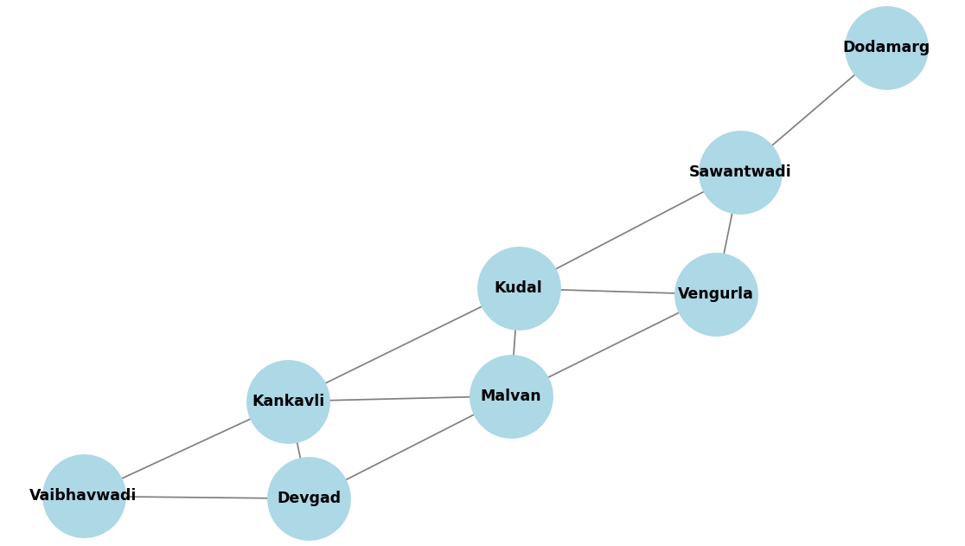

b] Write a program to implement breadth first search algorithm.
Code:
graph={'Kankavli':['Devgad','Malvan','Kudal','Vaibhavwadi'],
'Kudal':['Kankavli','Malvan','Sawantwadi','Vengurla'],
'Malvan':['Kudal','Kankavli','Devgad','Vengurla'],
'Devgad':['Malvan','Kankavli','Vaibhavwadi'],
'Sawantwadi':['Kudal','Vengurla','Dodamarg'],
'Dodamarg':['Sawantwadi'],
'Vaibhavwadi':['Devgad','Kankavli'],
'Vengurla':['Kudal','Malvan','Sawantwadi']}
visited=list()
queue=list()
bfs=list()
def BFS(node,visited,graph):
if(node not in visited):
visited.append(node)
queue.append(node)
while queue:
m=queue.pop(0)
bfs.append(m)
for i in graph[m]:
if (i not in visited):
visited.append(i)
queue.append(i)
BFS('Kankavli',visited,graph)
print ("The bfs path is : ")
for i in bfs:
print(i+" ",end="")

Output:

