Practical No. 5

a] Simulate tic – tac – toe game using min-max algorithm.
Code:
board=['' for _ in range(9)]

def print_board(board):
for row in [board[i*3:(i+1)*3]for i in range(3)]:
print('|'.join(row))
print('-'*5)

def check_win(board,player):
win_conditions=[(0,1,2),(3,4,5),(6,7,8),(0,3,6),(1,4,7),(2,5,8),(0,4,8),(2,4,6)]
for condition in win_conditions:
if board[condition[0]]==board[condition[1]]==board[condition[2]]==player:
return True
return False

def minimax(board,depth,is_maximizing):
if check_win(board,'X'):
return 1
elif check_win(board,'O'):
return -1
elif '' not in board:
return 0
if is_maximizing:
best_score=-float('inf')
for i in range(9):
if board[i]=='':
board[i]='X'
score=minimax(board,depth+1,False)
board[i]=''
best_score=max(score,best_score)
return best_score
else:
best_score=float('inf')
for i in range(9):
if board[i]=='':
board[i]='O'
score=minimax(board,depth+1,True)
board[i]=''
best_score=max(score,best_score)
return best_score

def ai_move(board):
best_score=-float('inf')
move=0
for i in range(9):
if board[i]=='':
board[i]='X'
score=minimax(board,0,False)
board[i]=''
if score>best_score:
best_score=score
move=i
board[move]='X'

def play_game():
while True:
print_board(board)
if check_win(board,'X'):
print("X wins!")
break
elif check_win(board,'O'):
print("O wins!")
break
elif '' not in board:
print("Its a tie!")
break
move = int (input("Enter your move(1-9)"))-1
if board[move]=='':
board[move]='O'
else:
print("Invalid move try again.")
continue
ai_move(board)

play_game()

Output:
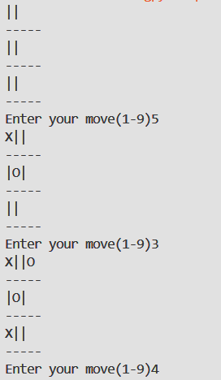
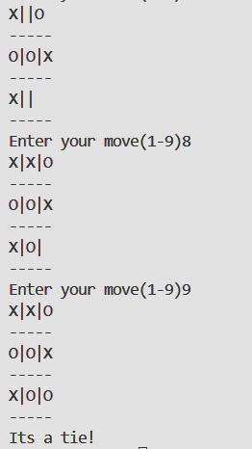

b] Write a program to shuffle Deck of cards.
Code:

import random
typ=['♥' , '♣' , '♦' , '♠']
num=['A','2','3','4','5','6','7','8','9','10','J','Q','K']
deck=[]
for i in typ:
for j in num:
deck.append(i+j)
random.shuffle(deck)
print(deck)

Output:
['♣A', '♣2', '♣3', '♣4', '♣5', '♣6', '♣7', '♣8', '♣9', '♣10', '♣J', '♣Q', '♣K', '♦A', '♦2', '♦3', '♦4', '♦5', '♦6', '♦7', '♦8', '♦9', '♦10', '♦J', '♦Q', '♦K', '♥A', '♥2', '♥3', '♥4', '♥5', '♥6', '♥7', '♥8', '♥9', '♥10', '♥J', '♥Q', '♥K', '♠A', '♠2', '♠3', '♠4', '♠5', '♠6', '♠7', '♠8', '♠9', '♠10', '♠J', '♠Q', '♠K']

