Practical No. 6

a]Design an application to simulate number puzzle problem.
Code:
from heapq import heappush, heappop
from itertools import chain

n = 3 # Size of the grid
row = [1, 0, -1, 0] # Row movements: down, left, up, right
col = [0, -1, 0, 1] # Column movements: down, left, up, right

def calculateManhattanCost(flattened_mat, flattened_final) -> int:
"""Calculate the Manhattan Distance."""
cost = 0
for i in range(len(flattened_mat)):
if flattened_mat[i] != 0:
# Find the goal position of the current tile in the final state
target_index = flattened_final.index(flattened_mat[i])
current_x, current_y = divmod(i, n)
target_x, target_y = divmod(target_index, n)
cost += abs(current_x - target_x) + abs(current_y - target_y)
return cost

def isSafe(x, y):
"""Check if the new position is within bounds."""
return 0 <= x < n and 0 <= y < n

def printMatrix(mat):
"""Print the 2D matrix."""
for row in mat:
print(' '.join(map(str, row)))
print()

def printSolutionPath(steps):
"""Print each step in the solution path."""
for step in steps:
printMatrix(step)

def solve(initial, empty_tile_pos, final):
"""Solve the 8-puzzle problem using an optimized A* algorithm and print every step."""

pq = []

start_state = tuple(chain.from_iterable(initial)) # Flatten initial
goal_state = tuple(chain.from_iterable(final)) # Flatten final

visited = set()

state_to_steps = {start_state: [initial]} # Start state and initial steps

cost = calculateManhattanCost(start_state, goal_state)

heappush(pq, (cost, 0, 0, start_state, empty_tile_pos))
while pq:

total_cost, curr_cost, level, current_state, empty_pos = heappop(pq)

if current_state == goal_state:
print("Solution found! Steps to solve:")
printSolutionPath(state_to_steps[current_state])
return

if current_state in visited:
continue

visited.add(current_state)

for i in range(4):
new_empty_x = empty_pos[0] + row[i]
new_empty_y = empty_pos[1] + col[i]

if isSafe(new_empty_x, new_empty_y):
# Swap the empty tile with the target tile
new_state_list = list(current_state)
new_empty_index = new_empty_x * n + new_empty_y
old_empty_index = empty_pos[0] * n + empty_pos[1]
new_state_list[old_empty_index], new_state_list[new_empty_index] = new_state_list[new_empty_index], new_state_list[old_empty_index]
new_state = tuple(new_state_list)

if new_state not in visited:
new_cost = calculateManhattanCost(new_state, goal_state)

new_state_matrix = [list(new_state[i:i + n]) for i in range(0, len(new_state), n)]

new_steps = state_to_steps[current_state] + [new_state_matrix]
state_to_steps[new_state] = new_steps

heappush(pq, (new_cost + level + 1, new_cost, level + 1, new_state, [new_empty_x, new_empty_y]))
print("No solution exists.")

initial = [[1, 2, 3], [5, 6, 0], [7, 8, 4]]
final = [[0, 1, 2], [3, 4, 5], [6, 7, 8]]

empty_tile_pos = [1, 2]

solve(initial, empty_tile_pos, final)

Output:
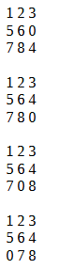
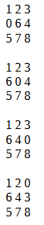
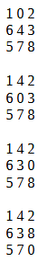
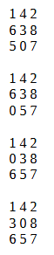
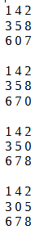
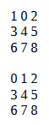
Solution found! Steps to solve:

