Practical No. 8

a] Derive the expressions based on Associative Law.

Code: For law a+(b+c)=(a+b)+c
a=int(input("Enter first number :"))
b=int(input("Enter second number :"))
c=int(input("Enter third number :"))

lhs=a+(b+c)
rhs=(a+b)+c
if(lhs==rhs):
print("LHS = ",lhs)
print("RHS = ",rhs)
print("LHS = RHS")
print("this is Associative law !!")
else:
print("LHS = ",lhs)
print("RHS = ",rhs)
print("LHS != RHS")

Output:
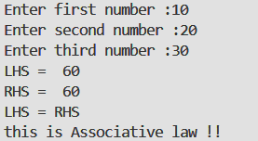

Code:For law a*(b*c)=(a*b)*c

a=int(input("Enter first number :"))
b=int(input("Enter second number :"))
c=int(input("Enter third number :"))

lhs=a*(b*c)
rhs=(a*b)*c
if(lhs==rhs):
print("LHS = ",lhs)
print("RHS = ",rhs)
print("LHS = RHS")
print("this is Associative law !!")
else:
print("LHS = ",lhs)
print("RHS = ",rhs)
print("LHS != RHS")

Output:
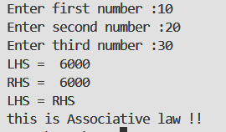

b] Derive the expressions based on Distributive Law.
Code: For law a*(b+c)=a*b+a*c

a=int(input("Enter first number :"))
b=int(input("Enter second number :"))
c=int(input("Enter third number :"))

lhs=a*(b+c)
rhs=a*b+a*c

if(lhs==rhs):
print("LHS = ",lhs)
print("RHS = ",rhs)
print("LHS = RHS")
print("this is Distributive law !!")
else:
print("LHS = ",lhs)
print("RHS = ",rhs)
print("LHS != RHS")

Output:
