Practical No. 1

a)Create an application that obtains four int values from the user and displays the product.

Code:

using System;

namespace ConsoleApp1
{
internal class Program
{
static void Main(string[] args)
{
Console.WriteLine("Samruddhi TYIT");
Console.Write("Enter 1st Number: ");
int s1 = Convert.ToInt32(Console.ReadLine());
Console.Write("Enter 2nd Number: ");
int s2 = Convert.ToInt32(Console.ReadLine());
Console.Write("Enter 3rd Number: ");
int s3 = Convert.ToInt32(Console.ReadLine());
Console.Write("Enter 4th Number: ");
int s4 = Convert.ToInt32(Console.ReadLine());
Console.Write("Product is " + (s1 * s2 * s3 * s4));
Console.ReadKey();
}
}
}

Output:

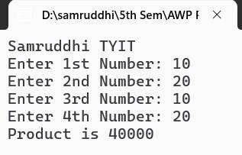
b)Create an application to demonstrate string operations.

Code:

using System;
using System.Linq;

namespace ConsoleApp2
{
internal class Program
{
static void Main(string[] args)
{
String s1 = "SAMRUDDHI";
String s2 = "INFORMATION";
String s3 = "TECHNOLOGY";
String s4 = "SRM College";
Console.WriteLine("Length of string Samruddhi : "+s1.Length);
Console.WriteLine("The position of letter A in Information is : " + s2.IndexOf("A"));
Console.WriteLine("Original String is : " + s1);
Console.WriteLine("String in Lower Case is : " + s1.ToLower());
Console.WriteLine("String "+s3+" starts with letter T : "+s3.StartsWith("T"));
Console.WriteLine("String "+s2+" ends with letter S : " + s2.EndsWith("S"));
Console.WriteLine("The strings "+s1+" & "+s2+" are Equal : " + s1.Equals(s2));
Console.WriteLine("The String "+s3+" contains LO in it : " + s3.Contains("LO"));
Console.WriteLine("Extracted portion of "+s2+" is : " + s2.Substring(2));
}
}
}

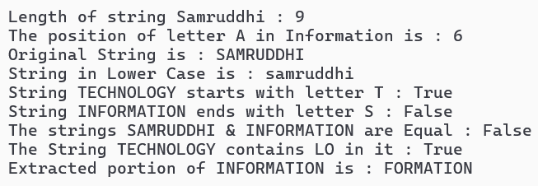
Output:
c)Create an application that receives the (Student Id, Student Name, Course Name, Date of Birth) information from a set of students. The application should also display the information of all the students once the data entered.

Code:

using System;

namespace StudentManagement
{
struct Students
{
int stud_id;
string stud_name;
string course_name;
DateTime stud_dob;
public void Input()
{
Console.Write("Enter Student ID:");
stud_id = Convert.ToInt32(Console.ReadLine());
Console.Write("Enter Student Name:");
stud_name = Console.ReadLine();
Console.Write("Enter Course Name:");
course_name = Console.ReadLine();
Console.Write("Enter Date of Birth (YYYY-MM-DD):");
stud_dob = DateTime.Parse(Console.ReadLine());
}
public void Display()
{
Console.WriteLine("\n");
Console.WriteLine("--------------------------");
Console.WriteLine("Student Information:");
Console.WriteLine("ID: " + stud_id);
Console.WriteLine("Name: " + stud_name);
Console.WriteLine("Course: " + course_name);
Console.WriteLine("Date of Birth: " + stud_dob.ToShortDateString());
}
}
class Practicalc
{
static void Main()
{
Students[] stud_list = new Students[2];
for (int i = 0; i < stud_list.Length; i++)
{
Console.WriteLine($"Enter details for Student {i + 1}:");
stud_list[i].Input();
}
for (int i = 0; i < stud_list.Length; i++)
{
stud_list[i].Display();
}
}
}
}
Output:

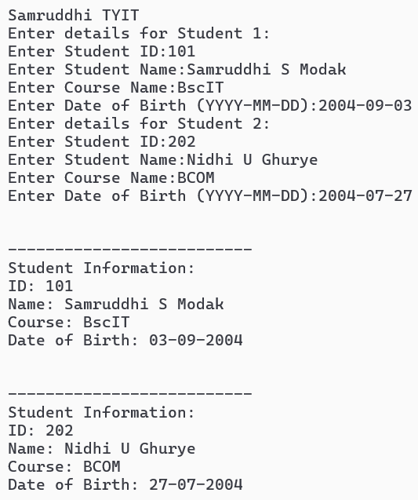

d)Create an application to demonstrate following operations

1)Generate Fibonacci series.

Code:
using System;
namespace Fibo
{
public class Fibonacci
{
static void Main(string[] args)
{
int f = 0, s = 1, t, num;
Console.WriteLine("Samruddhi TYIT");
Console.Write("Enter the count of numbers : ");
num = Convert.ToInt32(Console.ReadLine());
Console.Write("\n");
Console.WriteLine("The generated Fibonacci Series is : ");
Console.Write(f + " " + s + " ");
for (int i = 2; i < num; i++)
{
t = f + s;
Console.Write(t + " ");
f = s;
s = t;
}
}
}
}
Output:
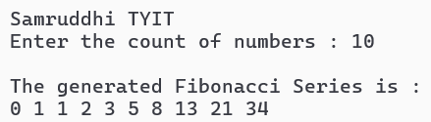

2)Test for prime numbers.

Code:
using System;
namespace PrimeNum
{
public class PrimeNumber
{
static void Main(string[] args)
{
int flag=0,s = 2, num;
Console.WriteLine("Samruddhi TYIT");
Console.Write("Enter the number : ");
num = Convert.ToInt32(Console.ReadLine());
Console.Write("\n");
while(s<num/2)
{
if (num % s == 0)
{
flag = 1;
break;
}
s++;

}
if(flag==0)
{
Console.WriteLine(num + " is Prime number");
}
else
{
Console.WriteLine(num + " is not A Prime number");
}
}
}
}

Output:

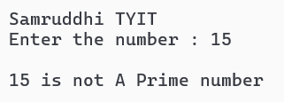
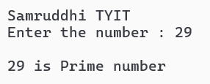

3)Test for Vowels

Code:
using System;
namespace ConsoleApp4
{
internal class Program
{
static void Main(string[] args)
{
Console.WriteLine("Samruddhi TYIT");
String[] ary = { "a", "e", "i", "o", "u" };
int flag = 0;
Console.Write("Enter Letter here : ");
String str = Console.ReadLine();
for(int i=0;i<ary.Length;i++)
{
if (str.ToLower() == ary[i])
{
flag = 1;
}
}
if(flag==1)
{
Console.WriteLine(str + " is A Vowel");
}
else
{
Console.WriteLine(str + " is A Consonant");
}
}
}
}

Output:
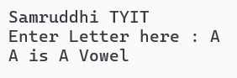
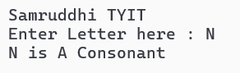

4)Use of foreach loop with arrays

Code:

using System;
namespace ConsoleApp4
{
internal class Program
{
static void Main(string[] args)
{
Console.WriteLine("Samruddhi TYIT");
int[] ary= { 10, 20, 30, 40, 50 ,60,70};
foreach (int i in ary)
{
Console.WriteLine("The Square of " + i + " is : " + (i * i));
}
}
}
}

Output:
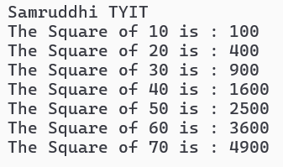

5)Reverse a number and find sum of digits of a number.

Code:

using System;

namespace ConsoleApp4
{
internal class Program
{
static void Main(string[] args)
{
int num, rev = 0, rem, sum = 0;
Console.WriteLine("Samruddhi TYIT");
Console.Write("Enter Number here : ");
num = Convert.ToInt32(Console.ReadLine());
while(num!=0)
{
rem = num % 10;
sum = sum + rem;
rev = rev * 10 + rem;
num = num / 10;
}
Console.WriteLine("The Reversed Number is : "+rev);
Console.WriteLine("The Sum of Digits is : " + sum);
}
}
}

Output:
