Practical no:10
a)Create a web application to demonstrate JS Bootstrap Button.
Code:
<%@ Page Language="C#" AutoEventWireup="true" CodeBehind="WebForm1.aspx.cs" Inherits="WebApplication2.WebForm1" %>

<!DOCTYPE html>
<html lang="en">
<head>
<meta charset="UTF-8">
<meta name="viewport" content="width=device-width, initial-scale=1.0">
<title>Bootstrap Demo</title>
<link href="https://cdn.jsdelivr.net/npm/bootstrap@5.3.0/dist/css/bootstrap.min.css" rel="stylesheet">
</head>
<body>

<div class="container mt-4">
<h2 class="text-center mb-4">Bootstrap Elements Demo</h2>
<div class="d-flex justify-content-center mb-4">
<button class="btn btn-primary">Primary Button</button>
<button class="btn btn-danger">Danger Button</button>
</div>
<form class="mb-4">
<div class="mb-3">
<label for="exampleInputEmail1" class="form-label">Email address</label>
<input type="email" class="form-control" id="exampleInputEmail1" aria-describedby="emailHelp">
<div id="emailHelp" class="form-text">We'll never share your email with anyone else.</div>
</div>
<div class="mb-3">
<label for="exampleInputPassword1" class="form-label">Password</label>
<input type="password" class="form-control" id="exampleInputPassword1">
</div>
<div class="mb-3 form-check">
<input type="checkbox" class="form-check-input" id="exampleCheck1">
<label class="form-check-label" for="exampleCheck1">Check me out</label>
</div>
<button type="submit" class="btn btn-success">Submit</button>
</form>
</div>

<script src="https://cdn.jsdelivr.net/npm/bootstrap@5.3.0/dist/js/bootstrap.bundle.min.js"></script>
</body>
</html>

Output:

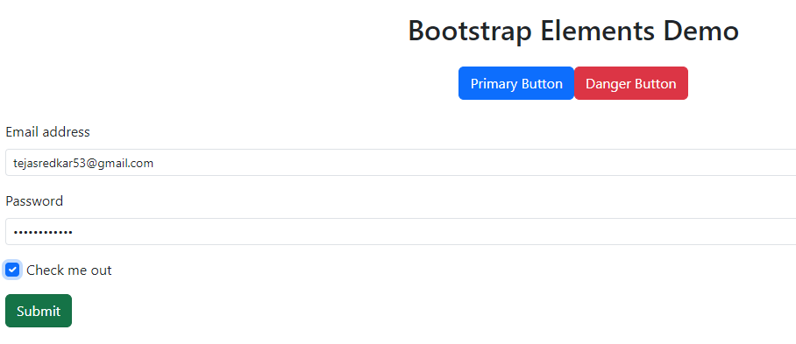

b)Create a web application to demonstrate use of various Ajax controls.
Code:
Webform.aspx
<%@ Page Language="C#" AutoEventWireup="true" CodeBehind="WebForm1.aspx.cs" Inherits="pract10.WebForm1" %>
<!DOCTYPE html>
<html xmlns="http://www.w3.org/1999/xhtml">
<head runat="server">
<title></title>
</head>
<body>
<form id="form1" runat="server">
<div>
<asp:ScriptManager ID="ScriptManager1" runat="server">
</asp:ScriptManager>
<br />
<br />
</div>

<asp:UpdatePanel ID="UpdatePanel1" runat="server">
<ContentTemplate>
<asp:Label ID="Label2" runat="server" Text="Label" style="z-index: 1; left: 370px; top: 125px; position: absolute;"></asp:Label>
<asp:Timer ID="Timer1" runat="server" Interval="1000" OnTick="Timer1_Tick"></asp:Timer>
<asp:Label ID="Label3" runat="server" style="z-index: 1; left: 368px; top: 71px; position: absolute" Text="Label"></asp:Label>
</ContentTemplate>
</asp:UpdatePanel>

<p></p>
</form>
</body>
</html>

WebForm.aspx.cs
using System;

namespace pract10
{
public partial class WebForm1 :System.Web.UI.Page
{
protected void Timer1_Tick(object sender, EventArgs e)
{
Label3.Text = DateTime.Now.ToString("D");
Label2.Text = DateTime.Now.ToString("T");
}
}
}

Output:
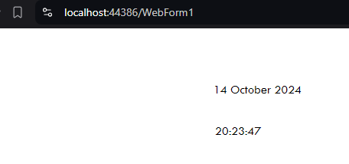

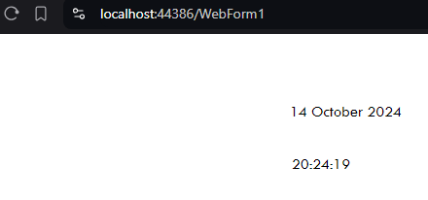

c)Create a web application to demonstrate Installation and use of NuGet package.
Code:
First install humanizer nuget package from “manage nuget packages” in refrences
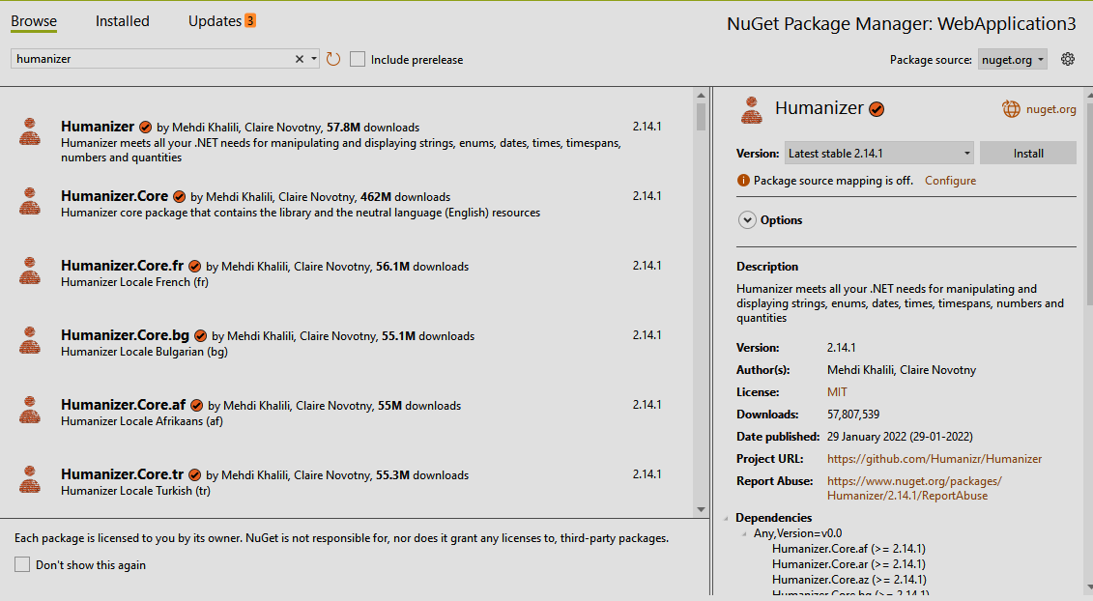

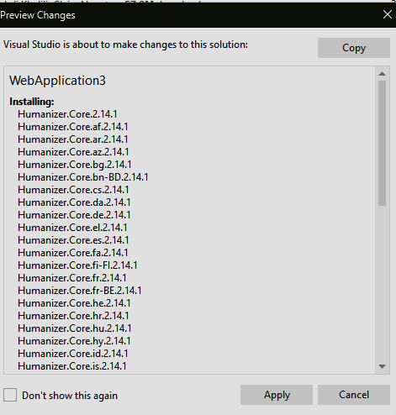

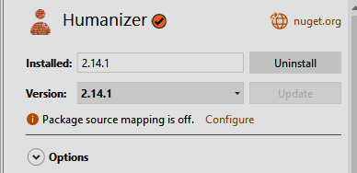

Webform.aspx:
<%@ Page Language="C#" AutoEventWireup="true" CodeBehind="WebForm1.aspx.cs" Inherits="WebApplication3.WebForm1" %>

<!DOCTYPE html>
<html xmlns="http://www.w3.org/1999/xhtml">
<head runat="server">
</head>
<body>
<form id="form1" runat="server">
<div>
<asp:Label ID="Label1" runat="server" Text="Start Date: " style="z-index: 1; left: 534px; top: 191px; position: absolute"></asp:Label>
<asp:TextBox ID="txtStartDate" runat="server" TextMode="Date" style="z-index: 1; left: 609px; top: 188px; position: absolute"></asp:TextBox>
<br /><br />

<asp:TextBox ID="txtEndDate" runat="server" TextMode="Date" style="z-index: 1; left: 607px; top: 225px; position: absolute"></asp:TextBox>
<br /><br />

<asp:Button ID="btnCalculate" runat="server" Text="Calculate Difference" OnClick="btnCalculate_Click" style="z-index: 1; left: 602px; top: 259px; position: absolute" />
<br /><br />

<asp:Label ID="lblResult" runat="server" Text="" style="z-index: 1; left: 648px; top: 312px; position: absolute"></asp:Label>

<asp:Label ID="Label2" runat="server" Text="End Date: " style="z-index: 1; left: 538px; top: 229px; position: absolute"></asp:Label>
</div>
</form>
</body>
</html>

Webform.aspx.cs
using Humanizer;
using System;
using System.Collections.Generic;
using System.Linq;
using System.Web;
using System.Web.UI;
using System.Web.UI.WebControls;
using Humanizer;

namespace WebApplication3
{
public partial class WebForm1 : System.Web.UI.Page
{
protected void Page_Load(object sender, EventArgs e)
{

}

protected void btnCalculate_Click(object sender, EventArgs e)
{
DateTime startDate = Convert.ToDateTime(txtStartDate.Text);
DateTime endDate = Convert.ToDateTime(txtEndDate.Text);

// Calculate the difference
TimeSpan difference = endDate - startDate;

// Use Humanizer to convert the difference into a human-readable format
lblResult.Text = $"Difference: {difference.Humanize(2)}";

}
}
}

Output:
