Practical no:7
a)Create a web application to demonstrate the use of different types of Cookies
Code:
Webform1.aspx
<%@ Page Language="C#" AutoEventWireup="true" CodeBehind="WebForm1.aspx.cs" Inherits="WebApplication4.WebForm1" %>

<!DOCTYPE html>
<html xmlns="http://www.w3.org/1999/xhtml">
<head runat="server">
<title>Login Page</title>
</head>
<body>
<form id="form1" runat="server">
<div>
<h2>Login</h2>

<asp:Label ID="lblUsername" runat="server" Text="Username: " style="z-index: 1; left: 397px; top: 343px; position: absolute"></asp:Label>
<asp:TextBox ID="txtUsername" runat="server" style="z-index: 1; left: 471px; top: 340px; position: absolute"></asp:TextBox>
<br /><br />

<asp:Label ID="lblPassword" runat="server" Text="Password: " style="z-index: 1; left: 397px; top: 384px; position: absolute"></asp:Label>
<asp:TextBox ID="txtPassword" runat="server" TextMode="Password" style="z-index: 1; left: 467px; top: 380px; position: absolute"></asp:TextBox>
<br /><br />

<asp:Button ID="btnLogin" runat="server" Text="Login" OnClick="btnLogin_Click" style="z-index: 1; left: 453px; top: 418px; position: absolute" />
</div>
</form>
</body>
</html>

Webform1.aspx.cs
using System;
using System.Collections.Generic;
using System.Linq;
using System.Web;
using System.Web.UI;
using System.Web.UI.WebControls;

namespace WebApplication4
{
public partial class WebForm1 : System.Web.UI.Page
{
protected void Page_Load(object sender, EventArgs e)
{

}
protected void btnLogin_Click(object sender, EventArgs e)
{

if (txtUsername.Text == "tejas" && txtPassword.Text == "123456")
{

HttpCookie cookie = new HttpCookie("UserInfo");
cookie["Username"] = txtUsername.Text;
cookie.Expires = DateTime.Now.AddHours(1); // Cookie expires in 1 hour
Response.Cookies.Add(cookie);
Response.Redirect("WebForm2.aspx");
}
else
{

Response.Write("<script>alert('Invalid credentials!');</script>");
}
}
}
}

Webform2.aspx
<%@ Page Language="C#" AutoEventWireup="true" CodeBehind="WebForm2.aspx.cs" Inherits="WebApplication4.WebForm2" %>

<!DOCTYPE html>
<html xmlns="http://www.w3.org/1999/xhtml">
<head runat="server">
<title>Welcome Page</title>
</head>
<body>
<form id="form2" runat="server">
<div>
<h2>Welcome!</h2>
<asp:Label ID="lblWelcome" runat="server" Text=""></asp:Label>
<br /><br />
<asp:Button ID="btnLogout" runat="server" Text="Logout" OnClick="btnLogout_Click" style="z-index: 1; left: 501px; top: 261px; position: absolute" />
</div>
</form>
</body>
</html>

Webform2.aspx.cs
using System;
using System.Collections.Generic;
using System.Linq;
using System.Web;
using System.Web.UI;
using System.Web.UI.WebControls;

namespace WebApplication4
{
public partial class WebForm2 : System.Web.UI.Page
{
protected void Page_Load(object sender, EventArgs e)
{
if (Request.Cookies["UserInfo"] != null)
{
string username = Request.Cookies["UserInfo"]["Username"];
lblWelcome.Text = $"Hello, {username}!";
}
else
{
lblWelcome.Text = "Hello, Guest!";
}
}

protected void btnLogout_Click(object sender, EventArgs e)
{
if (Request.Cookies["UserInfo"] != null)
{
HttpCookie cookie = new HttpCookie("UserInfo");
cookie.Expires = DateTime.Now.AddDays(-1);
Response.Cookies.Add(cookie);
}

Response.Redirect("WebForm1.aspx");
}
}
}

Output:
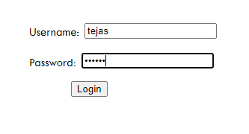

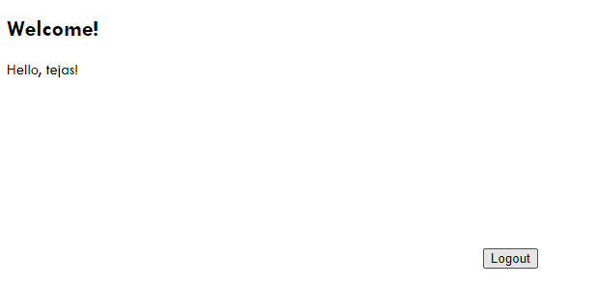

b)Create a web application to demonstrate Form Security and Windows Security with proper
Authentication and Authorization properties.
Code:

ASPX CODE:
<%@ Page Language="C#" AutoEventWireup="true" CodeBehind="WebForm12.aspx.cs" Inherits="WebApplication5.WebForm12" %>

<!DOCTYPE html>

<html xmlns="http://www.w3.org/1999/xhtml">
<head runat="server">
<title></title>
<style type="text/css">
.auto-style1 {
position: absolute;
top: 26px;
left: 456px;
z-index: 1;
width: 104px;
}
.auto-style2 {
position: absolute;
top: 142px;
left: 342px;
z-index: 1;
}
.auto-style3 {
position: absolute;
top: 211px;
left: 343px;
z-index: 1;
width: 67px;
}
.auto-style4 {
position: absolute;
top: 142px;
left: 458px;
z-index: 1;
}
.auto-style5 {
position: absolute;
top: 211px;
left: 459px;
z-index: 1;
}
.auto-style6 {
position: absolute;
top: 173px;
left: 673px;
z-index: 1;
width: 351px;
}
.auto-style7 {
position: absolute;
top: 305px;
left: 463px;
z-index: 1;
width: 142px;
}
</style>
</head>
<body>
<form id="form1" runat="server">

<div>
<asp:Label ID="Label1" runat="server" CssClass="auto-style2" Text="Username:"></asp:Label>
<asp:Label ID="Label2" runat="server" CssClass="auto-style3" Text="Password:"></asp:Label>
<asp:Label ID="Label3" runat="server" BorderStyle="Solid" CssClass="auto-style1" Font-Bold="True" Font-Size="Larger" Text="Login"></asp:Label>
</div>
<asp:TextBox ID="TextBox1" runat="server" CssClass="auto-style4"></asp:TextBox>
<asp:TextBox ID="TextBox2" runat="server" CssClass="auto-style5" TextMode="Password"></asp:TextBox>
<asp:Label ID="Label4" runat="server" CssClass="auto-style6" Enabled="False"></asp:Label>
<asp:Button ID="Button1" runat="server" CssClass="auto-style7" OnClick="Button1_Click" Text="Submit" />
</form>
</body>
</html>

C#CODE:
using System;
using System.Web.Security;
namespace WebApplication5
{
public partial class WebForm12 : System.Web.UI.Page
{

protected void Page_Load(object sender, EventArgs e)
{

}

protected void Button1_Click(object sender, EventArgs e)
{
string uname = TextBox1.Text;
string pass = TextBox2.Text;
if (FormsAuthentication.Authenticate(uname, pass))
{
FormsAuthentication.RedirectFromLoginPage(uname, false);
}
else
{
Label4.Text = "Login Details are Invalid";
}
}
}
}

Web.Config :
<?xml version="1.0" encoding="utf-8"?>
<!--
For more information on how to configure your ASP.NET application, please visit
https://go.microsoft.com/fwlink/?LinkId=169433
-->
<configuration>
<appSettings>
<add key="ValidationSettings:UnobtrusiveValidationMode" value="None" />
</appSettings>
<system.web>
<compilation debug="true" targetFramework="4.5" />
<httpRuntime targetFramework="4.5" />
<authentication mode="Forms">
<forms loginUrl="WebForm12.aspx" defaultUrl="WebForm13.aspx">
<credentials passwordFormat="Clear">
<user name="Admin" password="The World"/>
<user name="Lucifer" password="King"/>
</credentials>
</forms>
</authentication>
<authorization>
<allow users="Admin"/>
<allow users="Lucifer"/>
<deny users="?"/>
</authorization>
</system.web>
<system.codedom>
<compilers>
<compiler language="c#;cs;csharp" extension=".cs" type="Microsoft.CodeDom.Providers.DotNetCompilerPlatform.CSharpCodeProvider, Microsoft.CodeDom.Providers.DotNetCompilerPlatform, Version=2.0.1.0, Culture=neutral, PublicKeyToken=31bf3856ad364e35" warningLevel="4" compilerOptions="/langversion:6 /nowarn:1659;1699;1701" />
<compiler language="vb;vbs;visualbasic;vbscript" extension=".vb" type="Microsoft.CodeDom.Providers.DotNetCompilerPlatform.VBCodeProvider, Microsoft.CodeDom.Providers.DotNetCompilerPlatform, Version=2.0.1.0, Culture=neutral, PublicKeyToken=31bf3856ad364e35" warningLevel="4" compilerOptions="/langversion:14 /nowarn:41008 /define:_MYTYPE=\&quot;Web\&quot; /optionInfer+" />
</compilers>
</system.codedom>
</configuration>

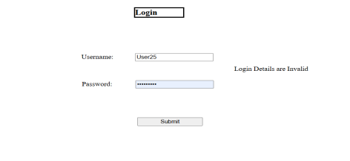
Output:
