**PRACTICAL NO.08**

**Write the program for the following:**

**A) Create a web application for inserting and deleting records from a database**

**CODE:**

**ASPX CODE:**

<%@ Page Language="C#" AutoEventWireup="true" CodeBehind="WebForm8.aspx.cs" Inherits="WebApplication5.WebForm8" %>

<!DOCTYPE html>

<html xmlns="http://www.w3.org/1999/xhtml">

<head runat="server">

<title></title>

</head>

<body>

<form id="form1" runat="server">

<div>

</div>

<asp:Label ID="Label1" runat="server" BorderStyle="Solid" Font-Bold="True" Font-Size="Larger" style="z-index: 1; left: 573px; top: 30px; position: absolute; width: 293px; height: 31px" Text="Database Management"></asp:Label>

<br /><br /> <br /><br /><br />

<table align="center">

<tr>

<td>RollNo</td>

<td>

<asp:TextBox ID="TextBox1" runat="server"></asp:TextBox></td>

</tr>

<tr>

<td>Name</td>

<td>

<asp:TextBox ID="TextBox2" runat="server"></asp:TextBox></td>

</tr>

<tr>

<td>Age</td>

<td>

<asp:TextBox ID="TextBox3" runat="server"></asp:TextBox></td>

</tr>

<tr>

<td>Class</td>

<td>

<asp:TextBox ID="TextBox4" runat="server"></asp:TextBox></td>

</tr>

<tr>

<td>

<asp:Button ID="insert" runat="server" Text="Insert" OnClick="insert_Click" Width="141px" /></td>

<td>

<asp:Button ID="update" runat="server" Text="Delete" OnClick="update_Click" style="margin-left: 33px" Width="149px" /></td>

</tr>

</table>

</form>

</body>

</html>

**C# CODE:**

using System;

using System.Data;

using System.Data.SqlClient;

namespace WebApplication5

{

public partial class WebForm8 : System.Web.UI.Page

{

SqlConnection con = new SqlConnection(@"Data Source=ROHIT\SQLEXPRESS;Initial Catalog=College; Integrated Security=True");

protected void Page_Load(object sender, EventArgs e)

{

}

protected void insert_Click(object sender, EventArgs e)

{

con.Open();

SqlCommand cmd = new SqlCommand(@"insert into Student(RollNo,Name,Age,Class)values(

'"+ Convert.ToInt32(TextBox1.Text)+"','"+TextBox2.Text+ "','" +Convert.ToInt32(TextBox3.Text)+ "','" + TextBox4.Text + "')",con);

cmd.ExecuteNonQuery();

Response.Write("Data inserted successfully");

con.Close();

}

protected void update_Click(object sender, EventArgs e)

{

con.Open();

SqlCommand cmd = new SqlCommand("delete from student WHERE RollNo="+ Convert.ToInt32(TextBox1.Text),con);

cmd.ExecuteNonQuery();

Console.WriteLine(cmd);

Response.Write("Data deleted successfully");

con.Close();

}

}

}

**OUTPUT:**

**Insert:**

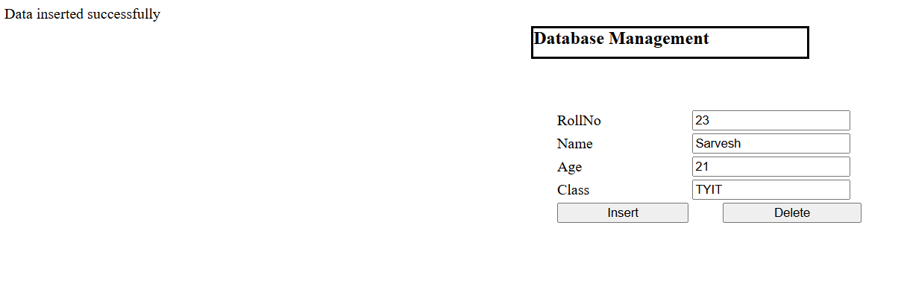

**SSMS:**

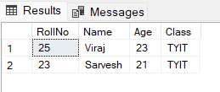

**Delete:**

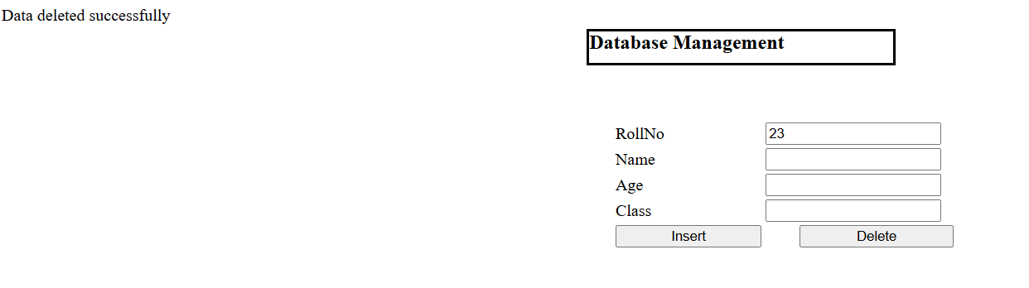

**SSMS:**

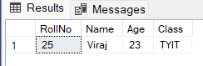

**B)Create a web application to display Using Disconnected Data Access and Databinding using**

**GridView.**

**CODE:**

**ASPX CODE:**

<%@ Page Language="C#" AutoEventWireup="true" CodeBehind="WebForm8.aspx.cs" Inherits="WebApplication5.WebForm8" %>

<!DOCTYPE html>

<html xmlns="http://www.w3.org/1999/xhtml">

<head runat="server">

<title></title>

</head>

<body>

<form id="form1" runat="server">

<div>

</div>

<asp:Label ID="Label1" runat="server" BorderStyle="Solid" Font-Bold="True" Font-Size="Larger" style="z-index: 1; left: 573px; top: 30px; position: absolute; width: 293px; height: 31px" Text="Database Management"></asp:Label>

<br /><br />

<br /><br />

<br />

<table align="center">

<tr>

<td>Employee ID</td>

<td>

<asp:TextBox ID="TextBox1" runat="server"></asp:TextBox></td>

</tr>

<tr>

<td>Employee Name</td>

<td>

<asp:TextBox ID="TextBox2" runat="server"></asp:TextBox></td>

</tr>

<tr>

<td>Age</td>

<td>

<asp:TextBox ID="TextBox3" runat="server"></asp:TextBox></td>

</tr>

<tr>

<td>Email</td>

<td>

<asp:TextBox ID="TextBox4" runat="server"></asp:TextBox></td>

</tr>

<tr>

<td>

<asp:Button ID="insert" runat="server" Text="Insert" OnClick="insert_Click" Width="141px" /></td>

<td>

<asp:Button ID="retrive" runat="server" Text="Retrive" OnClick="update_Click" style="margin-left: 33px" Width="149px" /></td>

</tr>

</table>

<asp:GridView ID="GridView1" runat="server" BackColor="White" BorderColor="White" BorderStyle="Ridge" BorderWidth="2px" CellPadding="3" CellSpacing="1" GridLines="None" style="z-index: 1; left: 412px; top: 383px; position: absolute; height: 180px; width: 330px">

<FooterStyle BackColor="#C6C3C6" ForeColor="Black" />

<HeaderStyle BackColor="#4A3C8C" Font-Bold="True" ForeColor="#E7E7FF" />

<PagerStyle BackColor="#C6C3C6" ForeColor="Black" HorizontalAlign="Right" />

<RowStyle BackColor="#DEDFDE" ForeColor="Black" />

<SelectedRowStyle BackColor="#9471DE" Font-Bold="True" ForeColor="White" />

<SortedAscendingCellStyle BackColor="#F1F1F1" />

<SortedAscendingHeaderStyle BackColor="#594B9C" />

<SortedDescendingCellStyle BackColor="#CAC9C9" />

<SortedDescendingHeaderStyle BackColor="#33276A" />

</asp:GridView>

</form>

</body>

</html>

**C# CODE:**

using System;

using System.Data;

using System.Data.SqlClient;

namespace WebApplication5

{

public partial class WebForm8 : System.Web.UI.Page

{

SqlConnection con = new SqlConnection(@"Data Source=ROHIT\SQLEXPRESS;Initial Catalog=College;

Integrated Security=True");

protected void Page_Load(object sender, EventArgs e)

{

}

protected void insert_Click(object sender, EventArgs e)

{

con.Open();

SqlCommand cmd = new SqlCommand(@"insert into Employee(eid,name,age,email)values(

'"+ Convert.ToInt32(TextBox1.Text)+"','"+TextBox2.Text+ "','" +Convert.ToInt32(TextBox3.Text)+ "','" + TextBox4.Text + "')",con);

cmd.ExecuteNonQuery();

Response.Write("Data inserted successfully");

con.Close();

}

protected void update_Click(object sender, EventArgs e)

{

con.Open();

SqlCommand cmd = new SqlCommand("select *from Employee", con);

SqlDataAdapter d = new SqlDataAdapter(cmd);

DataTable dt = new DataTable();

d.Fill(dt);

GridView1.DataSource = dt;

GridView1.DataBind();

con.Close();

}

}

}

**OUTPUT:**

**Insert:**

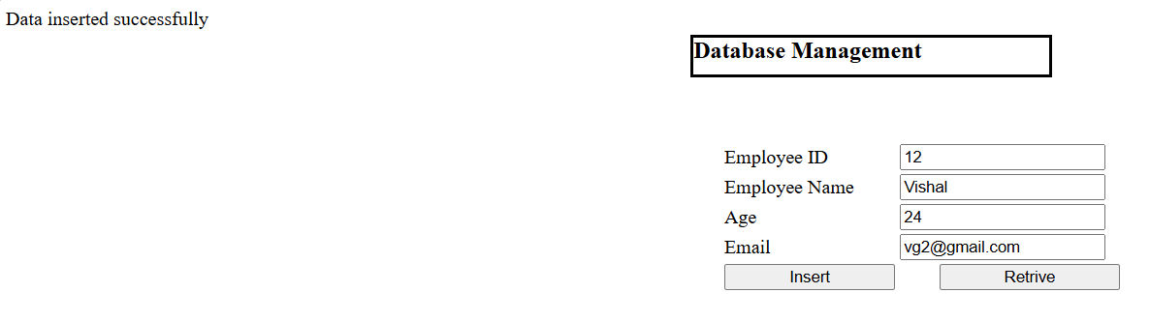

**Retrieve:**

