**Practical No.08**

**A)Create a web application for inserting and deleting records from a database. (Using Execute**

**Non Query).**

**ASPX CODE:**

<%@ Page Language="C#" AutoEventWireup="true" CodeBehind="WebForm8.aspx.cs" Inherits="WebApplication5.WebForm8" %>

<!DOCTYPE html>

<html xmlns="http://www.w3.org/1999/xhtml">

<head runat="server">

<title></title>

</head>

<body>

<form id="form1" runat="server">

<div>

</div>

<asp:Label ID="Label1" runat="server" BorderStyle="Solid" Font-Bold="True" Font-Size="Larger" style="z-index: 1; left: 501px; top: 30px; position: absolute; width: 333px; height: 31px" Text="USER MANAGEMENT"></asp:Label>

<br /><br />

<br /><br />

<br />

<asp:Label ID="Label2" runat="server" BorderStyle="Solid" CssClass="auto-style4" Font-Bold="True" Text="Enter ID :"></asp:Label>

<asp:TextBox ID="TextBox5" runat="server" CssClass="auto-style9" TextMode="Number"></asp:TextBox>

<table align="center">

<tr>

<td class="auto-style6"><b>Name</b></td>

<td class="auto-style7"> <asp:TextBox ID="TextBox1" runat="server"></asp:TextBox>&nbsp;</td>

</tr>

<tr>

<td><b>Age</b></td>

<td class="auto-style1">

<asp:TextBox ID="TextBox2" runat="server"></asp:TextBox></td>

</tr>

<tr>

<td><b>Department</b><asp:GridView ID="GridView1" runat="server" CellPadding="4" GridLines="None" style="z-index: 1; left: 412px; top: 383px; position: absolute; height: 180px; width: 330px" CssClass="auto-style2" ForeColor="#333333">

<AlternatingRowStyle BackColor="White" />

<EditRowStyle BackColor="#2461BF" />

<FooterStyle BackColor="#507CD1" ForeColor="White" Font-Bold="True" />

<HeaderStyle BackColor="#507CD1" Font-Bold="True" ForeColor="White" />

<PagerStyle BackColor="#2461BF" ForeColor="White" HorizontalAlign="Center" />

<RowStyle BackColor="#EFF3FB" />

<SelectedRowStyle BackColor="#D1DDF1" Font-Bold="True" ForeColor="#333333" />

<SortedAscendingCellStyle BackColor="#F5F7FB" />

<SortedAscendingHeaderStyle BackColor="#6D95E1" />

<SortedDescendingCellStyle BackColor="#E9EBEF" />

<SortedDescendingHeaderStyle BackColor="#4870BE" />

</asp:GridView>

</td>

<td class="auto-style1">

<asp:TextBox ID="TextBox3" runat="server"></asp:TextBox></td>

</tr>

<tr>

<td><b>MobileNo</b></td>

<td class="auto-style1">

<asp:TextBox ID="TextBox4" runat="server"></asp:TextBox></td>

</tr>

<tr>

<td>

<asp:Button ID="insert" runat="server" Text="Insert" OnClick="insert_Click" BorderStyle="Solid" Font-Bold="True" CssClass="auto-style8" />&nbsp;</td>

<td class="auto-style1">

&nbsp;</td>

</tr>

</table>

<asp:Button ID="delete" runat="server" Text="Delete" BorderStyle="Solid" CssClass="auto-style3" Font-Bold="True" OnClick="delete_Click" Width="149px" />

</form>

</body>

</html>

**C# CODE:**

using System;

using System.Data;

using System.Data.SqlClient;

namespace WebApplication5

{

public partial class WebForm8 : System.Web.UI.Page

{

SqlConnection con = new SqlConnection(@"Data Source=ROHIT\SQLEXPRESS;Initial Catalog=College; Integrated Security=True");

protected void Page_Load(object sender, EventArgs e)

{

retrive();

}

protected void insert_Click(object sender, EventArgs e)

{

con.Open();

SqlCommand cmd = new SqlCommand(@"insert into Users values(

'"+TextBox1.Text+"','" + Convert.ToInt32(TextBox2.Text)+ "','" +TextBox3.Text+ "','" +TextBox4.Text + "')",con);

cmd.ExecuteNonQuery();

Response.Write("Record Inserted Successfully");

retrive();

con.Close();

}

public void retrive()

{

SqlCommand cmd = new SqlCommand("select *from Users", con);

SqlDataAdapter d = new SqlDataAdapter(cmd);

DataTable dt = new DataTable();

d.Fill(dt);

GridView1.DataSource = dt;

GridView1.DataBind();

}

protected void delete_Click(object sender, EventArgs e)

{

con.Open();

SqlCommand cmd = new SqlCommand(@"delete from Users where ID=" + Convert.ToInt32(TextBox5.Text),con);

cmd.ExecuteNonQuery();

Response.Write("Record Deleted Successfully");

retrive();

con.Close();

} }}

**OUTPUT:**

**Insert:**

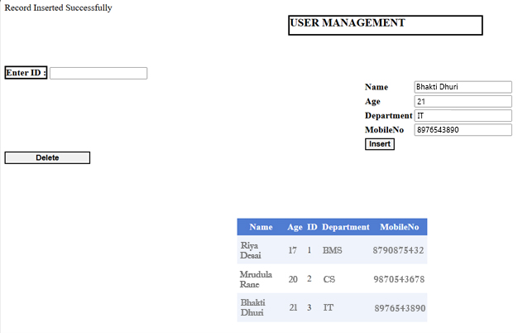

**Delete:**

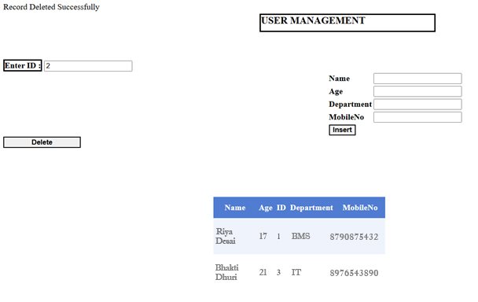

**B) Create a web application for user defined exception handling**

**ASPX CODE:**

**//Bhakti Dhuri**

<%@ Page Language="C#" AutoEventWireup="true" CodeBehind="WebForm10.aspx.cs" Inherits="WebApplication5.WebForm10" %>

<!DOCTYPE html>

<html xmlns="http://www.w3.org/1999/xhtml">

<head runat="server">

<title></title>

<style type="text/css">

.auto-style1 {

position: absolute;

top: 25px;

left: 471px;

z-index: 1;

width: 304px;

}

.auto-style2 {

position: absolute;

top: 98px;

left: 382px;

z-index: 1;

width: 226px;

}

.auto-style3 {

position: absolute;

top: 99px;

left: 646px;

z-index: 1;

}

.auto-style4 {

position: absolute;

top: 154px;

left: 373px;

z-index: 1;

}

.auto-style5 {

position: absolute;

top: 160px;

left: 644px;

z-index: 1;

}

.auto-style6 {

position: absolute;

top: 462px;

left: 372px;

z-index: 1;

width: 450px;

height: 44px;

}

.auto-style7 {

position: absolute;

top: 136px;

left: 921px;

z-index: 1;

width: 286px;

}

</style>

</head>

<body>

<form id="form1" runat="server">

<div>

</div>

<asp:Label ID="Label1" runat="server" CssClass="auto-style1" Font-Bold="True" Font-Size="Larger" Text="Arithmetic Operations"></asp:Label>

<asp:TextBox ID="TextBox1" runat="server" CssClass="auto-style3" TextMode="Number"></asp:TextBox>

<p>

<asp:Label ID="Label3" runat="server" CssClass="auto-style2" Font-Bold="True" Font-Size="Large" Text="Enter First Number :"></asp:Label>

</p>

<p>

&nbsp;</p>

<asp:Label ID="Label4" runat="server" CssClass="auto-style4" Font-Bold="True" Font-Overline="False" Font-Size="Large" Text="Enter Second Number :"></asp:Label>

<asp:TextBox ID="TextBox2" runat="server" CssClass="auto-style5"></asp:TextBox>

<br /> <br /> <br />

<asp:Label ID="error" runat="server" CssClass="auto-style7"></asp:Label>

<br /> <br /> <br /> <br /> <br /> <br />

<center><table>

<tr>

<td>

<asp:Button ID="add" runat="server" Text="Addition" OnClick="Button1_Click" /></td>

<td>

<asp:Button ID="sub" runat="server" Text="Subtraction" OnClick="Button2_Click" /></td>

<td>

<asp:Button ID="multi" runat="server" Text="Multiplication" OnClick="Button3_Click" /></td>

<td>

<asp:Button ID="div" runat="server" Text="Division" OnClick="Button4_Click" style="width: 85px" /></td>

</tr>

</table></center>

<asp:Label ID="show" runat="server" CssClass="auto-style6"></asp:Label>

</form>

</body>

</html>

**C# CODE:**

using System;

namespace WebApplication5

{

public class DivideByZeroException25:Exception

{

public DivideByZeroException25()

{

}

public DivideByZeroException25(string Message):base(Message)

{

}

}

public partial class WebForm10 : System.Web.UI.Page

{

protected void Page_Load(object sender, EventArgs e)

{

}

protected void Button1_Click(object sender, EventArgs e)

{

int res;

int n1 = Convert.ToInt32(TextBox1.Text);

int n2 = Convert.ToInt32(TextBox2.Text);

res = n1 + n2;

show.Text = "The Addition is : " + res.ToString();

} protected void Button2_Click(object sender, EventArgs e)

{

int res;

int n1 = Convert.ToInt32(TextBox1.Text);

int n2 = Convert.ToInt32(TextBox2.Text);

res = n1 - n2;

show.Text = "The Subtraction is : " + res.ToString();

}

protected void Button3_Click(object sender, EventArgs e)

{

int res;

int n1 = Convert.ToInt32(TextBox1.Text);

int n2 = Convert.ToInt32(TextBox2.Text);

res = n1 * n2;

show.Text = "The Multiplication is : " + res.ToString();

}

protected void Button4_Click(object sender, EventArgs e)

{ try

{ int n1 = Convert.ToInt32(TextBox1.Text);

int n2 = Convert.ToInt32(TextBox2.Text);

int a = DivisionOp(n1, n2);

show.Text = "The Division is : " + a.ToString();

}

catch (DivideByZeroException25 ex)

{

show.Text = ex.Message.ToString();

}}

public int DivisionOp(int n,int d)

{

if (d == 0)

{

throw new DivideByZeroException25("Exception Occured : Division By Zero is Not Possible");

}

else

{

return (n/d);

}} }}

**OUTPUT:**

