**Practical No.09**

Write the program for the following:

**A)Create a web application to demonstrate use of GridView button column and GridView events along with paging and sorting.**

**ASPX CODE:**

**//Bhakti Dhuri**

<%@ Page Language="C#" AutoEventWireup="true" CodeBehind="WebForm2.aspx.cs" Inherits="WebApplication8.WebForm2" %>

<!DOCTYPE html>

<html xmlns="http://www.w3.org/1999/xhtml">

<head runat="server">

<title></title>

<style type="text/css">

.auto-style1 {

position: absolute;

top: 24px;

left: 322px;

z-index: 1;

}

.auto-style3 {

position: absolute;

top: 432px;

left: 344px;

z-index: 1;

width: 543px;

height: 38px;

}

.auto-style4 {

width: 82px;

height: 180px;

position: absolute;

top: 110px;

left: 307px;

z-index: 1;

margin-left: 0px;

}

</style>

</head>

<body>

<form id="form1" runat="server">

<div>

</div>

<asp:Label ID="Label1" runat="server" BorderStyle="Solid" CssClass="auto-style1" Font-Bold="True" Font-Size="Large" Text="GridView Column Button With Paging and Sorting"></asp:Label>

<asp:Label ID="Label2" runat="server" CssClass="auto-style3" Font-Bold="True" Font-Size="Large"></asp:Label>

<asp:GridView ID="GridView1" runat="server" AllowPaging="true" AllowSorting="true" BackColor="White" BorderColor="White" BorderStyle="Ridge" BorderWidth="2px" CellPadding="3" CellSpacing="1" CssClass="auto-style4" GridLines="None" OnPageIndexChanging="GridView1_PageIndexChanging" OnRowCommand="GridView1_RowCommand" OnSorting="GridView1_Sorting">

<Columns>

<asp:ButtonField ButtonType="Button" CommandName="Show" Text="Show Detail" />

</Columns>

<FooterStyle BackColor="#C6C3C6" ForeColor="Black" />

<HeaderStyle BackColor="#4A3C8C" Font-Bold="True" ForeColor="#E7E7FF" />

<PagerStyle BackColor="#C6C3C6" ForeColor="Black" HorizontalAlign="Right" />

<RowStyle BackColor="#DEDFDE" ForeColor="Black" />

<SelectedRowStyle BackColor="#9471DE" Font-Bold="True" ForeColor="White" />

<SortedAscendingCellStyle BackColor="#F1F1F1" />

<SortedAscendingHeaderStyle BackColor="#594B9C" />

<SortedDescendingCellStyle BackColor="#CAC9C9" />

<SortedDescendingHeaderStyle BackColor="#33276A" />

</asp:GridView>

</form>

</body>

</html>

**C# CODE:**

using System;

using System.Web.UI.WebControls;

using System.Data;

using System.Data.SqlClient;

namespace WebApplication8

{

public partial class WebForm2 : System.Web.UI.Page

{

SqlConnection con = new SqlConnection(@"Data Source=BHAKTI;Initial Catalog=Employee;Integrated Security=True");

protected void Page_Load(object sender, EventArgs e)

{

if (!IsPostBack)

{

display();

}

}

public void display()

{

con.Open();

SqlDataAdapter sda = new SqlDataAdapter("select * from Employee",con);

DataTable dt = new DataTable();

sda.Fill(dt);

GridView1.DataSource = dt;

GridView1.DataBind();

con.Close();

ViewState["dt"] = dt;

ViewState["sort"] = "ASC";

}

protected void GridView1_RowCommand(object sender, GridViewCommandEventArgs e)

{

if(e.CommandName=="Show")

{

int index = Convert.ToInt32(e.CommandArgument.ToString());

GridViewRow row = GridView1.Rows[index];

String name = row.Cells[2].Text;

String sal = row.Cells[3].Text;

Label2.Text = "Selected Employee Name is :" + name + " and Salary is : " + sal;

}

}

protected void GridView1_PageIndexChanging(object sender, GridViewPageEventArgs e)

{

//paging concept

GridView1.PageIndex = e.NewPageIndex;

display();

}

protected void GridView1_Sorting(object sender, GridViewSortEventArgs e)

{

//sorting concept

DataTable res = ViewState["dt"] as DataTable;

if (res!=null && res.Rows.Count > 0 )

{

if (ViewState["sort"].ToString() == "DESC")

{

res.DefaultView.Sort = e.SortExpression + " DESC";

ViewState["sort"] = "DESC";

}

else

{

res.DefaultView.Sort = e.SortExpression + " ASC";

ViewState["sort"] = "ASC";

}

GridView1.DataSource = res.DefaultView;

GridView1.DataBind();

}

}

}

}

**OUTPUT:**

**GridView Button:**

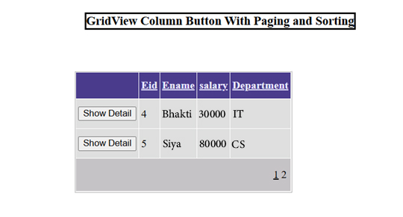

**Paging:**

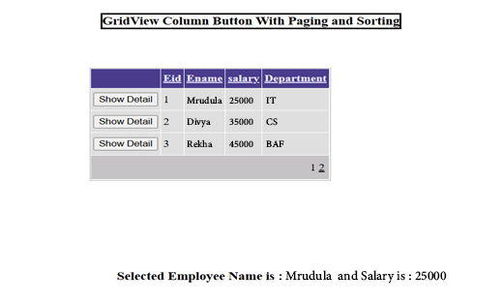

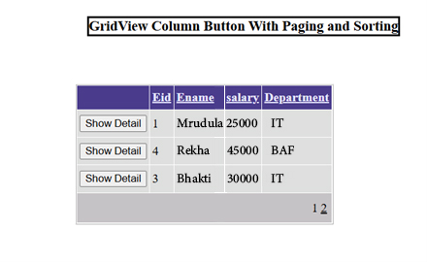**Sorting:**

**B)Create a web application to demonstrate data binding using DetailsView and FormView Control.**

**ASPX CODE:**

<%@ Page Language="C#" AutoEventWireup="true" CodeBehind="WebForm3.aspx.cs" Inherits="WebApplication8.WebForm3" %>

<!DOCTYPE html>

<html xmlns="http://www.w3.org/1999/xhtml">

<head runat="server">

<title></title>

<style type="text/css">

.auto-style1 {

position: absolute;

top: 19px;

left: 320px;

z-index: 1;

}

</style>

</head>

<body>

<form id="form1" runat="server">

<div>

<asp:Label ID="Label1" runat="server" BorderStyle="Solid" CssClass="auto-style1" Font-Bold="True" Font-Size="Large" Text="Data Binding Using DetailView and FormView"></asp:Label>

</div>

<br />

<asp:FormView ID="FormView1" runat="server" AllowPaging="True" DataSourceID="SqlDataSource1">

<EditItemTemplate>

Eid:

<asp:TextBox ID="EidTextBox" runat="server" Text='<%# Bind("Eid") %>' />

<br />

Ename:

<asp:TextBox ID="EnameTextBox" runat="server" Text='<%# Bind("Ename") %>' />

<br />

salary:

<asp:TextBox ID="salaryTextBox" runat="server" Text='<%# Bind("salary") %>' />

<br />

Department:

<asp:TextBox ID="DepartmentTextBox" runat="server" Text='<%# Bind("Department") %>' />

<br />

<asp:LinkButton ID="UpdateButton" runat="server" CausesValidation="True" CommandName="Update" Text="Update" />

&nbsp;<asp:LinkButton ID="UpdateCancelButton" runat="server" CausesValidation="False" CommandName="Cancel" Text="Cancel" />

</EditItemTemplate>

<HeaderTemplate>

Form View

</HeaderTemplate>

<InsertItemTemplate>

Eid:

<asp:TextBox ID="EidTextBox" runat="server" Text='<%# Bind("Eid") %>' />

<br />

Ename:

<asp:TextBox ID="EnameTextBox" runat="server" Text='<%# Bind("Ename") %>' />

<br />

salary:

<asp:TextBox ID="salaryTextBox" runat="server" Text='<%# Bind("salary") %>' />

<br />

Department:

<asp:TextBox ID="DepartmentTextBox" runat="server" Text='<%# Bind("Department") %>' />

<br />

<asp:LinkButton ID="InsertButton" runat="server" CausesValidation="True" CommandName="Insert" Text="Insert" />

&nbsp;<asp:LinkButton ID="InsertCancelButton" runat="server" CausesValidation="False" CommandName="Cancel" Text="Cancel" />

</InsertItemTemplate>

<ItemTemplate>

Eid:

<asp:Label ID="EidLabel" runat="server" Text='<%# Bind("Eid") %>' />

<br />

Ename:

<asp:Label ID="EnameLabel" runat="server" Text='<%# Bind("Ename") %>' />

<br />

salary:

<asp:Label ID="salaryLabel" runat="server" Text='<%# Bind("salary") %>' />

<br />

Department:

<asp:Label ID="DepartmentLabel" runat="server" Text='<%# Bind("Department") %>' />

<br />

</ItemTemplate>

</asp:FormView>

<asp:SqlDataSource ID="SqlDataSource1" runat="server" ConnectionString="<%$ ConnectionStrings:EmployeeConnectionString3 %>" SelectCommand="SELECT * FROM [Employee]"></asp:SqlDataSource>

<asp:DetailsView ID="DetailsView1" runat="server" Height="106px" Width="220px">

<FooterTemplate>

Detail View<br />

</FooterTemplate>

</asp:DetailsView>

</form>

</body>

</html>

**C# CODE:**

using System;

using System.Web.UI.WebControls;

using System.Data;

using System.Data.SqlClient;

namespace WebApplication8

{

public partial class WebForm3 : System.Web.UI.Page

{

SqlConnection con = new SqlConnection(@"Data Source=BHAKTI;Initial Catalog=Employee;Integrated Security=True");

protected void Page_Load(object sender, EventArgs e)

{

if (!IsPostBack)

{

//form view binded using ui

DetailViewBind();

FormViewBind();

}

}

public void DetailViewBind()

{

con.Open();

SqlDataAdapter sda = new SqlDataAdapter("select * from Employee", con);

DataTable dt = new DataTable();

sda.Fill(dt);

DetailsView1.DataSource = dt;

DetailsView1.DataBind();

con.Close();

}

public void FormViewBind()

{

// con.Open();

// SqlDataAdapter sda = new SqlDataAdapter("select * from Employee where Eid=1;", con);

// DataTable dt = new DataTable();

// sda.Fill(dt);

//FormView1.DataSource = dt;

//FormView1.DataBind();

// con.Close();

}

}

}

**OUTPUT:**

