Version Control System – Git

Version control is a system that records changes to a file or set of files over time so that you can recall specific versions later.

It allows you to revert selected files back to a previous state, revert the entire project back to a previous state, compare changes over time, see who last modified something that might be causing a problem, who introduced an issue and when, and more. Using a VCS also generally means that if you screw things up or lose files, you can easily recover.

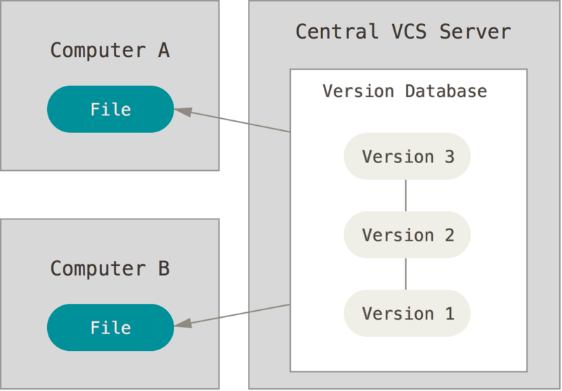
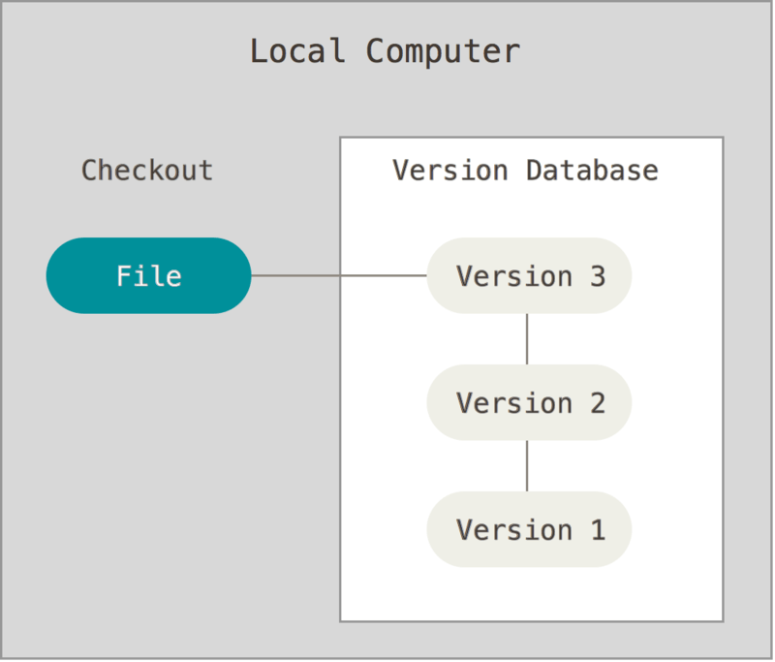
Local version control system
Centralized version control system
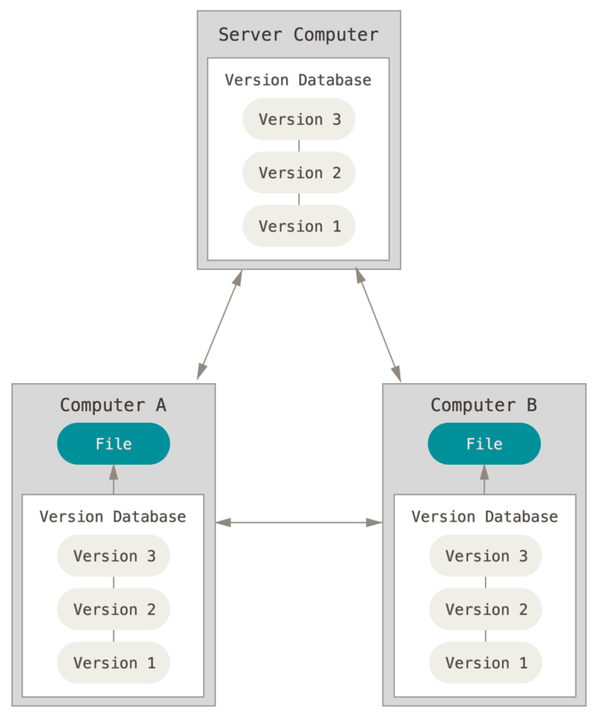
Distributed Version Control System(DVCS)

In a DVCS (such as Git, Mercurial, Bazaar or Darcs), clients don’t just check out the latest snapshot of the files; rather, they fully mirror the repository, including its full history. Thus, if any server dies, and these systems were collaborating via that server, any of the client repositories can be copied back up to the server to restore it. Every clone is really a full backup of all the data.

Git thinks of its data more like a series of snapshots of a miniature filesystem. With Git, every time you commit, or save the state of your project, Git basically takes a picture of what all your files look like at that moment and stores a reference to that snapshot. To be efficient, if files have not changed, Git doesn’t store the file again, just a link to the previous identical file it has already stored. Git thinks about its data more like a stream of snapshots.
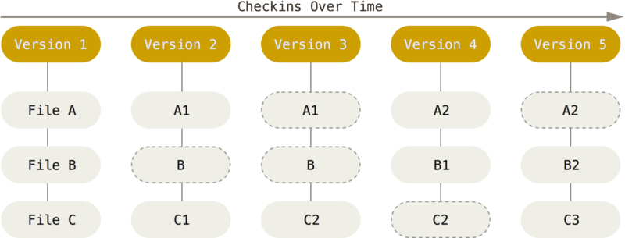
Most operations in Git need only local files and resources to operate — generally no information is needed from another computer on your network. Because you have the entire history of the project right there on your local disk, most operations seem almost instantaneous. For example, to browse the history of the project, Git doesn’t need to go out to the server to get the history and display it for you — it simply reads it directly from your local database. This means you see the project history almost instantly. If you want to see the changes introduced between the current version of a file and the file a month ago, Git can look up the file a month ago and do a local difference calculation, instead of having to either ask a remote server to do it or pull an older version of the file from the remote server to do it locally.

Everything in Git is checksummed before it is stored and is then referred to by that checksum. This means it’s impossible to change the contents of any file or directory without Git knowing about it. You can’t lose information in transit or get file corruption without Git being able to detect it. The mechanism that Git uses for this checksumming is called a SHA-1 hash. This is a 40-character string composed of hexadecimal characters (0–9 and a–f) and calculated based on the contents of a file or directory structure in Git. A SHA-1 hash looks something like this:
24b9da6552252987aa493b52f8696cd6d3b00373

You will see these hash values all over the place in Git because it uses them so much. In fact, Git stores everything in its database not by file name but by the hash value of its contents.

When you do actions in Git, nearly all of them only add data to the Git database. It is hard to get the system to do anything that is not undoable or to make it erase data in any way. As with any VCS, you can lose or mess up changes you haven’t committed yet, but after you commit a snapshot into Git, it is very difficult to lose, especially if you regularly push your database to another repository.

Git has three main states that your files can reside in: modified, staged, and committed:
- Modified means that you have changed the file but have not committed it to your database yet.
- Staged means that you have marked a modified file in its current version to go into your next commit snapshot.
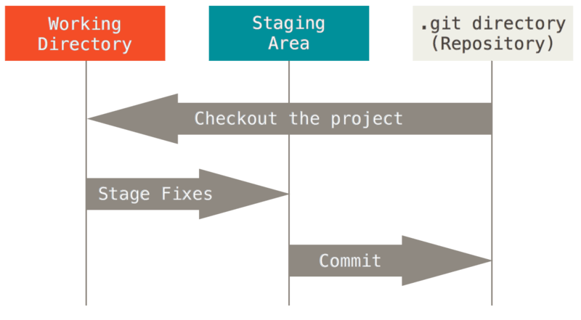
- Committed means that the data is safely stored in your local database.This leads us to the three main sections of a Git project: the working tree, the staging area, and the Git directory.
Three states of git
The working tree is a single checkout of one version of the project. These files are pulled out of the compressed database in the Git directory and placed on disk for you to use or modify.
The staging area is a file, generally contained in your Git directory, that stores information about what will go into your next commit. Its technical name in Git parlance is the “index”, but the phrase “staging area” works just as well.
The Git directory is where Git stores the metadata and object database for your project. This is the most important part of Git, and it is what is copied when you clone a repository from another computer.
The basic Git workflow goes something like this:
- You modify files in your working tree.
- You selectively stage just those changes you want to be part of your next commit, which adds only those changes to the staging area.
- You do a commit, which takes the files as they are in the staging area and stores that snapshot permanently to your Git directory.
If a particular version of a file is in the Git directory, it’s considered committed. If it has been modified and was added to the staging area, it is staged. And if it was changed since it was checked out but has not been staged, it is modified.

