This installation requires running Git from the Git Bash window (for the command line interface). It was done to keep Git separate from the rest of the win environment, but if problems are encountered with integration, it may be advisable to setup again in the future to allow commands to run from DOS as well as from GIT Bash. Options selected during installation are shown on the pages that follow. Some commands entered to configure Git after installation are also shown.

This install was done on a Windows 7 Notebook with 16 Gigs of Ram.

Git Installation setup screens:

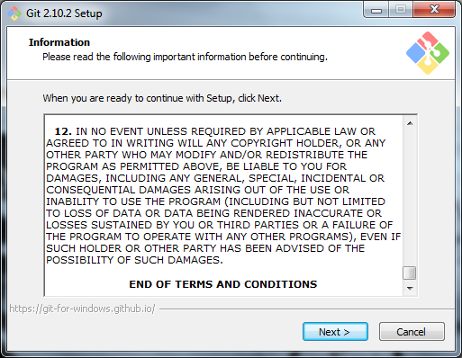

Changed installation directory to be consistent with my desired setup – default and what I changed it to follows:

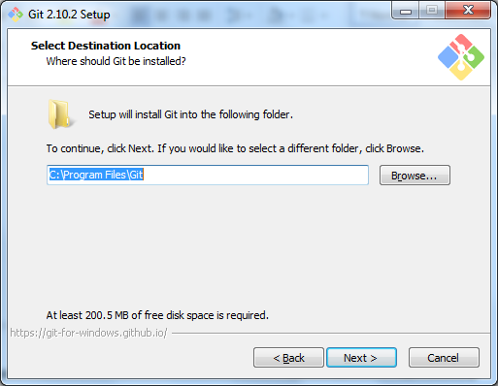

Changed above to this (forgot to get screen capture):

C:\ProgramFilesCoders\Git

Did this by manually changing the value, not browsing.

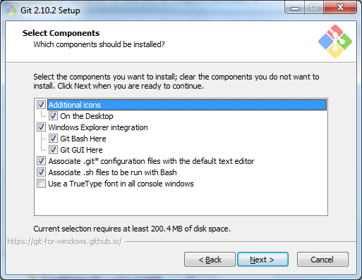

Concern: this may hook widnows notepad in as default text editor

Changing this to notepad++ may be indicated after installation

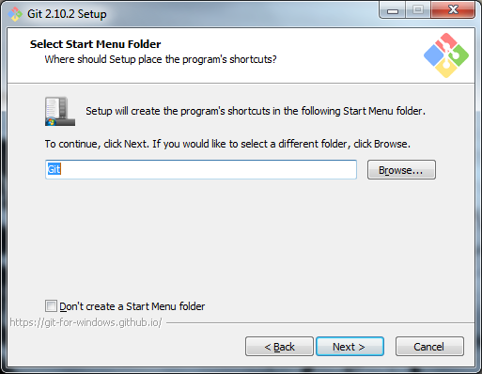

Default:

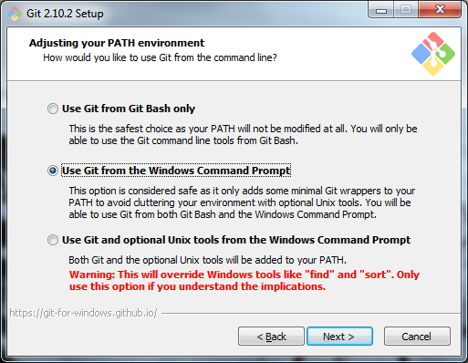

Changed above from default as per training videos for beginners:

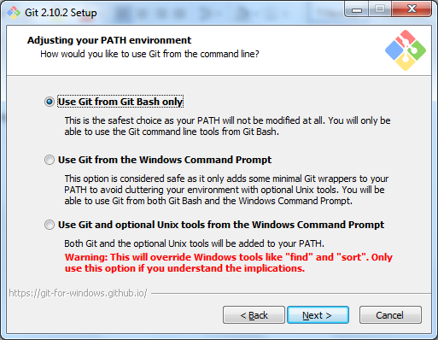

This setting may result in alteration to text files but keeping it anyway:

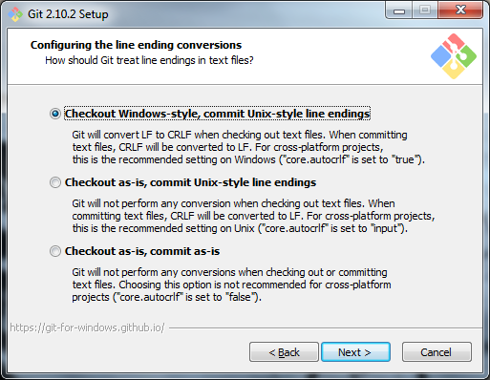

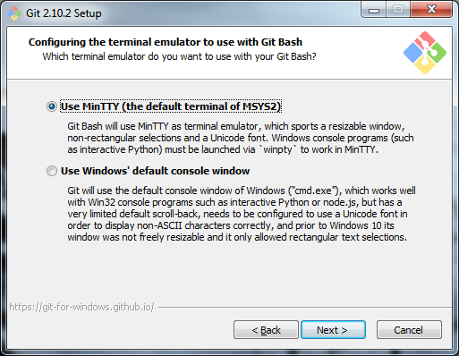

Keeping defaults:

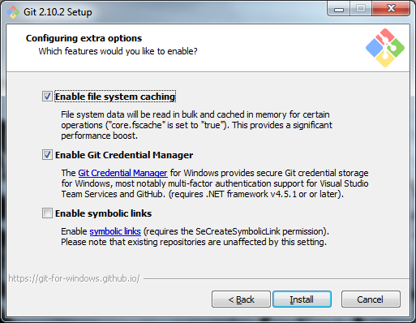

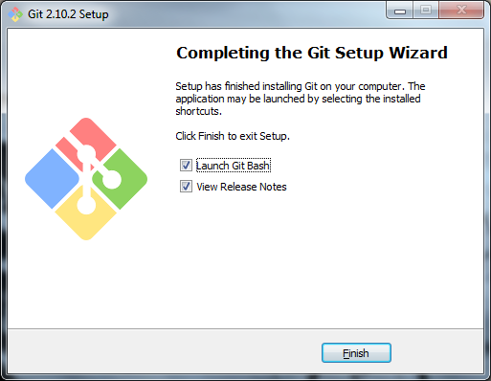

**Git Bash Windows: Commands after installation …**

$ git config --global user.name "<username>"

$ git config --global user.email "<email>"

$ git --version

git version 2.10.2.windows.1

$ git config --global core.editor "' C:\ProgramFilesCoders\Notepad_pp/notepad++.exe' -multiInst -nosession"

$ git config --list

core.symlinks=false

core.autocrlf=true

core.fscache=true

color.diff=auto

color.status=auto

color.branch=auto

color.interactive=true

help.format=html

http.sslcainfo=C:/ProgramFilesCoders/Git/mingw64/ssl/certs/ca-bundle.crt

diff.astextplain.textconv=astextplain

rebase.autosquash=true

credential.helper=manager

user.name=<username>

user.email=<email>

core.editor=' C:\ProgramFilesCoders\Notepad_pp/notepad++.exe' -multiInst –nosession