Supplementary Methods
ClawBio flow-compile: an agentic AI pipeline for automated CLIP-Seq data acquisition, validation and analysis on Flow.bio
GitHub: https://github.com/Chromojones/ClawBio/tree/skill/flow-compile (skill directory skills/flow-compile/, skill version 0.2.0; this document describes the pipeline as of 30 September 2026)

S1. Overview
flow-compile is a ClawBio skill that takes a published CLIP study (iCLIP, eCLIP, seCLIP, irCLIP, PAR-iCLIP, easyCLIP and related truncation-based protocols) from its GEO, SRA or ArrayExpress accession to an analysed project on the Flow.bio web platform. It is a self-contained directory: a SKILL.md specification, sixteen numbered stage scripts under stages/, a deterministic library under lib/, a reference corpus of rules under reference/, an index of every incident that produced a guardrail (FAILURES.md), and a test suite. An LLM agent (Claude Code, or any OpenClaw-compatible agent) drives it locally on the researcher's machine.
The design principle is a strict separation of roles. The stages execute and decide: each script decides one thing, records the decision in state.json, and refuses to run before the stages it depends on have completed. The agent dispatches: it runs the stages in order, gathers the evidence only it can gather (the CLIP subsection of a paper's Methods, GEO sample pages, ENA file reports, Flow search results), reads the artefacts each stage writes, and explains them. The researcher approves at three hard stops, where the run pauses on a person: the 5′ barcodes, the sample metadata, and the analysis parameters. Nothing reaches Flow that a person has not read.
The default route is SRA-direct. Flow pulls the reads from SRA/ENA itself, so for essentially every public study there is no local download, no FASTQ header cleaning and no multi-gigabyte staging disk; the work of the pipeline is metadata accuracy, barcode provenance and a remote header preview. A local-upload route survives only for a study that is absent from SRA/ENA. Both routes share the same three gates and the same delivery stages.
Every rule lives in exactly one place. SKILL.md is a map to the reference documents, each reference document owns one topic, and every incident that produced a guardrail is indexed in FAILURES.md against the test that encodes it, so a rule stated twice cannot drift. The suite currently holds 1,032 tests across 67 files, and includes tests that check the documentation against the scripts (every flag quoted in the demo walkthrough is checked against the stage parsers) and against the installed flowbio client (the import sheet's reserved columns are read from the library at test time, so a version bump that moves them fails CI rather than silently unattaching a study).

S2. Agentic Role Summary
Actor | Action | Rationale
Researcher (human) | Chooses the target accession; supplies a Flow project id (or asks for one to be created) and credentials; confirms the barcode proposals by setting status: confirmed on each; accepts the metadata after reading metadata_report.md; accepts the analysis parameters against the authors' own pipeline configuration. | The three decisions gated on a person are the three whose errors are silent: a wrong barcode demultiplexes reads into the wrong sample, a wrong target or antibody is wrong in the archive forever, and a wrong UMI length or mate corrupts an execution that finishes green.
Model (agent) | Runs the stages in order through flow_compile.py --next / --run; fetches the evidence the stages take as flags (GEO SOFT text via curl, the CLIP Methods excerpt as --paper-text, GEO sample pages, the ENA file report that becomes srr_map.tsv, ENA file sizes, Flow /search results, live sample records, execution processes); presents each gate's evidence to the researcher; runs the outward-facing commands the delivery stages print (import poll, sample edits, analysis runner). | Interpreting free-text methods sections and heterogeneous deposits is the task that cannot be automated with fixed patterns. The agent proposes with its reasoning shown and never fills a field it cannot quote; it does not approve on the researcher's behalf.
Stages and library (scripts) | Parse the series matrix; join it to the run map; collect barcode evidence by regex over the supplied corpus and from the deposited reads; build and validate the annotation; choose the route; classify FASTQ headers into one of four states; derive and cross-check the UMI parameters; build the accession sheet with a size ceiling; submit and poll the import; verify the samples against the sheet and write the repair edits; write the analysis runner under an 18-sample-per-execution ceiling; audit the run. | Deterministic, re-runnable and auditable: every stage hashes its inputs and arguments, declares its outputs, and exits with a code from a fixed contract. Every guardrail is a test, not a sentence.

S3. Pipeline Stages
Sixteen numbered scripts in four groups: a trunk every study takes (00–06), an SRA-direct line (101–110), a local line (201–210) for studies absent from SRA/ENA, and a shared delivery tail (11–13). Stage 108 sits on both lines. Everything a run writes lives under one --output directory; state.json holds decisions, never data, so a damaged one is repaired by deleting it and re-running. The driver knows only the order and where the run is:
python3 flow_compile.py --status --output <dir> # what has run, what is waiting
python3 flow_compile.py --next --output <dir> # the next command, required flags as placeholders
python3 flow_compile.py --run --output <dir> # run until a gate, or a stage needing operator flags

Exit codes are the interface between the stages, the driver and the agent. A gate (3) and a failed check (4) are different on purpose: “this barcode is awaiting approval” and “this barcode contradicts the reads” need different answers, and collapsing them into one warning is how an unapproved barcode once reached an upload.
Exit code | Meaning | What to do
0 | ok | continue
2 | usage error | fix the arguments
3 | gate — a human artefact is required | review the named artefact, re-run with the release flag
4 | check failed — the data is wrong | fix the data
5 | prerequisite stage not ok | run the stage it names

S3.1 Trunk — every study (stages 00–06)
# | Stage | Decides | Evidence in → artefact out
00 | 00_setup | The run directory, credentials and the project. Credentials are minted into an API token once (FLOWBIO_USERNAME/FLOWBIO_PASSWORD, or FLOW_TOKEN/FLOW_API_TOKEN, or ~/.config/flow/api-token) so no later stage prompts mid-run; --offline records that none exist. The project is adopted with --project-id or created with --create-project, and the creation is re-read from the API before it is trusted. | Flow login → state.json
01 | 01_study | Is the study public, and is it already on Flow? Public is read from the format of GEO's SOFT response (SOFT for a released series, HTML for an embargoed one), not from its wording. Prior upload is checked by searching the whole platform on accessions and target proteins, which survive inside deposited filenames; GSM and PubMed ids are not indexed. A check without its evidence is reported as not run, never as passed. | GEO SOFT (--geo-response), Flow /search (--search-results) → study_check.json
02 | 02_index | The samples, and the runs behind them. Joins the series matrix to srr_map.tsv (columns gsm, srr, srx; mate and fastq derived when absent). Both accessions are needed later: SRR for the header preview (ENA serves FASTQ per run) and SRX for the import. Disagreements are reported, not reconciled. | series matrix, srr_map.tsv → sheet_rows.json
03 | 03_barcodes | GATE 1. The 5′ barcode of every sample. Evidence is gathered in a fixed order: the series matrix; the CLIP subsection of the paper's Methods (--paper-text); GEO sample Data processing (--geo-cache-dir / --fetch-geo); and, as the final fallback, supplementary tables, filenames and the authors' pipeline config. With --fetch-reads the deposited reads are sampled from ENA and per-position base composition shows the in-line block, or shows that it was already removed before submission (in which case the barcode is recorded as metadata only, never trimmed again). Writes barcode_proposals.json and CONFIRM_BARCODES.md, exits 3. | GEO pages, paper Methods, ENA reads → barcodes.json once released with --accept-proposals <file>
04 | 04_annotate | Names, target, tag, agent, source, organism and crosslink mate: the sole writer of annotation content. Sample names follow protein_org_cell_RepN_SRR with the replicate read from the GEO title. When a PubMed id is present the paper is fetched (Europe PMC): Scientist = first author, PI = last author, and the purification agent is taken from the sentence naming the CLIP assay, in the form Rabbit Anti-TARGET (Vendor Catalog). Paired-end eCLIP rows have read 2 promoted as the crosslink mate. | series matrix, srr_map.tsv, paper Methods, PubMed → annotation.raw.csv, annotation_warnings.json
05 | 05_metadata | GATE 2. Is every field defensible? Validates the whole annotation in one pass. Errors stop at exit 3; warnings print and continue. Enforced: antibody has vendor and catalog; control libraries carry their own target (SMInput, IgG, noAbCtrl, AbControl) and inputs an empty agent; the source is a specific cell line, not a supplier phrase; organism is a Flow code (Hs, Mm); tag annotations follow the [mutation-]<terminus><tag> grammar; ambiguous pairs such as HEK293/HEK293T are warned, never auto-corrected. The one rule behind the checks: every value comes from a source you can quote, or is left empty for the gate to flag. | annotation.raw.csv → metadata_report.md, metadata_issues.json; released with --accept-metadata
06 | 06_route | SRA-direct or local, and which protocol. A study absent from SRA/ENA goes local (--not-in-sra, or --force-local --reason); every other study goes direct. The protocol is detected from the extraction protocol and data_processing, not from GEO's library_strategy (which has no CLIP entry). FLASH, uvCLAP and PAR-CLIP are refused by name because the CLIP-Seq pipeline assumes truncation-based crosslinking; a mixed series stops the run. | sheet_rows.json, matrix → route and protocol in state.json

S3.2 SRA-direct line (stages 101–110)
The route for essentially every study. Flow fetches the reads from ENA in the form @<run>.<n> <original spot name>, so the preview must see the study exactly as the import will; that is why the preview reads ENA rather than a local fastq-dump.
# | Stage | Decides | Evidence in → artefact out
101 | 101_preview | Header state and read structure of the deposited reads. Byte-range-fetches the first records of each run from the ENA FTP mirror (default 2,000 reads from 2 runs), classifies the header into one of four states (raw; randomer prepended by eclipdemux; :rbc: mid-header from the ENCODE portal; :rbc: terminal, typical iCLIP), and records whether the reads are untrimmed (one length, adapter reading through) or were processed before submission (varied lengths, no adapter), because a block already cut off must not be cut off again. Refuses the direct line when the UMI sits in the header comment: the SAM read name ends at the first space, so the comment is dropped at alignment and deduplication would fail after mapping. | ENA reads → read_structure.json
108 | 108_params | GATE 3, on both lines. Derives move_umi_to_header, umi_separator, umi_header_format (all-N of the confirmed barcode length), encode_eclip (true only for a prepended randomer, where the transform takes the first colon-delimited field as the UMI; on any :rbc: header it would take the instrument name and collapse the library to nothing on a green run), paired (the mate to analyse: second for ENCODE3 paired-end eCLIP, first for seCLIP, both otherwise) and skip_umi_dedupe. A coherence check refuses combinations that fail late and misleadingly (extraction with no separator). Composition finds the barcode/UMI boundary but not the UMI's last base, so the length is confirmed by a person against the authors' pipeline config. Confirmation compares parameters semantically, never byte-for-byte. | barcodes.json, read_structure.json, authors' config → pipeline_params.json; released with --accept-params
109 | 109_sheet | Builds and checks the accession sheet for flowbio samples import. Accessions must be experiments (SRX/ERX/DRX): a run accession returns HTTP 500 with no diagnostic, and asking for a run imports its whole parent experiment anyway, so the size ceiling counts the expanded experiment when --sizes (from the ENA file report) is given. strandedness is never emitted (rejected for CLIP with a 422); project is emitted when 00 recorded one (a reserved column since flowbio 0.12.0); empty optional values are dropped, not written blank. | annotation.raw.csv, srr_map.tsv (SRX), ENA sizes → import_sheet.csv
110 | 110_import | Submits the import only with --submit, and only after 108 is confirmed. The job is asynchronous: the stage records the job id and prints the poll command (flowbio --json samples import-status --job-id <JOB>), which the agent runs until COMPLETED. The sheet's project column attaches the samples, so there is no assignment step. Timing observed: about 3 minutes for one sample, about 30 for eight. | import_sheet.csv → import_job.json

S3.3 Local line (stages 201–210)
Only for a study absent from SRA/ENA. The reads are fetched by hand (one guarded wget -c per ENA FASTQ_URI, then gzip -t on every file, because an interrupted transfer is present but truncated) before 201 runs. Nothing renames reads locally: header cleaning (removespace) now runs inside the CLIP-Seq pipeline on Flow, so the filenames chosen at annotation are the filenames uploaded and the annotation is built in one pass.
# | Stage | Decides | Evidence in → artefact out
201 | 201_fetch | The reads directory (recorded absolute, for the upload command) and the header state, classified from a JSON list of sampled headers by the same classifier the direct line uses, so the two previews cannot diverge. | --fastq-dir, --headers → header state in state.json
108 | 108_params | The same shared gate as on the direct line. | → pipeline_params.json
210 | 210_upload | The upload sheet and the command that uploads it. Prints the vendored uploadsample_flowbio_v6.py command with --rows, --project-id and an absolute --base-dir filled in, --dry-run first. The stage uploads nothing itself. The upload endpoint keeps the __annotation columns, so this line needs no repair pass. | annotation.raw.csv → upload_sheet.csv

S3.4 Delivery — both lines (stages 11–13)
# | Stage | Decides | Evidence in → artefact out
11 | 11_verify | Did the samples arrive as the sheet described them? Compares one full GET /samples/{id} per sample (the project listing paginates at 10 per page while reporting the project total, and returns samples whose metadata is empty) against the sheet, in Flow's keys. The import job silently drops the __annotation columns (tag and cell-line detail) server-side, so on the direct line this stage always finds work: the differences are written as edits for flow_edit_samples.py (--dry-run, then --yes), which re-reads every edit, and the stage is re-run to zero. Missing samples are reported as a failed import. | --live-samples JSON → verify_report.json, repair_edits.csv
12 | 12_analysis | Writes the analysis runner with the parameters 108 approved and prints the command to run it. A check, not a gate: the parameters were the decision. It enforces the one rule that makes submission risky, at most 18 samples per execution, deriving the number of batches itself (-n on the vendored runner is the number of batches, not samples per batch); one execution covers one genome and one umi_header_format. The reference cross-check reports NOT COMPARED rather than passing by default unless --reference-params or a declared --no-reference-reason is supplied. | pipeline_params.json, sample count → run_analysis.sh
13 | 13_audit | Did every sample survive the run? Compares each sample's completed processes against the run's deepest sample, so a sample that failed or silently stopped is reported; --running reports hard failures only on a run still in progress. | --processes JSON (execution processes) → audit_report.json

S3.5 The three hard stops
None can be skipped, and none is a failure: a gate means the run is paused on a person. A gated stage does not satisfy a prerequisite, so nothing downstream can run past it; that is what makes it a stop rather than a message. Confirming a gate is a decision about evidence, not a flag that silences output: handing back an unedited proposals file is not approval.
Gate | Stage | Released by | Why a person decides | Rules
1 | 03_barcodes | --accept-proposals <file> with status: confirmed on every proposal | a wrong barcode demultiplexes into the wrong sample, with no error | reference/barcode-examples.md
2 | 05_metadata | --accept-metadata | a wrong target or antibody is wrong in the archive forever | reference/metadata-accuracy-checklist.md
3 | 108_params | --accept-params | a wrong UMI length or mate corrupts silently on an execution that finishes green | reference/eclip-analysis-params.md

Submission is deliberately not a fourth gate. An earlier version re-asked at submission a question the parameter gate had already settled, and a gate that re-asks a settled question trains its operator to click through. The batch ceiling is a rule, so it is enforced rather than approved.

S4. Design Considerations

S4.1 The stage contract and state.json
Sixteen scripts are more surface than one command, and the trade pays only because the guarantee lives in one place (stages/_common.py) and is checked by a test that loops over whatever is in stages/: every stage takes --output, names its prerequisites, declares its outputs, and uses the five exit codes. A stage declares its inputs; on start it hashes their contents together with its own arguments and reports whether the previous run still stands, so re-running a completed stage costs nothing and changing an upstream artefact recomputes the downstream stage on its own. A digest match alone is not “done”: the declared outputs must still exist.

S4.2 Gates exit; they do not warn
Barcodes, metadata and analysis parameters were once warnings that printed and continued, which is how an unapproved barcode could reach an upload. A gate now exits 3, writes its evidence, names its release flag, and does not satisfy a prerequisite; without the last part it would be decorative. The parameter gate compares the confirmed parameters to the derived ones semantically, because a byte comparison refused correct runs over key order and taught its operator to route around it.

S4.3 Evidence discipline
Every metadata value must come from a named source that can be quoted: a GEO field, an SDRF column, a vendor catalog entry, or a specific sentence in the paper. If it cannot be quoted it is left empty and the gate flags it; an empty field is caught, a plausible invention is not. Python never infers: there is deliberately no automatic barcode inference in barcode_extract.py, because a guess made in code is indistinguishable from a reading. Where evidence is genuinely incomplete (one sample lacking what its siblings have; a paper giving lengths but no motif; a stated barcode that is the RT primer and so the reverse complement of the read), the agent proposes with its reasoning in the proposal's notes and the researcher decides. The metadata checklist keeps a judgement register of the fields that remain agent-decided and therefore review targets, with the GSM-to-run mapping and the choice of Methods excerpt rated highest risk.

S4.4 SRA-direct by default
Step | SRA-direct (preferred) | Local download
Reads | Flow pulls from SRA/ENA | fetched by hand (wget -c from ENA FTP), verified with gzip -t
Disk | none | the full FASTQ set
Header check | ENA byte-range snippet (101_preview) | sampled headers on disk (201_fetch)
Header cleaning | not applicable | not applicable: removespace runs in the CLIP-Seq pipeline on Flow
Accession | SRX (experiment) | SRR (run)
Project | project column in the sheet (flowbio ≥ 0.12.0) | --project-id on upload
Annotations | dropped by the import; restored through 11_verify | kept by the upload endpoint
Entry point | 109_sheet → 110_import --submit | 210_upload, then the command it prints

S4.5 Flow API behaviour the pipeline encodes
Each of these was learned on a real study and is now enforced in code or caught by verification; the full list, with the study each cost, is in FAILURES.md and reference/sra-direct-import.md.
Fact | Symptom if ignored | Where enforced
The import accession must be an experiment (SRX/ERX/DRX), never a run | HTTP 500 with no diagnostic | lib/sra_import.py
samples import drops __annotation columns server-side; a colon does not carry one either | Job COMPLETED, every tag and cell-line annotation gone (GSE252683, 12 samples, no error) | 11_verify → flow_edit_samples.py
strandedness is rejected for CLIP even though the batch template lists it | 422 “Not a valid attribute for this sample type” | lib/sra_import.py
DELETE /samples/{id} returns 200 and is inconsistent; the working route is POST /samples/{id}/delete | a sample survives three “successful” deletes and still matches execution filters | FlowClient.delete_sample, accepts only a 404 on re-read
GET /projects/{id}/samples pages at 10 and its count is the project total; listed samples carry empty metadata | a truncated pre-flight reports “clean import” and uploads the study twice; a truncated verification reports every unfetched sample missing | FlowClient.paginate; consumers refuse a short envelope
Several write endpoints return 200 while doing nothing | a status code is believed; the resource is unchanged | every mutation is re-read (create_project, delete_sample, flow_edit_samples.py)
pubmed is a top-level sample property, not a metadata attribute; setting it populates the project's papers | a PMID left in comments loses the paper linkage entirely | 04_annotate, 11_verify
organism takes Flow's two-letter code (Hs, Mm), never a Latin or common name | all 18 rows of GSE159997 failed with “Does not exist” after 12.8 GB had been staged | lib/organism.py, 05_metadata
A sample with both mates need not be analysed paired-end: csv_params.samplesheet.paired selects the mate | a mate deleted from a sample breaks it silently in both directions | 108_params sets paired; 12_analysis passes it

S4.6 Failures as the specification
FAILURES.md holds one entry per incident, 22 at the time of writing, each pointing at the test that encodes it; module docstrings link back to the entry by anchor, so the reasoning for a guardrail is one hop from the line that implements it. Representative entries: an eCLIP header classifier that returned the same answer for a raw header and one whose randomer had already been prepended, so five real bases of insert were re-extracted; a protocol matcher that read PAR-iCLIP as iCLIP for months; a size ceiling that counted run accessions while the import expanded them to whole experiments; and two vendored lines that corrupt data silently if reverted (a / in removespace that, replaced, makes every UMI the constant 1; a paired value that, hardcoded, analyses the wrong mate). Development follows ClawBio's red/green rule: the test that reproduces an incident is written first.

S5. Supplementary Figures
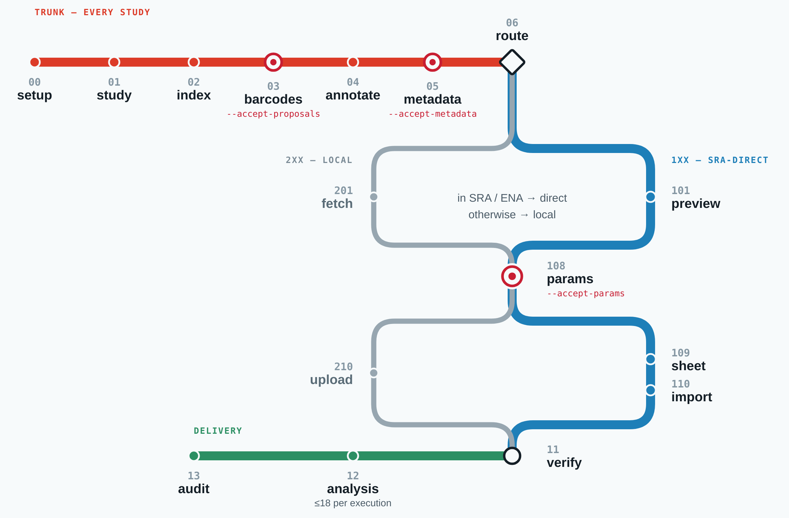
Figure S1. The flow-compile stage map. A red trunk every study takes runs through 00 setup, 01 study, 02 index, 03 barcodes, 04 annotate and 05 metadata to a decision at 06 route, where the map splits: the blue SRA-direct line (the default) through 101 preview, and the thinner grey local line, taken only when the study is not in SRA/ENA, through 201 fetch. Both meet at 108 params, the last hard stop, split again (109 sheet and 110 import; 210 upload) and converge at 11 verify, from which the green delivery line runs through 12 analysis, which carries the ceiling of 18 samples per execution, to 13 audit. Ringed stations are the three hard stops where a person signs off, each labelled with its release flag; the diamond is the route decision. Exit codes: 0 ok; 3 gate, paused on a person, not failed; 4 check failed, the data is wrong; 5 prerequisite not met. Source: flow-compile-line-map.svg.
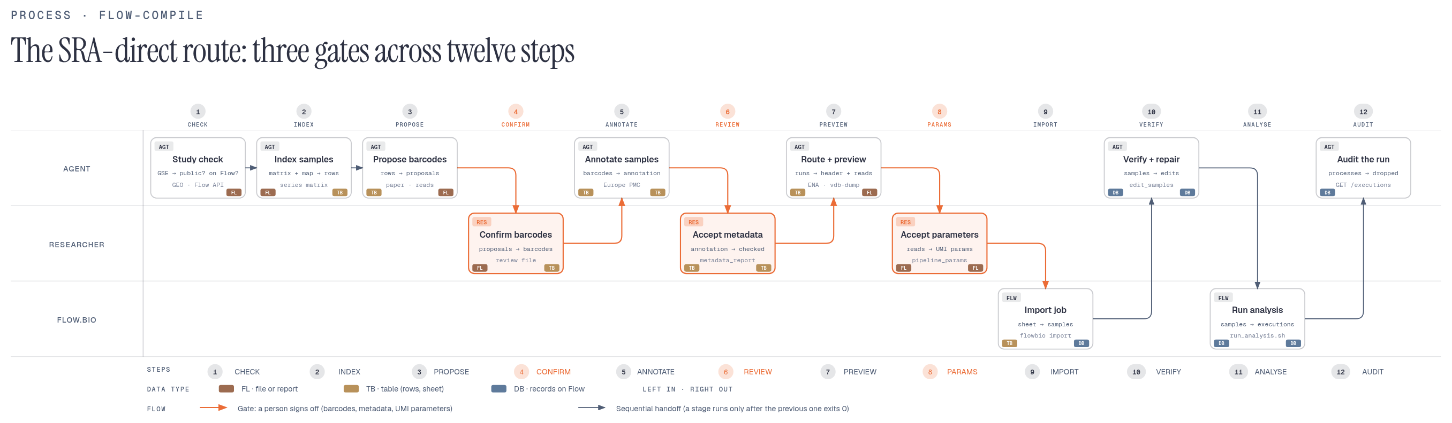
Figure S2. The SRA-direct route as a swimlane: who acts at each of twelve steps. Agent steps (top lane) index the study and propose; researcher steps (middle lane, orange) are the three gates, confirming barcodes, accepting metadata and accepting the UMI parameters; Flow.bio steps (bottom lane) are the import job and the analysis executions. Each box names its input and output and the tool or source behind it. An orange arrow is a hand-off to a person; a grey arrow is a sequential hand-off, where a stage runs only after the previous one exits 0. The local line (201, 210) is not drawn. Source: reference/diagrams/sra-direct-process.html.

S6. Software and Dependencies
The agent never calls the SRA, ENA or Flow APIs on its own initiative: it runs the stage scripts, supplies the evidence files they ask for, and runs the commands they print. Bioinformatics tooling on the researcher's machine is minimal because reads are not downloaded on the default route; the SRA Toolkit is no longer required at all.
Component | Version | Role in the pipeline
ClawBio | 0.5.2 (package); flow-compile skill 0.2.0 | Skill host, routing table, agent instructions (CLAUDE.md, SKILL.md)
Python | ≥ 3.11 | Stage scripts and library
pandas | ≥ 2.0 | Series-matrix parsing, annotation and sheet tables
biopython | ≥ 1.80 | Read sampling and sequence handling
requests | ≥ 2.31 | GEO, ENA, PubMed/Europe PMC and Flow REST calls
openpyxl | ≥ 3.1 | Supplementary and template spreadsheets
flowbio (Python client + CLI) | ≥ 0.12.0 | flowbio samples import / import-status; project and pubmed are reserved sheet columns from 0.12.0; required by the vendored upload and analysis scripts
curl | any | GEO SOFT endpoint (the HTML accession page sits behind reCAPTCHA); ENA file report for srr_map.tsv and sizes
wget, pigz | any | Local line only: ENA FTP download; removespace if ever run locally
lib/vendor/flow_api/upload/uploadsample_flowbio_v6.py | vendored | Local-line upload command printed by 210_upload
lib/vendor/flow_api/analysis/flowrunanalysis_flowbio.py | vendored | Analysis submission called by run_analysis.sh (12_analysis)
lib/vendor/flow_api/metadata/flow_edit_samples.py | vendored | Applies repair_edits.csv from 11_verify; re-reads every edit
lib/vendor/flow_api/preprocessing/removespace.py | vendored, reference only | Header cleaning now runs inside the CLIP-Seq pipeline on Flow
Flow.bio CLIP-Seq pipeline (goodwright/clipseq) | platform | Trimming, UMI handling, alignment, crosslink calling; parameters from pipeline_params.json
pytest | any | 1,032 tests across tests/unit, tests/stages, tests/e2e

Mandatory guardrails (SKILL.md): stages are entered only through their scripts and the driver; no barcode reaches an annotation without status: confirmed; no annotation reaches a sheet without the metadata gate released; no import or analysis is submitted without --accept-params; 110_import submits only with --submit, and 210_upload and 12_analysis never submit themselves. Credentials are read from the environment or the token file and are never written into generated scripts or the repository. Genetic data handled by ClawBio skills stays on the researcher's machine; here the reads never touch it.

S7. Reproducible Demo
DEMO.md walks GSE105082 (DHX9 iCLIP, GSM2817677, SRR6181530; Murat et al. 2018, PMID 30591072) through the trunk, both gates it can reach offline, and a dry-run upload, against data bundled in demo/: the full series matrix, a cached GEO sample page, a Methods excerpt quoting the barcodes NNNCGGANNN and NNNGGCANNN, and a five-read FASTQ snippet. Every flag in the walkthrough is checked against the stage parsers by tests/unit/test_docs.py.
python3 stages/00_setup.py --output $OUT --accession GSE105082 --offline
python3 stages/01_study.py --output $OUT
python3 stages/02_index.py --output $OUT --geo-matrix demo/GSE105082_series_matrix.txt \
--srr-map demo_gse105082_srr_map.tsv
python3 stages/03_barcodes.py --output $OUT --geo-matrix demo/GSE105082_series_matrix.txt \
--geo-cache-dir demo --paper-text demo/paper_PMC6307142_iclip_excerpt.txt # exit 3: gate 1
# set "status": "confirmed" on the NNNCGGANNN proposal, then
python3 stages/03_barcodes.py --output $OUT --accept-proposals $OUT/barcode_proposals.json
python3 stages/04_annotate.py --output $OUT --geo-matrix demo/GSE105082_series_matrix.txt \
--srr-map demo_gse105082_srr_map.tsv --paper-text demo/paper_PMC6307142_iclip_excerpt.txt
python3 stages/05_metadata.py --output $OUT # exit 3: the excerpt never names the antibody
python3 stages/05_metadata.py --output $OUT --accept-metadata
python3 stages/06_route.py --output $OUT --force-local --reason "offline demo, srr_map has no SRX"
python3 stages/201_fetch.py --output $OUT --headers $OUT/headers.json --fastq-dir demo
python3 stages/108_params.py --output $OUT # exit 3: gate 3, umi_header_format NNNNNNNNNN
python3 stages/108_params.py --output $OUT --accept-params
python3 stages/210_upload.py --output $OUT # writes upload_sheet.csv, prints the --dry-run command

The second gate stops on a real error, not a demonstration one: the paper excerpt never names the purification antibody, so the field is empty and the gate flags it. A real run drops --offline, supplies credentials and a project, gives 01 the GEO SOFT text and Flow search results, and carries an srx column in srr_map.tsv, so 06 routes direct and delivery is 109_sheet → 110_import instead of 210_upload.

