Configuration Guide
Settings Reference
Generated: February 28, 2026

Table of Contents
[Right-click and select "Update Field" to generate Table of Contents]

Configuration Guide

Overview
This guide provides a complete reference for every configuration option in both PreRollTracker and ApexAPI. PreRollTracker is configured primarily through environment variables in a .env file and application settings stored in the database. ApexAPI is configured through a single JSON file (apex_config.json).
Changing configuration values does not require writing code. For PreRollTracker, most changes require editing the .env file and restarting the service. For ApexAPI, most changes require editing apex_config.json and restarting the application.
---

1. PreRollTracker Environment Variables
PreRollTracker reads its environment from a .env file located in the application root directory (typically /opt/preroll-tracker/.env). The python-dotenv library loads this file automatically when the application starts.

1.1 Complete Environment Variable Reference
Variable | Required | Default | Description
`SECRET_KEY` | Yes | None (app refuses to start without it) | Cryptographic key used for session signing, CSRF tokens, and other security features. Must be a long random string. Generate with: `python3 -c "import secrets; print(secrets.token_hex(32))"`
`ADMIN_PASSWORD_HASH` | Yes | None | bcrypt hash of the admin password. Generated by `setup_password_standalone.py` or the settings page. Never store the plain-text password here.
`FLASK_ENV` | Recommended | `development` | Set to `production` for live deployment. Controls session cookie security (Secure flag), logging behavior, and debug mode.
`SENTRY_DSN` | Optional | Empty string (Sentry disabled) | Sentry Data Source Name for error tracking. Obtain from your Sentry project settings. Leave empty to disable Sentry.
`SENTRY_ENV` | Optional | `production` | Sentry environment tag. Useful if you run staging and production instances.
`BACKUP_ENCRYPTION_KEY` | Required for remote backups | Empty string | Passphrase used to encrypt database backups with AES-256-CBC. Must be a long, random string. If not set, remote (GitHub) backups will fail.
`GITHUB_REPO` | Required for remote backups | Empty string | GitHub repository in `owner/repo` format for uploading encrypted backups as pre-releases. Requires the `gh` CLI to be installed and authenticated.
`PUSHOVER_APP_TOKEN` | Optional | Empty string | Pushover application token for sending failure notifications. Used as a fallback if the app token is not configured in the database settings.
`LOG_LEVEL` | Optional | `INFO` | Logging level. Options: `DEBUG`, `INFO`, `WARNING`, `ERROR`, `CRITICAL`.

1.2 Example `.env` File
FLASK_ENV=production
SECRET_KEY=a1b2c3d4e5f6a1b2c3d4e5f6a1b2c3d4e5f6a1b2c3d4e5f6a1b2c3d4e5f6a1b2
ADMIN_PASSWORD_HASH=$2b$12$XXXXXXXXXXXXXXXXXXXXXXXXXXXXXXXXXXXXXXXXXXXXXXXXXXXXX
SENTRY_DSN=https://examplePublicKey@o0.ingest.sentry.io/0
SENTRY_ENV=production
BACKUP_ENCRYPTION_KEY=my-very-long-and-random-encryption-passphrase-here
GITHUB_REPO=mycompany/preroll-tracker
PUSHOVER_APP_TOKEN=aXXXXXXXXXXXXXXXXXXXXXXXXXXXXXX
LOG_LEVEL=INFO

1.3 Generating a SECRET_KEY
The SECRET_KEY is the most critical environment variable. It must be:
- At least 32 characters long.
- Randomly generated (do not use dictionary words or predictable patterns).
- Unique to each installation.
- Never shared or committed to version control.
Generate a secure key:
python3 -c "import secrets; print(secrets.token_hex(32))"
If the SECRET_KEY changes, all active sessions are invalidated (users are logged out) and all CSRF tokens become invalid.
---

2. PreRollTracker Application Settings
Beyond environment variables, PreRollTracker stores operational settings in the settings table of the SQLite database. These settings are managed through the admin dashboard's Settings page.

2.1 Production Settings
Setting | Type | Default | Description
Tare weight (0.5g) | Decimal | Configured per batch | Weight of the empty cone for 0.5g pre-rolls, used in yield calculations
Tare weight (0.7g) | Decimal | Configured per batch | Weight of the empty cone for 0.7g pre-rolls
Tare weight (1.0g) | Decimal | Configured per batch | Weight of the empty cone for 1.0g pre-rolls
Papers per box (0.5g) | Integer | 1000 | Number of papers/cones in a box for 0.5g size
Papers per box (0.7g) | Integer | 900 | Number of papers/cones in a box for 0.7g size
Papers per box (1.0g) | Integer | 1000 | Number of papers/cones in a box for 1.0g size

2.2 Work Schedule Settings
Setting | Type | Default | Description
Work hours start | Integer (0-23) | 9 | Start of the work day (used for production rate calculations)
Work hours end | Integer (0-23) | 17 | End of the work day
Work days | List of integers | [1,2,3,4,5] (Mon-Fri) | Days of the week when production occurs (1=Monday)

2.3 Inventory Alert Settings
Setting | Type | Default | Description
Alert threshold (0.5g) | Integer | 5 boxes | Number of remaining boxes that triggers a low inventory alert
Alert threshold (0.7g) | Integer | 3 boxes | Same for 0.7g cones
Alert threshold (1.0g) | Integer | 3 boxes | Same for 1.0g cones

2.4 Pushover Notification Settings (Database)
These are stored in the database and configured through the Settings page:
Setting | Type | Default | Description
Enabled | Boolean | False | Master switch for Pushover notifications
User Key | String | Empty | Your Pushover user key (from your Pushover account)
App Token | String | From `PUSHOVER_APP_TOKEN` env var | Pushover application token
Warning grams | Integer | 500 | Finished goods gram level that triggers a warning notification
Critical grams | Integer | 50 | Gram level that triggers a critical notification
Cooldown hours | Integer | 24 | Minimum hours between repeated notifications for the same package

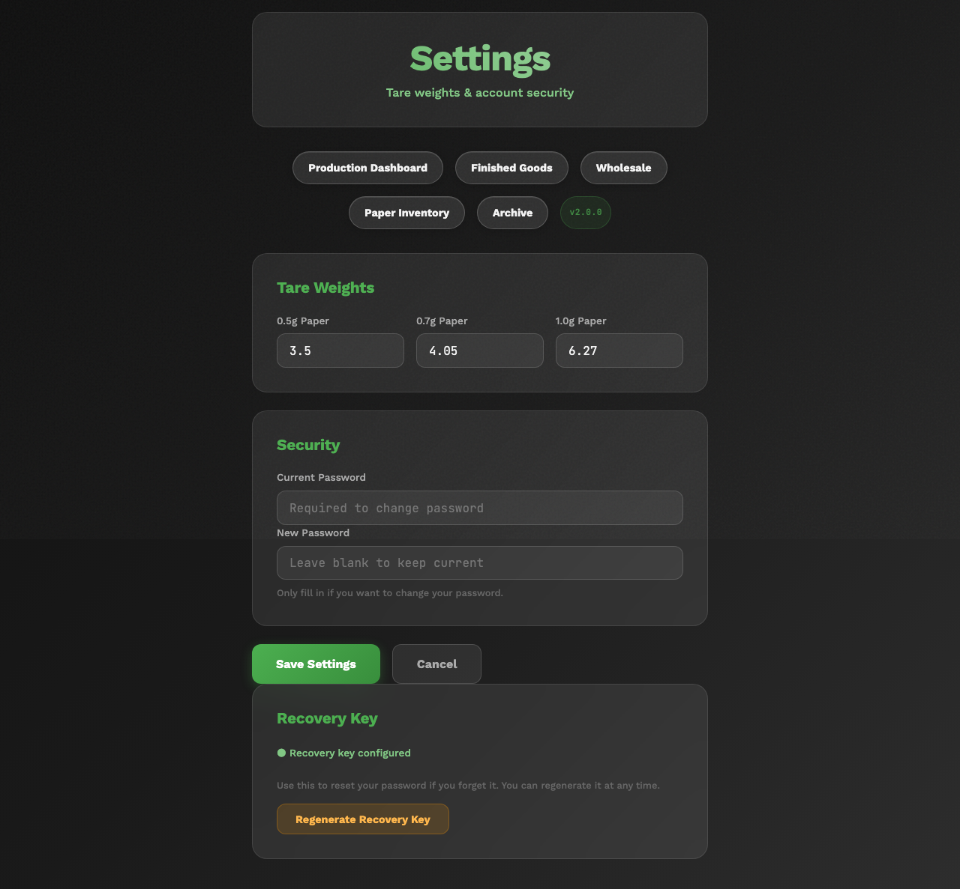
PreRollTracker Settings page showing the Pushover notification configuration section
---

3. ApexAPI Configuration (apex_config.json)
ApexAPI stores all of its configuration in a single JSON file: apex_config.json. This file is located in the application's root directory (next to the .exe on Windows, or in the project root during development).

3.1 Complete Configuration Reference

General Settings
Key | Type | Default | Description
`license_number` | String | `""` | Cannabis license number (for display and compliance)
`selected_printer` | String | `""` | Name of the default printer for order forms
`window_geometry` | String | `"1400x900"` | Window size on startup (width x height in pixels)
`window_state` | String | `"normal"` | Window state: `"normal"` or `"maximized"`
`ui_theme` | String | `"light"` | UI theme: `"light"` or `"dark"`
`log_level` | String | `"INFO"` | Logging level: `DEBUG`, `INFO`, `WARNING`, `ERROR`

API Connection Settings
Key | Type | Default | Description
`api_token` | String | `""` | Apex Trading API bearer token. Obtain from your Apex Trading account. Format: `"130-xEkX..."` (number, pipe, token string)
`dashboard_api_key` | String | `""` | PreRollTracker Dashboard API key. Copy from PreRollTracker Settings page.
`api_timeout` | Integer | `30` | HTTP request timeout in seconds for API calls
`print_timeout` | Integer | `60` | Timeout in seconds for print operations
`max_cache_size` | Integer | `1000` | Maximum number of entries in the in-memory LRU cache

Auto-Refresh Settings
Key | Type | Default | Description
`auto_refresh_enabled` | Boolean | `true` | Whether to automatically refresh order data
`auto_refresh_interval` | Integer | `5` | Seconds between automatic refreshes
`offer_startup_print` | Boolean | `true` | Whether to offer printing unprinted orders on startup

Order Filtering Settings
Key | Type | Default | Description
`excluded_statuses` | List | `["Complete", "Cancelled", "Delivered"]` | Order statuses to hide from the active order list
`excluded_products` | List | `["3rd Party Products - 3rd Party Products"]` | Product names to exclude from order forms
`include_3rd_party_products` | Boolean | `false` | Whether to include third-party products in order processing
`last_filter_value` | String | `""` | Remembered filter text from the last session

API Timestamp Tracking
Key | Type | Default | Description
`api_last_call_timestamps` | Object | `{}` | Tracks the last API call time per endpoint for `updated_at_from` compliance. Managed automatically.
`api_initial_sync_date` | String | `"2025-07-01T00:00:00Z"` | The earliest date to sync data from on first run. Orders before this date are ignored.

Cache Directory
Key | Type | Default | Description
`cache_directory` | String | `"cache"` | Directory for file-based API response caching (relative to application root)

Column Widths
Key | Type | Default | Description
`column_widths` | Object | `{}` | Saved column widths for the order table. Managed automatically as the user resizes columns.

---

4. Cache Warming Strategies and Tuning

4.1 What Is Cache Warming?
Cache warming is a proactive caching strategy where ApexAPI pre-fetches API data in the background before it is requested by the user. This makes the application feel faster because data is already available in the cache when needed.

4.2 Cache Warming Configuration
The cache_warming section of apex_config.json controls this behavior:
"cache_warming": {
"enabled": true,
"strategies": {
"orders_list": {
"enabled": true,
"interval_minutes": 2,
"run_on_startup": true
},
"predictive_details": {
"enabled": true,
"interval_minutes": 5,
"run_on_startup": false
},
"inventory": {
"enabled": true,
"interval_minutes": 1440,
"run_on_startup": true
},
"order_details": {
"enabled": true,
"interval_minutes": 30,
"run_on_startup": false
},
"third_party_status": {
"enabled": false,
"interval_minutes": 240,
"run_on_startup": false
}
}
}

4.3 Strategy Reference
Strategy | What It Caches | Default Interval | Run on Startup | Notes
`orders_list` | Active order list from Apex Trading | 2 minutes | Yes | Most frequently refreshed; keeps the order table current
`predictive_details` | Order details for orders likely to be viewed | 5 minutes | No | Pre-fetches details for recently updated orders
`inventory` | Full product inventory from Apex Trading | 1440 min (24 hr) | Yes | Large data set; refreshed daily
`order_details` | Individual order detail pages | 30 minutes | No | Caches details for all visible orders
`third_party_status` | Third-party product order statuses | 240 min (4 hr) | No | Disabled by default; enable only if using third-party products

4.4 Tuning Recommendations
- If the application feels slow: Enable all strategies and reduce intervals. Set orders_list to 1 minute.
- If API rate limits are a concern: Increase intervals or disable predictive_details and order_details.
- If startup is slow: Set run_on_startup to false for inventory (it is the largest fetch).
- If memory usage is high: Reduce max_cache_size from 1000 to 500.

4.5 Cache Logging
The cache_logging section controls diagnostic output for cache operations:
"cache_logging": {
"enabled": true,
"console_enabled": true,
"file_enabled": true,
"stats_interval_minutes": 5
}
Key | Type | Default | Description
`enabled` | Boolean | `true` | Master switch for cache logging
`console_enabled` | Boolean | `true` | Print cache stats to the console/terminal
`file_enabled` | Boolean | `true` | Write cache stats to the log file
`stats_interval_minutes` | Integer | `5` | How often to print cache hit/miss statistics

Set enabled to false to silence all cache-related log output.
---

5. Batch Inventory Sync Configuration

5.1 What Is Batch Inventory Sync?
Batch inventory sync is a background process in ApexAPI that keeps Apex Trading's batch inventory in sync with the pre-roll production data in PreRollTracker. When pre-rolls are packed, the dashboard tracks grams consumed. This sync service updates the corresponding Apex Trading batch quantities to match.

5.2 Configuration
The batch_inventory_sync section of apex_config.json:
"batch_inventory_sync": {
"enabled": true,
"poll_interval_seconds": 5,
"min_api_interval_seconds": 10,
"skip_if_no_change": true,
"auto_start": true
}
Key | Type | Default | Description
`enabled` | Boolean | `true` | Master switch for inventory sync
`poll_interval_seconds` | Integer | `5` | How often to check for changes (seconds). Cache makes each check fast (~2 seconds).
`min_api_interval_seconds` | Integer | `10` | Minimum time between actual API calls to Apex Trading (rate limiting)
`skip_if_no_change` | Boolean | `true` | Skip API calls if no order changes detected since last sync
`auto_start` | Boolean | `true` | Start sync automatically when the application launches

5.3 Tuning the Sync
- For faster sync: Reduce poll_interval_seconds to 3 and min_api_interval_seconds to 5. This updates Apex inventory within seconds of packing changes.
- For lower API usage: Increase poll_interval_seconds to 60 and min_api_interval_seconds to 120.
- To disable sync: Set enabled to false. Apex Trading inventory will not be updated automatically.
---

6. Push Notification Setup (Pushover)

6.1 What Pushover Does
PreRollTracker can send push notifications to your phone when:
- A backup fails.
- Finished goods inventory drops below warning or critical thresholds.
Notifications are sent via the Pushover service (https://pushover.net).

6.2 Setup Steps
- Create a Pushover account at https://pushover.net and install the Pushover app on your phone.
- Get your User Key from the Pushover dashboard. It looks like a 30-character alphanumeric string.
- Create an Application in Pushover to get an App Token. Name it something like "PreRollTracker".
- Configure PreRollTracker:
- Option A (Environment variable): Add PUSHOVER_APP_TOKEN=your-app-token to the .env file.
- Option B (Settings page): Enter the App Token and User Key in the Pushover section of the Settings page.
- Enable notifications by toggling the "Enabled" switch on the Settings page.
- Set thresholds:
- Warning grams: The gram level that triggers a warning (default: 500g).
- Critical grams: The gram level that triggers a critical alert (default: 50g).
- Cooldown hours: Minimum time between repeated alerts for the same package (default: 24 hours).
- Test the configuration by triggering a manual backup failure or checking a finished goods package near the threshold.
Pushover configuration section in PreRollTracker Settings showing User Key, App Token, and threshold fields

6.3 Backup Failure Notifications
Backup failure notifications use priority level 1 (high priority) in Pushover, which means they will sound an alert even if your phone is in quiet mode (depending on your Pushover settings).
The notification message includes the first 200 characters of the error message to help you diagnose the problem quickly.
---

7. Sentry Error Tracking Setup

7.1 What Sentry Does
Sentry captures unhandled exceptions, performance traces, and profiles from the running application. It groups similar errors together, tracks error frequency, and sends alerts when new issues appear.

7.2 Setup Steps
- Create a Sentry account at https://sentry.io (or use a self-hosted Sentry instance).
- Create a new project in Sentry. Choose "Flask" as the platform.
- Copy the DSN from the project settings. It looks like: https://publickey@o0.ingest.sentry.io/0
- Add to `.env`:
SENTRY_DSN=https://publickey@o0.ingest.sentry.io/0
SENTRY_ENV=production
- Restart the application:
sudo systemctl restart preroll-tracker
- Verify: Trigger a test error or check the Sentry dashboard for the startup event.

7.3 Sentry Configuration Details
The Sentry integration is configured in app.py with these settings:
Setting | Value | Description
`release` | `pre-roll-tracker@{git_sha}` | Links errors to specific code versions
`traces_sample_rate` | `0.05` (5%) | Percentage of requests that generate performance traces
`profiles_sample_rate` | `0.05` (5%) | Percentage of requests that generate CPU profiles
`send_default_pii` | `False` | Never sends personally identifiable information
`before_send` filter | Active | Drops ConnectionReset, BrokenPipe, and Timeout errors

7.4 Disabling Sentry
To disable Sentry, remove the SENTRY_DSN variable from the .env file (or set it to an empty string) and restart the application.
---

8. Pre-Roll Packing List Settings (ApexAPI)
The pre_roll_packing_list section of apex_config.json controls packing list behavior:
"pre_roll_packing_list": {
"auto_refresh_enabled": true,
"auto_refresh_interval": 60,
"auto_export_enabled": false,
"auto_export_path": "",
"default_view": "by_store",
"default_filter": "active",
"delivery_tracker_enabled": false,
"delivery_sheet_path": "",
"history_excel_path": ""
}
Key | Type | Default | Description
`auto_refresh_enabled` | Boolean | `true` | Auto-refresh the packing list view
`auto_refresh_interval` | Integer | `60` | Seconds between refreshes
`auto_export_enabled` | Boolean | `false` | Automatically export packing data to Excel
`auto_export_path` | String | `""` | File path for auto-exported Excel file
`default_view` | String | `"by_store"` | Default grouping: `"by_store"` or `"by_product"`
`default_filter` | String | `"active"` | Default filter: `"active"` or `"all"`
`delivery_tracker_enabled` | Boolean | `false` | Enable delivery tracking integration
`delivery_sheet_path` | String | `""` | Path to the delivery tracking Excel sheet
`history_excel_path` | String | `""` | Path to the history archive Excel sheet

---

Summary

PreRollTracker Configuration Quick Reference
What to Change | Where | Restart Required?
Admin password | `.env` (ADMIN_PASSWORD_HASH) or Settings page | Yes (for `.env` changes)
Session signing key | `.env` (SECRET_KEY) | Yes
Error tracking | `.env` (SENTRY_DSN) | Yes
Backup encryption | `.env` (BACKUP_ENCRYPTION_KEY) | Yes
GitHub backup target | `.env` (GITHUB_REPO) | Yes
Push notifications | Settings page (Pushover section) | No
Work schedule | Settings page | No
Inventory thresholds | Settings page | No
Tare weights | Settings page | No

ApexAPI Configuration Quick Reference
What to Change | Where | Restart Required?
Apex Trading token | `apex_config.json` (api_token) | Yes
Dashboard API key | `apex_config.json` (dashboard_api_key) | Yes
Cache warming | `apex_config.json` (cache_warming) | Yes
Inventory sync | `apex_config.json` (batch_inventory_sync) | Yes
UI theme | `apex_config.json` (ui_theme) | Yes
Order filters | `apex_config.json` (excluded_statuses) | Yes
Refresh interval | `apex_config.json` (auto_refresh_interval) | Yes
Log level | `apex_config.json` (log_level) | Yes

