Integration Guide
API & Service Connections
Generated: February 28, 2026

Table of Contents
[Right-click and select "Update Field" to generate Table of Contents]

Integration Guide

Overview
PreRollTracker and ApexAPI are two complementary applications that work together to manage the full lifecycle of cannabis pre-roll production and wholesale distribution. PreRollTracker handles production tracking (grinding, rolling, testing, packaging), while ApexAPI handles order management, inventory sync, and delivery logistics through the Apex Trading platform.
This guide explains how the two systems communicate, how data flows between them, how to set up the integration, and how to troubleshoot problems when things go wrong.
---

1. How PreRollTracker and ApexAPI Work Together

1.1 Role of Each Application
Application | Primary Role | Runs On | Data Source
PreRollTracker | Production tracking, METRC compliance, finished goods inventory | Linux web server (himomstats.online) | Manual production data entry, weight checks
ApexAPI | Order management, Apex Trading integration, inventory sync | Windows desktop (per workstation) | Apex Trading API, PreRollTracker API

1.2 The Big Picture
- Production staff use PreRollTracker (via web browser) to track pre-roll production: how much flower goes in, how many pre-rolls come out, what stage each batch is at.
- METRC finished goods packages are tracked in PreRollTracker with gram-level precision. As pre-rolls are packed against orders, grams are deducted from the appropriate METRC package.
- Wholesale orders come in through Apex Trading. ApexAPI pulls these orders and displays them for fulfillment.
- ApexAPI reads production data from PreRollTracker via its API to understand how many pre-rolls are available per strain and size.
- Batch inventory sync in ApexAPI updates Apex Trading's batch quantities to match what is actually available based on PreRollTracker's finished goods data.
- Google Sheets (optional) provides a shared packing list that production and fulfillment teams can both see and edit.

1.3 What Connects Them
The connection between the two systems is an HTTP API:
- ApexAPI acts as the client. It makes HTTP GET and POST requests.
- PreRollTracker acts as the server. It exposes API endpoints that return JSON data.
- Authentication uses an API key sent in the X-API-Key HTTP header.
- Base URL: https://himomstats.online
---

2. Data Flow Diagram
The following text-based diagram shows how data moves between all components:
+-------------------+ +-------------------+
| | | |
| Apex Trading |<-------->| ApexAPI |
| (Cloud API) | Orders | (Windows Desktop) |
| | Batches | |
+-------------------+ +--------+----------+
|
| Dashboard API Key
| (X-API-Key header)
|
v
+--------+----------+
| |
| PreRollTracker |
| (himomstats.online)|
| |
+--------+----------+
|
| Manual Data Entry
| (Web Browser)
|
v
+--------+----------+
| |
| Production Staff |
| |
+-------------------+

Data Flow Detail:

Apex Trading ----[Orders, Products]----> ApexAPI
ApexAPI ----[Batch Quantity Updates]----> Apex Trading
ApexAPI ----[Read Batches, Inventory]----> PreRollTracker
ApexAPI ----[SKU Breakdown, Sync Data]----> PreRollTracker
PreRollTracker ----[Available Grams, Batch Data]----> ApexAPI
Production Staff ----[Batch Updates, Weight Checks]----> PreRollTracker

Optional Google Sheets Integration:

ApexAPI ----[Packing List, History]----> Google Sheets
Google Sheets ----[Packed Quantities]----> ApexAPI
Production Staff ----[Manual PACKED Updates]----> Google Sheets

2.1 Data Flow Summary
Direction | What Flows | Protocol | Frequency
Apex Trading -> ApexAPI | Orders, product catalog | HTTPS (Bearer token) | Every 2 min (cache warming)
ApexAPI -> Apex Trading | Batch quantity updates | HTTPS PATCH (Bearer token) | Every 5 sec (batch sync)
ApexAPI -> PreRollTracker | Read active batches, finished goods | HTTPS GET (API key) | Every 5 sec (sync poll)
PreRollTracker -> ApexAPI | Available grams per METRC package, calculated units | HTTPS JSON response | On-demand via `/apex-calculate`
ApexAPI -> Google Sheets | Packing list data, history archives | Google Sheets API | Configurable (2 sec poll)
Google Sheets -> ApexAPI | Packed quantities (bidirectional) | Google Sheets API | Configurable

---

3. Setting Up the Dashboard API Key Connection

3.1 Prerequisites
Before setting up the integration:
- PreRollTracker must be running and accessible at https://himomstats.online.
- You must have admin access to PreRollTracker to obtain the API key.
- ApexAPI must be installed on the Windows workstation.

3.2 Step-by-Step Setup
- Log in to PreRollTracker in your web browser at https://himomstats.online.
- Navigate to Settings.
- Locate the API Key section. The key is a long alphanumeric string (UUID format or token format).
- Copy the API key to your clipboard.
- On the Windows machine, navigate to the ApexAPI installation folder (typically on the Desktop or in Program Files).
- Open apex_config.json in a text editor (Notepad is fine).
- Find the "dashboard_api_key" line and paste your key:
"dashboard_api_key": "45cf0a80-7502-4cbb-884d-83875fbc2190"
- Save the file.
- Restart ApexAPI (close and reopen the application).
- Check the connection status indicator in ApexAPI. It should show a green "Connected" status.
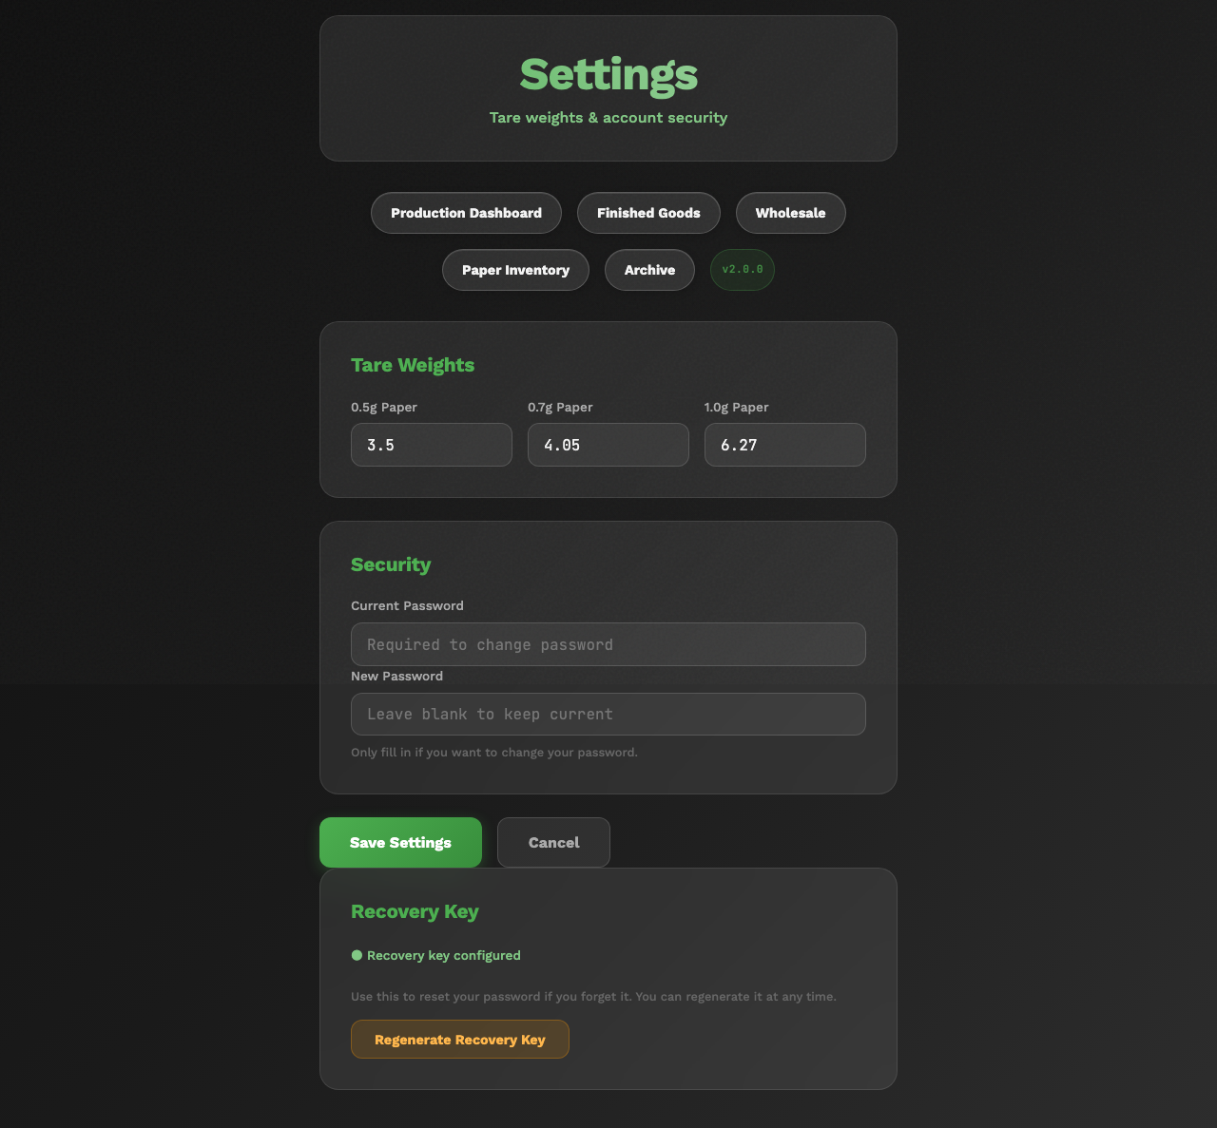
PreRollTracker Settings page with the API key visible and a copy button highlighted
📷 SCREENSHOT: ApexAPI main window showing green connection status for the Dashboard

3.3 Verifying the Connection
ApexAPI tests the connection by calling GET /api/overview on PreRollTracker. A successful connection returns the number of active batches.
If the connection fails:
- Verify the API key is correct (no extra spaces or line breaks).
- Verify PreRollTracker is accessible from the Windows machine: open a browser and go to https://himomstats.online.
- Check the ApexAPI logs in the logs/ directory for detailed error messages.
- If the API key was recently regenerated on PreRollTracker, update the dashboard_api_key in apex_config.json.
---

4. METRC Number Mapping and Batch Sync

4.1 The Mapping Challenge
The core integration challenge is that the two systems identify products differently:
- PreRollTracker tracks finished goods by METRC number (a state compliance tracking number like 1A406030001234567890). Each METRC package has a strain, initial grams, and current available grams.
- Apex Trading tracks inventory by batch ID (an integer assigned by Apex). Each batch has a product name that includes the strain and size info.
There is no direct link between a METRC number in PreRollTracker and a batch ID in Apex Trading. The source_tag field on Apex batches is often empty.

4.2 How the Mapping Works
ApexAPI's BatchMappingService bridges this gap using strain name matching:
- Fetch all batches from Apex Trading's API.
- Filter to relevant products: Only pre-roll products, CannaDarts, Magnetic Boxes, and Cocoa Blunts are included. The filter patterns are:
- cannadart
- magnetic.*box or mag.*box
- cocoa.*blunt
- Extract strain name from the Apex product name. For example, from "CannaDart - Blue Dream 0.5g" the service extracts "Blue Dream".
- Build a mapping: strain name -> list of BatchInfo objects (one per SKU type).
- Match against PreRollTracker: When syncing, the service matches a METRC package's strain to the corresponding Apex batches.

4.3 SKU Types and Grams Per Unit
The mapping service understands various SKU formats:
SKU Pattern | Example | Grams Per Unit | Pack Count
`singles_0_5g` | "CannaDart - Blue Dream 0.5g" | 0.5 | 1
`singles_1g` or `singles_1_0g` | "CannaDart - Blue Dream 1g" | 1.0 | 1
`box_0_5g_6pk` | "Magnetic Box - Blue Dream 6pk" | 0.5 | 6
`box_0_5g_12pk` | "Magnetic Box - Blue Dream 12pk" | 0.5 | 12
`custom_cocoa_blunt_1_0g` | "Cocoa Blunt - Blue Dream 1g" | 1.0 | 1

4.4 The Sync Process
When batch inventory sync runs (every 5 seconds by default):
- ApexAPI calls PreRollTracker's /apex-calculate endpoint.
- PreRollTracker returns, for each METRC package, the calculated available units per SKU type (accounting for orders, packed amounts, and manual exclusions).
- ApexAPI uses the BatchMappingService to find the corresponding Apex batch ID for each SKU type.
- ApexAPI sends a PATCH /api/v2/batches/{id} request to Apex Trading to update the quantity.
- State is tracked to avoid redundant updates (if quantities have not changed, the API call is skipped).
PreRollTracker ApexAPI Apex Trading
| | |
| GET /apex-calculate | |
|<-----------------------------| |
| {metrc_1: {0.5g: 200, | |
| 1g: 100}, ...} | |
|----------------------------->| |
| | BatchMappingService: |
| | strain -> batch_ids |
| | |
| | PATCH /api/v2/batches/123 |
| | {quantity: 200} |
| |----------------------------->|
| | |
| | PATCH /api/v2/batches/456 |
| | {quantity: 100} |
| |----------------------------->|

4.5 Cache TTL
The batch mapping cache refreshes every 5 minutes (300 seconds). This means:
- If a new batch is created in Apex Trading, it may take up to 5 minutes to appear in the mapping.
- If a batch is deleted, it may take up to 5 minutes for sync to stop trying to update it.
---

5. Google Sheets Integration Setup

5.1 Overview
ApexAPI can sync packing list data to Google Sheets for shared visibility between the production floor and the office. The integration uses a three-sheet architecture:
Sheet | Direction | Purpose
Packing List | Bidirectional | Active orders with PACKED quantities. Production edits PACKED counts; ApexAPI adds new orders.
History Sheet | Write-only | Archives completed items grouped by week.
Delivery Sheet | Write-only | Customer-facing delivery information.

5.2 Prerequisites
- A Google Cloud project with the Google Sheets API enabled.
- A service account with credentials (JSON key file).
- The target Google Spreadsheet shared with the service account's email address.

5.3 Setup Steps
- Create a Google Cloud Project (if you do not already have one):
- Go to https://console.cloud.google.com
- Create a new project or select an existing one.
- Enable the "Google Sheets API" from the API Library.
- Create a Service Account:
- In the Google Cloud Console, go to IAM & Admin > Service Accounts.
- Create a new service account.
- Download the JSON credentials file.
- Place the file in a secure location accessible to ApexAPI (e.g., the ApexAPI folder).
- Create the Google Spreadsheet:
- Create a new Google Sheets document for the packing list.
- Share it with the service account email (found in the JSON file under client_email). Give it "Editor" access.
- Note the spreadsheet ID from the URL: https://docs.google.com/spreadsheets/d/{SPREADSHEET_ID}/edit
- Configure ApexAPI:
- Open apex_config.json.
- Add or update the Google Sheets configuration (this may need to be added manually if it does not exist):
"google_sheets": {
"enabled": true,
"credentials_path": "path/to/credentials.json",
"packing_list_sheet_id": "your-spreadsheet-id",
"history_sheet_id": "",
"delivery_sheet_id": "",
"poll_interval_seconds": 2,
"fallback_to_excel": true,
"auto_create_sheets": true
}
- Restart ApexAPI. The application will create the required sheet tabs (Packing List, History, Delivery) automatically if auto_create_sheets is true.

5.4 Sheet Column Layout
Packing List columns:
Column | Content | Editable by
Product | Product name | ApexAPI (auto-populated)
Store | Customer/store name | ApexAPI
Ordered | Quantity ordered | ApexAPI
PACKED | Quantity packed | Production staff (manual)
Needs Production | Calculated shortfall | Formula
Needs Packing | Calculated packing need | Formula
Delivery Date | Target delivery date | Production staff
Delivery Notes | Notes about delivery | Production staff
Internal Notes | Internal team notes | Anyone
Invoice # | Apex order invoice number | ApexAPI
Batch # | METRC batch identifier | ApexAPI
Date | Order date | ApexAPI

5.5 Fallback Behavior
If Google Sheets is unavailable (credentials missing, API error, network issue), ApexAPI falls back to local Excel file operation when fallback_to_excel is true. This ensures packing list functionality is not completely lost during outages.
---

6. Troubleshooting Sync Issues

6.1 Dashboard Connection Fails
Symptom: ApexAPI shows "Cannot connect to dashboard" or connection status is red.
Diagnosis:
- Check if PreRollTracker is up: Open https://himomstats.online in a browser on the same machine.
- Check the API key: Compare dashboard_api_key in apex_config.json with the key shown in PreRollTracker's Settings page.
- Check the ApexAPI logs for the specific error message (timeout, 401, connection refused).
Resolution:
Error | Cause | Fix
Connection refused | PreRollTracker is not running | Restart the service: `sudo systemctl start preroll-tracker`
401 Unauthorized | API key mismatch | Copy the correct key from PreRollTracker Settings
Timeout | Network issue or slow server | Check server load and network connectivity
SSL error | Certificate problem | Verify HTTPS certificate is valid

6.2 Batch Sync Not Updating Apex Trading
Symptom: Pre-rolls are packed in PreRollTracker, but Apex Trading inventory does not change.
Diagnosis:
- Check if batch sync is enabled: Verify batch_inventory_sync.enabled is true in apex_config.json.
- Check the ApexAPI sync status indicator in the application.
- Check logs for "batch_inventory_sync" messages.
Common causes:
Issue | Explanation | Fix
Strain name mismatch | The strain name in PreRollTracker does not match any Apex product | Verify strain naming is consistent across both systems
No matching Apex batch | No pre-roll batch exists in Apex for that strain | Create the batch in Apex Trading
Cache stale | The batch mapping has not refreshed yet | Wait 5 minutes or restart ApexAPI
Sync disabled | `batch_inventory_sync.enabled` is `false` | Set to `true` and restart
API token expired | Apex Trading token is no longer valid | Generate a new token in Apex Trading

6.3 Orders Not Appearing in ApexAPI
Symptom: New orders placed in Apex Trading do not show up in ApexAPI.
Diagnosis:
- Check if auto-refresh is enabled: auto_refresh_enabled should be true.
- Check the Apex Trading API token: Is it still valid?
- Check the excluded_statuses list: Is the order's status being filtered out?
- Check the api_initial_sync_date: Orders before this date are ignored.
Resolution:
- If the token is expired, generate a new one in Apex Trading and update api_token in apex_config.json.
- If the order status is in excluded_statuses, remove that status from the list (or change the order status in Apex Trading).
- If the order is older than api_initial_sync_date, adjust the date backward.

6.4 Google Sheets Not Syncing
Symptom: The Google Sheet is not being updated with new orders or packed quantities are not syncing back.
Diagnosis:
- Check if Google Sheets integration is enabled in apex_config.json.
- Verify the credentials file exists at the configured path.
- Check that the spreadsheet is shared with the service account.
- Check ApexAPI logs for Google Sheets API errors.
Common errors:
Error | Cause | Fix
`credentials.json not found` | Wrong path in config | Correct the `credentials_path`
`403 Forbidden` | Sheet not shared with service account | Share with the service account email
`404 Not Found` | Wrong spreadsheet ID | Verify the `sheet_id` matches the URL
`Rate limit exceeded` | Too many API calls | Increase `poll_interval_seconds`

---

7. Understanding the Batch Mapping Process

7.1 From Strain to Batch ID
The batch mapping process is the core algorithm that bridges PreRollTracker and Apex Trading. Here is how it works step by step:
- ApexAPI fetches all active batches from Apex Trading via GET /api/v1/batches.
- For each batch, the PreRollProductParser analyzes the product name to extract:
- The strain name (e.g., "Blue Dream")
- The unit size (e.g., 0.5g, 1.0g)
- The pack configuration (single, 6-pack, 12-pack)
- The product type (CannaDart, Magnetic Box, Cocoa Blunt)
- The mapping is built as a dictionary: {strain_name: [BatchInfo, BatchInfo, ...]}. One strain can have multiple BatchInfo entries representing different SKU types.
- When sync runs, PreRollTracker provides available grams per METRC package per SKU type. ApexAPI looks up the strain of that METRC package in the mapping to find the corresponding Apex batch IDs.
- Each batch quantity is updated via the Apex Trading API. The quantity is calculated by dividing available grams by grams-per-unit for that SKU.

7.2 Example Walkthrough
Suppose PreRollTracker has a finished goods package:
- METRC number: 1A40603000123456
- Strain: "Wedding Cake"
- Available grams: 500g
And Apex Trading has these batches:
Batch ID | Product Name | SKU Key
1001 | "CannaDart - Wedding Cake 0.5g" | `singles_0_5g`
1002 | "CannaDart - Wedding Cake 1g" | `singles_1_0g`
1003 | "Magnetic Box - Wedding Cake 6pk" | `box_0_5g_6pk`

PreRollTracker's /apex-calculate endpoint returns:
{
"1A40603000123456": {
"strain": "Wedding Cake",
"available_grams": 500,
"units": {
"singles_0_5g": 200,
"singles_1_0g": 100,
"box_0_5g_6pk": 33
}
}
}
ApexAPI then:
- Looks up "Wedding Cake" in the batch mapping.
- Finds batch 1001 for singles_0_5g, batch 1002 for singles_1_0g, batch 1003 for box_0_5g_6pk.
- Sends PATCH /api/v2/batches/1001 {quantity: 200}.
- Sends PATCH /api/v2/batches/1002 {quantity: 100}.
- Sends PATCH /api/v2/batches/1003 {quantity: 33}.

7.3 When Mapping Fails
If the batch mapping service cannot find a match for a strain, it logs a warning and skips that METRC package. Common reasons for mapping failure:
- Spelling differences: "Wedding Cake" in PreRollTracker vs. "Wedding cake" in Apex (case sensitivity depends on normalization).
- New strain: A new strain was added to PreRollTracker but no corresponding batches exist in Apex Trading yet.
- Product type mismatch: The batch exists in Apex but is not a recognized pre-roll product type (not matching the sync patterns).
To resolve mapping failures:
- Check the ApexAPI logs for "no batch found for strain" messages.
- Verify the strain spelling matches exactly between both systems.
- Create the missing batch in Apex Trading if needed.
- Wait for the 5-minute cache to refresh (or restart ApexAPI).
---

Summary
Integration Task | How
Connect ApexAPI to PreRollTracker | Copy API key from Settings to `apex_config.json`
Verify connection | Check green status indicator in ApexAPI
Enable batch inventory sync | Set `batch_inventory_sync.enabled: true`
Set up Google Sheets | Create service account, share sheet, configure in `apex_config.json`
Troubleshoot sync | Check logs, verify strain names match, check API tokens
Force mapping refresh | Restart ApexAPI (clears 5-minute cache)
Regenerate API key | Settings page in PreRollTracker, then update `apex_config.json`

