Managing Inventory
Inventory Tracking Guide
Generated: February 28, 2026

Table of Contents
[Right-click and select "Update Field" to generate Table of Contents]

Managing Inventory Guide
This guide covers how to check and update inventory in PreRollTracker. Inventory includes paper/cone supplies (for rolling), finished goods (completed METRC packages), and wholesale holds (orders reserved for wholesale customers).
---

Checking Paper and Cone Inventory Levels
Paper and cone inventory tracks how many rolling papers or cones you have for each pre-roll size. This is important so you do not run out of supplies in the middle of a batch.

Getting to the Paper Inventory Page
- From the Production Dashboard, click the Paper Inventory button in the navigation bar. On a phone, tap the menu button (three horizontal lines) and then tap Paper Inventory.
What You'll See: A page titled "Paper Inventory" showing inventory levels for each pre-roll size.
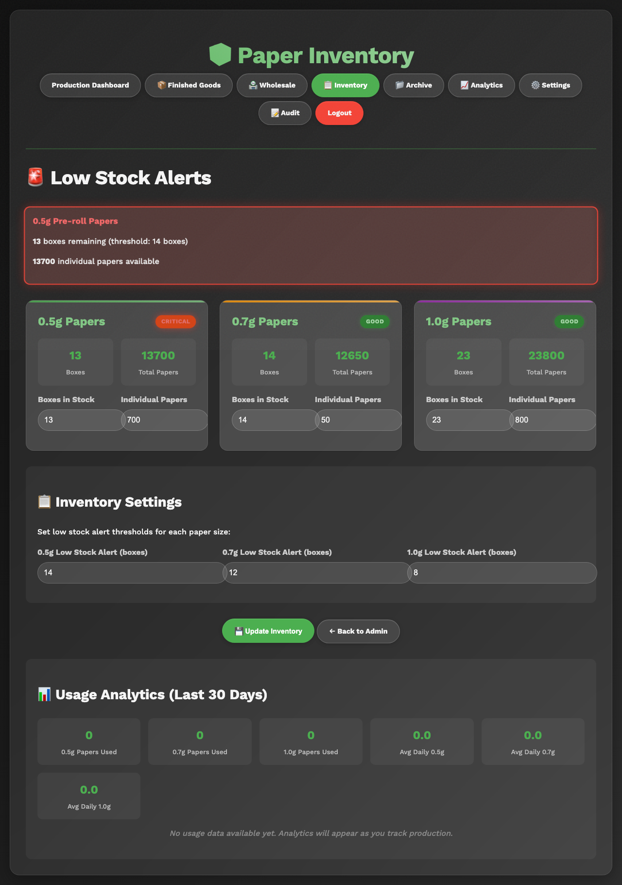
The Paper Inventory page showing current levels for all three sizes

Understanding the Inventory Display
For each pre-roll size (0.5g, 0.7g, and 1.0g), you will see:
- Boxes -- How many full, unopened boxes of papers/cones you have in stock.
- Individual Papers -- Any loose papers beyond full boxes (for example, if you opened a box and used some).
- Total Papers -- The combined total. This is calculated automatically: (Boxes x Papers Per Box) + Individual Papers.
- Days Remaining -- An estimate of how many days the current supply will last, based on how fast you have been using them.
- Low Stock Warning -- If the supply is below the alert threshold, you will see a warning indicator.

Papers Per Box by Size
The system knows how many papers come in each box:
Size | Papers Per Box
0.5g | 1,000 papers per box
0.7g | 900 papers per box
1.0g | 1,000 papers per box

The inventory card for one size showing boxes, individual papers, total, and days remaining

If Something Goes Wrong
- The numbers look outdated -- Refresh the page to see the latest data. Someone else may have updated the inventory since you last checked.
- "Days Remaining" shows a strange number -- This estimate is based on recent usage patterns. If production has been unusual lately (very fast or very slow), the estimate may be off.
---

Updating Inventory Counts (Boxes and Individual Papers)
When new supplies arrive or when you do a physical count, you need to update the inventory numbers in the system.

Updating Inventory from the Paper Inventory Page
- Go to the Paper Inventory page.
- Find the size you want to update (0.5g, 0.7g, or 1.0g).
- Look for the input fields for Boxes and Individual Papers.
- Change the Boxes number to the current number of full, unopened boxes you have on the shelf. Count them physically -- do not guess.
- Change the Individual Papers number to the count of any loose papers that are not part of a full box. If all papers are in full boxes, leave this at 0.
- Click the Update or Save button.
What You'll See: The total papers count updates automatically. The "days remaining" estimate recalculates too.
The inventory update fields for one size, showing the Boxes and Individual Papers input fields and the Save button

Example
You receive a shipment of 0.5g papers and now have:
- 12 full boxes (12 x 1,000 = 12,000 papers)
- 347 loose papers from a previously opened box
You would enter:
- Boxes: 12
- Individual Papers: 347
- Total Papers (calculated automatically): 12,347

Updating from the Admin Page
Your supervisor can also update inventory from the admin inventory page, which provides additional settings and threshold controls.
- Navigate to Paper Inventory through the admin navigation.
- Enter the new counts.
- Optionally update the low stock threshold (the number of papers at which a warning appears).
- Click Save.
The admin inventory page with threshold settings

If Something Goes Wrong
- I typed the wrong number -- Simply type the correct number and click Save again. The system always uses the latest number you enter.
- The inventory keeps going down even though I updated it -- This is normal. As pre-rolls are produced and counts are updated, the system tracks paper usage and decreases inventory automatically. Your update just resets the starting count.
---

Understanding Low Stock Alerts and What to Do
When paper or cone inventory drops below the alert threshold, the system warns you. These alerts appear in two places:

Where You See Alerts
- On the Production Dashboard -- An orange banner appears at the top of the page listing which sizes are running low.
- On the Paper Inventory page -- Low stock items are highlighted with a warning indicator.
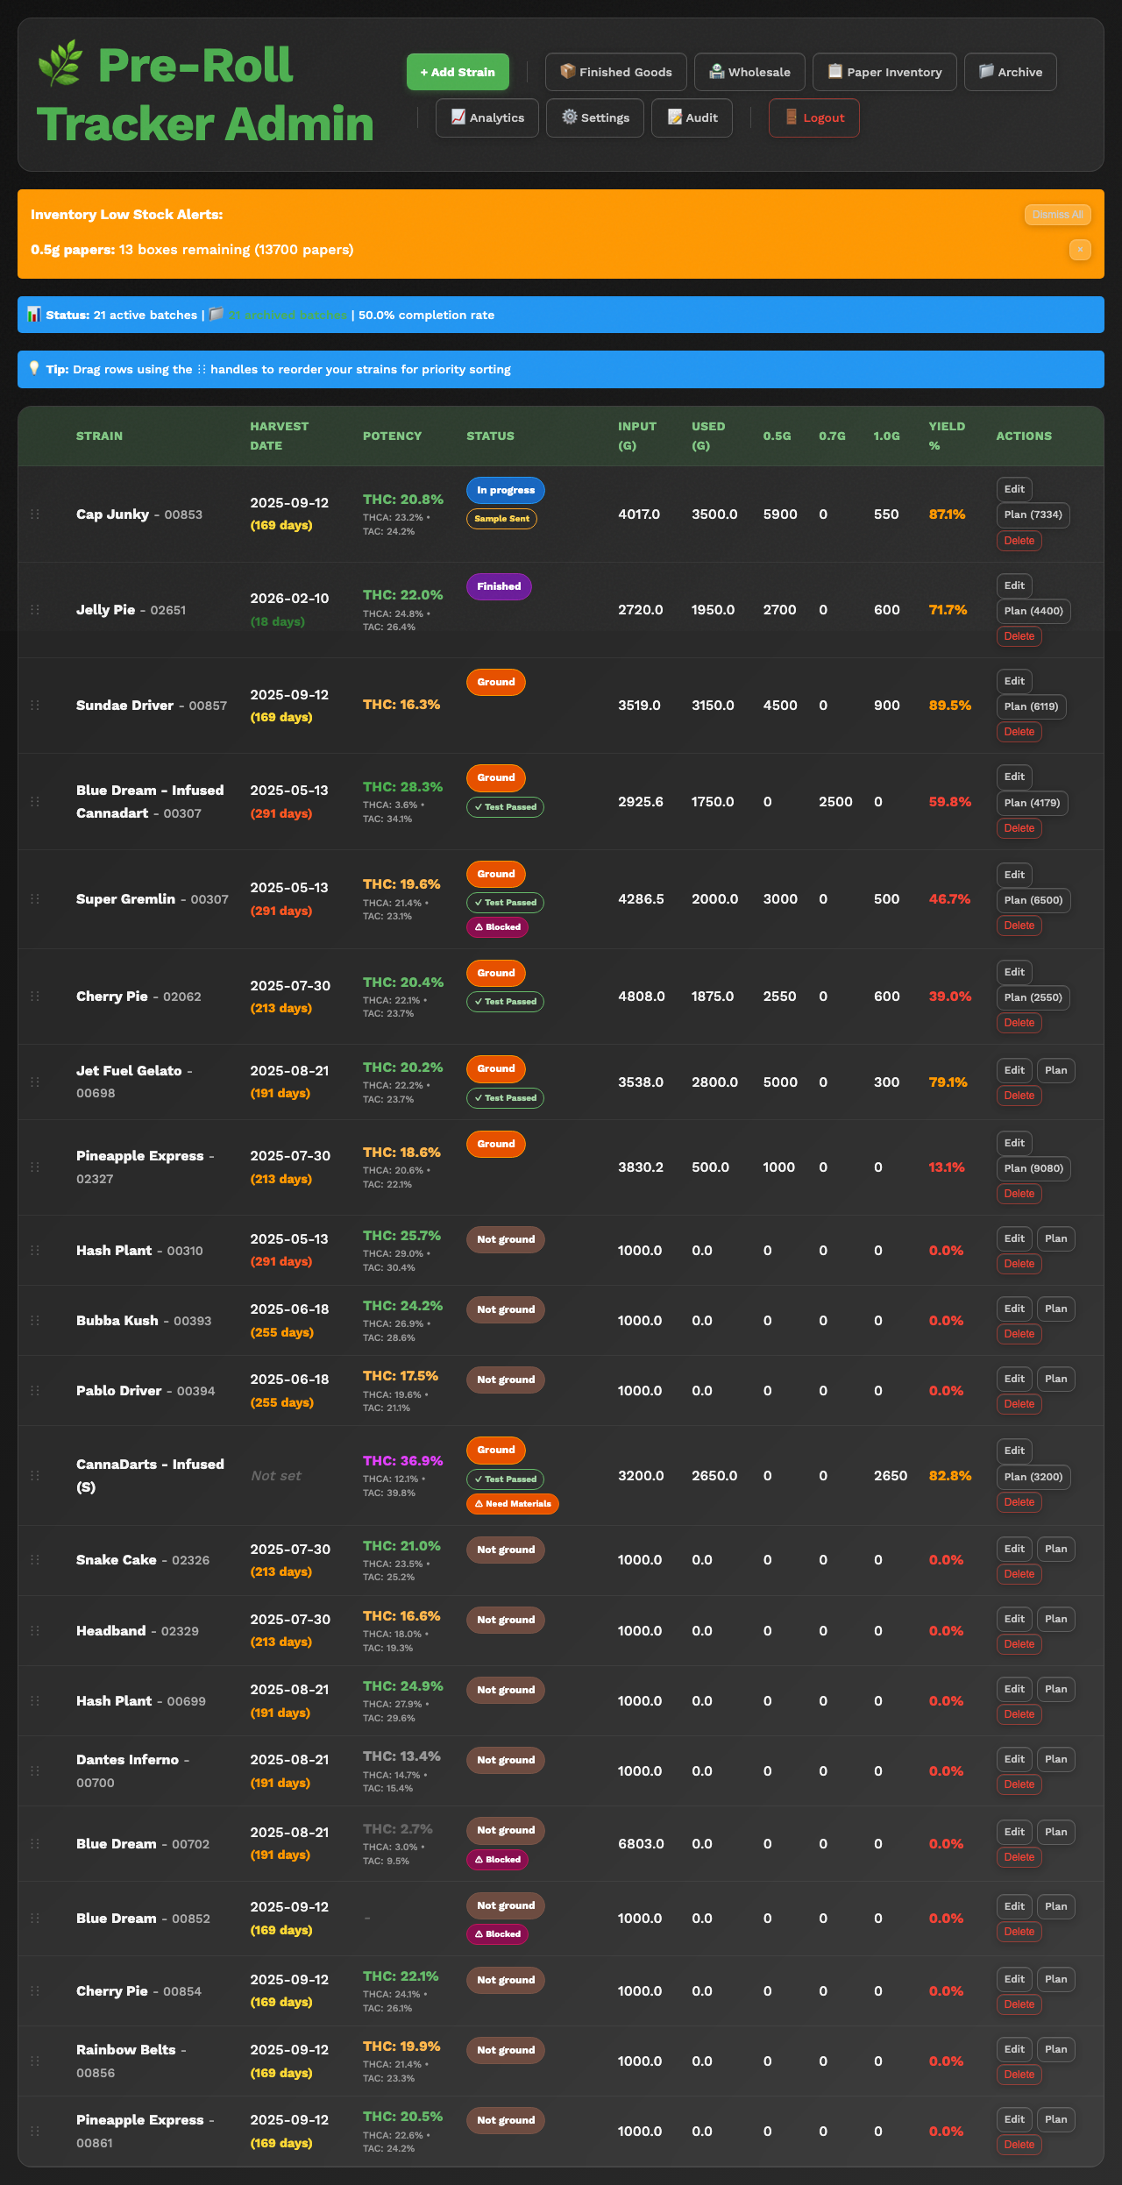
The orange low-stock alert banner on the Production Dashboard

What to Do When You See a Low Stock Alert
- Tell your supervisor immediately. They need to know so supplies can be ordered before you run out.
- Check the actual count. Look at the Paper Inventory page to see exactly how many papers are left and how many days they are expected to last.
- Do not ignore the alert. Running out of papers means production has to stop, which is costly.

Dismissing Alerts
After you have reported the low stock to your supervisor:
- On the Production Dashboard, you can dismiss individual alerts by clicking the X or Dismiss button next to each alert.
- You can also click Dismiss All to clear all inventory alerts at once.
- Dismissing an alert just hides the message. If inventory is still low, the alert will come back the next time the system checks.
The dismiss button on an inventory alert

If Something Goes Wrong
- Alerts keep coming back after I dismiss them -- This means inventory is still below the threshold. The alert will not go away permanently until inventory is restocked above the threshold level.
- I don't see any alerts even though we are low -- The alert thresholds may need to be adjusted. Ask your supervisor to check the threshold settings on the Paper Inventory page.
---

Working with Finished Goods (METRC Packages)
Finished Goods are batches that have been completed, packaged, and assigned a METRC tracking number. METRC is the tracking system used by the state to track cannabis from production to sale.

Getting to the Finished Goods Page
- From the Production Dashboard, click the Finished Goods button in the navigation bar. On a phone, tap the menu button and then tap Finished Goods.
What You'll See: A page titled "Finished Goods" showing all completed packages with their METRC numbers, strain names, quantities, and status.
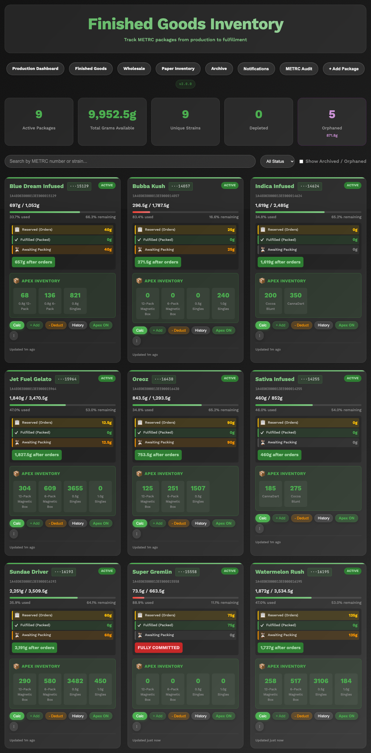
The Finished Goods page showing a list of packages with METRC numbers and quantities

Understanding the Finished Goods Display
Each finished goods package shows:
- METRC Number -- The official tracking number assigned by the METRC system. This is a long number or code.
- Strain -- The name of the strain.
- SKU Breakdown -- How many pre-rolls of each size and package type are in this METRC package.
- Status -- Whether the package is active (has units available), depleted (all units sold or reserved), or archived.
- Wholesale Holds -- If any units from this package have been reserved for wholesale orders, they show up here.

Searching Finished Goods
The Finished Goods page has a search bar:
- Tap or click the Search bar at the top of the page.
- Type a METRC number or strain name.
- The list filters to show only matching packages.
The search bar on the Finished Goods page with a search result

Viewing Package Details
Click or tap any package to see its full details, including:
- Complete METRC tracking information
- SKU breakdown by size (0.5g, 0.7g, 1.0g)
- Package types (singles, 6-packs, 12-packs)
- Current available units
- Wholesale holds applied to this package
The detail view of a single finished goods package

If Something Goes Wrong
- A package is missing -- Check if you have the "Include Archived" filter turned on. Depleted packages may be hidden by default.
- The counts don't match what I expect -- Wholesale holds reduce the available quantity. Check the wholesale holds section to see if units have been reserved.
---

Understanding SKU Breakdowns
SKU stands for "Stock Keeping Unit" -- it is the specific product type that is sold. In PreRollTracker, SKUs break down by:
- Pre-roll size -- 0.5g, 0.7g, or 1.0g
- Package type -- Singles (individual tubes), 6-packs, or 12-packs

How to Read a SKU Breakdown
On the Finished Goods page, each METRC package shows its SKU breakdown. For example:
SKU | Quantity
0.5g Singles | 200 units
0.5g 6-Packs | 30 packs (180 pre-rolls)
1.0g Singles | 150 units
1.0g 12-Packs | 10 packs (120 pre-rolls)

The breakdown shows you exactly how the pre-rolls from each batch were packaged and are available for sale.
A SKU breakdown table for a finished goods package

Packaging Breakdown on Batches
During the Bagging stage, your supervisor tracks how pre-rolls are being packaged. The batch detail shows:
- Singles -- Individual pre-rolls in tubes
- 6-Packs -- Packs of 6 pre-rolls
- 12-Packs -- Packs of 12 pre-rolls
- Loose/Tupperware -- Pre-rolls set aside for flexible packaging later
This packaging data flows into the finished goods SKU breakdown once the batch is completed and a METRC package is created.

If Something Goes Wrong
- The SKU numbers don't add up to the total -- This can happen if some pre-rolls are still loose (in tupperware) and have not been assigned to a specific package type yet.
---

Using the Wholesale Holds Feature
Wholesale holds allow you to reserve units from finished goods packages for specific wholesale customers or orders before they are shipped.

Getting to the Wholesale Page
- From the Production Dashboard, click the Wholesale button in the navigation bar. On a phone, tap the menu button and then tap Wholesale.
What You'll See: A page showing all available strains with their current inventory and any existing holds.
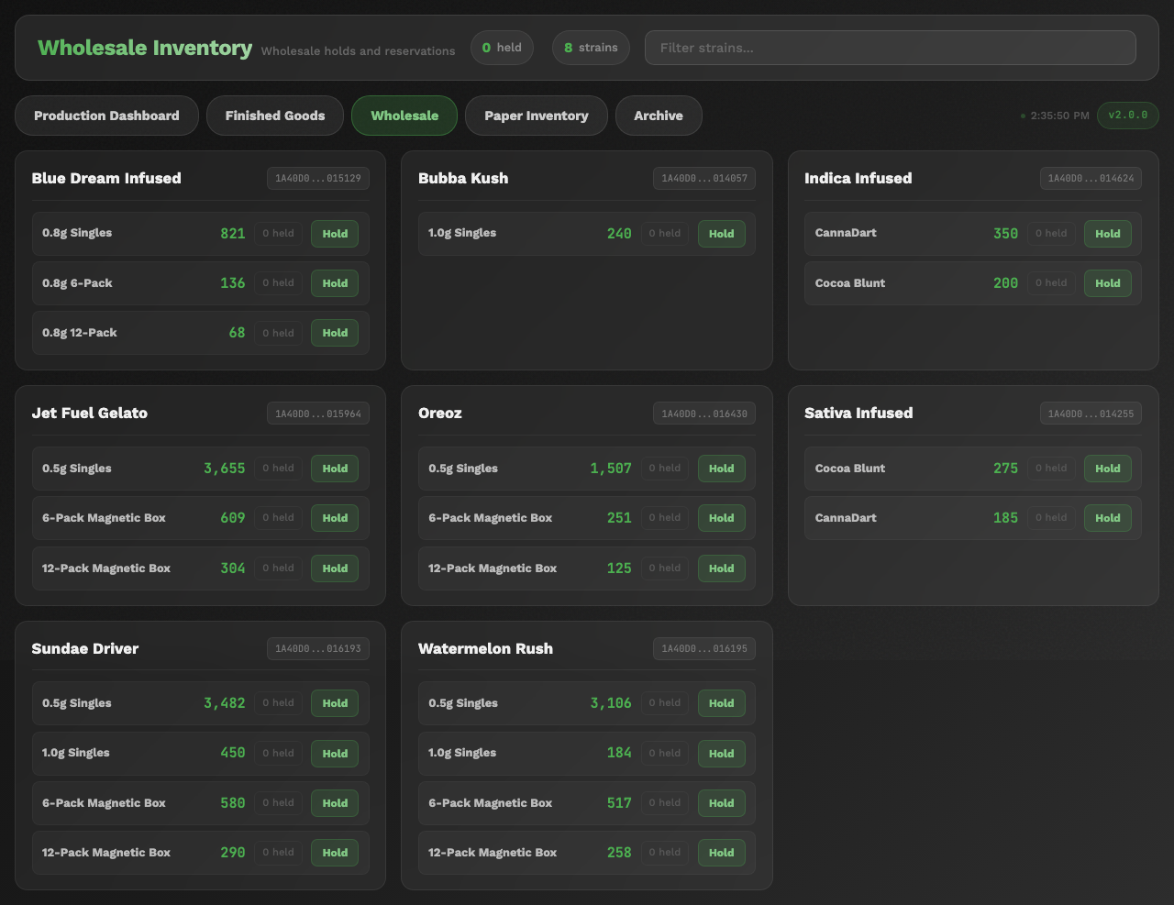
The Wholesale page showing available strains and inventory levels

Creating a Wholesale Hold
- On the Wholesale page, find the strain and package you want to reserve units from.
- Click the Hold or Reserve button for that product.
- In the form that appears:
- Select the METRC number (the specific package to hold from).
- Select the SKU (which size and package type to hold).
- Enter the Quantity -- how many units to reserve.
- Add Notes if needed (for example, the customer name or order number).
- Click Create Hold or Reserve.
What You'll See: The hold appears in the list with a hold ID. The available quantity for that SKU decreases by the amount held.
The create hold form showing METRC number, SKU, quantity, and notes fields

Viewing and Managing Holds
All active holds are visible on the Wholesale page:
- Each hold shows the METRC number, SKU, quantity, and any notes.
- The available quantity shown for each SKU already accounts for all active holds.

Releasing a Hold
When a wholesale order is shipped or cancelled, you need to release the hold:
- Find the hold on the Wholesale page.
- Click the Release or Delete button next to the hold.
- Confirm that you want to release the hold.
What You'll See: The hold is removed and the available quantity goes back up.
The release/delete button next to a wholesale hold

If Something Goes Wrong
- "Only X units available" -- You are trying to hold more units than are currently available. Check if other holds already exist for the same SKU.
- I released the wrong hold -- Contact your supervisor. They may be able to recreate the hold.
- The quantities look wrong -- Make sure you are looking at the correct METRC package and SKU. Different packages of the same strain may have different available quantities.
---

Summary
You now know how to:
- Check paper and cone inventory levels
- Update inventory counts when supplies arrive
- Understand and respond to low stock alerts
- View and search finished goods METRC packages
- Read SKU breakdowns
- Create and release wholesale holds
For help with common problems, see the Troubleshooting Guide.

