Getting Started
First-time Setup Guide
Generated: February 28, 2026

Table of Contents
[Right-click and select "Update Field" to generate Table of Contents]

Getting Started with PreRollTracker
Welcome to PreRollTracker, the production tracking tool used at HiMoM. This guide will walk you through everything you need to do the first time you use the app. Follow each step exactly and you will be up and running in just a few minutes.
---

Opening the Website
PreRollTracker runs in your web browser (Chrome, Safari, Firefox, or Edge). You do not need to install anything from the App Store or Google Play. Here is how to open it:
- Open your web browser. Look for the Chrome icon (a colorful circle), the Safari icon (a blue compass), or whatever browser you normally use to go on the internet.
- Tap or click on the address bar at the very top of the browser window. This is the long white bar where you see website addresses. If there is already text in the bar, tap it once so it becomes highlighted.
- Type the following address exactly as shown: himomstats.online
- Press the Enter key on your keyboard (or tap Go on your phone keyboard).
What You'll See: The login page will appear. It has a dark background with a green title that says "Admin Login" and a box to type your password.
📷 SCREENSHOT: The browser address bar with himomstats.online typed in it

Bookmarking the Website (So You Don't Have to Type the Address Every Time)

On a Computer (Chrome)
- After the page loads, look at the right side of the address bar.
- Click the star icon at the right end of the address bar.
- A small window will pop up. Click Done.
- Now you can find the site in your bookmarks anytime without typing the address.

On a Computer (Safari)
- After the page loads, click Bookmarks in the menu bar at the top of the screen.
- Click Add Bookmark.
- Click Add.

On an iPhone or iPad (Safari)
- Tap the Share button at the bottom of the screen. It looks like a square with an arrow pointing up.
- Scroll down and tap Add Bookmark.
- Tap Save.

On an Android Phone (Chrome)
- Tap the three dots in the top-right corner of Chrome.
- Tap the star icon or Add Bookmark.
📷 SCREENSHOT: The bookmark star icon highlighted in the browser address bar

If Something Goes Wrong
- "This site can't be reached" -- Check that you typed the address correctly. Make sure it says himomstats.online with no extra spaces or letters. Also check that you are connected to the internet (Wi-Fi or cell service).
- The page is blank or loading forever -- Try closing the browser completely and opening it again. Then type the address one more time.
---

Logging In
The app uses a shared password to keep things secure. Your supervisor or manager will give you the password.
- On the login page, tap or click inside the box that says Password.
- Type the password exactly as it was given to you. Passwords are case-sensitive, which means capital letters and lowercase letters matter. If the password is "Harvest2024" you must type it with the capital H.
- Look at the checkbox below the password box. It says "Remember me for 30 days". This checkbox is already checked by default. When it is checked, the app will keep you logged in for 30 days so you do not have to enter the password every time. Leave it checked unless you are on someone else's device.
- Click the green Login button.
What You'll See: If the password is correct, you will be taken to the Production Dashboard -- the main page of the app. If the password is wrong, you will see a red error message that says "Invalid password" and the login box will shake.
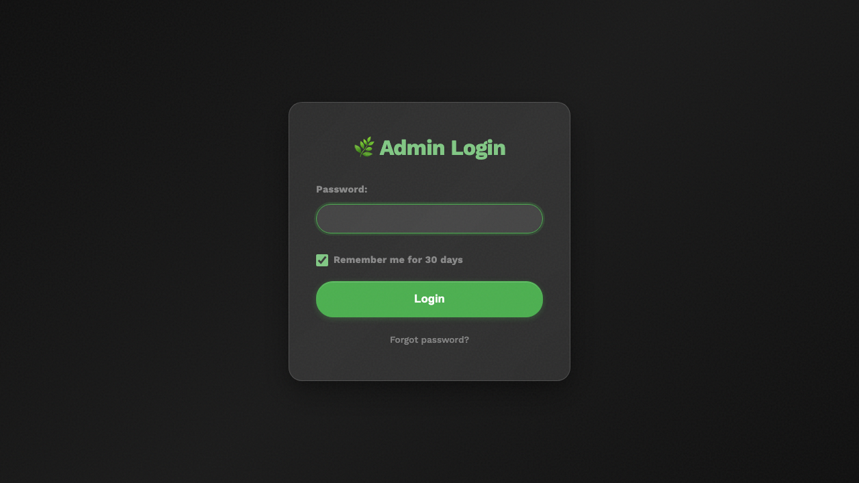
The login page with the password field, Remember Me checkbox, and Login button

If Something Goes Wrong
- "Invalid password" -- Double-check the password. Make sure Caps Lock is not on (look for a light on your keyboard). Try typing the password in a notes app first so you can see what you are typing, then copy and paste it.
- You forgot the password -- Click the "Forgot password?" link below the Login button. You will need a recovery key (a special code that looks like HARVEST-XXXX-XXXX-XXXX). If you do not have a recovery key, ask your supervisor to reset the password.
- The page keeps loading after you click Login -- Your internet connection might be slow. Wait about 30 seconds. If nothing happens, refresh the page and try again.
---

Tour of the Production Dashboard
After logging in, you land on the Production Dashboard. This is your home base -- the page you will use most often. Let's walk through what you see on screen.
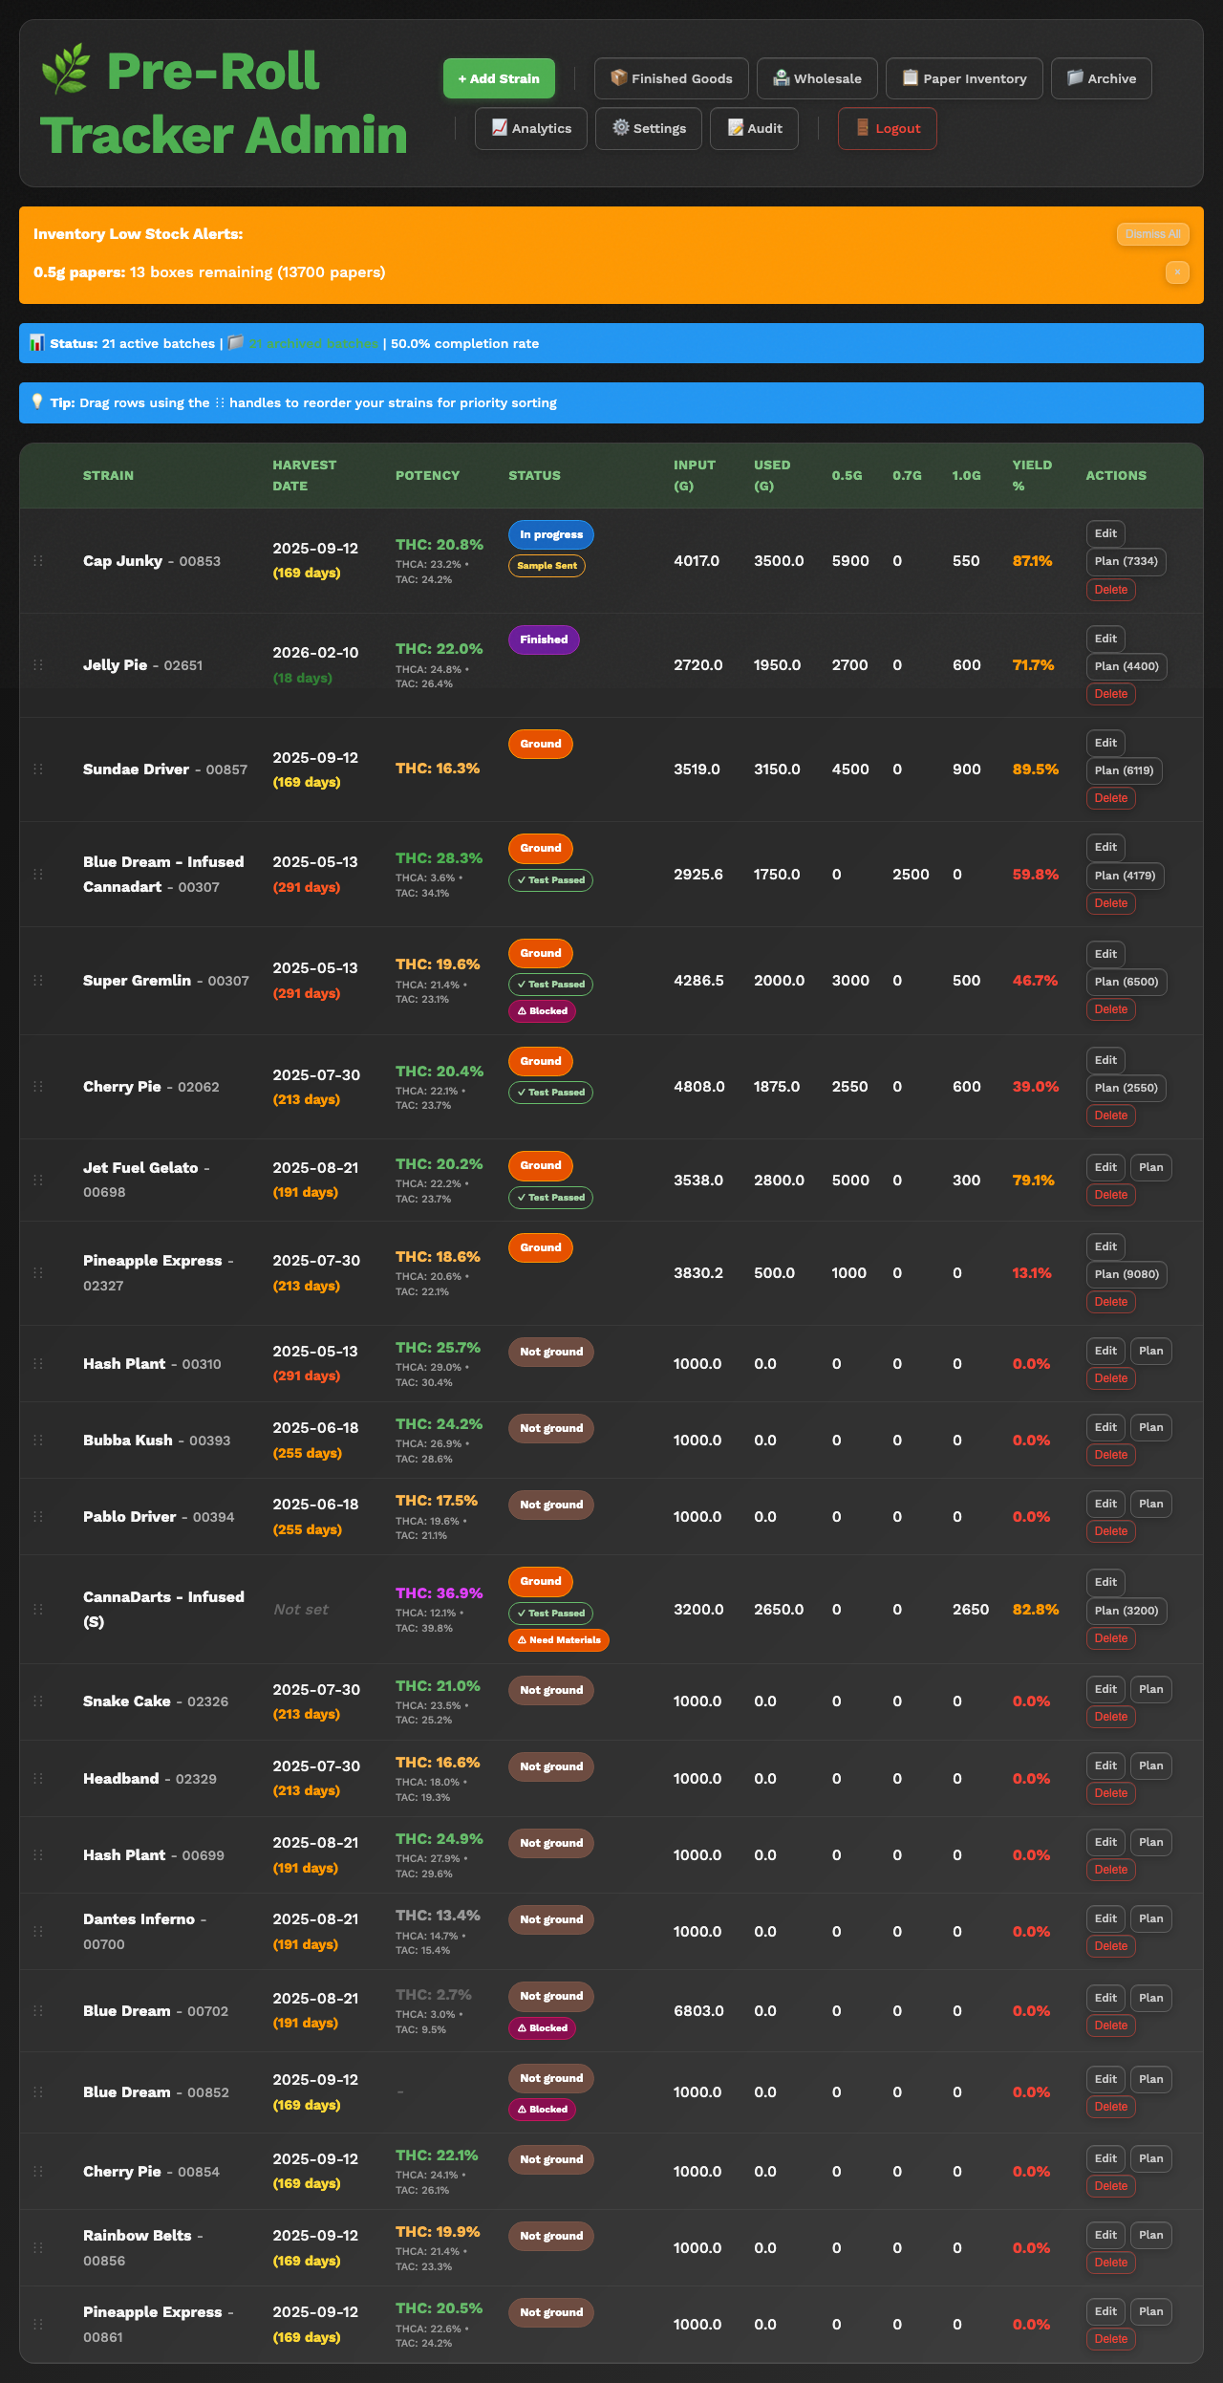
The full Production Dashboard with batches listed, header, and navigation buttons

The Header Bar
At the very top of the page, you will see a dark bar with the app name and navigation buttons.
- "Pre-Roll Tracker" -- The app title, shown in green text on the left side.
- Navigation buttons -- These buttons take you to different parts of the app. You will see buttons for pages like Finished Goods, Wholesale, Paper Inventory, Archive, and more. We will cover each of these in other guides.
On a phone, the navigation buttons are hidden behind a menu button (three horizontal lines, sometimes called a "hamburger menu") in the top-left corner. Tap it to see all the navigation options in a side panel.
The navigation bar with all buttons visible on desktop
📷 SCREENSHOT: The hamburger menu button on a phone screen

Active Batches Table
Below the header, you will see a table (or on a phone, a list of cards) showing all the batches that are currently being worked on. Each row represents one batch of pre-rolls. Here is what the columns mean:
- Strain -- The name of the cannabis strain for this batch (for example, "Blue Dream" or "OG Kush").
- Stage -- Where this batch is in the production process. Stages are color-coded. See the "Understanding Batch Stages" section below.
- Input Grams -- How many grams of flower were put into this batch to start.
- Counts (0.5g / 0.7g / 1.0g) -- How many pre-rolls of each size have been made so far.
- Total Pre-Rolls -- The total number of pre-rolls made across all sizes.
- THC % -- The THC potency of the strain.
- Harvest Date -- When the flower was harvested.
On a phone, you will see each batch as a card instead of a table row. The information is the same, just arranged differently to fit the smaller screen.
📷 SCREENSHOT: A close-up of one batch row showing strain name, stage badge, counts, and other details

Understanding Batch Stages
Every batch moves through a series of stages from start to finish. Each stage has a different color so you can quickly see where things stand:
Stage Number | Stage Name | Color | What It Means
0 | **Not ground** | Brown | Flower has been received but not ground yet
1 | **Ground** | Orange | Flower has been ground and is ready to roll
2 | **In progress** | Blue | Pre-rolls are actively being made right now
3 | **Finished** | Purple | All pre-rolls for this batch have been rolled
4 | **Waiting on testing** | Red | Batch is done rolling and waiting for lab test results
5 | **Test passed** | Green | Lab tests came back and the batch passed
6 | **Bagging** | Deep orange | Pre-rolls are being packaged into bags, tubes, or packs
7 | **Done** | Dark green | Batch is completely finished and ready for sale

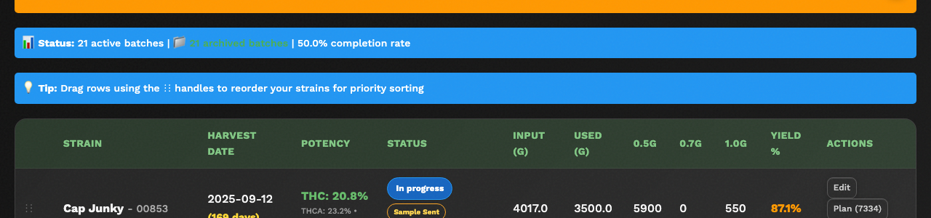
A few batches showing different stage badges with their colors

Inventory Alerts
If paper or cone supplies are running low, you will see an orange alert banner at the top of the dashboard. This tells you which size (0.5g, 0.7g, or 1.0g) is low and how many papers are left. When you see this, let your supervisor know so supplies can be reordered.
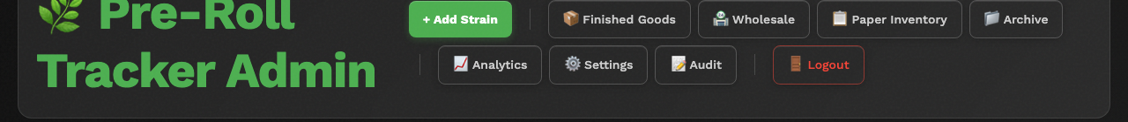
An inventory low-stock alert banner on the dashboard
---

Navigating Between Pages
PreRollTracker has several pages for different tasks. Here is how to get to each one:

On a Computer
Look at the navigation buttons in the header bar at the top of the dashboard. Click any button to go to that page:
- + Add Strain -- Create a new batch of pre-rolls.
- Finished Goods -- See completed METRC packages ready for sale.
- Wholesale -- Manage inventory holds for wholesale orders.
- Paper Inventory -- Check and update paper/cone supply levels.
- Analytics / Stats -- View production charts and numbers.
- Archive -- See all completed batches from the past.
- Settings -- Change app settings (password, tare weights, etc.).
- Audit -- View the history of every change made in the system.
- Logout -- Sign out of the app.

On a Phone
- Tap the menu button (three horizontal lines) in the top-left corner of the screen.
- A panel will slide in from the left side showing all the navigation options.
- Tap the page you want to go to.
- To close the menu without going anywhere, tap the dark area to the right of the panel, or tap the X button at the top of the panel.
📷 SCREENSHOT: The mobile navigation drawer showing all page options

Getting Back to the Dashboard
From any page, you can get back to the Production Dashboard by:
- Clicking the Production Dashboard or Admin button in the navigation.
- On a phone, opening the menu and tapping Production Dashboard.
---

Installing as a Phone App (PWA)
You can install PreRollTracker on your phone's home screen so it works like a regular app. This is called a "PWA" (Progressive Web App). It will open faster and look cleaner without the browser address bar showing.

On an iPhone or iPad (Safari)
- Open Safari and go to himomstats.online.
- Tap the Share button at the bottom of the screen (the square with an arrow pointing up).
- Scroll down in the menu that appears and tap Add to Home Screen.
- You will see a preview. The name should say "PreRoll Tracker" or similar. Tap Add in the top-right corner.
- The app icon will now appear on your home screen just like any other app. Tap it to open PreRollTracker.
What You'll See: The app will open in full-screen mode without the Safari address bar. It will have a dark green icon on your home screen.
📷 SCREENSHOT: The "Add to Home Screen" option in Safari's share menu
📷 SCREENSHOT: The PreRollTracker icon on an iPhone home screen

On an Android Phone (Chrome)
- Open Chrome and go to himomstats.online.
- Tap the three dots in the top-right corner of Chrome.
- Tap Add to Home screen (or you may see Install app).
- Tap Add or Install to confirm.
- The app icon will appear on your home screen.
📷 SCREENSHOT: The "Add to Home screen" option in Chrome's menu on Android

On a Computer (Chrome)
- Open Chrome and go to himomstats.online.
- Look at the right side of the address bar. You may see a small install icon (a monitor with a down arrow, or a plus sign inside a circle).
- Click that icon.
- Click Install in the popup that appears.
- The app will open in its own window and you will find a shortcut on your desktop or in your Start Menu.

If Something Goes Wrong
- You don't see "Add to Home Screen" -- Make sure you are using Safari on iPhone/iPad or Chrome on Android. Other browsers may not support this feature.
- The icon doesn't appear -- Try restarting your phone, then look on the last page of your home screen or in your app drawer (on Android).
- The app looks different after installing -- This is normal. When installed as an app, the browser address bar is hidden. Everything else works the same.
---

Summary
You now know how to:
- Open PreRollTracker in your browser by going to himomstats.online
- Log in with the shared password
- Understand what you see on the Production Dashboard
- Navigate to other pages using the menu buttons
- Install the app on your phone for quick access
Next, read the Daily Operations Guide to learn how to record production counts, update batch stages, and track your work throughout the day.

