Janex & Eureka Guidebook

Written by Cipher58
Chapters
Introduction 4
Janex: Python 4
Janex: Py-Torch 4
Janex: NLG 4
Janex: Spacy 4
Janex: Jarvis 5
Eureka-Py 5

Introduction

Janex: Python
Janex-Python is the original version of Janex, which focuses on using the physical structure of words and lettering to decide similarity, rather than the semantics or meanings behind them. It also provides many basic functions needed to build a more complex AI program.

Janex: Py-Torch
Janex-PyTorch is a far more advanced branch of the Janex family, as it utilises a Long Short-Term Memory Network combined with this data to fulfill intent classification requests.

Janex: NLG
Janex: NLG is by far the most powerful edition of Janex. It can rip down pieces of text into sentences, and then register which words come before and after each word, saving them to a database, and then reusing these patterns, with use of an LSTM, can predict the following words based on the trends in the data you feed to it.

Janex: Spacy
Janex: Spacy is a slightly new approach to intent classification. It uses the spacy models to convert words into numerical representations of themselves, and then use basic maths and cosine similarity calculations to determine the similarity between these words and the ones provided in the intents, using the highest match to classify inputs.

Janex: Jarvis
And Jarvis – he isn’t a library, it is an AI which uses all four previous Janex versions coinciding with each other, using Janex: NLG for text generation, Janex: PyTorch for intent classification, Janex: Python for text manipulation and Janex: Spacy to understand semantic input. He can be infinitely configured to suit your needs, straight from something as simple as modifying the config.json file, and can be spoke to via Discord, Whisper, Terminal, or others.

Eureka-Py
Eureka-Py is a library which allows you to connect to the Large Language Model known as Eureka. This guide will explain how you can incorporate this Artificial Intelligence into your projects without needing to run it locally, using simple commands from the Eureka-Py library.

Janex: Python Edition

Intent Classification
The ‘original’ version of Janex’ intent classifier worked by physically breaking down the text input and the available intents, and then matching the input with the patterns by their numeric and alphabetical composite.
While this is a very literal approach and is subsequently almost instant and lightweight, this literal method may lead to high inaccuracies with large sets of data, and so is only recommended for experimenting and/or for small basic datasets with unique words.
Whatsmore, if it identifies nouns, it will add an extra amount of similarity to that portion due to nouns being uncommon and therefore should be recognised as more important than common generic words.
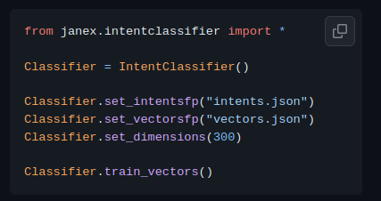
However, from versions 0.80.0 and up, the method was enhanced slightly to increase accuracy. Here is how the code would look after Janex is installed via pip.
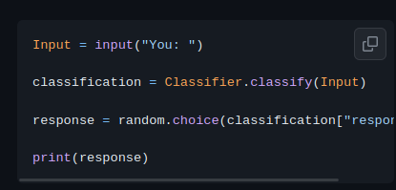

Other tools (Word Manipulation)
Janex also holds standalone tools which are used for larger Natural Language Processing (NLP) tasks.
This includes:

Tokenizing:
Breaking up sentences and blocks of text into words, and remembering the common patterns between them.

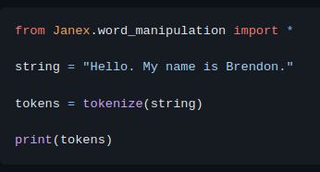

Stemming:
Reducing whole words down to their root form, removing tense or extensions.

Vectorizing:
Finding numeric representations of words to be used in mathematical cosine computations, stored in a numpy array (a set of numbers, the number of numbers depends on the set dimension).

