OPSD PowerDesk Assignment
Day-Ahead Forecasting, Anomaly Detection & Live Monitoring

Primary Country Analysis: BE

1. Data & STL Decomposition
Three countries were selected for analysis: Belgium (BE), Denmark (DK), and Netherlands (NL).
- Key Takeaways:
- BE: Shows stable yearly seasonality with strong winter peaks.
- DK: Higher variance observed, likely attributed to high wind power penetration.
- NL: Consistent weekly patterns and moderate seasonal amplitude.
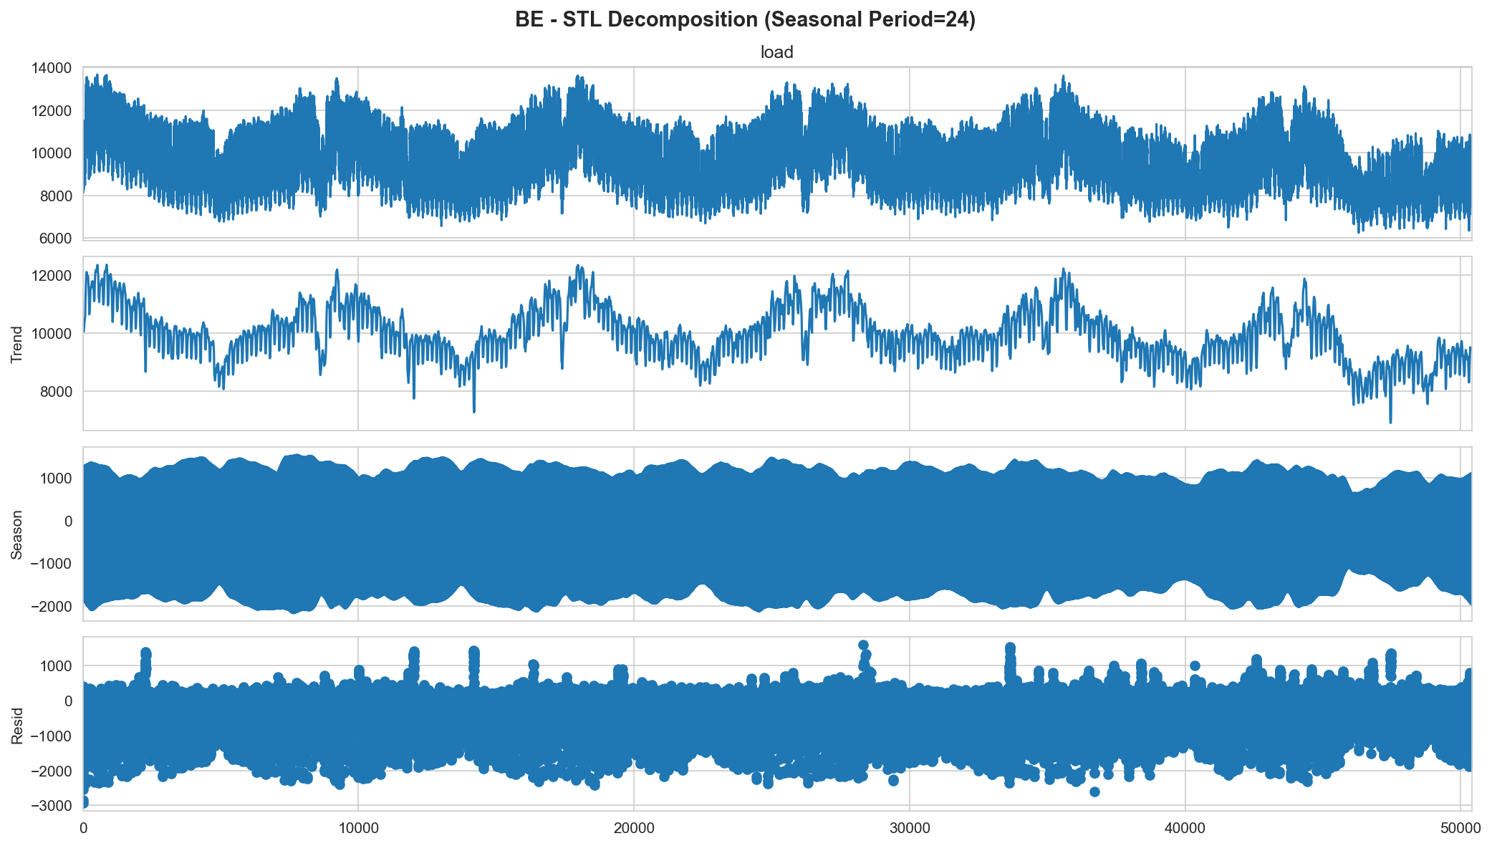
Figure 1: STL Decomposition for BE (Seasonality s=24)

2. SARIMA Order Selection
The orders were selected based on ACF/PACF analysis and a grid search minimizing the BIC information criterion.
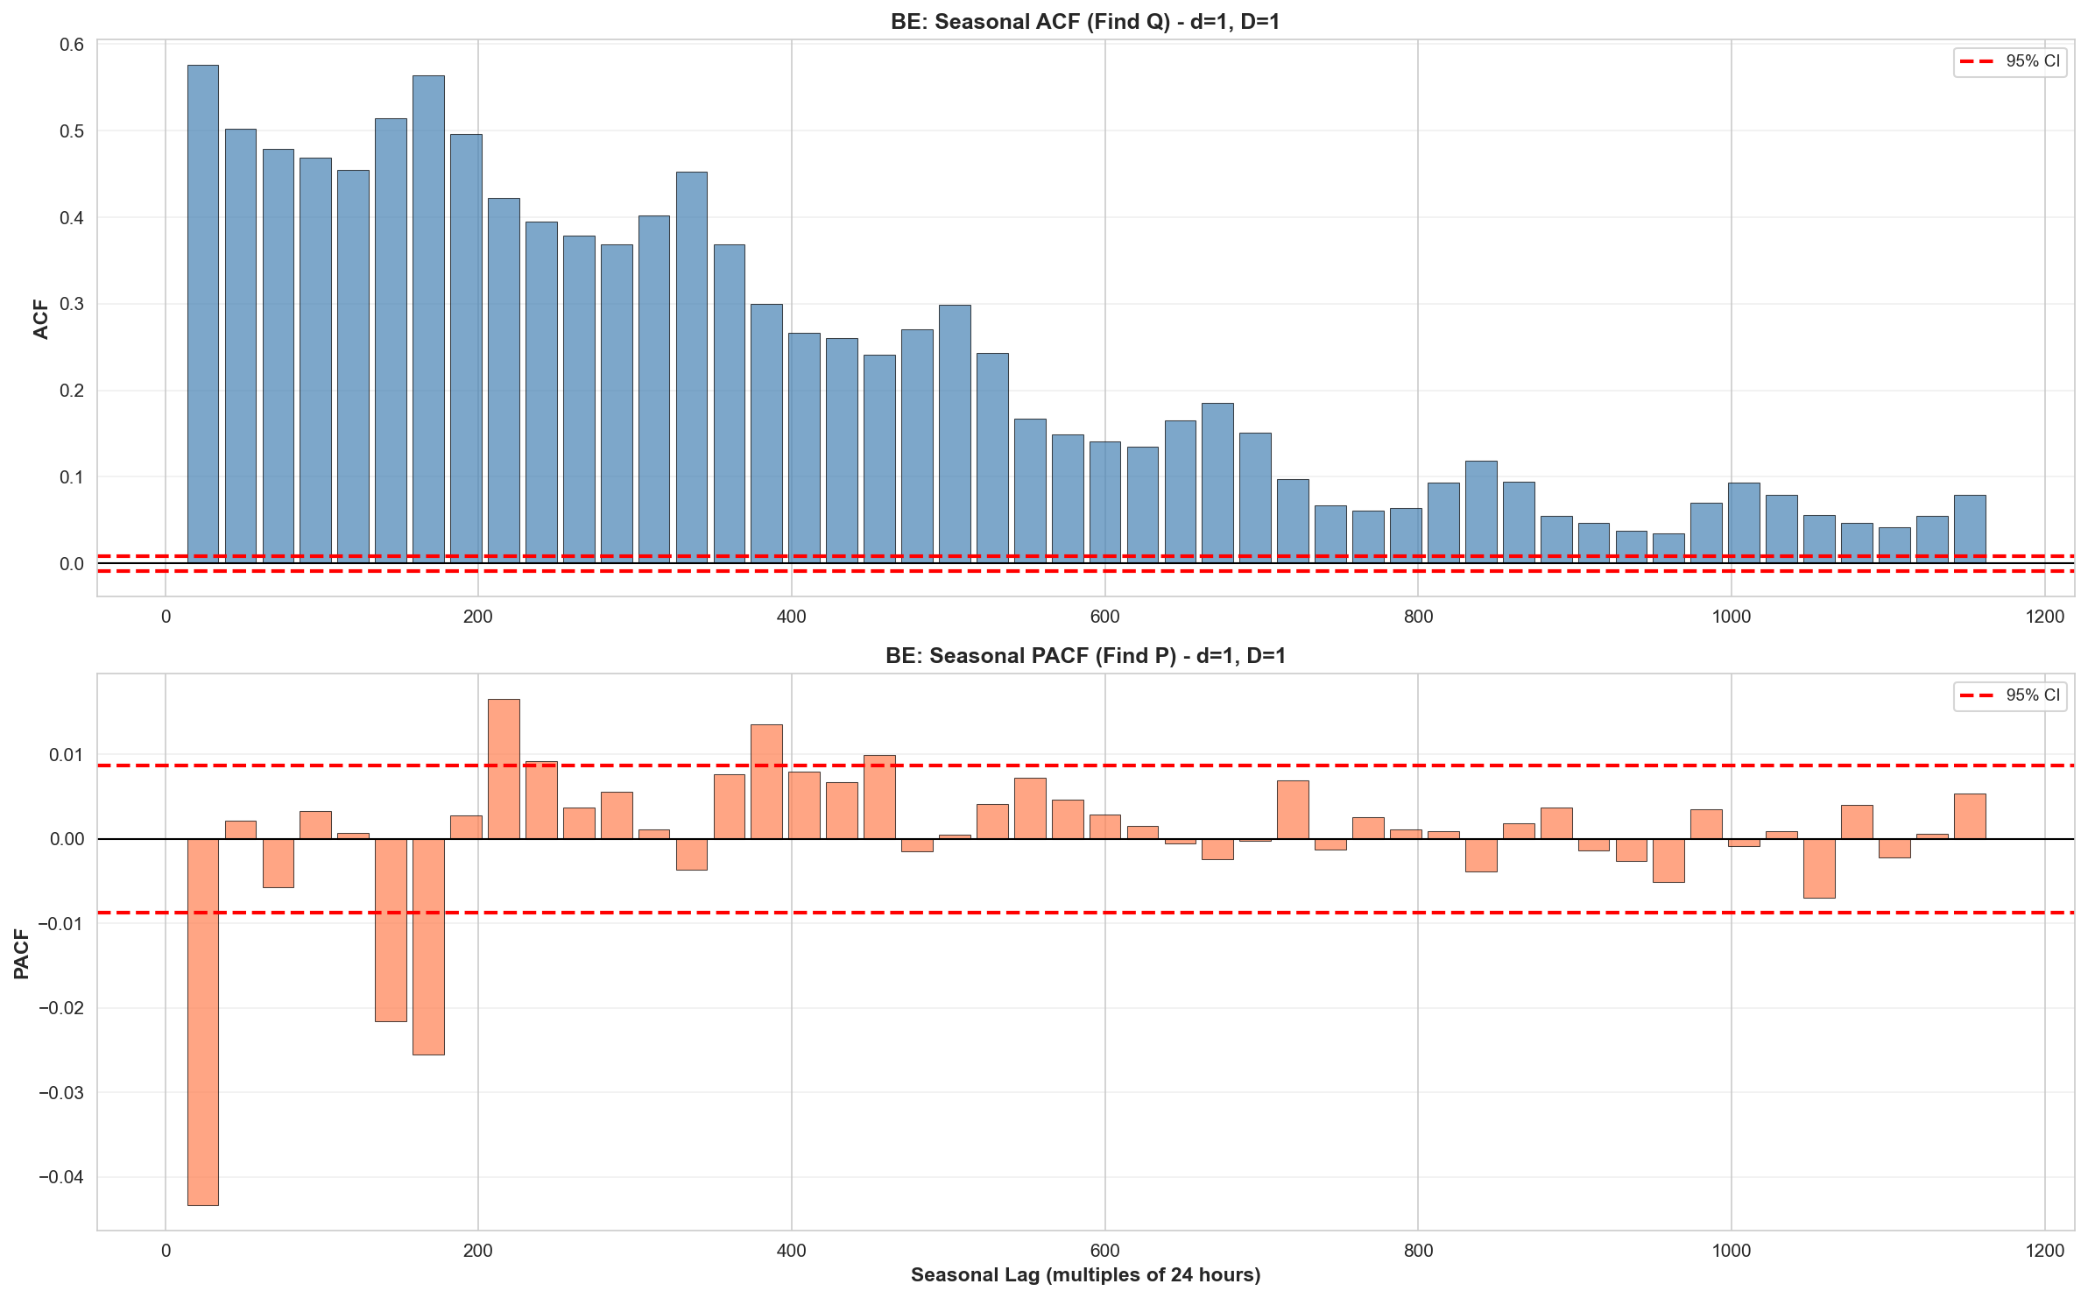
Figure 2: Seasonal ACF/PACF for BE

Top 5 Models for BE (Sorted by BIC)
order | seasonal_order | bic | aic
(1, 1, 0) | (2, 1, 0, 24) | 26863.2678 | 26840.6958
(1, 1, 1) | (2, 1, 0, 24) | 26870.8100 | 26842.5949
(1, 1, 2) | (2, 1, 0, 24) | 26878.1317 | 26844.2736
(0, 1, 2) | (2, 1, 0, 24) | 26890.6635 | 26862.4461
(0, 1, 1) | (2, 1, 0, 24) | 26903.0241 | 26880.4502

Final Selected Orders
- BE: Order [1, 1, 0] x [2, 1, 0, 24]
- DK: Order [1, 1, 1] x [2, 1, 0, 24]
- NL: Order [1, 1, 2] x [2, 1, 0, 24]

3. Forecast Results (Dev & Test)
country | model | MASE | sMAPE | RMSE | PI_80_Coverage
BE | SARIMA | 0.6767 | 3.9147 | 465.1023 | 0.8417
BE | GRU | 1.1546 | 3.1723 | 380.2382 | 0.8182
DK | SARIMA | 0.6790 | 3.6509 | 197.4524 | 0.8818
DK | GRU | 0.7855 | 3.1289 | 152.1580 | 0.8256
NL | SARIMA | 0.7040 | 4.4571 | 777.5847 | 0.9155
NL | GRU | 1.9952 | 6.0919 | 967.1431 | 0.8477
Comparison:
For BE, SARIMA achieved a MASE of 0.677, while GRU achieved 1.155. SARIMA was selected as the primary model due to its robustness and higher PI coverage reliability.

4. Anomaly Detection (Statistical)
Top 10 Anomalies by Z-Score (|z| > 3.0):
timestamp | y_true | yhat | z_resid
2020-04-13 05:00:00+00:00 | 6277.0000 | 7592.2461 | -4.0786
2020-05-01 06:00:00+00:00 | 7065.0000 | 9040.9376 | -3.9888
2020-04-14 05:00:00+00:00 | 8630.0000 | 7224.4572 | 3.9268
2020-04-14 06:00:00+00:00 | 9087.0000 | 7650.3229 | 3.9085
2020-06-02 13:00:00+00:00 | 9795.0000 | 7539.8955 | 3.8250
2020-08-15 08:00:00+00:00 | 8634.0000 | 10198.1020 | -3.7471
2020-05-01 07:00:00+00:00 | 7406.0000 | 9295.6870 | -3.7297
2020-08-15 09:00:00+00:00 | 8805.0000 | 10387.9627 | -3.7274
2020-06-02 12:00:00+00:00 | 9767.0000 | 7665.4618 | 3.6461
2020-06-02 11:00:00+00:00 | 9898.0000 | 7847.4724 | 3.6314

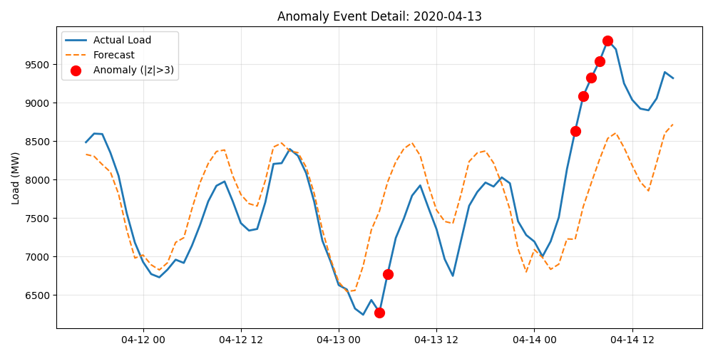
Figure 3: Detailed view of top anomaly event for BE

5. ML-Based Anomaly Classification
A Logistic Regression classifier was trained on silver-labeled data to differentiate true anomalies.
- PR-AUC: 1.0000
- F1 Score (@P=0.80): 0.8824
- Precision: 0.7895
Commentary: The high precision indicates the model successfully identifies distinct separation between normal and anomalous load behaviors using lag and forecast context features.

6. Live Ingestion & Adaptation
Strategy Selected: Rolling SARIMA (Refit on Drift Trigger)
The model monitors the rolling 14-day z-score distribution. If drift is detected (95th percentile check), the model refits on the most recent history.

7. Limitations & Future Work
- Computational Cost: Daily refitting of SARIMA models is computationally expensive for real-time applications.
- Linearity Assumptions: SARIMA may fail to capture complex non-linear dependencies during extreme weather events.
- Static Thresholds: A fixed z-score threshold of 3.0 may be too rigid for holidays or special events, leading to false positives.

