Structure

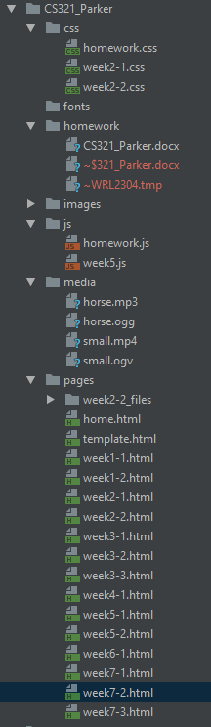

Week 7-1 Html

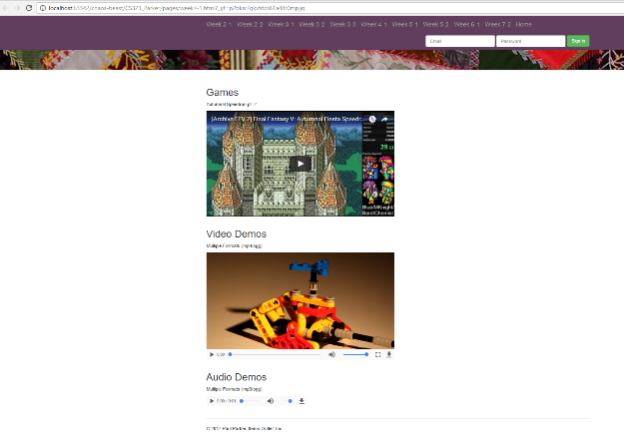

<!DOCTYPE html>  
<!-- saved from url=(0044)http://getbootstrap.com/examples/jumbotron/# -->  
<**html** lang=**"en"**>  
<**head**>  
 <**meta** http-equiv=**"Content-Type"** content=**"text/html; charset=UTF-8"**>  
  
 <**meta** http-equiv=**"X-UA-Compatible"** content=**"IE=edge"**>  
 <**meta** name=**"viewport"** content=**"width=device-width, initial-scale=1"**>  
 <!-- The above 3 meta tags *must* come first in the head; any other head content must come *after* these tags -->  
 <**meta** name=**"description"** content=**""**>  
 <**meta** name=**"author"** content=**""**>  
 <**link** rel=**"icon"** href=**"../images/week2-2favicon.ico"**>  
  
 <**title**>**Items Outlet, Inc.**</**title**>  
  
 <!-- Bootstrap core CSS -->  
 <**link** href=**"https://maxcdn.bootstrapcdn.com/bootstrap/3.3.6/css/bootstrap.min.css"** rel=**"stylesheet"**>  
  
 <!-- IE10 viewport hack for Surface/desktop Windows 8 bug -->  
 <**link** href=**"./week2-2_files/ie10-viewport-bug-workaround.css"** rel=**"stylesheet"**>  
  
 <!-- Custom styles for this template -->  
 <**link** href=**"./../css/homework.css"** rel=**"stylesheet"**>  
  
 <!-- HTML5 shim and Respond.js for IE8 support of HTML5 elements and media queries -->  
 <!--[if lt IE 9]>  
 <script src="https://oss.maxcdn.com/html5shiv/3.7.3/html5shiv.min.js"></script>  
 <script src="https://oss.maxcdn.com/respond/1.4.2/respond.min.js"></script>  
 <![endif]-->  
  
  
</**head**>  
  
<**body**>  
  
<**nav** class=**"navbar navbar-inverse navbar-fixed-top"**>  
 <**div** class=**"container"**>  
 <**div** class=**"navbar-header"**>  
 <**button** type=**"button"** class=**"navbar-toggle collapsed"** data-toggle=**"collapse"** data-target=**"#navbar"** aria-expanded=**"false"** aria-controls=**"navbar"**>  
 <**span** class=**"sr-only"**>**Toggle navigation**</**span**>  
 <**span** class=**"icon-bar"**></**span**>  
 <**span** class=**"icon-bar"**></**span**>  
 <**span** class=**"icon-bar"**></**span**>  
 </**button**>  
 <**a** class=**"navbar-brand"** href=**"./week2-1.html"**>**Week 2-1**</**a**>  
 <**a** class=**"navbar-brand"** href=**"./week2-2.html"**>**Week 2-2**</**a**>  
 <**a** class=**"navbar-brand"** href=**"./week3-1.html"**>**Week 3-1**</**a**>  
 <**a** class=**"navbar-brand"** href=**"./week3-2.html"**>**Week 3-2**</**a**>  
 <**a** class=**"navbar-brand"** href=**"./week3-3.html"**>**Week 3-3**</**a**>  
 <**a** class=**"navbar-brand"** href=**"./week4-1.html"**>**Week 4-1**</**a**>  
 <**a** class=**"navbar-brand"** href=**"./week5-1.html"**>**Week 5-1**</**a**>  
 <**a** class=**"navbar-brand"** href=**"./week5-2.html"**>**Week 5-2**</**a**>  
 <**a** class=**"navbar-brand"** href=**"./week6-1.html"**>**Week 6-1**</**a**>  
 <**a** class=**"navbar-brand"** href=**"./week7-2.html"**>**Week 7-2**</**a**>  
 <**a** class=**"navbar-brand"** href=**"./home.html"**>**Home**</**a**>  
 </**div**>  
 <**div** id=**"navbar"** class=**"navbar-collapse collapse"**>  
 <**form** class=**"navbar-form navbar-right"**>  
 <**div** class=**"form-group"**>  
 <**input** type=**"text"** placeholder=**"Email"** class=**"form-control"**>  
 </**div**>  
 <**div** class=**"form-group"**>  
 <**input** type=**"password"** placeholder=**"Password"** class=**"form-control"**>  
 </**div**>  
 <**button** type=**"submit"** class=**"btn btn-success"**>**Sign in**</**button**>  
 </**form**>  
 </**div**><!--/.navbar-collapse -->  
 </**div**>  
</**nav**>  
  
<!-- Main jumbotron for a primary marketing message or call to action -->  
<**div** class=**"jumbotron"**>  
 <**div** class=**"container"**>  
 <**h1**>**Items Outlet, Inc.**</**h1**>  
 <**p**>**The worlds #1 purveyor of items for all tastes and budgets**</**p**>  
 </**div**>  
</**div**>  
  
<**div** class=**"container"**>  
 <!-- Example row of columns -->  
 <**div** class=**"row"**>  
 <**div** class=**"col-md-12"**>  
 <**h2**>**Games**</**h2**>  
 <**p**>  
 **Autumnal Speedrun pt. 2** </**p**>  
 <**p**>  
 <**iframe** width=**"560"** height=**"315"** src=**"https://www.youtube.com/embed/4ESYg0_XY74"** frameborder=**"0"** allowfullscreen></**iframe**>  
 </**p**>  
 </**div**>  
 </**div**>  
 <**div** class=**"row"**>  
 <**div** class=**"col-md-12"**>  
 <**h2**>**Video Demos**</**h2**>  
 <**p**>  
 **Multiple Formats (mp4/ogg)** </**p**>  
 <**p**>  
 <**video** controls>  
 <**source** src=**../media/small.ogv** type=**video/ogg**>  
 <**source** src=**../media/small.mp4** type=**video/mp4**>  
 </**video**>  
 </**p**>  
 </**div**>  
 </**div**>  
 <**div** class=**"row"**>  
 <**div** class=**"col-md-12"**>  
 <**h2**>**Audio Demos**</**h2**>  
 <**p**>  
 **Multiple Formats (mp3/ogg)** </**p**>  
 <**p**>  
 <**audio** controls>  
 <**source** src=**"../media/horse.ogg"** type=**"audio/ogg"**>  
 <**source** src=**"../media/horse.mp3"** type=**"audio/mpeg"**>  
 </**audio**>  
 </**p**>  
 </**div**>  
 </**div**>  
  
 <**hr**>  
  
 <**footer**>  
 <**p**>**© 2017 Paul Parker, Items Outlet, Inc.**</**p**>  
 </**footer**>  
</**div**> <!-- /container -->  
  
  
<!-- Bootstrap core JavaScript  
================================================== -->  
<!-- Placed at the end of the document so the pages load faster -->  
<!-- Bootstrap core JavaScript ========== -->  
<**script** src=**"https://ajax.googleapis.com/ajax/libs/jquery/2.2.4/jquery.min.js"**></**script**>  
<**script**>window.jQuery || document.write('<script src="../../assets/js/vendor/jquery.min.js"><\/script>')</**script**>  
<**script** src=**"https://maxcdn.bootstrapcdn.com/bootstrap/3.3.6/js/bootstrap.min.js"**></**script**>  
<!-- IE10 viewport hack for Surface/desktop Windows 8 bug -->  
<**script** src=**"./week2-2_files/ie10-viewport-bug-workaround.js.download"**></**script**>  
<**script** src=**"../js/homework.js"**></**script**>  
  
  
</**body**>  
</**html**>

Week 7-2

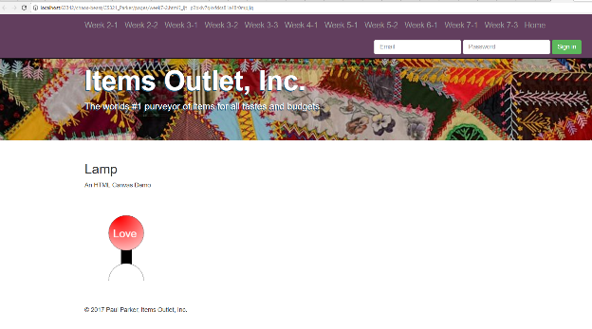

<!DOCTYPE html>  
<!-- saved from url=(0044)http://getbootstrap.com/examples/jumbotron/# -->  
<**html** lang=**"en"**>  
<**head**>  
 <**meta** http-equiv=**"Content-Type"** content=**"text/html; charset=UTF-8"**>  
  
 <**meta** http-equiv=**"X-UA-Compatible"** content=**"IE=edge"**>  
 <**meta** name=**"viewport"** content=**"width=device-width, initial-scale=1"**>  
 <!-- The above 3 meta tags *must* come first in the head; any other head content must come *after* these tags -->  
 <**meta** name=**"description"** content=**""**>  
 <**meta** name=**"author"** content=**""**>  
 <**link** rel=**"icon"** href=**"../images/week2-2favicon.ico"**>  
  
 <**title**>**Items Outlet, Inc.**</**title**>  
  
 <!-- Bootstrap core CSS -->  
 <**link** href=**"https://maxcdn.bootstrapcdn.com/bootstrap/3.3.6/css/bootstrap.min.css"** rel=**"stylesheet"**>  
  
 <!-- IE10 viewport hack for Surface/desktop Windows 8 bug -->  
 <**link** href=**"./week2-2_files/ie10-viewport-bug-workaround.css"** rel=**"stylesheet"**>  
  
 <!-- Custom styles for this template -->  
 <**link** href=**"./../css/homework.css"** rel=**"stylesheet"**>  
  
 <!-- HTML5 shim and Respond.js for IE8 support of HTML5 elements and media queries -->  
 <!--[if lt IE 9]>  
 <script src="https://oss.maxcdn.com/html5shiv/3.7.3/html5shiv.min.js"></script>  
 <script src="https://oss.maxcdn.com/respond/1.4.2/respond.min.js"></script>  
 <![endif]-->  
  
  
</**head**>  
  
<**body**>  
  
<**nav** class=**"navbar navbar-inverse navbar-fixed-top"**>  
 <**div** class=**"container"**>  
 <**div** class=**"navbar-header"**>  
 <**button** type=**"button"** class=**"navbar-toggle collapsed"** data-toggle=**"collapse"** data-target=**"#navbar"** aria-expanded=**"false"** aria-controls=**"navbar"**>  
 <**span** class=**"sr-only"**>**Toggle navigation**</**span**>  
 <**span** class=**"icon-bar"**></**span**>  
 <**span** class=**"icon-bar"**></**span**>  
 <**span** class=**"icon-bar"**></**span**>  
 </**button**>  
 <**a** class=**"navbar-brand"** href=**"./week2-1.html"**>**Week 2-1**</**a**>  
 <**a** class=**"navbar-brand"** href=**"./week2-2.html"**>**Week 2-2**</**a**>  
 <**a** class=**"navbar-brand"** href=**"./week3-1.html"**>**Week 3-1**</**a**>  
 <**a** class=**"navbar-brand"** href=**"./week3-2.html"**>**Week 3-2**</**a**>  
 <**a** class=**"navbar-brand"** href=**"./week3-3.html"**>**Week 3-3**</**a**>  
 <**a** class=**"navbar-brand"** href=**"./week4-1.html"**>**Week 4-1**</**a**>  
 <**a** class=**"navbar-brand"** href=**"./week5-1.html"**>**Week 5-1**</**a**>  
 <**a** class=**"navbar-brand"** href=**"./week5-2.html"**>**Week 5-2**</**a**>  
 <**a** class=**"navbar-brand"** href=**"./week6-1.html"**>**Week 6-1**</**a**>  
 <**a** class=**"navbar-brand"** href=**"./week7-1.html"**>**Week 7-1**</**a**>  
 <**a** class=**"navbar-brand"** href=**"week7-1.html"**>**Week 7-3**</**a**>  
 <**a** class=**"navbar-brand"** href=**"./home.html"**>**Home**</**a**>  
 </**div**>  
 <**div** id=**"navbar"** class=**"navbar-collapse collapse"**>  
 <**form** class=**"navbar-form navbar-right"**>  
 <**div** class=**"form-group"**>  
 <**input** type=**"text"** placeholder=**"Email"** class=**"form-control"**>  
 </**div**>  
 <**div** class=**"form-group"**>  
 <**input** type=**"password"** placeholder=**"Password"** class=**"form-control"**>  
 </**div**>  
 <**button** type=**"submit"** class=**"btn btn-success"**>**Sign in**</**button**>  
 </**form**>  
 </**div**><!--/.navbar-collapse -->  
 </**div**>  
</**nav**>  
  
<!-- Main jumbotron for a primary marketing message or call to action -->  
<**div** class=**"jumbotron"**>  
 <**div** class=**"container"**>  
 <**h1**>**Items Outlet, Inc.**</**h1**>  
 <**p**>**The worlds #1 purveyor of items for all tastes and budgets**</**p**>  
 </**div**>  
</**div**>  
  
<**div** class=**"container"**>  
 <!-- Example row of columns -->  
 <**div** class=**"row"**>  
 <**div** class=**"col-md-12"**>  
 <**h2**>**Lamp**</**h2**>  
 <**p**>  
 **An HTML Canvas Demo** </**p**>  
 <**p**>  
 <**canvas** id=**"lampCanvas"** width=**"200"** height=**"200"** onclick=**"**toggleColor()**"**></**canvas**>  
 </**p**>  
 </**div**>  
 </**div**>  
  
 <**hr**>  
  
 <**footer**>  
 <**p**>**© 2017 Paul Parker, Items Outlet, Inc.**</**p**>  
 </**footer**>  
</**div**> <!-- /container -->  
  
  
<!-- Bootstrap core JavaScript  
================================================== -->  
<!-- Placed at the end of the document so the pages load faster -->  
<!-- Bootstrap core JavaScript ========== -->  
<**script** src=**"https://ajax.googleapis.com/ajax/libs/jquery/2.2.4/jquery.min.js"**></**script**>  
<**script**>window.jQuery || document.write('<script src="../../assets/js/vendor/jquery.min.js"><\/script>')</**script**>  
<**script** src=**"https://maxcdn.bootstrapcdn.com/bootstrap/3.3.6/js/bootstrap.min.js"**></**script**>  
<!-- IE10 viewport hack for Surface/desktop Windows 8 bug -->  
<**script** src=**"./week2-2_files/ie10-viewport-bug-workaround.js.download"**></**script**>  
<**script** src=**"../js/homework.js"**></**script**>  
  
<**script** type=**"text/javascript"**>  
  
 var *rectangle*;  
 var *circle*;  
 var *isWhite* = false;  
 function renderStand() {  
 var canvas = document.getElementById("lampCanvas");  
 var stand = canvas.getContext("2d");  
 stand.beginPath();  
 stand.fillStyle = "black";  
 stand.arc(95, 200, 40, 0, (2 * *Math*.PI) / 2, true);  
 stand.fill();  
 stand.closePath();  
 stand.stroke();  
 }  
 function renderLamp() {  
 var canvas = document.getElementById("lampCanvas");  
 *rectangle* = canvas.getContext("2d");  
 *rectangle*.fillRect(83, 125, 25, 75);  
 *circle* = canvas.getContext("2d");  
 *circle*.beginPath();  
 *circle*.arc(95, 90, 40, 0, (2 * *Math*.PI));  
 *circle*.stroke();  
 renderStand();  
 toggleColor();  
 }  
  
 function toggleColor() {  
 *isWhite* = !*isWhite*;  
 var redGradient = *circle*.createRadialGradient(75,50,5,90,60,100);  
 redGradient.addColorStop(0,"red");  
 redGradient.addColorStop(1,"white");  
 *circle*.fillStyle = *isWhite* ? "#FFFFFF" : redGradient;  
 *circle*.fill();  
 renderText();  
 }  
  
 function renderText() {  
 var canvas = document.getElementById("lampCanvas");  
 var textCircle = canvas.getContext("2d");  
 textCircle.beginPath();  
 textCircle.arc(95, 90, 40, 0, (2 * *Math*.PI));  
 textCircle.font = "25px Arial";  
 textCircle.fillStyle = *isWhite* ? "#FF0000" : "#FFFFFF";  
 var text = *isWhite* ? "Lamp" : "Love";  
 textCircle.fillText(text, 65, 100);  
 }  
  
 renderLamp();  
  
</**script**>  
  
</**body**>  
</**html**>