Parker Paul

CS373

Unit 1 Lab

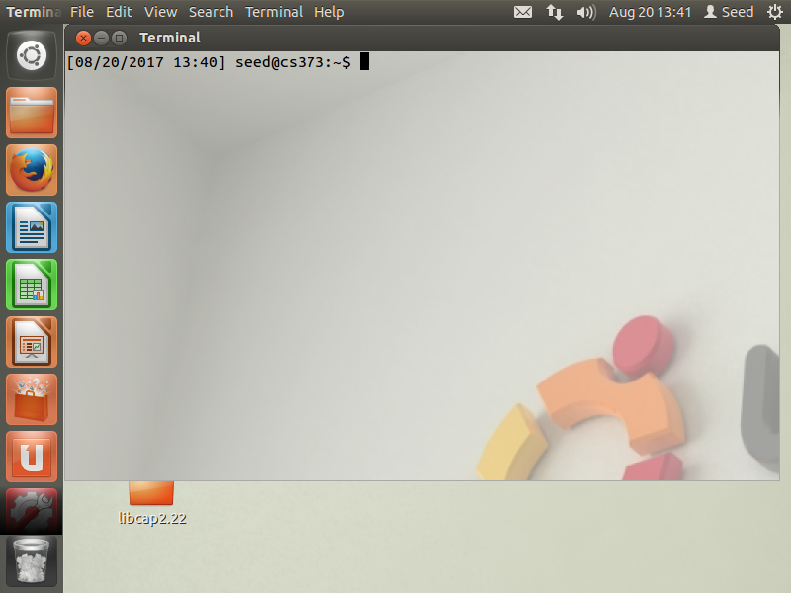

I wished I had taken this course 4 months ago. This isn’t the first time I’ve had to create a VM for Ubuntu. I headed up a development team that was working on a project for an application running on an embedded Linux OS and we used a VM for our development environment. This lab setup went pretty smooth, and I think this was mostly due to my previous experience. A small minor trick for Ubuntu specifically is that the terminal can be brought up with Ctrl+Alt+T.