Classwork 20260918

2026-Sept-18
Answer all following questions about abstract data types (linked list, binary tree, stack and queue).
The marks for each question are shown in brackets [ ]. Total marks: 100.
Write your answers in the answer boxes. For all programming questions, write Python code.

Question 1 - Binary tree concepts (25 marks)
The diagram below shows a binary search tree that stores integer values.
38
/ \
25 57
/ \ / \
16 32 45 63

(a) State the value of the root node and name all of the leaf nodes. [4]
Value of root : 38; Leaf nodes: 16,32,45,63

(b) State the level of the node with the value 45, and state the height (depth) of the tree. [4]
Level : 3; Height: 2.

(c) Explain what is meant by a subtree and identify one subtree in this diagram. [4]
A subtree is a node together with its descendants. One subtree:
25
/ \
16 32

(d) State the rule that makes this tree a binary search tree. [4]
Every left-hand child’s key is smaller than its parent’s key and every right-hand child’s key is greater or equal to its parent’s key.

(e) The value 40 is to be inserted into the tree. State which existing node it will become a child of, and whether it will be a left child or a right child. Explain how you decided. [4]
It will become a child of 45, and it will be a left child. First 40 > 38 so go to right subtree, and 40 < 57 so go to left subtree, and 40 < 45 so go to the left subtree. As 45 is a leaf, 40 will be the left child of the node.

(f) A binary search tree is to store records about students. Explain why 'student ID' is a better key than 'surname'. [5]
Because student ID can be compared and will not repeat, however surname may be repeated so that many nodes have the same key, thus not so convenient to implement search.

Question 2 - Linked list (35 marks)
A linked list is stored in two parallel 1D arrays. The variable startPointer holds the index of the first node in the list and heapStartPointer holds the index of the first free node. A null pointer is represented by -1.
DECLARE myLinkedList : ARRAY[0:6] OF INTEGER
DECLARE myLinkedListPointers : ARRAY[0:6] OF INTEGER
DECLARE startPointer : INTEGER
DECLARE heapStartPointer : INTEGER
CONSTANT nullPointer = -1

Index | myLinkedList | myLinkedListPointers
0 | 15 | 3
1 | | 2
2 | | 5
3 | 27 | 4
4 | 61 | -1
5 | | 6
6 | | -1

startPointer = 0 heapStartPointer = 1

(a) The function find(itemSearch) traverses the list until the item is found. Complete the trace table to show the search for the value 61. [6]
Iteration | itemPointer | myLinkedList[itemPointer] | Found? | Next pointer
1 | 0 | 15 | No | 3
2 | 3 | 27 | No | 4
3 | 4 | 61 | Yes! | -1

(b) Explain what is meant by a null pointer in this implementation, and state its value. [3]
Null pointer is the pointer that indicates the end of the linked list. Its value is -1.

(c) Complete the pseudocode for the procedure insertAtStart(itemAdd) that inserts the new value at the beginning of the list. [10]
PROCEDURE insertAtStart(itemAdd)
IF heapStartPointer = nullPointer THEN
OUTPUT "No space available"
ELSE
newNodePointer <- heapStartPointer
heapStartPointer <- myLinkedList[heapStartPointer]
myLinkedList[newNodePointer] <- itemAdd
myLinkedListPointers[newNodePointer] <- startPointer
startPointer <- newNodePointer
ENDIF
ENDPROCEDURE

Write the missing lines above. Use the box below for any working.

(d) Complete the pseudocode for the procedure removeItem(itemDelete) that removes the first node containing itemDelete from the list. Your answer must deal with removing the first node and with removing a node in the middle or at the end. [12]
PROCEDURE removeItem(itemDelete)
currentPointer <- startPointer
previousPointer <- nullPointer
WHILE currentPointer <> nullPointer AND myLinkedList[currentPointer] <> itemDelete
previousPointer <- currentPointer
currentPointer <- myLinkedListPointers[currentPointer]
ENDWHILE
IF currentPointer = nullPointer THEN
OUTPUT "Item not in list"
ELSE
IF previousPointer = nullPointer THEN
startPointer <- myLinkedListPointers[currentPointer]
ELSE
myLinkedListPointers[previousPoiter] <- myLinkedListPointers[currentPointer]
ENDIF
myLinkedListPointers[currentPointer] <- heapStartPointer
heapStartPointer <- currentPointer
ENDIF
ENDPROCEDURE

Write the missing lines above. Use the box below for any working.

(e) Describe how the node that has been removed is made available for use again. [4]
The node that has been removed is inserted to beginning of the heap linked list so that it can be used again when the linked list needs a new node from heap.

Question 3 - Stack and queue programming (40 marks)
A takeaway shop uses a circular queue to manage its orders. Each order is stored as a string containing the customer's name. A Python program is required to implement the queue.
(a) Write program code to declare a global 1D list orders with space for 8 items, and the global variables front, rear and orderCount, all initialised to 0. [3]
arr = [' ' for i in range(8)]
front = 0
rear = 0
orderCount = 0

(b) Write program code for the procedure enqueue(newOrder) that adds newOrder to the rear of the queue. It must check whether the queue is full and output "Queue full" if it is. The queue is circular, so the rear pointer must wrap around. [8]
def enqueue(newOrder):
global arr, front, rear, orderCount
if orderCount < 8:
arr[rear] = newOrder
orderCount += 1
if rear == 7:
rear = 1
else:
rear += 1
else:
print("Queue full")

(c) Write program code for the function dequeue() that removes and returns the order at the front of the queue. It must check whether the queue is empty and return the string "EMPTY" if it is. [8]
def dequeue():
global arr, front, rear, orderCount
if orderCount == 0:
return "EMPTY"
else:
orderCount -= 1
prevfront = front
if front == 7:
front = 1
else:
front += 1
return arr[prevfront]

(d) Write program code for the main program that: [10]
enqueues the four orders "Amy", "Ben", "Cara" and "Dan", in that order
dequeues two orders and outputs each one
enqueues two more orders, "Eve" and "Finn"
dequeues all the remaining orders and outputs each one
enqueue("Amy")
enqueue("Ben")
enqueue("Cara")
enqueue("Dan")
print(dequeue())
print(dequeue())
enqueue("Eve")
enqueue("Finn")
while orderCount > 0:
print(dequeue())

(e) Test your program with the data in part (d) and paste a screenshot of your output in the box below. [6]
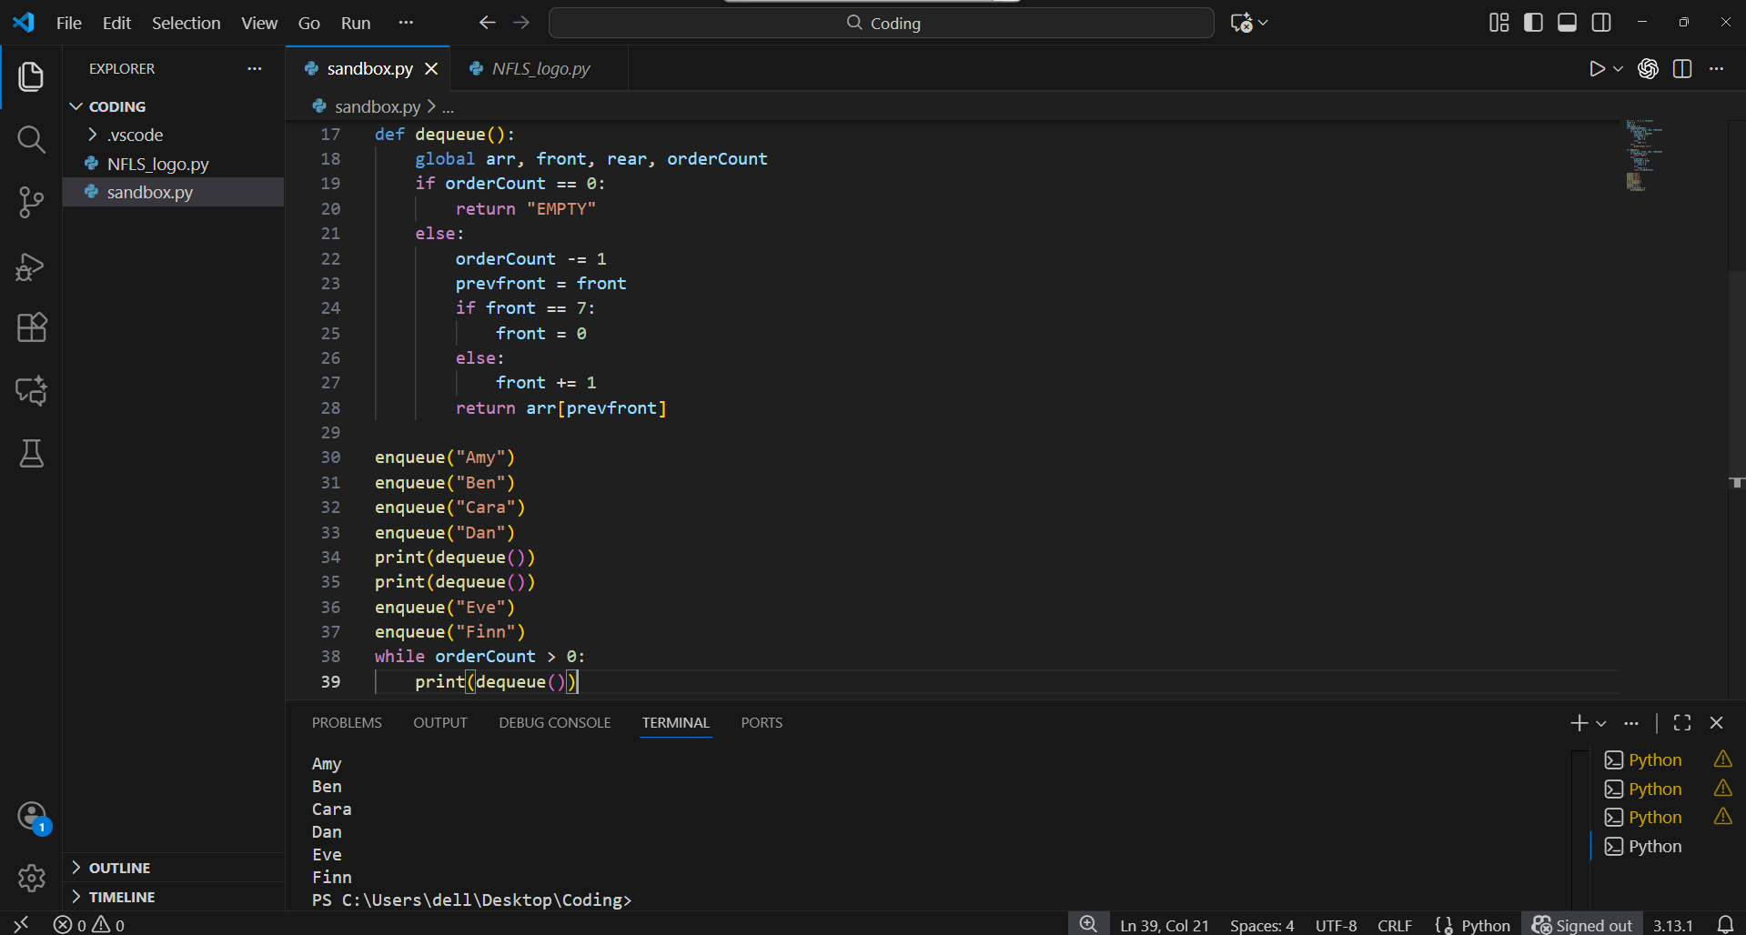
0

(f) The program is run again. After part (d) has finished, dequeue() is called three more times. State the value returned by each call and explain your answer. [5]
EMPTY
EMPTY
EMPTY
because the queue is already empty and have no remaining order, so that attempts to dequeue all returns empty.

