Homework assignment 04

Due 2026-Oct-15
Answer the following questions about object-oriented programming and abstract data
types (linked list and binary tree).
The marks for each question are shown in brackets [ ]. Total marks: 100.
Write your answers in the answer boxes. For all programming questions, write Python code.

Question 1 - Object-oriented programming (32 marks)
A car park charges for parking by the hour. A program stores data about the cars
using the class Car. The class is described below.
Car
RegNumber : String the registration number, e.g. "AB12 CDE"
HoursParked : Integer whole hours the car was parked
IsMember : Boolean True if the driver is a member

Constructor(...) initialises the three attributes
GetRegNumber() returns the registration number
SetHours(newHours) stores newHours if 1 <= newHours <= 24
CalcCharge() calculates the parking charge

All attributes are private.

(a) State what is meant by an attribute and by a method, and give one example of each from the class Car. [4]
An attribute is a data member that can be accessed inside the class and outside the class if public, and a method is a member function that can be called on one object.
Example of an attribute: RegNumber : String
Example of a method: GetRegNumber()

(b) Write program code to declare the class Car, its constructor, GetRegNumber() and SetHours(newHours). Do not declare CalcCharge(). All attributes must be private. [12]
class Car:
def __init__(self, RegNumber, HoursParked, IsMember):
self.__RegNumber = RegNumber #Private, string
self.__HoursParked = HoursParked #Private, integer
self.__IsMember = IsMember #Private, boolean
def GetRegNumber(self):
return self.__RegNumber
def SetHours(self, newHours):
self.__HoursParked = newHours

(c) CalcCharge() calculates and returns the parking charge. The charge is 2.00 for each whole hour the car was parked. If the driver is a member of the car park, 25% is taken off the total charge. Write program code for CalcCharge(). [5]
def CalcCharge(self):
if self.__IsMember:
return self.__HoursParked * 2.00 * 0.75
else:
return self.__HoursParked * 2.00

(d) Write program code for the main program that:
declares a local array Cars with space for 3 elements
takes as input the registration number, the number of hours parked and whether the driver is a member, for each of three cars
repeats the input of the number of hours until it is between 1 and 24 inclusive
creates an instance of Car for each car and stores it in the array
outputs the registration number and the charge for each car [7]
Cars = [None, None, None]
for i in range(3):
RegNumber = input("Enter the registration number of the car: ")
HoursParked = int(input("Enter the number of hours parked: "))
while not (1 <= HoursParked <= 24):
print("Invalid input. Please enter a number between 0 and 24.")
HoursParked = int(input("Enter the number of hours parked: "))
IsMember = bool(input("Is the car owner a member? (True/False): "))
Cars[i] = Car(RegNumber, HoursParked, IsMember)

for i in range(3):
out = "Car " + str(i + 1) + " has a registration number of "
out += str(Cars[i].GetRegNumber())
out += " and the charge for parking is £"
out += str(Cars[i].CalcCharge())
print(out)

(e) Test your program and take a screenshot of the output. Paste the screenshot into the box below. [4]
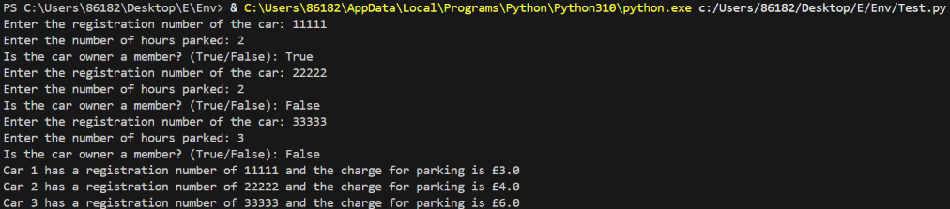

Question 2 - Linked list (28 marks)
A linked list is stored in two parallel 1D arrays. The variable startPointer holds the index of the first node in the list and heapStartPointer holds the index of the first free node. A null pointer is represented by -1.
DECLARE myLinkedList : ARRAY[0:7] OF INTEGER
DECLARE myLinkedListPointers : ARRAY[0:7] OF INTEGER
DECLARE startPointer : INTEGER
DECLARE heapStartPointer : INTEGER
CONSTANT nullPointer = -1

Index | myLinkedList | myLinkedListPointers
0 | 18 | 3
1 | | 4
2 | | 5
3 | 29 | 6
4 | | 2
5 | | -1
6 | 41 | 7
7 | 55 | -1

startPointer = 0 heapStartPointer = 1

(a) State the four values that are currently stored in the linked list, in order, and state which array indices are free. [4]
Four values: 18,29,41,55; Free indices: 1,2,4,5

(b) Write program code for the function getValues() that returns a list containing all of the data values stored in the linked list, in the order in which they appear in the list. [10]
def getValues():
arr = [None for i in range(8)]
curPt = startPointer
index = 0
if curPt == nullPointer:
return []
else:
while curPt != nullPointer:
arr[index] = myLinkedList[curPt]
curPt = myLinkedListPointers[curPt]
index = index + 1
return arr[0:index]

(c) Write program code for the function searchValue(target) that returns the number of nodes that were visited before the item was found. If the item is not in the list, the function returns -1. [8]
def searchValue(target):
count = 0
curPt = startPointer
if curPt == nullPointer:
return -1
else:
while curPt != nullPointer and myLinkedList[curPt] != target:
count = count + 1
curPt = myLinkedListPointers[curPt]
if curPt == nullPointer :
return -1
else:
return count

(d) Explain why searching this linked list takes longer than searching a sorted array that contains the same four values. In your answer, state the time complexity of each search. [6]
Searching this linked list can only be implemented linearly with a time complexity of O(n), but searching through a sorted a array may make use binary search with a time complexity of O(log n), which is less time-consuming than the O(n) linear method.

Question 3 - Binary tree (32 marks)
A binary search tree is implemented using an array of nodes. The array is declared as follows.
TYPE node
DECLARE item : INTEGER
DECLARE leftPointer : INTEGER
DECLARE rightPointer : INTEGER
ENDTYPE

DECLARE myTree[0:8] OF node
DECLARE rootPointer : INTEGER
DECLARE nextFreePointer : INTEGER
CONSTANT nullPointer = -1

The tree currently stores six values.

Index | item | leftPointer | rightPointer
0 | 50 | 1 | 2
1 | 30 | 3 | 4
2 | 70 | 5 | -1
3 | 20 | -1 | -1
4 | 40 | -1 | -1
5 | 65 | -1 | -1
6 | | 7 | -1
7 | | 8 | -1
8 | | -1 | -1

rootPointer = 0 nextFreePointer = 6

(a) Draw the binary search tree that is stored in the array. [4]
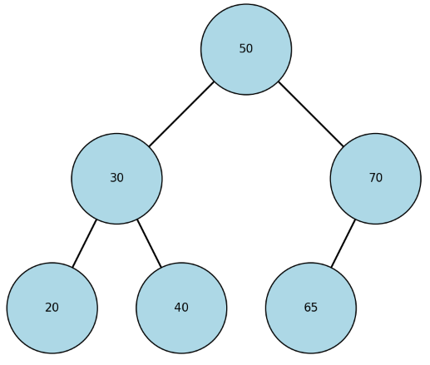

(b) Complete the pseudocode for the function find(itemSearch) that searches the tree. The function returns the array index of the node that contains itemSearch, or -1 if the item is not in the tree. [12]
FUNCTION find(itemSearch) RETURNS INTEGER
DECLARE itemPointer : INTEGER
itemPointer <- rootPointer
WHILE itemPointer <> nullPointer DO
IF myTree[itemPointer].item = itemSearch THEN
RETURN itemPointer
ELSE
IF myTree[itemPointer].item > itemSearch THEN
itemPointer <- myTree[itemPointer].leftPointer
ELSE
itemPointer <- myTree[itemPointer].rightPointer
ENDIF
ENDIF
ENDWHILE
RETURN -1
ENDFUNCTION

Write the missing lines above.

(c) The function call find(40) is made. Complete the trace table below to show the value of itemPointer at the start of each iteration, the value that is compared with itemSearch, and which branch is taken. [6]
Iteration | itemPointer | Value compared | Branch taken
1 | 0 | 50 | left
2 | 1 | 30 | right
3 | 4 | 40

(d) Explain why searching this binary search tree is usually faster than searching the linked list in Question 2. State also the maximum number of comparisons that find() would make for the tree shown above. [6]
Because each attemping to search the tree halves the range of items to be searched, making the time complexity O(log n), which is faster than the O(n) time complexity of the linear search of linked list. The maximum number of comparisons: 3.

(e) The function find(45) is now called. The value 45 is not stored in the tree. Describe what the function does and state the value that it returns. [4]
The function first compare it with 50, selecting the left branch and then compare it with 30, selecting the right branch and then compare it with 40, selecting the right branch. And finally the function finds the rightPointer of the node 40 is a nullPointer, so it eventually returns an -1.

Question 4 - Abstract data types (8 marks)
(a) State what is meant by an abstract data type, and give one example. [3]
An abstract data type is a data type with its own logical structure and methods whose implementing details are hidden inside. One example is stack.

(b) A queue can be implemented as a linear queue or as a circular queue. Explain one reason why a circular queue is often preferred. [3]
Because a circular queue can make use of all space in its implementing array, and move of front pointer will not cause a permanent loss of available space.

(c) State what is meant by a directed graph. [2]
A directed graph is a graph whose edges have their own direction.

