# Plaits Macro Oscillator MU

## Christer Janson

chrutil at hotmail dotcom

Here is a quick description of this project – a port of the Plaits Macro Oscillator to large format MU modular. Any errors in the following description and the associated PCBs and Panel are my own. There are no guarantees I got it right, but I did build several of these modules that appear to be working well with these instructions and drawings.

If you find an issue with this content, please contact me by email. Please realize that this email gets a lot of spam and multiple emails might be required to get my attention.

## Building

Populating the PCB is relatively straight forward.

Some components like the STM32 have very small pins and can take some practice to solder. There are multiple videos on youtube showing how to do this. I advise doing this part first and make sure you got it right before populating the rest of the board. There are a few other components that are very small, but the majority of components has been changed to larger footprint.

The connection between the two PCBs are done using two pine headers – a 10 pin and a 4 pin. The male 10 and 4 pin connectors go on the backside of the main pcb. The female counterparts are placed on the panel side of the ioboard pcb.

Also on the back side of the main pcb is the 4 pin male header serving as the programming port for connecting the ST-LINK V/2

## Programming

First setup the Mutable Instruments development environment.

There are many ways to do this and lots of instructions online. The following way worked for me.

I used the instructions located at: <https://github.com/pichenettes/mutable-dev-environment>

Once the environment is setup, in a Command Prompt window, CD into the installation folder (Assumed to D:\MutableDevEnv below)

D:

Cd \MutableDevEnv

Vagrant up

Vagrant ssh

[Now you should be logged in to the virtual machine]

[Build the binaries]

make -f plaits/bootloader/makefile hex

make -f plaits/makefile

[Then when the binaries are built]

[Make sure the Plaits module is powered and connected to ST-LINK V/2 as per the diagram below]

[Program the Plaits module]

make -f plaits/makefile upload

I used ST-LINK V/2 for programming the Plaits module. This is what I did on a PC running Windows 7.

Install ST-LINK V/2 drivers

ST-LINK V/2 should be connected to the PC before starting the Vagrant environment

Connect the ST-LINK V/2 to the Plaits module using the four pin connector on Plaits to the following pins on ST-LINK V/2. Do not forget to jumper pin 1 to pin 19 on the ST-LINK V/2

1 <-–> 19 jumper cable  
7 SWDIO  
9 SWCLK  
15 Reset  
4 GND

Here is a diagram of the connection, make sure the ST-LINK V/2 faces the right way. In the diagram the ‘key’ is facing left.

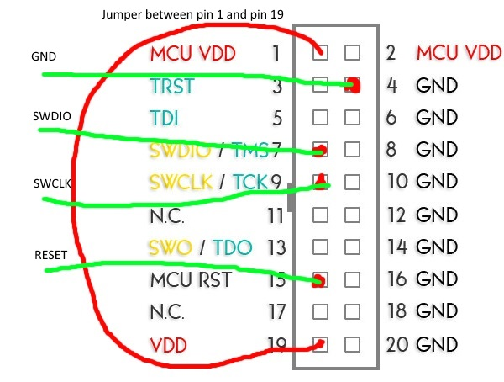

Last, many, many thanks to Olivier and Mutable Instruments for allowing us access to his IP.

This project is a small attempt to pay it forward.