School of Media Arts and Technology

BSc (Hons) Web Design and Development

Academic Year 2019-2020

Krisztian Nagy

Assignment 2

Human Digital Interaction Design

Tutor: Dr.Mohammed Al-Husban DATE: 2020.05.12

# **1 Contents**

**1 Contents** **2**

**2 Introduction** **4**

**2 Tasks** **5**

**2.1 Cognition & Perception** **5**

**2.2 Affordance** **6**

**Landing page of jobseeker:** **6**

**Listings of jobseeker:** **7**

**Sign In page:** **7**

**Apply:** **7**

**Feedback:** **8**

**2.3 Colour** **9**

**2.4 Icon metaphor** **10**

**Logo design:** **10**

**Icons on the site:** **10**

**2.5 Hierarchical task analysis** **11**

**2.6 Storyboarding** **13**

**3 Artefact (From Assessment 1, Part1)** **14**

**3.1 Need Analysis** **14**

**3.2 User Analysis (Personas)** **15**

**3.3 Task Analysis** **16**

**4 List of work** **17**

**4.1 Work that I contributed to the group** **17**

**4.2 Work that others have done** **18**

**5 Appendices** **19**

**Link to our prototype:** **19**

**Wireframing and layout:** **20**

**Team meetings:** **24**

# **2 Introduction**

Nowadays it is very important to create our websites in a way that not only satisfies the users with its aesthetic look but it needs to meet their expectations, which comes from their previous experience and cognitive thinking, to satisfy the user during interaction with our website. This user experience in combination with the responsibility to maintain a fully working site that is ensured to befit to its activities makes a successful website.

In this document I am going to analyse and explain the implementation of design principles that has been done in assignment 1 on this unit. From the explanation of how the principles came to consideration to the implementation to our website, and to its components I overview our work in assignment 1.

# 

# 

# **2 Tasks**

## 2.1 Cognition & Perception

Cognition and perception is very important during interaction with websites. In our design we considered Gestalt principles: simplicity, similarity, continuity and closure such as feedback, affordance, mapping, constraints and consistency described by Donald A. Norman in his book “The Design of Everyday Things”.

From the listed principles above we can state that we rely more on visual perception rather than cognition. The reason is that the information the user receives via visual perception is easy to process and its meaning is trivial and obvious until simplicity is consistent on our website. Which brings us to the question: How is simplicity considered in our website?

Simplicity can be separated to two different levels: The first is the simplicity of each item can be found on our web page such as buttons, icons and other functional items. On the website we did not use icons that were represented by images, we used labels on each button or functional item. In my opinion it should be a further study to bring icons to our website that can maintain a consistent simplicity on our website that ensures the statement I made previously. The second level of simplicity is more complicated. It requires the use and combination of principles listed above. It is more based on the structure of each component and of the whole website.

On the other hand, cognition is contained less on the website. Cognition can be found in principles such as closure, mapping and affordance. These principles are unavoidable on our SPA website. Closure used to group elements on the website so the user knows that certain elements on the website belong together without creating a separate section for each group. This also redounds simplicity on the website. Mapping is considered in functionality. Those of functional components that require the user to input are labelled inside of the component.

Cognition itself contains the previous experience with websites which later creates expectations. Constraints are considered in a way that is the reduction of user actions which makes the interaction with the website simple and easy.

## 2.2 Affordance

The implementation of principles was a whole new challenge as my teammates joined the production very late. I designed the whole jobseeker side of our website when they started the production. So the whole production separated this way.

### Landing page of jobseeker:

Closure and similarity used in the headline where the “For employers” and “Sign In” button are close to each other and they are similar in size. It also uses continuity as for each page the same headline appears with the difference of that the headlines of sup-pages contains the search field.

The search field uses visibility as search fields are centered on the viewport and mirrored design built around it. Also uses mapping, closure and similarity. Search fields are labelled within the box that the user expects to fill with relative information and each element of the search field component is aligned in the same row and close to each other, also similar in size and colour so the search field is recognizable as one group.

In the company ads section the structure of each advertisement is similar. It contains a company logo and company name below the logo and they are aligned in the same row close to each other. Continuity also can be seen here as components are aligned and they are similar.

In the section of popular jobs items are aligned vertically close to each other in each column which represents two different groups. Items in each column are using the same colour and text size that shows similarity. This section uses grey background which gives visibility not only to this but all three sections.

The section of career advice shows closure with the title, subtitle and its items. Visibility is inherited from the previous section (popular jobs) background colour.

### Listings of jobseeker:

The sub-page uses the same headline and footer with the same layout with the difference of the search field being replaced in the header. This ensures multi page continuity in our website.

Listing uses closure, similarity and continuity. Listed items and its short description is grouped with closure. Between the items there's similarity as its structure is similar. Continuity can be seen in that the items are aligned in a column using the same meta structure.

### Sign In page:

Sign in page or popup window based on closure, similarity and also uses mapping. The page shows two different ways to sign in or sign up. Sign In section mapping used to assign each label to their input field. These input fields are also similar and close to each other as this represents one group. The second group offers the opportunity to sign up via external accounts such as Google and Facebook. These links are similar in size and close to each other.

### Apply:

The popup window contains 4 groups that are declared with closure but not similarity this time. First the company name the user wants to apply to and their CV. Second is phone number and input field for phone number. Third is the notification checkbox and its description. Fourth is the continue and cancel button. The only similarity is shown in their same width which supports simplicity.

### 

### Feedback:

Feedback contains continuity as all items are vertically centered and also contains visibility as it is a vertically mirrored design as result “Successful application” is made more visible.

# 

## 

## 2.3 Colour

The SPA website connects freshly graduated candidates with companies. From this idea we started to think about the meaning of colours. We assigned graduates with fresh and new people full of energy and SPA wants companies to grow, to become more with these candidates. After a lecture on colour theory Noemi Domjan came up with colour palettes ( figure 1) and we chose green as the main colour for our website by its meaning that perfectly reflects our thoughts about SPA so far. Except one particular meaning. “People full of energy” - the meaning of energy assigned to yellow rather than green. I implemented this colour in our logo (explained in Icon metaphor).

The site uses green colour continuously on the jobseeker side, however it changes to blueish on the employer side, telling them we are safe and reliable whereas the colours in our logo still represents growth and energy.

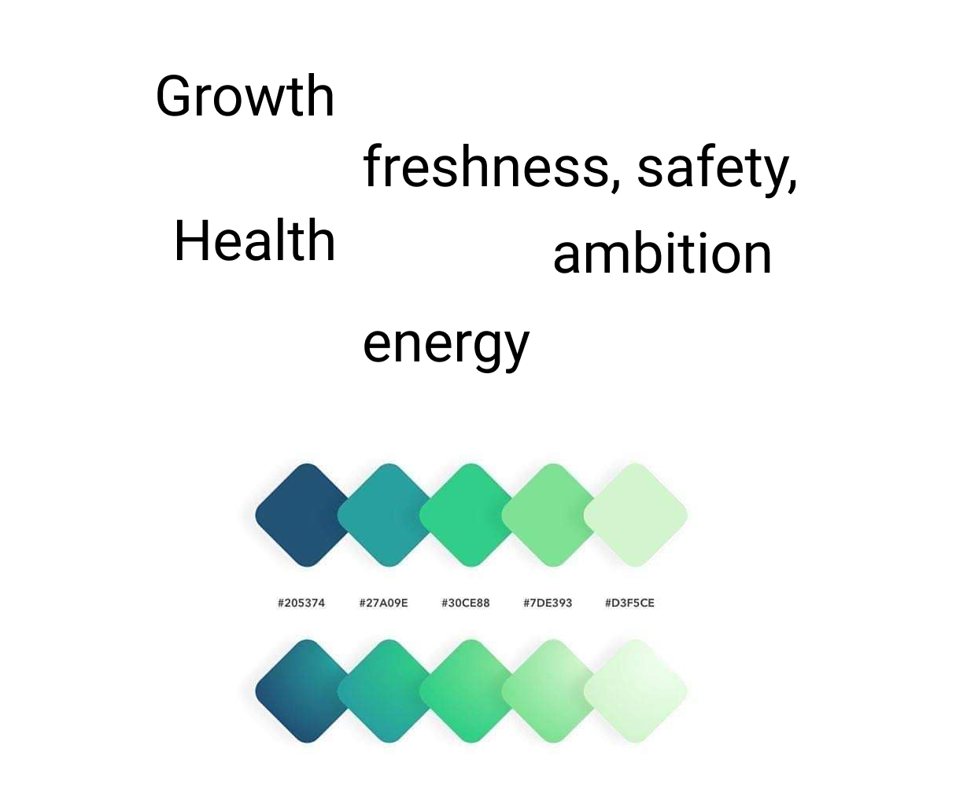

(Figure 1)

## 2.4 Icon metaphor

### Logo design:

Our logo I created represents the activity of SPA by its forms. It represents the cycle that is going on in SPA. Targeting freshly graduated people, leading them to the next level, the next phase of their life with finding an appropriate company to them. On the other hand, finding a graduate for a company as a candidate.

The green colour in the logo represents the growth for both sides that we ensure to them with our activity. The two arrows that become yellow at the end represent the energy and willingness of both ends form the graduates and the companies.

### Icons on the site:

Icons need to meet the expectations in terms of clarity, simplification and context. Our site does not use any icons. We did not take the responsibility to make mistakes with icons.

## 

## 

## 2.5 Hierarchical task analysis

Unfortunately, in assignment 1 we did not create a proper Hierarchical Task Analysis. With assignment 2 I created a hierarchical task analysis for jobseeker with a goal to apply for a job, and a hierarchical task analysis for employer with a goal to post a job.

(Figure 1 & Figure 2)

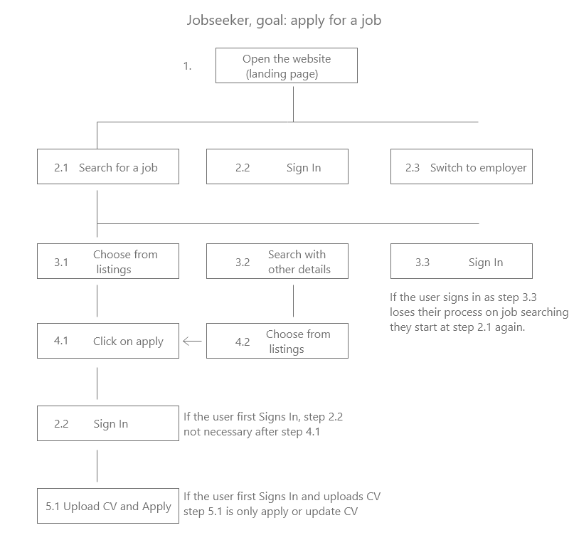

(Figure 1)

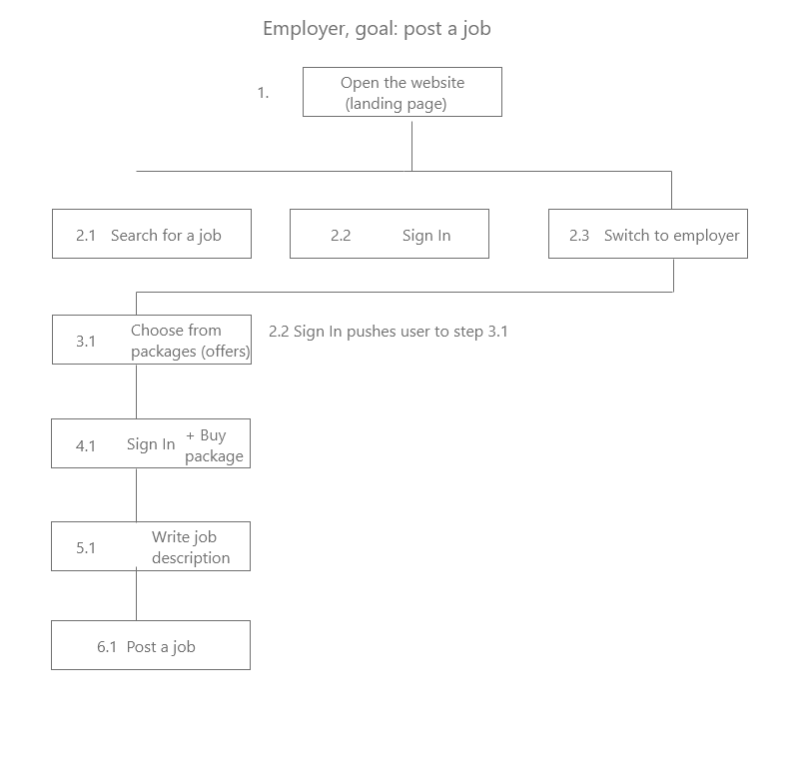

(Figure 2)

## 

## 2.6 Storyboarding

Storyboarding can be seen on figure1. In storyboarding I figured out what functionalities and buttons need to be on the site as minimum requirements. However, during prototyping I added more functionalities to the website in design to match the User Center Design as the minimum requirements leads us to a Task Center Design. (Figure3)

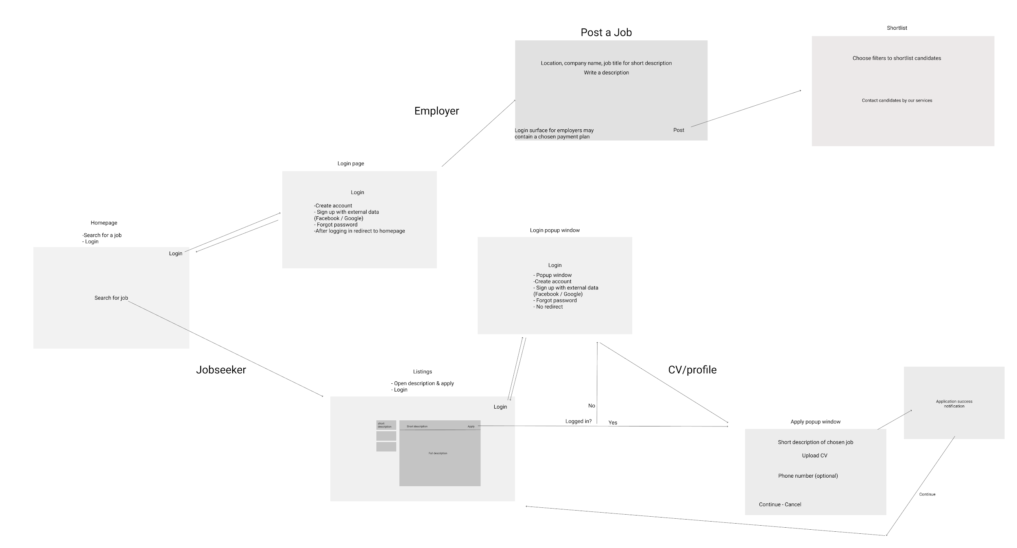

(Figure3 also can be found in our prototype for a more visible version)

## 

# 3 Artefact (From Assessment 1, Part1)

## 3.1 Need Analysis

In need analysis we separated UCD and TCD and followed tendencies, practices that continuously appear. As the findings of need analysis, our result showed us that UCD is a more common design. UCD websites offer much more content and sub-pages such as courses, social media and career advice. In our case study Indeed, the only TCD website offers career advice as well, but the principle of visibility in its design is used in a negative way. UCD websites attract people to spend more time on their website. I would say these successful websites tend to copy each other as they have too many design elements and design principles in common.

## 

## 3.2 User Analysis (Personas)

Alan Cooper introduced personas in his book “The Inmates are Running the Asylum (1999)”. I have created my persona in a way that the given information can be replaced in a timeline that the users need to do step by step to achieve their goals during interaction on a jobseeker site. (Figure 4 & 7 Done by me, Figure 5 by Gencho Apostolov, Figure 6 by Noemi Domjan)

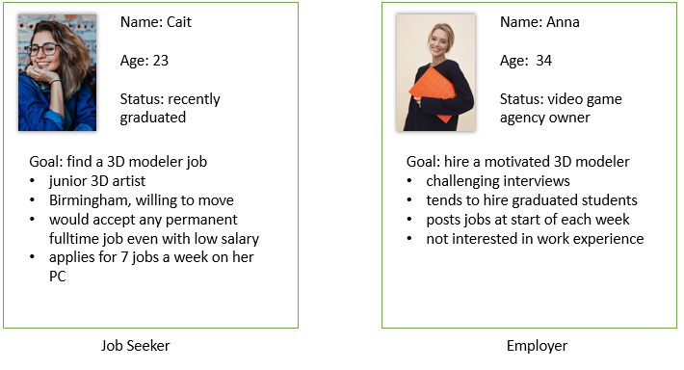

(Figure 4 left & Figure 5 right)

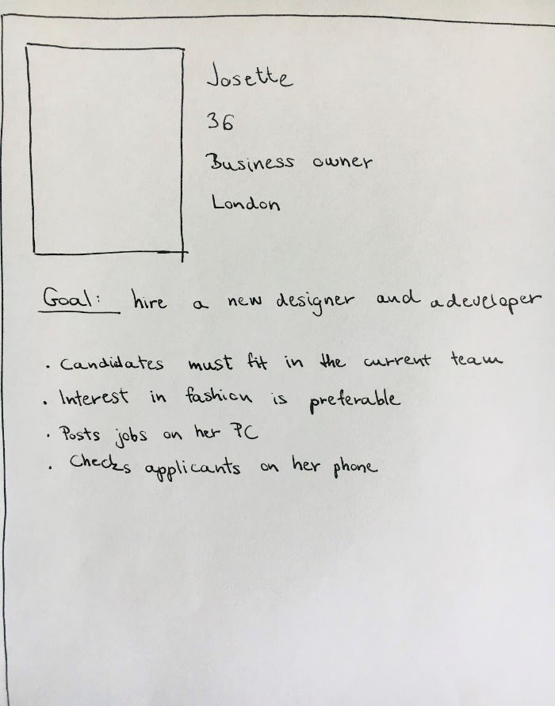

(Figure 6)

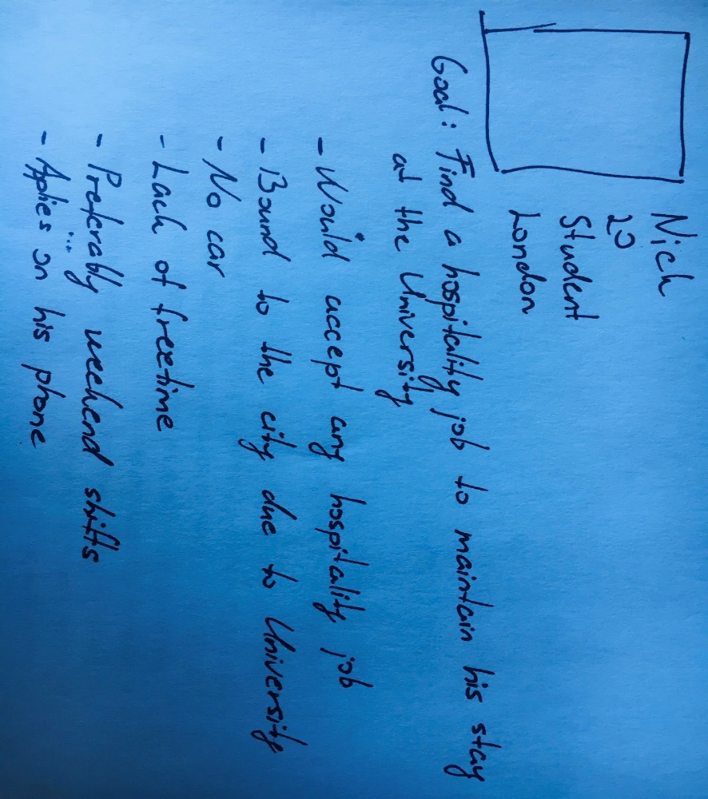

( Figure 7 )

## 3.3 Task Analysis

For jobseekers we set up a goal to finally apply for a job on a jobseeker website. Based on previous research from assignment 1 we defined the minimum that the user has to be done to apply for a job. (see below on Figure 3)

For employers we set up a goal to contact candidates after posting a job on a jobseeker website. From the same research from assignment 1 we defined the minimum that the employer has to be done until they can contact candidates. (see below Figure 4)

# 

(Figure 8 left & Figure 9 right)

# 

# 4 List of work

## 4.1 Work that I contributed to the group

* Logo design
* Jobseeker side of prototyping with landing page
* Wireframing for jobseeker side (appendices: wireframing and layout)
* Storyboarding (Figure 3)
* User journey ( We started it together, however I ended up overwrite the whole journey where Noemi Domjan joined and helped with employer side )
* 2 personas (Figure 4 and 7)
* Needs analysis (together)
* Task analysis (together)

## 

## 4.2 Work that others have done

* Employer side prototyping
* Wireframing for employer side (Noemi Domjan)
* Needs analysis (together)
* Task analysis (together)

# 

# 5 Appendices

## 

## Link to our prototype:

Figma:

https://www.figma.com/file/64zzWTVXBo0fblneXBZvA9/UX-design?node-id=204075%3A448

## 

## Wireframing and layout:

Home page:

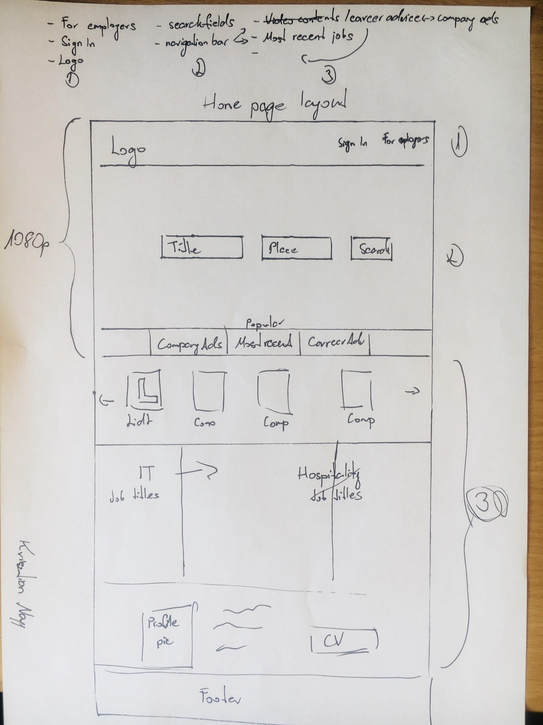

Listings:

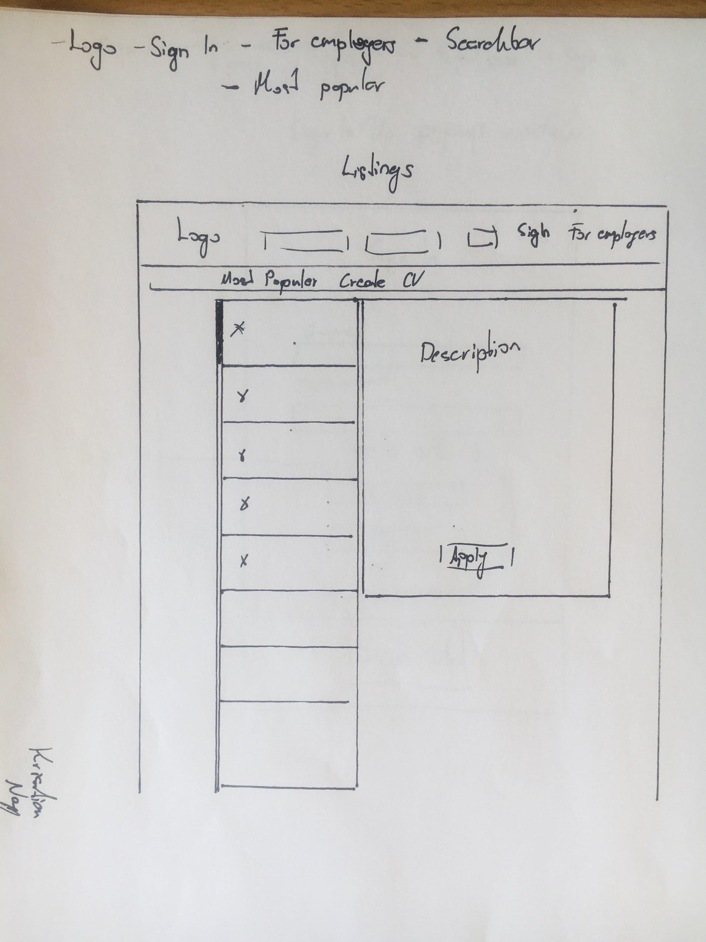

Sign In:

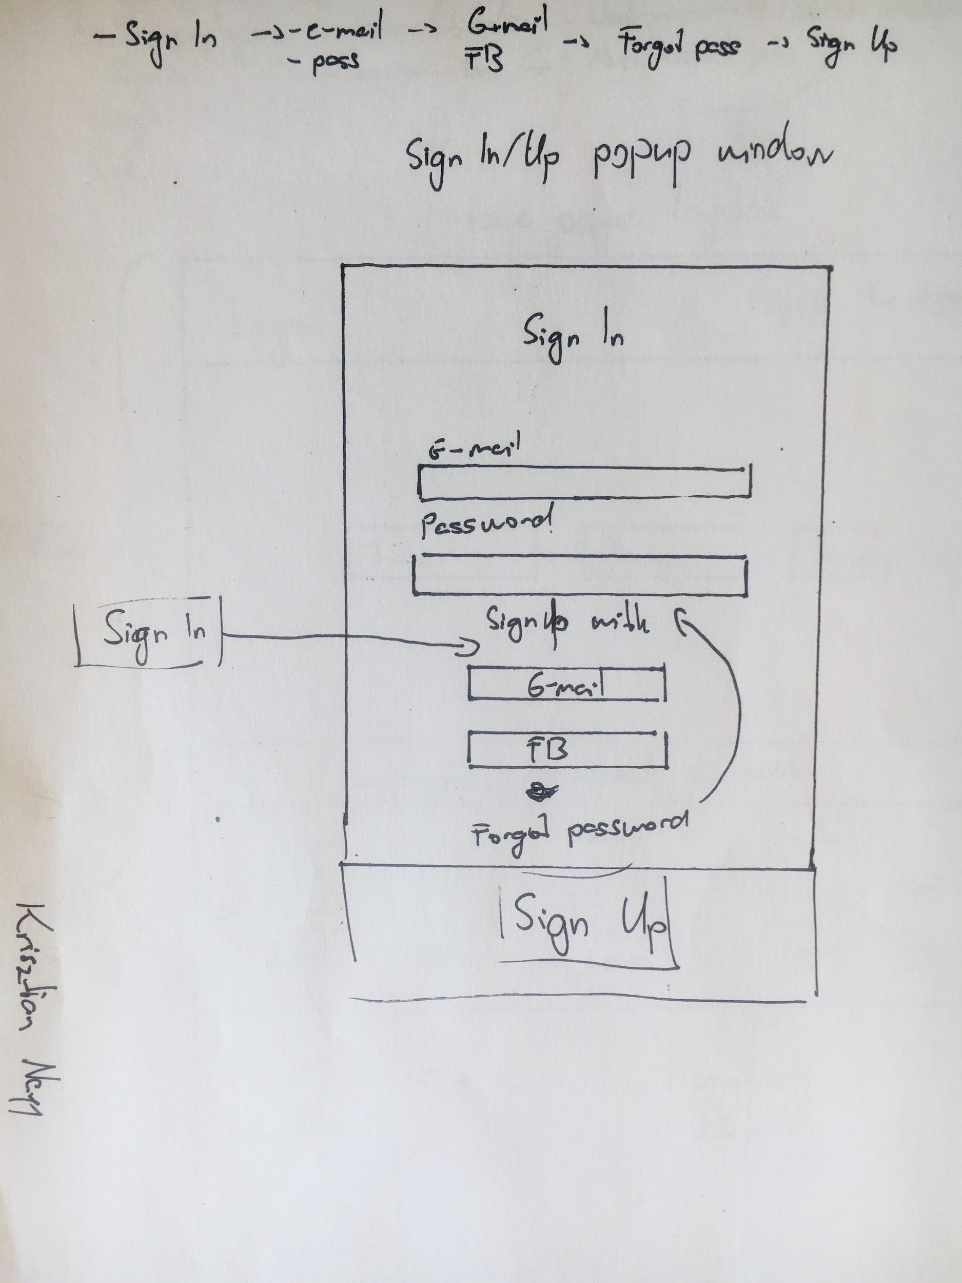

Apply:

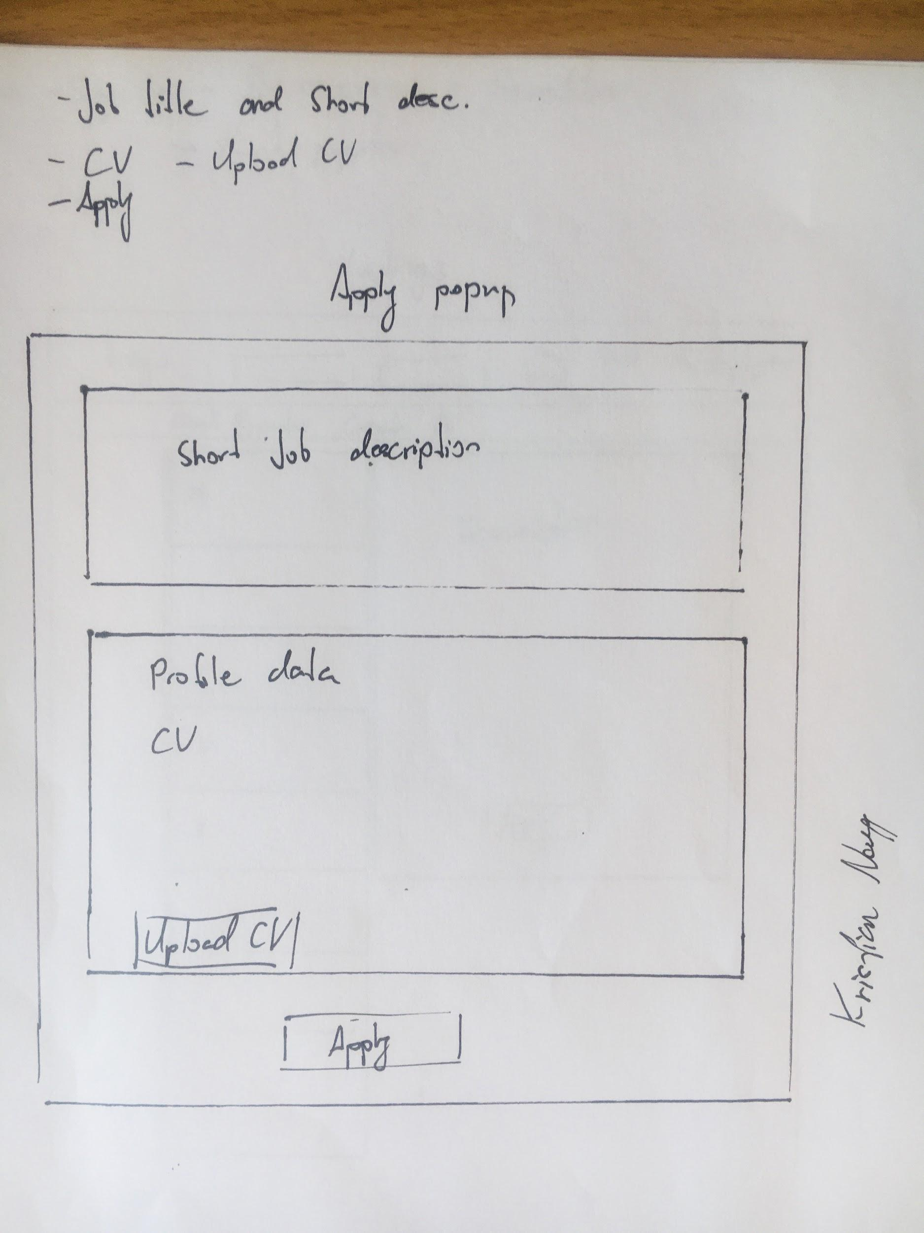

## 

## User journey:

Jobseeker

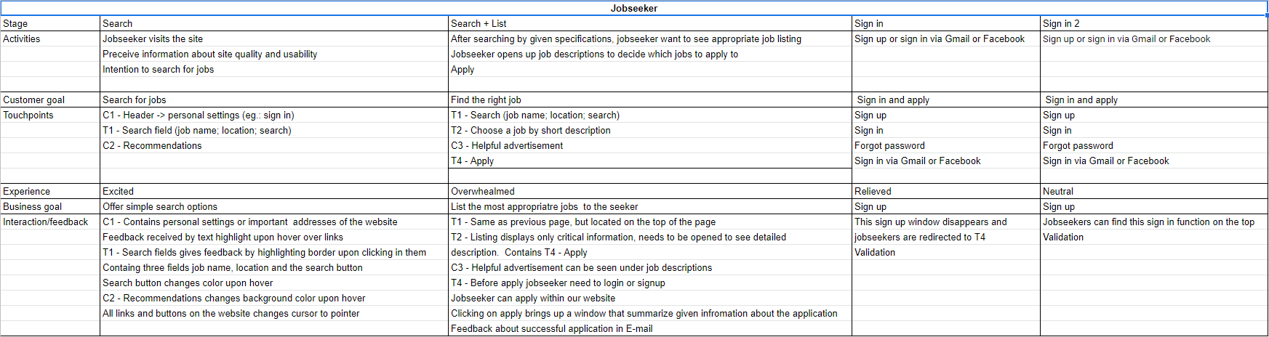

Employer

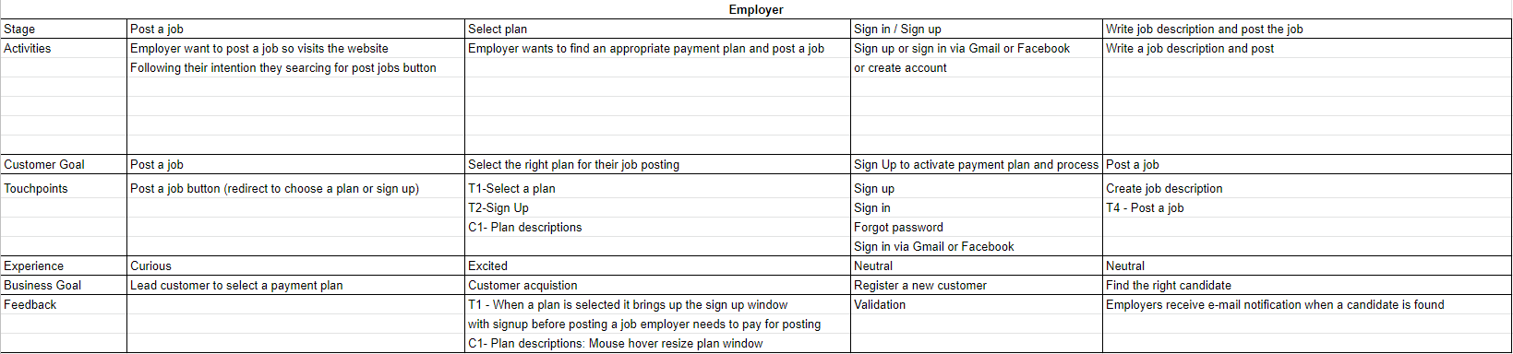

## Team meetings:

Team meeting1:

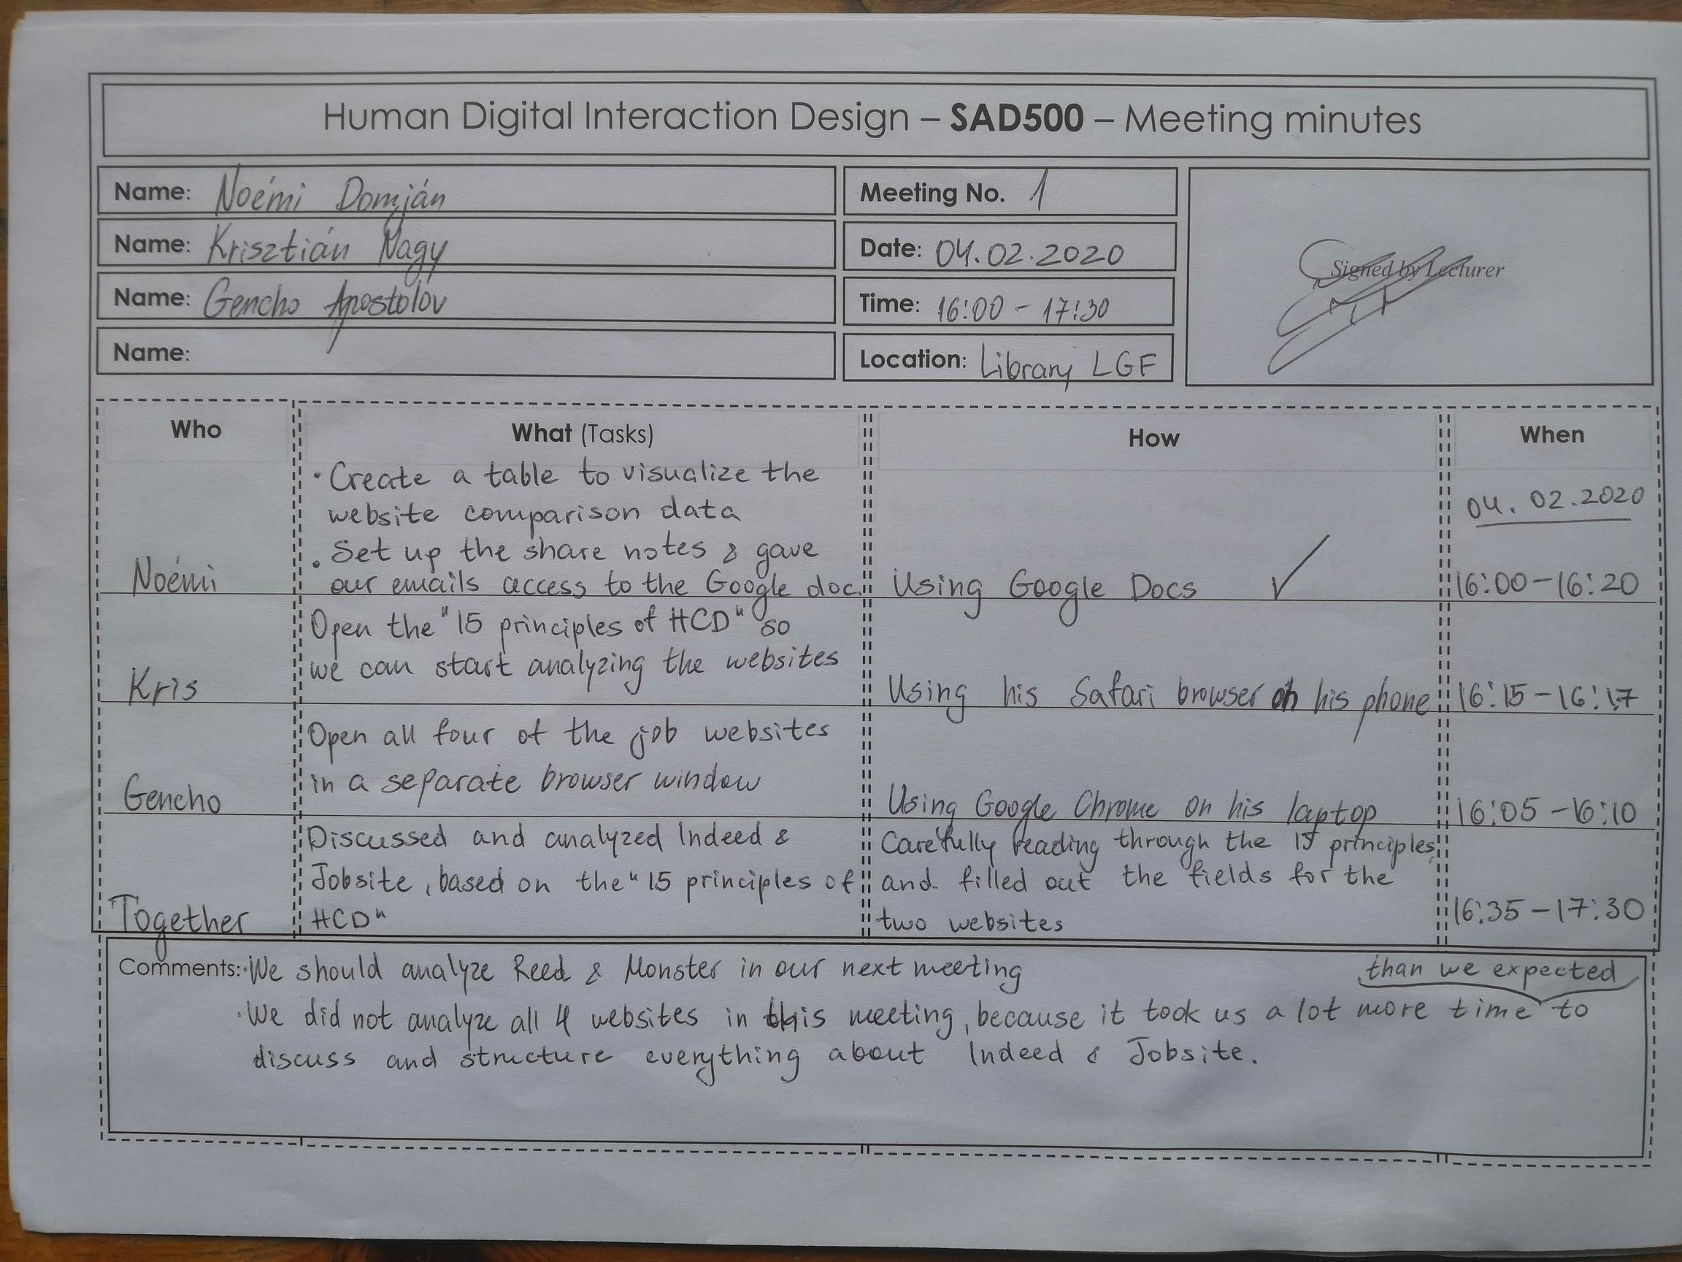

Team meeting 2:

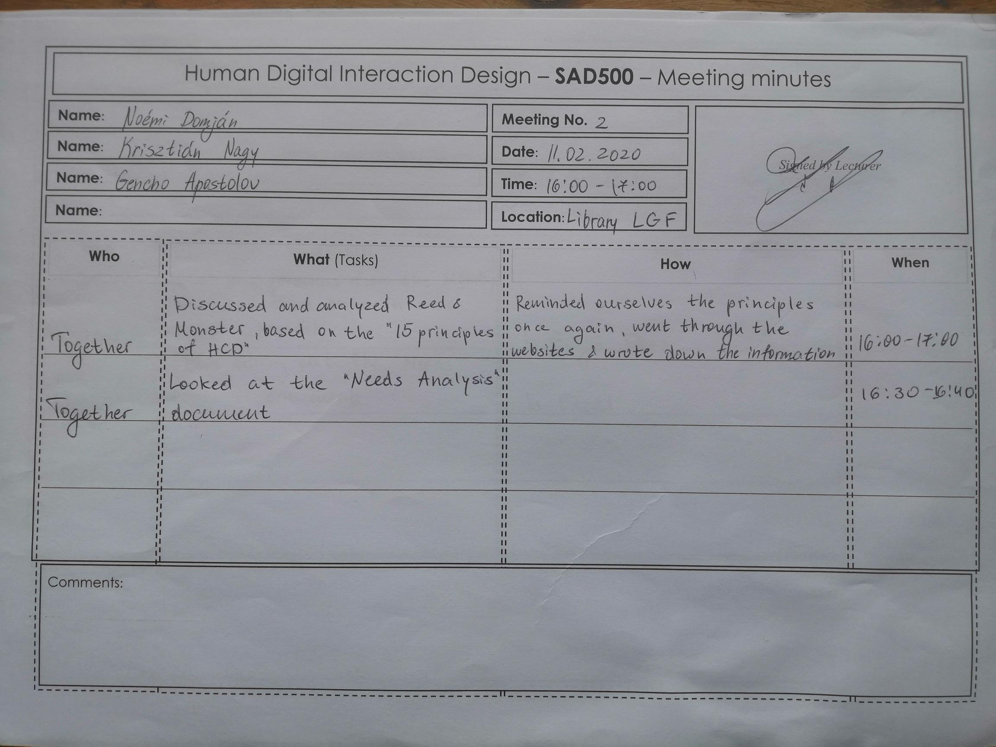

Team meeting 3:

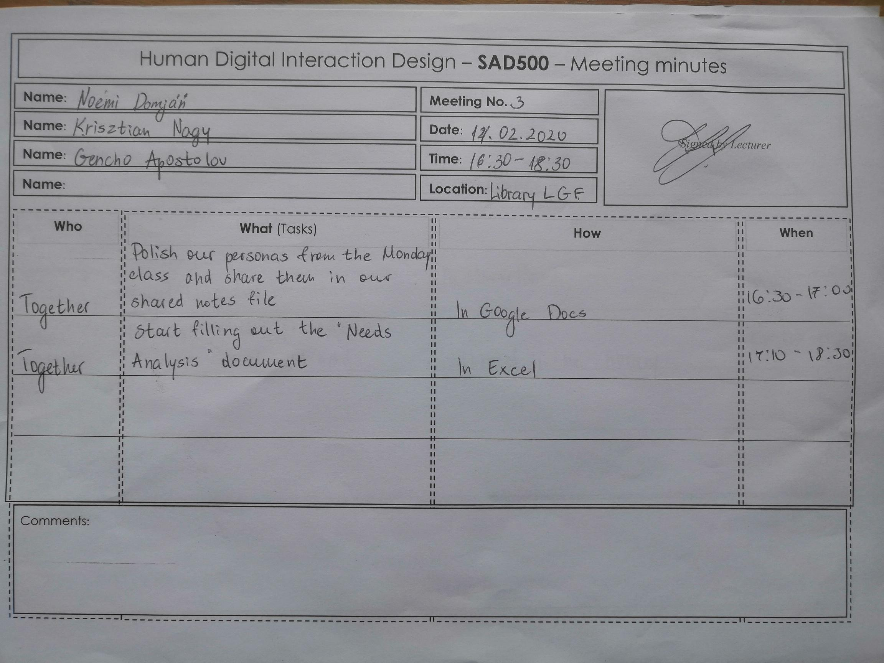

Team meeting 4:

