A.R.I.A: Advancing Litter Gathering and Parents’ Perception in Using Innovative Support

Abanto, Chrysler Clarence A.
Abilano, Miuel Jeline.
Ante, John Noriel B.
Dela Cruz, John Lloyd A.
De Leon, Daniela Jane D.
Del Rosario, Jhonemari Gerald M.
Pranada, Edge Phillipe P.
Temporal, Lorenzo L.

FEUR MARIKINA
SECONDARY BASIC EDUCATION
GRADE 12

2025
ABSTRACT
This study aimed to develop and evaluate A.R.I.A. (Advanced Retrieval Item Assistant), a semi-automated robot prototype designed to assist in household litter collection. Specifically, the study assessed the robot’s performance in terms of claw functionality, sensor efficiency, and basket capacity; its perceived usefulness in reducing time, improving tidiness, and supporting household responsibilities; and its applicability in real-life household settings. Furthermore, the study determined the significant relationship between the robot’s features and its perceived usefulness. A correlational research design was employed, utilizing a structured survey questionnaire administered to parents or legal guardians of selected Grade 11 and Grade 12 students from FEU Roosevelt Marikina. Due to restrictions on in-home testing, data were collected through a live demonstration of A.R.I.A. conducted during a Parent–Teacher Conference. Statistical tools such as mean, standard deviation, and linear regression analysis were used to analyze the data. The results revealed that A.R.I.A. was rated “Strongly Agree” across all performance indicators, with an overall mean of 3.44, indicating that the robot effectively performed its intended functions during the demonstration. In terms of usefulness, the robot obtained an overall mean of 3.43, suggesting that respondents perceived it as helpful in reducing cleaning time, improving tidiness, and assisting with household responsibilities. Additionally, the applicability of A.R.I.A. was rated highly, with an overall mean of 3.50, indicating that respondents found the robot practical, user-friendly, and suitable for household use.

Moreover, linear regression analysis showed a strong positive relationship between the robot’s features and its perceived usefulness (R = 0.764, R² = 0.583). Both performance and applicability were found to significantly predict usefulness, leading to the rejection of the null hypothesis.
In conclusion, the findings suggest that A.R.I.A. is a functional, useful, and applicable assistive robot for household litter collection. The study highlights the potential of semi-automated robotic systems in reducing household workload and improving efficiency in routine cleaning tasks.

TABLE OF CONTENTS
PAGE
LIST OF FIGURES . . . . . . . . . . . . . . . . . . . . . . . . . . . . . . . . . . . . . . . . . .

CHAPTER 1- THE PROBLEM AND ITS BACKGROUND . . . . . .... 1

Introduction . . . . . . . . . . . . . . . . . . . . .... . . . . . . . . . . . . . . . . . .... 1
Statement of the Problem . . . . . . . . . . . . . . . . . . . . . . . . . . . . . . . . . 4
Hypothesis . . . . . . . . . . . . . . . . . . . . . . . . . . . . . . . . . . . . . . . . . .... 5
Conceptual Framework . . . . . . . . . . . . . . . . . . . . . . . . . . . . . . . . .. 6
Theoretical Framework . . . . . . . . . . . . . . . . . . . . . . . . . . . . . . . . .. 7
Scope and Delimitation of the Study . . . . . . . . . . . . . . . . . . . . . . . . 8
Significance of the Study . . . . . . . . . . . . . . . . . . . . . . . . . . . . . . . . . 10
Definition of Terms . . . . . . . . . . . . . . . . . . . . . . . . . . . . . . . . . . . .. 12

CHAPTER 2- REVIEW OF RELATED LITERATURE AND 14
STUDIES . . . . . . . . . . . . . . . . . . . . . . . . . . . . . . . . . . . . . . . . . . . . .... . . . . 14

CHAPTER 3 - METHODS & PROCEDURE . . . . . . . . . . . . . . . . . . . . .. 23
Sampling Method . . . . . . . . . . . . . . . . . . . . . . . . . . . . . . . . . . . . . . . . 23
Locale . . . . . . . . . . . . . . . . . . . . . . . . . . . . . . . . . . . . . . . . 24
Research Design . . . . . . . . . . . . . . . . . . . . . . . . . . . . . . . . . . . . . . . . . 25
Respondents of the Study. . . . . . . . . . . . . . . . . . . . . . . . . . . . . . . . . . . 26
Instruments Used . . . . . . . . . . . . . . . . . . . . . . . . . . . . . . . . . . . . . . . . . 27
Ethical Consideration . . . . . . . . . . . . . . . . . . . . . . . . . . . . . . . . . . . . . . . 28
Data Gathering Technique. . . . . . . . . . . . . . . . . . . . . . . . . . . . . . . . . . 31
Statistical Treatment of Data . . . . . . . . . . . . . . . . . . . . . . . . . . . . . . . . 32

CHAPTER 4 - PRESENTATION, ANALYSIS AND. . . . . . . . . . . . . . . . . . . 34
INTERPRETATION OF DATA. . . . . . . . . . . . . . . . . . . . . . . . . . . . . . . . . . 34
CHAPTER 5 - SUMMARY OF FINDINGS, CONCLUSIONS AND
RECOMMENDATIONS . . . . . . . . . . . . . . . . . . . . . . . . . . . . . . . . 51

Summary of Findings . . . . . . . . . . . . . . . . . . . . . . . . . . . . . . . . . . . . . . 52
Conclusions . . . . . . . . . . . . . . . . . . . . . . . . . . . . . . . . . . . . . . . . . . . . 56
Recommendations . . . . . . . . . . . . . . . . . . . . . . . . . . . . . . . . . . . . . . . . . 57

APPENDICES
Appendix A- Research Questionnaires. . . . . . . . . . . . . . . . . . . . . . . . . . . . . . . . . . . 60
Appendix B- Populated results. . . . . . . . . . . . . . . . . . . . . . . . . . . . . . . . . . . . . . . . . . . 62
Appendix C- Linear Regression Analysis. . . . . . . . . . . . . . . . . . . . . . . . . . . . . . . . . . . . 63
Appendix D- Documentation of A.R.I.A. . . . . . . . . . . . . . . . . . . . . . . . . . . . . . . . . . . . 64
Appendix E- Sketch of A.R.I.A . . . . . . . . . . . . . . . . . . . . . . . . . . . . . . . . . . . . . . . . . . . 65

LIST OF FIGURES AND TABLES

LIST OF FIGURES
Figure 1 – Input-Process-Output (IPO) Conceptual Framework ........ . . . . . . . . . . . ….. 6
Figure 2 – Image of FEU Roosevelt Marikina ................................................................ 24
Figure 3 – Linear Regression Analysis ........................................................................... 46
Figure 4 – Normality Test of Regression Residuals (Shapiro–Wilk) ............................. 51
Figure 5 – Q–Q Plot of Regression Residuals ................................................................ 52
LIST OF TABLES
Table 1 – Interpretation of Weighted Mean for Questionnaire Responses ..................... 33
Table 2 – Perceived Performance of A.R.I.A. Claw Functionality in Picking Up Objects ......................................................................................................................................... 35
Table 3 – Perceived Performance of A.R.I.A. Sensor Efficiency in Detecting Litter ........ …………………………………………………………………………………………...36
Table 4 – Perceived Performance of A.R.I.A. Basket Capacity and Reliability in Storing Collected Litter ............................................................................................................... 37
Table 5 – Overall Perceived Performance of A.R.I.A. in Litter Collection ................... 37
Table 6 – Perceived Usefulness of A.R.I.A. in Reducing Time Spent on Routine Litter Collection ....................................................................................................................... 38
Table 7 – Perceived Contribution of A.R.I.A. to Tidiness and Household Safety through litter collection........................................................................................................... 39
Table 8 – Perceived Support of A.R.I.A. in Balancing balancing litter collection in household and work responsibilities........ ..…………………………………………………………………………………………40
Table 9 – Overall Perceived Usefulness of A.R.I.A. ................................................... 41
Table 10 – Perceived Applicability of A.R.I.A. in Daily Household Litter Management ....................................................................................................................................... 42
Table 11 – Applicability of A.R.I.A. in Supporting household litter collecting Efficiency and Convenience..................................................................................................................... ………………………………………………………………………………………….43
Table 12 – Perceived Practicality and User-Friendliness of A.R.I.A. in Household Settings ........................................................................................................................ 44
Table 13 – Overall Perceived Applicability of A.R.I.A. in Household Settings ........ 45
Table 14 – Linear Regression Model Fit Measures for the Relationship Between A.R.I.A. Features and Technology Acceptance ......................................................................... 47
Table 15 – Regression Coefficients for Predictors of A.R.I.A. Technology Acceptance ....................................................................................................................................... 48
Table 16 – Collinearity Statistics of Predictor Variables ............................................. 49

ACKNOWLEDGMENT
The researchers would like to express their sincere gratitude to the individuals who have contributed to the successful completion of this study.

First and foremost, the researchers extend their deepest appreciation to their teachers: Ms. Alline Mae Satorre, for her guidance in thesis writing; Mr. Genewel Geneza, for his support in the 3i subject; Mr. Vincent Liwag, for his expertise and assistance in statistical analysis; Mr. Jerald Lolor Rosento, for his guidance in Practical Research 2; and Ms. Irah Mae Vitug, for her valuable help in reviewing and refining the grammar of this study. Their knowledge, patience, and continuous support greatly contributed to the development of this research.

The researchers would also like to thank the panelists for their insightful comments, constructive suggestions, and professional feedback, which helped improve the quality of this study.

Furthermore, the researchers express their heartfelt gratitude to their parents for their unwavering support, encouragement, and understanding throughout the entire research process.

Lastly, the researchers extend their appreciation to FEU Roosevelt Marikina for providing the environment and opportunity to conduct this study successfully.

Chapter 1
THE PROBLEM AND ITS BACKGROUND

This chapter presents an overview of the key elements discussed in the research. It encompasses the introduction, problem statement, hypothesis, conceptual framework, scope and delimitations, significance of the study, and definitions of important terms.

Introduction

Many parents today work long hours to provide for their families, which limits the time they can dedicate to maintaining household cleanliness. Due to busy schedules and physical fatigue, litter such as small paper waste, plastic wrappers, and scattered debris is often left unattended in the home. Accumulated litter can create cluttered living spaces, increase the risk of minor accidents, and contribute to an untidy household environment. While various household tools exist, there is a lack of accessible and practical technological solutions specifically designed to assist parents in collecting and managing small household litter efficiently. This gap highlights the need for an innovative support system that focuses on litter gathering while helping parents save time in their daily routines.
This study is aligned with Sustainable Development Goal 3 (Good Health and Well Being), as it maintains a cleaner and more organized home environment. By collecting lightweight litter and small toys, the robot reduces clutter that may cause accidents and supports a safer living space for children and parents. A clean and orderly household can contribute to better mental well-being and reduced stress for family members. In relation to Sustainable Development Goal 9 (Industry, Innovation, and Infrastructure), the robot reflects the role of innovation and technology in addressing simple household challenges. The idea of creating a robot that assists in cleaning indoor litter shows how innovative solutions can improve daily living and support better household waste management. These days, the cleanliness of the household stands significant in the aspect of promoting a safe and healthy organized living environment. Many parents today experience struggles in managing household chores due to both work and house responsibilities. As parents give time to heavier responsibilities, routine tasks such as collecting scattered litter or small debris around the house may often be overlooked. When litter piles up, it creates cluttered spaces that may contribute to inconvenience and minor accidents inside the household. Several studies have proven that robotic technologies in assisting individuals have potential. For instance, Corpuz and Orquiza (2018) innovated a waste collector robot that is demonstrated as a support with high motion accuracy and responsiveness. While Barve (2020) designed a cleaning robot that is capable of having both manual and automatic operations. These developments significantly highlight how robotics support household routine tasks. Despite these technological innovations, lots of household cleaning robots are primarily designed for sweeping floor or vacuuming and it may not effectively address the collection of small scattered litter or debris. Furthermore, some studies on work-family balance reveal that parents often struggle on managing both house and work responsibilities. These studies highlight that working parents often experience struggles and stress due to demands of maintaining a neat and organized household while corresponding with work responsibilities (Bedejim et al., 2019, Lyttelton et al., 2022). These current challenges highlight the need for supportive innovation that can reduce routine household burdens and allow parents to focus on heavier responsibility and family time. In response to these challenges, this study introduces A.R.I.A. (Advanced Retrieval Item Assistant), a semi-automated robot that is designed to assist individuals in collecting small household litters.

Statement of the Problem
Many parents today face challenges in balancing their responsibilities at work and at home. One of the most overlooked tasks is maintaining household tidiness, particularly in managing litter and scattered objects. Due to their busy schedules, parents often struggle to keep the home environment organized, which may lead to accidents, added stress, and less quality time with their children. This study seeks to answer the following questions:

- What is the perceived performance of A.R.I.A. in terms of:
a. Claw functionality in picking up objects
b. Sensor efficiency in detecting litter and guiding movement
c. Basket capacity and reliability in storing collected litter

2. What is the perceived usefulness of A.R.I.A. in terms of:
a. Perceived support in reducing time spent on routine litter collection
b. Perceived contribution to tidiness and household safety through litter collection
c. Perceived support in balancing litter collection in household and work responsibilities
3. What is the perceived applicability of A.R.I.A. in:
a. Daily household litter management tasks
b. Supporting household litter collecting efficiency and convenience
c. Perceived practicality and user-friendliness in real-life household settings
4. Is there a significant relation between the features and the usefulness of A.R.I.A.?

Hypothesis

Null Hypothesis:
There is no significant relationship between the features and the usefulness of A.R.I.A. in managing household litter.

Alternative Hypothesis:
There is a significant relationship between the features and the usefulness of A.R.I.A. in managing household litter
Conceptual Framework
The conceptual framework offers a visual representation that serves as a guide for researchers throughout their study.
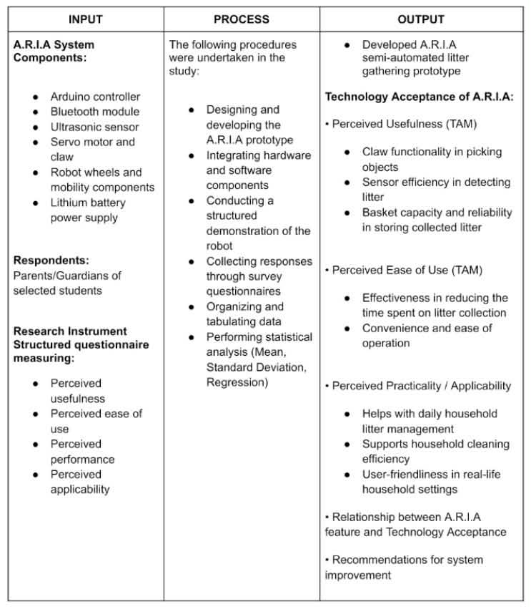

Figure 1. Input-Process-Output (IPO) Conceptual Framework of A.R.I.A
This conceptual framework follows the input-Process-Output (IPO) model. The input frame shows the objective of A.R.I.A, its materials, and the respondents that are qualified for the study. The process frame highlights the steps taken by the researchers. Finally, the output frame shows results of the study, such as the creation of a functional prototype, findings on its usefulness, and recommendations for future enhancement.

Theoretical Framework
Technology Acceptance Model
The theory supporting this study is the Technology Acceptance Model (TAM) proposed by Fred Davis in 1989. This theory explains how people accept and use new technologies. It focuses on two main components, which are perceived usefulness and perceived ease of use. Perceived usefulness means how much a person believes that technology can improve their work or make a task easier. Perceived ease of use means how simple and effortless it is to operate the technology.
In relation to this study, the Technology Acceptance model helps explain how people decide to use robot cleaning technologies (Davis, 1989). People are more likely to accept and depend on robot cleaners if they find them useful and helpful in saving time, reducing effort, and keeping their surroundings clean with little difficulty. This theory provides a clear understanding of how people’s beliefs, experiences, and attitudes accept automated cleaning devices.

Scope and Delimitation

This study focuses on the development and structured demonstration of A.R.I.A., a semi-automated robot prototype designed to assist in household litter gathering. The study evaluates A.R.I.A.’s performance in terms of claw functionality, mobility and movement control, detection capability, and basket capacity. It also determines parents’ perception of its usefulness and potential applicability in household settings.

Initially, the researchers intended to conduct in-home testing. However, during the pre-assessment stage, the majority of parents indicated that they did not permit household visitation. As a result, the data gathering procedure was revised. The actual demonstration and collection of data were conducted during the scheduled Parent–Teacher Conference (PTC) at FEU Roosevelt Marikina. A live, structured demonstration of the robot was performed within the school premises instead of individual household environments.

The respondents of the study were parents or legal guardians of selected Grade 11 and Grade 12 students from the following strands: Grade 11 EAIT (Engineering) GATES G, Grade 11 ASSH (Arts and Social Science) FREUD C, Grade 12 STEM C, and Grade 12 ICT B. The study is limited to short-duration, demonstration-based evaluation only and does not include long-term household implementation or actual in-home performance testing.

A.R.I.A. operates as a semi-automated system. While certain functions are programmed, the robot requires supervision and Bluetooth control for movement direction and positioning. The prototype is designed to collect small and lightweight litter such as plastic wrappers, paper waste, and similar debris, with an estimated carrying capacity of approximately 120 grams based on prototype testing and component limitations. Objects exceeding this weight, such as bottles, metal items, or bulky waste, are beyond the operational capability of the system.

Heavy waste materials and other household chores, including sweeping, laundry, dishwashing, and outdoor cleaning, are excluded from the scope of the study.

Significance of the Study
This research aims to provide support to parents who are busy with work or other tasks that can lead them to neglect and forget their household tasks especially when they have a child.
Parents
Parenting involves managing household and childcare responsibilities. This study aims to explore parents’ perceptions of how ARIA can assist them in maintaining a clean and organized home, even with their busy schedules.

Child
Children are likely to leave toys, food, or other items lying around. If not trained well, children may fail to develop the habit of cleaning up after themselves. This research aims at helping the child clean up while also learning from it.

Future Researchers
The study may be a great guide for future researchers by providing information, access to authentic sources, and a foundation for conducting similar research on household management and parenting.

Schools/Institutions
This study can benefit schools like FEU Roosevelt Marikina by offering insights into how technology-driven solutions like A.R.I.A. can be applied in practical research projects. It may also inspire other students to explore innovative approaches to real-life household and community challenges.

Community
The study highlights how parents’ perceptions of ARIA could influence broader acceptance of technology in households, potentially promoting cleaner and more organized living environments within the community.

Definition of Terms
A.R.I.A. (Advanced Retrieval Item Assistant)
A semi-automated robot developed in this study to assist parents in collecting small household litter. Unlike a fully automated system, A.R.I.A. requires user guidance and supervision during operation.

Efficiency
The degree to which A.R.I.A completes clutter collection tasks accurately and within a reasonable amount of time.

Functionality
The capability of the robot to perform its intended tasks, including movement, object detection, gripping, and carrying.

Innovative Support
The application of technological solutions, such as robotics, to assist with everyday household activities and improve convenience.

Jamovi
An open-source statistical software used for data analysis in research. It includes the calculation of the mean and standard deviation, to aid in the interpretation of collected data.

Litter
Refers to small, lightweight waste materials such as paper scraps, plastic wrappers, and similar debris scattered on the floor within household spaces. This term is used consistently throughout the study to describe the objects collected by A.R.I.A.

Semi-Automated Robot
A type of robot that performs certain tasks automatically while still requiring human input or control for some operations. In this study, A.R.I.A operates through programmed modes with limited user assistance.
CHAPTER II
REVIEW OF RELATED LITERATURE

In Chapter II, the researchers collected literature and studies from various web pages and previous research. The following contains reviews of related literature that gives evidence and definitions.

Robotics and Automation in Litter collection
Recent advancements in robotics have significantly contributed to the automation of litter collection and cleaning tasks, aiming to reduce human labor while improving environmental cleanliness. Robots equipped with intelligent control systems and sensors have proven to be effective in real-world applications. For instance, Corpuz and Orquiza (2018) developed a waste collecting robot that utilized fuzzy logic control to achieve 98.31% motion accuracy and a response time of only 0.63 seconds, demonstrating the benefits of adaptive algorithms in improving responsiveness within confined environments. Likewise,
Barve and colleagues (2020) designed a cost-effective floor-cleaning robot capable of operating manually via a mobile app or autonomously. Their prototype efficiently cleaned both dusty and wet surfaces while minimizing energy and water consumption, highlighting automation’s ability to reduce manual effort in everyday cleaning tasks. Automation has also been integrated into smart waste management systems. Ramos and Custodio (2021) introduced a collaborative application featuring sensor-equipped smart bins that monitored waste levels, predicted fill times, and optimized collection routes through machine learning. Their system was able to collect more than 80% of household plastic waste before bins were full, indicating that automation and route prediction can enhance waste collection efficiency. Similarly, Su et al. (2021) designed a litter collection robot equipped with a robotic arm, a vision system, and dual waste bins for recyclable and non-recyclable materials. Their robot successfully patrolled sidewalks, detected, classified, and sorted litter autonomously, showing the potential of robotics to support urban sanitation with minimal human intervention. Further technological developments have focused on sensor integration and artificial intelligence to improve environmental awareness and navigation.
Oye and Matthews (2021) reported that integrating multiple sensors such as ultrasonic, LiDAR, and camera modules improved obstacle detection accuracy by 94% and reduced collisions by 60%, compared to single-sensor systems. In another study, Almanzor and co-researchers (2022) developed Litterbot, a deep learning–based robot that used a Mask R-CNN model and soft robotic grippers to detect and collect litter with more than 80% accuracy. Páez-Ubieta et al. (2023) also demonstrated that combining visual and tactile sensors enhanced a robot’s ability to grasp various types of litter across uneven surfaces. Supporting this idea, Wang, Lin, and Liu (2023) reviewed bioinspired multimodal navigation methods and concluded that animal-like sensory systems improve adaptability in changing indoor and outdoor environments. Despite these technological advances, researchers have observed several challenges related to human–robot interaction and domestic adaptation. Coggins (2022) found that domestic robots such as Roomba simplify cleaning routines but also require users to perform new tasks such as maintenance and device integration.
Wellendorf, Søilen, and Veel (2022) noted that the presence of cleaning robots in households alters spatial organization and privacy perceptions, as people often view these machines as assistants or even companions. Similarly, Vaussard (2024) emphasized that while robotic cleaners perform effectively in controlled environments, they often struggle with real-world variability such as clutter and pets.
Hertzum (2024) added that users still perceive robot vacuums as less thorough than manual cleaning, though they appreciate the convenience and time saved. Recent studies continue to refine robot performance through improved sensor systems, intelligent control, and user-centered design. Megalingam and colleagues (2025) reviewed current innovations and noted that modern cleaning robots now combine LiDAR, cameras, proximity, and touch sensors with machine learning algorithms to navigate complex environments efficiently. However, persistent challenges such as power consumption and adaptability remain. In addition, Kim (2025) discovered that user acceptance of household robots depends largely on perceived usefulness and task relevance, underscoring the importance of tailoring robot functions to meet specific household needs.
Cagatin et al. (2021) from Our Lady of Fatima University developed the “Pristine: Automatic Floor Cleaning Robot,” which demonstrates the potential of robotics in maintaining cleanliness through automation. Although designed for indoor use, it still aligns with this theme as it showcases how robotic systems can contribute to the broader goal of litter management and environmental sustainability. Overall, literature on robotics and automation in litter collection shows a clear movement toward intelligent, sensor-driven, and user-adaptive systems capable of performing cleaning and waste management tasks autonomously. These studies collectively emphasize the transformative potential of robotics in maintaining cleanliness across domestic and public settings while acknowledging ongoing challenges in energy efficiency, adaptability, and human–robot interaction.

Work–Family Balance of Parents
Research consistently shows that parents, particularly mothers, experience challenges in balancing professional responsibilities and household duties. Bedejim, Labon, Loncio, and Batani (2019) examined working mothers at Benguet State University and found that many sacrifice rest and personal time to fulfill both career and family roles. Due to the high cost of childcare services, many rely on relatives for assistance. The study emphasized the need for institutional and family support systems to help parents manage dual responsibilities effectively.
Similarly, Abillar and Florida (2019) explored how full-time mothers navigate family and career roles under cultural and social expectations. Their findings revealed that mothers often prioritize family responsibilities over personal and intellectual growth, even when they desire professional advancement. This reflects the continuing influence of gender expectations in household role distribution.
Lyttelton, Zang, and Musick (2022) further investigated work–family dynamics under telecommuting arrangements. Their study found that although remote work increased flexibility, mothers continued to shoulder a disproportionate share of childcare and household tasks compared to fathers. While paternal involvement slightly increased, household labor remained largely gendered, reinforcing the unequal distribution of domestic responsibilities.
More recent studies expand the discussion by examining the psychological and developmental consequences of work–life imbalance. Wang, Zhang, Wu, and Zhao (2021) analyzed work–family conflict (WFC) and work–family enrichment (WFE) among dual-earner families. Their findings revealed that higher work–family conflict was associated with lower academic adjustment among adolescents, while work–family enrichment positively influenced children’s academic engagement. This suggests that parents’ ability to balance work and family roles has broader implications for family functioning and child development.
Hosokawa and Katsura (2021) examined the mediating role of maternal stress in the relationship between work–life balance and children’s social adjustment. Their study found that poor work–life balance increased maternal stress, which negatively affected parenting practices and children’s behavioral outcomes. The researchers emphasized that work–life imbalance not only impacts parents but also indirectly affects children’s emotional and academic readiness.
Additionally, Kowsalya and Mohanraj (2024) investigated the relationship between work–life balance and parental stress among working parents across various occupational backgrounds. Using a correlational design, they found that parents experiencing imbalance between career and household obligations reported moderate to high stress levels. Major stressors included work demands, childcare responsibilities, and financial pressures. The study highlighted that insufficient balance between work and family life significantly affects parental well-being and overall family dynamics.
Across these studies, a consistent theme emerges: parents face considerable strain in managing both professional and domestic responsibilities. The unequal distribution of household tasks, occupational pressures, and caregiving duties contribute to parental stress and reduced well-being. These findings underscore the importance of supportive mechanisms and practical solutions that may help ease routine household burdens and promote healthier family functioning.

Waste management Awareness and Environmental Practices
Waste management is important nowadays as our world delves deeper into technological and consumer consumption. Being knowledgeable about waste can help reduce, avoid, and prevent environmental crises. For instance, the study of Sambat et al. (2024) shows how parents are knowledgeable about waste, as well as their awareness and practices when they encounter it. Recent studies by the International Journal of Scientific Research Archives (2024),
Jeremias and Fellizar (2021), and Trushna et al. (2024) emphasized the importance of KAP, or Knowledge, Attitude, and Practices, towards waste. It is suggested that the more people practice KAP, the more they reduce waste and promote waste segregation, leading to a more environmentally friendly community. Additionally, parents play a big role in helping their children practice waste management. Children are easy to teach as they learn by imitating the behavior of their parents. A study by
Matsekoleng (2020) supports this claim, showing how children can learn waste management through their parents. Using PEAR activities, children can participate and learn how to properly dispose of waste, become more responsible, and take part in cleaning litter in their households. With the recent increase in waste, a new technological solution is being sought. Artificial intelligence (AI) is now being used to help manage waste and provide effective collection routes for garbage truck operators. The study of Fang et al. (2023) proves that implementing AI technologies can significantly help in managing waste in cities. Modern technologies and innovations also play a big role in waste management, contributing to a progressive and faster way of handling waste. The study of Czekała et al. (2023) supports this idea, showing that modern innovations improve the efficiency of waste management, reducing the time and effort required from people and leading to a cleaner and greener environment.

Synthesis
Research in robotics and automation demonstrates significant progress in developing intelligent systems capable of performing litter collection and cleaning tasks autonomously. Studies show that sensor integration, adaptive control systems, and machine learning algorithms enhance the efficiency and responsiveness of robotic cleaning devices (Corpuz & Orquiza, 2018; Barve et al., 2020; Su et al., 2021). However, user perception and adaptability remain critical factors influencing the effectiveness of these systems in domestic environments (Coggins, 2022; Hertzum, 2024; Kim, 2025).
Simultaneously, literature on work–family balance highlights the pressures experienced by working parents in managing career demands and household responsibilities. Studies consistently reveal that parents, particularly mothers, face unequal domestic workloads and increased stress levels (Bedejim et al., 2019; Lyttelton et al., 2022). Furthermore, work–life imbalance has been linked to parental stress and negative implications for children’s academic and social adjustment (Wang et al., 2021; Hosokawa & Katsura, 2021; Kowsalya & Mohanraj, 2024). These findings suggest that reducing routine household burdens may contribute to improved parental well-being and family functioning.
Additionally, research on waste management awareness emphasizes the importance of parental influence in promoting environmental practices within households (Sambat et al., 2024; Jeremias & Fellizar, 2021). Technological innovations continue to support more efficient waste management systems (Fang et al., 2023; Czekała et al., 2023), reinforcing the potential role of assistive technologies in maintaining cleaner environments.
Collectively, these studies provide a foundation for evaluating A.R.I.A. as a litter-gathering assistance prototype. While prior research demonstrates technological feasibility and identifies parental workload challenges, there remains a need to assess user perception and perceived effectiveness of such systems within specific community settings. The present study addresses this gap by examining the features of A.R.I.A. and parents’ evaluation of its effectiveness during structured demonstration.

CHAPTER III
METHODOLOGY

This chapter contains the research methodology employed, the sources of data, instruments used, including the data gathering procedure and statistical treatment used in the study.

Sampling Method
The researchers employed purposive sampling to select respondents who were relevant to the objectives of the study. Grade 11 and Grade 12 students from FEU Roosevelt Marikina served as the initial point of contact. Parents were selected based on the following criteria Must be a parent or legal guardian of a Grade 11 or Grade 12 student enrolled at FEU Roosevelt Marikina, Must be present during the scheduled Parent–Teacher Conference (PTC), Must be willing to observe the structured demonstration of A.R.I.A. and complete the evaluation questionnaire. This sampling method ensured that the respondents were appropriate evaluators of the robot’s functionality and were capable of providing informed perceptions regarding its usefulness and potential applicability in household settings.

Locale
The research was carried out at FEU Roosevelt Marikina Situated along J.P. Rizal Street in Barangay Lamuan, FEU Roosevelt Marikina served as the central venue for organizing the study, preparing and validating the research instruments, and conducting the initial development and testing of the A.R.l.A. robot.



Figure 2. Image of Feu Roosevelt Marikina: Source Google maps

Research Design

The usefulness of the project A.R.I.A: Advancing Litter Gathering and Parents’ Perception in Using Innovative Support was used to assessed using a Correlational research design. The design was used to determine and analyze the relationship between the features of A.R.I.A and overall usefulness in household litter management among parents. The study examined how A.R.I.A’s functionality, ability, efficiency and task performance inside the household and on how it’s related among parents who’s juggling their time from household chores to their daily responsibilities. In connection of the Statement of the Problem 4, the researchers managed to gather respondents from a selected participants whether if its significant relationship exists between the features of the system and its usefulness support among parents.

Respondents of the Study

The respondents of this study were fifty (50) parents or legal guardians of selected Grade 11 and Grade 12 students from FEU Roosevelt Marikina. These parents were chosen as the primary respondents because the study aimed to evaluate the functionality of A.R.I.A. and determine parents’ perception of its usefulness and potential applicability as a semi-automated litter-gathering robot. The respondents were drawn from the following strands, Grade 11 EAIT (Engineering) GATES G, Grade 11 ASSH (Arts and Social Science) FREUD C, Grade 12 STEM C, Grade 12 ICT B. Fifty (50) parents were included in the final data collection for the actual study. The selection of parents was based on their availability during the scheduled Parent–Teacher Conference (PTC) and their willingness to observe the structured demonstration and complete the survey questionnaire.

Instrument Used
The primary instrument used in this study was a structured evaluation questionnaire. The questionnaire was designed to measure the performance, perceived usefulness, and applicability of A.R.I.A. based on the Statement of the Problem (SOP 1–4). It utilized a 4-point Likert scale to quantify parents’ responses regarding the robot’s functionality, efficiency, and practical usability. We also consulted Ian Thedorore Jesalva, a Computer Engineering graduate from Technological University of the Philippines to support us in making our product. All final data used for analysis were obtained from the accomplished questionnaires collected immediately after the live demonstration during the Parent–Teacher Conference (PTC).

Ethical Consideration
To ensure the protection of the rights, dignity, and welfare of all participants. The research was conducted with honesty, transparency, and respect, ensuring that no harm, discrimination, or undue pressure was imposed on any respondent. Ethical compliance was observed to maintain the validity, credibility, and integrity of the study.

Conflict of Interest
The researchers declare that there are no financial, personal, or institutional conflicts of interest that could influence the conduct or results of the study. All materials, instruments, and references used were selected solely for academic purposes and have no direct affiliation with the researchers.

Vulnerability
No vulnerable populations were involved in this study. The respondents consisted solely of parents, specifically working parents, who voluntarily agreed to participate. All participants were legally capable of providing informed consent and were fully informed about the purpose and procedures of the study prior to participation.

Risks
The study involved minimal risk. Respondents were asked to answer questions related to household cleanliness, time management, and perceptions of semi-automated cleaning robot. Some questions may have caused mild inconvenience or discomfort; therefore, participants were informed that they may skip any question or withdraw from the study at any time without consequence. The researchers ensured that all responses were handled with strict confidentiality.

Benefits
The findings of the study may benefit parents by providing insights into how semi-automated cleaning technologies, such as A.R.I.A., can assist in managing household cleanliness and time efficiency. The results may also contribute to future innovations in household robotics and serve as a reference for researchers conducting similar studies related to technology-assisted home management.

Privacy and Confidentiality
All data collected were treated with the utmost confidentiality. Respondents were not required to provide identifying information, and all responses were anonymized. Data were used exclusively for academic purposes and were accessible only to the research team.

Informed Consent
All participants were provided with an Informed Consent Form prior to participation. The form clearly explained the purpose of the study, procedures involved, potential risks and benefits, and the rights of the respondents. Participation proceeded only after consent was voluntarily given.

Recruitment
Permission was obtained from the appropriate authorities prior to data collection. Parents were invited to participate through voluntary recruitment methods. Questionnaires were distributed either online or in printed form, depending on accessibility and convenience for the respondents.

Incentives and Compensation
No incentives, monetary compensation, or rewards were offered to participants. Participation was entirely voluntary and free from coercion.

Community Consideration
This study contributes to the wider community by exploring technological solutions that may support working parents in managing household responsibilities. Findings will be presented responsibly and in an accessible manner to promote awareness of the potential benefits of household automation technologies.

Data Gathering Procedure

Prior to the main data collection, the researchers conducted a pre-assessment through Google Forms to determine which parents would allow the researchers to conduct testing within their household. The purpose of this pre-assessment was to identify parents willing to accommodate in-home demonstration of A.R.I.A. However, the majority of parents indicated that they did not permit household visitation. Since the intended household setup could not be implemented, the researchers consulted their research adviser and agreed to modify the data gathering procedure. Instead of conducting in-home testing, the researchers carried out a structured live demonstration during the Parent–Teacher Conference (PTC) at FEU Roosevelt Marikina. During the demonstration, A.R.I.A. was presented in a designated classroom within the school premises. The robot operates as a semi-automated system, meaning it requires supervision and manual control through a Bluetooth controller. While some programmed features assist in movement and basic response functions, the direction, stopping, and positioning of the robot are guided by the operator. Parents observed the demonstration of the robot’s litter collection process, including its movement, claw mechanism, and basket functionality. After the demonstration, parents were given a structured questionnaire to evaluate, The perceived performance of A.R.I.A., Its perceived usefulness, potential applicability in household settings. All completed questionnaires were collected immediately and prepared for statistical analysis using Jamovi software.

Statistical Treatment of Data
The data gathered from the questionnaires and observational checklist were analyzed using descriptive and inferential statistical tools.
Sample Standard Deviation:
Standard deviation was used to measure the spread of the data around the mean. A smaller value indicates that the responses or measurements are closely clustered, while a larger value shows more variability. In this study, the sample standard deviation was computed since the data were collected from a selected sample.

$$s=\sqrt{\frac{\sum_{ }^{ }{{\left(X - \overline{x}\right)}^{2}}}{n-1}}$$
Weighted Mean
The weighted mean was used to analyze responses from Parts III and IV of the questionnaires, which utilized a 4-point Likert scale. It was also used to evaluate results from the observational checklist.
Formula:
$$\frac{\sum_{ }^{ }{fx}}{n}$$
Where f is frequency, x is the weight (1-4), and n is the total respondent.
Interpretation of Weighted Mean (Questionnaire)
Table 1: Interpretation Of Weighted Mean for Questionnaire Responses
Weighted Mean Range Verbal Interpretation
3.26 - 4.00 | Strongly Agree
2.51 - 3.25 | Agree
1.76 - 2.50 | Disagree
1.00 - 1.75 | Strongly Disagree

Linear Regression Analysis
Linear regression analysis was used to determine whether there is a significant relationship between the features of A.R.I.A. and its perceived usefulness in managing household litter.
In this study, the independent variables were, Perceived Performance of A.R.I.A. (SOP 1) and Perceived Applicability and Practicality of A.R.I.A. (SOP 3). The dependent variable was Perceived Usefulness of A.R.I.A. (SOP 2). Linear regression was performed using Jamovi statistical software, which generated the R value, R² value, regression coefficients, t-values, and p-values to determine the strength and significance of the relationship between the variables.

CHAPTER IV
PRESENTATION, ANALYSIS, AND INTERPRETATION OF DATA

This chapter presents the analysis and interpretation of data gathered to determine the performance, perceived usefulness, and applicability of A.R.I.A. The results are organized according to the Statement of the Problem (SOP 1–4). Mean, linear Regression, standard deviation was used to analyze the responses.

1. What is the perceived performance of A.R.I.A. in terms of:
- Claw functionality in picking up objects
- Sensor efficiency in detecting litter and guiding movement
- Basket capacity and reliability in storing collected litter

Table 2:
Perceived Performance of A.R.I.A. Claw Functionality in Picking Up Objects
Indicator | Mean | SD | Interpretation
Q1: I observed that A.R.I.A. Successfully picked up litter when guided. | 3.42 | 0.609 | Strongly Agree
Q2: I observed that the claw mechanism grasped litter properly | 3.34 | 0.557 | Strongly Agree
Category Mean | 3.38 | 0.593 | Strongly Agree

The category mean of 3.38 indicates that respondents positively perceived A.R.I.A.’s claw functionality during the demonstration. The mean scores for Q1 (M = 3.42, SD = 0.609) and Q2 (M = 3.34, SD = 0.557) suggest that participants observed that the robot was generally capable of successfully grasping and lifting litter when guided. The relatively low standard deviations suggest that participants had similar observations regarding the claw’s ability to securely pick up objects, reflecting consistent perception among respondents. This finding is supported by Corpuz and Orquiza (2018), who demonstrated that robotic systems with adaptive control mechanisms can effectively perform object-handling tasks with high accuracy.
Table 3:
Perceived Performance of A.R.I.A. Sensor Efficiency in Detecting Litter and Guiding Movement
Indicator | Mean | SD | Interpretation
Q3: I observed that A.R.I.A's sensors detects obstacles accurately | 3.48 | 0.544 | Strongly Agree
Q5: I observed that A.R.I.A. moved steadily guided operation | 3.52 | 0.505 | Strongly Agree
Category Mean | 3.50 | 0.525 | Strongly Agree

The category mean of 3.50 indicates that respondents perceived A.R.I.A.’s sensor system as responsive and reliable during guided operation. The mean scores for Q3 (M = 3.48, SD = 0.544) and Q5 (M = 3.52, SD = 0.505) suggest that participants observed accurate obstacle detection and steady movement throughout the demonstration. The scores nearing the upper range of the scale imply that respondents recognized the robot’s ability to navigate smoothly without abrupt or unstable motions. This reflects a positive perception of sensor coordination and movement control. The low and closely related standard deviation values indicate that participants shared similar observations regarding the robot’s navigation efficiency, reinforcing the consistency of perceived sensor performance.

Table 4:
Perceived Performance of A.R.I.A. Basket Capacity and Reliability in Storing Collected Litter
Indicator | Mean | SD | Interpretation
Q4: I observed that the basket securely held collected items. | 3.42 | 0.538 | Strongly Agree
Category Mean | 3.42 | 0.538 | Strongly Agree

The category mean of 3.42 indicates that respondents perceived the basket mechanism as sufficiently secure in holding collected litter. With a mean score above 3.00 and a low standard deviation (0.538), participants observed that the collected items remained stable within the container during operation. This suggests that, based on the demonstration, respondents viewed the storage component as reliable and functional for household litter management tasks.
Table 5:
A.R.I.A. Litter Collection Performance
Overall | Mean | SD
Overall | 3.44 | 0.55

The Table 5 overall mean of 3.44 indicates that respondents generally perceived A.R.I.A.’s operational performance positively. Based on the demonstration, participants observed that the robot was capable of performing its intended litter-picking functions, including grasping, detecting obstacles, moving steadily, and storing collected items securely.
The relatively low overall standard deviation (≈0.55) suggests that perceptions were consistent among respondents. Overall, the findings indicate that A.R.I.A.’s technical features were perceived as functional and dependable during guided household operation.

2. What is the perceived usefulness of A.R.I.A. in terms of:
  - Perceived support in reducing time spent on routine litter collection
  - Perceived contribution to tidiness and household safety through litter collection
  - Perceived support in balancing litter collection in household and work responsibilities
Table 6:
Perceived Usefulness of A.R.I.A. in Reducing Time Spent on Routine Litter Collection
INDICATOR | MEAN | SD | INTERPRETATION
Q2: I observed that A.R.I.A. reduced the time required for litter collection | 3.34 | 0.593 | Strongly Agree
Category Mean | 3.34 | 0.593 | Strongly Agree

The category mean of 3.34 indicates that respondents perceived A.R.I.A. as contributing to reduced cleaning time. Participants observed that the robot assisted in completing litter collection tasks more efficiently during the demonstration. The mean reflects a positive perception that the system helps streamline routine cleaning tasks A.R.I.A. contributes to minimizing the time spent on routine household litter collection tasks.

Table 7:
Perceived Contribution of A.R.I.A. to Tidiness and Household Safety through litter collection
INDICATOR | MEAN | SD | INTERPRETATION
Q3: I observed that A.R.I.A. contributed to improved tidiness | 3.54 | 0.542 | Strongly Agree
Q1: I observed that A.R.I.A. reduced the user's physical effort | 3.34 | 0.658 | Strongly Agree
Category Mean | 3.44 | 0.600 | Strongly Agree

The category mean of 3.44 indicates that respondents perceived improvements in tidiness and physical convenience during operation. Q3 (M = 3.54) suggests strong perception that the robot contributed to cleaner surroundings. Q1 (M = 3.34) reflects that participants observed reduced physical effort while using the robot.
These findings suggest that respondents viewed A.R.I.A. as supportive in maintaining cleanliness while minimizing physical strain.
Table 8:
Perceived Support of A.R.I.A. in Balancing balancing litter collection in household and work responsibilities
Responsibilities
INDICATOR | MEAN | SD | INTERPRETATION
Q4: I observed that A.R.I.A. supported the user during the collection process | 3.48 | 0.544 | Strongly Agree
Q5: I observed that A.R.I.A. functioned consistently during testing. | 3.46 | 0.542 | Strongly Agree
Category Mean | 3.47 | 0.543 | Strongly Agree

The category mean of 3.47 indicates that respondents strongly perceived A.R.I.A. as helpful in supporting parents during household responsibilities. Participants observed consistent operation and supportive functionality during the collection process. The low variation suggests uniform perception among respondents regarding the robot’s assistance.

Table 9:
Overall Perceived Usefulness of A.R.I.A.
Overall | Mean | SD
Overall | 3.43 | 0.58

The overall findings indicate that A.R.I.A. was positively perceived as effective in managing household litter tasks, improving cleanliness, and assisting with workload management.

3. What is the perceived applicability of A.R.I.A. in:
a. Daily Household Litter Management Tasks
b. Supporting household litter collecting efficiency and convenience
c. Perceived practicality and user-friendliness in real-life household settings

Table 10:
Applicability of A.R.I.A. in Daily Household Litter Management Tasks
Indicator | Mean | SD | Interpretation
Q1: I observed that A.R.I.A was easy to operate after instructions | 3.42 | 0.575 | Strongly Agree
Category Mean | 3.42 | 0.575 | Strongly Agree

The mean of 3.42 indicates that respondents observed that A.R.I.A. could be operated with minimal difficulty after receiving instructions. Participants perceived that the interface and controls were understandable and manageable during demonstration. This aligns with Kim (2025), which highlights that ease of use significantly affects user acceptance of robotic systems.

Table 11
Applicability of A.R.I.A. in Supporting household litter collecting Efficiency and Convenience
Indicator | Mean | SD | Interpretation
Q3: I observed that A.R.I.A. functioned properly on flat surfaces | 3.50 | 0.580 | Strongly Agree
Q4: I observed that A.R.I.A. performed its intended semi-automated functions | 3.56 | 0.501 | Strongly Agree
Category Mean | 3.53 | 0.541 | Strongly Agree

The category mean of 3.53 suggests that respondents observed consistent task execution under normal indoor surface conditions. The high rating for semi-automated function (3.56) indicates that participants particularly noticed the robot’s ability to perform programmed actions without constant manual correction.

Table 12:
Perceived Practicality and User-Friendliness of A.R.I.A. in Real-Life Household Settings
Indicator | Mean | SD | Interpretation
Q2: I observed that A.R.I.A. appeared safe for indoor household use. | 3.50 | 0.505 | Strongly Agree
Q5: I observed that A.R.I.A. demonstrated potential for real household applications | 3.52 | 0.505 | Strongly Agree
Category Mean | 3.51 | 0.505 | Strongly Agree

The category mean of 3.51 indicates that respondents strongly agreed that A.R.I.A. provides practical and user-friendly assistance in real-life home settings. Participants perceived the robot as safe for indoor use and observed its potential for actual household application.The identical standard deviations (0.505) indicate highly consistent responses among participants. This is consistent with Vaussard (2024), who stated that while robots are effective in controlled settings, their practicality depends on adaptability to real environments. A.R.I.A.’s positive perception suggests acceptable real-world applicability.
Table 13:
Overall Applicability of A.R.I.A. in Household Settings
Overall | Mean | SD
Overall | 3.50 | 0.53

The overall applicability of A.R.I.A. was rated Strongly Agree, with an overall mean of 3.50. This indicates that respondents strongly perceive the robot as applicable and useful in real-life household settings. All categories received high ratings, particularly in efficiency, safety, and practical usability. The relatively low standard deviation values reflect consistent positive perceptions among participants. This supports Fang et al. (2023), who emphasized that technological innovations improve efficiency and practicality in waste management systems. Overall, the findings demonstrate that A.R.I.A. is viewed not only as functional but also as practical, convenient, and suitable for real household environments.

4. Is there a significant relationship between the features and the usefulness of A.R.I.A.?

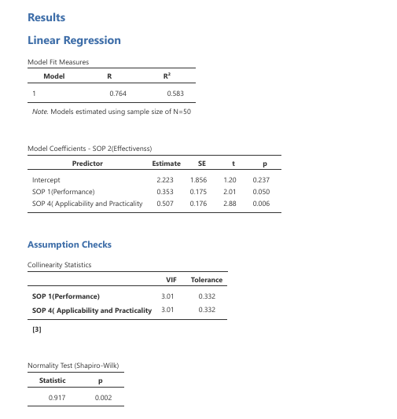

Figure 3: Linear Regression Analysis
Figure 3 illustrates the regression relationship between the features of A.R.I.A. and its perceived usefulness. The upward trend observed in the regression line indicates that improvements in the robot’s performance and applicability are associated with higher perceived usefulness in household litter management. This suggests that respondents who observed better functionality and usability of A.R.I.A. were more likely to perceive the robot as effective in assisting with household cleaning tasks.

Table 14:
Linear Regression Model Fit Measures for Relationship Between Features and Usefulness of A.R.I.A.
R (Correlation Coefficient) | R² (Coefficient of Determination)
0.764 | 0.583

The regression model produced an R value of 0.764, indicating a strong positive relationship between the independent variables (SOP 1: Performance and SOP 3: Applicability and Practicality) and the dependent variable (SOP 2: Perceived Usefulness of A.R.I.A.).
The R² value of 0.583 indicates that 58.3% of the variance in the perceived usefulness of A.R.I.A. can be explained by the combined influence of its performance features and applicability/practicality features.
This means that respondents’ perception of A.R.I.A.’s usefulness is largely influenced by how well the robot performs its operational functions (such as claw control, sensor detection, and basket reliability) and how practical or usable it appears in real household environments.
The remaining 41.7% of the variance may be explained by other external factors not included in the model, such as user familiarity with robotics, individual expectations, or environmental conditions during the demonstration.
An R² value of 0.583 indicates a moderately strong model fit, suggesting that the robot’s observed features play an important role in shaping respondents’ perceptions of its usefulness.

Table 15:
Regression Coefficients for Predictors of A.R.I.A.’s Perceived Usefulness
Predictor | Estimate | Standard Error (SE) | t-test | p-value(Significance Level)
Intercept | 2.223 | 1.856 | 1.20 | 0.237
SOP 1 (Performance) | 0.353 | 0.175 | 2.01 | 0.050
SOP3 (Applicability & Practicality) | 0.507 | 0.176 | 2.88 | 0.006

Table 15 shows the regression coefficients that determine how strongly each feature predicts the perceived usefulness of A.R.I.A. For SOP 1 (Performance), the predictor obtained an estimate of 0.353 with a p-value of 0.050, which meets the 0.05 level of significance. This indicates that the performance of A.R.I.A.—including its claw functionality, sensor efficiency, and basket reliability—significantly contributes to its perceived usefulness. In practical terms, when respondents observed that the robot was able to pick up litter properly, detect obstacles, and store collected items securely, they were more likely to perceive the robot as effective in assisting with household cleaning tasks.
For SOP 3 (Applicability and Practicality), the predictor obtained an estimate of 0.507 with a p-value of 0.006, indicating a highly significant relationship. This result shows that the usability and real-life practicality of the robot strongly influence how effective respondents perceive A.R.I.A. to be. Since the coefficient for applicability is higher than that of performance, the findings suggest that respondents placed greater importance on how practical and convenient the robot is for everyday household use rather than solely on its technical capabilities.
Overall, the results indicate that both performance and applicability significantly influence the perceived usefulness of A.R.I.A.
Table 16: Collinearity Statistics
Predictor | VIF (Variance Inflation Factor) | Tolerance
SOP 1 (Performance) | 3.01 | 0.332
SOP 3 (Applicability & Practicality) | 3.01 | 0.332
Table 16 presents the collinearity statistics used to determine whether multicollinearity exists between the predictors in the regression model. The Variance Inflation Factor (VIF) values for both predictors are 3.01, while the tolerance values are 0.332. Since the VIF values are below the threshold of 10 and the tolerance values are greater than 0.10, the results indicate that no multicollinearity problem exists between performance and applicability. This means that both variables independently contribute to predicting the perceived usefulness of A.R.I.A. without overlapping excessively in the regression model.

This means that the performance features of A.R.I.A. (claw functionality, sensor efficiency, and basket reliability) significantly predict its perceived usefulness. The positive estimate (0.353) indicates that as performance improves, perceived usefulness also increases. At a 0.05 level of significance, both performance (p = 0.050) and applicability (p = 0.006) significantly predict usefulness. Since all p-values are below 0.05, we reject the null hypothesis and the features of A.R.I.A. significantly influence its usefulness in managing household litter.

The positive coefficient of 0.507 indicates that higher levels of perceived practicality—such as ease of operation, safe indoor use, and the robot’s ability to function on typical household surfaces—are associated with higher ratings of A.R.I.A.’s usefulness. Furthermore, the coefficient for applicability (0.507) is larger than the coefficient for performance (0.353), suggesting that respondents placed greater importance on the robot’s real-world usability and practicality than on technical performance alone. This means that respondents tended to evaluate A.R.I.A. as more effective when they perceived it as easy to use, safe for indoor environments, and capable of functioning in real household conditions.

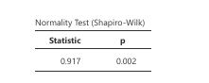

Figure 4: Normality Test of Regression Residuals (Shapiro–Wilk)
Figure 4 presents the results of the Shapiro–Wilk test, which was used to assess the normality of the regression residuals. The test produced a statistic value of 0.917 and a p-value of 0.002. Since the p-value is less than 0.05, the results indicate that the residuals slightly deviate from perfect normal distribution. However, in social science research with a sample size of 50 respondents, minor deviations from normality are considered acceptable, especially when supported by graphical inspection of residual plots.

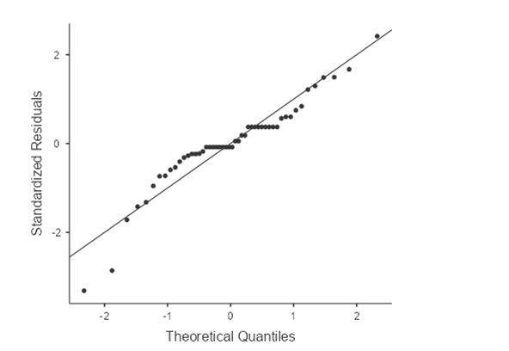

Figure 5: Q–Q Plot of Regression Residuals
Figure 5 shows the Q–Q plot used to visually assess the normality of the regression residuals. The plotted points generally follow the diagonal reference line, indicating that the residuals are reasonably distributed around the expected normal distribution. Although slight deviations appear at the tails of the plot, the overall pattern suggests that the regression model maintains an acceptable level of normality for analysis.

CHAPTER V
SUMMARY OF FINDINGS, CONCLUSIONS AND RECOMMENDATIONS

This chapter presents the summary of the findings, conclusions, and recommendations of the study entitled “A.R.I.A.: Advancing Litter Gathering and Parents’ Perception in Using Innovative Support.” The summary highlights the key results obtained from the data gathered and analyzed in Chapter IV.
The findings are organized according to the Statement of the Problem, which examined the perceived performance, perceived usefulness, and applicability of A.R.I.A. in household litter management. In addition, a linear regression analysis was conducted to determine whether there is a significant relationship between the features of A.R.I.A. and its perceived usefulness.
Based on the results of the statistical analyses, conclusions were drawn to provide a clear understanding of the outcomes of the study. Furthermore, recommendations are presented to guide future researchers, developers, and potential users in improving the design, functionality, and practical application of A.R.I.A. for household litter management.

Summary of Findings

The findings of the study are summarized according to the statement of the problems presented in the
introduction of this research.
1. What is the perceived performance of A.R.I.A. in terms of:
a. Claw functionality in picking up objects
b. Sensor efficiency in detecting litter and guiding movement
c. Basket capacity and reliability in storing collected litter
The findings indicate that A.R.I.A. demonstrated a positive perceived operational performance, with an overall mean of 3.44, interpreted as Agree. In terms of claw functionality, respondents observed that the robot was able to grasp and pick up litter properly when guided, with a category mean of 3.38. Sensor efficiency received a slightly higher evaluation with a category mean of 3.50, indicating that participants perceived the robot as capable of detecting obstacles and moving steadily during guided operation. Meanwhile, the basket capacity and reliability obtained a category mean of 3.42, suggesting that respondents observed that the storage component securely held collected items during the demonstration. Overall, the relatively low standard deviation values indicate that respondents had consistent observations regarding the robot’s technical performance.
2. What is the perceived usefulness of A.R.I.A. in terms of:
a. Reducing the time parents spend on routine litter collection
b. Improving tidiness and safety in the household environment through litter collection
c. Assisting parents in balancing litter collection in household and work responsibilities
The results revealed that the overall perceived usefulness of A.R.I.A. was rated Agree, with an overall mean of 3.43. Respondents perceived that the robot contributes to reducing the time required for routine litter collection, as reflected by the category mean of 3.34. In terms of improving tidiness and household safety, respondents agreed that the robot helped maintain a cleaner environment while reducing physical effort, resulting in a category mean of 3.44. Additionally, the system received a Strongly Agree rating in assisting users during the cleaning process and functioning consistently during testing, with a category mean of 3.47. These findings indicate that participants perceived A.R.I.A. as an effective tool for supporting household litter management and reducing manual effort.
3. What is the perceived applicability of A.R.I.A. in:
a. Daily household litter management tasks
b. Supporting litter collecting efficiency and convenience
c. Providing practical, user-friendly assistance in real-life home settings
The applicability of A.R.I.A. was rated Strongly Agree, with an overall mean of 3.50. Respondents strongly perceived that the robot can be applied in real household environments and can be operated with minimal difficulty after receiving instructions. The robot’s ability to function properly on flat surfaces and perform semi-automated tasks received a high category mean of 3.53, suggesting reliable operation in typical indoor conditions. In addition, respondents strongly agreed that the system appeared safe for indoor use and demonstrated potential for real household application, resulting in a category mean of 3.51. The low standard deviation values indicate that respondents shared consistent perceptions regarding the robot’s practical usability and applicability in daily household tasks.

4. Is there a significant relationship between the features and the usefulness of A.R.I.A.?
The results of the linear regression analysis indicated a positive relationship between the features of A.R.I.A. and its perceived usefulness in managing household litter. The regression model produced an R value of 0.764 and an R² value of 0.583, indicating that 58.3% of the variation in perceived usefulness can be explained by the robot’s performance and applicability features. This suggests that the technical features and usability of the robot play an important role in influencing how respondents perceive its usefulness. Further analysis of the regression coefficients showed that both predictors contribute to the perceived usefulness of A.R.I.A. Performance (SOP 1) obtained a regression coefficient of 0.353 with a p-value of 0.050, while applicability and practicality (SOP 3) obtained a higher coefficient of 0.507 with a p-value of 0.006.

Since the p-values are equal to or less than the 0.05 level of significance, the null hypothesis is rejected. This indicates that the features of A.R.I.A., particularly its practical usability and operational performance, significantly influence its perceived usefulness in managing household litter tasks.

Conclusion
The findings of the study indicate that A.R.I.A. demonstrated satisfactory performance in terms of claw functionality, sensor efficiency, and basket capacity, successfully picking up lightweight litter, detecting objects, and storing collected materials during the demonstration. These features enabled the robot to perform its intended role of assisting in household litter gathering, supporting basic litter collection tasks in a home setting. Respondents also perceived A.R.I.A as an effective tool for managing household litter, noting that it could help reduce the time spent on routine chores and contribute to a tidier and safer environment. Moreover, parents agreed that the robot could assist in balancing household responsibilities with other daily tasks, highlighting its practicality and applicability. Furthermore, the analysis indicated that the variables examined in the study have a significant relationship, suggesting that A.R.I.A' performance may influence the perception and satisfaction of the users.

Recommendation

Parents.
Parents may consider using semi-automated assisting technologies such as A.R.I.A. to help manage small household litter and maintain a cleaner environment despite busy schedules. The semi-automated robot may support parents in reducing the time spent on routine cleaning tasks, allowing them to focus more on family responsibilities and quality time with their children.

Children.
Children are encouraged to develop responsible cleaning habits by participating in simple household tasks. The use of A.R.I.A. may help children become more encouraged to use and understand the importance of cleanliness and organization within households.

Future Researchers.
Future researchers may further improve the prototype by enhancing specific components of A.R.I.A., such as the claw mechanism and sensor system. Improvements may include using higher-quality materials to increase durability and stability, upgrading the system from an Arduino Uno to a Raspberry Pi for better processing capability, and integrating artificial intelligence to improve distance measurement, object detection, and automated litter collection. Researchers may also refine the claw design to provide a stronger and more stable grip when picking up objects.

Schools and Institutions.
Schools and educational institutions may encourage students to conduct similar technology-based research projects that address real-life problems. Studies like this can promote innovation, critical thinking, and practical applications of technology in everyday household and community situations that may help us improve our day to day lives.

Community.
The community may benefit from greater awareness and acceptance of technological innovations that assist with household tasks. The use of semi automated robots like A.R.I.A. may promote cleaner living spaces and encourage families to adopt practical solutions that improve household organization and safety.

APPENDICES
Appendix A: Survey Questionnaire
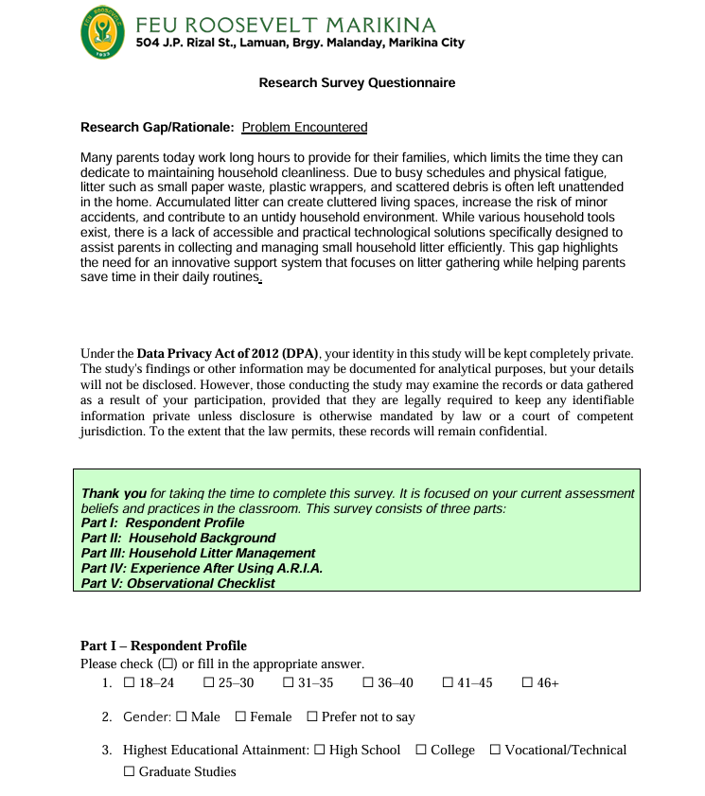

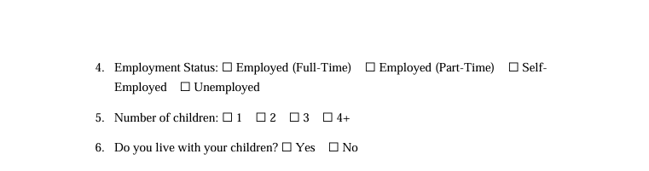

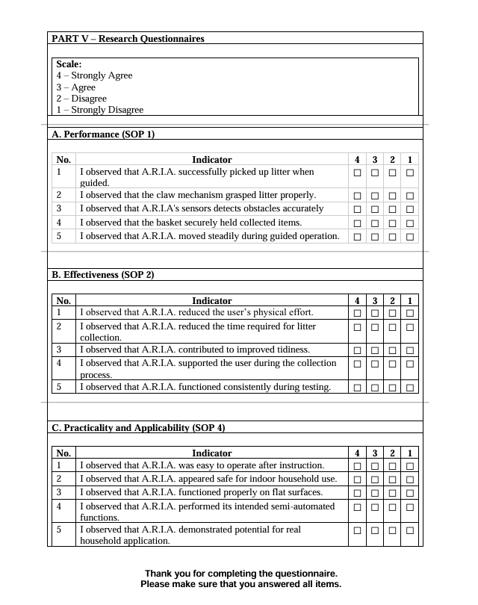

Appendix B: Populated Results
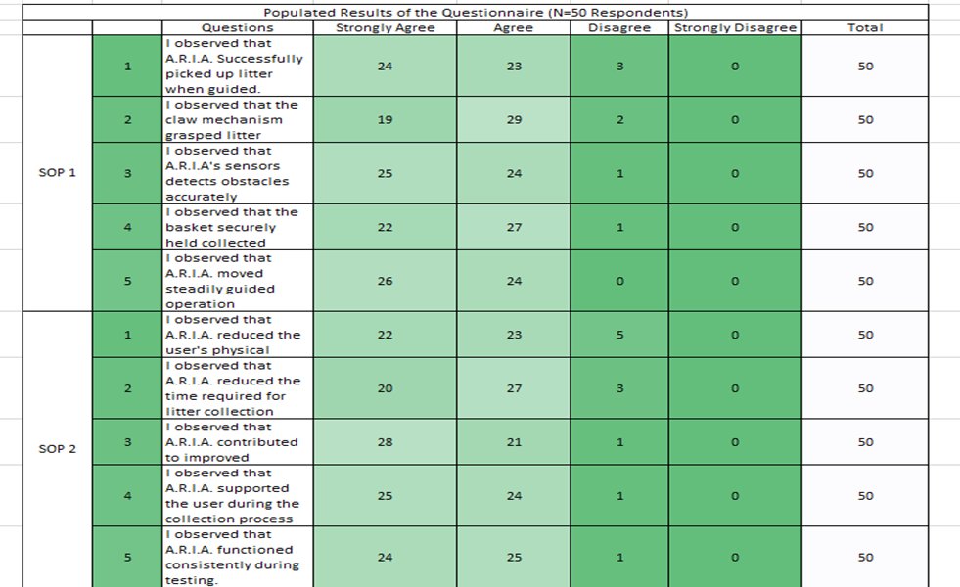

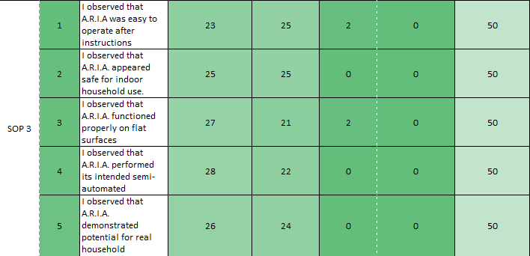

Appendix C: Linear Regression Analysis
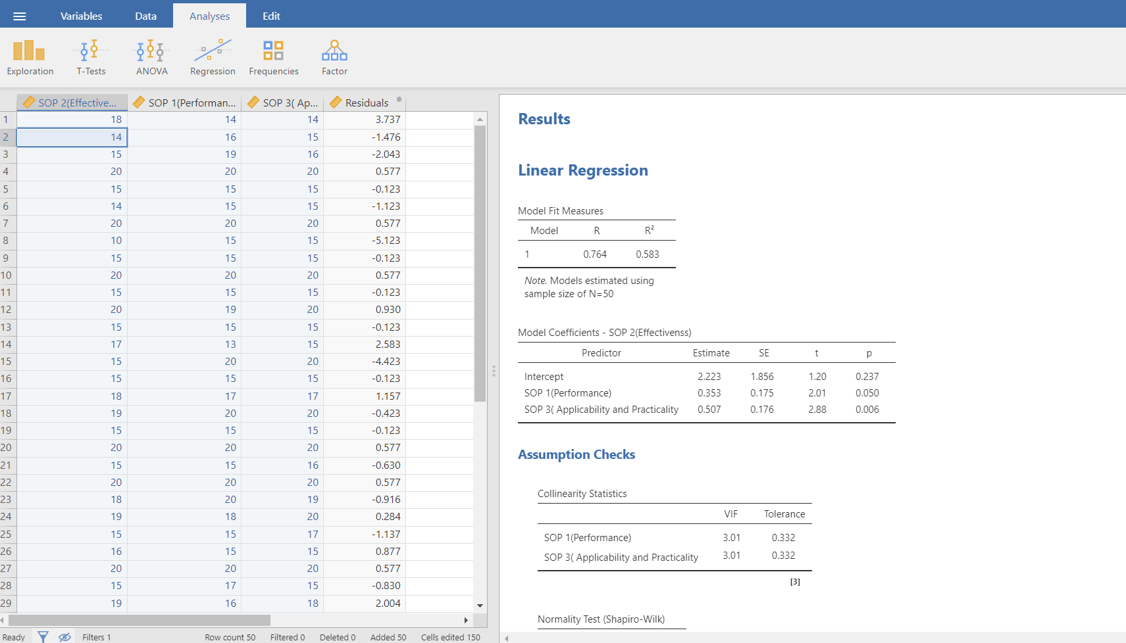

Appendix D: Documentation of A.R.I.A
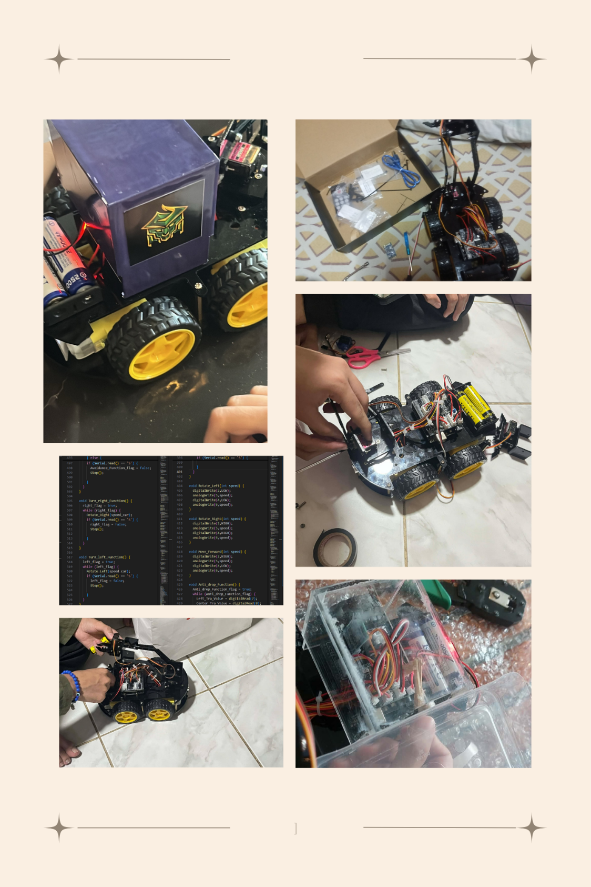

Appendix E: Sketch of A.R.I.A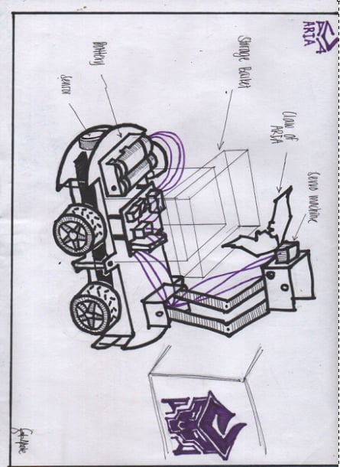

REFERENCES
Abillar, A. A., & Florida, M.A.O.(2019).Family, career and intellectual pursuits of full-time mothers in selected local villages from one province in the Philippines. Asia Pacific Journal of Multidisciplinary Research, 7(1), 114–121. https://scholar.google.com/scholar

Almanzor, M. A., Anvo, S., Thuruthel, T. G., & Iida, F. (2022).
Autonomous detection and sorting of litter using deep learning and soft robotic grippers. Frontiers in Robotics and AI, 9, 106485 https://doi.org/10.3389/frobt.2022.106483

Alsarve, J. (2024). Managing families, managing time: Parents’ work–family difficulties and work–family strategies over time. Community, Work & Family. https://doi.org/10.1080/13668803.2024.2425377

Balagtas, C.A., & Crua, M. (2024). Assessment of waste management awareness and practices among parents: A sequential explanatory study. International Journal of Multidisciplinary: Applied Business and Education Research, 5(6), 1669–1679. https://doi.org/10.11594/ijmaber.05.06.06

Barve, P. S., Mendhe, M. K., Shahale, A., Ambare, A., & Mukte, A. (2020).
The floor cleaning robot design and operation. International Journal for Research in Applied Science & Engineering Technology, 8(11), 677–681.

Bedejim, A. N., Labon, K. O., Loncio, R. S., & Batani, R. S. (2019).
Balancing life: The struggles of working mothers with children 5 years old and below in Benguet State University, Philippines. Mountain Journal of Science and Interdisciplinary Research, 79(3), 76–89. https://doi.org/10.70884/mjsir.v79i3.238

Cagatin, J. V., Gonzales, M. J., Sigua, E. J., & Junio, K. (2021).
Pristine: Automatic floor cleaning robot (Research project). Our Lady of Fatima University,Senior High School. https://www.coursehero.com/file/86457767/RESEARCH-PROJECTdocx/

Coggins, T. N. (2022). More work for Roomba? Domestic robots, housework and the production of privacy. Prometheus, 38(1), 98–112. https://www.jstor.org/stable/48676469

Corpuz, R.S.A. ,& Orquiza, J.C.R. (2018). Utilization of fuzzy logic control in a waste robot. ResearchGate. https://doi.org/10.13140/RG.2.2.29577.85605

Hertzum, M. (2024). Inferior, yet transformative: The user experience with robotic vacuum cleaners. Roskilde University. https://mortenhertzum.dk/publ/IWC2024.pdfLocal

Hosokawa, R., & Katsura, T. (2021).
Maternal work-life balance and children’s social adjustment: The mediating role of perceived stress and parenting practices. International Journal of Environmental Research and Public Health, 18(13), 6924. https://doi.org/10.3390/ijerph18136924

International Journal of Scientific Research Archives. (2024).
Waste disposal knowledge, attitude, and practices of households in Barangay Poblacion, Compostela, Cebu. https://ijsra.net/sites/default/files/IDSRA-2024-0987.pdf

Jeremias, H .I.M.,& Fellizar ,F.M.D.R.(2021).Knowledge, awareness, perceptions, and practices on solid waste management of households in selected urban barangays in Sorsogon City, Philippines. https://d1wqtxts1xzle7.cloudfront.net/75807808/362-libre.pdf?1638802470=&response-content

Jianguo JackWang, Lin, S.-S., & Liu,A. (2023).Bioinspired perception and navigation of service robots in indoor environments: A review. Biomimetics, 8(4), 350. https://doi.org/10.3390/biomimetics8040350

Kim, M. (2025). Adoption of home service robots: Exploring household differences in perceived usefulness.IEEEAccess.https://scholar.google.com/scholar?hl=en&as_sdt=0%2C5&q=assistant+robots+for+household+family+&btnG=#d=gs_qabs&t=1759473092495&u=%23p%3Dych_fwd-YzwJ

Kowsalya, N., & Mohanraj, P.(2025). Work-life balance and parental stress: Examining the challenges faced by working parents. International Journal of Multidisciplinary ResearchandGrowthEvaluation,7(2).https://www.researchgate.net/publication/394050874_Worklife_balance_and_parental_stress_Examining_the_challenges_faced_by_working_parents

Lyttelton, T., Zang, E., & Musick,K.(2022).Parents’ work arrangements and gendered time use during the COVID-19 pandemic. Journal of Marriage and Family, 84(1), 193–212. https://doi.org/10.1111/jomf.12810

Matsekoleng, T. K.(2020).Parents’ daily household activities on child litter awareness: An action research case. Eurasia Journal of Mathematics, Science and Technology Education, 16(12). https://doi.org/10.29333/ejmste/9343

Megalingam, R. K., Rajesh, S., Kotaprolu, S. S., Nithul, B., Kumar, D. V., & Rudravaram, G.(2025).Cleaning robots: A review of sensor technologies and intelligent control strategies for cleaning. Journal of Field Robotics. https://doi.org/10.1002/rob.22515

Páez-Ubieta, I., Castaño-Amorós, A., Puente, S. T., & Gil, A. (2023).
Vision and tactile robotic system to grasp litter in outdoor environments. Journal of Intelligent & Robotic Systems, 107(3), 54. https://doi.org/10.1007/s10846-023-01930-2

Ramos, J. M., & Custodio, R.(2021). A collaborative application for assisting the management of household plastic waste through smart bins: A case study in the Philippines. International Journal of Environmental Research and Public Health, 18(15), 7894. https://doi.org/10.3390/ijerph18157894

Sambat, L.M.D.(2024).Assessment of waste management awareness and practices among parents. International Journal of Multidisciplinary: Applied Business and Education Research, 5(6), 112–123. https://doi.org/10.11594/ijmaber.05.06.06

Su, J., Cao, Y., Tang, A., Wang, S., & Dong, J. (2021).
Design of litter collection robot for urban environment. https://doi.org/10.1115/imece2021-69732

Trushna, T., Pathak, P., & Kumar, A. (2024).
Interventions to promote household waste segregation: A systematic review. Waste Management, 175, 45–58. https://doi.org/10.1016/j.wasman.2024.01.015

Vaussard, F. (2024). Lessons learned from robotic vacuum cleaners entering the home ecosystem.ScienceDirect.https://www.sciencedirect.com/science/article/abs/pii/S0921889013001899

Wang, X., Zhang, L., Wu, X., & Zhao, M. (2021).
Work-family conflict, enrichment, and adolescent academic adjustment in dual-earner families. Frontiers in Psychology, 12, 712954. https://doi.org/10.3389/fpsyg.2021.712954

Wellendorf,K., Søilen, K. L. G., & Veel, K. (2022).
Calm surveillance in the leaky home: Living with a robot vacuum cleaner. ResearchGate.https://www.researchgate.net/profile/KristinVeel/publication/361461831_Calm-Surveillance-in-the-Leaky-Home-Living-with-a-Robot-Vacuum-Cleaner/links/62b2d571d49f803365b14793/Calm-Surveillance-in-the-Leaky-Home-Living-with-a-Robot-Vacuum-Cleaner.pdf

