PostgresSQL
https://www.npmjs.com/package/postgres

Big picture
SQL is a language (how to talk to database)
PostgreSQL / MySQL are database systems (software). Database Management Systems (DBMS)
PostgreSQL supports both SQL (relational) and JSON (non-relational) querying.

What relational(SQL) means?
In relational database:
- Data is stored in tables
- Tables have rows and columns
- Tables can be linked together using relationship

What “JSON (non-relational)” means
PostgreSQL can also store JSON JavaScript Object Notation
Instead of strict columns, you can store:
- Flexible
- Nested
- Schema-less data

Managing table

PostgreSQL data types

Boolean
It can hold one of the 3 possible values: true, false, or null.
Use keyword boolean or bool to declare a column with Boolean data type

Character such as char, varchar, and text
PostgreSQL provide 3 character data type: CHAR(n), VARCHAR(n), and TEXT
- CHAR(n): is the fixed-length character with white space padded. (n) is the exact number of characters the column will hold. If you insert string that is fewer than n character, PostgreSQL will automatically fill the remaining space with blanks to make it exactly n characters. If you try to insert a string longer than n character, PostgreSQL will give an error.
- VARCHAR(n): variable-length character string. n specifies the maximum number of characters the column can hold. Unlike CHAR(n), it does not pad spaces for shorter string. it will gives an error for longer string than n.
- TEXT: variable-length character string that unlimited length.

Numeric such as integer floating point number
It provides 2 distinct types of numbers:
- Integer
There are 3 kinds of integer in PostgreSQL
- Small integer SMALLINT is 2-byte signed integer that has range from -31768 to 32767
- Integer INT is a 4-byte integer
- Serial same as integer except PostgreSQL will automatically generate and populate values into the SERIAL column. This is the same as AUTO_INCREMENT in MySQL.
- Float
There are 3 main types of floating-point numbers:
- float(n) with precision at least n and up to a maximum of 8 bytes.
- real or float8 is 4-byte floating point number.
- numeric or numeric(p,s) is a real number with p digits with s number after decimal point.

Temporal such as date, time, timestamp, and interval
- DATE stores date only
- TIME stores time of the day values
- TIMESTAMP stores both date and time values
- TIMESTAMPTZ is abbreviation for timestamp with time zone
- INTERVAL stores periods (span of time, like duration between 2 dates or times) such as 5 days, 3 hours 30 minutes, 2 years 6 months

UUID (Universally Unique Identifier)
It allows to store Universal Unique Identifier, UUID guarantee better uniqueness than SERIAL and can be used to hide sensitive data exposed to the public such as value of id in URL

Array for storing array of string, numbers
To store array of string and number

Create table
To create table, use keyword CREATE TABLE
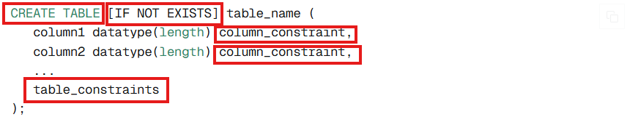
IF NOT EXISTS: PostgreSQL will only create table if it has not been yet created, if it is already created, PostgreSQL will not throw error instead it will issue a notice.
Specify table column with data type and column constraint separated by commas
Column constraint specifies the rule that is applied to data within column to ensure data integrity. The column constraints include the following
PRIMARY KEY, FOREIGN KEY, NOT NULL, UNIQUE, CHECK, and DEFAULT
Specify table constraints including PRIMARY KEY, FOREIGN KEY, CHECK constraints

CREATING TABLE WITH SERIAL
SERIAL is integer but which is auto-incremented with every new row created

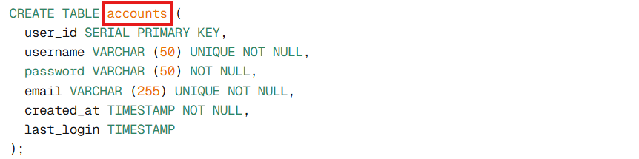

CREATING TABLE WITH GENERATED AS IDENTITY
- GENERATE AS IDENTTY is modern SQL-standard way to create an auto-incrementing column in PostgreSQL
- Unlike SERIAL, it implicitly attaches a sequence to the column
There are 2 variants:
- GENERATED ALWAYS AS IDENTITY: sequence is always used; you cannot manually insert a value unless you override it.
- GENERATED BY DEFAULT AS IDENTITY: sequence is used by default, but you can manually insert a value if needed.
Using GENERATED ALWAYS AS IDENTITY
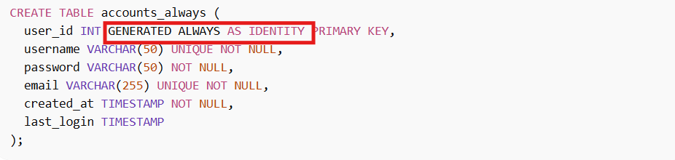
- user_id auto-increments automatically every time a new row is added
- you cannot manually inserted a value into user_id without special override
- ideal when you want a strict control over IDs so there are no duplicates or gaps due to manual inserts.
Using GENERATED BY DEFAULT AS IDENTITY
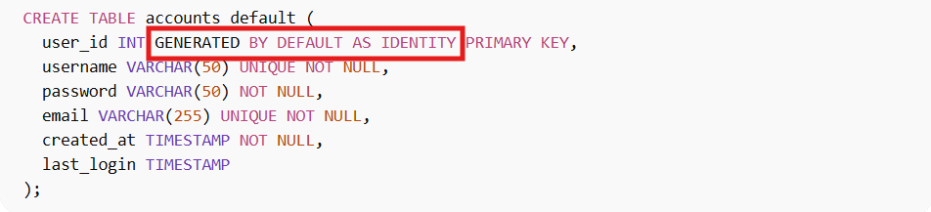
- user_id auto-increments automatically if you do not provide a value.
- You can manually insert a specific value for user_id if you want (the sequence will continue from the last generated numbers)
- Useful when you want flexibility.

CREATING TABLE USING UUID AS PRIMARY KEY
- Enable the extension in your database
PostgreSQL comes with many optional modules called extensions. These add extra function or features to the database.
- pgcrypto = PostgreSQL cryptography function
- One of its most popular functions: get_random_uuid() which generates random UUID
- CREATE TABLE USING UUID
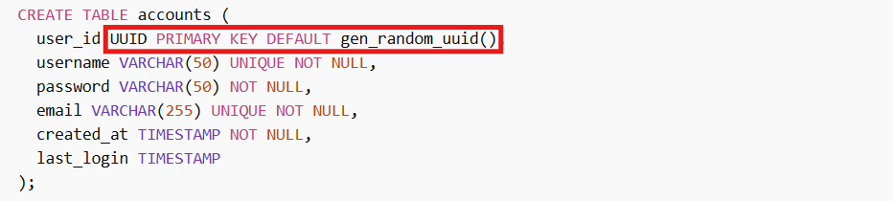

alter table
below is the basic syntax of altering a table
PostgreSQL provide the following action for altering table:
- Add a column
- Drop a column
- Change data type of a column
Using expression: optional; needed if PostgreSQL cannot automatically convert the old data type to the new type.
USING salary:: NUMERIC: converts the text value of salary to numeric
- Rename a column
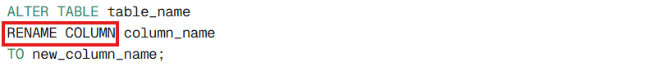

- Add constraint to a column.
It adds constraint UNIQUE to the column url
- Rename table

