Next.js

Getting started
In next.js, routing is file-system based, which means folder and files directly map to routes
How it works: (App router)
- Each folder = route segment
- A page.js or page.tsx inside that folder = the actual page
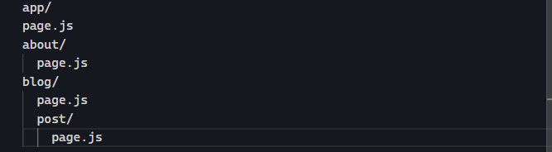
Routes created:
- / ➡️ app/page.js
- /about ➡️ app/about/page.js
- /blog ➡️ app/blog/page.js
- /blog/post ➡️ app/blog/post/page.js
Special files in folders
Next.js also uses special filenames inside folders:
- Layout.js ➡️ shared layout for that route segment
- Loading.js ➡️ loading UI
- Error.js ➡️ error UI
- Route.js ➡️ API endpoints

CSS Styling

CSS Modules
It allows you to scope CSS to a component by automatically creating unique class names, so you do not have to worry about the style collusion as well.
The name should end .module.css
We use import to import the file
We add it by this way:
The shape is class inside home.module.css
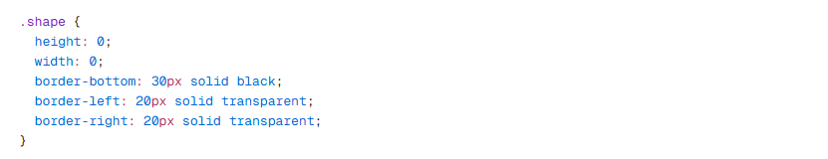
Tailwind and CSS modules are 2 most common way styling Next.js applications.

Using clsx library

Basic usage
This library is used to toggle class names. There may be a case where you need to conditionally style an element base on state or some other condition.
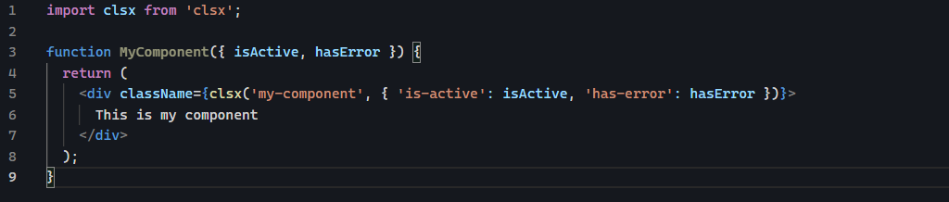
In the example above, clsx combines static class ‘my-component’ with the conditional classes ‘is-active’ and ‘has-error’.

Using array
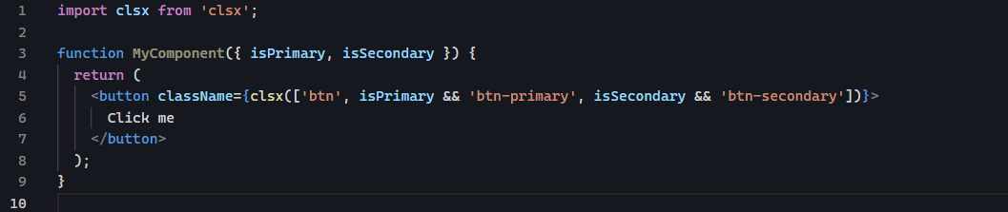
The difference with the basic usage is that, in this example, static class is wrapped inside array

Optimizing Fonts and Images

How to add custom fonts with next/font

Using custom font
When browser load the page, it does not wait for the custom fonts to finish downloading. It renders the text immediately using a fallback system font.
Once the custom font finishes downloading, the browser replaces the fallback font with the custom one

Using next/font
When you use font from next/font, Next.js automatically optimizes the fonts. It download fonts at build time and hosts them with other static assets. This mean when user visits application, there no additional network request for fonts which would impact the performance.

Adding primary font (from next/font/google)
Import font from next/font/google
Export font to be used elsewhere
Inter here is factory function that takes config object like (subsets, weight, style, variable, etc..) and return an object containing:
- Classname to use in JSX
- CSS variable (if variable is used)
- Other metadata for font optimization
In inter, we have this
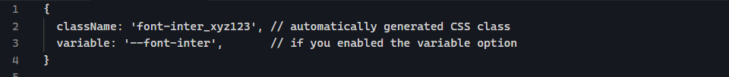
- inter.calssname is the string of CSS class automatically generated by Next.js.
- Next.js generates a CSS rule for the font-face with that class name.

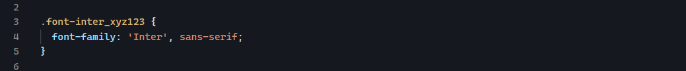
We add the font by accessing the classname property
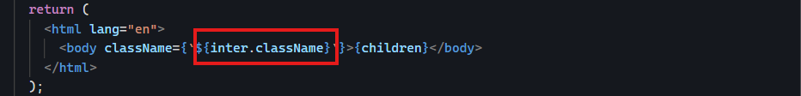

How to add images with next/images

Why optimizing images?
- Automatic responsive images (no manual srcset)
With <img>, you must write and maintain
With <Image/>, Next.js generates srcset and serve the correct size per device
What width and height actually mean?
Width and height define the intrinsic dimensions used for layout and they tell the browser:
- Reserve a space for an image with this aspect ratio.
Import image from ‘next/image

Creating Layouts and Pages

Nested Routing
Next.js uses file-system routing where folders are used to create nested routes. Each folder represents a route segment that maps to a URL segment
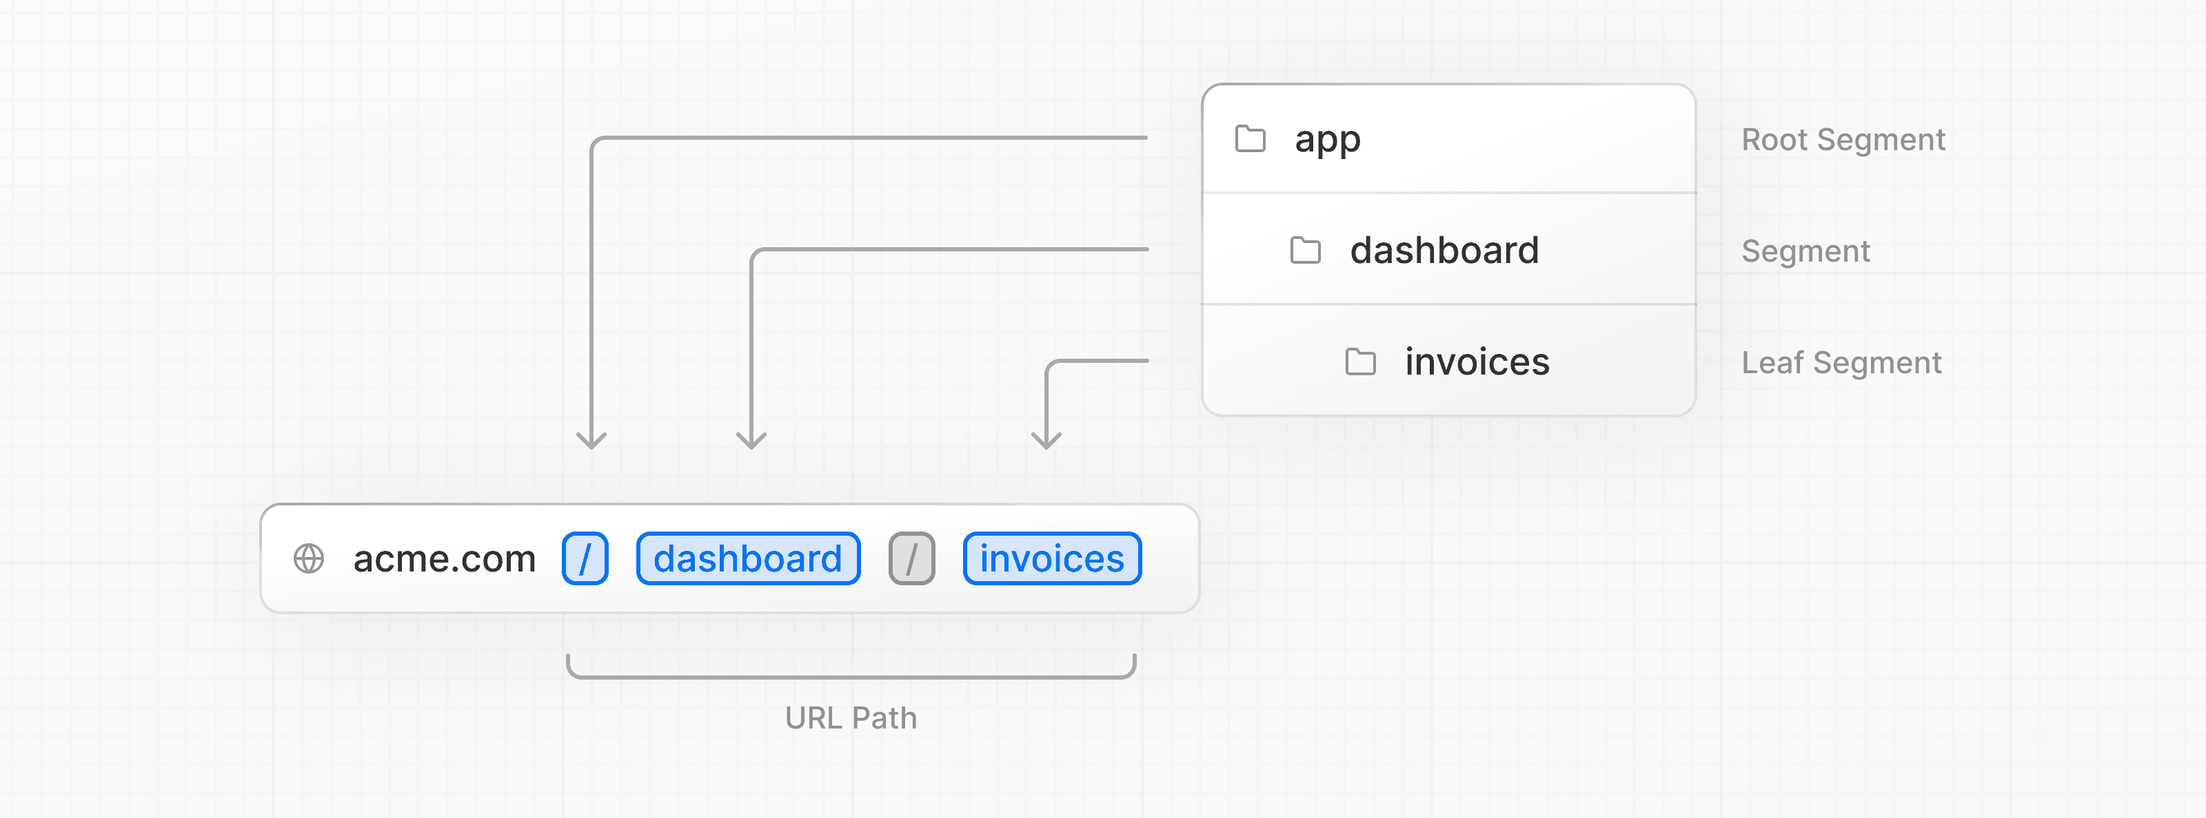
You can create separate UIs for each route using layout.tsx and page.tsx files where layout.tsx is the common layout.
Page.tsx is the actual page and it exports React component, and it is required for route to be accessible.

Colocation
Even when the route is made publicly accessible, only the content returned by page.tsx or route.tsx is sent to the client. This means that project files can be safely collocated inside route segment in the app directory without accidentally being routable.
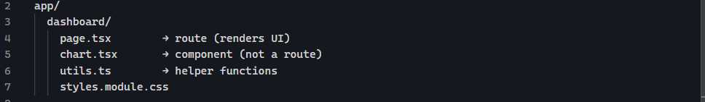
We can place file safely inside the same route folder. But those files apart from page.tsx and route.tsx will not be sent to client.

Navigating between Pages

Why optimize navigation?
Traditionally, we use anchor tag <a> to link between pages, but using <a> will reload the full page

The <Link /> component
In Next.js, we can use the <Link /> component to link between pages.
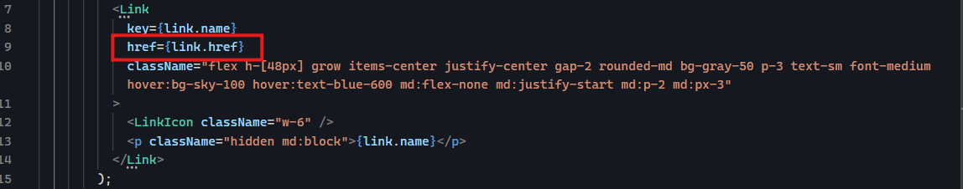
<Link /> is comparable to <a> both has href attribute

Showing active links
We use active Link to show to user which page he is currently on. To do this, you need to get user’s current path from URL. Next.js provide hook called usePathname() that we can use to check the path and implement active link.
By default, files in the app/ directory are server components, that means:
- They run on server
- The do not have access to browser features
- They cannot use React hooks like useState, useEffect, or usePathname
When you add directive “use client”, this tells Next.js that “This component must run on the browser, not on the server”

Setting up your Database

Fetching Data

Static and Dynamic Rendering

Streaming

Adding Search and Pagination

Mutating Data

Handling Errors

Improving Accessibility

Adding Authentication

Adding Metadata

Next Steps

