https://recharts.github.io/en-US/

Recharts

Roadmap
Stage 1 — Learn the Basics
- Understand what a chart is in Recharts
- Learn the key components:
  - LineChart, BarChart, PieChart
  - Line, Bar, Pie
  - XAxis, YAxis
  - Tooltip, Legend, CartesianGrid
- Learn how data looks (data array of objects)
- Goal: Render a simple static chart with hardcoded data
Stage 2 — Static Chart Practice
- Build your first chart using hardcoded data
- Experiment with:
  - Changing dataKey
  - Adding XAxis and YAxis
  - Adding Tooltip and Legend
- Goal: Get comfortable with the structure of a chart
Stage 3 — Dynamic Data
- Fetch data from an API or database
- Store it in React state
- Pass it into your chart
- Handle loading states (while data is fetching)
- Goal: Your chart now reflects real-time data
Stage 4 — Multiple Charts & Styling
- Add different types of charts: Line + Bar + Pie
- Style your charts:
  - Colors, stroke, grid lines
  - Responsiveness (works on mobile)
- Goal: Make your dashboard look professional
Stage 5 — Advanced Features (Optional)
- Animations
- Interactive charts (clicks, tooltips, filtering)
- Real-time updates (websockets or polling)
- Goal: Make charts fully dynamic and interactive

Stage 1 — Recharts Basics

What is rechart
Rechart is a React chart library that uses React components and lets you draw charts by passing data.

Key Components

Component | What it does | Example use
LineChart | Container for line charts | <LineChart data={data}>
Line | The actual line on the chart | <Line dataKey="sales" />
BarChart | Container for bar charts | <BarChart data={data}>
Bar | The actual bar | <Bar dataKey="sales" />
XAxis | Horizontal labels | <XAxis dataKey="month" /> for labels/categories
YAxis | Vertical axis | <YAxis /> for numeric
Tooltip | Shows value on hover | <Tooltip />
Legend | Shows label/color | <Legend />
CartesianGrid | Adds grid lines | <CartesianGrid stroke="#ccc" />

How Data Works
Recharts expects an array of object:
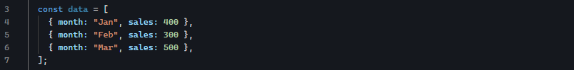
- Each object is one point on the chart.
- dataKey=”sales”, use the sales value for plotting.
- XAxis dataKey=”month”, labels come from month

Summary
- Container (LineChart, BarChart)
- Visual element (Line, Bar)
- Axes (XAxis, YAxis)
- Extras (Tooltip, Legend, CartesianGrid)
- Data: array of objects, dataKey tells chart which field to use

Stage 2 — Build Your First Static Chart

Import Components
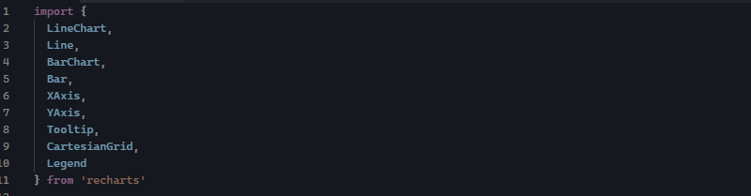

Render Chart
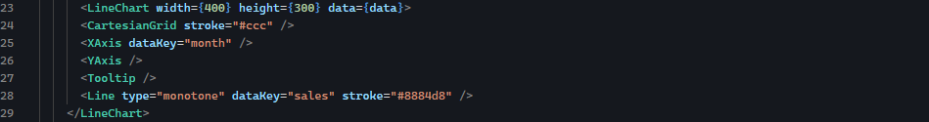
YAxis for numeric value.
XAxis for label/categories.

Stage 3 — Dynamic Chart in React
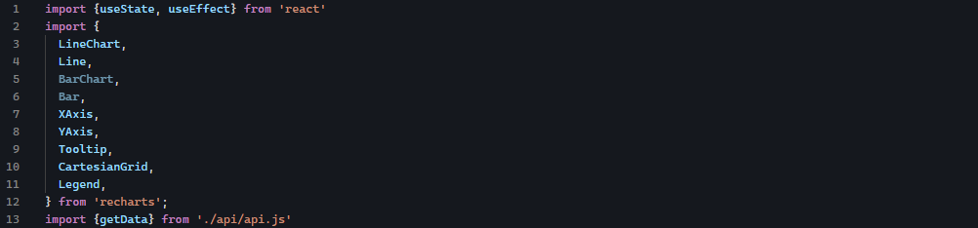
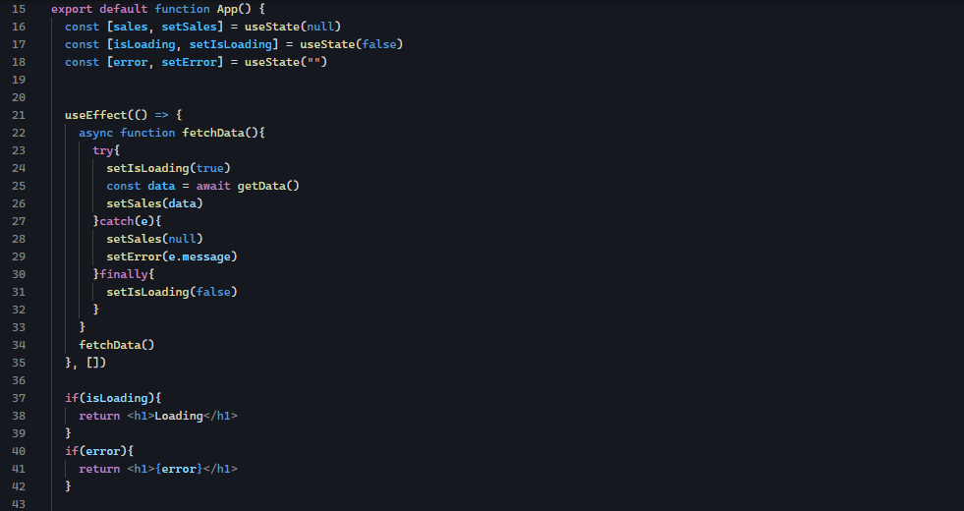
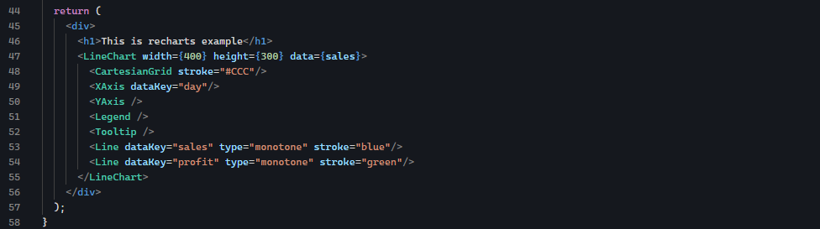

Stage 4 — Step 1: Add a Second Chart && Styling

Important Concept
Chart Type | Where data goes
LineChart | data on container
BarChart | data on container
PieChart | data on <Pie />

Import Cell component from recharts
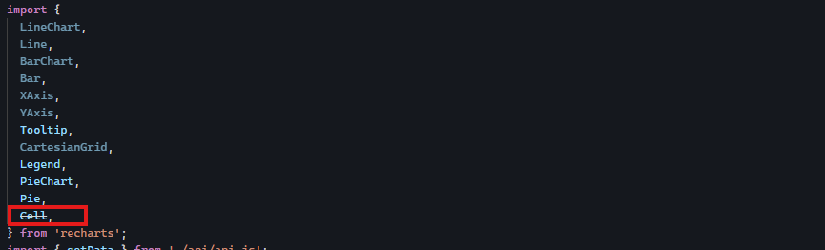
Create an array of colors
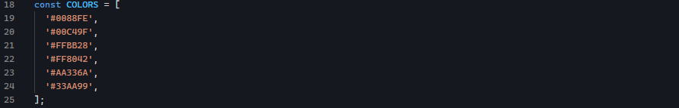
Then use it inside a Pie and Cell components
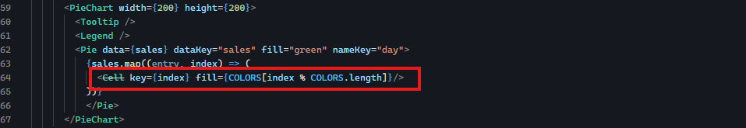

What This Does
- sales.map(...) → loops through each slice
- Cell → assigns a color to each slice
- index % COLORS.length → cycles colors if data is longer

Make Charts Responsive
Import ResponsiveContainer from recharts
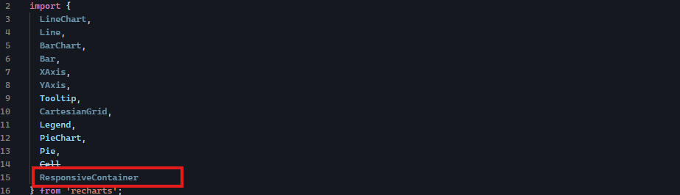
Wrap chart inside ResponsiveContainer and wrap them inside a div with width 100% and defined height
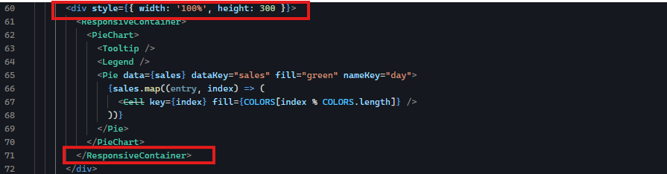

Important Rule
When using ResponsiveContainer:
- When using ResponsiveContainer:
- Remove width and height from charts

