🧠 Phase 1 — Data Model Thinking (FOUNDATION)
Goal: Understand how MongoDB “thinks”
Learn:
- Document vs collection
- Flexible schema concept
- Embedded vs referenced data (VERY important)
Practice mentally:
- How would a “User” look?
- How would “Orders inside Users” look?
Key idea:
MongoDB = document modeling, not table design
🧱 Phase 2 — Schema Basics (Mongoose core)
Goal: Learn structure definition
Learn:
- Schema definition
- Data types
- required / default
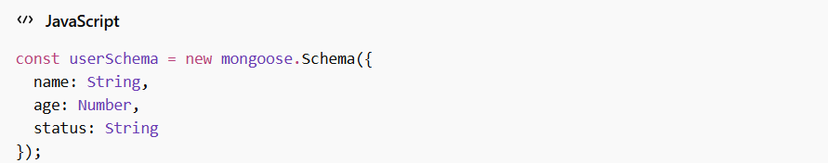
Understand:
- Schema is NOT database requirement
- It’s a validation + structure layer
🔗 Phase 3 — Models (bridge layer)
Goal: Understand interaction layer
Learn:
- mongoose.model()
- Model vs Schema difference
Core idea:
Schema = shape
Model = interface to collection
🔍 Phase 4 — Query Mastery (CORE SKILL)
Goal: Become fluent in reading/writing data
Learn deeply:
Basic queries
Filtering
Operators
- $gt, $lt, $in, $or, $and
Sorting / limiting
🧠 Phase 5 — Schema Evolution (REAL WORLD THINKING)
Goal: Learn how schemas evolve over time
Learn:
- required fields
- defaults
- validation
- timestamps
- indexes
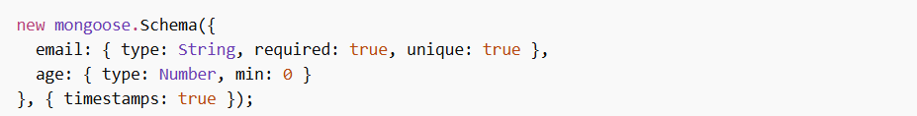
Understand:
Schema is not static — it evolves with queries
🧩 Phase 6 — Data Modeling Decisions (IMPORTANT)
Goal: Think like a database designer
Learn:
- Embedding vs referencing
Example:
- Embed comments inside posts?
- Or separate collection?
Key questions:
- Read frequency?
- Update frequency?
- Data size?
👉 This is where MongoDB mastery begins.
⚙️ Phase 7 — Advanced Query Thinking
Goal: Handle complex data queries
Learn:
- chained queries
- filtering combinations
- pagination logic thinking
- index usage awareness
Example:
📊 Phase 8 — Aggregation Thinking (IMPORTANT STEP)
Goal: Learn data transformation
Learn pipeline concept:
- $match
- $group
- $project
- $sort
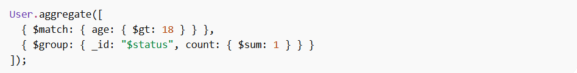
Understand:
Aggregation = SQL GROUP BY equivalent, but more powerful
🧠 Phase 9 — Mental Mastery (FINAL LEVEL)
You are done when you can:
- Look at a problem → design schema
- Predict query performance
- Decide embedding vs referencing instantly
- Write aggregation without thinking syntax
- 📚 Best FREE Resources (ONLY MongoDB + Mongoose)

Official MongoDB Docs
https://www.mongodb.com/docs/

Query & operators
https://www.mongodb.com/docs/manual/reference/operator/query/

Mongoose docs
https://mongoosejs.com/docs/

Aggregation
https://www.mongodb.com/docs/manual/aggregation/

🧠 Phase 1 — Data Model Thinking (FOUNDATION)
Document vs Collection
Collection is a group of documents. (Folder)
Document is a single JSON-like object. (File)
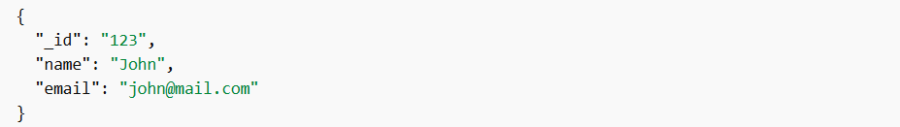
Flexible Schema
MongoDB does not require uniform structure. Users can have different data structures.
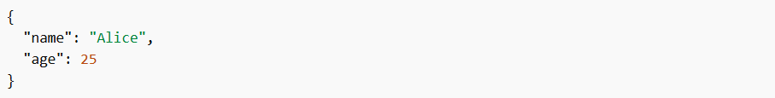
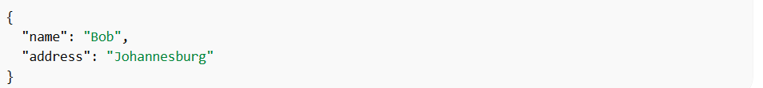
Same collection, but different structure.
Embedded vs Referenced Data
- EMBEDDED DATA or Denormalized (nested inside)
It means that the data are stored inside single document instead of having different collections.
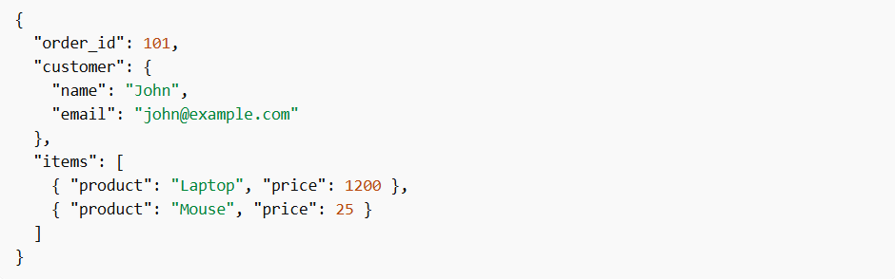
🛒 Order ➡️ the main document (order_id)
🧑 Customer ➡️ embedded inside "customer"
📦 Products (items) ➡️ embedded inside "items" array
They are all stored inside single document.
- Referenced Data (Normalized)
We have different collections, and related data are stored in separate documents and connect them using references (Ids).
Customers collection
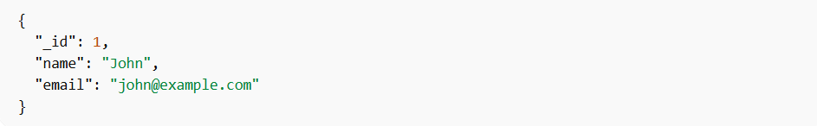
Orders collection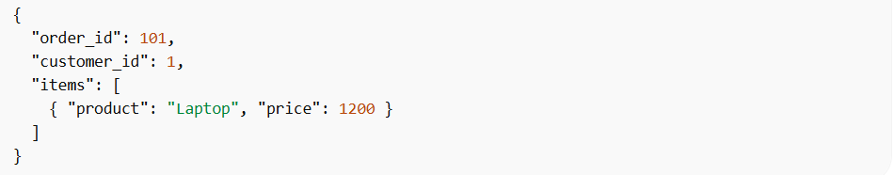
The order only stores customer_id, not full customer info.
🧱 Phase 2 — Schema Basics (Mongoose core)
In pure MongoDB, you can insert anything. MongoDB does not care.
Mongoose adds schema layer on top of MongoDB.
Schema is not database rule, it is JavaScript-level structure + validation system. It enforce safety and clarity.
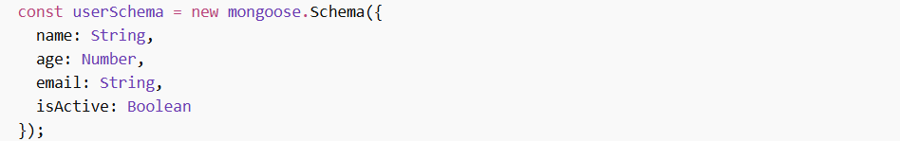
Here, we defined fields, and their expected data types.
Here are mostly used data types in mongoose
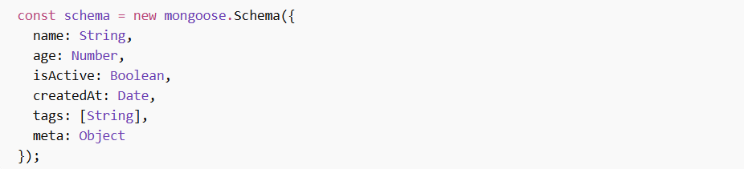
Advanced nested structure
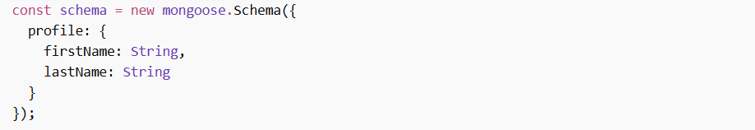
This is called embedded structure inside schema.
🔗 Phase 3 — Models (bridge layer)
What a model really is?
A Model is a class built from a schema that lets you create and interact with documents in a specific collection.
Model = Constructor function
This is like creating an object from a class.
Instance methods:
Static methods:
🔍 Phase 4 — Query Mastery (CORE SKILL)
- Basic Filtering (WHERE equivalent)
Find all blogs with a title
Find by author
- 🔢 Comparison Operators (VERY IMPORTANT)
MongoDB uses special operators starting with $
Greater than
Less than
Greater or equal
Less or equal
- IN Operator (match multiple values)
Status is either in draft or published
- OR condition
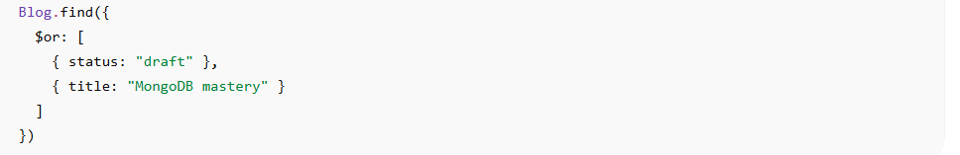
- AND condition (implicit)
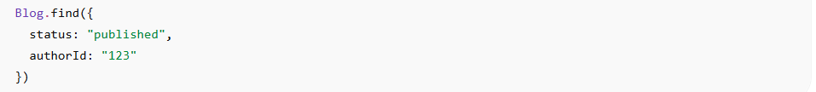
- Sorting
Ascending order
Descending order
-1 = newest first
- Check existence of field
- Check if the value of field is not null
It checks if the value of a field is not null, but it implicitly excludes missing fields.
Here, it combine 7 and 8 to make sure that the field is present and the value is not null.
It check if the field is present. Even if the value is null, it will still match.
- Limiting results
Only 5 results
- Skip (pagination basics)
Skip first 10, then get the next 5
Real-World Pattern (VERY IMPORTANT)
Pagination formula:
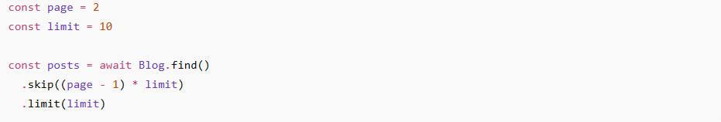
📊 Phase 8 — Aggregation Thinking (IMPORTANT STEP)
Query: Give me documents matching this condition.
Aggregation: take documents, transform them step-by-step, and produce new results.
So instead of just filtering data, we are:
- Reshaping it
- Grouping it
- Calculating it
- Building new outputs
🧩 The 4 core building blocks (MASTER THESE FIRST)
- $match: Filter stage
This is basically .find() inside aggregation
Purpose: reduce dataset early such as only published blog.
Always try to place $match at the beginning of your pipeline to minimize data flow.
- $group: Combine data
Purpose: group document by field, calculate totals, averages, counts
- $project: Shape output
Purpose: chose fields, rename fields, create computed fields. Such as only show title and views.
- $sort: Order results
same idea as before, but inside pipeline
🧠 Mental model (VERY IMPORTANT)
- Step 1: filter data
- Step 2: group it
- Step 3: reshape it
- Step 4: sort final result
🧠 The syntax shape
Every aggregation syntax looks like this:
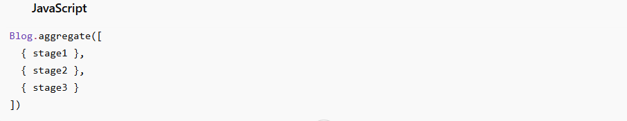
Note:
- It is always an array
- Each item is a stage
- Order matters (top ➡️ bottom execution)
⚙️ Stage 1: $match (Filtering)
This is just like .find()
Example idea: only published blogs
🧠Stage 2: $group (CORE IDEA)
This is the most important concept in aggregation.
It combines multiple documents into one result.
Example problem: total view by author
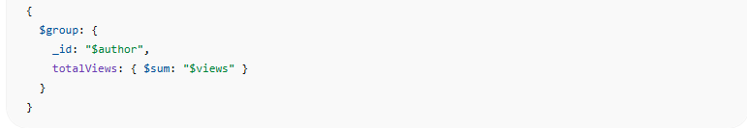
What this means _id?
It means group by this field (author), in MongoDB, you write “$author”. Group all documents that have the same author
Important: Inside aggregation expressions, $ means a field reference
totalViews: new computed field name.
$sum: add values together
$group is where calculations happen.
What $group does
It can:
- sum values → $sum
- count → $sum: 1
- average → $avg
- min/max → $min, $max
🧠Stage 3: $project (reshape output)

Right now we have:
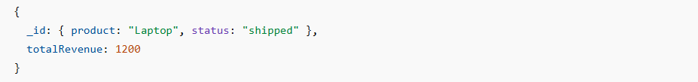
But frontend APIs usually want:
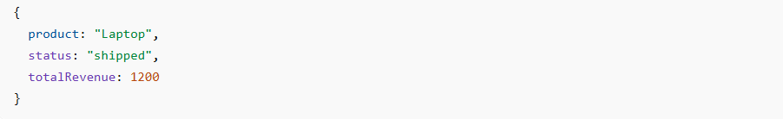
That’s when $project comes in.
Goal:
- remove _id
- flatten nested _id
- create clean fields
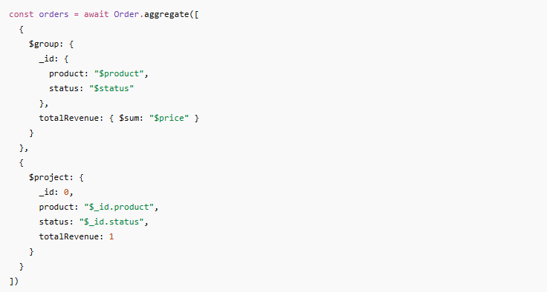
🧠 What $project is doing
- remove _id
_id: 0 this hides MongoDB default grouping key.
- Extract value from _id
Flatten nested object.
- Keep field as-is
Means keep this field unchanged
Final output
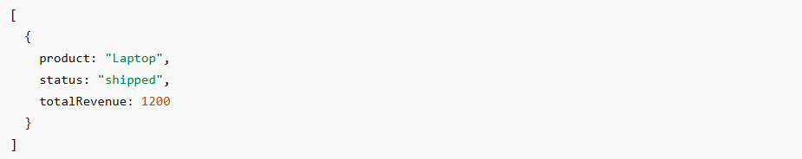
🧪 Exercise 1 — Basic grouping warm-up
👉 Group orders by city of the user (NOT product) and count how many orders per city.
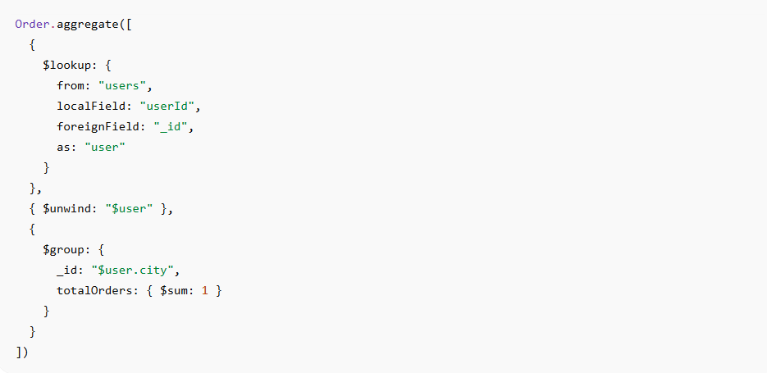
1️⃣ $lookup = JOIN
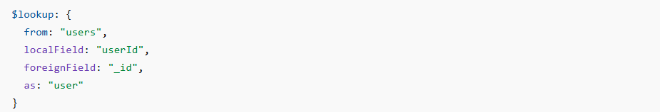
What it means in simple English:
“Take each order and attach the matching user document”
🔥 Meaning step by step
- localField: "userId"
👉 This is the field in the orders collection
- foreignField: "_id"
👉 This is the field in the users collection
- The matching logic
MongoDB does this:
So it finds the user whose _id matches the order’s userId.
- as: "user"
👉 This is just the output field name
So MongoDB attaches the result like:

