TypeScript

Introduction

What is typescript?
TypeScript lets you explicitly tell JavaScript what type something should have. TypeScript is JavaScript with extra features, especially the ability to describe and check the types of your data before your code runs.

Dynamically vs statically typed language
In dynamically typed language, type checking happens at runtime, some type errors are discovered while running.
In statically typed language, type checking happens before runtime, may type errors are discovered during compilation.

TypeScript compiler
TypeScript is transpiled into JavaScript using a compiler.

Installing compiler
We are installing TypeScript, which includes the TypeScript compiler called tsc.

Configuring the compiler
That command creates a TypeScript configuration file for your project.
- Code example:
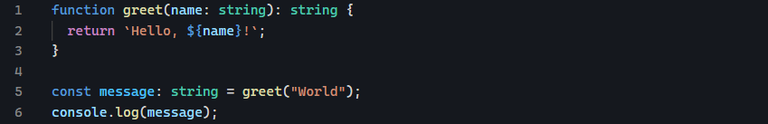
- Compile your TypeScript code:
This will generate a hello.js file in the same directory.
Then run the compiled JavaScript node hello.js

TypeScript simple types
Most basic types in TypeScript are called primitives.
- Boolean
- Number
It represents both integers and floating-point numbers. TypeScript uses the same number type for all numeric.
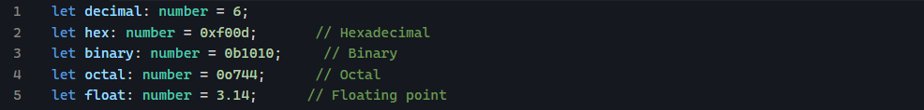
- String
It represents text data. It can use single or double quotes, or backticks for template literals.

TypeScript explicit & inference
TypeScript offers two ways to work with types:
- Explicit typing: you explicitly declare the type of variable
  - Used for function parameters and return types, object literals, when the initial value might not be the final type.
- Type inference: TypeScript automatically determines the type based on the assigned value.
  - Used for simple variable declaration with immediate assignment, when the type is obvious from the context.

TypeScript special types

Any
It is the most flexible type in TypeScript, it tells the compiler to skip type checking for a particular variable.
When to use any:
  - When migrating JavaScript code to TypeScript
  - When working with dynamic content where type is unknown

Unknown
You tell TypeScript: I do not know what type value is.
When to use unknown:
  - When working with data from external source (APIS, user input, etc)
  - When migrating from JavaScript to TypeScript in a type-safe way.
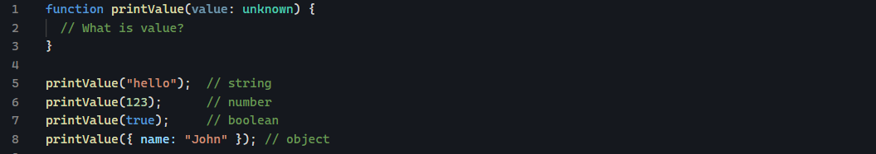

Difference between any and unknown
- Any: TypeScript skips type checking, you can do almost anything with the value
- Uknown: TypeScript does not let you use the value directly. You must check/ narrow the type first, then you can safely use it.
You need to check:
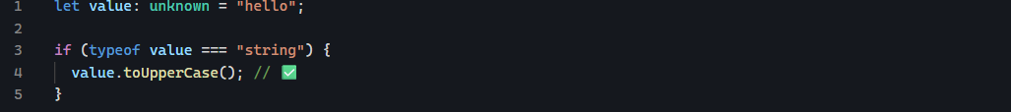

Never
Compare void and never
This function finishes, but does not return a value.
This function never finished normally.it throws an error and stops.
Never, the function does not successfully finish, therefore it never produces a returned value.
Another function is infinite loop
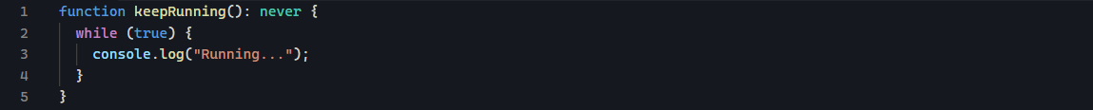

TypeScript arrays

Readonly
Readonly can prevent array from being changed. The array can be read, but do not let my code modify it.
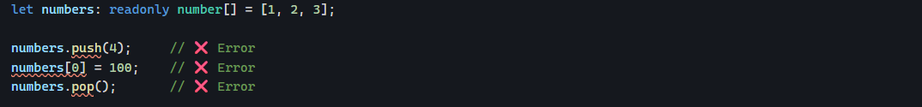

TypeScript object types
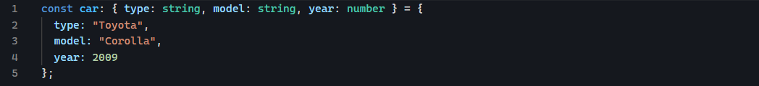

Optional properties
An optional property is a property that may or may not exist on an object.
The key is ?

TypeScript type and interface

What problem are type and interface solving?
Suppose you have a user object:
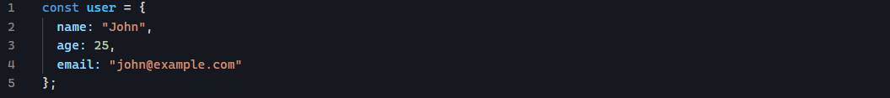
This object has a particular shape:
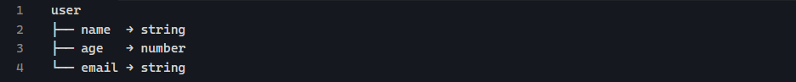
As your application gets bigger, you might want to describe that shape and reuse it. That’s where type and interface come in.
They allow you to say: A User should have these properties, with these types.

Type
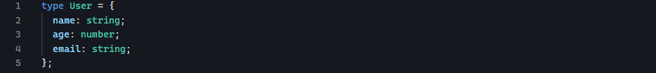
Type is a TypeScript keyword which means I want to create a type definition.
You are creating your own type called User. This is the name you’re giving your type.
You could call it:
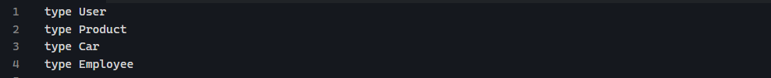
The name is your choice, although conventionally we us PascalCase for types:
How to use it?
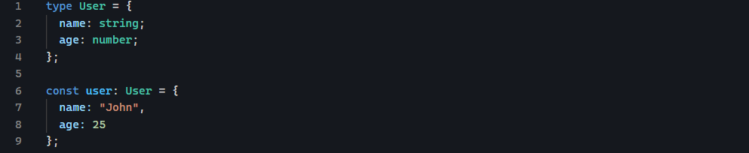
Optional properties with type:
The ? means the property is optional.

Interface
An interface is a description of what an object should look like.
You can define exact same object using an interface:
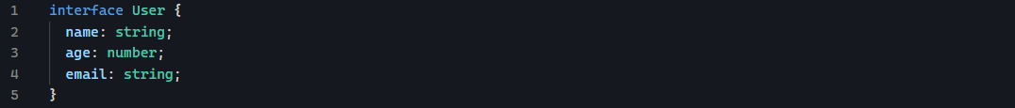
Any object that I call User must have name that is string, age what is number and email that is a string.
Interface is Typescript keyword which means: I am defining the structure / shape that an object should follow.
You can then use it:
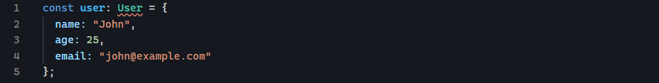

Difference between Type and Interface
What is the difference between Type and Interface
For basic object, they are very similar.
Type:
- Type can represent more than objects
- It can represent a primitive also
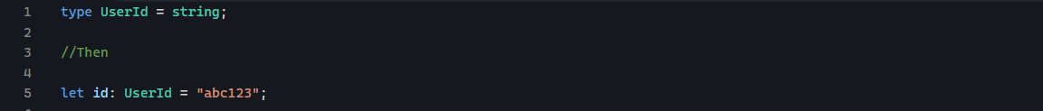
- You can also create a union
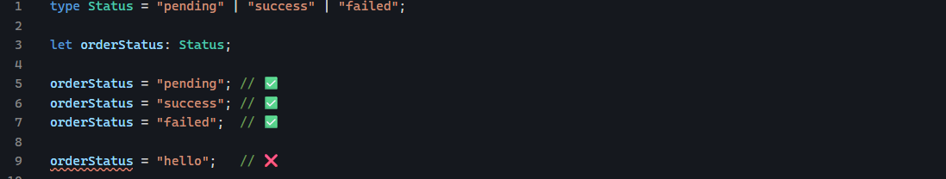
- You can also use unions with types
Meaning:
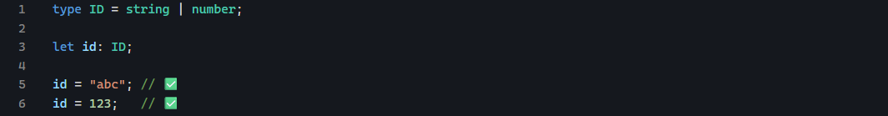
- Type can create intersections
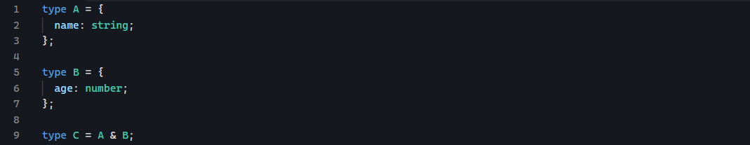
C now requires both:

Interface:
- Interface is primarily designed to describe the structure of an object.
- But you cannot use an interface in the same way as:
An interface isn’t designed for creating a union of literal values.
- Interface can extend multiple interfaces
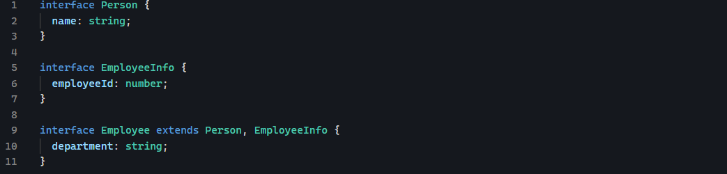
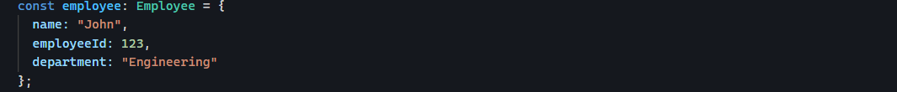
- Both type and interface can build upon other object definitions, but they do it differently.
With interface:
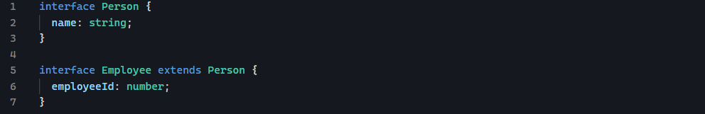
Now employee has:
With type:
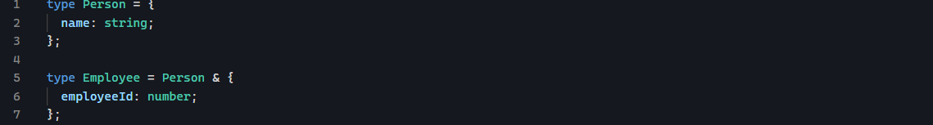
The & means: combine these types.
Both can describe functions
This means: Add describes a function that takes two numbers and returns a number
Interface can also describe a function:

Enum
It gives a name to a fixed set of related values.
Suppose your application has 3 possible order status:
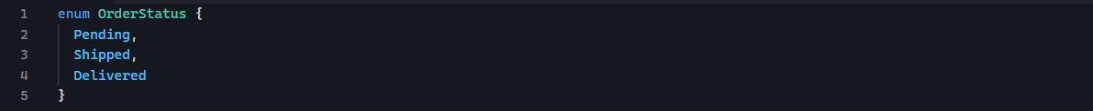
Now the orderStatus represents those 3 possible statuses.
It tells TypeScript: I am creating an enumeration.
An enumeration is basically a collection of named values.
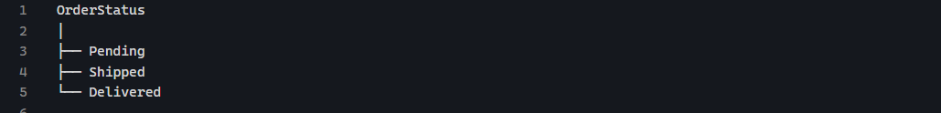

Using the enum
You can do this:

What value do enums actually contain?
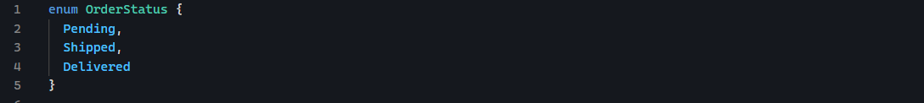
TypeScript gives them numeric values by default:
You can explicitly assign values:
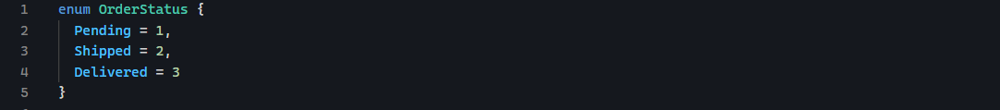
You can also use string
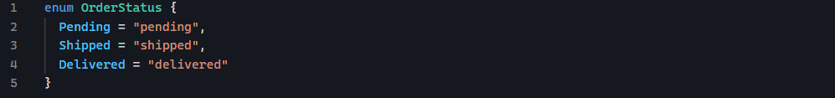

Union type

What is a union type?
A union type means that a value can be one type or another type. The symbol is | which you can read or.
This means id can contain a string OR a number

TypeScript Generics

What problem do generics solve?
Imagine you have this function:
It takes a string and returns a string
You could make another one for numbers:
You could make another for boolean:
Notice something: the logic is exactly the same.
The only thing changing is the type.
Generics let us say:
I do not know the type yet, but whatever type you give me, I’ll preserve that type. That’s the core idea of generics.

First generic
The first T declares a generic type parameter.
The second T says the value parameter has type T.
The third T says the function returns a value of type T.

What is T?
T isn’t a real TypeScript like string, number, and boolean. It is a placeholder for a type.
For example, when you write:
You are effectively saying T=string

Generic with Interface
Here T means the type of value stored inside the box.
You can create:
Here T=string

Generic with types
Then:

Multiple generic types
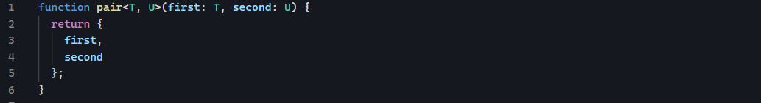
Here we have:
Two generic type parameters:
Suppose:
TypeScript infers: T=string, U=number.
Therefore the result is:

T, U, K, etc
These are just convention
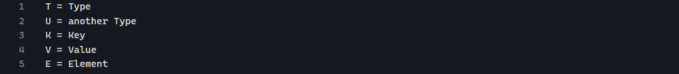

Generic constraints
Consider:
TypeScript complains because T could be:
- Number
- Boolean
- Date
Those don’t not necessarily have .length. we can use extends.
Now T is constrained, it means:
So it works with the following:
But this doesn’t:
Because number does not have .length.

What does extends mean here?
When you see:
It means T must satisfy the requirements of something.
For example:
It means T must have length property. And that property must be a number.

